Docs Qualification React TD
Star Wars Dictionary
Hosted Link: Star Wars Dictionary (sheltered-atoll-19870.herokuapp.com)
Github Link: tegarabd/star-wars-dictionary (github.com)
- Home Page

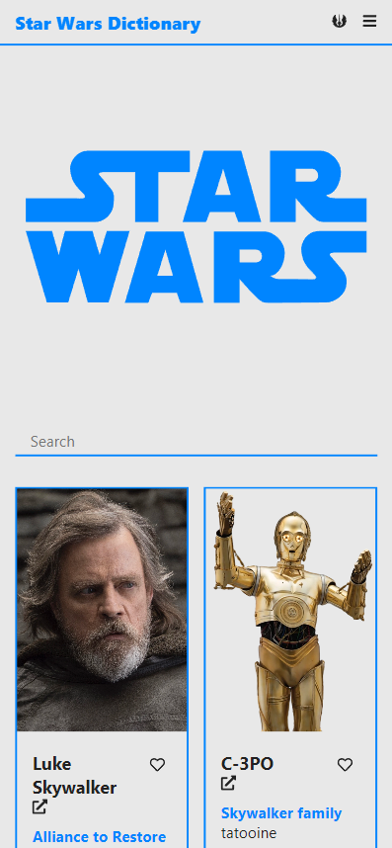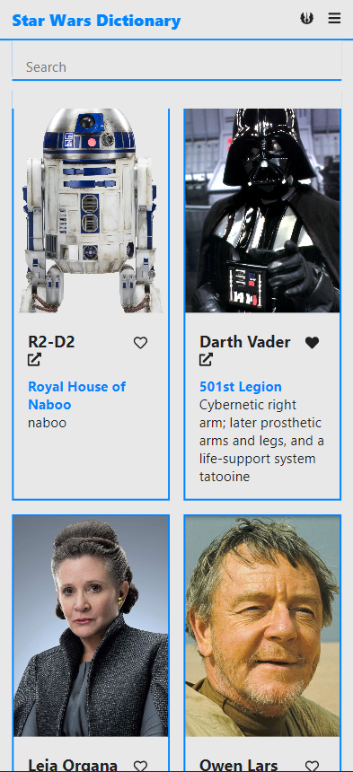

The home page contains a list of all Star Wars characters and a search bar to search for characters based on their names. Toggle favorite through heart button on each character card.

- Detail Page

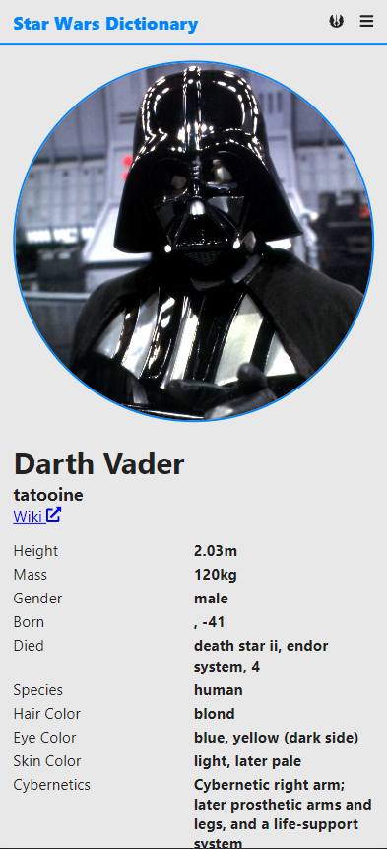

The detail page show the detail of particular character such as image, name, home world, height, mass, species, etc.

- Favorite Page

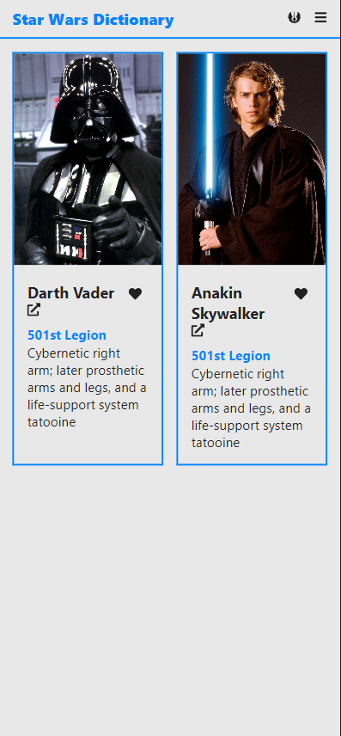

The favorite page show all the list of user’s favorite character that stores in localstorage.

- Navigation

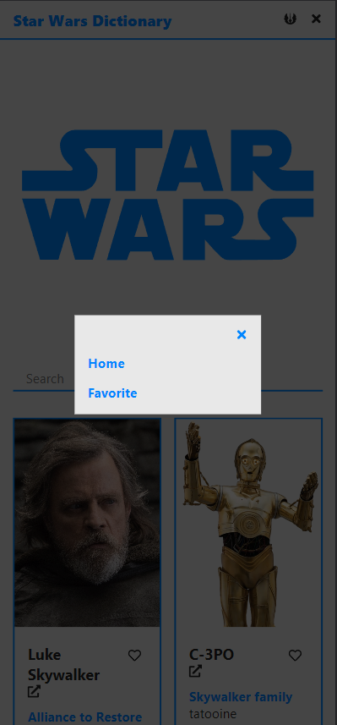

For navigation click burger menu button, it will show popup the list of page to navigate. Close the popup with x button.

- Theme

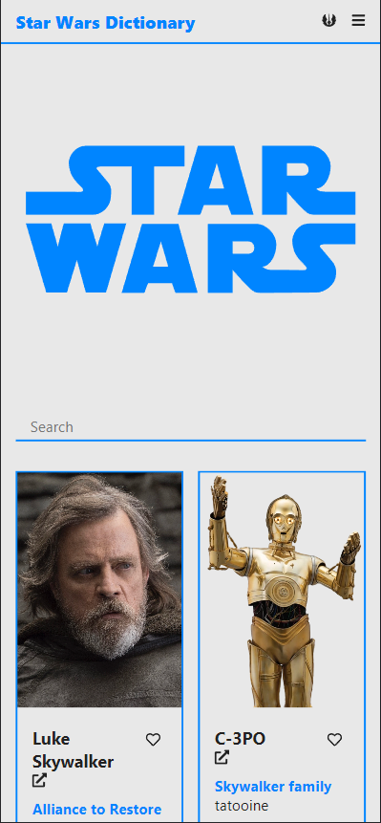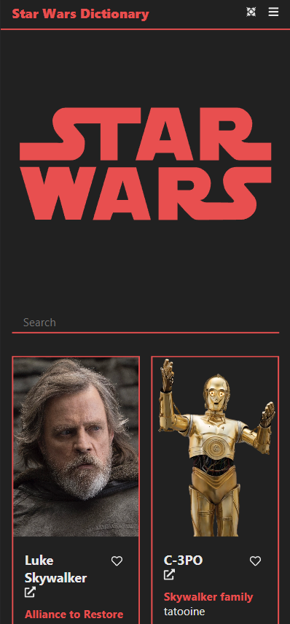

Change theme with Jedi or Sith Button.

