**Build your portfolio project (Week 2): MVP Complete**

Keteri Online System is a web-based software designed to automate the job search in a local market. The system allows clients to look at posted jobs online if they want to hire a professional then they can just look at the platform based on the rating. The system can be more efficient and convenient for clients as hirers or job seekers to find jobs on the platform. This in turn can make job searching experience good with improved management and organization for the local job market.

The system typically includes a website for clients to interact with and a back-end administrative panel for the clients to manage their operations.

* Online User registering: clients and workers can easily register with their requirements and qualifications.
* Job registration: Customers can check seat availability in real-time and choose their preferred seat based on the bus layout.

By automating the hiring process, the Keteri Online Systems major project helps reduce the hassle encountered during manual registration and job search and also reduces the cost of papers, minimizes the risk of human error, and increases the overall efficiency of the job posting and employee hiring process. Additionally, clients and workers benefit from the convenience of online availability to view jobs posted.

**Keteri Online System Challenges**

Online job sites are constantly changing and need to be adjusted accordingly. With the evolution of such a system, it becomes crucial to standardize the online job search process. Some of the key challenges that may be faced in such systems are:

1. **Attracting Employers and Job Seekers**: the following factors affect this challenge.

* **Competition**: there are multiple online job sites to play with currently and it is a must to convince clients (employers) to post jobs and also job seekers to use it happily
* **Building trust:** as it is known employers need a wide range of qualified candidates and job seekers need a wide range of opportunities and it can be tough to attract both sides in the initial phase.

1. **Content quality and moderation**: this is also one challenge faced when doing such job site business.

* **Fake job postings**: malicious actors might post fake jobs to scam users. There the system needs to protect such things to take this out and protect users.

1. **User Experience:** search functionality and user interface by itself need to be done with great care for efficient connection of potential employers with the right candidates quickly. In addition, the platform needs to be user-friendly and intuitive for both employers and job seekers.
2. **Monetization:** can also be another challenge if subscription fees are deterred for the service given. In such cases, there needs to be a balance affordably offering a valuable. In addition, if adverts are done for monetization, great care needs to be taken not to overwhelm users which may create negative experiences.

**3. Collaboration/Communication**

Keteri Online system project, I am working alone, and am analyzing important issues and reviewing some related projects.

Team member

* Tegbabu S. Nuramo

4. **Project Updates**

Keteri Online system in the next version will be updated to a mobile app for Android and iOS, and an additional alert system for users will be integrated.

5. **Progress**

1. Problem identified
2. Reviewed related project
3. Make a project flowchart
4. Selected technologies
5. Started implementation of the project

The progress made this week can be rated as 9 out of 10 and some uncompleted tasks are there and the progress went well. Most of the tasks are complete and the only part not complete according to the plan is the admin part. I am working on it.

1. **Challenges Encountered**

One of the technical challenges I faced this week was when I started implementing the admin part. The specific technical challenge is the authentication made when the employer or workers are registered and when the system tries to match the employer with the respective potential workers. The requests made by the employer and workers are handled in the admin dashboard. When the admin attempts to take a request and after review by the team manually, the request approval will be made. Therefore, the challenge I am tackling is this part.

As a non-technical challenge, time is my most ardent challenge where I cannot take all the things on time. But thanks to the concept of grith and also some motivating PLD sessions, I was able to go through the projects.

1. **Screenshot**

**Login and Sign-Up Part**

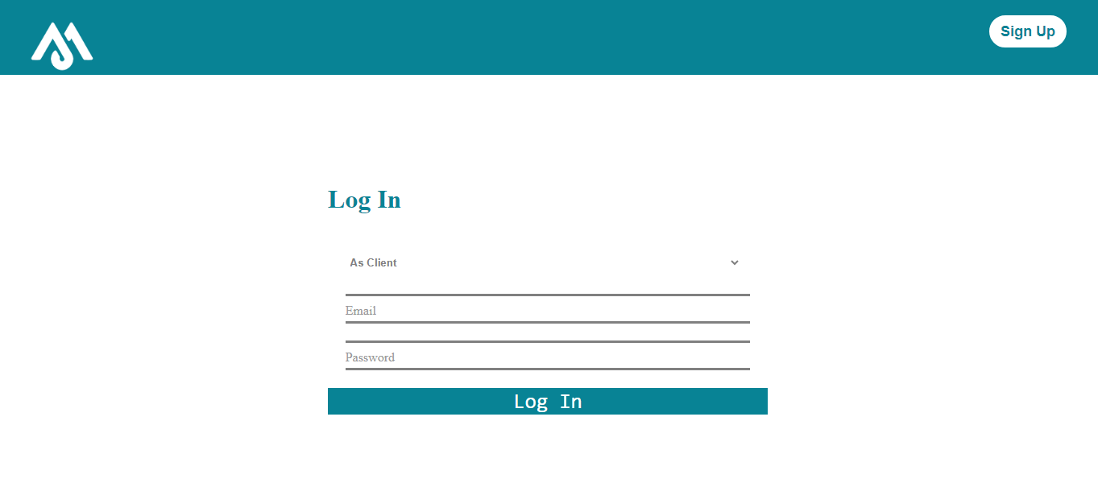

**Home before login part**



**Home after login part**

