csl_zipf_Pilot 2 analyses - No exclusions

Thomas Gorman

4/30/2020

# Test above chance

## [1] "Total Subjects before any exclusions: 172"

## [1] "Total Subjects remaining for analyses: 172"

# Looking At the Effect of Testing Phase

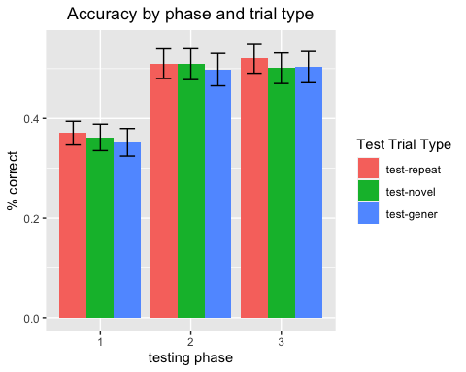

# Comparing The 3 conditions

### Some sbjs get removed for having non-finite values for accuracy - when they answered “I don’t know” to every option

## Warning: Removed 106 rows containing non-finite values (stat_summary).

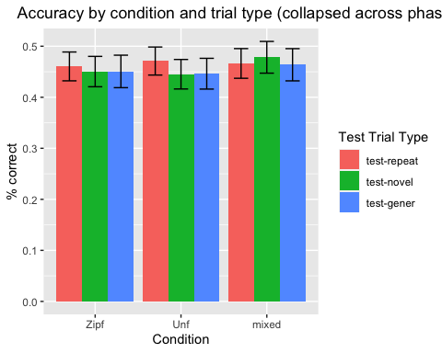

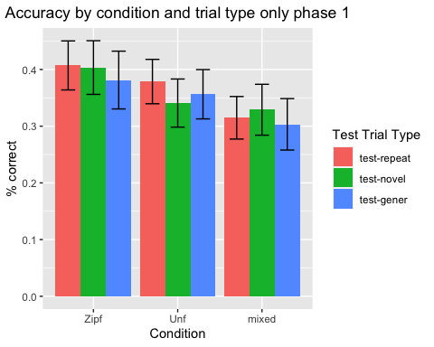

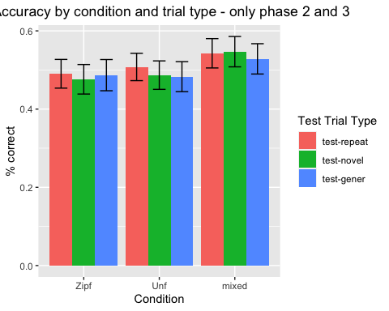

# Condition and Phase compared together

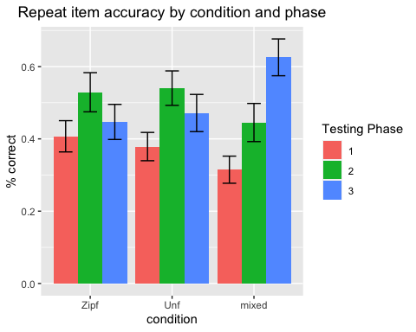

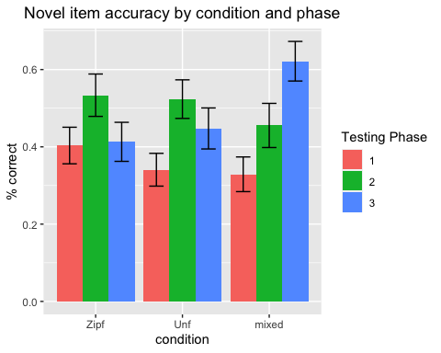

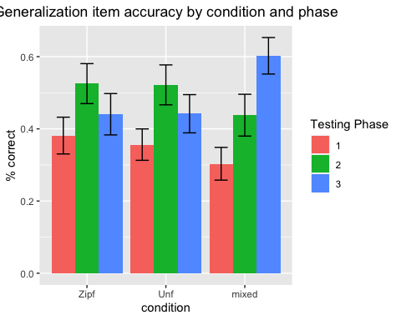

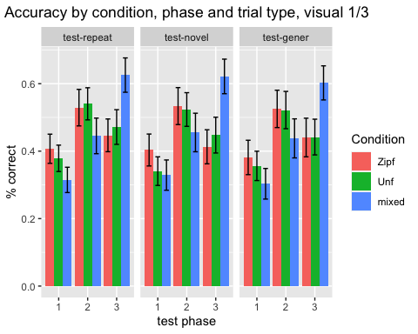

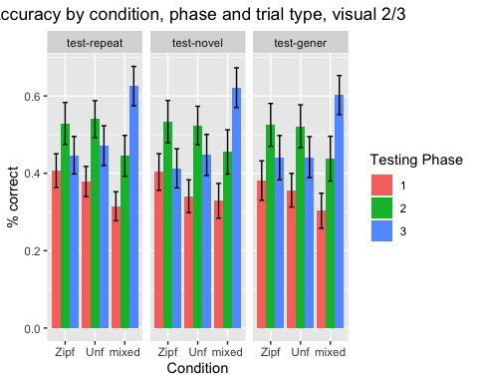

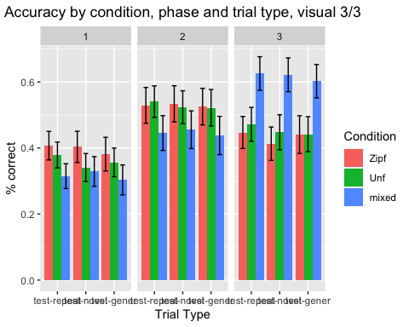

# Condition Order Comparison - 6 possible orders of doing the 3 training conditions

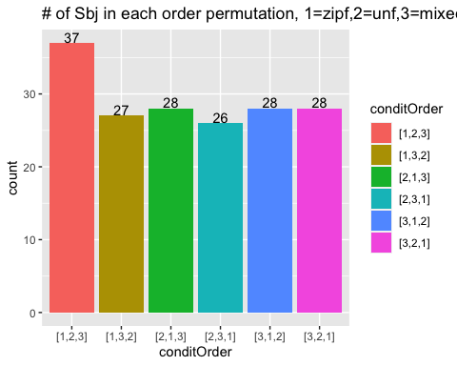

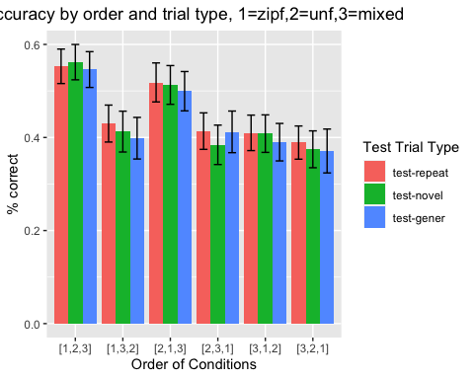

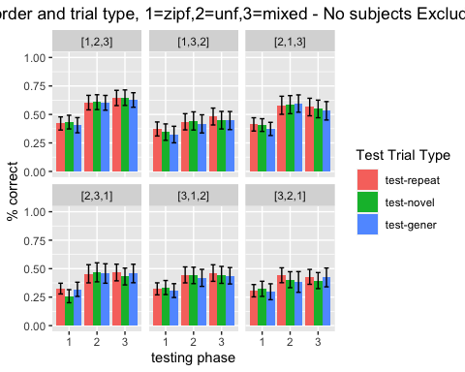

# Performance when controlling for the effect of phase - Z scores

### I take the overall average and strd deviation for each phase, then compute how many standard devaition units each condition is above or below that average

## Warning: Ignoring unknown parameters: fun.y

## No summary function supplied, defaulting to `mean_se()`

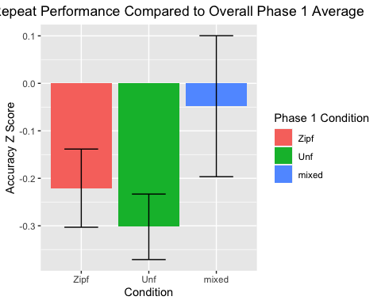

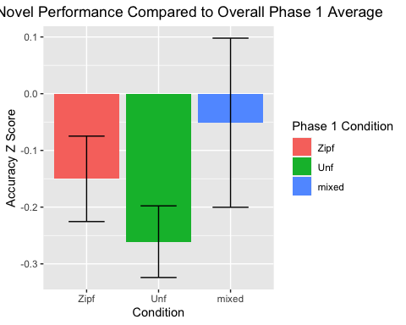

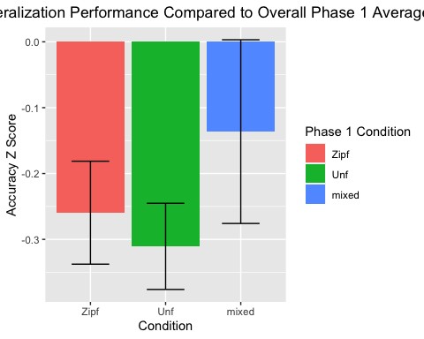

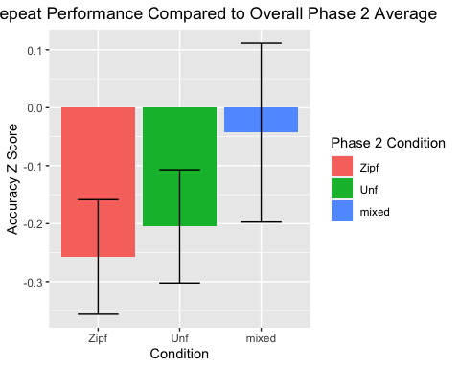

## Warning: Ignoring unknown parameters: fun.y

## No summary function supplied, defaulting to `mean_se()`

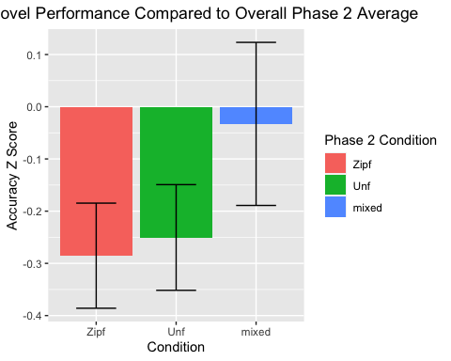

## Warning: Ignoring unknown parameters: fun.y

## No summary function supplied, defaulting to `mean_se()`

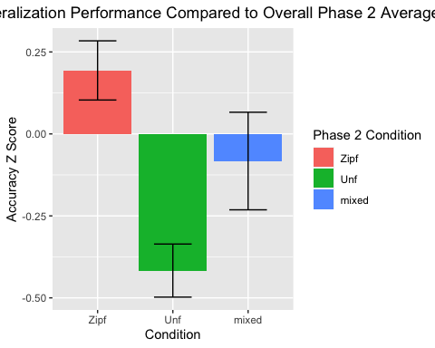

## Warning: Ignoring unknown parameters: fun.y

## No summary function supplied, defaulting to `mean_se()`

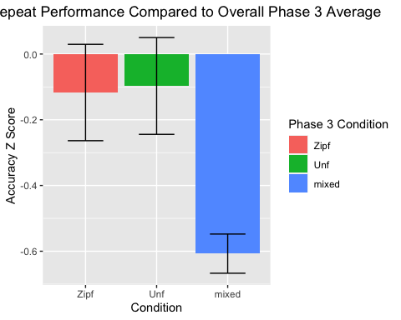

## Warning: Ignoring unknown parameters: fun.y

## No summary function supplied, defaulting to `mean_se()`

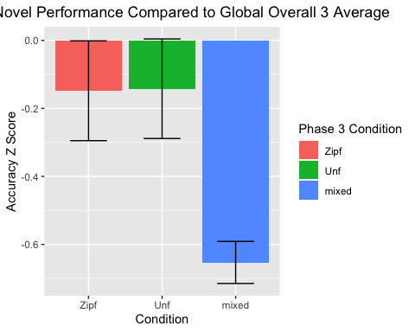

## Warning: Ignoring unknown parameters: fun.y

## No summary function supplied, defaulting to `mean_se()`

