csl_zipf_pilot2

Thomas Gorman

4/22/2020

# Test above chance

## [1] "Total Subjects before any exclusions: 111"

## [1] "Total Subjects excluded for below chance performance in any of the 3 test-repeat phases: 57"

## [1] "Total Subjects remaining for analyses: 54"

# Looking At the Effect of Testing Phase

## Warning: Removed 9 rows containing non-finite values (stat_summary).  
  
## Warning: Removed 9 rows containing non-finite values (stat_summary).

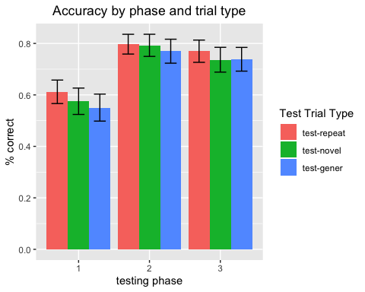

# Comparing The 3 conditions

### Some sbjs get removed for having non-finite values for accuracy - when they answered “I don’t know” to every option

## Warning: Removed 9 rows containing non-finite values (stat_summary).  
  
## Warning: Removed 9 rows containing non-finite values (stat_summary).

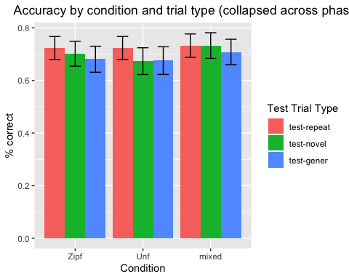

## Warning: Removed 5 rows containing non-finite values (stat_summary).

## Warning: Removed 5 rows containing non-finite values (stat_summary).

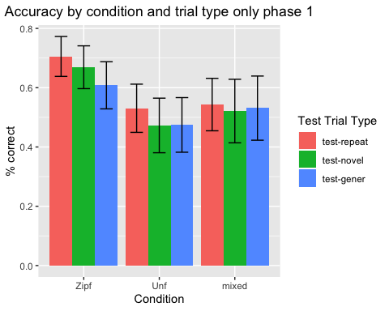

## Warning: Removed 4 rows containing non-finite values (stat_summary).

## Warning: Removed 4 rows containing non-finite values (stat_summary).

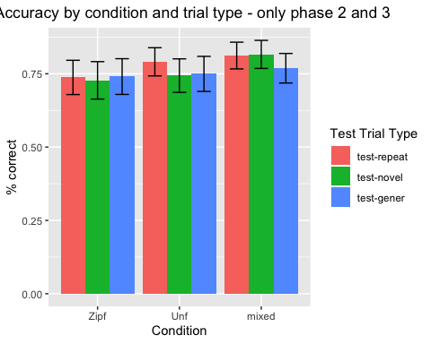

# Condition and Phase compared together

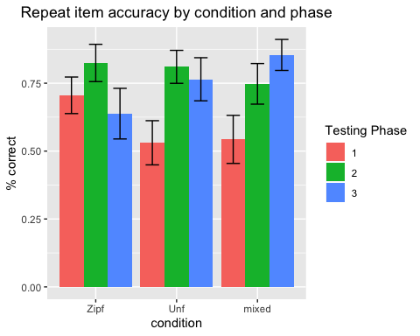

## Warning: Removed 1 rows containing non-finite values (stat_summary).  
  
## Warning: Removed 1 rows containing non-finite values (stat_summary).

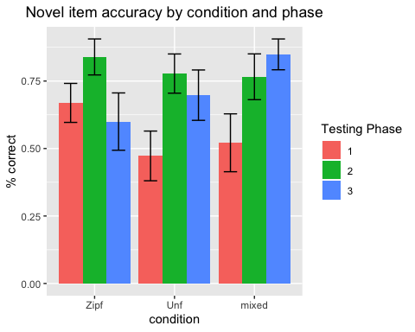

## Warning: Removed 8 rows containing non-finite values (stat_summary).

## Warning: Removed 8 rows containing non-finite values (stat_summary).

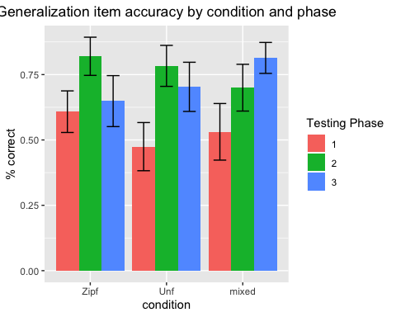

## Warning: Removed 9 rows containing non-finite values (stat_summary).

## Warning: Removed 9 rows containing non-finite values (stat_summary).

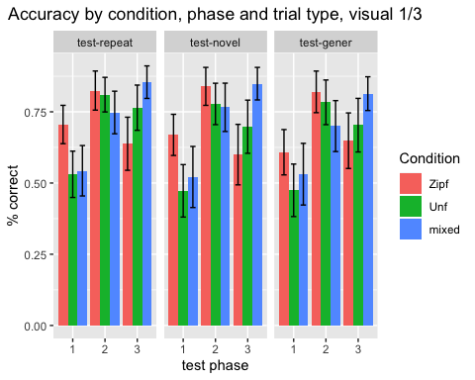

## Warning: Removed 9 rows containing non-finite values (stat_summary).  
  
## Warning: Removed 9 rows containing non-finite values (stat_summary).

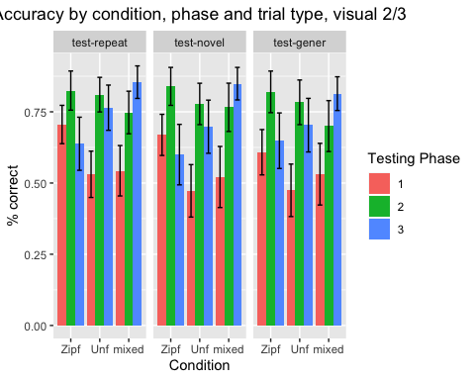

## Warning: Removed 9 rows containing non-finite values (stat_summary).  
  
## Warning: Removed 9 rows containing non-finite values (stat_summary).

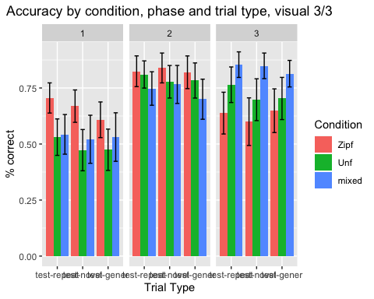

# Condition Order Comparison - 6 possible orders of doing the 3 training conditions

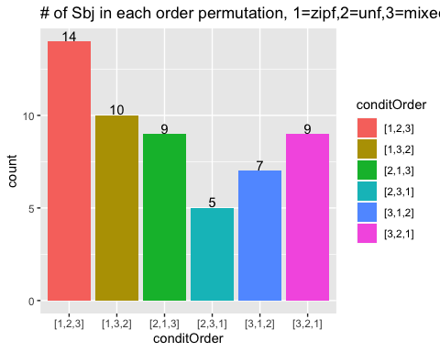

## Warning: Removed 9 rows containing non-finite values (stat_summary).  
  
## Warning: Removed 9 rows containing non-finite values (stat_summary).

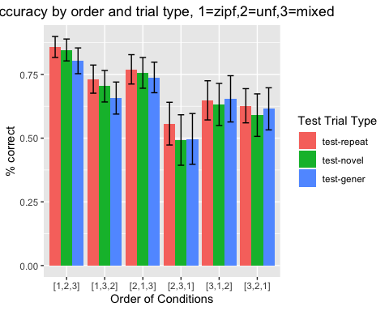

## Warning: Removed 9 rows containing non-finite values (stat_summary).  
  
## Warning: Removed 9 rows containing non-finite values (stat_summary).

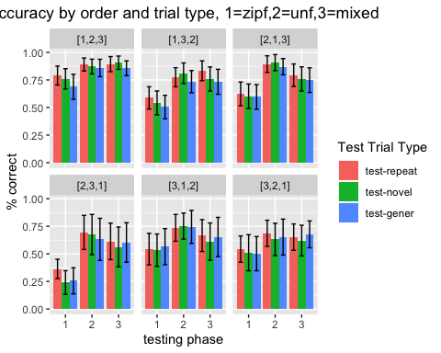

# Performance when controlling for the effect of phase - Z scores

### I take the overall average and strd deviation for each phase, then compute how many standard devaition units each condition is above or below that average

