Appendix

Thomas E. Gorman

Torsten Reimer

Juan Pablo Loaiza Ramirez

Hayden Barber

## Energy Literacy Questions

### Energy Literacy/Knowledge Quiz

1. **Electrical energy units (kWh):** The amount of ELECTRICAL ENERGY (ELECTRICITY) we use is measured in units called…
   * Kilowatt (kW)
   * Kilowatt-hours (kWh)
   * British Thermal Units (BTU)
   * Volts (V)
   * Horsepower (HP)
2. **Energy consumed and appliance power rating:** The amount of ENERGY consumed by an electrical appliance is equal to the power rating of the appliance (watts or kilowatts)…
   * Multiplied by the cost of electricity
   * Added to the cost of electricity
   * Multiplied by the time it’s used
   * Divided by the time it’s used
   * Added to the time it’s used
3. **Incandescent lightbulb conversion:** When you turn on an incandescent light bulb, which of the following energy conversion takes place?
   * Electrical energy to radiant energy (light)
   * Chemical energy to radiant energy (light)
   * Electrical energy to radiant energy (light) and thermal energy (heat)
   * Chemical energy to radiant energy (light) and thermal energy (heat)
   * Electrical energy to radiant energy (light) and mechanical energy
4. **Reason to buy energy star appliances:** The best reason to buy an ENERGY STAR® appliance is…
   * ENERGY STAR appliances are usually bigger
   * ENERGY STAR appliances cost more
   * ENERGY STAR appliances use less energy
   * ENERGY STAR appliances are more modern looking
   * ENERGY STAR appliances cost less
5. **Which appliances uses the most energy:** Which uses the MOST ENERGY in the average American home in one year?
   * Refrigerating food and beverages
   * Washing and drying clothing
   * Heating and cooling rooms
   * Heating and cooling water
   * Lighting the home
6. **Which appliance uses the most electricity:** Which of the following items uses the MOST ELECTRICITY in the average home in one year?
   * Lights
   * Refrigerator
   * Telephone
   * Television
   * Computer
7. **Which source provides most electricity in the US:** Which of the following sources provides most of the ELECTRICITY in the United States?
   * Nuclear power
   * Burning petroleum
   * Burning coal
   * Solar energy
   * Water (hydro) power
8. **Problem with electric cars:** Some people think that if we run out of fossil fuels we can just switch over to electric cars. What is wrong with this idea?
   * Most electricity is currently produced from fossil fuels (coal, oil, natural gas)
   * Switching to electric cars will make unemployment rates go up
   * It has been proven that it is impossible to build electric cars in great quantities
   * You can’t use electricity to operate a car
   * There is nothing wrong with this idea

DeWaters, J. E., & Powers, S. E. (2011). Energy literacy of secondary students in New York State (USA): A measure of knowledge, affect, and behavior. Energy Policy, 39(3), 1699–1710. https://doi.org/10.1016/j.enpol.2010.12.049

# Experiment 1 - Energy Planning Task

### State averages of consumption

| Source | Texas average | Texas Family | California average | California Family | Colorado average | Colorado Family | Mass. average | Mass. Family |
| --- | --- | --- | --- | --- | --- | --- | --- | --- |
| Cooling | 4,249 |  | 1,289 |  | 498 |  | 322 |  |
| Heating | 5,099 |  | 5,597 |  | 16,411 |  | 19,108 |  |
| Water heating | 4,396 |  | 4,601 |  | 5,832 |  | 5,070 |  |
| Refrigerator | 1,318 |  | 1,055 |  | 1,142 |  | 1,025 |  |
| Other | 7,883 |  | 6,916 |  | 6,652 |  | 6,682 |  |
| Total | 22,945 |  | 19,458 |  | 30,535 |  | 32,207 |  |

### Example 1 of task given to participants - reference class is USD. - Massachusetts Family

The Davis family wants to reduce its household electricity bill by $1,042 next year. Please complete two possible action plans that will help the Davis family achieve this goal. Please enter how many kWh should be used next year by each appliance and the total kWh each plan would use. Enter only whole numbers. Try to provide close estimations. You may use a calculator to complete the task.

Note: The Davis family used 14,086 more kWh than the average household in Massachusetts last year.

| Category | Electricity Used Last Year by the Davis Family (kWh) | Average Electricity Used Last Year by Households in Massachusetts (kWh) | Action Plan 1 | Action Plan 2 |
| --- | --- | --- | --- | --- |
| Cooling (Central A/C) | 419 | 322 |  |  |
| Heating the Home | 26,751 | 19,108 |  |  |
| Water Heating | 10,543 | 5,070 |  |  |
| Refrigerator | 1,230 | 1,025 |  |  |
| Other (Television, Lighting, Electronics, Washer/Dryer, etc.) | 7,350 | 6,682 |  |  |
| Total kWh | 46,293 | 32,207 |  |  |

### Example 2 - reference class is kWh - Colorado Family

The Wells family wants to reduce its household electricity use by 5,965 kWh next year. Please complete two possible action plans that will help the Wells family achieve this goal. Please enter how many kWh should be used next year by each appliance and the total kWh each plan would use. Enter only whole numbers. Try to provide close estimations. You may use a calculator to complete the task.

Note: The Wells family used 9,233 more kWh than the average household in Colorado last year.

| Category | Electricity Used Last Year by the Wells Family (kWh) | Average Electricity Used Last Year by Households in Colorado (kWh) | Action Plan 1 | Action Plan 2 |
| --- | --- | --- | --- | --- |
| Cooling (Central A/C) | 697 | 498 |  |  |
| Heating the Home | 18,052 | 16,411 |  |  |
| Water Heating | 11,667 | 5,832 |  |  |
| Refrigerator | 1,370 | 1,142 |  |  |
| Other (Television, Lighting, Electronics, Washer/Dryer, etc.) | 7,882 | 6,652 |  |  |
| Total kWh | 39,768 | 30,535 |  |  |

### Example 3 - reference class is percentage - Texas Family

The Smith family wants to reduce its household electricity use by 15% next year. Please complete two possible action plans that will help the Smith family achieve this goal. Please enter how many kWh should be used next year by each appliance category and the total kWh each plan would use. Enter only whole numbers. Try to provide close estimations. You may use a calculator to complete the task.

Note: The Smith family used 6,101 more kWh than the average household in Texas last year.

| Category | Electricity Used Last Year by the Smith Family (kWh) | Average Electricity Used Last Year by Households in Texas (kWh) | Action Plan 1 | Action Plan 2 |
| --- | --- | --- | --- | --- |
| Cooling (Central A/C) | 6,573 | 4,249 |  |  |
| Heating the Home | 6,118 | 5,099 |  |  |
| Water Heating | 5,257 | 4,396 |  |  |
| Refrigerator | 2,639 | 1,318 |  |  |
| Other (Television, Lighting, Electronics, Washer/Dryer, etc.) | 8,459 | 7,883 |  |  |
| Total kWh | 29,046 | 22,945 |  |  |

### Example 4 - California Family

The Adams Family

| Category | Electricity Used Last Year by the Adams Family (kWh) | Average Electricity Used Last Year by Households in California (kWh) | Action Plan 1 | Action Plan 2 |
| --- | --- | --- | --- | --- |
| Cooling (Central A/C) | 2,581 | 1,289 |  |  |
| Heating the Home | 6,157 | 5,597 |  |  |
| Water Heating | 5,061 | 4,601 |  |  |
| Refrigerator | 1,266 | 1,055 |  |  |
| Other (Television, Lighting, Electronics, Washer/Dryer, etc.) | 7,608 | 6,916 |  |  |
| Total kWh | 22,673 | 19,458 |  |  |

### Breakdown of the states given to participants

| Source | Texas average | Texas Family | California average | California Family | Colorado average | Colorado Family | Mass. average | Mass. Family |
| --- | --- | --- | --- | --- | --- | --- | --- | --- |
| Cooling | 4,249 | 6,573 | 1,289 | 2,581 | 498 | 697 | 322 | 419 |
| Heating | 5,099 | 6,118 | 5,597 | 6,157 | 16,411 | 18,052 | 19,108 | 26,751 |
| Water heating | 4,396 | 5,257 | 4,601 | 5,061 | 5,832 | 11,667 | 5,070 | 10,543 |
| Refrigerator | 1,318 | 2,639 | 1,055 | 1,266 | 1,142 | 1,370 | 1,025 | 1,230 |
| Other | 7,883 | 8,459 | 6,916 | 7,608 | 6,652 | 7,982 | 6,682 | 7,350 |
| Total | 22,945 | 29,046 | 19,458 | 22,673 | 30,535 | 39,768 | 32,207 | 46,293 |

# Experiment 2 - Energy Planning Task

### Task amounts: 15% vs. 10% exact

| State/Reference | 15% kWh | 10% kWh | 15% USD | 10% USD | 15% Percent | 10% Percent |
| --- | --- | --- | --- | --- | --- | --- |
| Adams / Cali | 3,401 | 2,267 | $510 | $340 | 15% | 10% |
| Smith / Texas | 4,357 | 2,905 | $479 | $320 | 15% | 10% |
| Wells / Colorado | 5,965 | 3,977 | $656 | $438 | 15% | 10% |
| Davis / Mass | 6,944 | 4,629 | $1,042 | $694 | 15% | 10% |

### Task amounts: 15% vs. 10% rounded

| State/Reference | 15% kWh | 10% kWh | 15% USD | 10% USD | 15% Percent | 10% Percent |
| --- | --- | --- | --- | --- | --- | --- |
| Adams / Cali | 3,450 | 2,300 | $518 | $345 | 15% | 10% |
| Smith / Texas | 4,350 | 2,900 | $479 | $319 | 15% | 10% |
| Wells / Colorado | 6,000 | 4,000 | $660 | $440 | 15% | 10% |
| Davis / Mass | 6,900 | 4,600 | $1,035 | $690 | 15% | 10% |

### Adams Family / Cali ($0.15 per kWh) (diff: 3,542)

| Source | State average | Exact | Rounded |
| --- | --- | --- | --- |
| Cooling | 1,289 | 2,581 | 3,000 |
| Heating | 5,597 | 6,157 | 6,000 |
| Water heating | 4,601 | 5,061 | 5,000 |
| Refrigerator | 1,055 | 1,266 | 1,000 |
| Other | 6,916 | 7,608 | 8,000 |
| **Total** | **19,458** | **22,673** | **23,000** |

### Smith Family / Texas ($0.11 per kWh) (diff: 6,055)

| Source | State average | Exact | Rounded |
| --- | --- | --- | --- |
| Cooling | 4,249 | 6,573 | 7,000 |
| Heating | 5,099 | 6,118 | 6,000 |
| Water heating | 4,396 | 5,257 | 5,000 |
| Refrigerator | 1,318 | 2,639 | 3,000 |
| Other | 7,883 | 8,459 | 8,000 |
| **Total** | **22,945** | **29,046** | **29,000** |

### Wells Family / Colorado ($0.11 per kWh) (diff: 9,465)

| Source | State average | Exact | Rounded |
| --- | --- | --- | --- |
| Cooling | 498 | 697 | 1,000 |
| Heating | 16,411 | 18,052 | 18,000 |
| Water heating | 5,832 | 11,667 | 12,000 |
| Refrigerator | 1,142 | 1,370 | 1,000 |
| Other | 6,652 | 7,982 | 8,000 |
| **Total** | **30,535** | **39,768** | **40,000** |

### Davis Family / Massachusetts ($0.15 per kWh) (diff: 13,793)

| Source | State average | Exact | Rounded |
| --- | --- | --- | --- |
| Cooling | 322 | 419 | 0 |
| Heating | 19,108 | 26,751 | 27,000 |
| Water heating | 5,070 | 10,543 | 11,000 |
| Refrigerator | 1,025 | 1,230 | 1,000 |
| Other | 6,682 | 7,350 | 7,000 |
| **Total** | **32,207** | **46,293** | **46,000** |

pacman::p_load(dplyr,purrr,tidyr,stringr,here,tibble,brms,rstan,bayestestR,emmeans,tidybayes,modelsummary,  
 ggplot2,gt,knitr,kableExtra,ggh4x,patchwork, ggridges,ggstance,lme4,flextable,pander)  
  
options(digits=2, scipen=999, dplyr.summarise.inform=FALSE)  
  
walk(c("fun_plot"), ~ source(here::here(paste0("scripts/", .x, ".R"))))  
  
theme_set(theme_nice())  
  
s1 <- readRDS(here::here("data/s1_processed.rds")) |>   
 filter(!(id %in% readRDS(here::here("data/s1_discrep_ids.rds")))) |> # n=17  
 filter(!(id %in% readRDS(here::here("data/s1_grp_outlier_ids.rds")))) |> # n=6  
 mutate(refClass = factor(refClass, levels=c("kWh","Percentage","USD")))  
  
s2_long <- readRDS(here::here("data/s2_processed.rds")) |>   
 filter(!(id %in% readRDS(here::here("data/s2_discrep_ids.rds")))) |> # n=10  
 filter(!(id %in% readRDS(here::here("data/s2_grp_outlier_ids.rds"))) ) |> # n=6  
 mutate(refClass = factor(refClass, levels=c("kWh","Percentage","USD")))  
  
  
  
  
s1_agg <- s1 |>   
 filter(appliance !="Total kWh") |>   
 group_by(id,refClass,state,block,plan,edu,pct_goal,calc) |>   
 summarise(total_kWh = sum(value),orig_kWh=sum(family),   
 pct_change = abs(round((orig_kWh-total_kWh)/orig_kWh,3)),   
 n_change = sum(value!=family),  
 state_p_dif=mean(state_p_dif),  
 state_f_dif=mean(state_f_dif),  
 n_less_avg = sum(less_avg),  
 duration=first(duration)) |>   
 mutate(matched_goal = (pct_change == pct_goal),   
 error = pct_change - pct_goal,  
 abs_error = abs(error),  
 log_abs_error=log(abs(error)+.007),   
 close_match = abs_error <= 0.02) |>  
 ungroup() |> # Add ungroup here  
 mutate(  
 accuracy_level = factor(  
 case_when(  
 abs_error == 0.00 ~ "Exact match",  
 abs_error <= 0.05 ~ "0.01-5% error",  
 TRUE ~ "Over 5% error" # Capture all remaining cases  
 ),   
 levels = c("Exact match", "0.01-5% error", "Over 5% error"),  
 ordered = TRUE  
 )  
 ) |> relocate(accuracy_level, .after= "pct_change")  
  
  
  
s1_agg4 <- s1_agg |> group_by(id,refClass,calc) |>   
 mutate(n_accuracy = n_distinct(accuracy_level)) |>   
 summarise(  
 mg=sum(matched_goal),  
 mgc=sum(close_match),  
 n=n(),   
 pct=mg/n,  
 pct_close=mgc/n,  
 mean_pct_change=mean(pct_change),  
 mean_abs_error=mean(abs_error),  
 mean_log_abs_error=mean(log_abs_error),  
 n_accuracy=first(n_accuracy)) |>   
 mutate(accuracy_level = factor(  
 case_when(  
 mean_abs_error < 0.02 ~ "Exact match",  
 mean_abs_error <= 0.05 ~ "0.01-5% error",  
 TRUE ~ "Over 5% error" # Capture all remaining cases  
 ),   
 levels = c("Exact match", ".01-5% error", "Over 5% error"),  
 ordered = TRUE  
 ))  
  
s2_agg <- s2_long |>   
 filter(appliance != "TOTAL") |>   
 group_by(id,refClass,calc, state,pct,pct_goal,plan,rounded) |>   
 summarise(  
 total_kWh = sum(value),  
 orig_kWh = sum(family),  
 pct_change = round((orig_kWh - total_kWh) / orig_kWh, 3),  
 state_dif = mean(state_dif),  
 duration=first(duration),.groups = "drop") |>   
 mutate(  
 matched_goal = (pct_change == pct),  
 close_match = abs(pct_change - pct) <= 0.02,  
 error = pct_change - pct,  
 abs_error = abs(error),  
 log_abs_error=log(abs(error)+.007)) |>   
 ungroup() |>   
 mutate(  
 accuracy_level = factor(  
 case_when(  
 abs_error == 0.00 ~ "Exact match",  
 abs_error <= 0.05 ~ "0.01-5% error",  
 TRUE ~ "Over 5% error" # Capture all remaining cases  
 ),   
 levels = c("Exact match","0.01-5% error", "Over 5% error"),  
 ordered = TRUE  
 )  
 )  
  
s2_agg4 <- s2_agg |> group_by(id,refClass,calc) |>   
 mutate(n_accuracy = n_distinct(accuracy_level)) |>   
 summarise(  
 mg=sum(matched_goal),  
 mgc=sum(close_match),  
 n=n(),   
 pct=mg/n,  
 pct_close=mgc/n,  
 mean_pct_change=mean(pct_change),  
 mean_abs_error=mean(abs_error),  
 mean_log_abs_error=mean(log_abs_error),  
 n_accuracy=first(n_accuracy)) |>   
 mutate(accuracy_level = factor(  
 case_when(  
 mean_abs_error < 0.02 ~ "Exact match",  
 mean_abs_error <= 0.05 ~ ".01-5% error",  
 TRUE ~ "Over 5% error" # Capture all remaining cases  
 ),   
 levels = c("Exact match", "01-5% error", "Over 5% error"),  
 ordered = TRUE  
 ))

# Subject Counts

s1 %>%  
 group_by(id) %>%  
 summarise(total_subjects = n_distinct(id)) %>%  
 ungroup() %>%  
 summarise(total_subjects = n_distinct(id)) %>%  
 bind_cols(  
 s1 %>%  
 group_by(refClass) %>%  
 summarise(subjects_per_refClass = n_distinct(id)) %>%  
 ungroup()  
 ) %>%  
 print()

# A tibble: 3 × 3  
 total_subjects refClass subjects_per_refClass  
 <int> <fct> <int>  
1 229 kWh 76  
2 229 Percentage 67  
3 229 USD 86

s2_long %>%  
 group_by(id) %>%  
 summarise(total_subjects = n_distinct(id)) %>%  
 ungroup() %>%  
 summarise(total_subjects = n_distinct(id)) %>%  
 bind_cols(  
 s2_long %>%  
 group_by(refClass) %>%  
 summarise(subjects_per_refClass = n_distinct(id)) %>%  
 ungroup()  
 ) %>%  
 print()

# A tibble: 3 × 3  
 total_subjects refClass subjects_per_refClass  
 <int> <fct> <int>  
1 190 kWh 68  
2 190 Percentage 67  
3 190 USD 55

# Demographics S1

n_exclusion_s1 <-readRDS(here::here("data/s1_grp_outlier_ids.rds")) |> length() # 6  
  
  
average_age <- s1 |> ungroup() |>   
 summarise(average_age = mean(age, na.rm = TRUE), sd_age = sd(age, na.rm = TRUE))   
  
# average_age sd_age  
# <dbl> <dbl>  
# 1 34.3 10.2  
  
gender_counts <- s1 |>   
 group_by(id,gender) |>  
 slice(1) |>  
 group_by(gender) |>   
 summarise(count = n())   
  
# gender count  
# <fct> <int>  
# 1 Male 136  
# 2 Female 92  
# 3 Not specified 1  
  
# s1 %>% ungroup() |>   
# summarise(  
# total_subjects = n_distinct(id),  
# .groups = 'drop'  
# ) %>%  
# left_join(  
# s1 %>%  
# group_by(refClass) %>%  
# summarise(  
# subjects_in_class = n_distinct(id),  
# .groups = 'drop'  
# )  
# ) %>%  
# print()

# Demographics S2

n_exclusion_s2 <-readRDS(here::here("data/s2_grp_outlier_ids.rds")) |> length() # 6  
  
average_age <- s2_long |> ungroup() |>   
 summarise(average_age = mean(age, na.rm = TRUE), sd_age = sd(age, na.rm = TRUE))  
 # average_age sd_age  
 # <dbl> <dbl>  
 # 35.5 9.47  
  
gender_counts <- s2_long |>   
 group_by(id,gender) |>   
 slice(1) |>  
 group_by(gender) |>  
 summarise(count = n())   
# gender count  
# <fct> <int>  
# 1 Male 102  
# 2 Female 88

## Study 1

### Amount of change

# plot mean_pct_change distribution  
s1_agg4 |> ggplot(aes(x = refClass, y = mean_pct_change, fill = refClass)) +  
 geom_boxplot() +  
 labs(title = "S1. Mean % Change by Reference Class",  
 x = "Reference Class",  
 y = "Mean % Change",  
 fill = "Reference Class") +  
 theme_minimal()

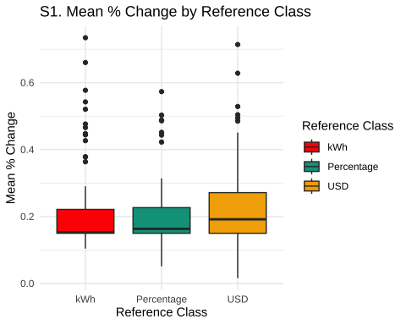

# plot mean_pct_change density  
s1_agg4 |> ggplot(aes(x = mean_pct_change, fill = refClass)) +  
 geom_density(alpha = 0.5) +  
 labs(title = "S1. Mean % Change Density by Reference Class",  
 x = "Mean % Change",  
 fill = "Reference Class") +  
 theme_minimal()

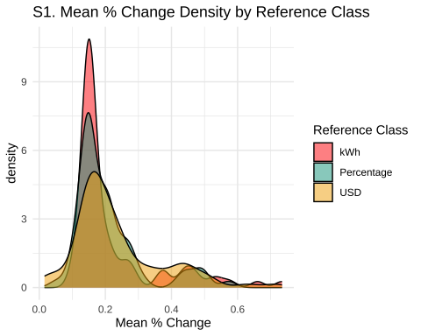

# diagnostics

ordinal_model_s1 <- brm(  
 accuracy_level ~ refClass +calc + (1|id) + (1|state),  
 data = s1_agg,  
 family = cumulative("logit"),  
 cores = 4,  
 iter = 4000,  
 control = list(adapt_delta = 0.98),   
 prior = c(prior(normal(0, 4), class = "Intercept"),   
 prior(normal(0, 4), class = "b")),   
 file = paste0(here::here("data/model_cache",'s1_acc3_add.rds'))   
)  
  
plot(ordinal_model_s1, condition = "refClass")

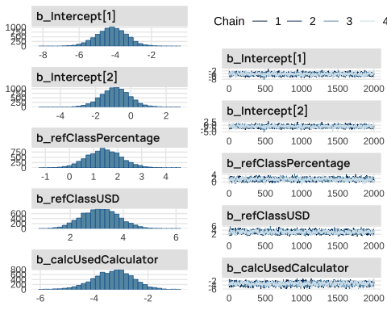

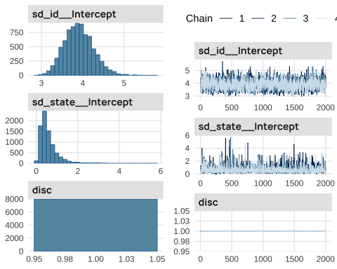

## Study2

ordinal_model_s2_logit <- brm(  
 accuracy_level ~ refClass + calc+pct_goal+rounded + (1|id)+ (1|state),  
 data = s2_agg,  
 family = cumulative("logit"),  
 cores = 4,  
 iter = 3000,  
 control = list(adapt_delta = 0.99), # Recommended for ordinal models  
 prior = c(prior(normal(0, 2), class = "Intercept"), # Priors for thresholds  
 prior(normal(0, 2), class = "b")), # Priors for predictors  
 file = paste0(here::here("data/model_cache",'s2_acc3_add.rds')) # Cache for efficiency  
)

# diagnostics

plot(ordinal_model_s2_logit, condition = "refClass")

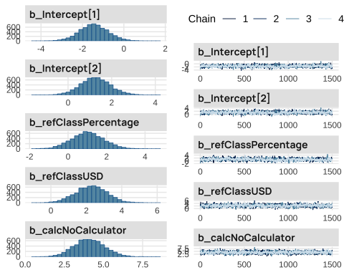

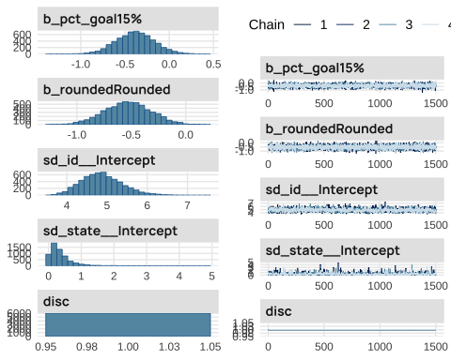

### Tables

# observed_props_s2 <- s2_agg |>  
# group_by(id,refClass, accuracy_level,calc) |>  
# summarise(n = n()) |>  
# group_by(refClass) |>  
# mutate(prop = n/sum(n)) |>  
# group_by(refClass,accuracy_level) |>  
# summarise(n = sum(n), prop = sum(prop)) |>  
# mutate(n_prop=paste0(n," (",round(prop*100,1),"%)" ), pct_grp=paste0(round(prop*100,1), "%")) |> ungroup()  
#   
  
  
  
# compute percentage of subjects per accuracy level per group  
observed_props_s2 <- s2_agg |>  
 group_by(refClass, accuracy_level) |>  
 summarise(n = n()) |>  
 group_by(refClass) |>  
 mutate(prop = n/sum(n)) |>  
 mutate(n_prop=paste0(n," (",round(prop*100,1),"%)" ), pct_grp=paste0(round(prop*100,1), "%")) |> ungroup()  
  
observed_props_s2 |>   
 mutate(n_total=sum(n)/3) |>   
 group_by(accuracy_level) |>  
 mutate(ns=sum(n)/4) |>   
 mutate(Total = paste0(round(ns/n_total*100,1), "%")) |>  
 select('Reference Class'=refClass, 'Accuracy Level'=accuracy_level, '% in Group'=pct_grp, "Combined Groups %" =Total) |>  
 pivot_wider(  
 names_from = 'Reference Class',  
 values_from = c('% in Group')  
 ) |> relocate("Combined Groups %" , .after=last_col()) |>   
 kable(escape=FALSE,booktabs=TRUE,align=c("l"))

|  |  |  |  |  |  |  |  |  |  |  |  |  |  |  |  |  |  |  |  |  |
| --- | --- | --- | --- | --- | --- | --- | --- | --- | --- | --- | --- | --- | --- | --- | --- | --- | --- | --- | --- | --- |
| Table 1: Study 2: The table shows the percentage of participants who fell into each accuracy level for each reference class condition (percentages of kWh, $, and USD columns reflect within condition percentages). The combined group column reflects the percentage of participants in each accuracy level when aggregating across across all reference class conditions.   | Accuracy Level | kWh | Percentage | USD | Combined Groups % | | --- | --- | --- | --- | --- | | Exact match | 44.1% | 27.6% | 19.5% | 23.4% | | 0.01-5% error | 14.7% | 25.4% | 15.9% | 14.1% | | Over 5% error | 41.2% | 47% | 64.5% | 37.5% | |

# compute percentage of subjects per accuracy level per group  
observed_props_s2 <- s2_agg |>  
 group_by(refClass, accuracy_level) |>  
 summarise(n = n()) |>  
 group_by(refClass) |>  
 mutate(prop = n/sum(n)) |>  
 mutate(n_prop=paste0(n," (",round(prop*100,1),"%)" ), pct_grp=paste0(round(prop*100,1), "%")) |> ungroup()  
  
observed_props_s2 |>   
 mutate(n_total=sum(n)/3) |>   
 group_by(accuracy_level) |>  
 mutate(ns=sum(n)/4) |>   
 mutate(Total = paste0(round(ns/n_total*100,1), "%")) |>  
 select('Reference Class'=refClass, 'Accuracy Level'=accuracy_level, '% in Group'=pct_grp, "Combined Groups %" =Total) |>  
 pivot_wider(  
 names_from = 'Reference Class',  
 values_from = c('% in Group')  
 ) |> relocate("Combined Groups %" , .after=last_col()) |>   
 kable(escape=FALSE,booktabs=TRUE,align=c("l"))

|  |  |  |  |  |  |  |  |  |  |  |  |  |  |  |  |  |  |  |  |  |
| --- | --- | --- | --- | --- | --- | --- | --- | --- | --- | --- | --- | --- | --- | --- | --- | --- | --- | --- | --- | --- |
| Table 2: Study 2: The table shows the percentage of participants who fell into each accuracy level for each reference class condition (percentages of kWh, $, and USD columns reflect within condition percentages). The combined group column reflects the percentage of participants in each accuracy level when aggregating across across all reference class conditions.   | Accuracy Level | kWh | Percentage | USD | Combined Groups % | | --- | --- | --- | --- | --- | | Exact match | 44.1% | 27.6% | 19.5% | 23.4% | | 0.01-5% error | 14.7% | 25.4% | 15.9% | 14.1% | | Over 5% error | 41.2% | 47% | 64.5% | 37.5% | |

**?@tbl-s2-prop** shows that, once again, participants in the kWh condition achieved closer alignment with the target goals (44% exact matches), followed by Percentage (27%) and USD (18%). These percentages are consistent with the patterns observed in Study 1, reinforcing the conclusion that providing goals in kWh supports better accuracy.

# prop_acc_s1 <- s1_agg %>%  
# group_by(refClass, accuracy_level) %>%  
# summarise(count = n()) %>%  
# group_by(accuracy_level) |>  
# mutate(Probability = count / sum(count)) %>%  
# ungroup()  
  
  
# ggplot(prop_acc_s1, aes(x = accuracy_level, y = Probability, fill = refClass)) +  
# geom_bar(stat = "identity", position = position_dodge()) +  
# scale_y_continuous(labels = scales::percent) +  
# labs(title = "S1. % of Participants within each Accuracy Bin",  
# x = "Accuracy Level",  
# y = "Percentage of Participants",  
# fill = "Reference Class") +  
# theme_minimal()   
  
ggplot(data = s1_agg, aes(x = refClass, fill = accuracy_level)) +  
 geom_bar(position = "dodge", aes(y = (..count..)/sum(..count..))) +  
 scale_y_continuous(labels = scales::percent) +  
 labs(title = "Accuracy Levels by Reference Class",  
 x = "Reference Class Condition",  
 y = "Percentage of Participants",  
 fill = "Accuracy Level") +  
 theme_minimal()

|  |
| --- |
| Figure 1: Study 1: Proportion of participants in each accuracy level, colored by reference class. A larger % of participants in the Exact Match bin indicates better performance. |

ggplot(data = s2_agg, aes(x = refClass, fill = accuracy_level)) +  
 geom_bar(position = "dodge", aes(y = (..count..)/sum(..count..))) +  
 scale_y_continuous(labels = scales::percent) +  
 facet_wrap(~rounded+pct_goal) +  
 labs(title = "Accuracy Levels by Reference Class",  
 x = "Reference Class Condition",  
 y = "Percentage of Participants",  
 fill = "Accuracy Level") +  
 theme_minimal()

|  |
| --- |
| Figure 2: Experiment 2. Proportion of participants in each accuracy level, colored by reference class, and seprated in facets based on the levels of reduction goal, and rounding. A larger % of participants in the Exact Match, or 0.01-2% error bins indicates better performance. |

# % of entire sample   
prop_combo_s2 <- s2_agg %>%  
 group_by(refClass, accuracy_level,pct_goal) %>%  
 summarise(count = n()) %>%  
 group_by(refClass) %>%  
 mutate(Probability = count / sum(count)) %>%  
 ungroup()  
  
  
ggplot(prop_combo_s2, aes(x = accuracy_level, y = Probability, fill = refClass)) +  
 geom_bar(stat = "identity", position = position_dodge()) +  
 scale_y_continuous(labels = scales::percent) +  
 labs(title = "S1. % of Participants within each Accuracy Bin",  
 x = "Accuracy Level",  
 y = "Percentage of Participants",  
 fill = "Reference Class") +  
 theme_minimal()   
  
  
# ggplot(data = s2_agg, aes(x = refClass, fill = accuracy_level)) +  
# geom_bar(position = "dodge", aes(y = (..count..)/sum(..count..))) +  
# scale_y_continuous(labels = scales::percent) +  
# labs(title = "Accuracy Levels by Reference Class",  
# x = "Reference Class Condition",  
# y = "Percentage of Participants",  
# fill = "Accuracy Level") +  
# theme_minimal()

|  |
| --- |
| Figure 3 |

### Model Tables

library(marginaleffects)  
marginaleffects_by_pct <- avg_slopes(  
 ordinal_model_s2_logit,  
 variables = "refClass",  
 by = c("pct_goal", "accuracy_level")  
 )  
  
marginaleffects_by_pct |> kable(escape=FALSE,booktabs=TRUE,align=c("l"))

| term | group | contrast | pct_goal | estimate | conf.low | conf.high |
| --- | --- | --- | --- | --- | --- | --- |
| refClass | Exact match | Percentage - kWh | 10% | -0.07 | -0.19 | 0.04 |
| refClass | Exact match | USD - kWh | 10% | -0.15 | -0.26 | -0.03 |
| refClass | 0.01-5% error | Percentage - kWh | 10% | 0.00 | -0.02 | 0.02 |
| refClass | 0.01-5% error | USD - kWh | 10% | -0.02 | -0.06 | 0.01 |
| refClass | Over 5% error | Percentage - kWh | 10% | 0.07 | -0.05 | 0.19 |
| refClass | Over 5% error | USD - kWh | 10% | 0.17 | 0.04 | 0.29 |
| refClass | Exact match | Percentage - kWh | 15% | -0.07 | -0.19 | 0.04 |
| refClass | Exact match | USD - kWh | 15% | -0.15 | -0.27 | -0.03 |
| refClass | 0.01-5% error | Percentage - kWh | 15% | 0.00 | -0.01 | 0.03 |
| refClass | 0.01-5% error | USD - kWh | 15% | -0.01 | -0.05 | 0.02 |
| refClass | Over 5% error | Percentage - kWh | 15% | 0.07 | -0.04 | 0.18 |
| refClass | Over 5% error | USD - kWh | 15% | 0.17 | 0.04 | 0.29 |

# Group Term Contrast pct_goal Estimate 2.5 % 97.5 %  
 # Exact match refClass Percentage - kWh 10% -0.073089 -0.19345 0.0421  
 # Exact match refClass USD - kWh 10% -0.150377 -0.26763 -0.0324  
 # 0.01-5% error refClass Percentage - kWh 10% 0.000166 -0.01468 0.0223  
 # 0.01-5% error refClass USD - kWh 10% -0.018067 -0.05721 0.0100  
 # Over 5% error refClass Percentage - kWh 10% 0.073590 -0.04623 0.1885  
 # Over 5% error refClass USD - kWh 10% 0.171389 0.03806 0.2953  
 # Exact match refClass Percentage - kWh 15% -0.076254 -0.19838 0.0448  
 # Exact match refClass USD - kWh 15% -0.158520 -0.28022 -0.0346  
 # 0.01-5% error refClass Percentage - kWh 15% 0.003111 -0.00833 0.0299  
 # 0.01-5% error refClass USD - kWh 15% -0.007757 -0.04633 0.0197  
 # Over 5% error refClass Percentage - kWh 15% 0.071884 -0.04499 0.1843  
 # Over 5% error refClass USD - kWh 15% 0.168805 0.03638 0.2940  
   
   
avg_predictions(ordinal_model_s2_logit, newdata = datagrid(id=unique,refClass=unique),by="refClass") |> kable(escape=FALSE,booktabs=TRUE,align=c("l"))

| group | refClass | estimate | conf.low | conf.high |
| --- | --- | --- | --- | --- |
| Exact match | kWh | 0.42 | 0.34 | 0.51 |
| Exact match | Percentage | 0.34 | 0.27 | 0.43 |
| Exact match | USD | 0.25 | 0.18 | 0.35 |
| 0.01-5% error | kWh | 0.21 | 0.17 | 0.24 |
| 0.01-5% error | Percentage | 0.21 | 0.18 | 0.25 |
| 0.01-5% error | USD | 0.20 | 0.16 | 0.23 |
| Over 5% error | kWh | 0.37 | 0.29 | 0.46 |
| Over 5% error | Percentage | 0.44 | 0.36 | 0.53 |
| Over 5% error | USD | 0.54 | 0.45 | 0.65 |

# Group refClass Estimate 2.5 % 97.5 %  
 # Exact match kWh 0.420 0.336 0.513  
 # Exact match Percentage 0.340 0.266 0.427  
 # Exact match USD 0.254 0.179 0.347  
 # 0.01-5% error kWh 0.209 0.173 0.244  
 # 0.01-5% error Percentage 0.213 0.182 0.247  
 # 0.01-5% error USD 0.199 0.160 0.233  
 # Over 5% error kWh 0.368 0.291 0.457  
 # Over 5% error Percentage 0.444 0.360 0.532  
 # Over 5% error USD 0.544 0.446 0.648   
 #   
  
ame2 <- avg_slopes(  
 ordinal_model_s2_logit,   
 variables = "refClass"  
)  
ame2 |> kable(escape=FALSE,booktabs=TRUE,align=c("l"))

| term | group | contrast | estimate | conf.low | conf.high |
| --- | --- | --- | --- | --- | --- |
| refClass | Exact match | Percentage - kWh | -0.07 | -0.19 | 0.04 |
| refClass | Exact match | USD - kWh | -0.15 | -0.27 | -0.03 |
| refClass | 0.01-5% error | Percentage - kWh | 0.00 | -0.01 | 0.02 |
| refClass | 0.01-5% error | USD - kWh | -0.02 | -0.05 | 0.01 |
| refClass | Over 5% error | Percentage - kWh | 0.07 | -0.05 | 0.19 |
| refClass | Over 5% error | USD - kWh | 0.17 | 0.04 | 0.29 |

# Group Contrast Estimate 2.5 % 97.5 %  
 # Exact match Percentage - kWh -0.072820 -0.1920 0.04245  
 # Exact match USD - kWh -0.150425 -0.2668 -0.03252  
 # 0.01-5% error Percentage - kWh 0.000449 -0.0127 0.02116  
 # 0.01-5% error USD - kWh -0.015279 -0.0524 0.00957  
 # Over 5% error Percentage - kWh 0.072572 -0.0453 0.18601  
 # Over 5% error USD - kWh 0.168592 0.0373 0.29260

me <- conditional_effects(ordinal_model_s2_logit, effects = "refClass",categorical=TRUE)  
plot(me, points = TRUE)

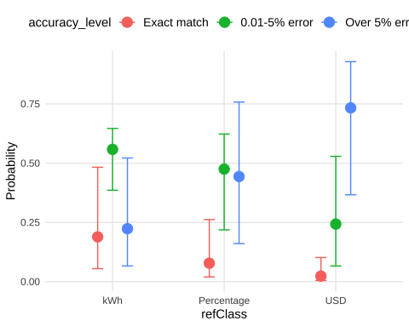

### Goal Manipulation

ggplot(s2_agg, aes(y = pct_goal, x = log_abs_error, color = calc)) +  
 geom_density_ridges(aes(fill = calc), alpha = 0.2, scale = 0.5,  
 jittered_points = TRUE, point_alpha = 0.7,point_size=.4,  
 position = position_raincloud(width = 0.05, height = 0.1,  
 ygap = 0.05)) +  
 geom_boxploth(width = 0.05, alpha = 0.2, outlier.shape = NA, show.legend = FALSE) +  
 #scale_y_discrete(expand = expansion(mult = c(0.2, 0.4))) +  
 # guides(fill = "none", color = guide_legend(reverse = TRUE)) +  
 guides(fill = "none") +  
 labs(x = "Log Absolute Deviation", y = "Reference Class", color = "") +  
 theme(legend.position = "top")

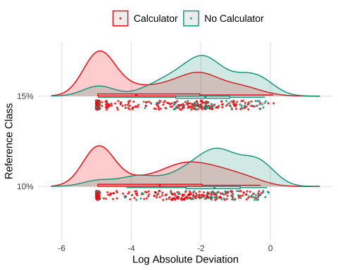

ggplot(prop_combo_s2, aes(x = accuracy_level, y = Probability, fill = pct_goal)) +  
 geom_bar(stat = "identity", position = position_dodge()) +  
 scale_y_continuous(labels = scales::percent) +  
 labs(title = "S1. % of Participants within each Accuracy Bin",  
 x = "Accuracy Level",  
 y = "Percentage of Participants",  
 fill = "Reference Class") +  
 theme_minimal()

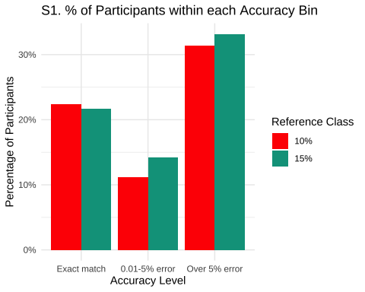

ggplot(data = s2_agg, aes(x = accuracy_level, fill = pct_goal)) +  
 geom_bar(position = "dodge", aes(y = (..count..)/sum(..count..))) +  
 scale_y_continuous(labels = scales::percent) +  
 labs(title = "Accuracy Levels by Reference Class",  
 x = "Accuracy Level",  
 y = "Percentage of Participants",  
 fill = "Reference Class") +  
 theme_minimal()

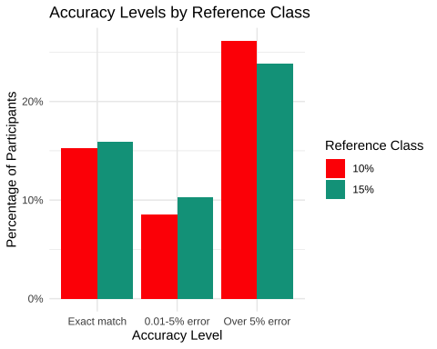

ggplot(data = s2_agg, aes(x = accuracy_level, fill = pct_goal)) +  
geom_bar(position = "dodge", aes(y = (..count..)/sum(..count..))) +  
scale_y_continuous(labels = scales::percent) +  
facet_wrap(~refClass) +  
labs(title = "Accuracy Levels by Reference Class",  
 x = "Accuracy Level",  
 y = "Percentage of Participants",  
 fill = "Reference Class") +  
theme_minimal()

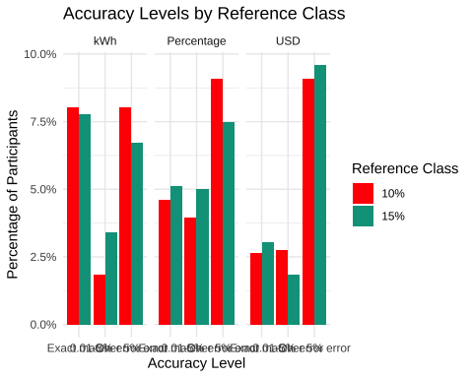

### Rounding

ggplot(s2_agg, aes(y = refClass, x = log_abs_error, color = rounded)) +  
 geom_density_ridges(aes(fill = rounded), alpha = 0.2, scale = 0.5,  
 jittered_points = TRUE, point_alpha = 0.7,point_size=.4,  
 position = position_raincloud(width = 0.05, height = 0.1,  
 ygap = 0.05)) +  
 geom_boxploth(width = 0.05, alpha = 0.2, outlier.shape = NA, show.legend = FALSE) +  
 #scale_y_discrete(expand = expansion(mult = c(0.2, 0.4))) +  
 # guides(fill = "none", color = guide_legend(reverse = TRUE)) +  
 guides(fill = "none") +  
 labs(x = "Log Absolute Deviation", y = "Reference Class", color = "") +  
 theme(legend.position = "top")

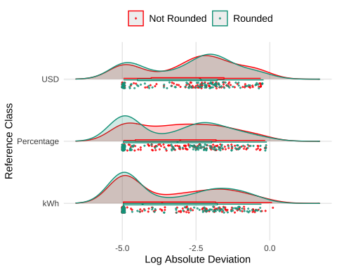

ggplot(data = s2_agg, aes(x = accuracy_level, fill = rounded)) +  
geom_bar(position = "dodge", aes(y = (..count..)/sum(..count..))) +  
scale_y_continuous(labels = scales::percent) +  
facet_wrap(~refClass) +  
labs(title = "Accuracy Levels by Reference Class",  
 x = "Accuracy Level",  
 y = "Percentage of Participants",  
 fill = "Reference Class") +  
theme_minimal()

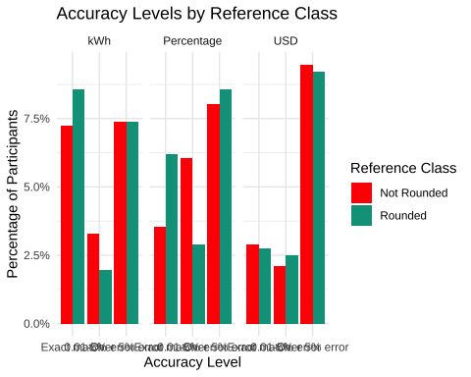

### Individual Differences

As in Experiment 1, we further investigated the role of individual differences in energy literacy in predicting planning accuracy. A Bayesian linear regression model, analogous to the one used in Experiment 1 (log_abs_error ~ els + (1|id) + (1|state)), revealed a significant negative relationship between energy literacy scores and log-transformed absolute error (Estimate = -3.21, 95% CI: -3.89 to -2.52). This finding indicates that participants with higher energy literacy scores tended to produce more accurate plans, exhibiting smaller deviations from the target reduction goals. The conditional effect plot (**?@fig-s2-els**) visually confirms this relationship, showing a clear decreasing trend in log absolute error as energy literacy increases.

s2_agg |> group_by(id,refClass,calc,pct_goal,pct_change) |>   
 filter(plan=="plan1",rounded=="Rounded") |>   
 mutate(n_accuracy = n_distinct(accuracy_level)) |>   
 summarise(mg=sum(matched_goal),n=n(), pct=mg/n,mean_pct_change=mean(pct_change),mean_abs_error=mean(abs_error),n_accuracy=first(n_accuracy)) |>  
 ungroup() |>   
 mutate(goal_pct = as.numeric(stringr::str_remove(pct_goal,"%"))/100) |>  
 filter(mean_abs_error <= 0.50) |>  
 mutate(id=reorder(id,pct_change)) |>   
 ggplot(aes(y=id,x=mean_pct_change,col=refClass)) +   
 geom_point(size=1,alpha=0.6,position = position_jitter(w=0, h=0.17)) +  
 geom_vline(aes(xintercept=goal_pct),linetype="dashed",alpha=.5) +  
 ggh4x::facet_nested_wrap(~pct_goal,axes="all",scales="free",ncol=2) +   
 labs(y="Participant Id", x="Percent Change", title="Individual Performance") +  
 theme(axis.text.y=element_text(face = "plain", size = rel(0.7))) +   
 scale_x_continuous(breaks = seq(0, 0.5, by = 0.05),  
 labels = scales::percent_format(accuracy = 1))

|  |
| --- |
| Figure 4: Study 2: Individual performance in the energy planning task, colored by reference class. The dashed line represents the target reduction goal. Participants are shown along the y axis, those who fall above or below the dashed line have not met the target goal. The x-axis represents the percent change in energy usage from the prior year. |

s2_long |> filter(id %in% unique(s2_long$id)[1:30]) |>   
 filter(appliance!="TOTAL",state=="California") |>   
 ggplot(aes(x=appliance,y=value)) + geom_point(aes(shape=plan)) +  
 geom_point(aes(y=state_avg),color="red") +  
 geom_point(aes(y=family),color="blue") +  
 theme(axis.text.x = element_text(angle = 45, hjust = 1))  
  
  
s2_long |> filter(id %in% unique(s2_long$id)[1:30]) |>   
 filter(appliance!="TOTAL",state=="California") |>   
 ggplot(aes(x=appliance,y=value)) + geom_point(aes(shape=plan)) +  
 geom_point(aes(y=state_avg),color="red") +  
 geom_point(aes(y=family),color="blue") +  
 facet_wrap(~id) + theme(axis.text.x = element_text(angle = 45, hjust = 1))

|  |
| --- |
| Figure 5: Study 2: Respones patterns for a subset of individiual participants. Black points are participant responses, red points are the state average, and blue points are the family average. The x-axis represents the appliance category, and the y-axis represents the energy usage in kWh. |

|  |
| --- |
| Figure 6: Study 2: Respones patterns for a subset of individiual participants. Black points are participant responses, red points are the state average, and blue points are the family average. The x-axis represents the appliance category, and the y-axis represents the energy usage in kWh. |

### Tables

### Distance plots

# s2_agg |> group_by(id,refClass,calc) |>   
# mutate(n_accuracy = n_distinct(accuracy_level)) |>   
# summarise(mg=sum(matched_goal),n=n(), pct=mg/n,mean_pct_change=mean(pct_change),  
# mean_abs_error=mean(abs_error),mean_log_abs_error=mean(log_abs_error),  
# n_accuracy=first(n_accuracy))   
  
s2_agg4 %>% ggplot(aes(x=refClass,y=mean_log_abs_error,fill=refClass)) +   
 stat_summary(fun=mean, geom="bar") +  
 stat_summary(fun.data=mean_cl_normal, geom="errorbar", width=0.2) +  
 geom_jitter(alpha = 0.2, width = 0.2, height = 0)   
s2_agg4 |>   
 ggplot(aes(x = mean_log_abs_error,fill = refClass)) +  
 geom_density(alpha = 0.7)

|  |
| --- |
| Table 3: Study 2: Summary of planning accuracy by reference class. The table shows performance as both the % of trials where participants matched the goal, and the mean absolute error from the target reduction goal. |

Additional data collected included:

* **Energy Literacy Quiz**: An 8-item questionnaire assessing participants’ knowledge of energy consumption and conversion (DeWaters & Powers, 2011).
* **Calculator Usage Tracking**: Questions determined whether participants used a calculator, paper/pen, or other methods to complete the tasks.
* **Demographic Survey**: Collected information on gender, age, income, education, employment status, and state of residence.
* **Environmental Attitudes Survey**: Assessed participants’ pro-environmental attitudes and perceived importance of energy conservation.

DeWaters, J. E., & Powers, S. E. (2011). Energy literacy of secondary students in New York State (USA): A measure of knowledge, affect, and behavior. *Energy Policy*, *39*(3), 1699–1710. <https://doi.org/10.1016/j.enpol.2010.12.049>