Planning to Save Energy: How Information Format Affects Accuracy

Thomas E. Gorman

Torsten Reimer

Juan Pablo Loaiza Ramirez

Tuesday, November 19, 2024

Abstract

This study examines how presenting energy information in different formats (kWh, %, USD) affects planning accuracy. Across two experiments, the kWh format generally led to better accuracy, while the USD format consistently led to the worst performance. These findings highlight the importance of effective information presentation to promote energy conservation.

# Introduction

### Literature Review

Energy poverty continues to be a pervasive issue in the United States Memmott et al. (2021) . This challenge partly arises from difficulties in converting information across numerical formats, impeding the development of precise energy reduction plans Reimer et al. (2015). Prior research by Canfield et al. (2017) demonstrated that presenting energy information in tabular formats enhances comprehension relative to graphs.

### Hypotheses

Building on these findings and informed by prior work showing that frequencies (like absolute units in kWh) are easier to comprehend and facilitate more precise decision-making compared to percentages, our study also utilizes a tabular format, but manipulates whether participants must consider energy information presented as absolute units (kWh), percentages (%), or monetary costs (USD). We hypothesize that presenting information in absolute units (kWh) will lead to more accurate household energy conservation planning.

# Experiment 1

See Figure 1 for an example of a planning trial as it was seen by participants.

## Methods

### Participants

We implemented our task and surveys on Qualtrics, and recruited participants through Amazon Mechanical Turk. In Experiment 1, 252 participants were intially recruited, but data from 17 participants were corrupted due to experimenter error, leaving a final sample of 235 participants. Most participants (76%) reported using a calculator to complete the task.

### Materials and Design

The study employed a mixed design with reference class (kWh, percentage, USD) as a between-subjects factor and state/family scenario as a within-subjects factor. Each participant completed energy reduction planning tasks for two different states, with state order counterbalanced across participants. The family scenarios featured four households in different climate regions: Texas (Smith family) and California (Adams family) representing warm climates, and Colorado (Wells family) and Massachusetts (Davis family) representing cold climates. We obtain average utility use from each state by CITE SOURCE FOR STATE AVGS?

### Procedure

Participants received energy usage data for two hypothetical families and were tasked with creating action plans to meet specified reduction goals by allocating usage across five appliance categories: heating, cooling, water heating, refrigerator, and an other appliances (e.g., TV, lighting).

For each family scenario, the particpipants were shown a table containing the families utility usage from the prior year, alongside the state averages for each appliance category (both prior year usage and stage averages are always shown in kWh). For each scenario, participants were asked to create two possible action plans to achieve the target reduction in total household energy usage (see Figure 1). Depending on their reference class condition, the target reduction amount presented either in kilowatt-hours (kWh), as percentages of total household usage, or in U.S. dollars. In all conditions, the target reduction was equivalent to a 15% reduction in total household kWh.

|  |
| --- |
| Figure 1: Example trial in the energy planning task. Participants are shown the prior year electricity use of a household, and are tasked with creating a plan for the next year that will meet the energy reduction goal. Study 1 manipulates the format of the reduction goal to be either a percentage (15% given as goal reduction), kilowatt hours (5965 kWh given), or USD ($656) |

Additional data collected included:

* **Energy Literacy Quiz**: An 8-item questionnaire assessing participants’ knowledge of energy consumption and conversion.
* **Calculator Usage Tracking**: Questions determined whether participants used a calculator, paper/pen, or other methods to complete the tasks.
* **Demographic Survey**: Collected information on gender, age, income, education, employment status, and state of residence.
* **Environmental Attitudes Survey**: Assessed participants’ pro-environmental attitudes and perceived importance of energy conservation.

## Results

| refClass | Avg. % meeting goal | Avg. Deviation From Goal |
| --- | --- | --- |
| kWh | 0.38 | 0.15 |
| Percentage | 0.22 | 0.16 |
| USD | 0.10 | 0.19 |

For our primary analyses of participants’ ability to create accurate energy-saving plans, we employed an accuracy level binning approach by categorizing responses into four distinct levels: Exact match, 0.01–2% error, 2.01–15% error, and Over 15% error.

| Accuracy Level | kWh | Percentage | USD | Combined Groups % |
| --- | --- | --- | --- | --- |
| Exact match | 37.5% | 22.1% | 9.8% | 22.6% |
| 0.01-2% error | 15.1% | 17.6% | 11.2% | 14.4% |
| 2.01-15% error | 26.3% | 41.9% | 47.8% | 38.9% |
| Over 15% error | 21.2% | 18.4% | 31.2% | 24.1% |

|  |
| --- |
| Figure 2 |

We analyzed planning accuracy using Bayesian ordinal regression. The dependent variable, plan error, was computed by binning the goal deviation into four ordered levels: exact match (0% error), minor deviations (0.01-2% error), moderate deviations (2.01-15% error), and major deviations (>15% error). For each comparison, we provide posterior odds ratios (OR) and their 95% CIs.

| comparison | odds_ratio | ci_lower | ci_upper |
| --- | --- | --- | --- |
| Percentage vs kWh | 2.27407 | 0.6177874 | 6.14783 |
| USD vs kWh | 14.09463 | 4.0796697 | 38.03732 |

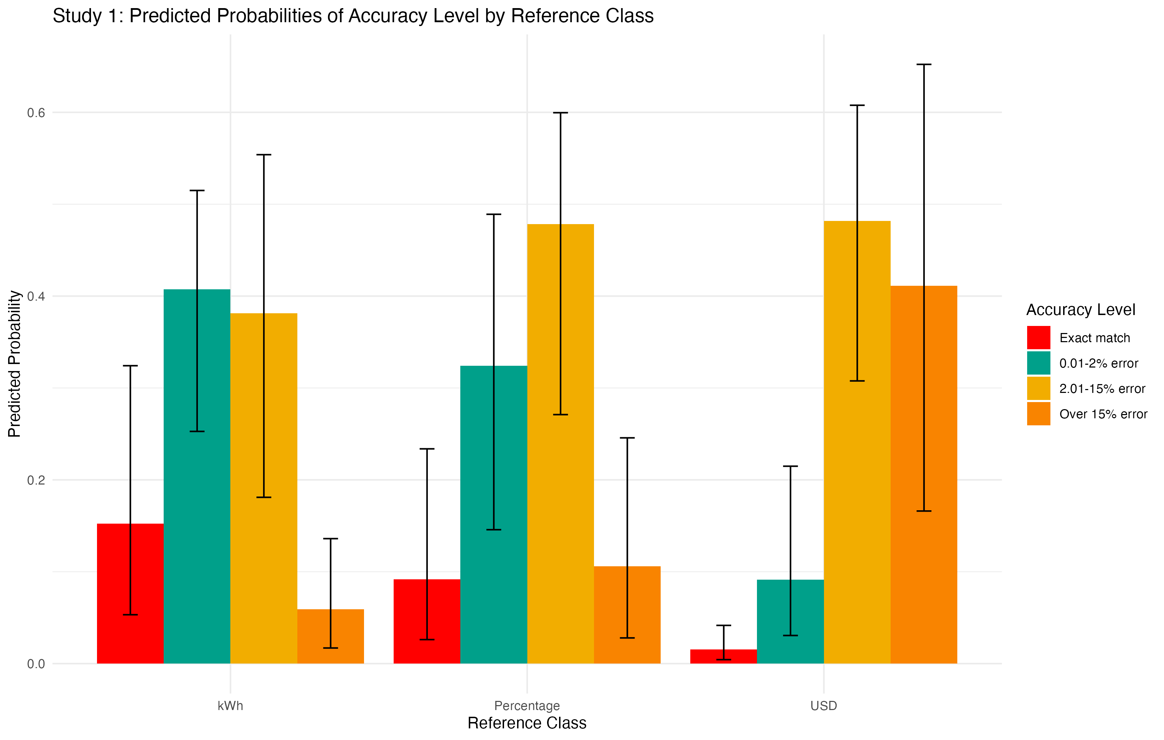

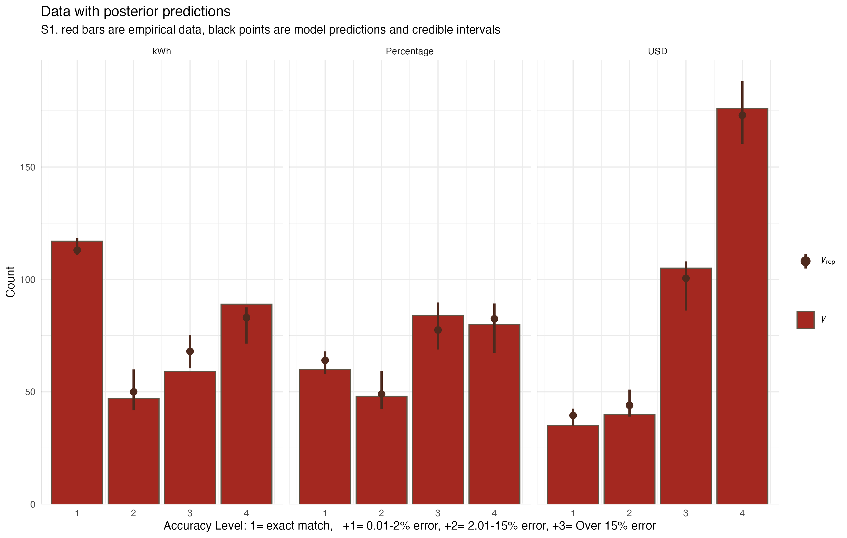

List of 1  
 $ legend.background: list()  
 ..- attr(*, "class")= chr [1:2] "element_blank" "element"  
 - attr(*, "class")= chr [1:2] "theme" "gg"  
 - attr(*, "complete")= logi FALSE  
 - attr(*, "validate")= logi TRUE

# Experiment 2

## Methods

The experimental procedures in study 2 are quite similar to those in study 1, but we also included a rounding manipulation (rounded vs. not rounded), and a manipulation of the goal (10% reduction vs. 15% rediction). We recruited 206 participants from Amazon Mechanical Turk, but data from from 10 participants were corrupted due to experimenter error, leaving a final sample of 196 participants.

Note that reference class remains a between-subjects variable, while percent goal, rounding, and state are within-subjects variables. In study 2, the new design is a 4 state temperature (2 warm vs. 2 cold states) X 2 task goal (10% vs. 15%) X 2 last year’s usage for the family and the state average (exact vs. rounded numbers) within X 3 task reference class (USD vs. Percentage vs. kWh) between.

## Results

| refClass | Avg. % meeting goal | Avg. Deviation From Goal |
| --- | --- | --- |
| kWh | 0.44 | 0.13 |
| Percentage | 0.27 | 0.16 |
| USD | 0.18 | 0.17 |

| Accuracy Level | kWh | Percentage | USD | Combined Groups % |
| --- | --- | --- | --- | --- |
| Exact match | 43.5% | 26.8% | 18.5% | 30.2% |
| 0.01-2% error | 8% | 13.8% | 9.1% | 10.3% |
| 2.01-15% error | 21% | 33.3% | 38.4% | 30.5% |
| Over 15% error | 27.5% | 26.1% | 34.1% | 29% |

|  |
| --- |
| Figure 3 |

|  |
| --- |
| Figure 4 |

### Individual Differences

|  |
| --- |
| Figure 5 |

|  |
| --- |
| Figure 6 |

|  |
| --- |
| Figure 7 |

# Discusion

# References

Canfield, C., Bruine De Bruin, W., & Wong-Parodi, G. (2017). Perceptions of electricity-use communications: Effects of information, format, and individual differences. *Journal of Risk Research*, *20*(9), 1132–1153. <https://doi.org/10.1080/13669877.2015.1121909>

Memmott, T., Carley, S., Graff, M., & Konisky, D. M. (2021). Sociodemographic disparities in energy insecurity among low-income households before and during the COVID-19 pandemic. *Nature Energy*, *6*(2), 186–193. <https://doi.org/10.1038/s41560-020-00763-9>

Reimer, T., Jones, C., & Skubisz, C. (2015). Numeric Communication of Risk. In *The SAGE handbook of risk communication* (pp. 167–179).