HTW
Thomas Gorman
Rob Goldstone
Wednesday, October 11, 2023
Author note
TODO: List of authors here; there's a bug(?) in pandoc/quarto where the full author object isn't available?

Abstract
Keywords: Learning Generalization, Function Learning, Visuomotor learning, Training Variability

HTW

Introduction
In project 1, we applied model-based techniques to quantify and control for the similarity between training and testing experience, which in turn enabled us to account for the difference between varied and constant training via an extended version of a similarity based generalization model. In project 2, we will go a step further, implementing a full process model capable of both 1) producing novel responses and 2) modeling behavior in both the learning and testing stages of the experiment. Project 2 also places a greater emphasis on extrapolation performance following training - as varied training has often been purported to be particularly beneficial in such situations. Extrapolation has long been a focus of the literature on function learning (Brehmer, 1974; Carroll, 1963). Central questions of the function learning literature have included the relative difficulties of learning various functional forms (e.g. linear vs.bilinear vs. quadratic), and the relative effectiveness of rule-based vs. association-based exemplar models vs. various hybrid models (Bott & Heit, 2004; DeLosh et al., 1997; Jones et al., 2018; Kalish et al., 2004; M. Mcdaniel et al., 2009; M. A. Mcdaniel & Busemeyer, 2005). However the issue of training variation has received surprisingly little attention in this area.

Methods

Participants
Data was collected from 647 participants (after exclusions). The results shown below consider data from subjects in our initial experiment, which consisted of 196 participants (106 constant, 90 varied). The follow-up experiments entailed minor manipulations: 1) reversing the velocity bands that were trained on vs. novel during testing; 2) providing ordinal rather than numerical feedback during training (e.g. correct, too low, too high). The data from these subsequent experiments are largely consistently with our initial results shown below.

Task
We developed a novel visuomotor extrapolation task, termed the Hit The Wall task, wherein participants learned to launch a projectile such that it hit a rectangle at the far end of the screen with an appropriate amount of force. Although the projectile had both x and y velocity components, only the x-dimension was relevant for the task. Link to task demo

Procedure
Upon arrival at the laboratory, participants were provided with a description of the experiment and signed informed consent forms. They were then seated in front of a computer equipped with a mouse and were given instructions on how to perform the “Hit The Wall” (HTW) visuomotor extrapolation task.
The HTW task involved launching projectiles to hit a target displayed on the computer screen. Participants completed a total of 90 trials during the training stage. In the varied training condition, participants encountered three velocity bands (800-1000, 1000-1200, and 1200-1400). In contrast, participants in the constant training condition encountered only one velocity band (800-1000).
During the training stage, participants in both conditions also completed “no feedback” trials, where they received no information about their performance. These trials were randomly interleaved with the regular training trials.
Following the training stage, participants proceeded to the testing stage, which consisted of three phases. In the first phase, participants completed “no-feedback” testing from three novel extrapolation bands (100-300, 350-550, and 600-800), with each band consisting of 15 trials.
In the second phase of testing, participants completed “no-feedback” testing from the three velocity bands used during the training stage (800-1000, 1000-1200, and 1200-1400). In the constant training condition, two of these bands were novel, while in the varied training condition, all three bands were encountered during training.
The third and final phase of testing involved “feedback” testing for each of the three extrapolation bands (100-300, 350-550, and 600-800), with each band consisting of 10 trials. Participants received feedback on their performance during this phase.
Throughout the experiment, participants’ performance was measured by calculating the distance between the produced x-velocity of the projectiles and the closest edge of the current velocity band. Lower distances indicated better performance.
After completing the experiment, participants were debriefed and provided with an opportunity to ask questions about the study.
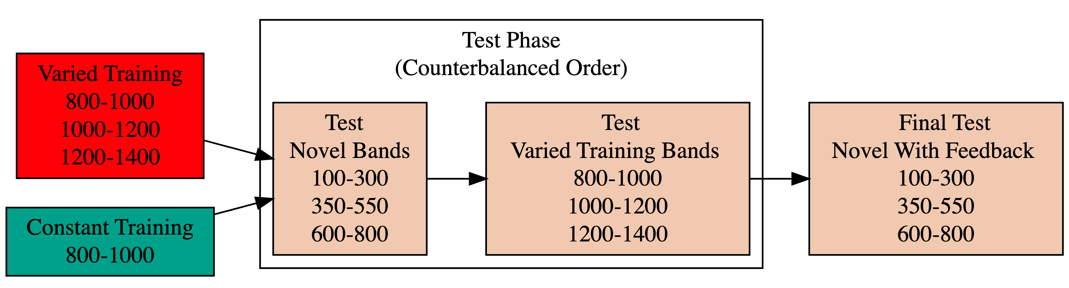
Figure 1: Experiment 1 Design. Constant and Varied participants complete different training conditions.

Analyses Strategy
All data processing and statistical analyses were performed in R version 4.31 Team (2020). To assess differences between groups, we used Bayesian Mixed Effects Regression. Model fitting was performed with the brms package in R Bürkner (2017), and descriptive stats and tables were extracted with the BayestestR package Makowski et al. (2019). Mixed effects regression enables us to take advantage of partial pooling, simultaneously estimating parameters at the individual and group level. Our use of Bayesian, rather than frequentist methods allows us to directly quantify the uncertainty in our parameter estimates, as well as circumventing convergence issues common to the frequentist analogues of our mixed models. For each model, we report the median values of the posterior distribution, and 95% credible intervals.
Each model was set to run with 4 chains, 5000 iterations per chain, with the first 2500 of which were discarded as warmup chains. Rhat values were generally within an acceptable range, with values <=1.02 (see appendix for diagnostic plots). We used uninformative priors for the fixed effects of the model (condition and velocity band), and weakly informative Student T distributions for for the random effects.
We compared varied and constant performance across two measures, deviation and discrimination. Deviation was quantified as the absolute deviation from the nearest boundary of the velocity band, or set to 0 if the throw velocity fell anywhere inside the target band. Thus, when the target band was 600-800, throws of 400, 650, and 1100 would result in deviation values of 200, 0, and 300, respectively. Discrimination was measured by fitting a linear model to the testing throws of each subjects, with the lower end of the target velocity band as the predicted variable, and the x velocity produced by the participants as the predictor variable. Participants who reliably discriminated between velocity bands tended to have positive slopes with values ~1, while participants who made throws irrespective of the current target band would have slopes ~0.
Summary of Deviation- Constant
Band | Band Type | Mean | Median | Sd
100-300 | Extrapolation | 254 | 148 | 298
350-550 | Extrapolation | 191 | 110 | 229
600-800 | Extrapolation | 150 | 84 | 184
800-1000 | Trained | 184 | 106 | 242
1000-1200 | Extrapolation | 233 | 157 | 282
1200-1400 | Extrapolation | 287 | 214 | 290

Summary of Deviation- Varied
Band | Band Type | Mean | Median | Sd
100-300 | Extrapolation | 386 | 233 | 426
350-550 | Extrapolation | 285 | 149 | 340
600-800 | Extrapolation | 234 | 144 | 270
800-1000 | Trained | 221 | 149 | 248
1000-1200 | Trained | 208 | 142 | 226
1200-1400 | Trained | 242 | 182 | 235

Table 1: Testing Deviation - Empirical Summary

Results

Testing Phase - No feedback.
In the first part of the testing phase, participants are tested from each of the velocity bands, and receive no feedback after each throw.

Deviation From Target Band
Descriptive summaries testing deviation data are provided in Table 1 and Figure 2. To model differences in accuracy between groups, we used Bayesian mixed effects regression models to the trial level data from the testing phase. The primary model predicted the absolute deviation from the target velocity band (dist) as a function of training condition (condit), target velocity band (band), and their interaction, with random intercepts and slopes for each participant (id).
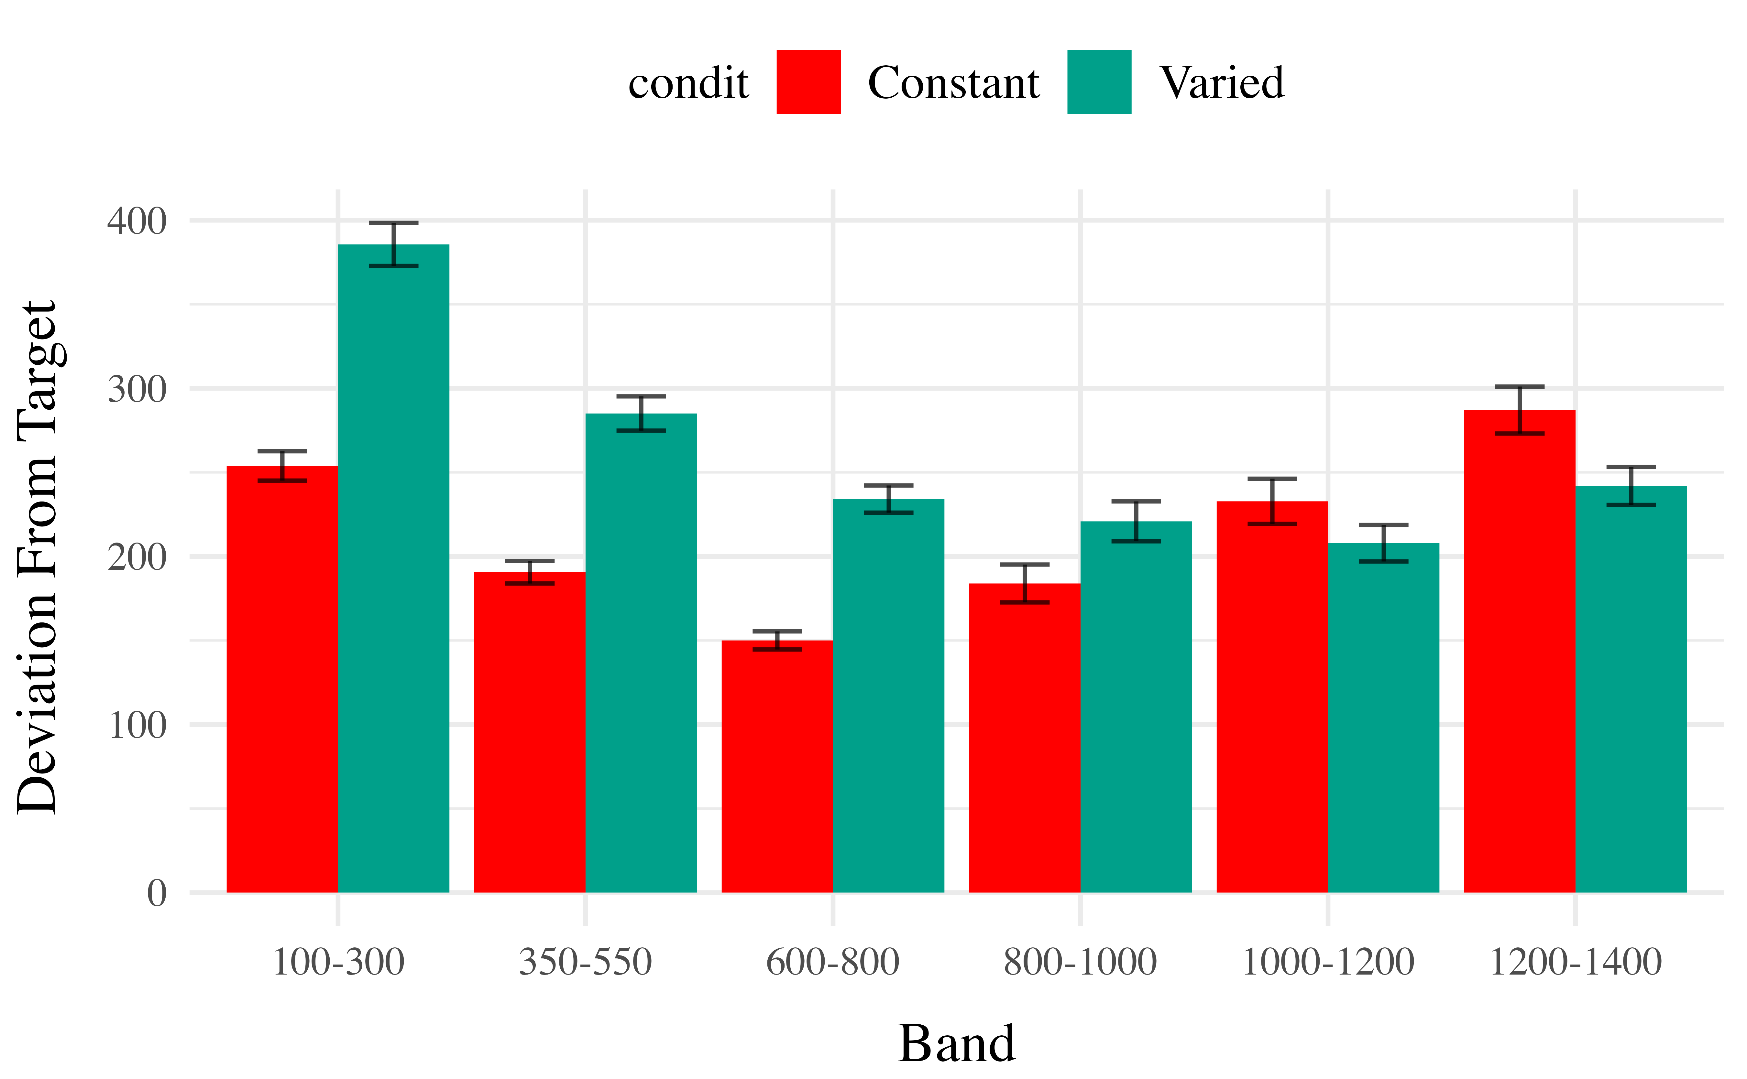
Figure 2: E1. Deviations from target band during testing without feedback stage.
Table 2: Experiment 1. Bayesian Mixed Model predicting absolute deviation as a function of condition (Constant vs. Varied) and Velocity Band
Coefficients
Term | Estimate | 95% CrI Lower | 95% CrI Upper | pd
Intercept | 205.09 | 136.86 | 274.06 | 1.00
conditVaried | 157.44 | 60.53 | 254.90 | 1.00
Band | 0.01 | -0.07 | 0.08 | 0.57
condit*Band | -0.16 | -0.26 | -0.06 | 1.00
contrast | Band | value | lower | upper | pd
Constant - Varied | 100 | -141.49 | -229.2 | -53.83 | 1.00
Constant - Varied | 350 | -101.79 | -165.6 | -36.32 | 1.00
Constant - Varied | 600 | -62.02 | -106.2 | -14.77 | 1.00
Constant - Varied | 800 | -30.11 | -65.1 | 6.98 | 0.94
Constant - Varied | 1000 | 2.05 | -33.5 | 38.41 | 0.54
Constant - Varied | 1200 | 33.96 | -11.9 | 81.01 | 0.92

The model predicting absolute deviation (dist) showed clear effects of both training condition and target velocity band (Table X). Overall, the varied training group showed a larger deviation relative to the constant training group (β = 157.44, 95% CI [60.53, 254.9]). Deviation also depended on target velocity band, with lower bands showing less deviation. See Table 2 for full model output.

Discrimination between bands
In addition to accuracy/deviation, we also assessed the ability of participants to reliably discriminate between the velocity bands (i.e. responding differently when prompted for band 600-800 than when prompted for band 150-350). Table 3 shows descriptive statistics of this measure, and Figure 1 visualizes the full distributions of throws for each combination of condition and velocity band. To quantify discrimination, we again fit Bayesian Mixed Models as above, but this time the dependent variable was the raw x velocity generated by participants on each testing trial.
Figure 3: E1 testing x velocities. Translucent bands with dash lines indicate the correct range for each velocity band.
Band | Band Type | Mean | Median | Sd
100-300 | Extrapolation | 524 | 448 | 327
350-550 | Extrapolation | 659 | 624 | 303
600-800 | Extrapolation | 770 | 724 | 300
800-1000 | Trained | 1001 | 940 | 357
1000-1200 | Extrapolation | 1167 | 1104 | 430
1200-1400 | Extrapolation | 1283 | 1225 | 483

Band | Band Type | Mean | Median | Sd
100-300 | Extrapolation | 664 | 533 | 448
350-550 | Extrapolation | 768 | 677 | 402
600-800 | Extrapolation | 876 | 813 | 390
800-1000 | Trained | 1064 | 1029 | 370
1000-1200 | Trained | 1180 | 1179 | 372
1200-1400 | Trained | 1265 | 1249 | 412

Table 3: Testing vx - Empirical Summary
Table 4: Experiment 1. Bayesian Mixed Model Predicting Vx as a function of condition (Constant vs. Varied) and Velocity Band
Fit to all 6 bands
Term | Estimate | 95% CrI Lower | 95% CrI Upper | pd
Intercept | 408.55 | 327.00 | 490.61 | 1.00
conditVaried | 164.05 | 45.50 | 278.85 | 1.00
Band | 0.71 | 0.62 | 0.80 | 1.00
condit*Band | -0.14 | -0.26 | -0.01 | 0.98
Fit to 3 extrapolation bands
Term | Estimate | 95% CrI Lower | 95% CrI Upper | pd
Intercept | 478.47 | 404.00 | 551.45 | 1.00
conditVaried | 142.04 | 37.17 | 247.59 | 1.00
Band | 0.50 | 0.42 | 0.57 | 1.00
condit*Band | -0.07 | -0.17 | 0.04 | 0.89

See Table 4 for the full model results. The estimated coefficient for training condition ( = 164.05, 95% CrI [45.5, 278.85]) suggests that the varied group tends to produce harder throws than the constant group, but is not in and of itself useful for assessing discrimination. Most relevant to the issue of discrimination is the slope on Velocity Band ( = 0.71, 95% CrI [0.62, 0.8]). Although the median slope does fall underneath the ideal of value of 1, the fact that the 95% credible interval does not contain 0 provides strong evidence that participants exhibited some discrimination between bands. The estimate for the interaction between slope and condition ( = -0.14, 95% CrI [-0.26, -0.01]), suggests that the discrimination was somewhat modulated by training condition, with the varied participants showing less senitivity between vands than the constant condition. This difference is depicted visually in Figure 4.@tbl-e1-slope-quartile shows the average slope coefficients for varied and constant participants separately for each quartile. The constant participant participants appear to have larger slopes across quartiles, but the difference between conditions may be less pronounced for the top quartiles of subjects who show the strongest discrimination. Figure Figure 5 shows the distributions of slope values for each participant, and the compares the probability density of slope coefficients between training conditions. Figure 6
The second model, which focused solely on extrapolation bands, revealed similar patterns. The Velocity Band term ( = 0.5, 95% CrI [0.42, 0.57]) still demonstrates a high degree of discrimination ability. However, the posterior distribution for interaction term ( = -0.07, 95% CrI [-0.17, 0.04] ) does across over 0, suggesting that the evidence for decreased discrimination ability for the varied participants is not as strong when considering only the three extrapolation bands.
  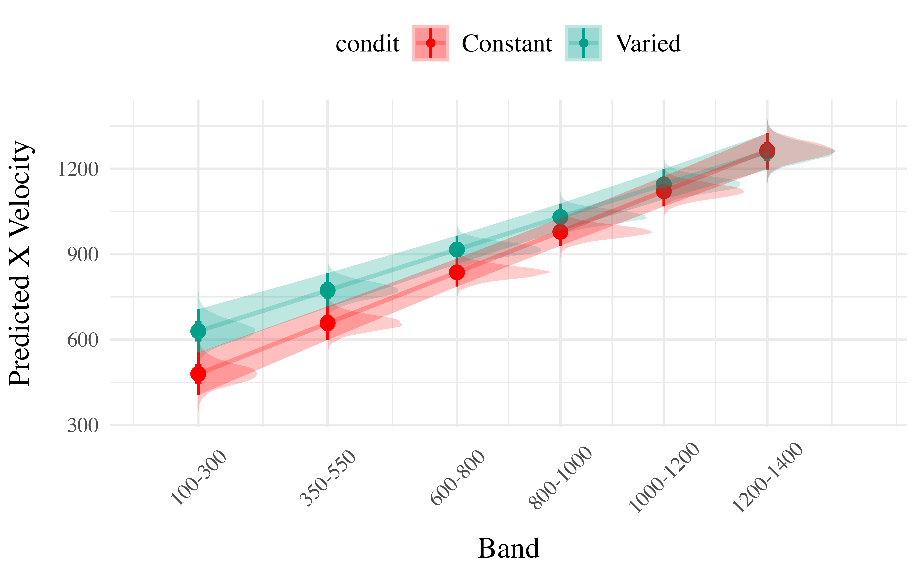
  (a) Model fit to all 6 bands
  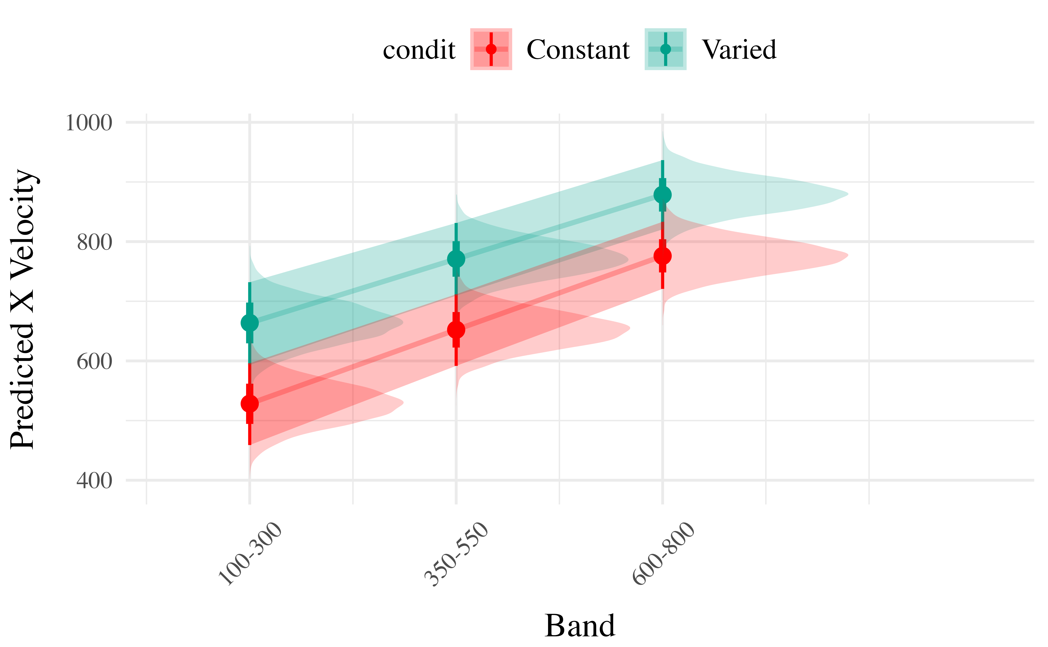
  (b) Model fit to only 3 extrapolation bands
Figure 4: Conditional effect of training condition and Band. Ribbons indicate 95% HDI. The steepness of the lines serves as an indicator of how well participants discriminated between velocity bands.
Table 5: Slope coefficients by quartile, per condition
Condition | Q_0%_mean | Q_25%_mean | Q_50%_mean | Q_75%_mean | Q_100%_mean
Constant | -0.108 | 0.479 | 0.690 | 0.934 | 1.39
Varied | -0.198 | 0.270 | 0.585 | 0.897 | 1.29

  (a) Slope estimates by participant - ordered from lowest to highest within each condition.
  (b) Destiny of slope coefficients by training group
Figure 5: Slope distributions between condition
(a) subset with largest slopes
(b) subset with smallest slopes
Figure 6: Subset of Varied and Constant Participants with the smallest and largest estimated slope values. Red lines represent the best fitting line for each participant, gray lines are 200 random samples from the posterior distribution. Colored points and intervals at each band represent the empirical median and 95% HDI.

Experiment 2
Figure 7 illustrates the design of Experiment 2. The stages of the experiment (i.e. training, testing no-feedback, test with feedback), are identical to that of Experiment 1. The only change is that Experiment 2 participants train, and then test, on bands in the reverse order of Experiment 1 (i.e. training on the softer bands; and testing on the harder bands).
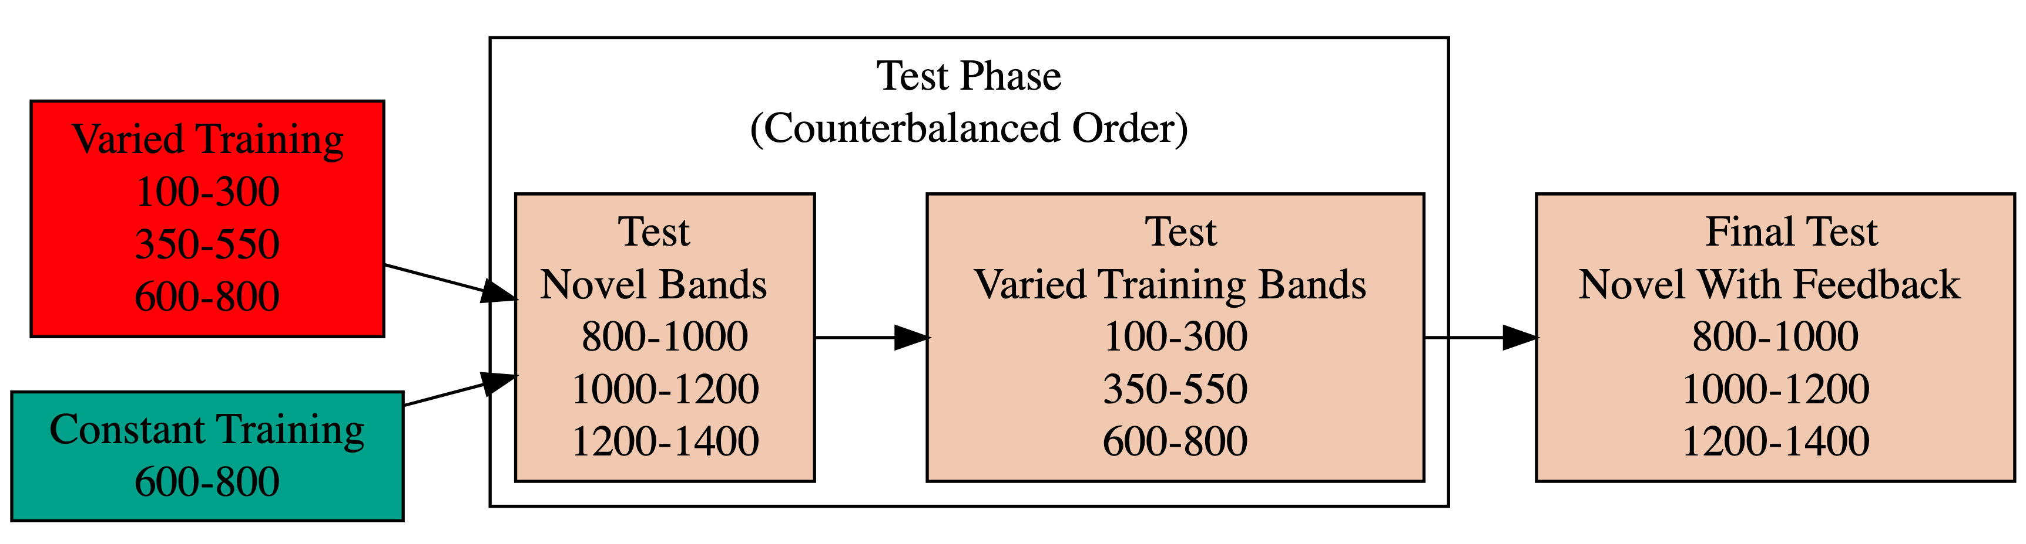
Figure 7: Experiment 2 Design. Constant and Varied participants complete different training conditions. The training and testing bands are the reverse of Experiment 1.

E2 Results

Testing Phase - No feedback.
In the first part of the testing phase, participants are tested from each of the velocity bands, and receive no feedback after each throw.

Deviation From Target Band
Descriptive summaries testing deviation data are provided in Table 6 and Figure 8. To model differences in accuracy between groups, we used Bayesian mixed effects regression models to the trial level data from the testing phase. The primary model predicted the absolute deviation from the target velocity band (dist) as a function of training condition (condit), target velocity band (band), and their interaction, with random intercepts and slopes for each participant (id).

Table 6: Testing Deviation - Empirical Summary
Band | Band Type | Mean | Median | Sd
100-300 | Extrapolation | 206 | 48 | 317
350-550 | Extrapolation | 194 | 86 | 268
600-800 | Trained | 182 | 112 | 240
800-1000 | Extrapolation | 200 | 129 | 233
1000-1200 | Extrapolation | 238 | 190 | 234
1200-1400 | Extrapolation | 311 | 254 | 288
Band | Band Type | Mean | Median | Sd
100-300 | Trained | 153 | 25 | 266
350-550 | Trained | 138 | 53 | 233
600-800 | Trained | 160 | 120 | 183
800-1000 | Extrapolation | 261 | 207 | 257
1000-1200 | Extrapolation | 305 | 258 | 273
1200-1400 | Extrapolation | 363 | 314 | 297

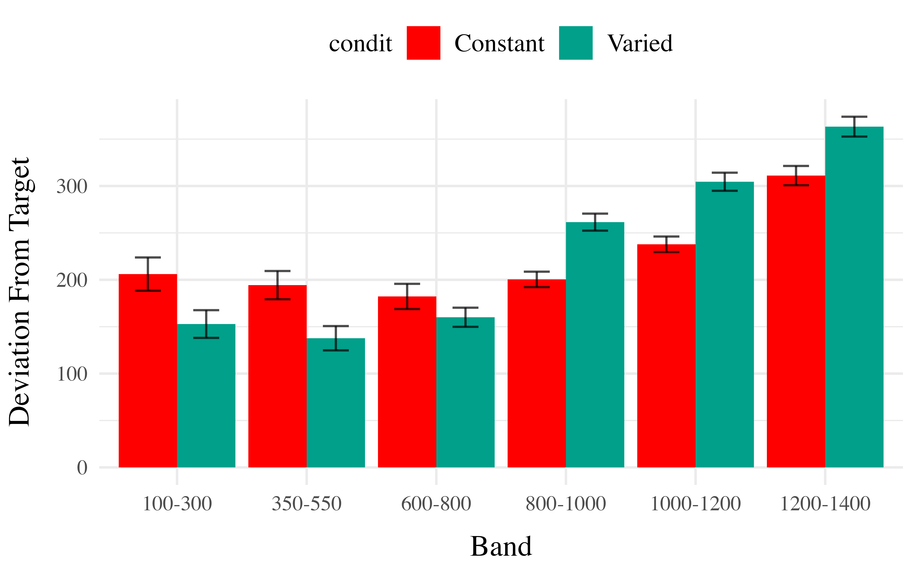
Figure 8: E2. Deviations from target band during testing without feedback stage.
Table 7: Experiment 2. Bayesian Mixed Model predicting absolute deviation as a function of condition (Constant vs. Varied) and Velocity Band
Term | Estimate | 95% CrI Lower | 95% CrI Upper | pd
Intercept | 151.71 | 90.51 | 215.86 | 1.00
conditVaried | -70.33 | -156.87 | 16.66 | 0.94
Band | 0.10 | 0.02 | 0.18 | 1.00
condit*Band | 0.12 | 0.02 | 0.23 | 0.99
Contrasts
contrast | Band | value | lower | upper | pd
Constant - Varied | 100 | 57.6 | -20.5 | 135.32 | 0.93
Constant - Varied | 350 | 26.6 | -30.9 | 83.84 | 0.83
Constant - Varied | 600 | -4.3 | -46.7 | 38.52 | 0.58
Constant - Varied | 800 | -29.3 | -69.4 | 11.29 | 0.92
Constant - Varied | 1000 | -54.6 | -101.1 | -5.32 | 0.98
Constant - Varied | 1200 | -79.6 | -139.5 | -15.45 | 0.99

The model predicting absolute deviation showed a modest tendency for the varied training group to have lower deviation compared to the constant training group (β = -70.33, 95% CI [-156.87, 16.66]),with 94% of the posterior distribution being less than 0. This suggests a potential benefit of training with variation, though the evidence is not definitive.

Experiment 3
The major manipulation adjustment of experiment 3 is for participants to receive ordinal feedback during training, in contrast to the continuous feedback of the earlier experiments. Ordinal feedback informs participants whether a throw was too soft, too hard, or fell within the target velocity range. Experiment 3 participants were randomly assigned to both a training condition (Constant vs. Varied) and a Band Order condition (original order used in Experiment 1, or the Reverse order of Experiment 2).

Results

Testing Phase - No feedback.
In the first part of the testing phase, participants are tested from each of the velocity bands, and receive no feedback after each throw. Note that these no-feedback testing trials are identical to those of Experiment 1 and 2, as the ordinal feedback only occurs during the training phase, and final testing phase, of Experiment 3.

Deviation From Target Band
Descriptive summaries testing deviation data are provided in Table 8 and Figure 9. To model differences in accuracy between groups, we fit Bayesian mixed effects regression models to the trial level data from the testing phase. The primary model predicted the absolute deviation from the target velocity band (dist) as a function of training condition (condit), target velocity band (band), and their interaction, with random intercepts and slopes for each participant (id).
Table 8: Testing Deviation - Empirical Summary
Band | Band Type | Mean | Median | Sd
100-300 | Extrapolation | 396 | 325 | 350
350-550 | Extrapolation | 278 | 176 | 299
600-800 | Extrapolation | 173 | 102 | 215
800-1000 | Trained | 225 | 126 | 284
1000-1200 | Extrapolation | 253 | 192 | 271
1200-1400 | Extrapolation | 277 | 210 | 262
Band | Band Type | Mean | Median | Sd
100-300 | Extrapolation | 383 | 254 | 385
350-550 | Extrapolation | 287 | 154 | 318
600-800 | Extrapolation | 213 | 140 | 244
800-1000 | Trained | 199 | 142 | 209
1000-1200 | Trained | 222 | 163 | 221
1200-1400 | Trained | 281 | 227 | 246
Band | Band Type | Mean | Median | Sd
100-300 | Extrapolation | 403 | 334 | 383
350-550 | Extrapolation | 246 | 149 | 287
600-800 | Trained | 155 | 82 | 209
800-1000 | Extrapolation | 207 | 151 | 241
1000-1200 | Extrapolation | 248 | 220 | 222
1200-1400 | Extrapolation | 322 | 281 | 264
Band | Band Type | Mean | Median | Sd
100-300 | Trained | 153 | 0 | 307
350-550 | Trained | 147 | 55 | 258
600-800 | Trained | 159 | 107 | 192
800-1000 | Extrapolation | 221 | 160 | 235
1000-1200 | Extrapolation | 244 | 185 | 235
1200-1400 | Extrapolation | 324 | 264 | 291

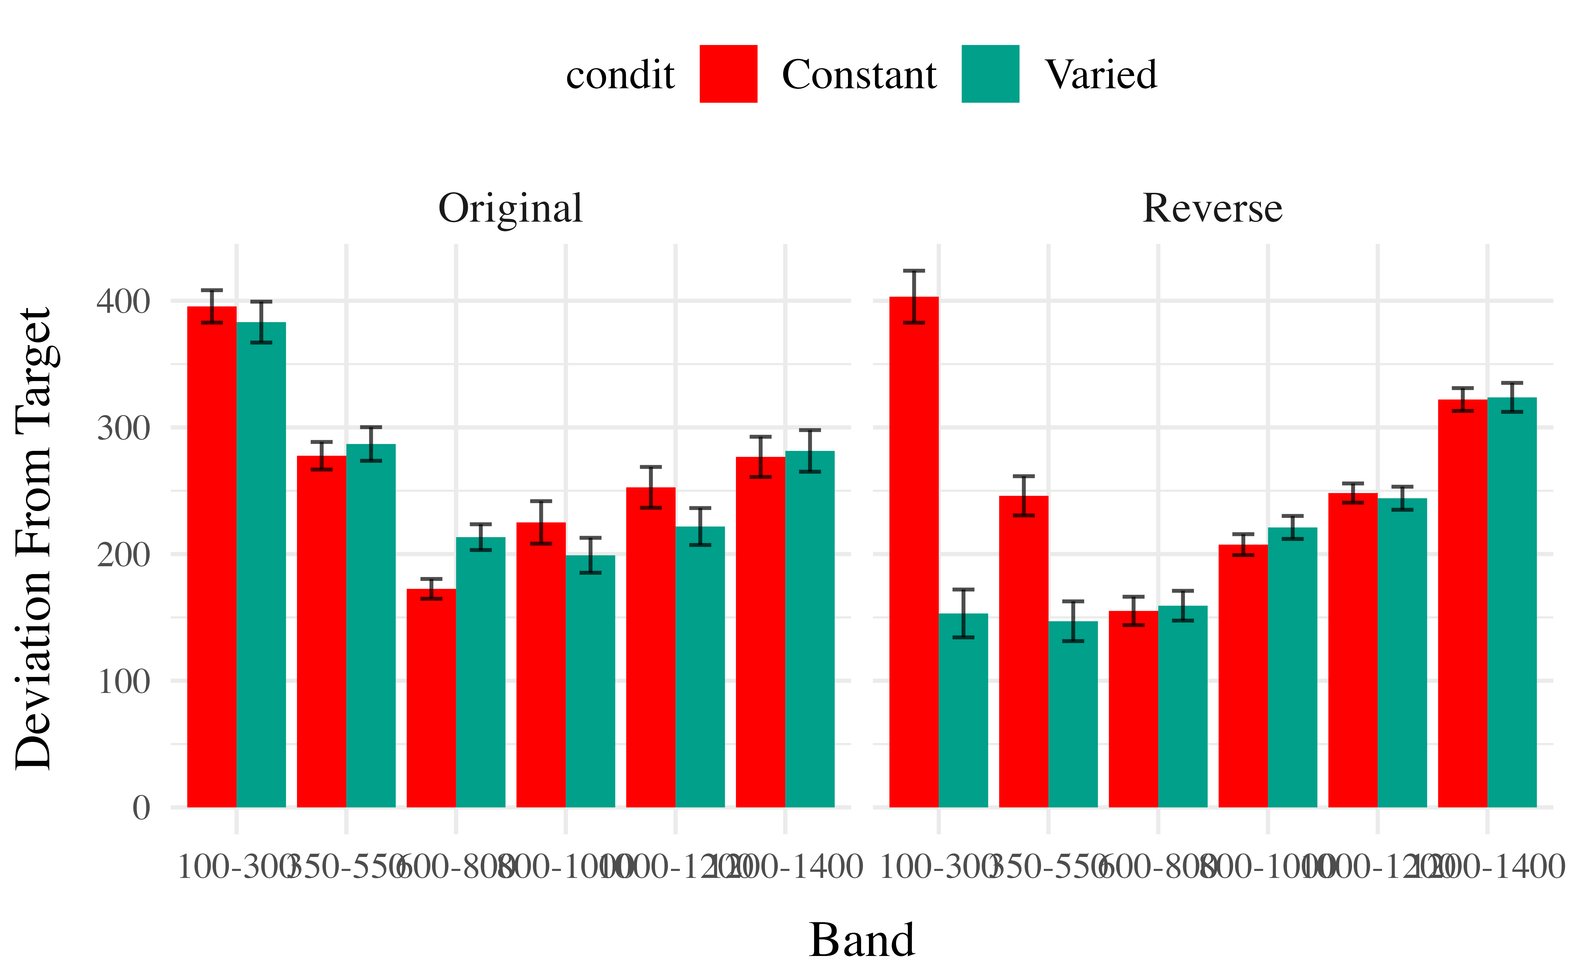
Figure 9: e3. Deviations from target band during testing without feedback stage.
Table 9: Experiment 3. Bayesian Mixed Model predicting absolute deviation as a function of condition (Constant vs. Varied) and Velocity Band
Term | Estimate | 95% CrI Lower | 95% CrI Upper | pd
Intercept | 306.47 | 243.89 | 368.75 | 1.00
conditVaried | -90.65 | -182.79 | 3.75 | 0.97
Band | -0.07 | -0.13 | 0.00 | 0.97
condit*Band | 0.09 | -0.01 | 0.19 | 0.96

The effect of training condition in Experiment 3 showed a similar pattern to Experiment 2, with the varied group tending to have lower deviation than the constant group (β = -90.65, 95% CrI [-182.79, 3.75]), with 97% of the posterior distribution falling under 0.
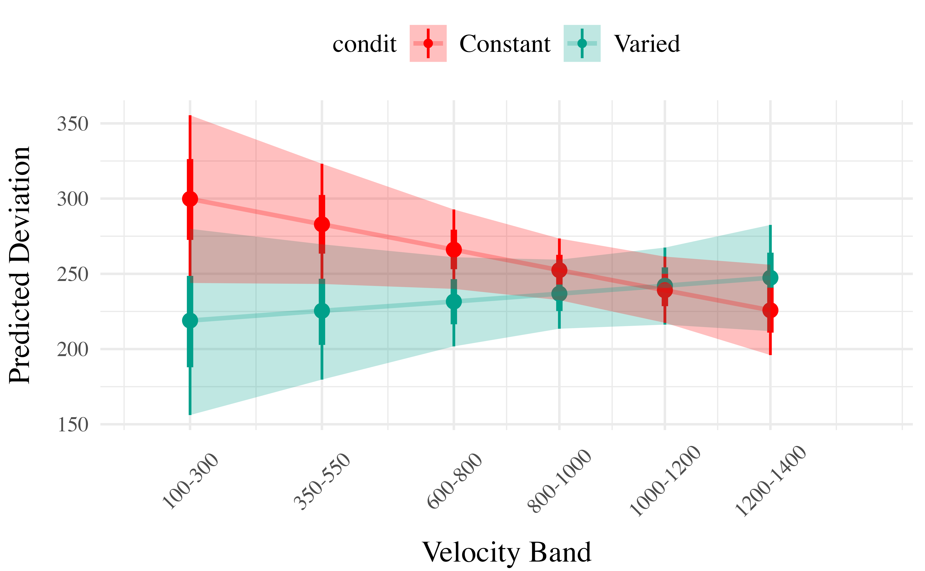
Figure 10: e3. Conditioinal Effect of Training Condition and Band. Ribbon indicated 95% Credible Intervals.

Discrimination between Velocity Bands
In addition to accuracy/deviation. We also assessed the ability of participants to reliably discriminate between the velocity bands (i.e. responding differently when prompted for band 600-800 than when prompted for band 150-350). Table 10 shows descriptive statistics of this measure, and Figure 1 visualizes the full distributions of throws for each combination of condition and velocity band. To quantify discrimination, we again fit Bayesian Mixed Models as above, but this time the dependent variable was the raw x velocity generated by participants.

Figure 11: e3 testing x velocities. Translucent bands with dash lines indicate the correct range for each velocity band.
Table 10: Testing vx - Empirical Summary
Band | Band Type | Mean | Median | Sd
100-300 | Extrapolation | 680 | 625 | 370
350-550 | Extrapolation | 771 | 716 | 357
600-800 | Extrapolation | 832 | 786 | 318
800-1000 | Trained | 1006 | 916 | 417
1000-1200 | Extrapolation | 1149 | 1105 | 441
1200-1400 | Extrapolation | 1180 | 1112 | 443
Band | Band Type | Mean | Median | Sd
100-300 | Extrapolation | 667 | 554 | 403
350-550 | Extrapolation | 770 | 688 | 383
600-800 | Extrapolation | 869 | 814 | 358
800-1000 | Trained | 953 | 928 | 359
1000-1200 | Trained | 1072 | 1066 | 388
1200-1400 | Trained | 1144 | 1093 | 426
Band | Band Type | Mean | Median | Sd
100-300 | Extrapolation | 684 | 634 | 406
350-550 | Extrapolation | 729 | 679 | 350
600-800 | Trained | 776 | 721 | 318
800-1000 | Extrapolation | 941 | 883 | 387
1000-1200 | Extrapolation | 1014 | 956 | 403
1200-1400 | Extrapolation | 1072 | 1014 | 442
Band | Band Type | Mean | Median | Sd
100-300 | Trained | 392 | 270 | 343
350-550 | Trained | 540 | 442 | 343
600-800 | Trained | 642 | 588 | 315
800-1000 | Extrapolation | 943 | 899 | 394
1000-1200 | Extrapolation | 1081 | 1048 | 415
1200-1400 | Extrapolation | 1185 | 1129 | 500

Table 11: Experiment 3. Bayesian Mixed Model Predicting Vx as a function of condition (Constant vs. Varied) and Velocity Band
Term | Estimate | 95% CrI Lower | 95% CrI Upper | pd
Intercept | 607.67 | 536.02 | 679.87 | 1
conditVaried | -167.76 | -277.14 | -64.08 | 1
Band | 0.44 | 0.35 | 0.52 | 1
condit*Band | 0.18 | 0.06 | 0.31 | 1

See Table 11 for the full model results.
Slope estimates for experiment 3 suggest that participants were capable of distinguishing between velocity bands even when provided only ordinal feedback during training (β = 0.44, 95% CrI [0.35, 0.52]). Unlike the previous two experiments, the posterior distribution for the interaction between condition and band was consistently positive, suggestive of superior discrimination for the varied participants β = 0.18, 95% CrI [0.06, 0.31].

Modeling
In project 1, we applied model-based techniques to quantify and control for the similarity between training and testing experience, which in turn enabled us to account for the difference between varied and constant training via an extended version of a similarity based generalization model. In project 2, we will go a step further, implementing a full process model capable of both 1) producing novel responses and 2) modeling behavior in both the learning and testing stages of the experiment. For this purpose, we will apply the associative learning model (ALM) and the EXAM model of function learning (DeLosh 1997). ALM is a simple connectionist learning model which closely resembles Kruschke’s ALCOVE model (Kruscke 1992), with modifications to allow for the generation of continuous responses.

ALM & Exam Description
DeLosh et al. (1997) introduced the associative learning model (ALM), a connectionist model within the popular class of radial-basis networks. ALM was inspired by, and closely resembles Kruschke’s influential ALCOVE model of categorization (Kruschke, 1992).
ALM is a localist neural network model, with each input node corresponding to a particular stimulus, and each output node corresponding to a particular response value. The units in the input layer activate as a function of their Gaussian similarity to the input stimulus. So, for example, an input stimulus of value 55 would induce maximal activation of the input unit tuned to 55. Depending on thevalue of the generalization parameter, the nearby units (e.g. 54 and 56; 53 and 57) may also activate to some degree. ALM is structured with input and output nodes that correspond to regions of the stimulus space, and response space, respectively. The units in the input layer activate as a function of their similarity to a presented stimulus. As was the case with the exemplar-based models, similarity in ALM is exponentially decaying function of distance. The input layer is fully connected to the output layer, and the activation for any particular output node is simply the weighted sum of the connection weights between that node and the input activations. The network then produces a response by taking the weighted average of the output units (recall that each output unit has a value corresponding to a particular response). During training, the network receives feedback which activates each output unit as a function of its distance from the ideal level of activation necessary to produce the correct response. The connection weights between input and output units are then updated via the standard delta learning rule, where the magnitude of weight changes are controlled by a learning rate parameter.
See for a full specification of the equations that define ALM and EXAM.

Model Table

ALM Activation & Response
Step | Equation | Description
ALM Activation & Response
Input Activation |  | Activation of each input node , is a function of the Gaussian similarity between the node value and stimulus X.
Output Activation |  | Activation of each Output unit is the weighted sum of the input activations and association weights.
Output Probability |  | Each output node has associated response, . The probability of response is determined by the ratio of output activations.
Mean Output |  | The response to stimulus x is the weighted average of the response probabilities.
ALM Learning
Feedback Activation |  | After responding, feedback signal Z is presented, activating each output node via the Gaussian similarity to the ideal response.
Update Weights |  | Delta rule to update weights. Magnitude of weight changes controlled by learning rate parameter alpha.
EXAM
Extrapolation |  | Novel test stimulus X activates input nodes associated with trained stimuli.
 |  | Slope value computed from nearest training instances and then added to the response associated with the nearest training instance,m(x)

Model Fitting and Comparison
Following the procedure used by M. Mcdaniel et al. (2009), we will assess the ability of both ALM and EXAM to account for the empirical data when fitting the models to 1) only the training data, and 2) both training and testing data. Models will be fit directly to the trial by trial data of each individual participants, both by minimizing the root-mean squared deviation (RMSE), and by maximizing log likelihood. Because ALM has been shown to do poorly at accounting for human patterns extrapolation (DeLosh et al., 1997), we will also fit the extended EXAM version of the model, which operates identically to ALM during training, but includes a linear extrapolation mechanism for generating novel responses during testing.

References
Bott, L., & Heit, E. (2004). Nonmonotonic Extrapolation in Function Learning. Journal of Experimental Psychology: Learning, Memory, and Cognition, 30, 38–50.
Brehmer, B. (1974). Hypotheses about relations between scaled variables in the learning of probabilistic inference tasks. Organizational Behavior and Human Performance, 11(1), 1–27. https://doi.org/10.1016/0030-5073(74)90002-6
Bürkner, P.-C. (2017). Brms: An R Package for Bayesian Multilevel Models Using Stan. Journal of Statistical Software, 80, 1–28. https://doi.org/10.18637/jss.v080.i01
Carroll, J. D. (1963). Functional Learning: The Learning of Continuous Functional Mappings Relating Stimulus and Response Continua. ETS Research Bulletin Series, 1963(2), i–144. https://doi.org/10.1002/j.2333-8504.1963.tb00958.x
DeLosh, E. L., McDaniel, M. A., & Busemeyer, J. R. (1997). Extrapolation: The Sine Qua Non for Abstraction in Function Learning. Journal of Experimental Psychology: Learning, Memory, and Cognition, 19.
Jones, A., Schulz, E., Meder, B., & Ruggeri, A. (2018). Active Function Learning [Preprint]. Animal Behavior and Cognition. https://doi.org/10.1101/262394
Kalish, M. L., Lewandowsky, S., & Kruschke, J. K. (2004). Population of Linear Experts: Knowledge Partitioning and Function Learning. Psychological Review, 111(4), 1072–1099. https://doi.org/10.1037/0033-295X.111.4.1072
Kruschke, J. K. (1992). ALCOVE: An exemplar-based connectionist model of Category Learning. Psychological Review, 99(1).
Makowski, D., Ben-Shachar, M. S., & Lüdecke, D. (2019). bayestestR: Describing Effects and their Uncertainty, Existence and Significance within the Bayesian Framework. Journal of Open Source Software, 4(40), 1541. https://doi.org/10.21105/joss.01541
Mcdaniel, M. A., & Busemeyer, J. R. (2005). The conceptual basis of function learning and extrapolation: Comparison of rule-based and associative-based models. Psychonomic Bulletin & Review, 12(1), 24–42. https://doi.org/10.3758/BF03196347
Mcdaniel, M., Dimperio, E., Griego, J., & Busemeyer, J. (2009). Predicting transfer performance: A comparison of competing function learning models. Journal of Experimental Psychology. Learning, Memory, and Cognition, 35, 173–195. https://doi.org/10.1037/a0013982
Team, R. C. (2020). R: A Language and Environment for Statistical Computing. R: A Language and Environment for Statistical Computing.

