Jeff Meirhofer
EE477
HW1

2.1
t = (-10:.01:20);
x = 3 * cos((pi/5)*t - (pi/4));
plot(t,x), title('x(t) = 3cos((pi/5)*t - pi/4)'), ylabel('x(t)'), xlabel('t');

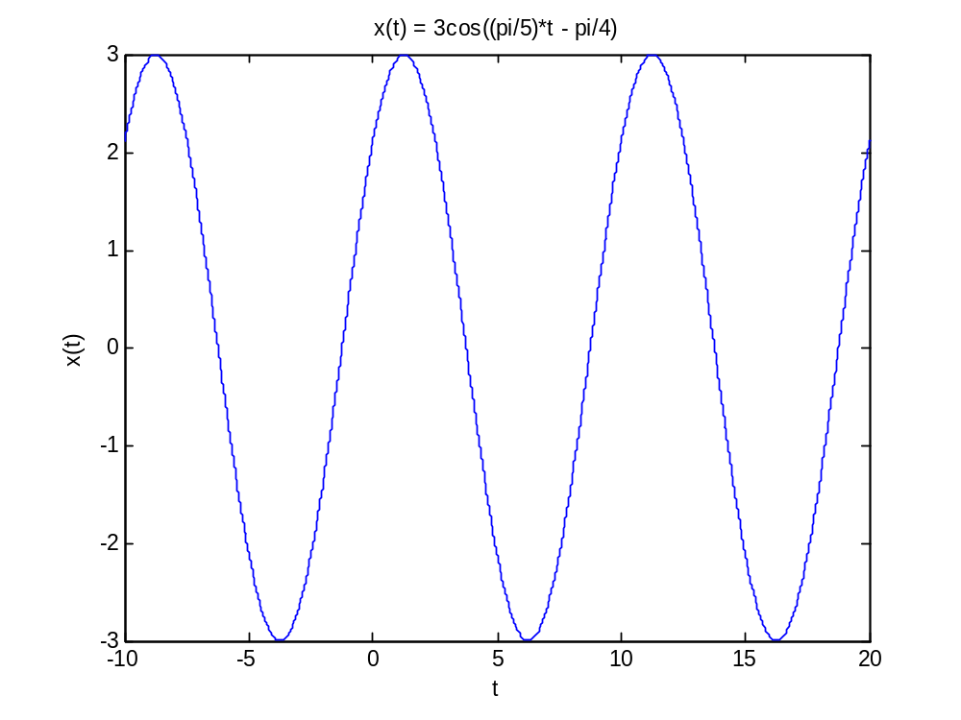

2.2 a
theta = (0:.01:6*pi);
y = cos(theta);
plot(theta, y), title('y = cos(theta)'), ylabel('y'), xlabel('theta');

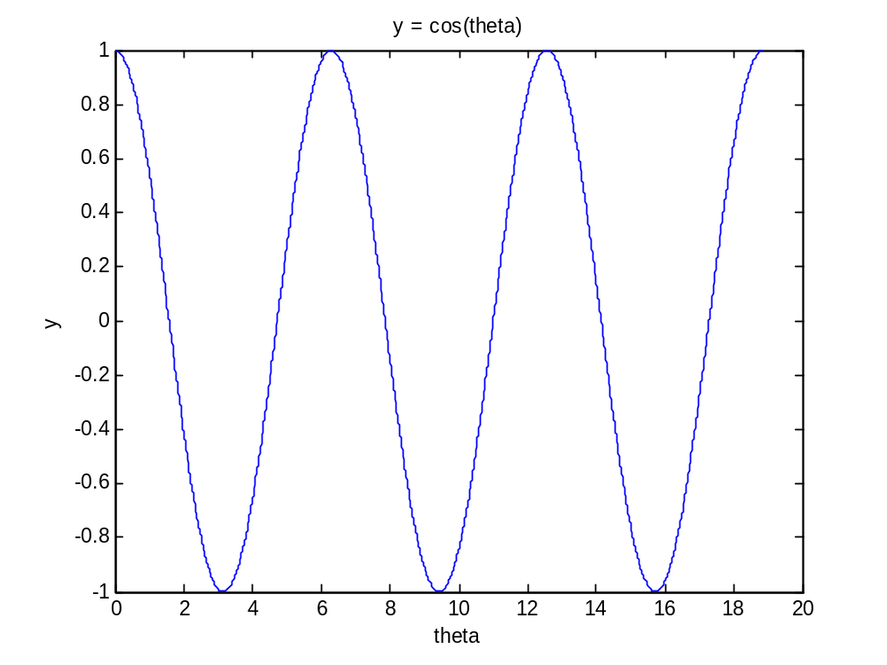
2.2 b

t = (0:.01:30);
y = cos(0.2*pi*t);
plot(t, y), title('y = cos(0.2*pi*t)'), ylabel('y'), xlabel('t');
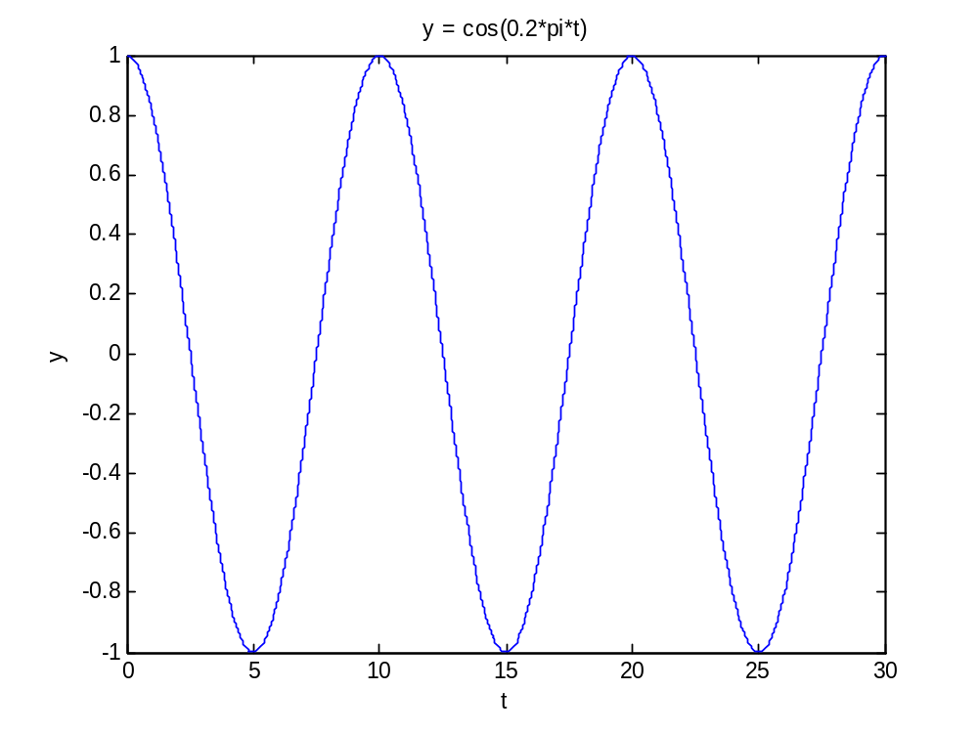

2.2 c

2.2 d

2.3

Amplitude = 20
period = .025 seconds, frequency = 1/.025 = 40 Hz. ω = 2 * pi * f = 251.3
Frequency = 251.3 radians/second
Phase = -0.005 * 2*pi*40
Phase = -1.26 [radians]

