To: Prof. Ross Snider
From: Jeff Meirhofer
Regarding: Lab #1 – Introduction to MATLAB
Date: January 22, 2009

Summary:
The purpose of this lab is to give a quick review of some of the powerful operations MATLAB can perform. The lab covers many of the basics of MATLAB, as well as some more advanced techniques. Plotting sinusoids, dealing with complex numbers, and manipulating arrays are just some of the topics reviewed in this lab.

Basics of MATLAB

3.1 a) MATLAB was used to generate two sinusoids, x1 and x2. The code used to do this is in the appendix.

3.1 b) The signals are plotted from t = -1/3000 to t = 2/3000 in order to show three periods of each signal. The sampling frequency is 100 * f_{o} in order to ensure 100 samples per period.
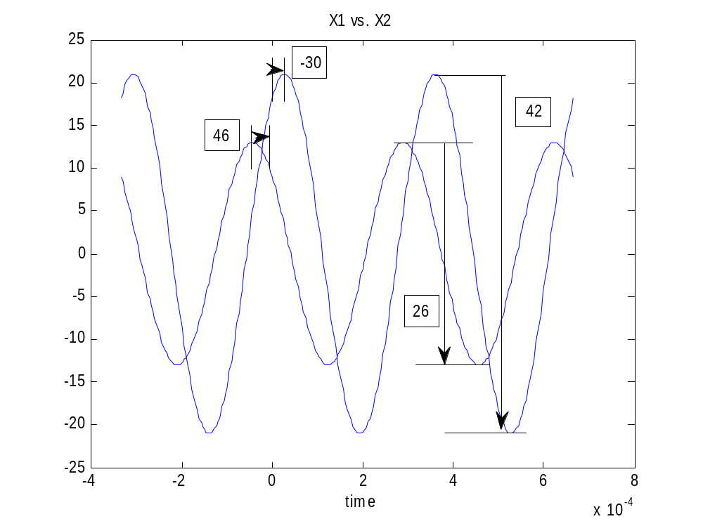
Figure 1. Two sinusoids, x1 and x2, plotted on the same graph

3.1 c) The amplitudes and phases of the two signals are verified in Figure 1.

3.1 d) The two sinusoids are graphed on separate graphs in the same window, using the subplot function.

3.1 e) The signals are now added to create a third signal. All three signals are graphed on separate graphs in the same window, as shown in Figure 2.
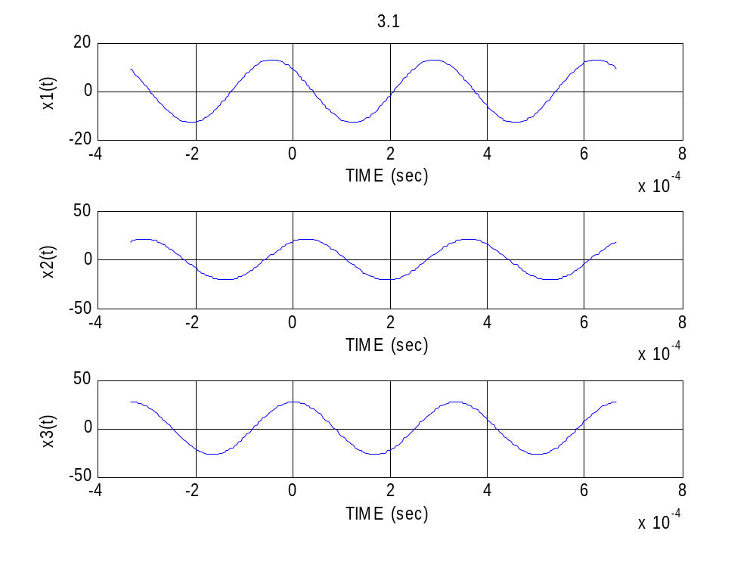
Figure 2. Three plots showing the signals x1, x2, and x3 on the same time interval.

3.1 f) The magnitude and phase of each signal was measured by using the “ginput” command. After the signals are plotted, the user is prompted to click on the peak of each signal nearest to time t=0. When all three points are completed, the program automatically computes amplitudes and phases from the x-y coordinates and displays them. The values for magnitude were about 12.98, 21.11, and 27.14 for x1, x2, and x3, respectively. The phase angles turned out to be around 43.3°, -29.8°, and -3.7°.

4.1 a) To create a vector from 0 to 10 in steps of .5, you could type “yy = 0:0.5:10;”.

4.1 b) To create a vector of one hundred 100's, one could use the statement “yy = 100*ones(1,100);”.

4.2 a) You can return the magnitude of the complex number yy by typing “abs(yy)”.

4.2 b) Similarly, the phase of the complex number can be returned by typing “angle(yy)”. The units of the answer are in radians.

4.3 a) To execute a script file, you can type the name of it (without the extension) into the command window. The file must be in your current directory. In this case, you would type “example”.

4.3 b) The file would not run correctly. You could rename it to example.m and it would work properly.

4.3 c) The plots are similar sinusoidal signals but are phase shifted by 90 degrees, since one is based on sine and the other is based on cosine.
APPENDIX

3.1

A1 = 13; %amplitude of x1
A2 = 21; %amplitude of x2
phi1 = 46*pi/180; %phase of x1
phi2 = -30*pi/180; %phase of x2

period = 1/3000;
fs = 3000*100; %sampling frequency

t = -period:1/fs:2*period;

x1 = A1*cos(2*pi*3000*t + phi1);
x2 = A2*cos(2*pi*3000*t + phi2);

subplot(3,1,1),plot(t,x1),grid on,title('3.1'),xlabel('TIME (sec)'),ylabel('x1(t)')
subplot(3,1,2),plot(t,x2),grid on,xlabel('TIME (sec)'),ylabel('x2(t)')

x3 = x1 + x2;

subplot(3,1,3),plot(t,x3),grid on,xlabel('TIME (sec)'),ylabel('x3(t)')

%the user clicks on the highest peak nearest to t=0 of each signal
%the program automatically displays magnitude and phase
x = 1:3;
y = 1:3;
[x,y] = ginput(3);
angle = - x*180/pi*2*pi*3000
magnitude = y

