To: Prof. Ross Snider
From: Jeff Meirhofer
Regarding: Lab #3 – Synthesis of Sinusoidal Signals
Date: February 5, 2009

Summary:

The purpose of this lab is to experiment with the synthesis of sinusoidal signals. The signals will be used to construct musical notes. These notes will then be used to represent an entire song. Some advanced techniques are then implemented in order to improve the sound quality of the song.

Musical Synthesis of Signals

3) We can use the signal to generate a sound that we can hear. The frequency of the signal determines the pitch of the sound. We know that the musical note A₄ has a frequency of 440 Hz. We also know that the frequencies for all the notes on a typical piano keyboard are related by a constant rate. For example, the frequency of a key N steps above A₄ would be . Using this formula, we can calculate the frequency of every note we need to play. We will use this relation to construct a fairly complicated song.

3 a) The sampling frequency we chose was 11025 Hz, which should work well with the D/A converter of our Windows PC.

3 b) We decided we wanted a quarter note to last .7 seconds through trial and error.

3 c) We calculated all the frequencies for the notes we needed, and defined them at the start of our song’s m-file so they would be easier to work with.

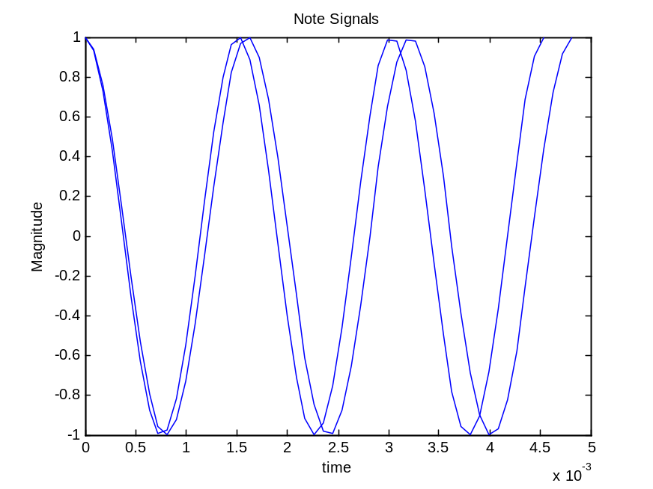
3 f) We plot a few waveforms to make sure that they are being constructed correctly.

Figure 1. Plot of some sinusoids generated to represent musical notes.

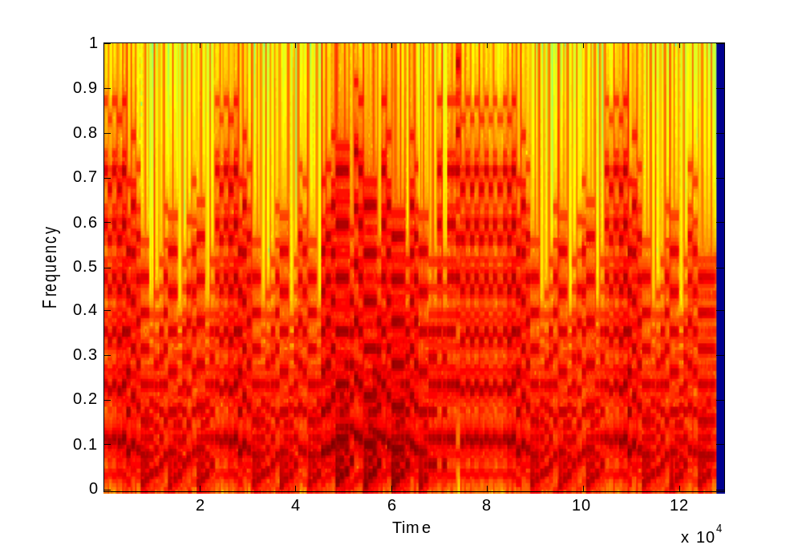
3.1 ) Once our song is complete, we can generate a spectrogram of its frequencies over time with the “specgram()” function. The spectrogram is shown below.

Figure 2. Spectrogram of the song.

3.2 ) We chose to synthesize Für Elise by Beethoven (at least the first page). First, we figured out the key number for each note used, and created constants using the note names. This makes the programming of the song a little easier to follow. Next, we created three vectors each for the treble clef and bass clef. One vector handles the note, one handles its duration, and one handles its volume. The file that plays the song is constantly calling the “note” function to generate the signal needed for each note. At the end of the main file, the treble clef notes and bass clef notes are added to each other using the “soundsc()” function. This function is like the “sound()” function, but scales the amplitude of the signal. In practice, we found it to have much higher sound quality.

3.3 ) The final step taken was to perform some conditioning of the notes to make them sound more realistic and of higher quality. This was done using four different techniques:
- Adding Harmonics
- Adjusting the Volume
- Adding an Envelope
- Slightly Varying the Signal with a Sine Wave

The first improvement was to add in some harmonics of the tone being generated. After some experimentation, I decided to use 6 harmonics. Their respective amplitudes were generated by dividing 100 (amplitude of fundamental) by 2 * N (where N is the Nth harmonic). This makes the signal sound slightly better than before.

Another improvement made was to change the volume of the notes based on how the musical piece is written. This means paying attention to the specified dynamics, crescendos, and decrescendos. This makes the piece sound more realistic and gives it some variety.

The third improvement was to create an envelope for each note. This envelope attenuates the signal based on four different time sections. It forces the note to fade in and fade out slowly, instead of instantly. This technique make the note sound more realistic.

The last improvement is a technique which we devised and was not mentioned in the lab exercise. It may not be an improvement but we decided to try it anyways. Since a real person playing a real instrument would not play a note perfectly along the envelope, the technique was to vary the tone slightly with a very fast sine wave as it is being played. This modification is added together with the envelope. The total envelope can be seen in the graph below.

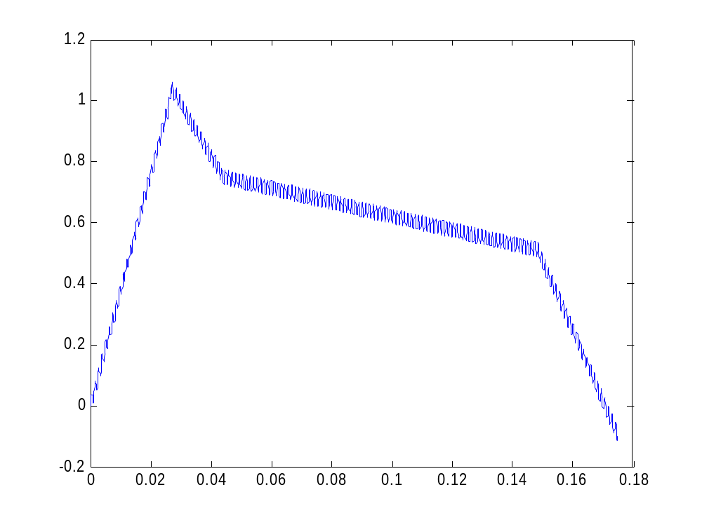
Figure 3. E(t), the envelope that each note is varied with.

Conclusion

After the modifications have been made, the song sounds much better. However, it would be nice to figure out which harmonics (and their amplitudes) to add to make the signal sound more like some real instrument. Despite the artificial sound, it is still pretty impressive sounding for being created from different frequencies of cosines.

APPENDIX

2.2
%a
A = 100;
f0 = 1100;
w0 = 2*pi*f0;
phi = 0;

fs = 8000;

t = [0:1/fs:2];

x1 = A*cos(w0*t+phi);

soundsc(x1,fs)

%b
A = 100;
f0 = 1650;
w0 = 2*pi*f0;
phi = pi/3;

x2 = A*cos(w0*t+phi);

soundsc(x2,fs)

xx = [x1 zeros(1,2000) x2];

soundsc(xx,fs)
%c

fs = 16000;

soundsc(xx,fs)

2.3
%---- play_scale.m
%---
keys = [40 42 44 45 47 49 51 52];
%--- NOTES: C D E F G A B C
% key #50 is middle-C
%
dur = 0.25 * ones(1,length(keys));
fs = 11025;
xx = zeros(1,sum(dur)*fs+1);
n1 = 1;
for kk = 1:length(keys)
keynum = keys(kk);

tone = note(keynum, dur(kk));

n2 = n1 + length(tone) - 1;
xx(n1:n2) = xx(n1:n2) + tone;
n1 = n2;
end
soundsc( xx, fs )

3.2
clear all;
T = .7*4;

E5 = 56;
D5sh = 55;
D5 = 54;
C5 = 52;
B4 = 51;
A4 = 49;
G4sh = 48;
C4 = 40;
E4 = 44;
G4 = 47;
A3 = 37;
G3sh = 36;
E3 = 32;
A2 = 25;
E2 = 20;
F5 = 57;
E6 = 68;
F4 = 45;
C3 = 28;
G3 = 35;
C4 = 40;
G2 = 23;
B3 = 39;

pp = 0.125;
p = 0.25;
mf = 1;

keys = [ ...
E5 D5sh ...
E5 D5sh E5 B4 D5 C5 ...
A4 0 C4 E4 A4 ...
B4 0 E4 G4sh B4 ...
C5 0 E4 E5 D5sh ...
... %end of line 1
E5 D5sh E5 B4 D5 C5 ...
A4 0 C4 E4 A4 ...
B4 0 E4 C5 B4 ...
A4 0 B4 C5 D5 ...
E5 G4 F5 E5 ...
... %end of line 2
D5 F4 E5 D5 ...
C5 E4 D5 C5 ...
B4 0 E4 E5 0 ...
0 E5 E6 0 0 D5sh ...
E5 0 0 D5sh E5 D5sh ...
... %end of line 3
E5 D5sh E5 B4 D5 C5 ...
A4 0 C4 E4 A4 ...
B4 0 E4 G4sh B4 ...
C5 0 E4 E5 D5sh ...
E5 D5sh E5 B4 D5 C5 ...
... %end of line 4
A4 0 C4 E4 A4 ...
B4 0 E4 C5 B4 ...
A4 0 ...
];

volume = [ ...
pp pp ...
pp*2 pp*4 pp*6 pp*6 pp*4 pp*2 ...
pp pp pp pp pp ...
pp pp pp pp pp ...
pp pp pp pp pp ...
... %end of line 1
pp*2 pp*4 pp*6 pp*6 pp*4 pp*2 ...
pp pp pp pp pp ...
pp pp pp pp pp ...
pp pp mf mf mf ...
mf mf mf mf ...
... %end of line 2
mf mf mf mf ...
mf mf*0.9 mf*0.8 mf*0.6 ...
p p p p p ...
p p p p p p ...
p p p pp pp pp ...
... %end of line 3
pp*2 pp*4 pp*6 pp*6 pp*4 pp*2 ...
pp pp pp pp pp ...
pp pp pp pp pp ...
pp pp pp pp pp ...
pp*2 pp*4 pp*6 pp*6 pp*4 pp*2 ...
... %end of line 4
pp pp pp pp pp ...
pp pp pp pp pp ...
pp pp ...
];

dur = [ ...
(1/16*T*ones(1,2)) ...
(1/16*T*ones(1,6)) ...
(1/8*T*ones(1,1)) (1/16*T*ones(1,4)) ...
(1/8*T*ones(1,1)) (1/16*T*ones(1,4)) ...
(1/8*T*ones(1,1)) (1/16*T*ones(1,4)) ...
... %end of line 1
(1/16*T*ones(1,6)) ...
(1/8*T*ones(1,1)) (1/16*T*ones(1,4)) ...
(1/8*T*ones(1,1)) (1/16*T*ones(1,4)) ...
(1/8*T*ones(1,1)) (1/16*T*ones(1,4)) ...
((1/8+1/16)*T*ones(1,1)) (1/16*T*ones(1,3)) ...
... %end of line 2
((1/8+1/16)*T*ones(1,1)) (1/16*T*ones(1,3)) ...
((1/8+1/16)*T*ones(1,1)) (1/16*T*ones(1,3)) ...
(1/8*T*ones(1,1)) (1/16*T*ones(1,4)) ...
(1/16*T*ones(1,6)) ...
(1/16*T*ones(1,6)) ...
... %end of line 3
(1/16*T*ones(1,6)) ...
(1/8*T*ones(1,1)) (1/16*T*ones(1,4)) ...
(1/8*T*ones(1,1)) (1/16*T*ones(1,4)) ...
(1/8*T*ones(1,1)) (1/16*T*ones(1,4)) ...
(1/16*T*ones(1,6)) ...
... %end of line 4
(1/8*T*ones(1,1)) (1/16*T*ones(1,4)) ...
(1/8*T*ones(1,1)) (1/16*T*ones(1,4)) ...
(1/4*T*ones(1,1)) (1/8*T*ones(1,1)) ...
... %end of line 5
];

fs = 11025;
xx = zeros(1,sum(dur)*fs+1);
n1 = 1;
for kk = 1:length(keys)
keynum = keys(kk);

tone = note(keynum, dur(kk), volume(kk));

n2 = n1 + length(tone) - 1;
xx(n1:n2) = xx(n1:n2) + tone;
n1 = n2;
end

keys = [ ...
0 ...
0 ...
A2 E3 A3 0 0 ...
E2 E3 G3sh 0 0 ...
A2 E3 A3 0 0 ...
... %end of line 1
0 ...
A2 E3 A3 0 0 ...
E2 E3 G3sh 0 0 ...
A2 E3 A3 0 0 ...
C3 G3 C4 0 0 ...
... %end of line 2
G2 G3 B3 0 0 ...
A2 E3 A3 0 0 ...
E2 E3 E4 0 E4 ...
E5 0 0 D5sh E5 0 ...
0 D5sh E5 0 0 ...
... %end of line 3
0 ...
A2 E3 A3 0 0 ...
E2 E3 G3sh 0 0 ...
A2 E3 A3 0 0 ...
0 ...
... %end of line 4
A2 E3 A3 0 0 ...
E2 E3 G3sh 0 0 ...
A2 E3 A3 0 0 ...
... %end of line 5
];

volume = [ ...
pp ...
pp ...
pp pp pp pp pp ...
pp pp pp pp pp ...
pp pp pp pp pp ...
... %end of line 1
pp ...
pp pp pp pp pp ...
pp pp pp pp pp ...
pp pp pp mf mf ...
mf mf mf mf mf ...
... %end of line 2
mf mf mf mf mf ...
mf mf*0.9 mf*0.8 mf mf ...
p p p p p ...
p p p p p p ...
p p p p p ...
... %end of line 3
pp ...
pp pp pp pp pp ...
pp pp pp pp pp ...
pp pp pp pp pp ...
pp ...
... %end of line 4
pp pp pp pp pp ...
pp pp pp pp pp ...
pp pp pp pp pp ...
... %end of line 5
];

dur = [ ...
(1/8*T*ones(1,1)) ...
(3/8*T*ones(1,1)) ...
(1/16*T*ones(1,4)) (1/8*T*ones(1,1)) ...
(1/16*T*ones(1,4)) (1/8*T*ones(1,1)) ...
(1/16*T*ones(1,4)) (1/8*T*ones(1,1)) ...
... %end of line 1
(3/8*T*ones(1,1)) ...
(1/16*T*ones(1,4)) (1/8*T*ones(1,1)) ...
(1/16*T*ones(1,4)) (1/8*T*ones(1,1)) ...
(1/16*T*ones(1,4)) (1/8*T*ones(1,1)) ...
(1/16*T*ones(1,4)) (1/8*T*ones(1,1)) ...
... %end of line 2
(1/16*T*ones(1,4)) (1/8*T*ones(1,1)) ...
(1/16*T*ones(1,4)) (1/8*T*ones(1,1)) ...
(1/16*T*ones(1,3)) (1/8*T*ones(1,1)) (1/16*T*ones(1,1)) ...
(1/16*T*ones(1,6)) ...
(1/16*T*ones(1,4)) (1/8*T*ones(1,1)) ...
... %end of line 3
(3/8*T*ones(1,1)) ...
(1/16*T*ones(1,4)) (1/8*T*ones(1,1)) ...
(1/16*T*ones(1,4)) (1/8*T*ones(1,1)) ...
(1/16*T*ones(1,4)) (1/8*T*ones(1,1)) ...
(3/8*T*ones(1,1)) ...
... %end of line 4
(1/16*T*ones(1,4)) (1/8*T*ones(1,1)) ...
(1/16*T*ones(1,4)) (1/8*T*ones(1,1)) ...
(1/16*T*ones(1,4)) (1/8*T*ones(1,1)) ...
];
fs = 11025;
yy = zeros(1,sum(dur)*fs+1);
n1 = 1;
for kk = 1:length(keys)
keynum = keys(kk);

tone = note(keynum, dur(kk), volume(kk));

n2 = n1 + length(tone) - 1;
yy(n1:n2) = yy(n1:n2) + tone;
n1 = n2;
end

soundsc( xx+yy, fs )

NOTE

function [ tone ] = note( keynum,dur,volume )
%NOTE Produce a sinusoidal waveform corresponding to a given piano key number
%
% usage: tone = note(keynum,dur)
%
% tone = the output sinusoidal waveform
% keynum = the piano keyboard number of the desired note
% dur = the duration (in seconds) of the output note

fs = 11025;
tt = 0:(1/fs):dur;
if keynum == 0
tone = 0*tt;
else
f0 = 440*2^((keynum-49)/12);
N = 6;
k = [1:N];
fk = [k*f0];
Z = ones(1,length(fk));

for h = 1:length(Z)
Z(h) = 100/(2*h);
end

tA = 0:(1/fs):0.15*dur;
tD = 0.15*dur:(1/fs):0.25*dur;
tS = 0.25*dur:(1/fs):0.85*dur;
tR = 0.85*dur:(1/fs):dur;

EA = 6.67*tA/dur;
ED = -3*tD/dur + 1.5;
ES = -0.4*tS/dur + .85;
ER = -4*tR/dur + 3.9;

E = [EA ED ES ER];

[tt, tone] = sumcos(fk,Z,fs,dur);

E = E(1:length(tone)); %envelope

E = E + sin(2*pi*150*tt/dur)*0.025; %envelope with sine modulation

%plot(tt,E)

tone = tone.*E*volume;
end

SUMCOS

function [ t, xx ] = sumcos( f, Z, fs, dur )
%SUMCOS Function to synthesize a sum of cosine waves
%usage:
% xx = sumcos(f, Z, fs, dur)
% f = vector of frequencies
% (these could be negative or positive)
% Z = vector of complex exponentials Amp*e^(j*phase)
% fs = the sampling rate in Hz
% dur = total time duration of signal
%
% Note: f and Z must be the same length
% Z(1) corresponds to frequency f(1)
% Z(2) corresponds to frequency f(2), etc.

t = [0:1/fs:dur];
xx = real(Z*exp(j*2*pi*f(:)*t(:)'));

