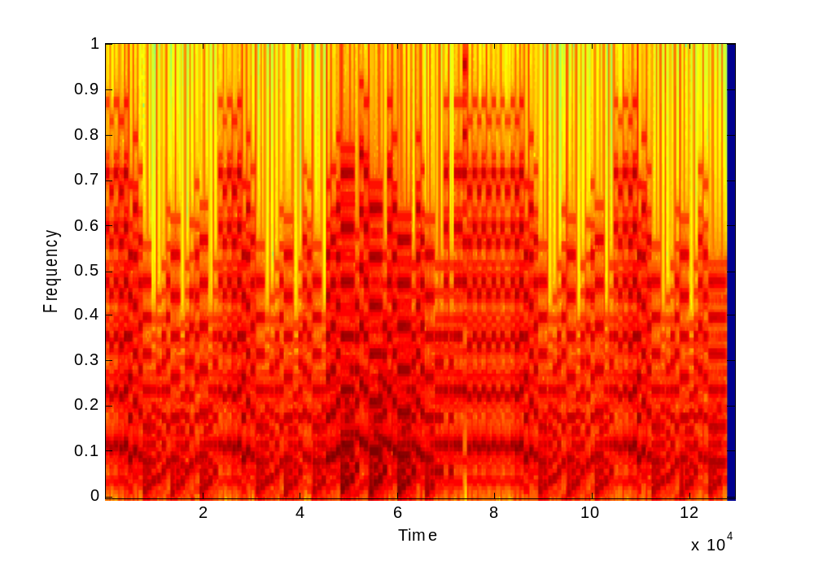
3.1 ) Once the song is complete, we can generate a spectrogram of its frequencies over time with the “specgram()” function. The spectrogram is shown below.

Figure 2. Spectrogram of the song.

3.2 ) We chose to synthesize Für Elise by Beethoven (at least the first page). First, we figured out the key number for each note used, and created constants using the note names. This makes the programming of the song a little easier to follow. Next, we created three vectors each for the treble clef and bass clef. One vector handles the note, one handles its duration, and one handles its volume. The file that plays the song is constantly calling the “note” function to generate the signal needed for each note. At the end of the main file, the treble clef notes and bass clef notes are added to each other using the “soundsc()” function. This function is like the “sound()” function, but scales the amplitude of the signal. In practice, we found it to have much higher sound quality.

3.3 ) The final step taken was to perform some conditioning of the notes to make them sound more realistic and of higher quality. This was done using four different techniques:
- Adding Harmonics
- Adjusting the Volume
- Adding an Envelope
- Slightly Varying the Signal with a Sine Wave

The first improvement was to add in some harmonics of the tone being generated. After some experimentation, I decided to use 6 harmonics. Their respective amplitudes were generated by dividing 100 (amplitude of fundamental) by 2 * N (where N is the Nth harmonic). This makes the signal sound slightly better than before.

Another improvement made was to change the volume of the notes based on how the musical piece is written. This means paying attention to the specified dynamics, crescendos, and decrescendos. This makes the piece sound more realistic and gives it some variety.

The third improvement was to create an envelope for each note. This envelope attenuates the signal based on four different time sections. It forces the note to fade in and fade out slowly, instead of instantly. This technique make the note sound more realistic.

The last improvement is a technique which we devised and was not mentioned in the lab exercise. It may not be an improvement but we decided to try it anyways. Since a real person playing a real instrument would not play a note perfectly along the envelope, the technique was to vary the tone slightly with a very fast sine wave as it is being played. This modification is added together with the envelope. The total envelope can be seen in the graph below.

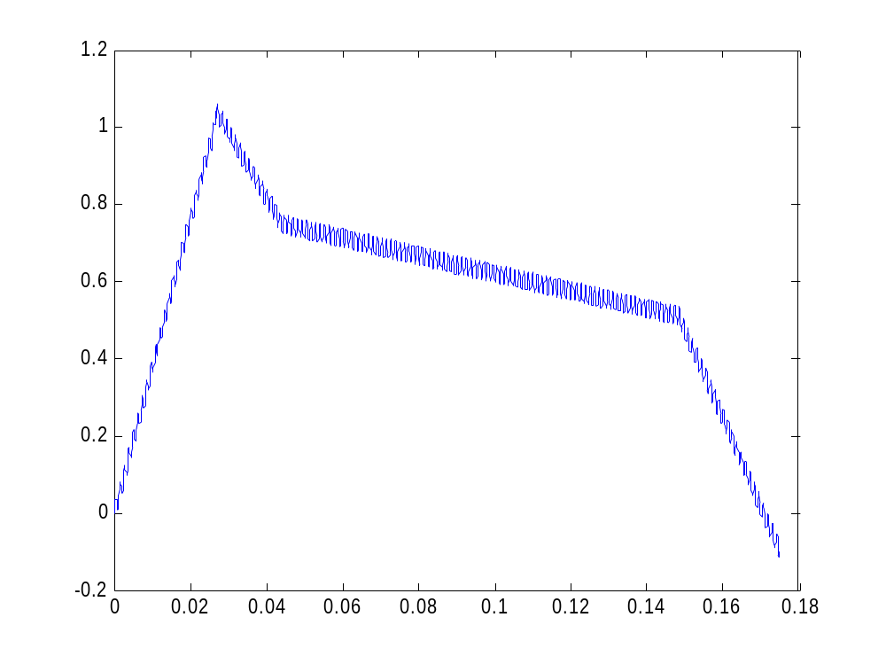
Figure 3. E(t), the envelope that each note is varied with.

Conclusion

After the modifications have been made, the song sounds much better. However, it would be nice to figure out which harmonics (and their amplitudes) to add to make the signal sound more like some real instrument. Despite the artificial sound, it is still pretty impressive sounding for being created from different frequencies of cosines.

