To: Prof. Ross Snider
From: Jeff Meirhofer
Regarding: Lab #7 – Everyday Sinusoidal Signals
Date: March 5, 2009

Summary:

The purpose of this lab is explore the use of FIR filters for signals that are used to transmit data. First, we will generate the tones used for touch tone telephone dialing. We will use FIR filters to detect which frequencies are present in these tones and ultimately which button has been pressed. Next, we will use FIR filters to demodulate AM signals in order to get the message from them.

Practical Application of FIR Filters

3 a) First, the equation for an AM signal is derived. This is appended.

3 b & c) Now we will create a test AM signal to analyze. It will have a carrier frequency of 1200 Hz, and a message frequency of 100 Hz. The message has an amplitude of 0.8. The modulated signal, along with the message signal itself are shown below.

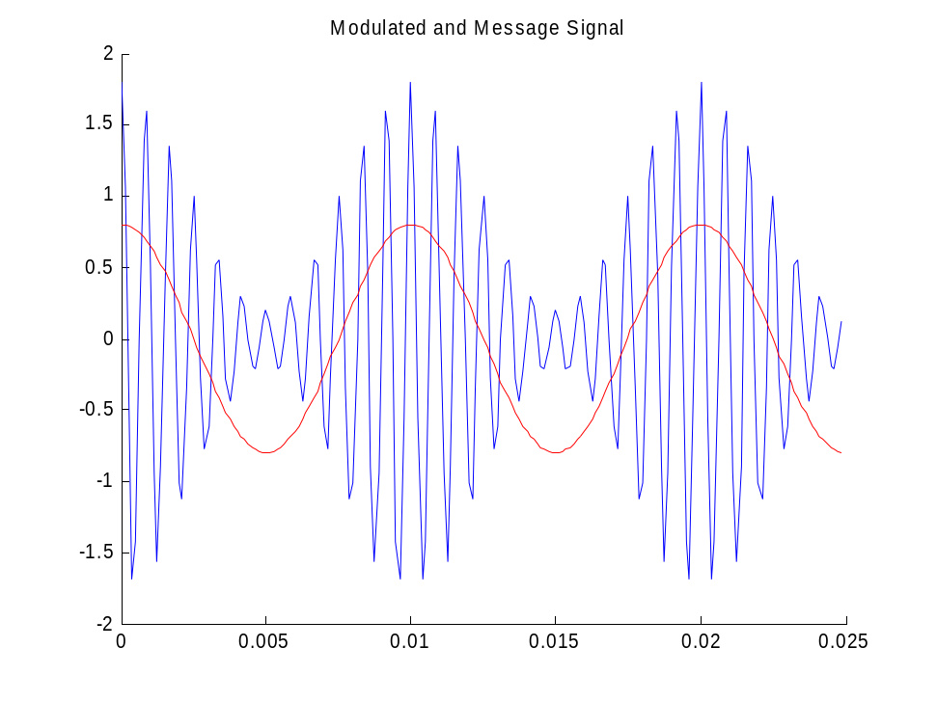
Figure 1. Modulated FM signal and its message signal

3 d) Now we will observe the spectra of the carrier, message, and modulated signals using the “showspec” command. We can see the spectrums are exactly like we would expect.

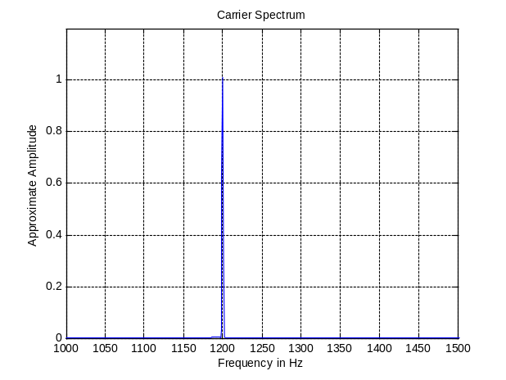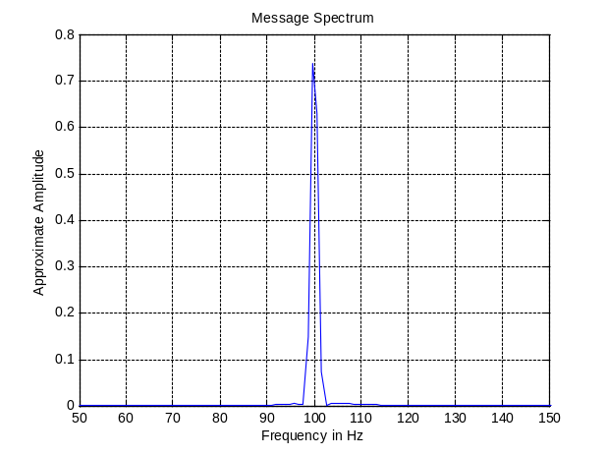
Figure 2. Spectrum of Carrier Figure 3. Spectrum of Message

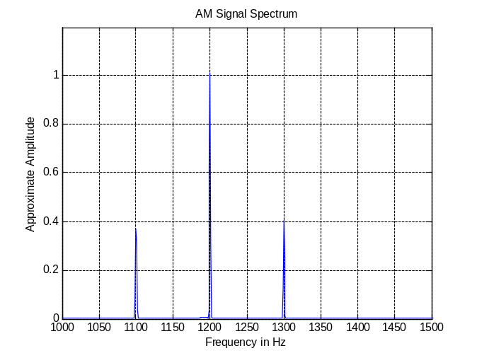
Figure 3. Spectrum of AM signal

4.1 a) Now we will use bandpass filters to decode DTMF signals. First, we will create a bandpass filter at 770 Hz.

4.1 b) Now we will create a bandpass filter at 1336 Hz. In Figure 4, we can see the coefficients of each of the filters.
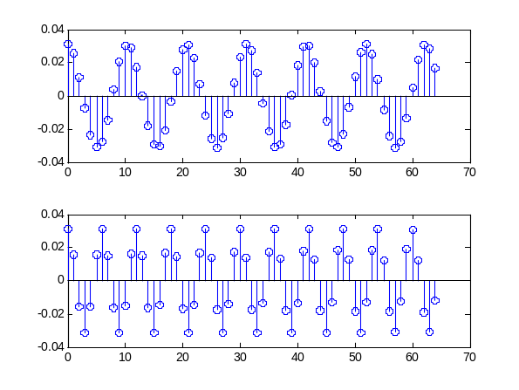
Figure 4. Filter coeffients
4.1 c & d) Now we will plot the frequency response of the filter.
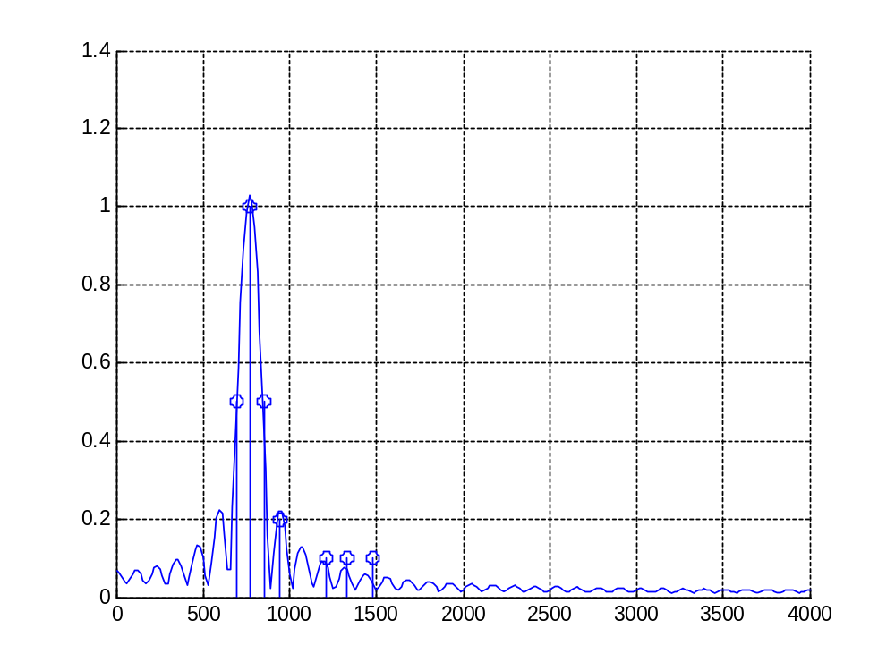
Figure 5. Frequency response of 770 Hz bandpass filter

4.1 e) We can see from the plot how the other DTMF frequencies will be filtered out. No frequency besides 770 has a magnitude greater than 0.5. It looks like the passband is narrow enough.

4.1 f) Now we will plot the 1336 Hz filter.
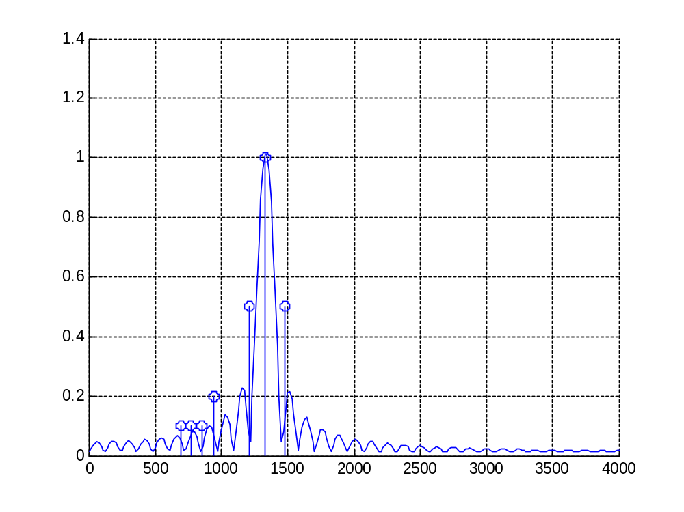
Figure 6. Frequency response of 1336 Hz bandpass filter
The 1336 Hz filter works even better in terms of rejecting other frequencies. We can see that even the closest frequencies have a very low magnitude response in the filter. This should work well.

4.2 a & b) Now we must complete the function that determines if a particular frequency is present in a signal called “dtmfscor”. This function convolves the input with a bandpass filter and then compares the result to the input. If the square of the average of the results is larger than 1/5 the square of the input, the function will return 1 (true). It returns false otherwise.

4.3) In this part, we will write a “dtmfdeco” function that uses “dtmfscor” to determine which key has been pressed. It tests the signal with bandpass filters for each frequency and uses the results to determine which key has been pressed. To use it, we call “dtmfmain”, which uses “dtmfdial”, “dtmfscor”, and “dtmfdeco”.

5 a i) In this section, we will multiply the AM signal by the carrier. We can look at the spectrum of this new signal.
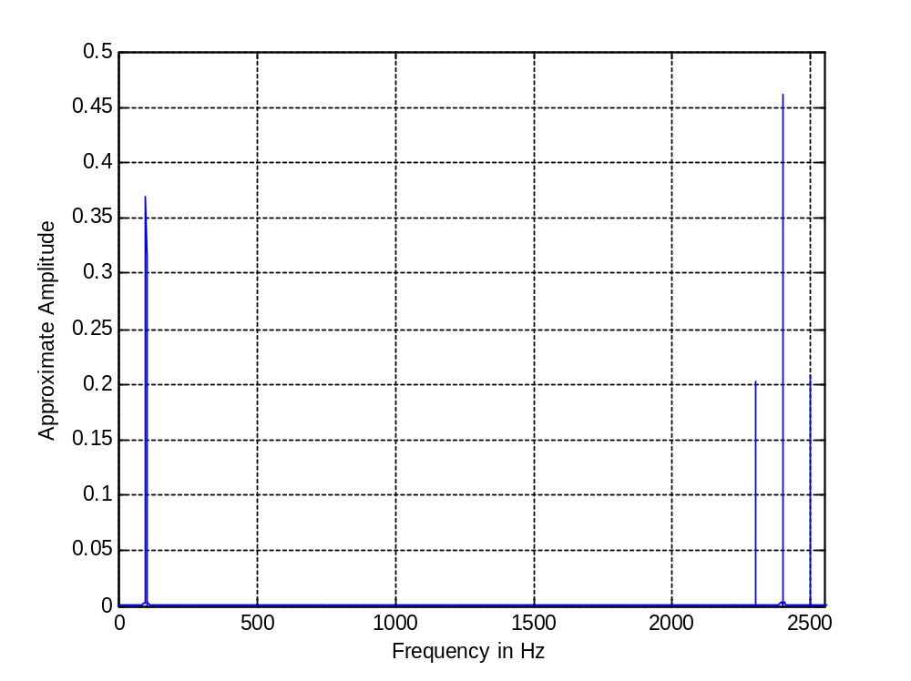
Figure 7. Spectrum of AM signal multiplied by carrier.

We can see that there are peaks at the frequency of the message signal(100 Hz), at two times the carrier(2400 Hz), and 2 times the carrier plus and minus the message (2300 Hz and 2500 Hz).

5 a ii) Now we will create a notch filter that filters out the high-frequency portion of the signal. The frequency response of this filter is shown on the next page. We can see that the filter is designed to attenuate the signal at 2400 Hz.

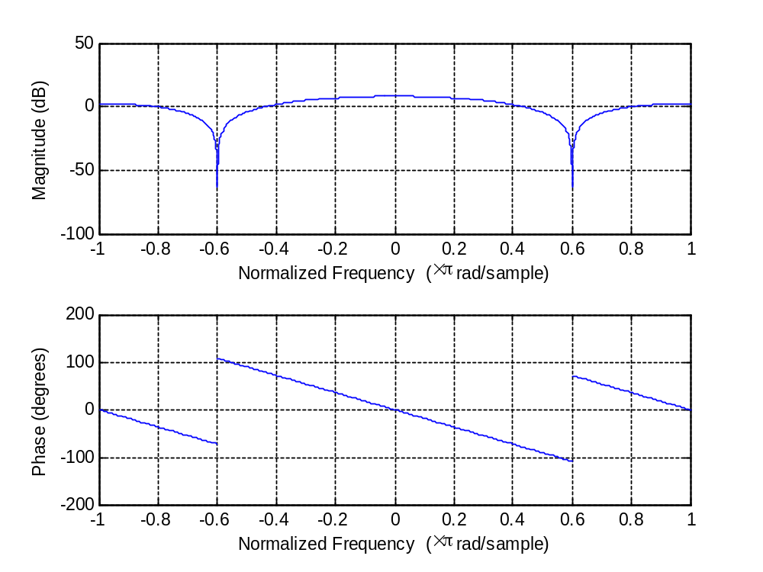
Figure 8. Frequency response of notch filter.

5 a iii) Now we will actually implement the filter. The response is shown in the next figure.

5 b) MATLAB contains a built-in function for AM demodulation named “amdemod”. We will try this function on our signal and compare it to the AM demodulation that we just did.
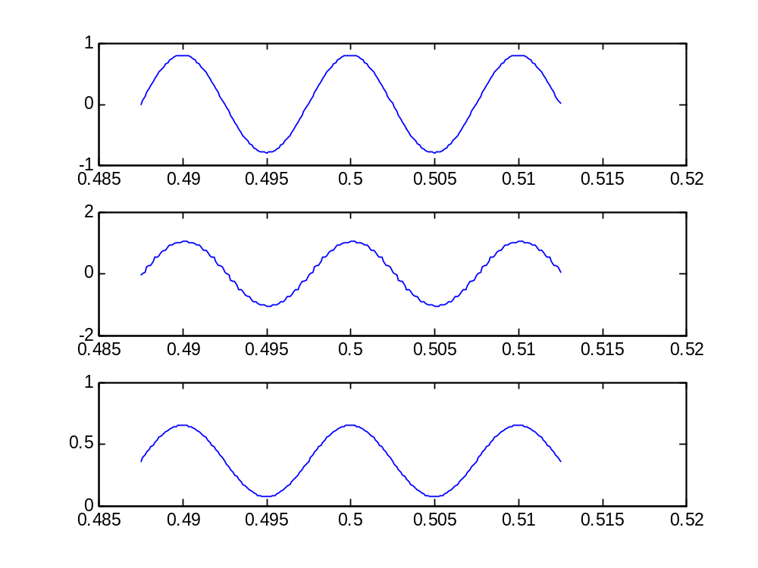
Figure 9. Output of system compared to input.

5 c) Figure 9 shows the time domain response of the original signal, our demodulated signal, and the demodulated signal using ‘amdemod”. We can see that our signal is a little less quality than the others. It appears “jagged”. Both of the demodulated signals have a different amplitude than the original message, and the “amdemod” signal has a DC offset.

5 d) Now we will do the same comparison, but this time we will compare spectrums.

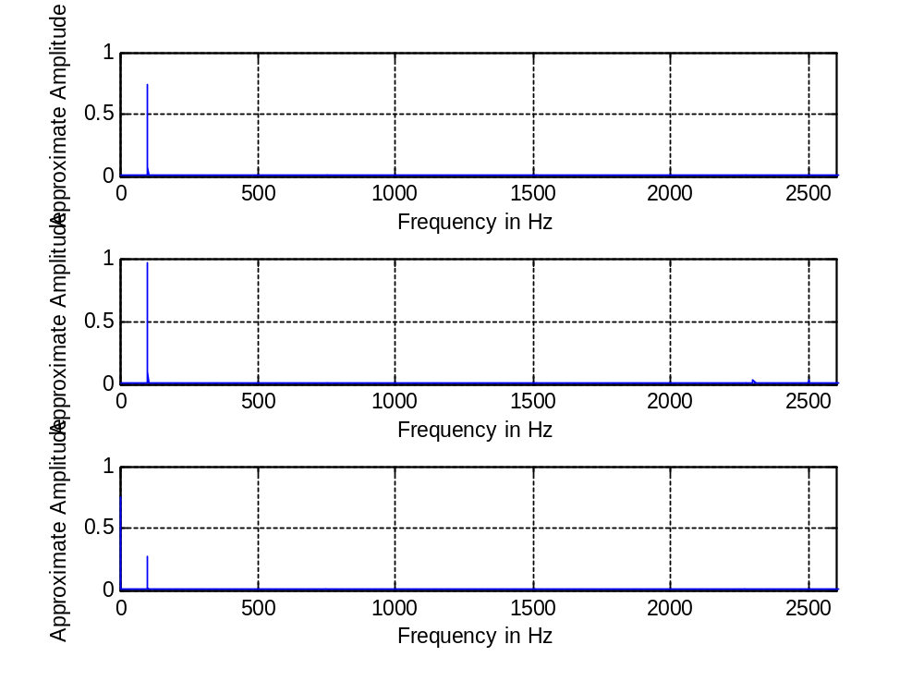
Figure 10. Comparison of spectrums

We can see that the signal which we demodulated still has small frequency components at the carrier frequency. This is probably why the signal is not of very high quality.

5 e) To improve our demodulation, we can use run the signal through the same notch filter again. This is equivalent to using a higher-order notch filter. The results are shown on the next page.

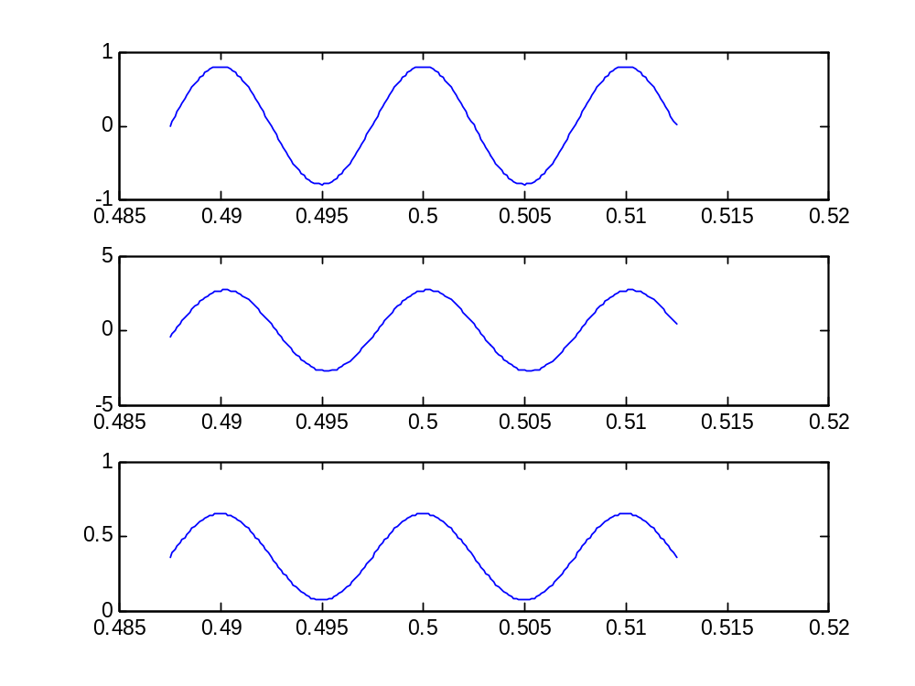
Figure 11. Comparison with improved demodulation.

We can see that our message is now of higher quality. The signal is less “jagged”.

Appendix

3

close all
clear all

dur = 1;
fs = 8000;
fc = 1200;
fm = 100;
A = 0.8;
phi = 0;

t = [0:1/fs:dur];

mm = A*cos(2*pi*fm*t);
cc = cos(2*pi*fc*t);

AM = (1+mm).*cc;

figure(1)
hold on
plot(t(1:200),AM(1:200),'b-')
plot(t(1:200),mm(1:200),'r--')
hold off
title('Modulated and Message Signal')

figure(2),showspec(mm,fs),title('Message Spectrum'),axis([50 150 0 0.8])
figure(3),showspec(cc,fs),title('Carrier Spectrum'),axis([1000 1500 0 1.2])
figure(4),showspec(AM,fs),title('AM Signal Spectrum'),axis([1000 1500 0 1.2])

4.1

close all
clear all

fs = 8000;

L = 64;
n = [0:L];

h770 = 2/L*cos(2*pi*770*n/fs);
h1336 = 2/L*cos(2*pi*1336*n/fs);

figure(1)
subplot(2,1,1),stem(n,h770)
subplot(2,1,2),stem(n,h1336)

ww = 0:(pi/256):pi;
ff = ww/(2*pi)*fs;
H770 = freqz(h770,1,ww);

figure(2)
hold on
plot(ff,abs(H770))
stem([697 770 852 941 1209 1336 1477], [.5 1 .5 .2 .1 .1 .1])
hold off
grid on

H1336 = freqz(h1336,1,ww);

figure(3)
hold on
plot(ff,abs(H1336))
stem([697 770 852 941 1209 1336 1477], [.1 .1 .1 .2 .5 1 .5])
hold off
grid on

DTMFDECO

function [ key ] = dtmfdeco ( xx, fs )
%DTMFDECO Returns the key number of corresponding to the DTMF waveform, xx.
%
% ff = sampling freq (DEFAULT = 8000 Hz if not specified).
%
if (nargin < 3), fs = 8000; end;

tone_pairs = [ 697 697 697 770 770 770 852 852 852 941 941 941; ...
1209 1336 1477 1209 1336 1477 1209 1336 1477 1336 1209 1477 ];

top = [];
bottom = [];

for m = 1:length(tone_pairs)
top = [top dtmfscor( xx, tone_pairs(1,m), 64, fs )];
bottom = [bottom dtmfscor( xx, tone_pairs(2,m), 64, fs )];
end;

for m = 1:length(top)
if ( (top(m) == 1) && (bottom(m) == 1) )
key = m;
end;
end;

DTMFSCOR

function [ ss ] = dtmfscor( xx, freq, L, fs )
%DTMFSCOR Returns: 1 (TRUE) if freq is present in xx, 0 (FALSE) if freq is not present in xx
%
% xx = input DTMF signal
% freq = test frequency
% L = length of FIR bandpass filter
% fs = sampling freq (DEFAULT is 8000)
%
% The signal detection is done by filtering xx with a length-L
% BPF, hh, squaring the output, and comparing with an arbitrary
% setpoint based on the average power of xx.
%

if (nargin < 4), fs = 8000; end;

hh = [];
ss = [];

for m = 1:length(freq)

hh = [ hh 2/L*cos(2*pi*freq(m)*[1:L]/fs) ];

end;

ss = (mean(conv(xx,hh).^2) > mean(xx.^2)/5);

DTMFDIAL

function [ tones ] = dtmfdial( nums )
%DTMFDIAL Create a vector of tones which will dial a DTMF (Touch Tone)
%telephone system.
% usage:
% nums = vector of numbers ranging from 1 to 12
% tones = vector containing the corresponding tones.
if (nargin < 1)
error('DTFMDIAL requires one input');
end
fs = 8000; %This MUST be 8000, so dtmfdeco() will work.
tt1 = 0:1/fs:0.1;
tt5 = 0:1/fs:0.5;

tones = 0;

one = cos(2*pi*1209*tt5) + cos(2*pi*697*tt5);
two = cos(2*pi*1336*tt5) + cos(2*pi*697*tt5);
three = cos(2*pi*1477*tt5) + cos(2*pi*697*tt5);
four = cos(2*pi*1209*tt5) + cos(2*pi*770*tt5);
five = cos(2*pi*1336*tt5) + cos(2*pi*770*tt5);
six = cos(2*pi*1477*tt5) + cos(2*pi*770*tt5);
seven = cos(2*pi*1209*tt5) + cos(2*pi*852*tt5);
eight = cos(2*pi*1336*tt5) + cos(2*pi*852*tt5);
nine = cos(2*pi*1477*tt5) + cos(2*pi*852*tt5);
star = cos(2*pi*1209*tt5) + cos(2*pi*941*tt5);
zero = cos(2*pi*1336*tt5) + cos(2*pi*941*tt5);
pound = cos(2*pi*1477*tt5) + cos(2*pi*941*tt5);

for i=1:length(nums)
if nums(i) == 1
tones = [ tones cos(2*pi*0*tt1) one ];
elseif nums(i) == 2
tones = [ tones cos(2*pi*0*tt1) two ];
elseif nums(i) == 3
tones = [ tones cos(2*pi*0*tt1) three ];
elseif nums(i) == 4
tones = [ tones cos(2*pi*0*tt1) four ];
elseif nums(i) == 5
tones = [ tones cos(2*pi*0*tt1) five ];
elseif nums(i) == 6
tones = [ tones cos(2*pi*0*tt1) six ];
elseif nums(i) == 7
tones = [ tones cos(2*pi*0*tt1) seven ];
elseif nums(i) == 8
tones = [ tones cos(2*pi*0*tt1) eight ];
elseif nums(i) == 9
tones = [ tones cos(2*pi*0*tt1) nine ];
elseif nums(i) == 10
tones = [ tones cos(2*pi*0*tt1) zero ];
elseif nums(i) == 11
tones = [ tones cos(2*pi*0*tt1) star ];
elseif nums(i) == 12
tones = [ tones cos(2*pi*0*tt1) pound ];
end
end
5

close all
clear all

%5.a)
dur = 1;
fs = 8000;
fc = 1200;
fm = 100;
A = 0.8;
phi = 0;

t = [0:1/fs:dur];

mt = A*cos(2*pi*fm*t);
ct = cos(2*pi*fc*t);

xt = (1+mt).*ct;

dt = (xt.*ct)-1/2;

figure(1),showspec(dt,fs),axis([ 0 2550 0 .5 ])

bk = [1 -2*cos(2*pi*2400/fs) 1];

ww = -pi:(pi/8000):pi;

figure(2),freqz(bk,1,ww)

yt = firfilt(bk,dt);

%5.b)
dt = amdemod(xt,fc,fs,1.2)

%5.c)
start = length(t)/2-100;
stop = length(t)/2+100;

figure(3)
subplot(3,1,1),plot(t(start:stop),mt(start:stop))
subplot(3,1,2),plot(t(start:stop),yt(start:stop))
subplot(3,1,3),plot(t(start:stop),dt(start:stop))

%5.d)
figure(4)
subplot(3,1,1),showspec(mt,fs),axis([ 0 2600 0 1 ])
subplot(3,1,2),showspec(yt,fs),axis([ 0 2600 0 1 ])
subplot(3,1,3),showspec(dt,fs),axis([ 0 2600 0 1 ])

figure(5)
pt = firfilt(yt, bk);
subplot(3,1,1),plot(t(start:stop),mt(start:stop))
subplot(3,1,2),plot(t(start:stop),pt(start:stop))
subplot(3,1,3),plot(t(start:stop),dt(start:stop))

