To: Prof. Ross Snider
From: Jeff Meirhofer
Regarding: Lab #10 – The z, n, and ω Domains
Date: April 2, 2009

Summary:

The purpose of this lab is to become better acquainted with the relationships between the z-domain, n domain, and ω domain. The z-domain represents the poles and zeros of a system, the n domain is the impulse response of the system, and the ω domain is the frequency response of the system. We will use a MATLAB GUI called PEZ to compare the three domains.

Domain Comparison

3) In the following sections, we will work through a series of exercises that will help us gain understanding of the domain relationships.

4 a) We start by using the GUI to place a pole at z = ½. This is easily done, by simply selecting to place a pole and clicking where we want it. We can edit the coordinates manually so that they are exact. We click the edit button and select the pole/zero that we want to edit.

4 b) Now we will grab the pole and drag it towards the origin. We can see that the impulse response (h[n]) decays quicker as we get closer to the origin, and the frequency response becomes wider and decreases in magnitude.

4 c) If we try moving the pole the other way (towards one), h[n] decays slower, and the frequency response narrows and increases in magnitude.

4 d) If the pole is placed exactly on the unit circle, h[n] becomes flat and the frequency response narrows and increases in magnitude.

4 e) When the pole is moved outside the unit circle, the system becomes unstable. The impulse response increases exponentially, and the frequency response narrows and increases in magnitude.

4 f) We can see that poles should be placed on or inside the unit circle in order to guarantee system stabiliby.

5 a) The “plus or minus” part of the quadratic formula guarantees that roots will come in conjugate pairs.

5 b) For this part, we place a pole with magnitude 0.75 at angle 45°, and two zeros at the origin.

5 c) We use the quadratic formula to derive the coefficients for the filter. The b coefficients are
b = {G 0 0}, and the a coefficients are a = {1 1.06 -.5625}.

5 d) When we increase the angle of the pole, the impulse response oscillates quicker and the frequency response passband gets farther away from zero.

5 e) When we increase the magnitude of the pole, h[n] increases in magnitude and the frequency response increases in magnitude. When the pole is placed outside the unit circle, the response blows up.

6 a) Now we will experiment with placing poles. Each time we place a pole at the origin, the impulse response gets shifted back by one. The magnitude of the frequency response is the same, but the phase gets more repeating ramps in it.

6 b) Now we place zeros at -1, -j, and j. This creates a 4-point running sum filter. The slope of its phase response is about 10.

6 c) We can create the first filter by placing zeros at π/2 and - π/2 (with magnitude 1), and two poles at the origin. When we multiply the polynomials out, we get a = {1} and b = {1 0 1}. The second filter can be implemented with poles at π/2 and - π/2 with magnitude 0.9, and two zeros at the origin. This leaves us with a = {-1 0 -0.81} and b = {1 0 0}.

6 d) Freqz verifies that the response of each filter is correct.

6 e) Now we put the filters together by placing all of the poles and zeros in pez at the same time. The coefficients for the cascaded system are a = {-1 0 -0.81} and b = {1 0 1}.

6 f) Shown below is a picture of the frequency response of the cascaded system. We can see that the filter has a notch at ω = π/2 and - π/2. This is because of the zeros that are placed there. When the magnitude of zero from one filter is multiplied by the magnitude from the other filter, the result is still zero. The gains of π and 0 are the same because all of the poles and zeros are along the vertical axis. These two frequencies are equidistant from each pole and zero.
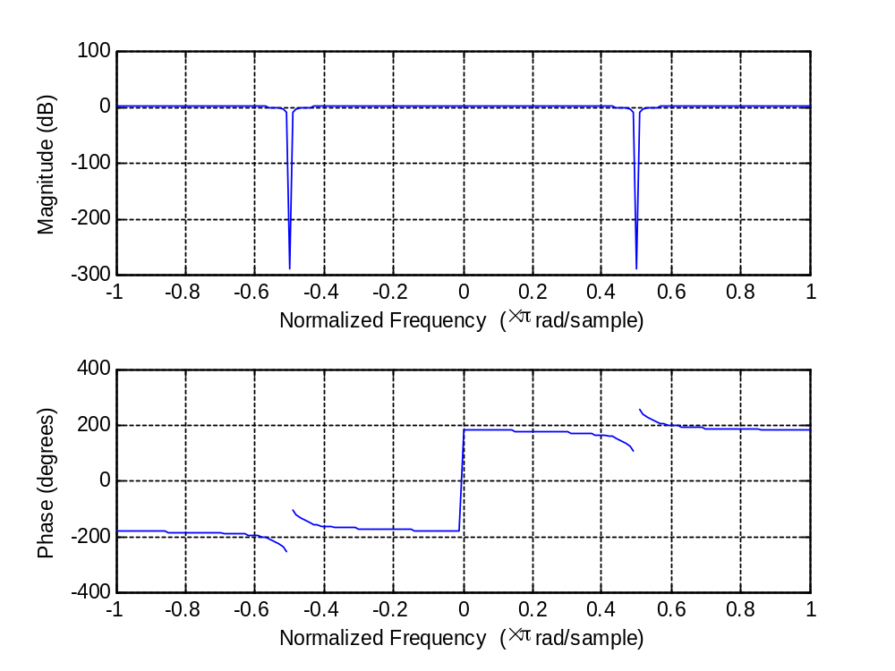
Figure 1. Frequency response of cascaded system

