To: Prof. Ross Snider
From: Jeff Meirhofer
Regarding: Lab #11 – Extracting Frequencies of Musical Tones
Date: April 22, 2009

Summary:

The purpose of this lab is to design and explore a system that creates a piece of music by analyzing the frequency content of its time-domain signal. This system will need to be comprised of a spectrogram function, a peak picking function, a function to edit the signals, and a function to actually display the notes. We will test the system on the first few bars of Fur Elise, which we wrote in an earlier lab.

Frequency Content Analysis

3) Since we must use four different components for the music writer, we will gather each of the components separately before we test the entire system.

3.2) We will start by getting a function to compute the spectrogram of a signal. This function will tell us the frequency content of a small piece of the signal (the window). We will use a Hanning window for this spectrogram. For section 2, we analyzed some spectrogram code and figured out how to calculate num_segs and the test condition of the while loop. We can then use these to complete the code. We can also get some error-checking and other commands from a built-in spectrogram function in the DSP toolbox. The spectrogram computes the Fast-Fourier Transform (FFT) of each window in a user-defined number of windows across the time-domain signal. Figure 1 shows the time-domain response of the signal (although you can’t see the individual sine waves, they are there).

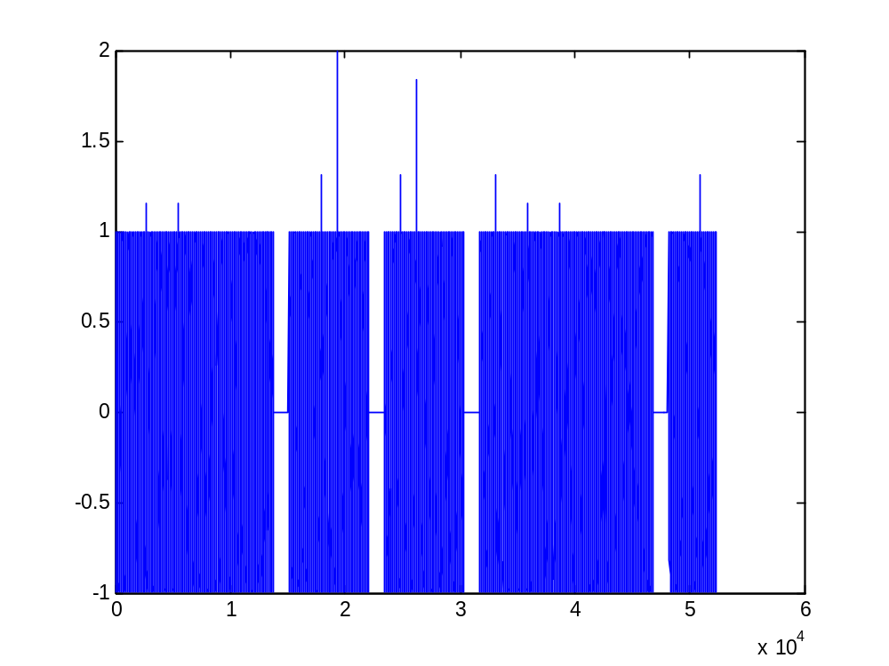
Figure 1. Time-Domain representation of the test signal (Fur Elise).
3.3) The spectrogram has some parameters that we must tune. The window length must be long enough to get good frequency content, but short enough to get a good representation of where the frequency content occurred. We chose a window length of 2000. We must also specify the FFT length, and the window overlap. These basically impact the computation time. We chose 1024 for FFT length, because it is faster when the length is a power of 2. For the overlap, we chose 1900. The spectrogram seems to run fairly fast, even with this large overlap. The figure below shows the frequency content of the signal with relation to time. You can see where the different frequencies of the notes are detected.
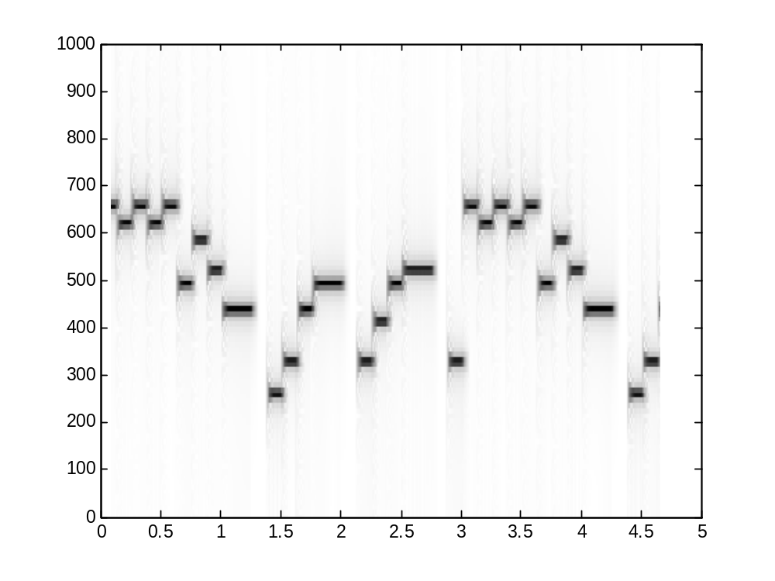
Figure 2. Time vs. Frequency for the test signal (Fur Elise).

3.4) Now we must do the peak picking and editing. We got the peak picker straight from the DSP toolbox. We left the peak picker as is, and just did more work on the editing instead. We set the peak-picking threshold at 50. The peak picker finds the location where the frequency content is at its maximum amplitude. Theoretically, this should be the frequency of the signal at this time. In Figure 3, you can see multiple spectrogram windows overlapped. These are the functions that the peak picker looks at. Our editing function takes this information, along with the spectrogram information, and constructs a matrix of peaks, their locations, and the frequency of that peak. We can then use this matrix to determine where the note is changed. If we know where the note changes, we can use the total time of the signal to determine the duration of each note. We can also do some math to determine the key number of each frequency. The number must be rounded to the nearest integer, of course.

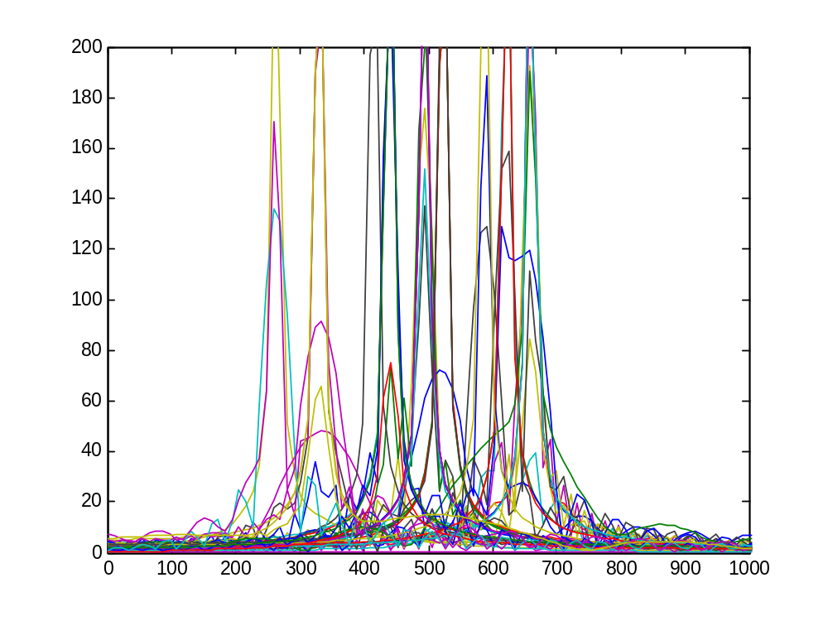
Figure 3. Multiple spectrogram windows overlapped.

3.5) Once we have all this information ( key numbers and durations), we can call the “wrinotes” function that is built-in. This function will display the notes on a musical score.

4 ) We tested our system on the first few bars of Fur Elise. Since “wrinotes” can only display eighth notes, the score isn’t completely accurate. But we can still understand the main concept. The system transcribed the music pretty well. A sample is shown below in Figures 4 & 5.

Conclusion
The music writing function seems to work fairly well, but is very complicated to implement. All of the relevant code is attached.
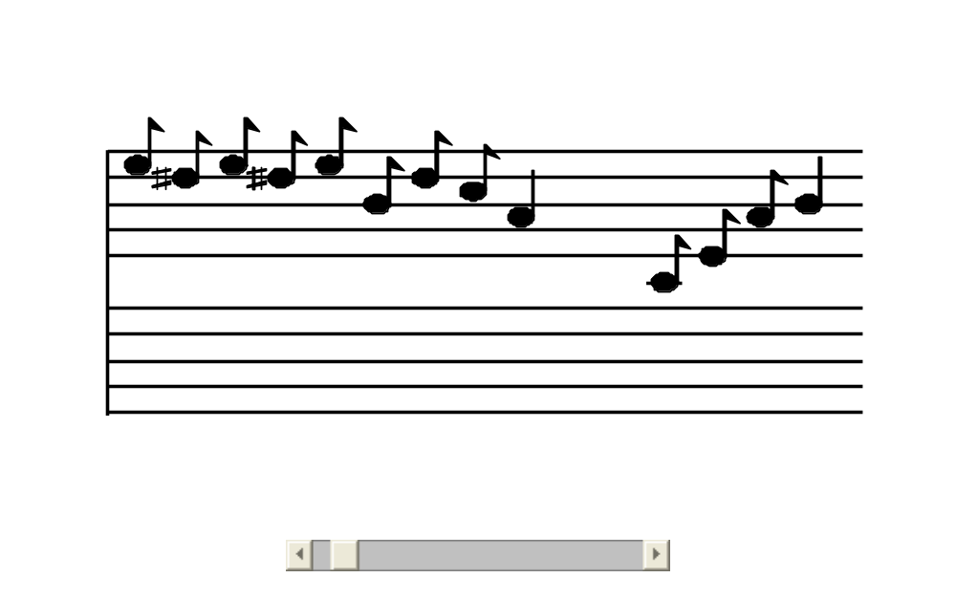
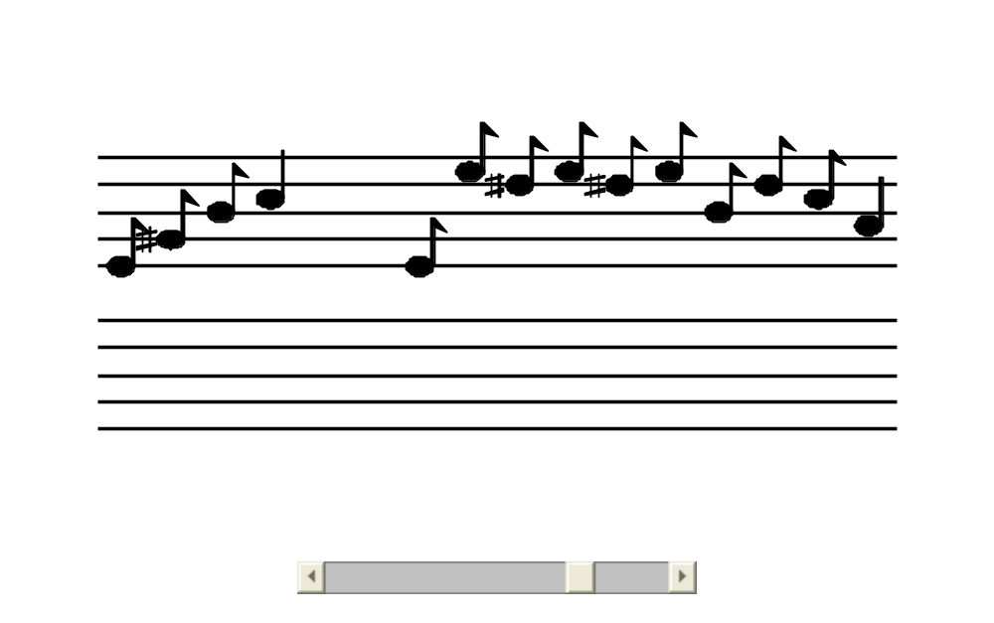
Figures 4 & 5. Automatically generated music score.

Appendix

Spectrogram

function [B,F,T] = SPECTROGRAM(xx,window,Noverlap,Nfft,fs)
%SPECTROGRAM Summary of this function goes here
% Detailed explanation goes here

L = length(window);
if L<=1
if( L==0 ), L = Nfft, end
L = window;
window = hanning(L);
end
if size(xx,1)==1
xx = xx(:);
end
shift = L-Noverlap;
if( shift<0 )
error('SPECTGR: overlap must be less than window length')
end
Lx = length(xx);
num_segs = 1 + fix( (Lx-L)/shift );
B = zeros( Nfft/2+1, num_segs ); %- Pre-allocate the matrix
iseg = 0;
while( iseg<num_segs )
nstart = 1 + iseg*shift;
xsegw = window .* xx( nstart:nstart+L-1);
XX = fft( xsegw, Nfft );
iseg = iseg + 1;
B(:,iseg) = XX(1:Nfft/2+1);
end
F = (0:(Nfft/2))/Nfft * fs;
T = (L/2 + shift*(0:num_segs-1) ) / fs;

B = abs(B);

imagesc( T, F, B ), axis([0 5 0 1000]); colormap(1-gray(256)); axis xy;

Peak Picker

function [peaks, locs] = pkpick( x, thresh, number )
%PKPICKER pick out the peaks in a vector
% Usage: [peaks,locs] = pkpick( x, thresh, number )
% peaks : peak values
% locs : location of peaks (index within a column)
% x : input data (if complex, operate on mag)
% thresh : reject peaks below this level
% number : max number of peaks to return
%
% see also PKINTERP

if nargin == 1
thresh = -inf; number = -1;
elseif nargin == 2
number = -1;
end

[M,N] = size(x);
if M==1
x = x(:); %-- make it a single column
[M,N] = size(x);
end
if any(imag(x(:))~=0)
x = abs(x); %---- complex data, so work with magnitude
end
for kk = 1:N
mask = diff( sign( diff( [x(1,N)-1; x(:,N); x(M,N)-1] ) ) );
jkl = find( mask < 0 & x >= thresh );
if (number>0 & length(jkl)>number)
[tt,ii] = sort(-x(jkl));
jkl = jkl(ii(1:number));
jkl = sort(jkl); %-- sort by index
end
L = length(jkl);
peaks(1:L,kk) = x(jkl);
locs(1:L,kk) = jkl;
end

Test Function

close all
clear all
T = 2;

E5 = 56;
D5sh = 55;
D5 = 54;
C5 = 52;
B4 = 51;
A4 = 49;
G4sh = 48;
C4 = 40;
E4 = 44;
G4 = 47;
A3 = 37;
G3sh = 36;
E3 = 32;
A2 = 25;
E2 = 20;
F5 = 57;
E6 = 68;
F4 = 45;
C3 = 28;
G3 = 35;
C4 = 40;
G2 = 23;
B3 = 39;

pp = 0.125;
p = 0.25;
mf = 1;

keys = [ ...
E5 D5sh ...
E5 D5sh E5 B4 D5 C5 ...
A4 0 C4 E4 A4 ...
B4 0 E4 G4sh B4 ...
C5 0 E4 E5 D5sh ...
... %end of line 1
E5 D5sh E5 B4 D5 C5 ...
A4 0 C4 E4 A4 ...
];

dur = [ ...
(1/16*T*ones(1,2)) ...
(1/16*T*ones(1,6)) ...
(1/8*T*ones(1,1)) (1/16*T*ones(1,4)) ...
(1/8*T*ones(1,1)) (1/16*T*ones(1,4)) ...
(1/8*T*ones(1,1)) (1/16*T*ones(1,4)) ...
... %end of line 1
(1/16*T*ones(1,6)) ...
(1/8*T*ones(1,1)) (1/16*T*ones(1,4)) ...
];

totaltime = sum(dur);
fs = 11025;
xx = zeros(1,sum(dur)*fs+1);
n1 = 1;
for kk = 1:length(keys)
keynum = keys(kk);

tone = note(keynum, dur(kk));

n2 = n1 + length(tone) - 1;
xx(n1:n2) = xx(n1:n2) + tone;
n1 = n2;
end

%soundsc( xx, fs )

figure(1),plot(xx);

window = Hann_window(2000);
Noverlap = 1900;
Nfft = 1024;
fs = 11025;

figure(2)
[B,F,T] = SPECTROGRAM(xx,window,Noverlap,Nfft,fs);

figure(3),plot(F,B),axis([0 1000 0 200])

[M,N] = size(B);

P = ones(N,3);

for k = 1:N
[peaks locs] = pkpick(B(:,k), 50, 1);
if(length(peaks) > 0)
P(k,1) = peaks;
P(k,2) = k;
P(k,3) = F(locs);
else
P(k,1) = 0;
P(k,2) = k;
P(k,3) = 0;
end
end

Q = diff(P(:,3));
Q = find(abs(Q) > 20 );

Q = [0 ; Q];

time = totaltime/N;
durs = diff(Q).*time;

Q = Q';
Q = Q(2:length(Q));
Q = Q(:);

durs = durs.*8; %get numbrs close to whole numbers
durs = floor(durs + .5); %round down to whole numbers
durs = durs./12; %put the smallest notes at 1/8th notes

notes = P(Q-1,3);

for k = 1:length(notes)
if (notes(k) ~= 0)
notes(k) = ((12*log(notes(k))-12*log(55)+ 13*log(2))/log(2));
end
end
notes = floor(notes + .5);

durs = durs';
notes = notes';

wrinotes(notes, durs, 's')

