**Purpose**

The purpose of the lab is to examine the spectral content of an amplitude modulated carrier signal. The student will be able to determine the modulation index, sideband power, and carrier power of a sine wave modulated AM signal, and to identify the envelope of the modulated waveform on an oscilloscope.

**Pre-Lab**

Calculate the magnitude spectrum for the DSB-SC signal used in part 4) of the procedure. Be able to identify the positive envelope of the time waveform of a modulated signal. Calculate the magnitude spectrum you expect to see for AM signals in 10, 12, and 14.

**Textbook References**

Section 5-3, P310 in Couch: DSB-SC (double sideband suppressed carrier)

Section 5-1 for AM (amplitude modulation)

Figure 4.1 for DSB-SC

Figure 5.1 for AM display of the time waveforms

Examples 4-1 and 5-1 for sideband power calculation are useful.

**METHOD:**

**DSB-SC **

1. We will use the math function of the oscilloscope to perform the multiplication of m(t) with the carrier cos(ct) to generate DSB-SC. Check with your instructor to be sure your set up is correct.
   1. Set one signal generator for a 12 KHz sinusoid, 2V p-p into the scope, no offset, and display the signal on channel 1 of the scope (50 ohm input).
   2. Use a second signal generator to get a 1 KHz sinusoid 2V p-p and display the signal on channel 2 of the scope Consider this the modulating signal, m(t).
   3. Set the horizontal time to 100 μs/ DIV so that exactly one cycle of m(t) is shown and trigger the scope off the 1 KHz signal.
   4. Display the 12 KHz signal centered in the top half of the scope display, using two divisions, and the 1 KHz signal in the bottom half of the display, again two divisions high.
   5. Push the “math” button on the scope and choose ‘ch1 x ch2' to get the product of the two signals. The result is a DSB-SC signal.
   6. Display the signal centered on the vertical axis, two divisions high. Note that the 12 KHz signal moves in the envelope of the DSB-SC signal. Change the scope timing to 200 μs/ DIV to observe more of the DSB-SC signal.
2. Return to 100 μs/ DIV on the scope to display one full cycle of m(t). Stop the display. Observe the 180 degree phase change in the 12 KHz signal as the m(t) sinusoid goes from positive to negative. This change is easier to see if the 1 KHz waveshape is changed to a square wave. Try this and then change m(t) back to a sin wave.
   1. Plot the 12 KHz, 1 KHz, and ch1 x ch2 signals shown on the scope. Be sure to show the 180 degree phase change that occur when m(t) changes sign.
   2. Is the positive envelope of the DSB-SC signal the same as the 1 KHz sinusoid shown at the bottom of the scope?
3. The spectrum of the DSB-SC signal is the convolution of the input signal spectrum M(f) and the spectrum of the cos(2ft) carrier.
   1. Sketch the magnitude spectrum as shown by the FFT.
   2. Compare your measurements to the theoretical values (calculate them for your report)
4. Real transmitters have carrier harmonic distortion. Change the carrier to a 12 KHz square wave. (Think of the harmonics as distortion of a 12 KHz sin wave.)
   1. Make a spectral plot of s(t) when the carrier is a 12 KHz square wave. Plot out to 40 KHz. (the third harmonic. (Make sure the third harmonic 1/3 the height of the fundamental).
   2. Can the m(t) be recovered by bandpass filtering just the carrier 3rd harmonic with a bandwidth 2.5KHz? Explain in your report.

**AM- Amplitude Modulation  –**

1. We will use the internal modulator of the generator to examine AM time waveforms and spectra.
   1. Set the frequency of the generator to a 12 MHz sinusoid (the carrier signal), the carrier frequency, and center it on the scope display.
   2. Set the generator to internal AM sinewave modulation with a frequency of 10 KHz. Note that the amplitude of the signal on the scope drops by 2:1 so that the pk-pk voltage will be 2V when the modulation level, =1.
   3. Next set the modulation level (or depth) to 50%.
2. Trigger your scope off the 10 KHz m(t) signal and sample fast enough to prevent aliasing but slow enough to see the 10 KHz envelope.
   1. Adjust the scope time base to see several cycles of the modulating signal and plot the waveform. Identify that the positive envelope or negative envelope looks like m(t).
   2. Are there any phase reversals in the carrier due to m(t)?
3. Set up the spectrum Analyzer SA for a center of 12 MHz and a span of 100 KHz, and a linear vertical scale.
   1. Capture or plot the spectrum. Label the carrier and the sidebands.
   2. What is the ratio of the power of one of the sidebands to the power of the carrier? Determine this value in theory and compare to your measured data.
   3. What is the modulation efficiency of s(t) when m(t) is a sinusoid and 50%?
   4. Increase the 10 KHz modulating signal frequency of the generator while the observing the SA. Explain the relationship of the s(t) transmission bandwidth to the m(t) frequency.
4. Return the modulating frequency to 10 KHz and change the percent modulation to 100%.
   1. Capture or plot the wave shape seen on the oscilloscope.
   2. Is the envelope still 1+m(t)?
   3. Measure the amplitude of the carrier and a sideband. Determine the values in theory and compare to your measured data.
   4. What is the modulation efficiency of s(t) when m(t) is a sinusoid and 100%?
5. Change the percent modulation to 120% to display “over-modulation” (>100%).
   1. Plot or sketch the wave shape seen on the scope.
   2. Is the positive envelope still m(t)? (Hint, can you see any phase reversals in the carrier?)
6. Use the SA to measure the amplitude of the carrier and the sidebands. Compare the measured values to the theoretical values in your report.

**Supplemental Information**





Phase

Reversal

of carrier





* **Attach your pre-lab questions**

**DSB-SC**

1. Observe the 180 degree phase change in the 12 KHz signal as the m(t) sinusoid goes from positive to negative.
   1. Plot the 12 KHz, 1 KHz, and ch1 x ch2 signals shown on the scope. Be sure to show the 180 degree phase change that occur when m(t) changes sign.

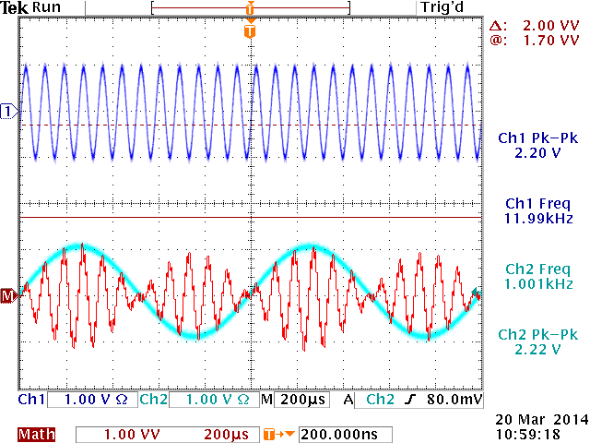

* 1. Is the positive envelope of the DSB-SC signal the same as the 1 KHz sinusoid shown at the bottom of the scope?

**Yes**

1. The spectrum of the DSB-SC signal is the convolution of the input signal spectrum M(f) and the spectrum of the cos(2ft) carrier.
2. Sketch or plot the magnitude spectrum as shown by the FFT.
3. Compare your measurements to the theoretical values (calculate them for your report)
4. Change the carrier to a 12 KHz square wave. (Think of the harmonics as distortion of a 12 KHz sin wave.)
5. Make a spectral plot of s(t) when the carrier is a 12 KHz square wave. Plot out to 40 KHz.
6. Can the m(t) be recovered by bandpass filtering just the carrier 3rd harmonic with a bandwidth 2.5KHz? Explain.

**AM- Amplitude Modulation**

1. Trigger your scope off the 10 KHz m(t) signal and sample fast enough to prevent aliasing but slow enough to see the 10 KHz envelope.
2. Identify that the positive envelope or negative envelope looks like m(t).

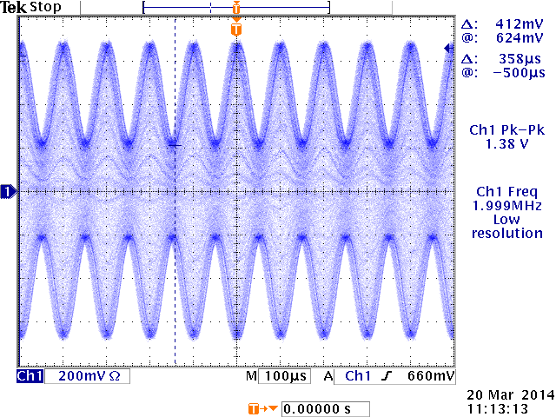

1. Are there any phase reversals in the carrier due to m(t)?

**Yes, at the troughs in the modulation wave.**

1. Set up the spectrum Analyzer SA for a center of 12 MHz and a span of 100 KHz, and a linear vertical scale.
2. Capture or plot the spectrum. Label the carrier and the sidebands.
3. What is the ratio of the power of one of the sidebands to the power of the carrier? Determine this value in theory and compare to your measured data.
4. What is the modulation efficiency of s(t) when m(t) is a sinusoid and 50%?

1. Return the modulating frequency to 10 KHz and change the percent modulation to 100%.
2. Capture or plot the wave shape seen on the oscilloscope.

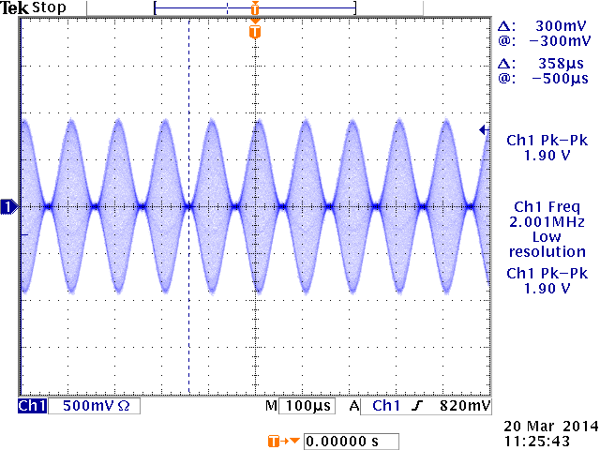

1. Is the envelope still 1+m(t)?

**Yes**

1. Measure the amplitude of the carrier and a sideband. Determine the values in theory and compare to your measured data.
2. What is the modulation efficiency of s(t) when m(t) is a sinusoid and 100%?
3. Change the percent modulation to 120% to display “over-modulation” (>100%).
4. Plot or sketch the wave shape seen on the scope.

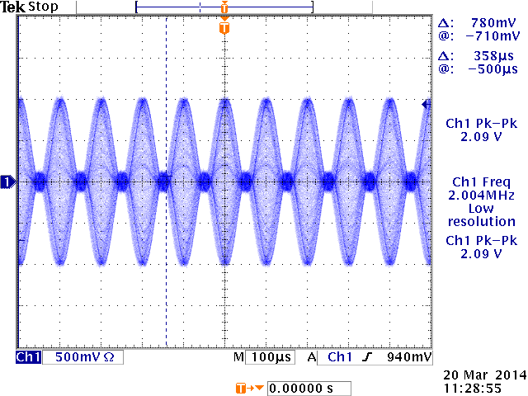

1. Is the positive envelope still m(t)? (Hint, can you see any phase reversals in the carrier?)

**Yes**

1. Use the SA to measure the amplitude of the carrier and the sidebands. Compare the measured values to the theoretical values in your report.