**Purpose**

We examine the properties of a noisy binary signal using an oscilloscope to display an eye pattern. You will need 2ea 1K ohm resistors, a 100 ohm resistor, and a floppy disc to capture csv data files or screen photos for your reports. The Matlab program from last week may be used to analyze the data. You are encouraged to start using Matlab for analysis in your reports.

**Components Required:**

* Small bread-board to build the circuit on( or just use clip leads directly)
* 2ea 1k ohm resistors
* 1 ea 100 ohm resistor
* Floppy disk for screen captures

**Pre-lab**

* For an eye pattern define:
  + inter-symbol interference ISI
  + Noise margin
  + Timing sensitivity
  + Zero-crossing jitter
* Read the application note on eye patterns.

**Reference Sources**

* Couch section 3-5, fig 3-18, and attached figure
* App-note on website on eye pattern analysis of digital waveforms



Figure Test Circuit

**METHOD:**

**Eye Pattern with Noise**

1. Connect a Function Generator set for a 1 Vpp 20kHz sinusoid to one input of a resistive adder as in figure 1. The other input of the adder is to come from a second generator set for a measured noise output of 1Vp-p. You will adjust this amplitude part d). The adder uses two 1kΩ resistors, one in series with each source, feeding a common 100Ω resistor. Display the voltage across the 100Ω on a scope.

* 1. Derive triggering for the scope from the sync output of the function generator. The sync output is a square wave synchronized to the sine wave. You need to get the scope to trigger on both negative and positive changes in the square wave. Try the following trigger settings.

Display persistence – adjust for best view

Slope - positive

Mode - auto

EXT INPUT

Coupling - AC or DC

* 1. Adjust the sweep rate and trigger delay of the scope until you see an eye pattern.
  2. Adjust the levels of the two sources so that there are clearly some axis crossings at the center of the eye. Remember that the noise Vpk to Vrms ratio is about 3:1 (you may use the actual value you found in lab 3 if you are using the same generator).
  3. Verify your settings with the instructor before you record the following:
     1. Record the Vp-p and Vrms values of just the noise
     2. Record the Vpp and Vrms of just the signal
     3. Calculate the signal to noise ratio in dB
  4. Plot (or capture the screen to a floppy) and identify the following for part d)
     1. ISI (volts p-p)
     2. Noise Margin
     3. Timing sensitivity
     4. Zero-crossing Jitter
     5. Optimum sampling time

**Signal to noise estimate in Frequency Domain**

1. Observe the spectrum of the signal of part d) using the FFT.
   1. Record the 20 KHz signal RMS volts from the FFT.
   2. Record the Sample rate.
   3. Estimate the RMS noise density of the spectrum at a frequency where the noise is “flat”.
   4. Use your estimate of the noise bandwidth of the generator found in Lab 3 to estimate the total noise power using a-c. Then find the normalized Vnoise rms.
   5. Estimate of the SNR (in dB) using a) and c) and compare your result with part 1diii. Discuss any differences in your report. (you may use characteristics of the noise spectrum from lab 3 for noise bandwidth)

**Eye Pattern with Noise, SNR near threshold**

1. Now, adjust the SNR (signal to noise ratio) by changing the noise voltage so that an axis crossing at the optimum sample time is never observed but the noise is still abundantly obvious. The eye pattern will look “closed”.
   1. Calculate the new SNR as in part 1) and show the instructor your results. (it should be approximately 10dB)
   2. How many dB did the SNR change from 1) to 3)? Look at figure 7-14 in the text and estimate what the BER would be for your SNR for a polar baseband digital signal. Note: Eb/No dB is equivalent to SNR dB

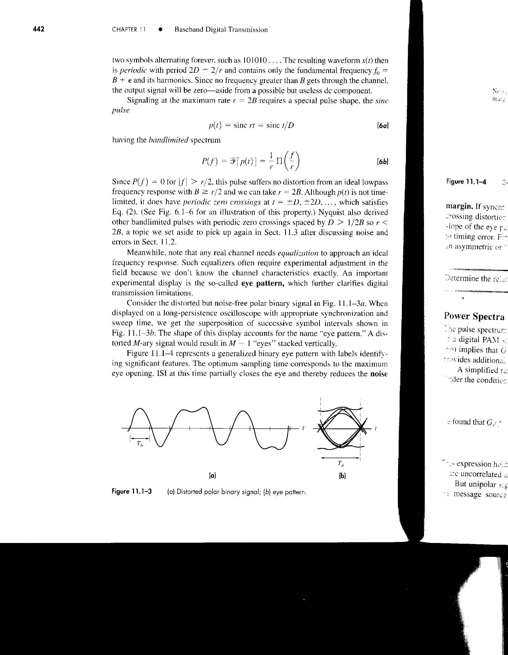

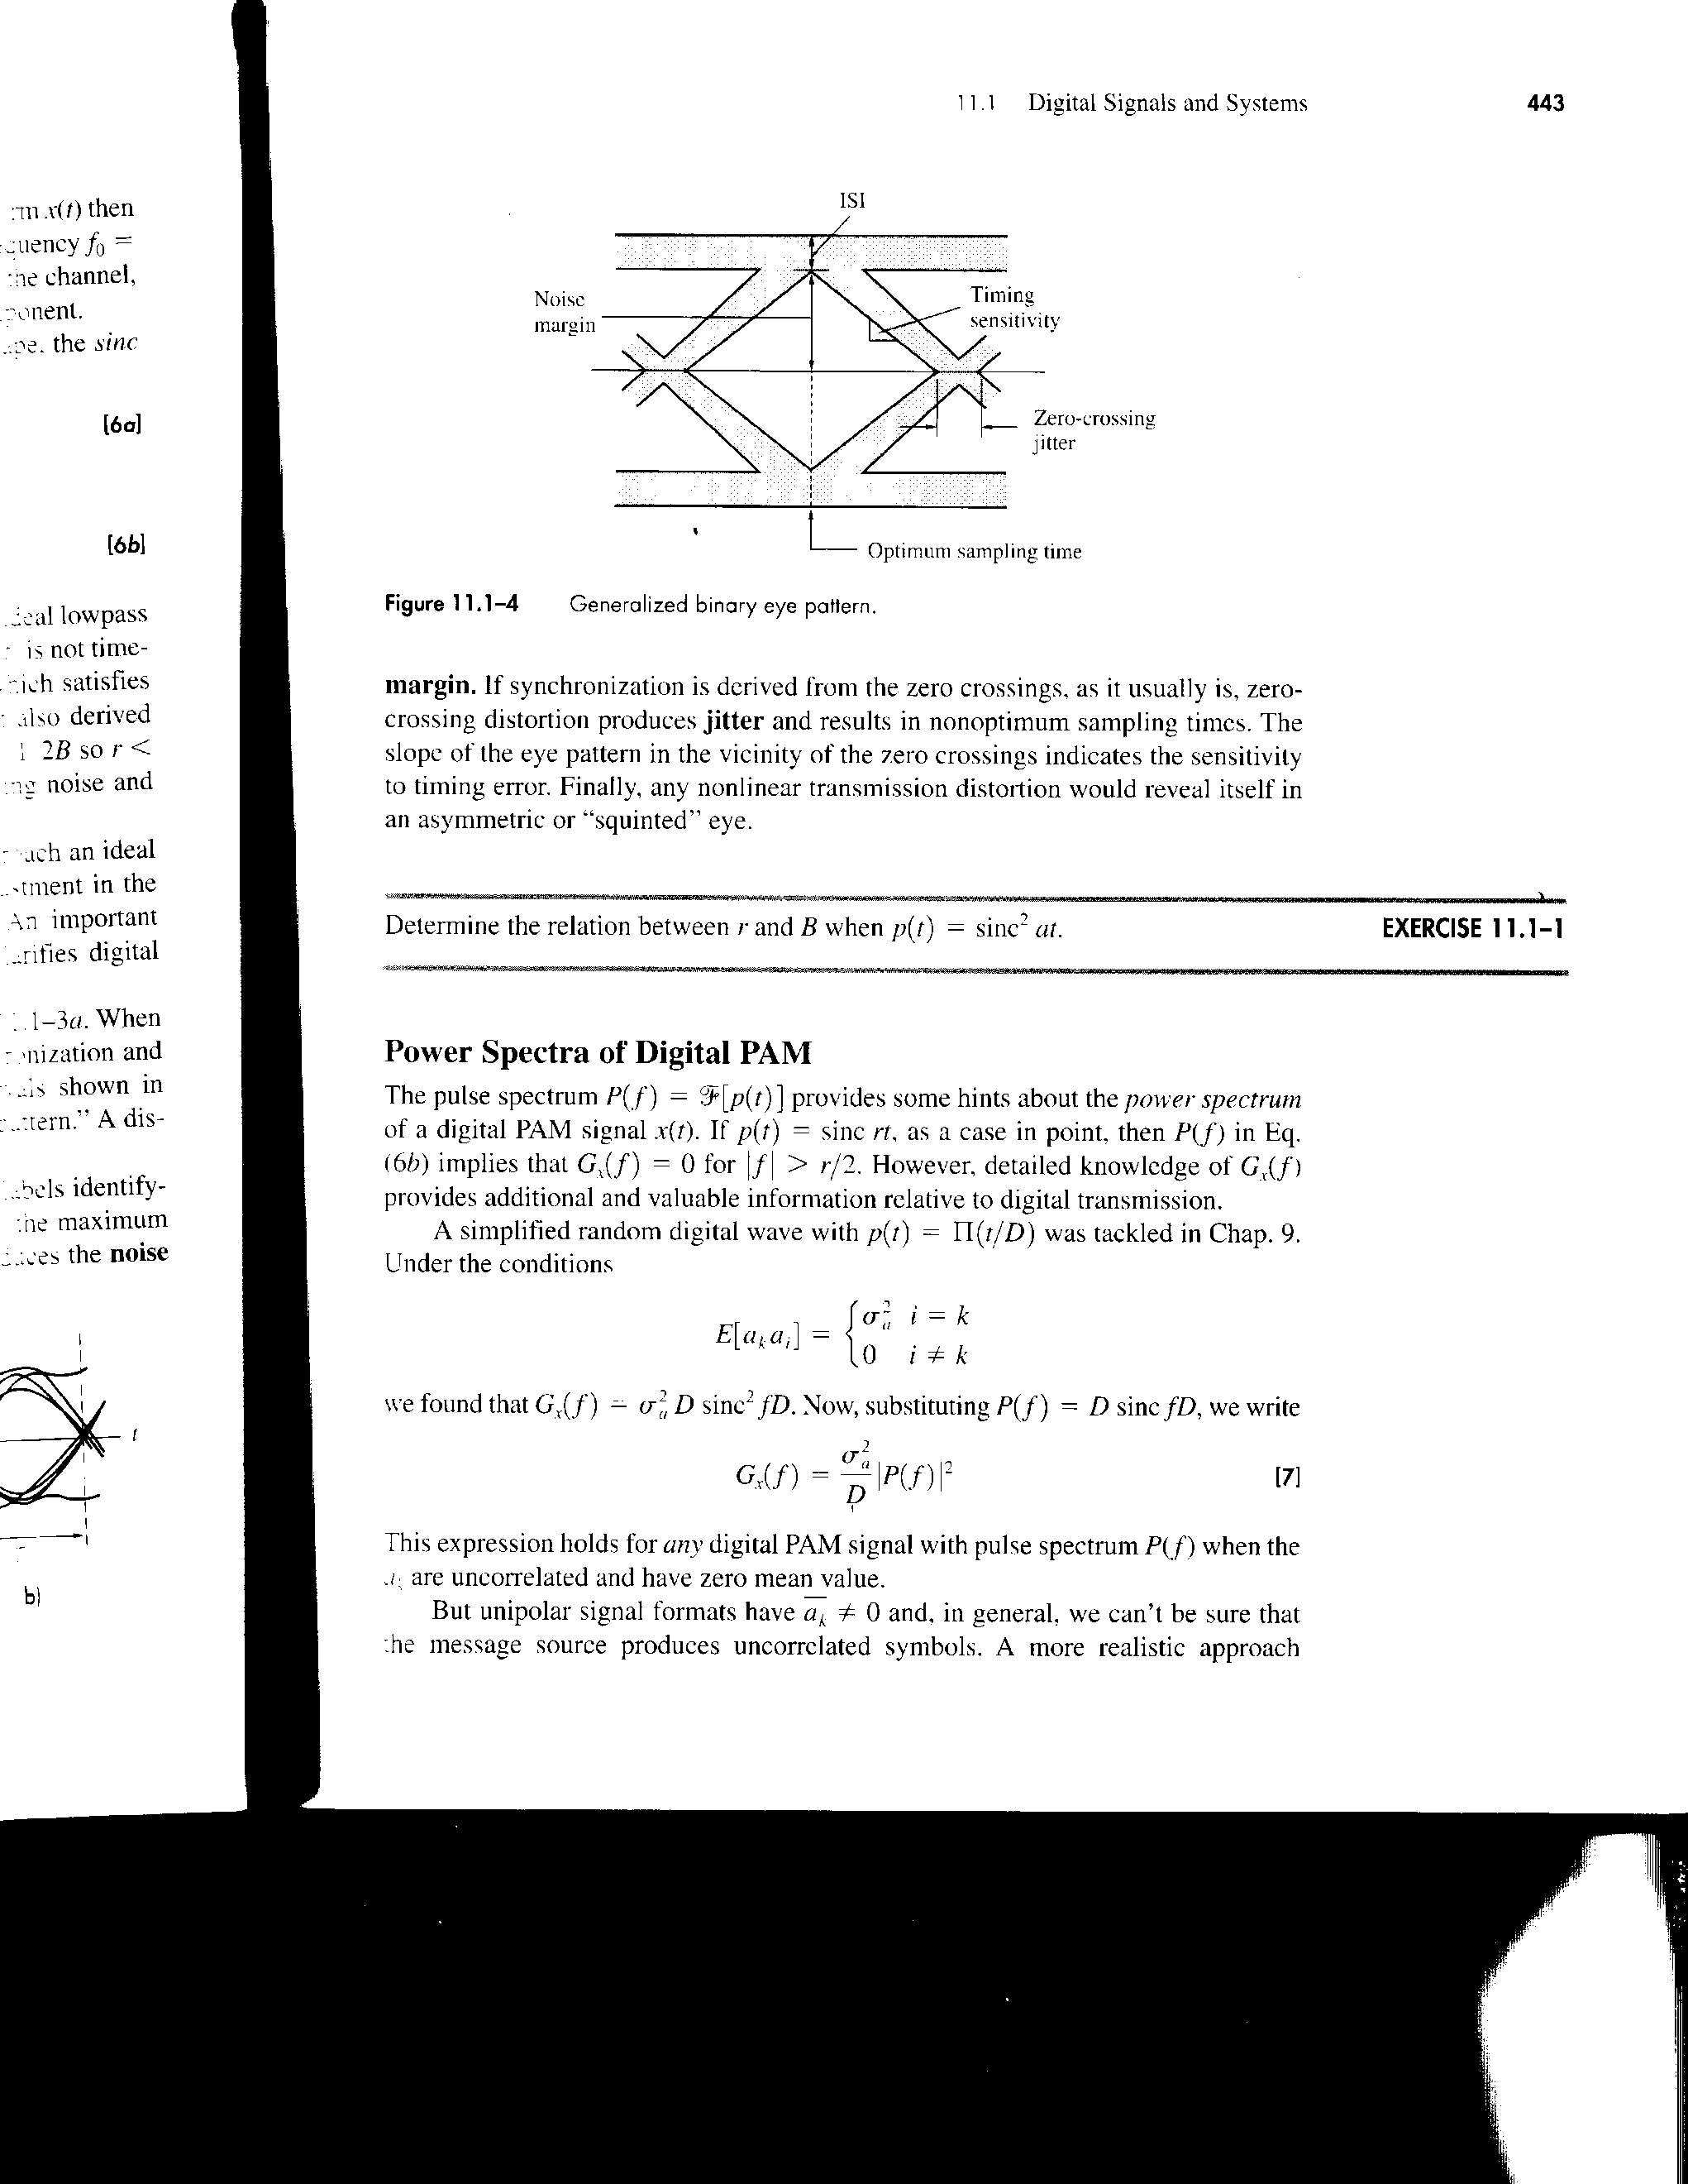

* **Attach your pre-lab questions**

**Eye Pattern with Noise**

Measured Signal and Noise:

* 1. Verify your settings with the instructor before you record the following:
     1. Vp-p and Vrms values of just the noise:

|  |  |  |
| --- | --- | --- |
|  | Vp-p | Vrms |
| Noise | 75 mV | 10.2 mV |

* + 1. Vpp and Vrms of just the signal:

|  |  |  |
| --- | --- | --- |
|  | Vp-p | Vrms |
| Signal | 96 mV | 30.9 mV |

* + 1. Calculate the signal to noise ratio in dB:

SNR = 9.7 dB

Eye Pattern plot:

* 1. Plot (or screen capture) and identify: the following for settings of part c)
     1. ISI (volts p-p) – 29.6 mV
     2. Noise Margin (volts) – 23.2 mV
     3. Timing sensitivity (volts/second) – 2960 V/s
     4. Zero-crossing Jitter (seconds) – 7.76 uV
     5. Optimum sampling time – 13.1 us

Volts

t

**Signal to noise estimate in Frequency Domain**

1. Observe the spectrum of the signal of part d) using the FFT.
   1. Record the 20 KHz signal RMS volts from the FFT:

28.4 mV

* 1. Record the Sample rate:

10 MS/s

* 1. Estimate the RMS noise density:

200 uV/RBW

* 1. Calculation for Vnoise rms:

11 mV

* 1. Estimated SNR (in dB) using a) and d):

8.23 dB

* 1. Compare 2e with part 1diii. Discuss any differences:

**Eye Pattern with Noise, SNR near threshold**

1. Now, adjust the SNR (signal to noise ratio) by changing the noise voltage so that an axis crossing at the optimum sample time is never observed but the noise is still abundantly obvious. The eye pattern will look “closed”.
   1. Calculate the new SNR as in part 1d) and show the instructor your results. (it should be approximately 10dB)

* + 1. Vp-p and Vrms values of just the noise:

12 mVrms

* + 1. Vpp and Vrms of just the signal:

28.2mVrms

* + 1. Calculate the signal to noise ratio in dB:

7.4 dB

* 1. How many dB did the SNR change from 1) to 3)?
  2. Look at figure 7-14 in the text and estimate what the BER would be for your S/N for a polar baseband digital signal. Note: Eb/No dB is equivalent to S/N dB