A system for managing a health fund.

Adding friends to the checkout, withdrawing them.

as well as updating and adding details regarding the corona virus, for each member of the health fund.

Client:angular Developed in visual studio code

Server:C# Developed in visual studio 2022

DB:Sql Developed in sql sever managment2019

Download sql server : <https://www.microsoft.com/en-us/sql-server/sql-server-downloads>

Download visual studio code 2022 : <https://visualstudio.microsoft.com/vs/whatsnew/>

Download visual studio code : <https://code.visualstudio.com/download>

Install Node.js: Vue.js requires Node.js, which includes the npm package manager. You can

download and install Node.js from the official website: <https://nodejs.org>

**Install Angular CLI**: Make sure you have Angular CLI (Command Line Interface) installed on your system. Open a terminal or command prompt and run the following command to install it globally: npm install -g @angular/cli

**Create a New Project**: Once Angular CLI is installed, you can create a new Angular project by running the following command: ng new my-angular-app

Install bootstrap on your angular project: npm install bootstrap

Demonstrations from the client:

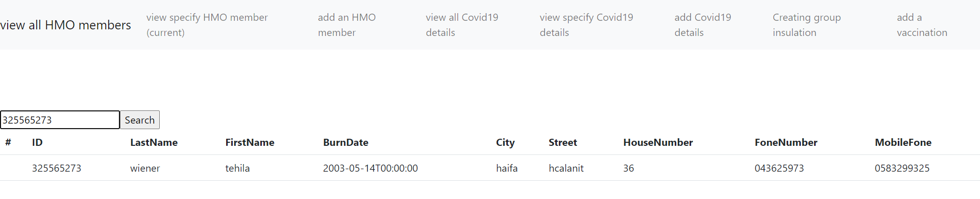

View specify HMO member

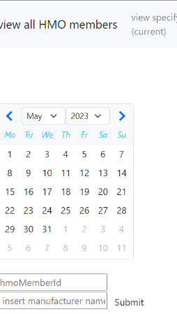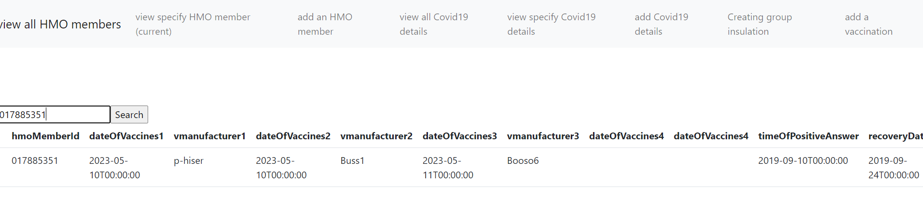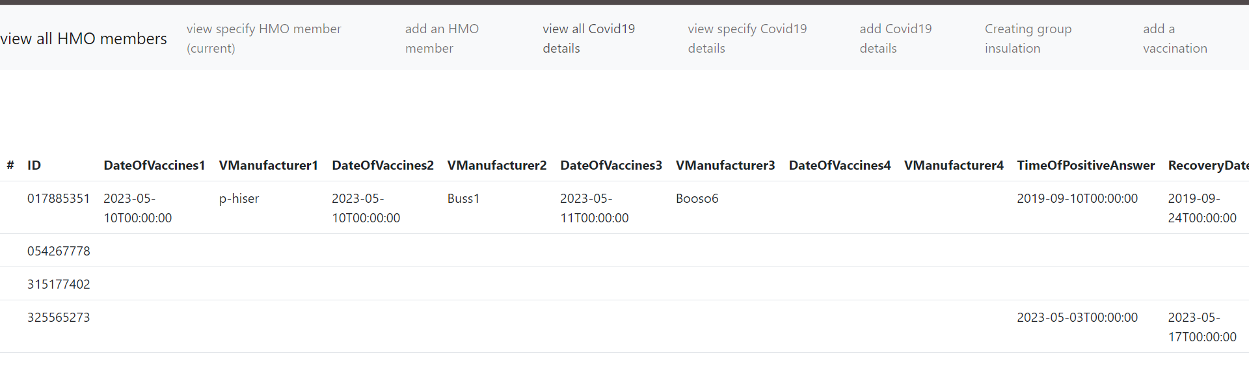view all corona details

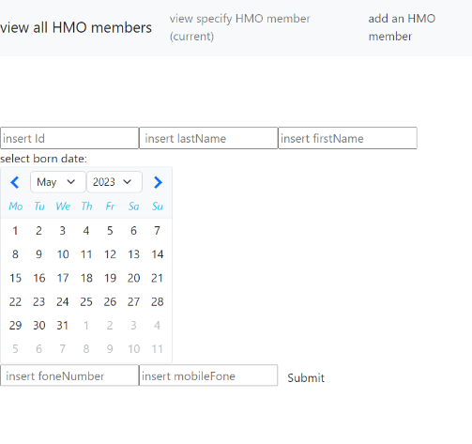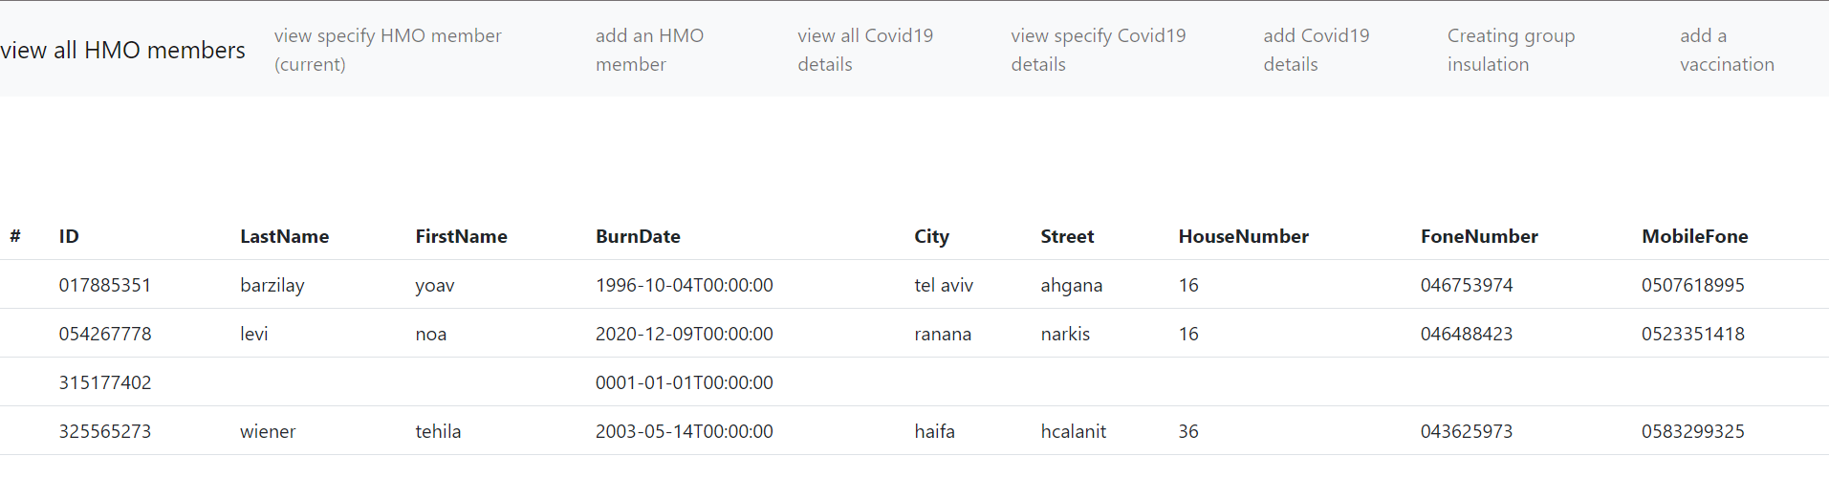

view corona details by ID

View all HMO members

Add an HMO member

Add a vaccination