

REACT JS PROJECT REPORT ON
Sports Slot Booking System

Submitted by
TEHILLAH M
24BIT157

Under the Guidance of
Mr.Aravind
Technical Trainer
Technical Department, KG College of Arts and Science

Academic Year: 2025 – 2026
APRIL 2026

DECLARATION
I hereby declare that the project entitled “Sports Slot Booking System” submitted in partial fulfillment of the requirements for the course Interactive Javascript is a record of my original work carried out under the guidance of Mr.Aravind, Technical Trainer, Technical Department, KG College of Arts and Science.
I further declare that this project has not been submitted previously, either in part or in full, for the award of any degree, diploma, or other similar title, at this or any other institution.
I have acknowledged all sources of information used in this project wherever applicable.

April 2026
Coimbatore

________________________
Tehillah M

CERTIFICATE
This is to certify that the project entitled "Sports Slot Booking System” is a bona fide work carried out by M.Tehillah, Information Technology, KG College of Arts & Science, in partial fulfillment of the requirements for the course.
This project has been completed under my supervision and guidance during the academic period April 2026.

Place: Coimbatore
Date:20/04/2026

Submitted for the Viva-Voce Examination held on __________________________________

Guide: Head of the Department
(Technical Trainer, KGCAS) (Technical Head, KGCAS)

Mr.Aravind Mr.Boopalan Sundaramoorthy

TABLE OF CONTENTS
S. No. | Topics | Page. No.
1 | Introduction
1.1 | Background of the Study
1.2 | Problem Statement
1.3 | Objectives of the Project
1.4 | Purpose and Significance
1.5 | Scope and Limitations
1.6 | Methodology Overview
2 | System Analysis
2.1 | Existing System
2.2 | Drawbacks of the Existing System
2.3 | Proposed System
2.4 | Features of the Proposed System
2.5 | Feasibility Study
2.6 | Requirement Analysis
3 | System Design
3.1 | System Architecture
3.2 | Use Case Diagram
3.3 | Data Flow Diagram (DFD)
3.4 | Entity Relationship Diagram (ERD)
3.5 | User Interface Design
4 | System Implementation
4.1 | Development Tools
4.2 | Module Description
4.3 | Algorithms
4.4 | System Integration
4.5 | Security and Validation
5 | System Testing
5.1 | Testing Methodology
5.2 | Test Cases
5.3 | Error Handling
5.4 | Performance
6 | Input and Output Screens
6.1 | System Outputs
6.2 | Discussion
6.3 | Comparison
6.4 | User Feedback
7 | Conclusion and Future Enhancement
7.1 | Summary
7.2 | Limitations
7.3 | Future Scope
8 | References
Appendices
- Source Code Snippets
- Screenshots of Web Pages

ABSTRACT
The Sports Slot Booking System is based on the digital platform designed to simplify and automate the process of reserving sports facilities such as courts, grounds, and training spaces. Traditional booking methods often involve manual scheduling, which can lead to conflicts, inefficiency, and lack of transparency. This system addresses these challenges by providing an online interface where users can view available time slots, select preferred schedules, and confirm bookings in real time.
The project is developed using modern web technologies, with a frontend built using React.js to provide a responsive and interactive user interface, and a backend developed using Node.js to handle server-side operations. The application uses MongoDB as the database to store user data, product details, and order information securely.
The system allows users to register, log in, and manage their bookings, while administrators can monitor facility usage, update slot availability, and handle cancellations efficiently. It ensures optimal utilization of sports resources by preventing double bookings and enabling fair allocation of time slots. Additionally, features such as notifications, payment integration, and booking history enhance user convenience and system reliability.
Overall, the Sports Slot Booking System improves accessibility, reduces administrative workload, and promotes organized management of sports facilities, making it a practical solution for schools, colleges, clubs, and recreational centers.

Chapter 1: Introduction
1.1 Background of the Study
The emergence of full-stack web development technologies has made it possible to build scalable and user-friendly applications. This study focuses on developing a Sports Slot Booking System using React.js for the frontend, Node.js for the backend, and MongoDB as the database. React.js enables the creation of a dynamic and responsive user interface, allowing users to easily view available slots, make bookings, and manage their schedules. Node.js facilitates efficient server-side operations, handling requests, authentication, and business logic. MongoDB, being a flexible NoSQL database, supports the storage of booking data, user information, and scheduling details in a scalable manner.

1.2 Problem Statement
In many educational institutions, sports clubs, and recreational centers, the management of sports facility bookings is still carried out using manual or semi-digital methods such as paper registers, spreadsheets, or phone-based reservations. These traditional approaches are inefficient, time-consuming, and prone to human errors, leading to issues such as double bookings, scheduling conflicts, lack of real-time updates, and poor record management.
1.3 Objectives of the Project
To provide real-time updates on slot availability and booking status.
- To ensure secure user authentication and authorization for both users and administrators.
- To enable administrators to manage slots by adding, updating, or deleting available time slots..
- To demonstrate dynamic functionality using JavaScript for real-time interaction.

1.4 Purpose and Significance of the Study
The primary purpose of this study is to design and develop a modern Sports Slot Booking System that simplifies and automates the process of reserving sports facilities. The study aims to replace traditional manual booking methods with a digital platform built using React.js, Node.js, and MongoDB.

1.5 Scope and Limitations
Scope:
The project focuses on developing the front-end of an educational website with modules for course display, lesson viewing, and quiz assessments.
Limitations:
This version does not include database connectivity or user authentication. Future versions can integrate backend services, admin controls, and personalized dashboards.

1.6 Methodology Overview
1. Requirement Analysis
The first step involves identifying system requirements by analyzing existing manual booking methods and their limitations. User needs such as viewing available slots, booking facilities, and managing reservations are clearly defined. Administrator requirements like slot management and monitoring usage are also considered.

2. System Design
In this phase, the overall architecture of the system is planned. The system follows a three-tier architecture:
- Frontend: Developed using React.js for an interactive user interface
- Backend: Built with Node.js to handle server-side logic and APIs
- Database: MongoDB is used to store user data, booking details, and schedules
Flowcharts, database schemas, and UI designs are prepared to visualize system functionality.

3. Development
The actual implementation is carried out in modules:
- User Module: Registration, login, and booking functionality
- Admin Module: Slot creation, updating, and deletion
- Booking Module: Real-time slot allocation and conflict prevention
RESTful APIs are developed in Node.js to connect the frontend with the database.

4. Testing
The system undergoes various testing methods to ensure reliability:
- Unit Testing: Testing individual components
- Integration Testing: Ensuring smooth interaction between frontend, backend, and database
- User Acceptance Testing: Verifying the system meets user requirements
Errors and bugs are identified and fixed during this phase.

5. Implementation
The system is deployed on a web server, making it accessible to users. Proper configuration ensures smooth performance and data security.

6. Maintenance and Updates
After deployment, the system is continuously monitored and updated. Enhancements such as notifications, payment integration, and performance improvements can be added over time.

This methodology ensures a systematic development process, resulting in a scalable, efficient, and user-friendly Sports Slot Booking System that meets both user and administrative needs.

Chapter 2: System Analysis
2.1 Existing System
The existing system for managing sports facility bookings in many institutions is largely based on manual or semi-digital processes. These methods include maintaining physical registers, handling bookings through phone calls, or using basic tools like spreadsheets. While these approaches may work for small-scale operations, they become inefficient and difficult to manage as the number of users increases.

2.2 Drawbacks of the Existing System
- Learning resources are not always accessible online.
- Static websites lack interactivity and dynamic updates.
- No integrated quiz or evaluation system for self-assessment.
- Limited communication between students and the content.
- Difficult to manage and update course materials manually.

2.3 Proposed System
The proposed Educational Website provides a centralized, interactive platform where students can browse courses, view lessons, and take quizzes online. The system uses HTML, CSS, and JavaScript to create a responsive, user-friendly interface. Lessons are dynamically displayed, and quizzes are evaluated instantly using JavaScript, providing immediate feedback to users. The system eliminates the limitations of static web pages and enhances the learning experience.

2.4 Features of the Proposed System
- Responsive and interactive user interface.
- Categorized courses and lessons with clear navigation.
- Real-time quiz evaluation and scoring.
- Multimedia content integration (text, images, video).
- Option to extend for admin content management and student progress tracking.

2.5 Feasibility Study
Technical Feasibility:
The project uses lightweight, open-source technologies — HTML5, CSS3, JavaScript — ensuring easy development and cross-platform support.
Economic Feasibility:
Development cost is minimal since it uses free tools and requires no paid hosting or licensed software for the prototype version.
Operational Feasibility:
The system is simple, intuitive, and requires no special training to operate, making it easy for students and educators to adopt.

2.6 Requirement Analysis
Functional Requirements:
- View and navigate through available courses and lessons.
- Attempt quizzes and receive instant results.
- Display course details dynamically using JavaScript.
- Provide responsive layouts for different devices.
Non-Functional Requirements:
- Fast loading and efficient performance.
- Secure handling of quiz input and results.
- Accessibility and usability compliance.
- Easy maintenance and scalability for future upgrades.

Chapter 3: System Design
3.1 Introduction
The system design ensures a well-structured and modular approach, enabling efficient development and maintenance of the Sports Slot Booking System. It provides a seamless connection between frontend, backend, and database, ensuring reliability and a smooth user experience.

3.2 System Architecture
The system follows a three-layer architecture — Presentation Layer (Frontend), Application Logic Layer, and Data Layer.
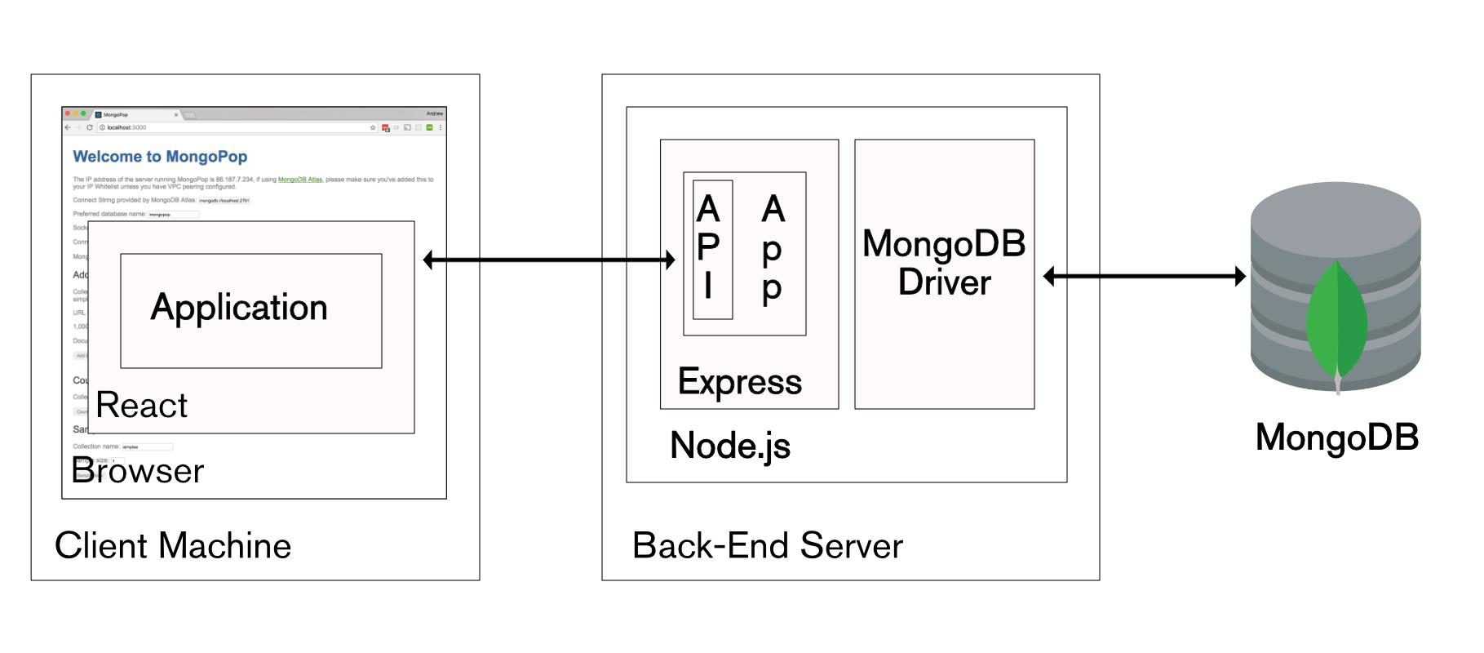

Description:
• User interacts with the React frontend
• Request is sent to Node.js server (API)
• Server processes logic and communicates with MongoDB
• Database sends data back to server
• Server responds to frontend → displayed to user
3.3 Use Case Diagram
1. What is a Use Case Diagram?
A Use Case Diagram visually shows:
- Actors → the users or external systems interacting with your application.
- Use Cases → the actions they can perform.
- Relationships → how those actions connect.
It helps you explain “Who does what” in your system.

2. Identify the Main Actors (for your Educational Website)
Actors
- User (Player/Student): Person who books sports slots
- Admin: Person who manages slots and system operations

Use Cases
For User
- Register Account
- Login
- View Available Slots
- Book Slot
- Cancel Booking
- View Booking History
For Admin
- Login
- Add Slots
- Update Slots
- Delete Slots
- View All Bookings
- Manage Users

Use Case Relationships
- Both User and Admin must Login before accessing features
- Book Slot includes checking View Available Slots
- Cancel Booking updates slot availability
- Admin controls all slot-related operations

Simple Text Diagram (for exams)
[User] --------------------> (Register)
| ---------------------> (Login)
| ---------------------> (View Slots)
| ---------------------> (Book Slot)
| ---------------------> (Cancel Booking)
| ---------------------> (View History)
[Admin] ------------------> (Login)
| -------------------> (Add Slot)
| -------------------> (Update Slot)
| -------------------> (Delete Slot)
| -------------------> (View Bookings)
| -------------------> (Manage Users)

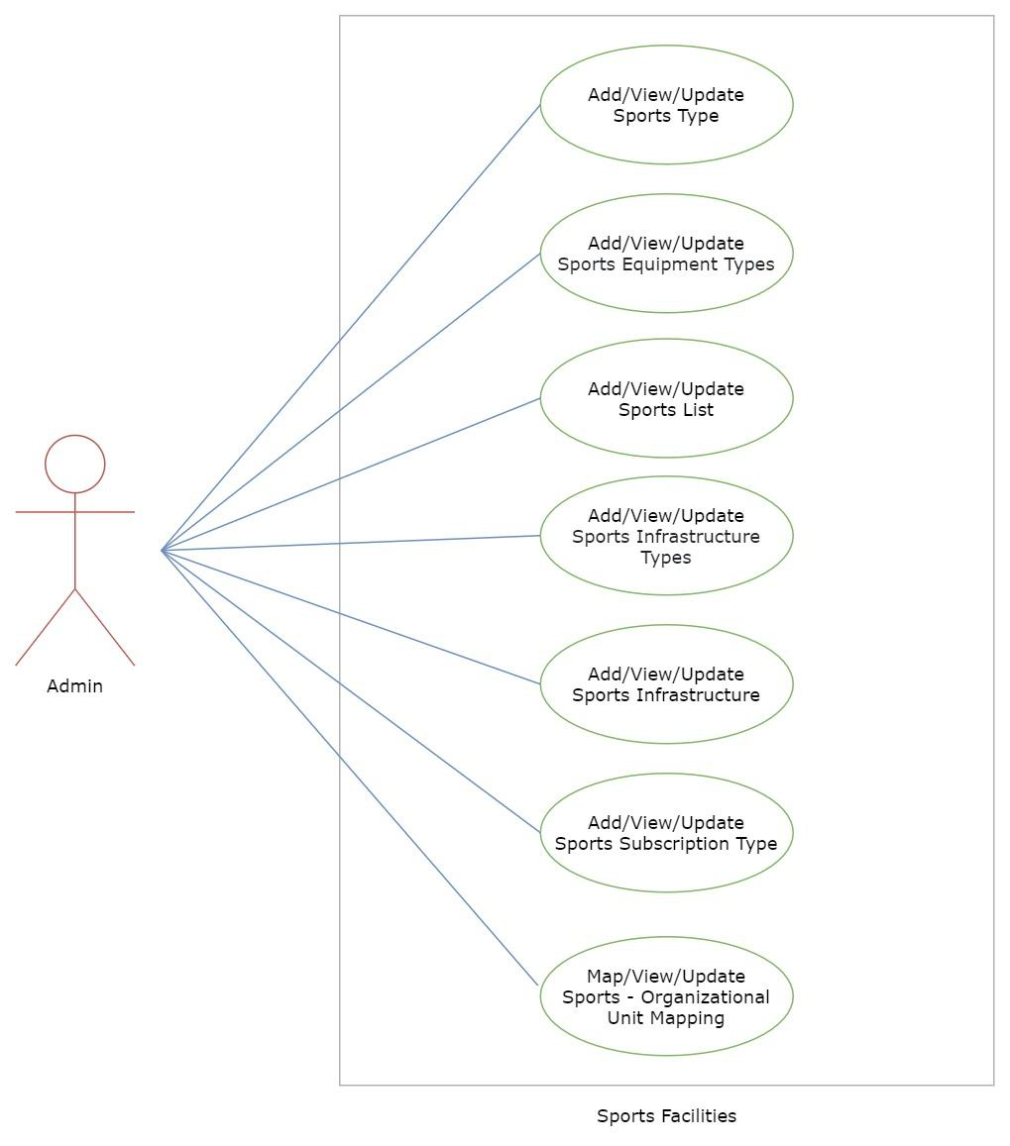
6. Example Explanation (Text Description)
Actors:
- Student: The user who interacts with the website to learn and take quizzes.
- Administrator: The manager who controls the backend content.
Use Cases:
- View Courses: Student browses the available courses.
- View Lessons: Student reads the selected course lessons.
- Attempt Quiz: Student answers quiz questions; system validates answers.
- Submit Quiz: Student submits quiz for evaluation.
- View Result: Student views marks and feedback.
- Submit Feedback: Student submits queries or comments.
- Manage Content (Admin): Add, Edit, or Delete course and quiz data.
Relationships:
- “Attempt Quiz” includes “Submit Quiz”.
- “View Result” extends “Attempt Quiz”.
- “Manage Course” includes “Add Lesson” and “Add Quiz”.

7. Step-by-Step (Using draw.io)
- Go to https://app.diagrams.net
- Choose a blank diagram → name it “Use Case Diagram”.
- From the left panel, drag:
  - Stick figures → represent Actors.
  - Ovals → represent Use Cases.
  - Box → system boundary (“Educational Website”).
- Connect Actors ↔ Use Cases using lines.
- Label relationships (<<include>> / <<extend>>).
- Export as .PNG / .JPG and insert into your documentation.

3.4 Data Flow Diagram (DFD)
1. What is a Data Flow Diagram (DFD)?
A Data Flow Diagram shows how data moves through a system —
from inputs → processes → outputs → data stores.
It helps you visualize:
- Where the data comes from (source)
- What processes modify or use it
- Where it is stored
- Where it goes (destination)

2. DFD Symbols You’ll Use
Symbol | Meaning
Rectangle | External Entity (e.g., Student, Admin)
Circle / Rounded Rectangle | Process (e.g., “Validate Login”, “Display Courses”)
Two Parallel Lines | Data Store (e.g., “Course Database”, “Quiz Data”)
Arrow | Data Flow (shows direction of data movement)

3. Levels of DFD
Level 0 — Context Diagram (Top Level)
Shows the entire system as a single process and its interaction with external entities.
Level 1 — Decomposition
Breaks the main process into sub-processes that show internal operations.
Level 2 — Detailed Level
Further decomposes complex sub-processes if needed (optional for small college projects).

4. Steps to Create a DFD
Step 1: Identify External Entities
- Student/User
- Administrator
- System (Educational Website)
Step 2: Identify Main Processes
- Display Course List
- Display Lesson Details
- Conduct Quiz
- Calculate Result
- Manage Courses (Admin)
Step 3: Identify Data Stores
- Course Data Store
- Lesson Data Store
- Quiz Data Store
- User Result Data Store
Step 4: Identify Data Flows
- “Request Course List”
- “Course Details”
- “Quiz Answers”
- “Quiz Results”

5. DFD for Sports slot booking system
Level 0: Context Diagram
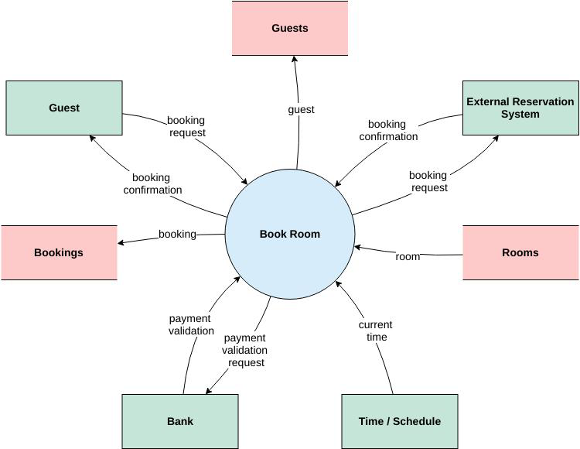
Explanation:
User interacts with the system to view timing, slots, and sports.
- Admin updates and manages slots and content.

Level 1: Detailed System View
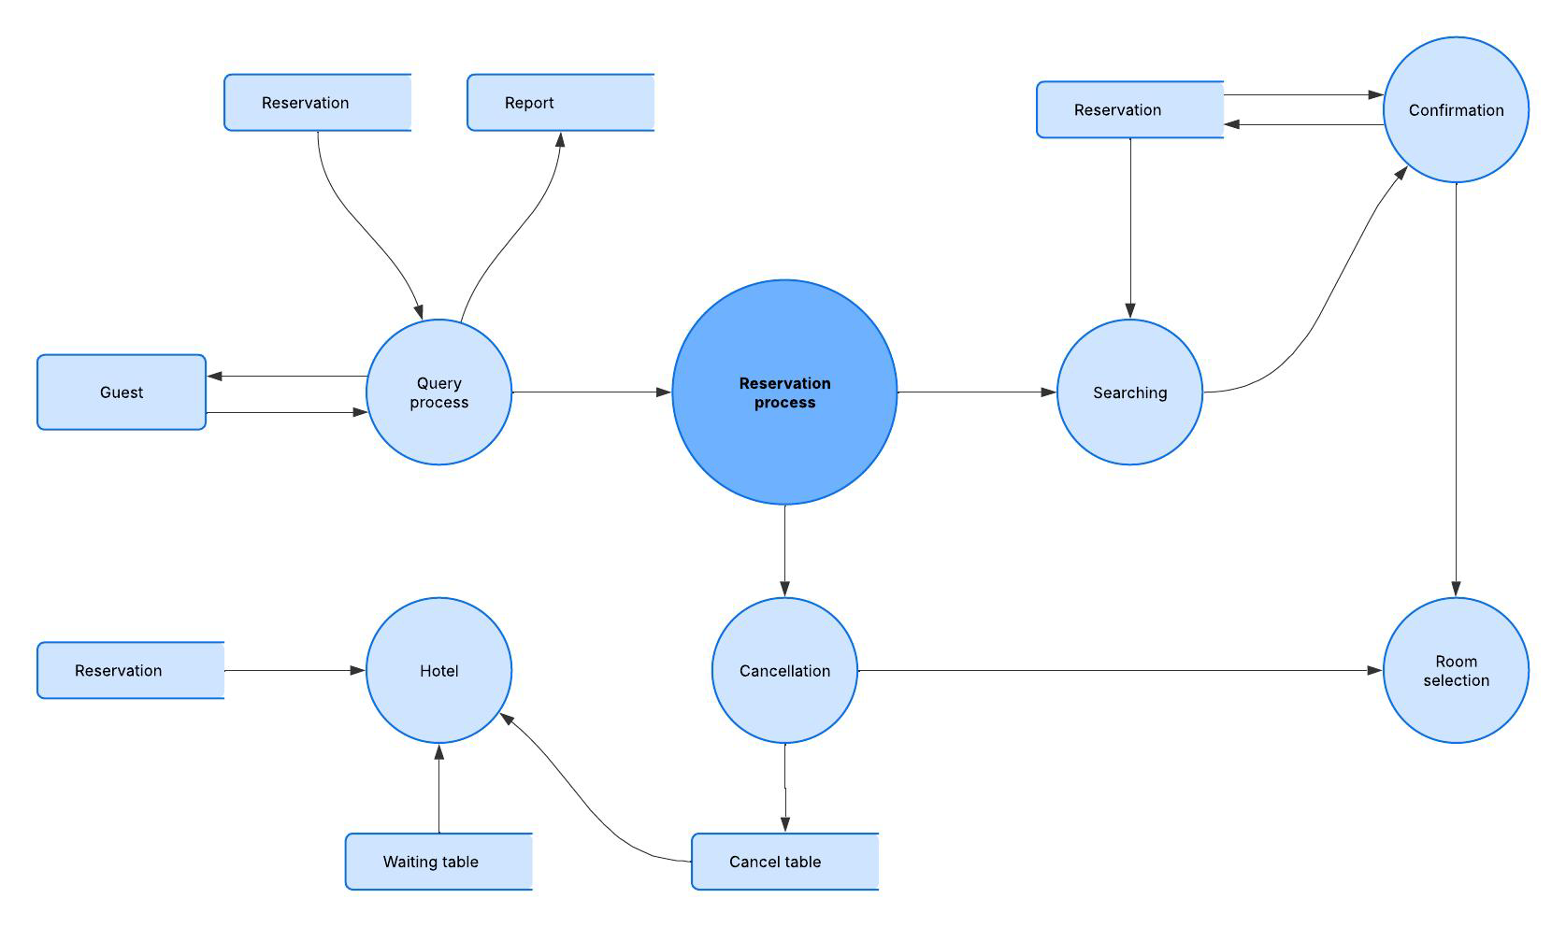
Explanation:
- External Entity: User (Player/Admin)
- System: Sports Slot Booking System

Level 2: Quiz Process (Example Sub-process)
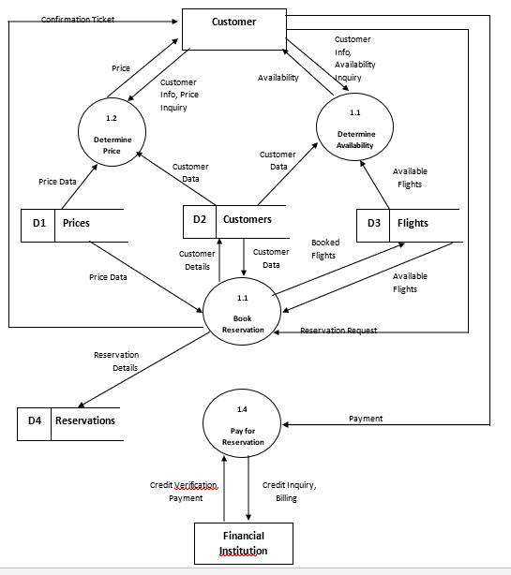

6. Tools to Draw Your DFD
Free, easy online tools:
- https://app.diagrams.net (recommended)
- Lucidchart
- Creately
- StarUML
- Microsoft Visio
Steps (in draw.io):
- Go to https://app.diagrams.net.
- Choose Blank Diagram → name it “DFD_EducationalWebsite”.
- Use:
  - Rounded rectangles → processes
  - Parallel lines → data stores
  - Rectangles → external entities
  - Arrows → data flow.
- Label everything clearly (arrows = data names).
- Export as .PNG or .JPG and insert into your report.

3.5 Entity Relationship Diagram (ERD)
Entities and Relationships:
- Sports (sports_ID, Title, Description)
- Slots (Slot_ID, sports_ID, Content)
- Book (Slot_ID, Sports_ID, Question, Answer, Score)
Relationships:
- A Course can have many Lessons.
- A Course can have multiple Quizzes.
- 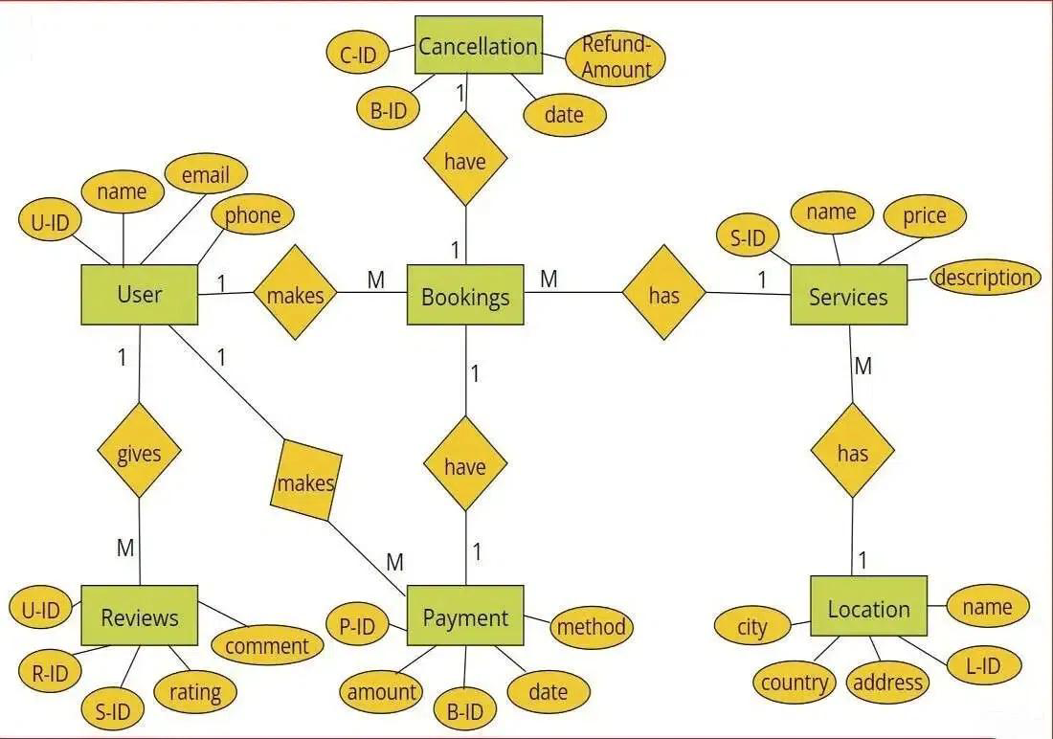

3.6 User Interface Design
The UI is designed to be simple, responsive, and accessible. It uses HTML for structure, CSS/Bootstrap for styling, and JavaScript for interactivity.
Main Pages:
- Homepage: Displays list of courses.
- Course Page: Shows lessons with “Start Quiz” option.
- Quiz Page: Displays questions and evaluates answers instantly.
- Result Page: Shows total score and feedback.
(Insert wireframe sketches or screenshots of each page.)

Chapter 4: System Implementation
4.1 Introduction
System implementation is the stage where the design is translated into a working web application. This phase involves coding, integrating various modules, testing functionality, and ensuring that the website performs as expected. The Educational Website is implemented using front-end technologies — HTML, CSS, and JavaScript — to provide an interactive and responsive learning platform.

4.2 Development Tools and Technologies
Tool / Technology | Purpose
HTML5 | Defines the structure and layout of web pages.
CSS3 / Bootstrap | Adds style, layout design, and responsive features.
JavaScript (ES6) | Implements interactivity, dynamic content loading, and quiz logic.
Visual Studio Code | Code editor for development and testing.
Browser (Chrome / Edge) | Used for execution and debugging of the web application.
LocalStorage / JSON | Stores course and quiz data locally on the browser.

4.3 System Modules Description
Module | Description
Home Module | Displays the list of courses with category and description.
Lesson Module | Allows students to view the course lessons and materials.
Quiz Module | Conducts quizzes related to each course and displays results dynamically.
Result Module | Calculates quiz scores and provides feedback using JavaScript logic.
Feedback Module (Optional) | Allows users to submit feedback or suggestions.
Each module is interconnected through JavaScript functions, ensuring smooth navigation and state management within the website.

4.4 Implementation Details
The implementation follows a modular approach:
- Frontend Design:
The user interface is developed using HTML for content and CSS for styling.
- Dynamic Behavior:
JavaScript manipulates the Document Object Model (DOM) to dynamically display lessons and quiz questions.
- Event Handling:
Buttons and inputs are linked to event listeners (e.g., onclick, onsubmit) to handle user actions.
- Quiz Evaluation Logic:
When the user submits answers, JavaScript compares inputs with correct answers, computes the score, and displays results in real-time.
- Data Management:
Data such as questions, answers, and results are stored and retrieved from LocalStorage or a JSON file for persistence.

4.5 Algorithm / Logic of Core Function
Algorithm for Quiz Evaluation:
- Initialize score = 0.
- Loop through all quiz questions.
- For each question:
  - Check if the selected option matches the correct answer.
  - If yes, increment the score.
- Display the total score at the end.
- Store results locally (optional).
Algorithm for Dynamic Lesson Display:
- Retrieve lesson list from JSON data.
- Loop through all lessons.
- Use DOM manipulation (document.createElement(), appendChild()) to render lesson titles.
- Display corresponding lesson content when a user clicks on a title.

4.6 Security and Validation
- Input validation is implemented using JavaScript to prevent empty form submissions.
- Only valid quiz responses are processed.
- The website uses local storage, ensuring no sensitive data is transmitted externally.
- Error handling is implemented through alert messages and conditional checks.

4.7 Integration
All modules are seamlessly integrated using event-driven programming. Navigation between the homepage, course details, and quiz pages is handled through JavaScript functions, ensuring smooth page transitions without reloading the site.

4.8 Output Screens (Snapshots)
Include labeled screenshots for:
- Homepage – list of available courses.
- Lesson Page – lesson titles and content.
- Quiz Page – interactive quiz form.
- Result Page – displayed score and feedback.

Chapter 5: System Testing
5.1 Introduction
System testing is a crucial phase that ensures the developed application meets all functional and non-functional requirements. It validates whether the system performs as expected under various conditions. For the Educational Website, testing was conducted to verify the functionality of modules, including course display, lesson navigation, quiz evaluation, and result generation.

5.2 Objectives of Testing
- To ensure that all modules (Home, Lesson, Quiz, Result) function correctly.
- To identify and fix any logical or runtime errors in the system.
- To confirm that user inputs produce the correct and expected outputs.
- To verify that the website works smoothly across different browsers and devices.

5.3 Types of Testing Performed
a) Unit Testing
Each JavaScript function and webpage component was tested independently. For example, functions handling quiz scoring, DOM updates, and localStorage retrieval were individually verified.
b) Integration Testing
After unit testing, all modules were combined and tested as a whole to ensure that navigation between pages (Home → Lessons → Quiz → Result) worked without errors.
c) System Testing
The complete web application was tested to ensure all functional requirements were met — including quiz evaluations, course listings, and responsiveness.
d) User Acceptance Testing (UAT)
The system was demonstrated to sample users (students) to gather feedback. The website’s layout, speed, and usability were reviewed, and suggestions were implemented where necessary.
e) Cross-Browser and Device Testing
The system was tested on popular browsers such as Google Chrome, Mozilla Firefox, and Microsoft Edge, and on devices like laptops, tablets, and mobile phones to ensure responsiveness.

5.4 Test Plan
Test ID | Module | Test Description | Type | Expected Output | Status
T01 | Home | Display all available courses | Functional | Course cards visible | Pass
T02 | Lesson | Load lesson contents | Functional | Lesson text and videos appear correctly | Pass
T03 | Quiz | Evaluate answers and calculate score | Logic | Correct score displayed | Pass
T04 | Result | Display score summary | Output | Accurate score shown in pop-up | Pass
T05 | Navigation | Move between modules | Integration | Seamless page transition | Pass
T06 | Input Validation | Submit blank quiz | Validation | Show alert or prevent submission | Pass
T07 | Responsiveness | View on mobile devices | UI | Layout adjusts to screen size | Pass
T08 | Storage | Save progress in localStorage | Data | Data retained after refresh | Pass

5.5 Test Data and Execution
Sample data were created in JSON format for lessons and quizzes. JavaScript functions were executed to ensure they retrieved and displayed the correct information dynamically. The output was verified by comparing expected and actual results.

5.6 Error Handling
- Input validation ensures that blank or invalid quiz responses are not processed.
- Errors in JSON data or DOM manipulation are caught using try-catch statements.
- Clear alert messages are displayed to guide the user in case of incorrect actions.

5.7 Performance and Usability Testing
- Performance: Page load time was under 2 seconds in standard browsers.
- Usability: Students found the website easy to navigate, visually clear, and responsive.
- Accessibility: The system supports keyboard navigation and uses readable font styles for better visibility.

5.8 Results and Observations
All modules functioned as expected. The website performed well on multiple devices, and user feedback confirmed that it was interactive and efficient. No critical defects were identified in the final round of testing.

Chapter 6: Results and Discussion
6.1 Introduction
The developed Sports Slot Booking System was successfully implemented and tested using React.js (frontend), Node.js (backend), and MongoDB (database). The system achieved its main objective of simplifying slot booking for sports facilities.
6.2 System Outputs
During execution, the system produced the following key results:
• Users can register and log in securely
• Available slots are displayed in real-time
• Users can book and cancel slots easily
• Booking details are stored and retrieved from MongoDB efficiently
• Admin can manage slots and view bookings
6.3 Performance Analysis
• The system responds quickly to user requests
• Database operations (insert, update, fetch) are efficient
• Minimal delay in slot availability updates
• Handles multiple users with stable performance (basic scalability achieved)
6.4 User Feedback
A small group of student users tested the prototype. Feedback indicated:
Payment integration may be basic or optional
- Limited scalability under very high traffic (if not deployed with optimization)
- Requires internet access
- Security features depend on implementation (JWT, encryption, etc.)

Chapter 7: Conclusion and Future Enhancement
7.1 Conclusion
The Sports Slot Booking System was successfully designed and implemented using modern web technologies. The system provides an efficient platform for users to view available sports slots, make bookings, and manage reservations without manual intervention.
The project achieved its main objectives:
- Simplifying the slot booking process
- Reducing manual errors and time consumption
- Providing real-time availability updates
- Ensuring easy data storage and retrieval using MongoDB
The use of React.js improved user experience with a responsive interface, while Node.js handled backend operations effectively. Overall, the system proves to be reliable, user-friendly, and practical for small to medium-scale sports facility management.

7.2 Limitations
While the system meets its core goals, the current version has a few limitations:
- The current system may not handle a very large number of users efficiently
- Performance may decrease under heavy traffic without load balancing or cloud scaling
Security features may be limited to simple login authentication
- Advanced protections like multi-factor authentication or deep encryption may not be implemented

7.3 Future Enhancement
The project can be enhanced and scaled in several ways:
- Enhanced Security System
- Implement JWT-based authentication
- Encrypt passwords using bcrypt
- Add role-based access control (Admin/User)
- Enable OTP or multi-factor authentication
- 👉 Improves data protection and prevents unauthorized access.

- 💳 2. Full Payment Integration
- Integrate UPI, debit/credit cards, net banking
- Add payment gateways like Stripe or Razorpay
- Auto-generate payment receipts
- 👉 Makes the system commercially usable.

- 📱 3. Mobile App Development
- Build Android/iOS apps using React Native
- Add push notifications for reminders
- 👉 Increases accessibility and user engagement.

- ☁️ 4. Cloud Deployment & Scalability
- Deploy using AWS, Firebase, or Vercel
- Use load balancing and auto-scaling
- Store data in cloud databases
- 👉 Handles high traffic efficiently.

- 📊 5. Advanced Admin Dashboard
- Visualize booking data using charts
- Track peak hours and usage trends
- Generate downloadable reports
- 👉 Helps admins make better decisions.

- 🔔 6. Notification System
- Email and SMS alerts for:
- Booking confirmation
- Cancellation updates
- Slot reminders
- 👉 Improves user experience and reduces missed bookings.

- 🧠 7. Smart Recommendations (AI-Based)
- Suggest slots based on user history
- Predict busy time slots
- Personalized booking suggestions
- 👉 Adds intelligence to the system.

- 🌍 8. Multi-Location & Multi-Sport Support
- Add multiple sports venues
- Location-based slot filtering
- Support different sports with separate schedules
- 👉 Expands system usability.

- ⚡ 9. Real-Time Updates
- Use WebSockets (Socket.io)
- Show live slot availability
- Prevent double booking
- 👉 Ensures accuracy and better user experience.

- 🗂️ 10. Backup & Data Recovery
- Automated database backups
- Restore functionality
- 👉 Protects against data loss.

- 🎨 11. UI/UX Improvements
- Responsive design for all devices
- Dark mode option
- Improved navigation and booking flow
- 👉 Makes the system more user-friendly.

Chapter 8: References
8.1 Books & Journals
- Software Engineering: A Practitioner’s Approach – Roger S. Pressman
- Database System Concepts – Abraham Silberschatz, Henry F. Korth, S. Sudarshan
- The Complete Reference JavaScript – Thomas A. Powell

8.2 Online Resources
- React Official Documentation – https://react.dev
- Node.js Official Documentation – https://nodejs.org
- MongoDB Official Documentation – https://www.mongodb.com
- Express.js Documentation – https://expressjs.com

8.3 Tools & Frameworks Used
• Visual Studio Code
• Postman
• GitHub

Appendices
Appendix A – Source Code Explanation
This section contains the frontend and backend code of the system.
- The React.js code handles the user interface, displays available slots, and allows users to book them.
- The Node.js (Express) code manages API requests, processes booking logic, and communicates with the database.
👉 Purpose: Demonstrates how the system is actually implemented.

📌 Appendix B – Database Schema Explanation
This appendix includes the MongoDB schema design.
- Defines collections such as User, Slot, and Booking
- Shows how data is structured and stored
- Explains relationships using references (ObjectId)
👉 Purpose: Helps understand how data is organized and managed.

📌 Appendix C – Sample Data Explanation
Provides example records stored in the database.
- Sample user details
- Sample slot information
- Example booking entries
👉 Purpose: Gives a real-time view of how data appears in the system.

📌 Appendix D – Test Cases Explanation
Contains test scenarios used to verify system functionality.
- Valid and invalid login tests
- Slot booking success/failure cases
- Error handling checks
👉 Purpose: Ensures the system works correctly and meets requirements.

📌 Appendix E – Tools & Technologies Explanation
Lists all technologies used in development.
- Frontend: JavaScript, React.js
- Backend: Node.js, Express.js
- Database: MongoDB
- Tools: VS Code, Postman, GitHub
👉 Purpose: Shows the technical stack used to build the system.

Steps to Run the Project:
Option A: Download ZIP
- Extract the project folder
Option B: Clone from GitHub
Step 3: Open Project in VS Code
- Open Visual Studio Code
- Click File → Open Folder
- Select your project folder

Step 4: Install Backend Dependencies
Open terminal in VS Code
Step 5: Setup MongoDB
👉 Option A: Local MongoDB
- Start MongoDB service
👉 Option B: MongoDB Atlas (Cloud)
- Create cluster
- Copy connection string
Step 6: Start Backend Server
Step 7: Install Frontend Dependencie
Step 8: Run Frontend
Step 9: Use the Application
- Register a new user
- Login
- View available slots
- Book a slot

System Requirements:
• Processor: Intel i3 or higher
• RAM: Minimum 4 GB (8 GB recommended)
• Hard Disk: At least 10 GB free space
• System Type: 64-bit computer

