**NamesAndRoles LTI Service**

**Contents**

**Bright Space** 2

**IMS Global** 5

**Moodle** 6

# **Bright Space**

Link**:**[**https://community.d2l.com/brightspace/kb/articles/23756-names-and-roles-extension-with-lti-1-3**](https://community.d2l.com/brightspace/kb/articles/23756-names-and-roles-extension-with-lti-1-3)

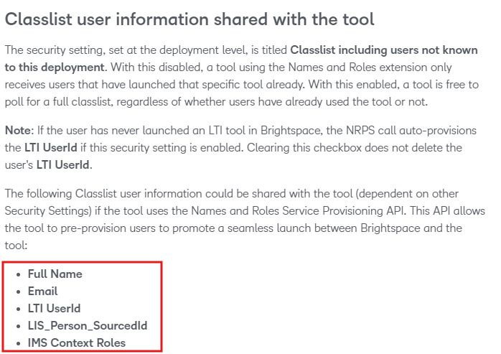

|  |
| --- |
| **Sample LTIK JWT object** |
|  |
| **Sample NamesAndRoles JSON object** | |
| {  "id":"https://testconestoga.desire2learn.com/d2l/api/lti/nrps/2.0/deployment/178ce421-9978-4fb4-8deb-b24f11f79e84/orgunit/418015/memberships",  "context":{"id":"418015","label":"custom_shell_477263_7453616_20F","title":"VARLAB-DEV1"},  "members":  [  {"user_id":"00129057-29b4-4bab-8470-67eaddc8042e_212555","status":"Active","name":"Jindo Kim","given_name":"Jindo","family_name":"Kim","email":"jkim8918@conestogac.on.ca","roles":["http://purl.imsglobal.org/vocab/lis/v2/membership#Instructor"]},{"user_id":"b52d9241-e75c-45bb-8578-31038b18d7df_211764","status":"Active","name":"Jonathan Bezeau","given_name":"Jonathan","family_name":"Bezeau","email":"jbezeau@conestogac.on.ca","roles":["http://purl.imsglobal.org/vocab/lis/v2/membership#Instructor"]},  {"user_id":"7b0bb820-04c7-4294-bcdc-6051e94b42f5_201710","status":"Active","name":"Chris Park","given_name":"Chris","family_name":"Park","email":"hpark7884@conestogac.on.ca","roles":["http://purl.imsglobal.org/vocab/lis/v2/membership#Instructor"]},  {"user_id":"3c603911-f88c-4d67-8c18-5abff357270d_182753","status":"Active","name":"Dany Ko","given_name":"Dany","family_name":"Ko","email":"dko8957@conestogac.on.ca","roles":["http://purl.imsglobal.org/vocab/lis/v2/membership#Instructor"]}  ]  } | |
|  | |

# **IMS Global**

**Sample Metadata**

Link:   
<https://www.imsglobal.org/spec/lti-nrps/v2p0>

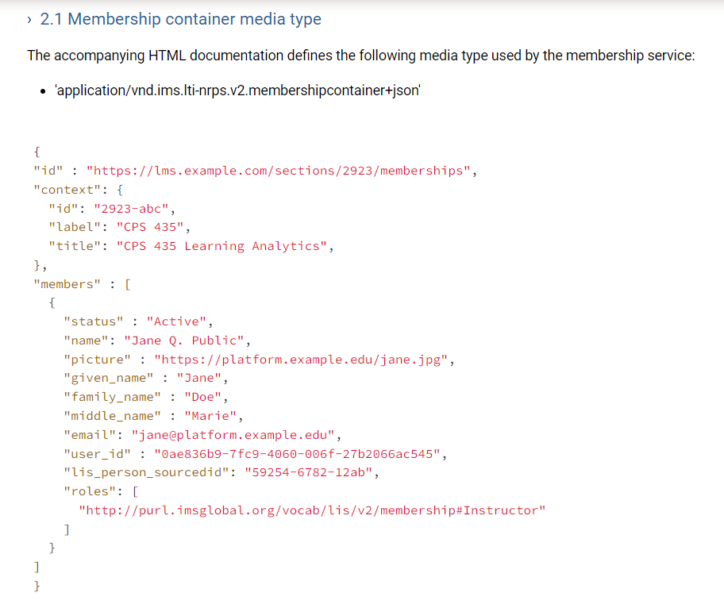

# **Moodle**

|  |
| --- |
| **Sample NamesAndRoles JSON object** |
| j:{  "id":"https://vconestoga.duckdns.org/mod/lti/services.php/CourseSection/12/bindings/359/memberships",  "context":  {"id":"12",  "label":"test_course",  "title":"test_course"},  "members":  [  {"status":"Active",  "roles": ["Instructor","http://purl.imsglobal.org/vocab/lis/v2/person#Administrator"],  "user_id":"22",  "lis_person_sourcedid":"",  "name":"ChrisPark",  "given_name":"Chris",  "family_name":"Park",  "email":"cpark@conestogac.on.ca"}  ]  } |
|  |