Quick Google Maps
Extension Key: cbgooglemaps
Language: en
Keywords: forAdmins, forBeginners
Copyright 2000-2016, Christian Brinkert, <christianbrinkert@googlemail.com>

This document is published under the Open Content License
available from http://www.opencontent.org/opl.shtml

The content of this document is related to TYPO3
- a GNU/GPL CMS/Framework available from www.typo3.org
Table of Contents
Quick Google Maps 1
Introduction 3
What does it do? 3
Screenshots 3
Users manual 6
Installation 6
Administration 7
Configuration 8
Google API definition 8
Google map options 8
Display settings 8
Valid parameter definition 8
Use your own template 9
Example 9
Tutorial: Map by content elemtent 10
Set location: 10
Set frontend layout 11
Tutorial 2: Map by Fluid configuration 13
Tutorial 3: Map by typoscript configuration 14
Known problems 15
To-Do list 16
ChangeLog 17

Introduction

What does it do?
This “Quick Google Maps” extension provides the possibility to include individual maps to your frontend in a simple way:
- define the location by given address (street, zip, city and/or country), by coordinates or by manual setting and dragging the google pin
- simple click for retrieving geo coordinates from given address
- check location in preview window, and justify location by manually dragging of the locatioin pin
- define your desired layout by selecting map type, zoom level, controls, width and height
- based on Google API 3, therefore no API-Key is required!

ATTENTION:

Version 2.x supports TYPO3 versions up to 6.1.x

Version 3.x only supports TYPO3 version 6.x and higher

(Between version 2 and 3 there are only a few functional differences which will be marked in the following documentation)

ATTENTION II:

It could be mandatory that you have to define an API-Key from Google for the maps, please request a “Google Maps Javascript API Key from “https://console.developers.google.com” and define this key to the typo3 constants.
An API-Key is mandatory if more than 2.500 maps requests per day will be done, if no api key is defined the amount of 2.500 request will be assigned to your server IP!

Screenshots
Set a location by inserting an address, coordinates and/or dragging the google pin.
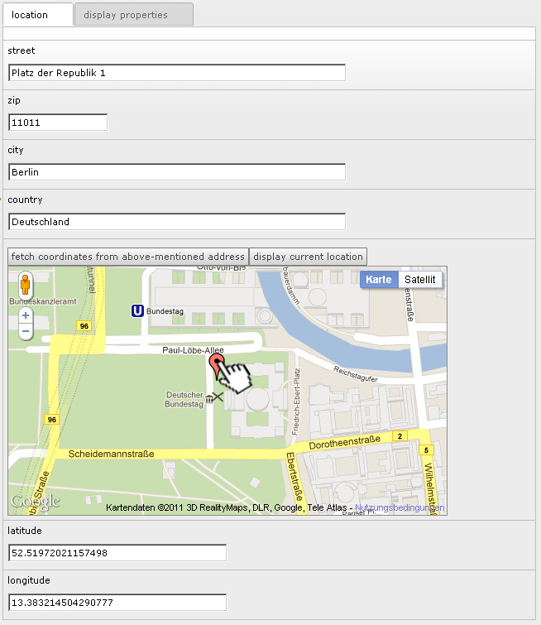
Backend: define a location

Set the desired layout parameter to the frontend.
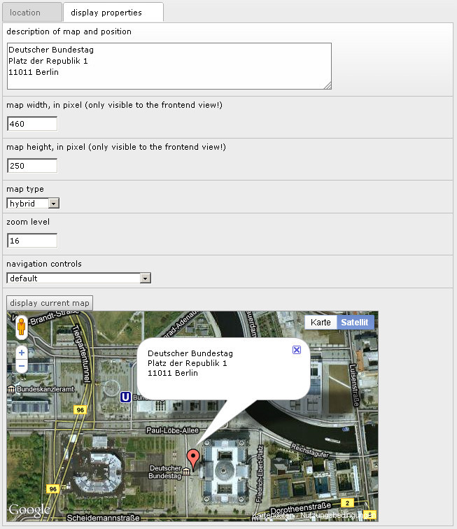
Backend: define the desired layout

Final output to the frontend:
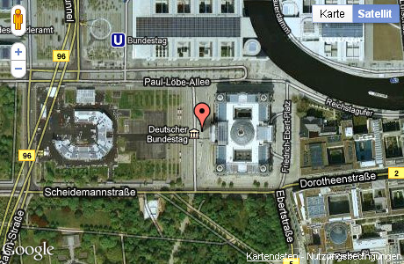
Frontend: view example

Users manual

Installation
- This extension requires “extbase” and “fluid”, so it's necessary to install these extensions first!
(You will find this extensions in the repository)
- Install the extension from the Extension Repository by search for the extension key “cbquickgooglemap”.
- Include the static templates to your Template.
  - Select the template module to the left side in the backend
  - choose now the root page in the page-tree, where the root template is located
  - click “Edit the whole template record” and
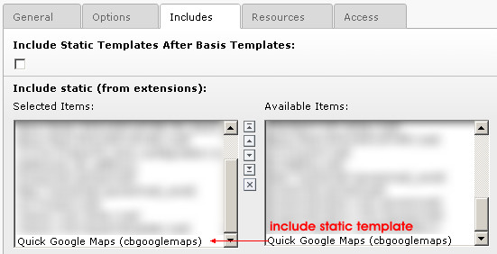
  - select the tab “Includes” and add the “Quick Google Maps (cbgooglemaps) to the selected Items. (see following Screenshot)
  - after saving this template update you can include maps to your page!

Nothing else is required and since Google API3, no API-Key is required!

Administration
The administration of this extension is limited to set some default values which will be used, if the editor will not define any value to some required fields.
This configuration values can either be set as constants or by TypoScript (see “Configuration” chapter):

To set initial values by constants,
Choose the template module
Navigate to the page which includes the root-template
Choose the “Constant Editor” in the dropdown box (top of the page)
And select the constant category “PLUGIN.TX_CBGOOGLEMAPS (x)”

Now you should see six or more constants which can be edited.
Constant: | Description
googleapi.uri | URI to include google javascript api3, should not be edited.  Default: http://maps.google.com/maps/api/js?sensor=false
googleapi.key | API key for googlemaps, see following url for closer information and getting an api key:  https://developers.google.com/maps/documentation/javascript/
options.useScrollwheel | Activate or deactivate the option to zoom in the map by mouse scrollwheel.  Only available for extension version 3.1.0 or higher  Default: true
display.width | Set the default width of the map in the frontend view in pixel. Will be used if the editor does not define any value.
display.height | Set the default height of the map in the frontend view in pixel. Will be used if the editor does not define any value.
display.mapType | Choose the type of the map between these values: HYBRID, TERRAIN, SATELLITE and ROADMAP
display.zoom | Zoom level of the map in the frontend view. Must be an positive integer greater or equal to 0. Commonly value between 10 an 20 are used.
display.mapControl | Choose the type of displayed control elements. Valid values are DEFAULT, SMALL, ZOOM_PAN and ANDROID
display.icon | Set an individual icon to mark the position in the map. Set the path relative from document root, e.g. “fileadmin/user_uploads/myGooglePin.png”. The targeting point resides to the center bottom of the grafic  Only available for extension version 3.1.0 or higher
display.styling | Specify the path and filename to the google maps styling file which includes the json data to style the map, e.g. “fileadmin/googlemapsStyling.txt”  Only available for extension version 3.1.0 or higher

Configuration
The configuration can be done by setting constants or by TypoScript. To
plugin.tx_cbgooglemaps.settings.

Google API definition
Property: | Description: | Default:
googleapi.uri | URI to include google javascript api3, should not be edited. Should normally not be modified. | http://maps.google.com/maps/api/js?sensor=false
goolgeapi.key | Google maps API key, see following url for closer information and getting a key  https://developers.google.com/maps/documentation/javascript/

Google map options
Property: | Description: | Default:
options.useScrollwheel | Deactivate the support for zooming in google maps by mouse wheel, default: activated.  Only available for extension version 3.1.0 or higher | true

Display settings
This values will be used as defaults if the editor entered no value
Property: | Description: | Default:
Display.width | Set the default width of the map in the frontend view in pixel. Will be used if the editor does not define any value. | 480
display.width | Set the default height of the map in the frontend view in pixel. Will be used if the editor does not define any value. | 270
display.mapType | Choose the type of the map between these values: HYBRID, TERRAIN, SATELLITE and ROADMAP | HYBRID
display.zoom | Zoom level of the map in the frontend view. Must be an positive integer greater or equal to 0. Commonly value between 10 an 20 are used. | 12
display.navigationControl | Choose the type of displayed control elements. Valid values are DEFAULT, SMALL, ZOOM_PAN and ANDROID | DEFAULT
display.icon | Set an individual icon as marker for the map. Set the path and filename relative to the document root folder, e.g. “fileadmin/user_uploads/myGooglePin.png”. The targeting point resides to center bottom of the assigned grafic.  Only available for extension version 3.1.0 or higher
display.mapStyling | Specify the styling for a googlemap as json string. You can reference to a textfile, e.g. “fileadmin/googlemapsStyling.txt” or by a simple string like “[...json-data...]”. The styling will be included to the map.  Only available for extension version 3.1.0 or higher

Valid parameter definition
You can limit by which mapTypes and navigationControls the editor can choose of.
Property: | Description: | Default:
valid.mapTypes | Available valid map Types | HYBRID,ROADMAP,SATELLITE,TERRAIN
valid.navigationControl | Available valid navigation controls | SMALL,DEFAULT,ANDROID,ZOOM_PAN

Use your own template
If you wish to use your own templates, just copy the original templates from extension folder:
=> /typo3conf/ext/cbgooglemaps/Resources/Private/Templates/*
to a new location you want, e.g.
=> fileadmin/cbgooglemaps
edit the templates and set new template location by typoscript:

plugin.tx_cbgooglemaps.view.templateRootPaths.100 = fileadmin/cbgooglemaps/

!!!Attention!!!
Use for TYPO3 Versions below 6.2 “templateRootPath” instead of “templateRootPaths”, watch trailing (s) - “templateRootPath” is deprecated.

Example
Here an example to all possible definitions:

plugin.tx_cbgooglemaps {
settings{
googleapi {
uri = http://maps.google.com/maps/api/js
key = …
}
options{
useScrollwheel = false
}
display{
width = 480
height = 270
mapType = HYBRID
zoom = 12
navigationControl = DEFAULT
icon = fileadmin/user_uploads/myGooglePin.png
mapStyling = fileadmin/googlemapsStyling.txt
}
valid{
mapTypes = HYBRID,ROADMAP,SATELLITE,TERRAIN
navigationControl = SMALL,DEFAULT,ANDROID,ZOOM_PAN
}
}
}

or include map styling by string, e.g. to override default configuration to a single page branch:

plugin.tx_cbgooglemaps {
settings{
display{
mapStyling (
[{"featureType":"landscape", … many more ... ,{"gamma":1}]}]
)
}
}
}

Tutorial: Map by content elemtent
This tutorial will describe how to include a new map to your frontend:

Set location:
- First create new content element of type “plugin” in the backend.
- In the appearing Flexform define now the location by entering the desired
- Address (1) or
- coordinates
- If inserted address data, please click to the “fetch coordinates from above-mentioned address” to retrieve coordinates from google (2)
- Now click the preview button “display current location” to verify the current location (3)
- If necessary adjust the location by manually editing the coordinates ;-) or by dragging the google pin to the desired position. (4)

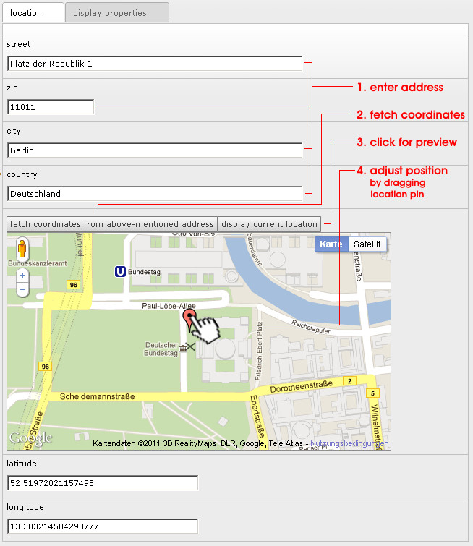

Set frontend layout
After specifying the location you can choose how the map should be displayed. This is optional and can be ignored if the default view should be used.

Manual layout setting:
- Insert free text, which should be inserted as pin flag. (1)
- Specify the desired width and height in pixel (2)
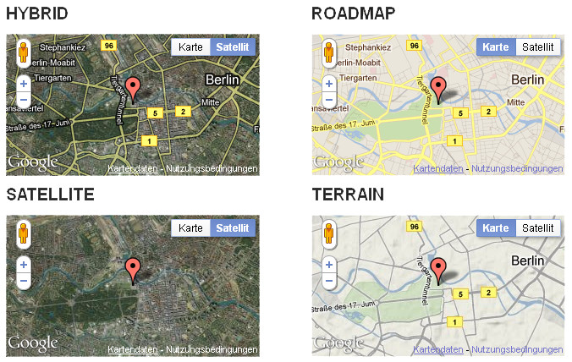
- Select kind of mapType, how the map should be displayed. The following types are available:
- Define the desired zoom level. (Typical used values between 12 and 18)
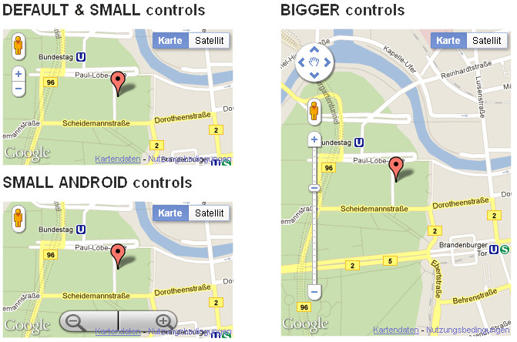
- Select the desired controls, you can choose between: DEFAULT, SMALL, ZOOM_PAN and SMALL ANDROID like. See following Screenshot:
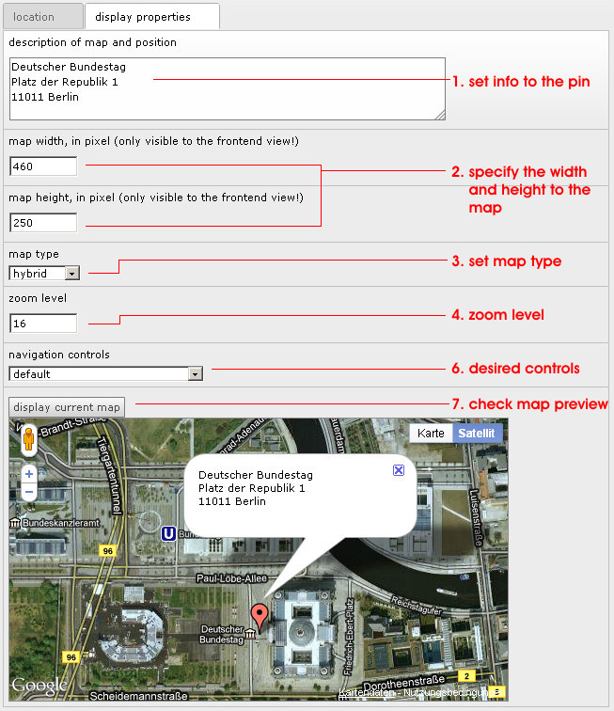
That's all, after saving your map inputs, the google map will be displayed to your frontend after saving this content element.

Tutorial 2: Map by Fluid configuration
In the following I'll explain how to include a google map by fluid and typoscript:
TypoScript object:
Add the following typoscript configuration anywhere want or at least at the page you want to include a map:
lib.mapByFluid = USER_INT
lib.mapByFluid{
userFunc = TYPO3\CMS\Extbase\Core\Bootstrap->run
vendorName = Brinkert
extensionName = Cbgooglemaps
pluginName = Quickgooglemap
controller = Map
action = index
settings =< plugin.tx_cbgooglemaps.settings
}
Fluid usage:
Add the following fluid snippet to include a google map, the parameters will be transferred to map settings in the data attribute:
<f:cObject typoscriptObjectPath="lib.mapByFluid" data="{latitude:52.51859, longitude:13.374645, mapType:'ROADMAP'}" />

It's also possible to set the other settings by data attribute. You can use the following properties:
Property: | Description: | Default:
width | Set the width of the map in the frontend view in pixel. Will be used if the editor does not define any value. If no value was given the map will be extended to 100% for resonsive behavoir
height | Set the height of the map in the frontend view in pixel. Will be used if the editor does not define any value.
infoText | Text for the info text box associated to the pin
infoTextOpen | Decide if the textbox should be opend at start
navigationControl | Choose the type of displayed control elements. Valid values are DEFAULT, SMALL, ZOOM_PAN and ANDROID
zoom | Zoom level of the map in the frontend view. Must be an positive integer greater or equal to 0. Commonly value between 10 an 20 are used.
mapType | Choose the type of map type, f.e. ROADMAP, HYBRID, SATELITE
icon | Set an individual icon as marker for the map. Set the path and filename relative to the document root folder, e.g. “fileadmin/user_uploads/myGooglePin.png”. The targeting point resides to center bottom of the assigned grafic.  Only available for extension version 3.1.0 or higher
mapStyling | Specify the styling for a googlemap as json string. You can reference to a textfile, e.g. “fileadmin/googlemapsStyling.txt” or by a simple string like “[...json-data...]”. The styling will be included to the map.  Only available for extension version 3.1.0 or higher

Tutorial 3: Map by typoscript configuration
In the following I'll explain how to include a google map by typoscript:

TypoScript object:
Add the following typoscript configuration anywhere want or at least at the page you want to include a map:

lib.mapByTs = USER_INT
lib.mapByTs {
userFunc = TYPO3\CMS\Extbase\Core\Bootstrap->run
vendorName = Brinkert
extensionName = Cbgooglemaps
pluginName = Quickgooglemap
controller = Map
action = index
settings =< plugin.tx_cbgooglemaps.settings
settings{
display.width = 800
display.height = 450
display.mapType = HYBRID
display.zoom = 10
latitude = 48.1959245
longitude = 16.4037389
infoText = So long and thanx for the fish.
InfoTextOpen = true
}
}

Known problems
- Currently no problems known,
=> but feel free to search for :-)

To-Do list
- Nothing yet

ChangeLog

Version | Changes:
1.0.0 | Frst TER release
...
2.0.6 | Bug-Fix: Transfered JS-Files from EXT:/Resources/Private to EXT:/Resources/Public-Folder  (THX to Alexander.Kai Ude for your hint!)
...
3.0.0 | Compatibility Update to TYPO3 6.0 – 6.2  Previous TYPO3 versions are only supported in the 2.x version tree!
3.1.0 | Compatibility Update to TYPO3 7.0  Extended configuration to deactivate mousewheel zooming and set individual goole marker pins and individual google maps styling
3.2.0 | Added support for map inclusion by fluid und typoscript
3.2.1-3.2.3 | Some small bug fixes and integration of api key configuration

