
Name: Tehreem Khan Subject: Cloud Computing
Registration No: 2023-BSE-064 Section: 5-B

Assignment 1: Git, Gitea, GitHub, LFS, and GitHub Pages
- Screenshot of your Gitea repository (showing README listing names & roll numbers)

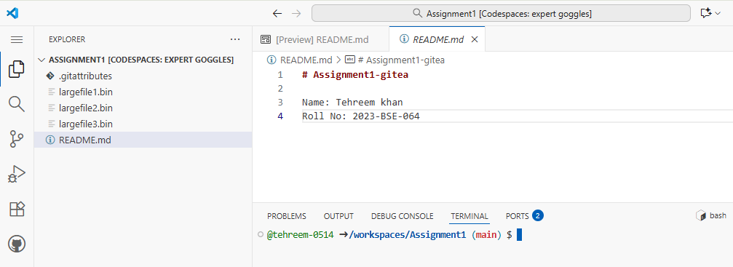

- GitHub assignment 1 repo link (with README and large files)
https://github.com/tehreem-0514/Assignment1.git

- Screenshot or output of git remote -v showing both remotes

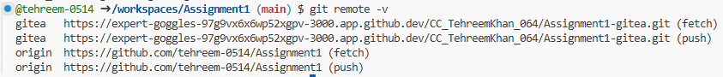

- GitHub Pages link to your CV/portfolio
https://tehreem-0514.github.io/

