Lab Session 03
Week 3: Transaction Processing and Concurrency Control
Course: CSC333 Advance Database Management Systems Lab (3+1) | CLOs: 1, 2, 3
Name: ____________________________ | Roll No: ____________________
Section / Semester: ________________ | Date: _______________________

Week 3: Transaction Processing and Concurrency Control
- Task 1: Simulate a basic transaction in SQL and explore ACID properties.
- Task 2: Implement locking (shared, exclusive) using a DBMS.
- Task 3: Explore multiversion concurrency control (MVCC) in PostgreSQL.

Objective:
- Understand what a transaction is and why databases need transactions.
- Control transactions with BEGIN, COMMIT, ROLLBACK and SAVEPOINT.
- Demonstrate the four ACID properties: Atomicity, Consistency, Isolation and Durability.
- Understand concurrency problems and the PostgreSQL isolation levels.
- Implement shared and exclusive locks at row level and table level, and observe waiting and deadlock.
- Explain how multiversion concurrency control (MVCC) lets readers and writers work without blocking each other.
- Use two simultaneous sessions in pgAdmin to simulate concurrent users.

Required Equipment / Tools:
- Computer with PostgreSQL (version 14 or later) installed, as set up in Lab Session 01.
- pgAdmin 4 with two Query Tool tabs open on the same database (they act as two different users).
- An empty database named lab3 for this session.

Introduction:
A transaction is a group of SQL operations that the database treats as one logical unit of work: either all of it happens or none of it does. The classic example is a bank transfer. Money must be subtracted from one account and added to another. If the system fails after the first step, the money would simply vanish. Transactions prevent this.
Real databases are used by many people at the same time. Concurrency control is the set of techniques that lets many transactions run together while every user still sees correct, consistent data.
Transaction commands:
Command | Meaning
BEGIN | Start a transaction block.
COMMIT | Make all changes of the transaction permanent.
ROLLBACK | Cancel all changes made since BEGIN.
SAVEPOINT name | Set a marker inside a transaction.
ROLLBACK TO name | Undo only the work done after the savepoint; the transaction stays open.
Outside a BEGIN ... COMMIT block every single statement is its own transaction and is committed automatically (autocommit).
ACID properties:
Property | Meaning | Bank-transfer example
Atomicity | All operations succeed or none does | Debit and credit both happen, or neither
Consistency | A transaction moves the database from one valid state to another; constraints are never broken | A balance can never become negative
Isolation | Concurrent transactions do not see each other's unfinished work | Another user never sees the money "in flight"
Durability | Once committed, changes survive a crash | A committed transfer is not lost after power failure

Problems caused by concurrency:
Problem | What happens
Lost update | Two transactions read the same value and both overwrite it, so one change is lost.
Dirty read | A transaction reads data that another transaction has changed but not yet committed.
Non-repeatable read | Reading the same row twice in one transaction gives different values because another transaction committed in between.
Phantom read | Running the same query twice returns a different set of rows because another transaction inserted or deleted rows.

Isolation levels in PostgreSQL:
Level | What a transaction sees | Anomalies prevented
Read Committed (default) | Each statement sees the data committed before that statement began | Dirty read
Repeatable Read | A snapshot taken at the first query; it never changes during the transaction | Dirty, non-repeatable and phantom reads
Serializable | Behaves as if transactions ran one after another; may fail and must be retried | All of the above
PostgreSQL never allows dirty reads: asking for Read Uncommitted gives Read Committed behavior.
Locking:
A lock stops other transactions from using data in a conflicting way while one transaction works on it. Two basic kinds exist:
- Shared lock (S): taken for reading. Many transactions can hold a shared lock on the same item together.
- Exclusive lock (X): taken for writing. Only one transaction can hold it, and no one else may read-lock or write-lock the item.
Held by A \ Requested by B | Shared (S) | Exclusive (X)
Shared (S) | Granted | B must wait
Exclusive (X) | B must wait | B must wait

A deadlock happens when two transactions each hold a lock the other needs, so both wait forever. PostgreSQL detects this (after about one second), aborts one transaction with an error and lets the other continue.
MVCC (multiversion concurrency control):
Instead of making readers wait for writers, PostgreSQL keeps several versions of a row. Every row version records the ID of the transaction that created it (xmin) and the one that deleted or replaced it (xmax). A transaction only sees the versions that were valid for its snapshot. The result is that readers never block writers and writers never block readers. Only two writers changing the same row must wait for each other.
Points to remember (important for viva):
- A plain SELECT takes no row locks in PostgreSQL. Row locks come from UPDATE, DELETE, SELECT ... FOR UPDATE and SELECT ... FOR SHARE.
- After an error inside a transaction, PostgreSQL refuses further commands until you issue ROLLBACK.
- Always finish every transaction with COMMIT or ROLLBACK. An open transaction keeps its locks and blocks others.
Oracle note: Oracle also uses MVCC (readers do not block writers), and its default isolation is Read Committed. Locking syntax is similar: SELECT ... FOR UPDATE, LOCK TABLE.

Procedure:

Setup
- Start pgAdmin 4, connect to the server, right-click Databases > Create > Database..., type lab3 and click Save.
- Select lab3 and open Tools > Query Tool. This is Session A.
- Select lab3 again and open a second Query Tool. This is Session B. Each tab has its own connection, so it behaves like a separate user. Check that both tabs show lab3.
- Run each statement one at a time: highlight it and press F5. This matters for transactions, because you need to control the order in which the two sessions act.
Tools used in this lab
Command / feature | Purpose
BEGIN, COMMIT, ROLLBACK | Start, save and cancel a transaction.
SELECT ... FOR SHARE / FOR UPDATE | Take a shared or exclusive row lock explicitly.
LOCK TABLE ... IN ... MODE | Take a table lock.
pg_locks, pg_stat_activity | System views showing held and waited locks and what each session is doing.
xmin, xmax, ctid | Hidden columns exposing row versions (MVCC).
Stop button in the Query Tool | Cancels a statement that is waiting for a lock.

Create the sample data (Session A):
CREATE TABLE account (
acc_no int PRIMARY KEY,
holder text NOT NULL,
balance numeric(12,2) NOT NULL CHECK (balance >= 0)
);

INSERT INTO account VALUES
(1, 'Ali', 50000),
(2, 'Sara', 30000),
(3, 'Hamza', 20000);

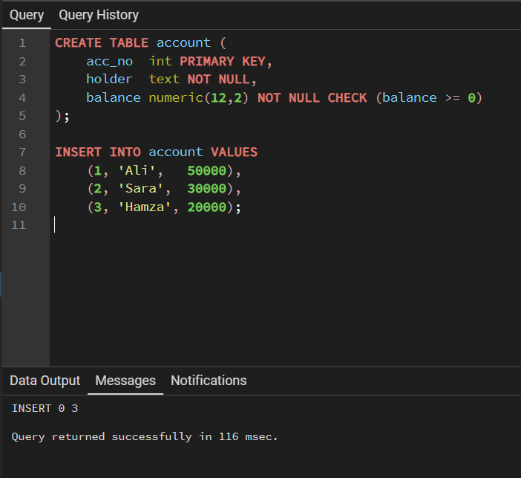

Example 1 (Task 1): Simulate a Basic Transaction in SQL and Explore ACID Properties
Example Problem Scenario
A bank transfers Rs. 5,000 from Ali (account 1) to Sara (account 2). Both the debit and the credit must happen together. Use Session A only.
Step 1: A successful transaction (COMMIT)
BEGIN;
UPDATE account SET balance = balance - 5000 WHERE acc_no = 1;
UPDATE account SET balance = balance + 5000 WHERE acc_no = 2;
COMMIT;

SELECT * FROM account ORDER BY acc_no;
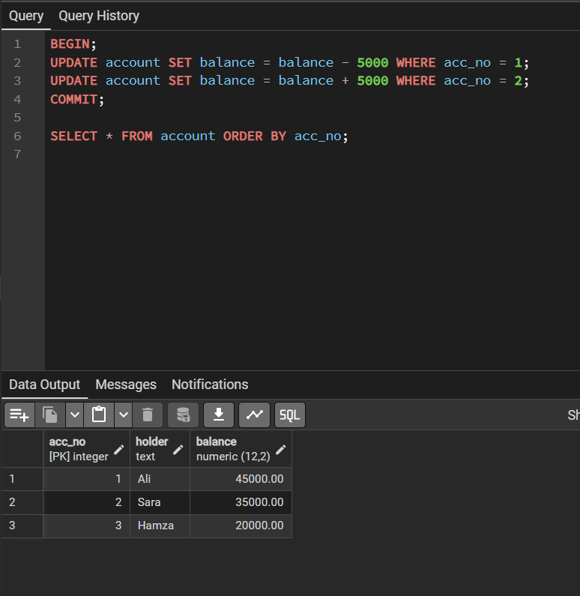
acc_no | holder | balance
1 | Ali | 45000.00
2 | Sara | 35000.00
3 | Hamza | 20000.00

Step 2: Atomicity: cancel a transaction (ROLLBACK)
BEGIN;
UPDATE account SET balance = balance - 5000 WHERE acc_no = 1;
SELECT * FROM account ORDER BY acc_no; -- Ali shows 40000 inside

ROLLBACK;
SELECT * FROM account ORDER BY acc_no; -- Ali is back to 45000
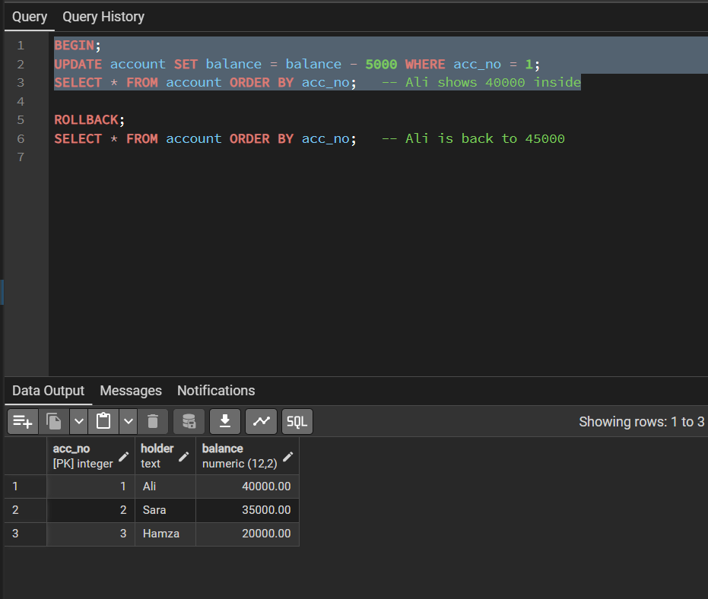
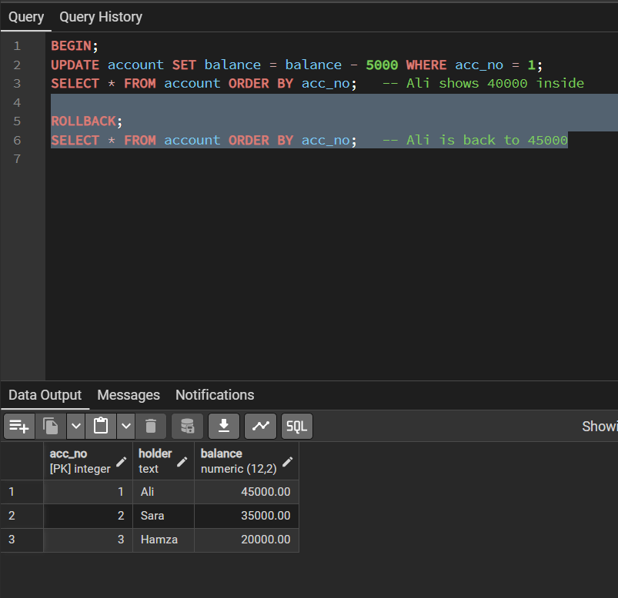
Step 3: Consistency: a rule violation aborts the transaction
BEGIN;
UPDATE account SET balance = balance - 100000 WHERE acc_no = 3;
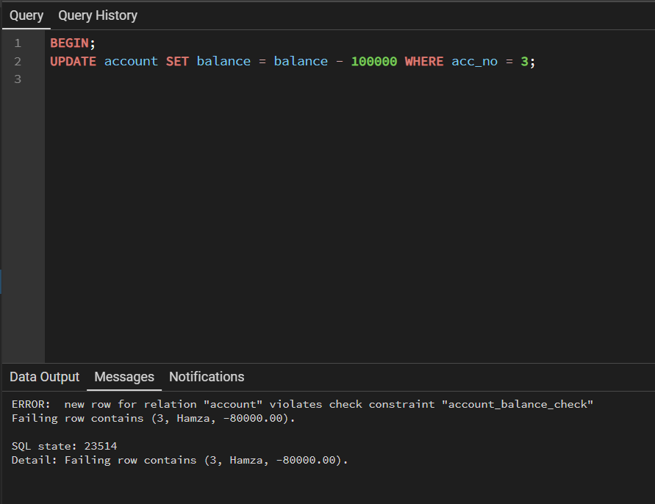
PostgreSQL rejects it: ERROR: new row for relation "account" violates check constraint "account_balance_check". Hamza has only 20000, so the balance would become negative. The transaction is now in an aborted state; try SELECT * FROM account; and you will see "current transaction is aborted". Finish it with:
ROLLBACK;
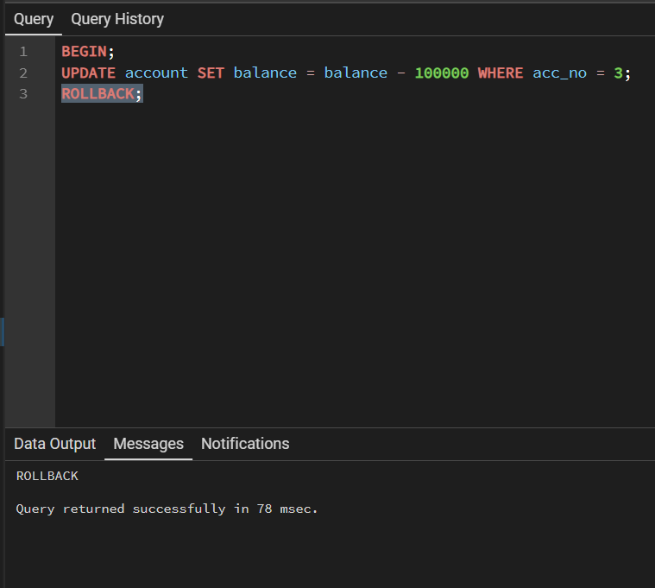
Step 4: SAVEPOINT: undo only part of a transaction
BEGIN;
UPDATE account SET balance = balance + 1000 WHERE acc_no = 1;
SAVEPOINT sp1;
UPDATE account SET balance = balance + 9999 WHERE acc_no = 2;
ROLLBACK TO sp1; -- undoes only Sara's change
COMMIT;

SELECT * FROM account ORDER BY acc_no;
Ali now has 46000 (his +1000 was kept), while Sara is still 35000 (the +9999 was undone).
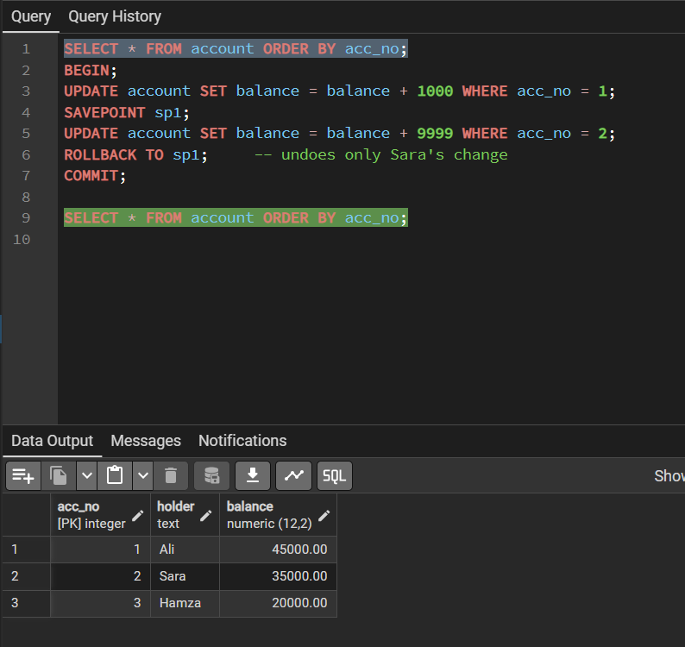

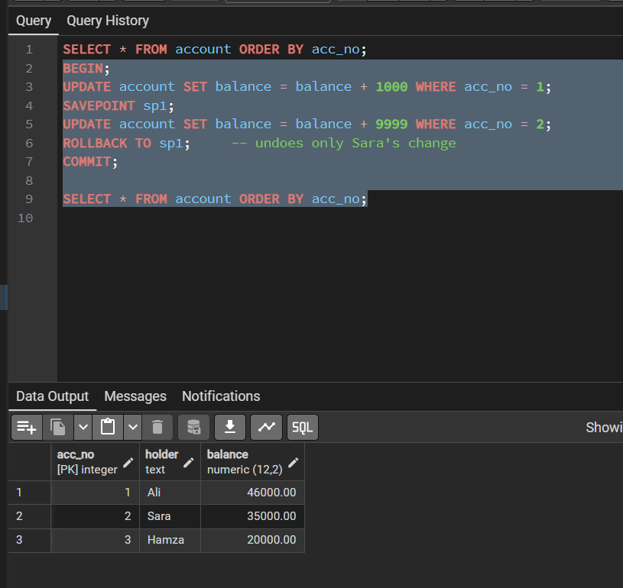
Step 5: Durability
SHOW synchronous_commit;
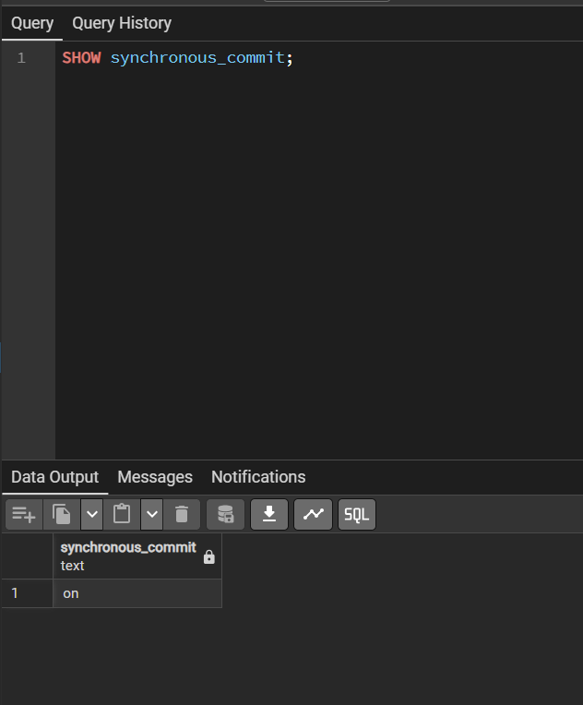
The value on means PostgreSQL writes the commit record to its write-ahead log (WAL) on disk before it reports COMMIT as done. After a crash, committed changes are rebuilt from the log. This is durability. (Recovery is studied in Lab 4.)
Explanation of Changes:
Property | Where you saw it
Atomicity | Step 2: the debit was visible inside the transaction but disappeared completely after ROLLBACK.
Consistency | Step 3: the CHECK (balance >= 0) rule stopped an invalid state.
Isolation | Studied with two sessions in Examples 2 and 3.
Durability | Step 5: committed work is written to the WAL before COMMIT returns.

Example 2 (Task 2): Implement Locking (Shared, Exclusive) Using a DBMS
Example Problem Scenario
Two users work on the same account table at the same time. We will make them collide on purpose and watch the locks. Use Session A and Session B, running one statement at a time in the order shown.
Step 1: Exclusive lock (a write blocks another write)
Session A
BEGIN;
UPDATE account SET balance = balance + 100 WHERE acc_no = 1;
-- do NOT commit yet
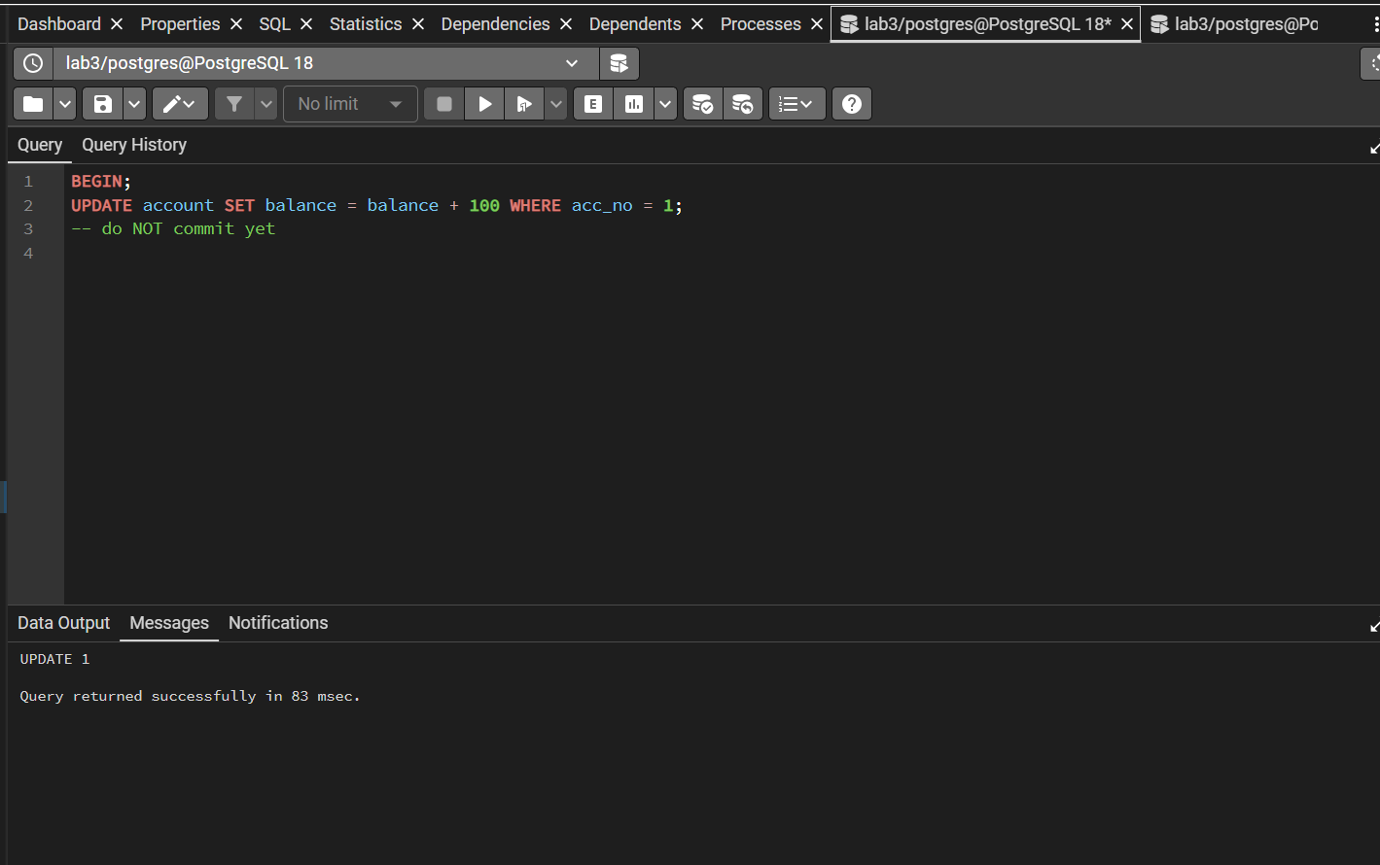
Session B
UPDATE account SET balance = balance + 200 WHERE acc_no = 1;
-- the tab keeps "Running..." because it is WAITING for A
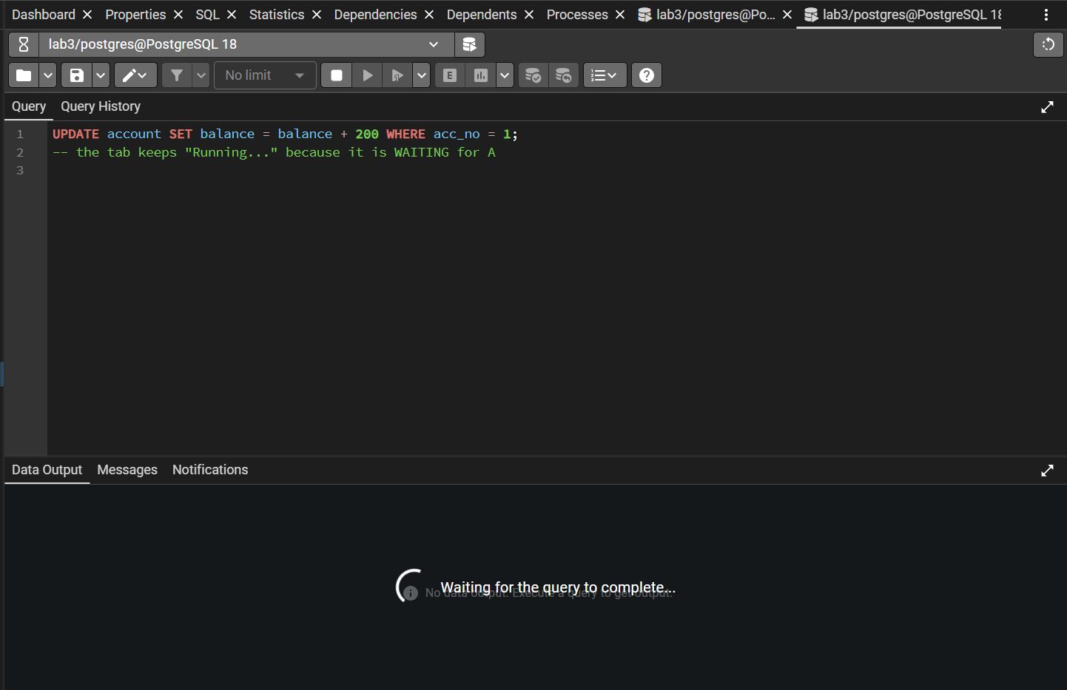
Session B (open another statement after cancelling the wait with the Stop button)
UPDATE account SET balance = balance + 200 WHERE acc_no = 2;
-- different row: completes immediately
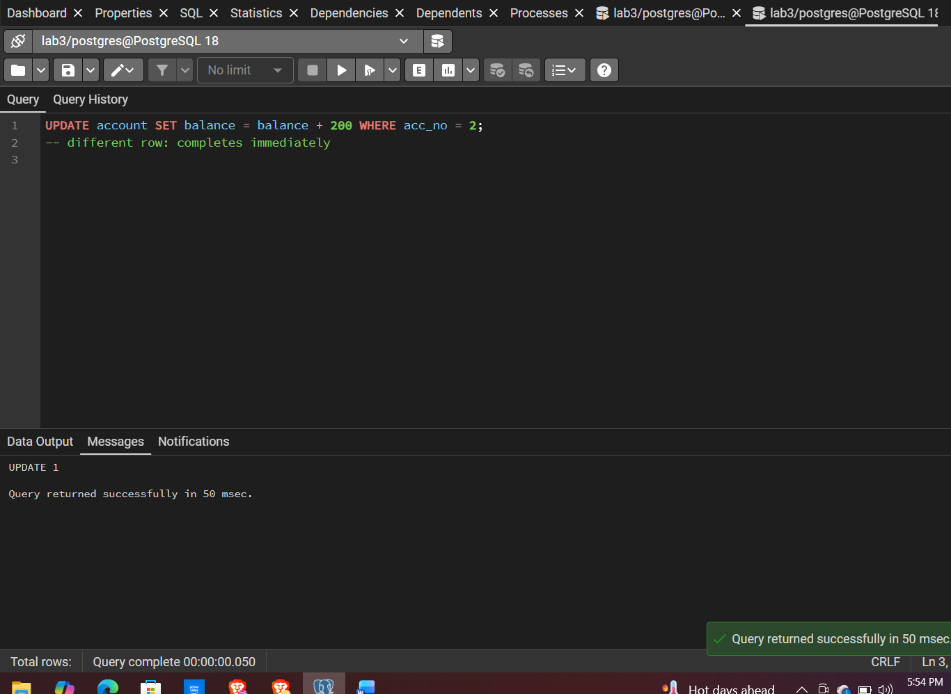
Session A
COMMIT;
-- the waiting update in B (if still running) now completes
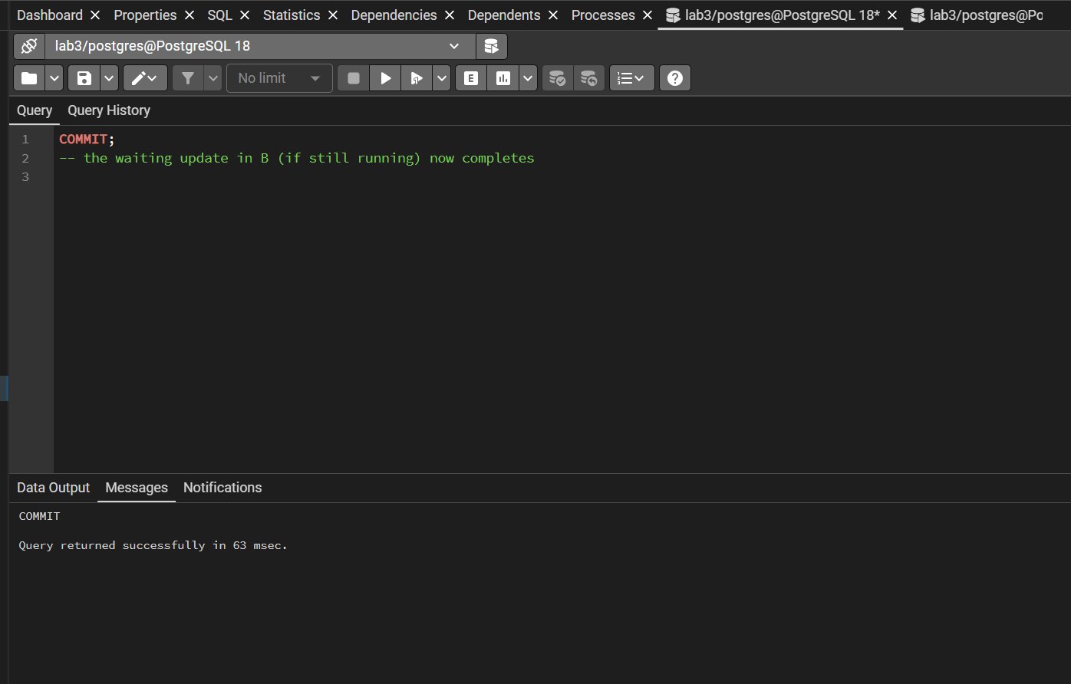
Locking is at row level: A's exclusive lock covers only account 1. Account 2 is free, and B can change it without waiting.
Step 2: Shared lock (readers share, writers wait)
Session A
BEGIN;
SELECT * FROM account WHERE acc_no = 2 FOR SHARE;
Session B
SELECT * FROM account WHERE acc_no = 2 FOR SHARE;
-- works at once: shared + shared are compatible

UPDATE account SET balance = balance + 1 WHERE acc_no = 2;
-- waits: an exclusive lock conflicts with A's shared lock
Session A
COMMIT;
-- B's update completes
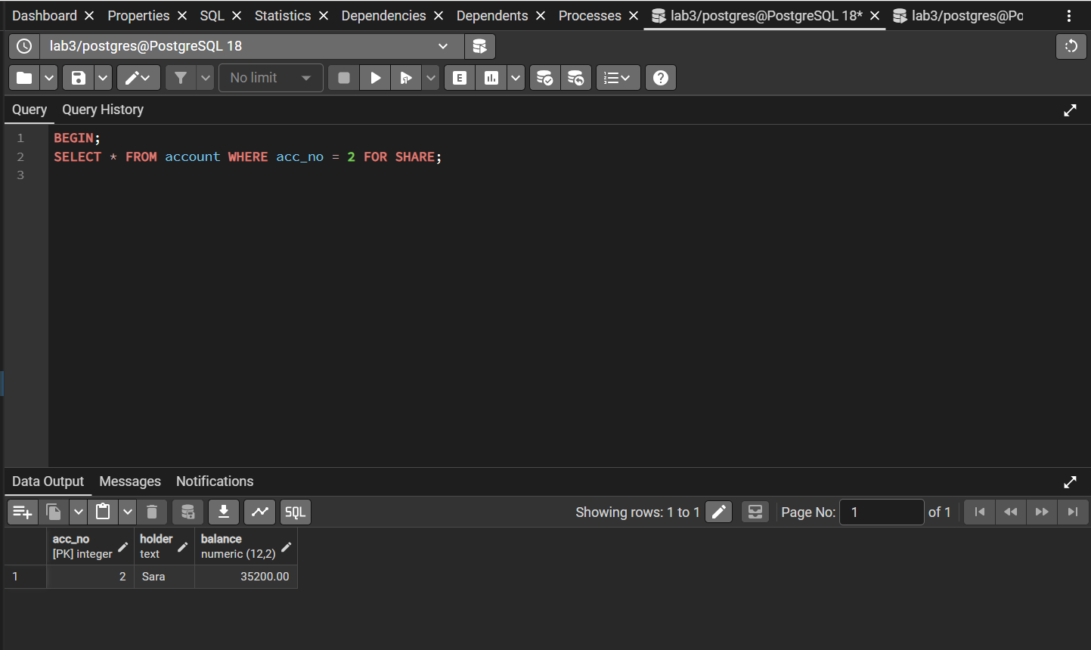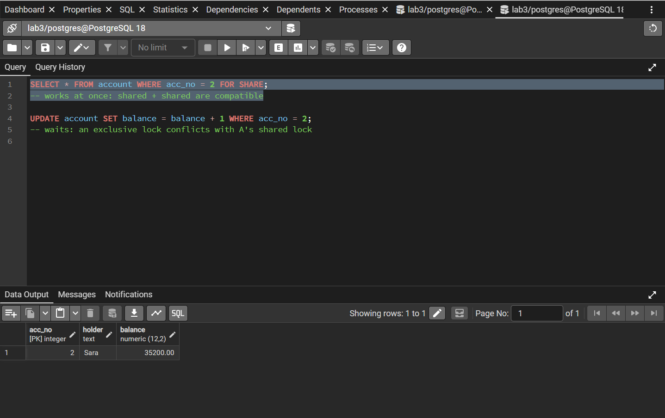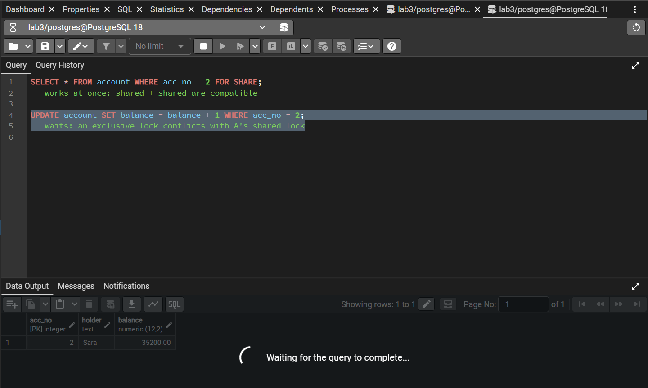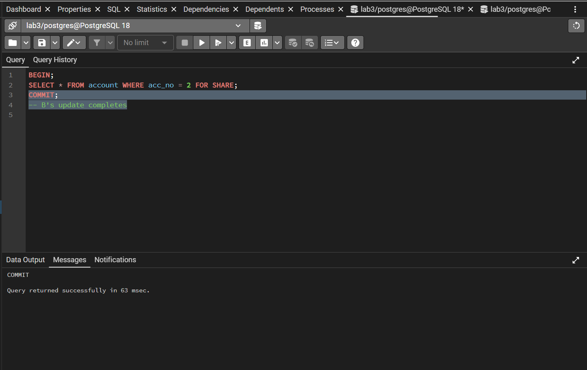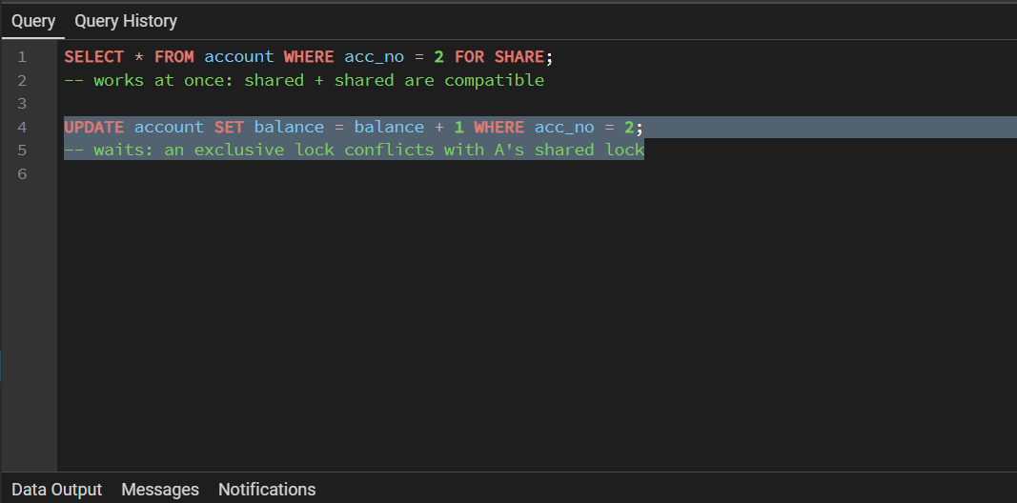
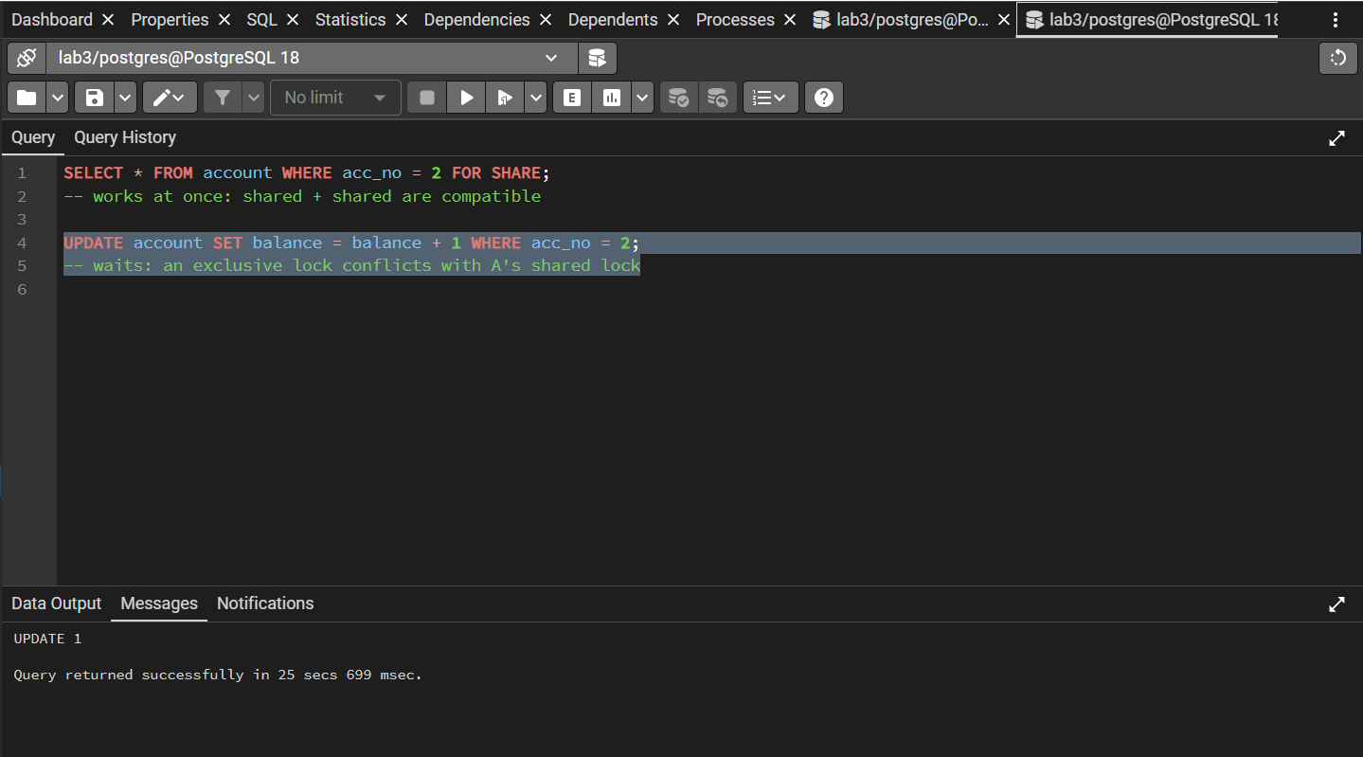
Step 3: Look at the locks
While one session is waiting (repeat Step 1, but leave A uncommitted), run this in a third tab or in Session A:
SELECT locktype, relation::regclass AS table_name,
mode, granted, pid
FROM pg_locks
WHERE relation = 'account'::regclass;

SELECT pid, state, wait_event_type, left(query, 45) AS query
FROM pg_stat_activity
WHERE datname = 'lab3';
A row with granted = false is the waiting session. In pg_stat_activity, wait_event_type = Lock marks the blocked query. Row locks themselves are stored with the row and so do not appear in pg_locks; you see the table-level lock (e.g. RowExclusiveLock) taken by the writer.
Step 4: Table-level locks
Session A (shared table lock)
BEGIN;
LOCK TABLE account IN SHARE MODE;
Session B
SELECT * FROM account; -- works
UPDATE account SET balance = balance + 1 WHERE acc_no = 3; -- waits
Session A
ROLLBACK;
Session A (exclusive table lock)
BEGIN;
LOCK TABLE account IN ACCESS EXCLUSIVE MODE;
Session B
SELECT * FROM account; -- even a plain read waits
Session A
ROLLBACK;
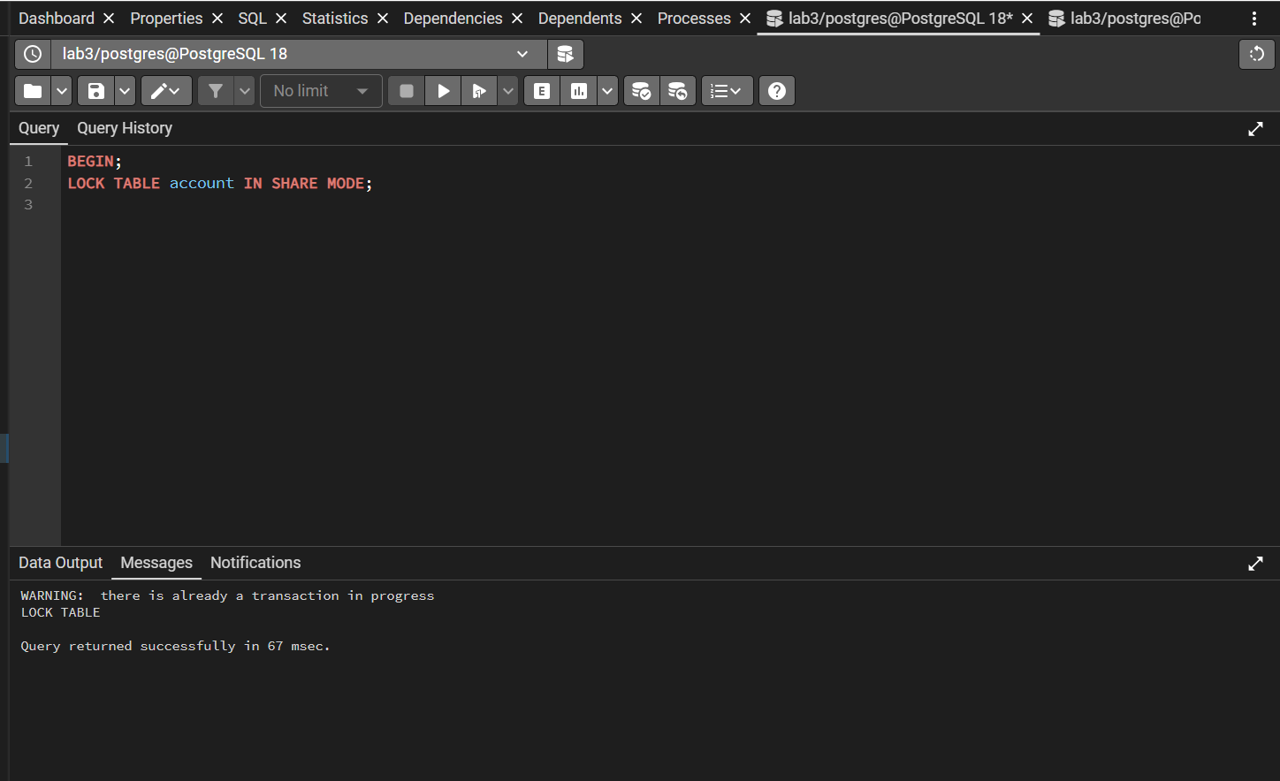
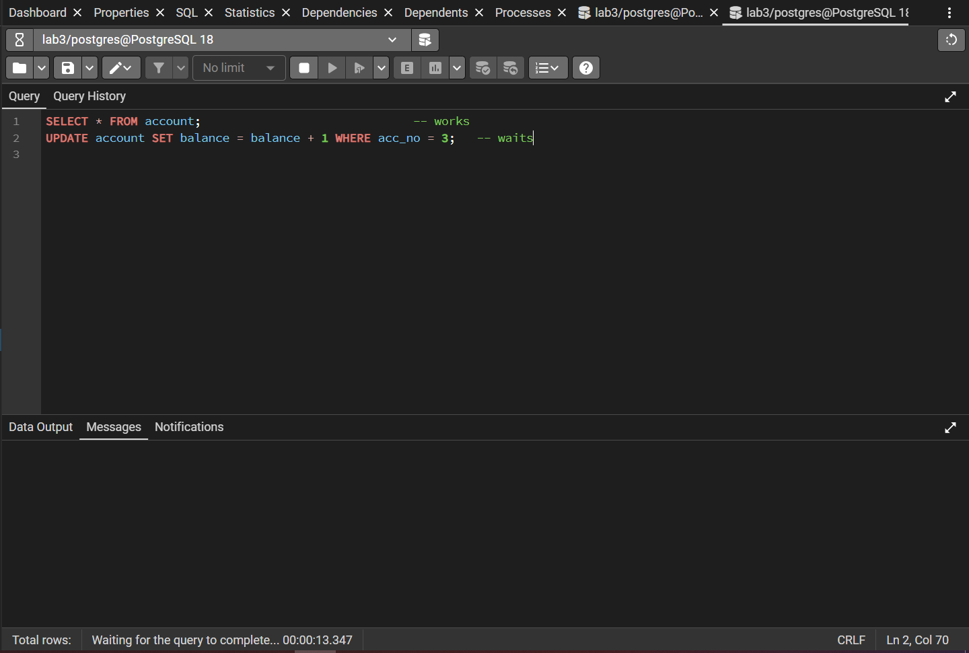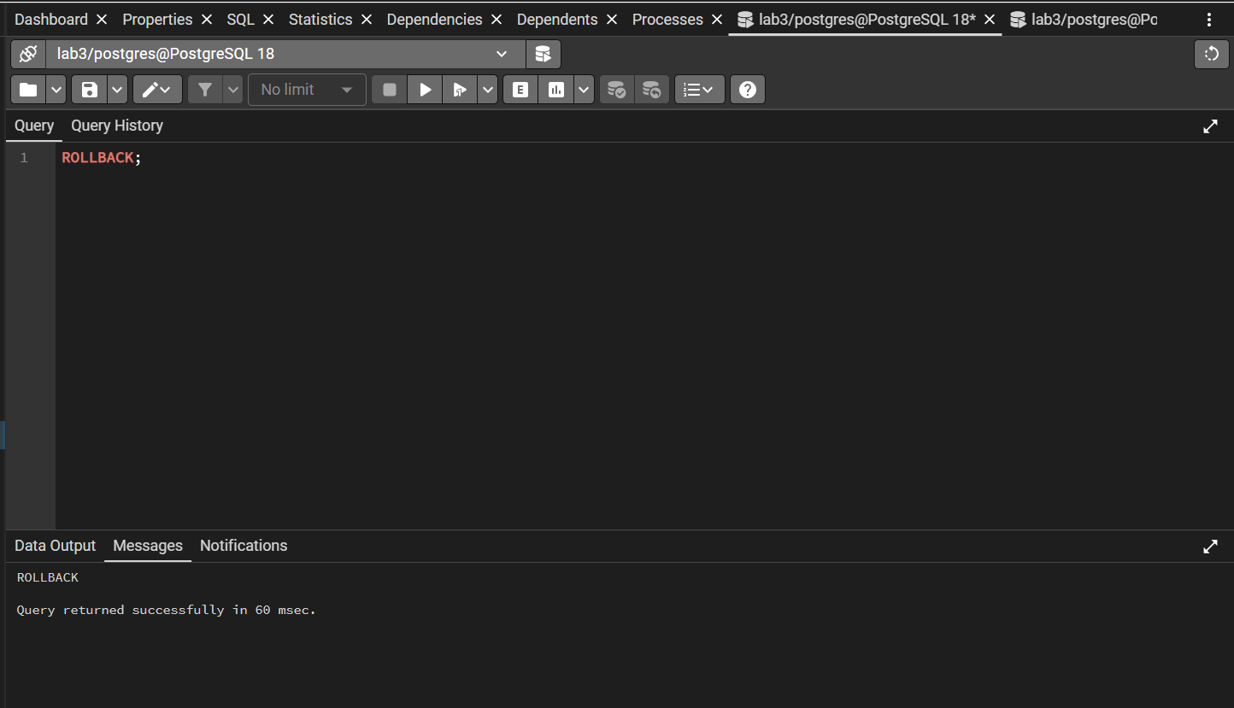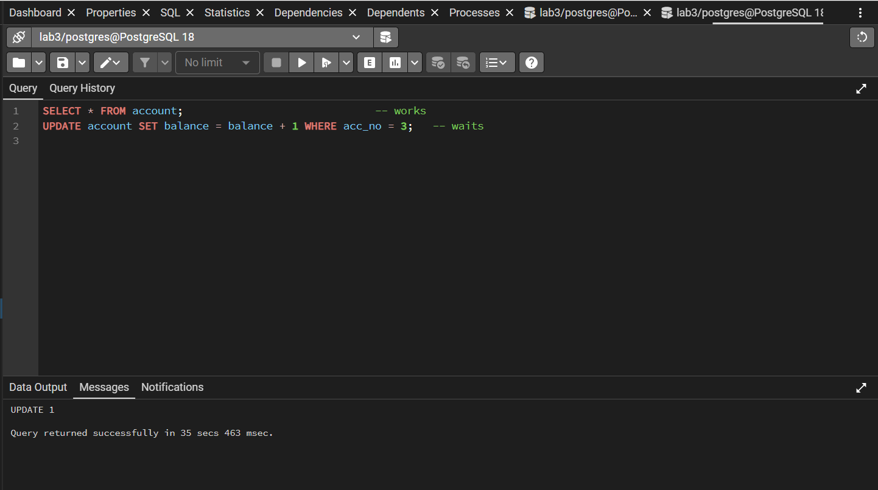
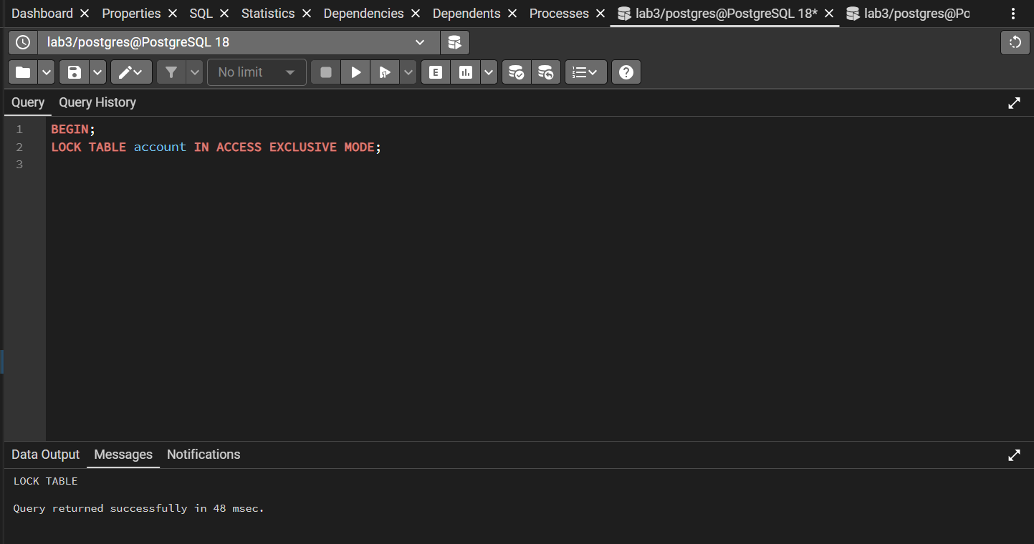
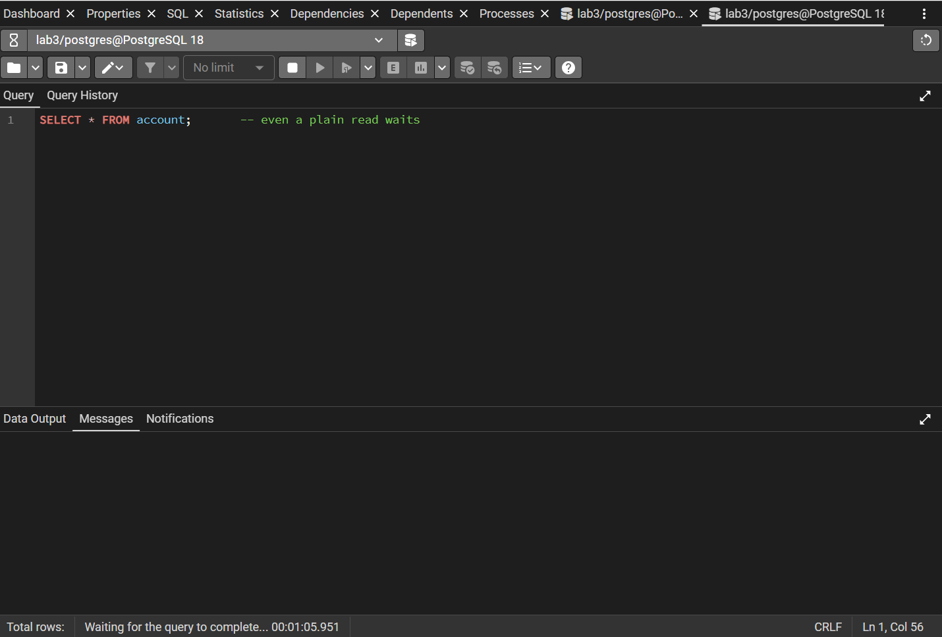
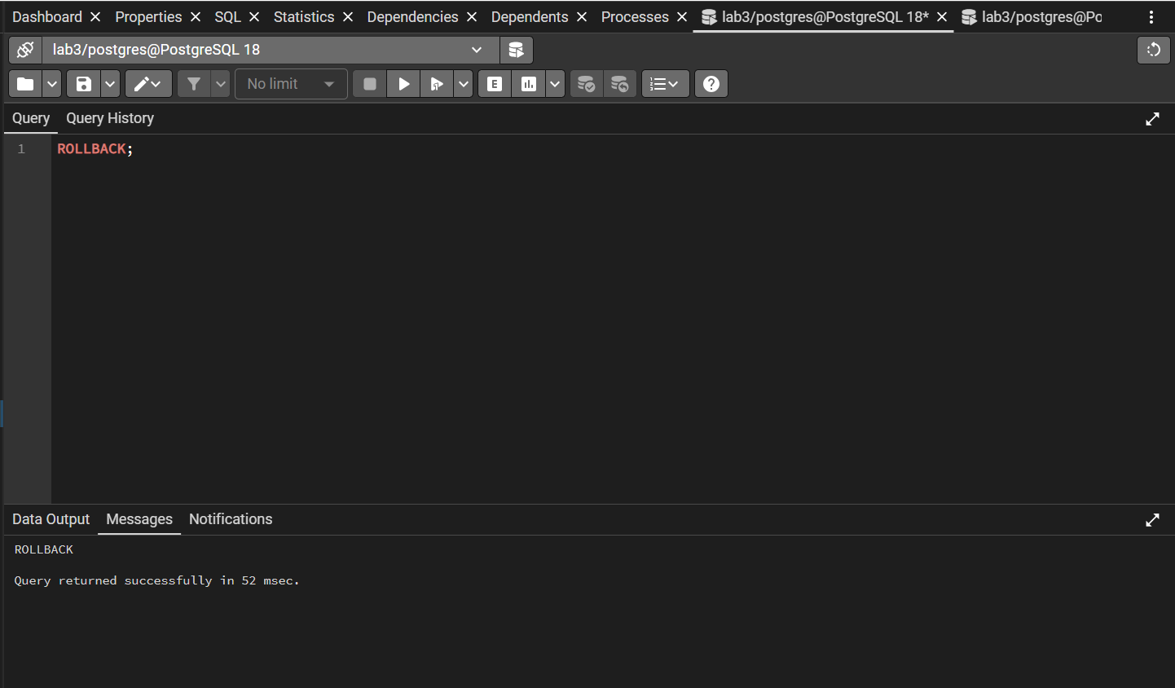
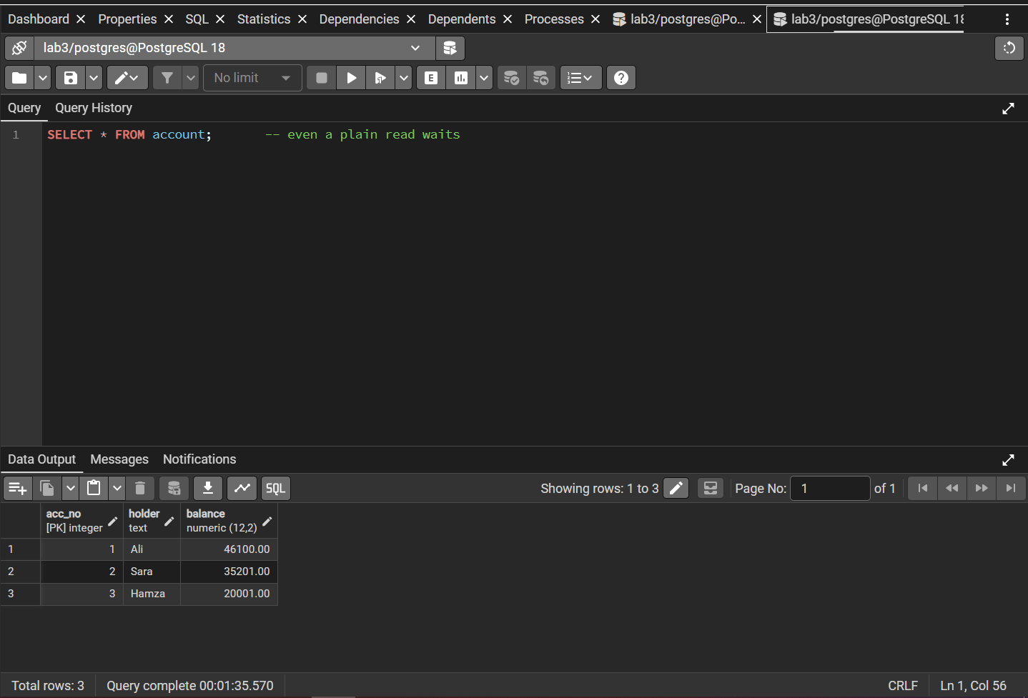
Step 5: Deadlock
Session A
BEGIN;
UPDATE account SET balance = balance + 1 WHERE acc_no = 1;
Session B
BEGIN;
UPDATE account SET balance = balance + 1 WHERE acc_no = 2;
Session A
UPDATE account SET balance = balance + 1 WHERE acc_no = 2; -- waits for B

Session B
UPDATE account SET balance = balance + 1 WHERE acc_no = 1; -- waits for A
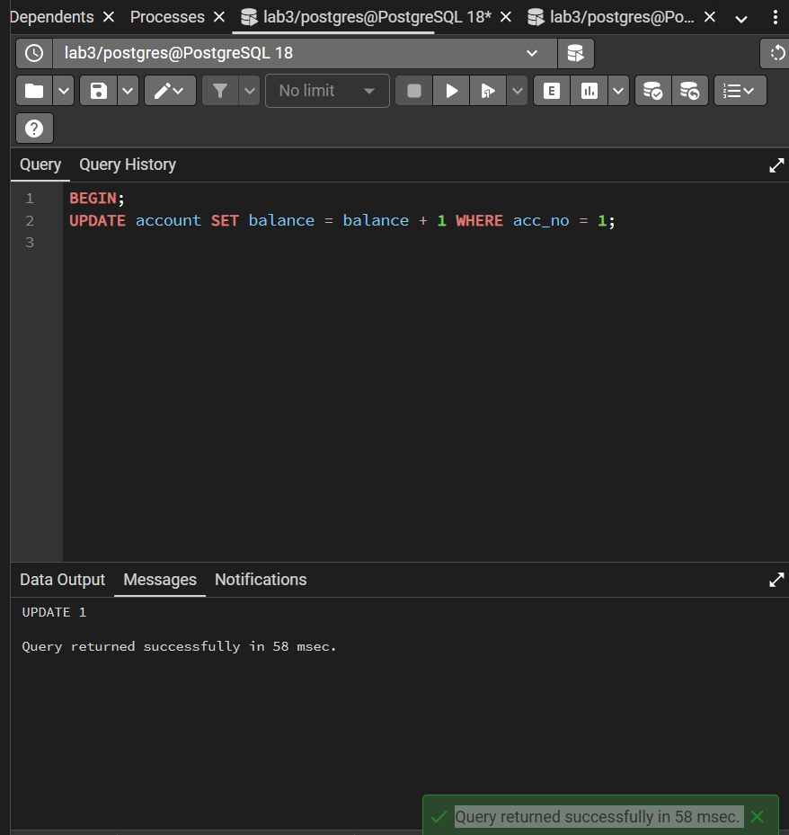
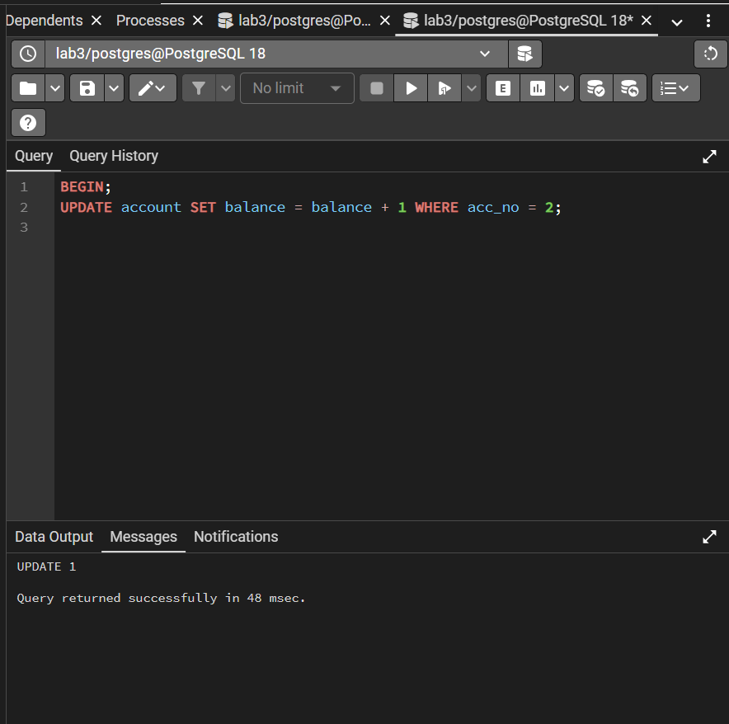
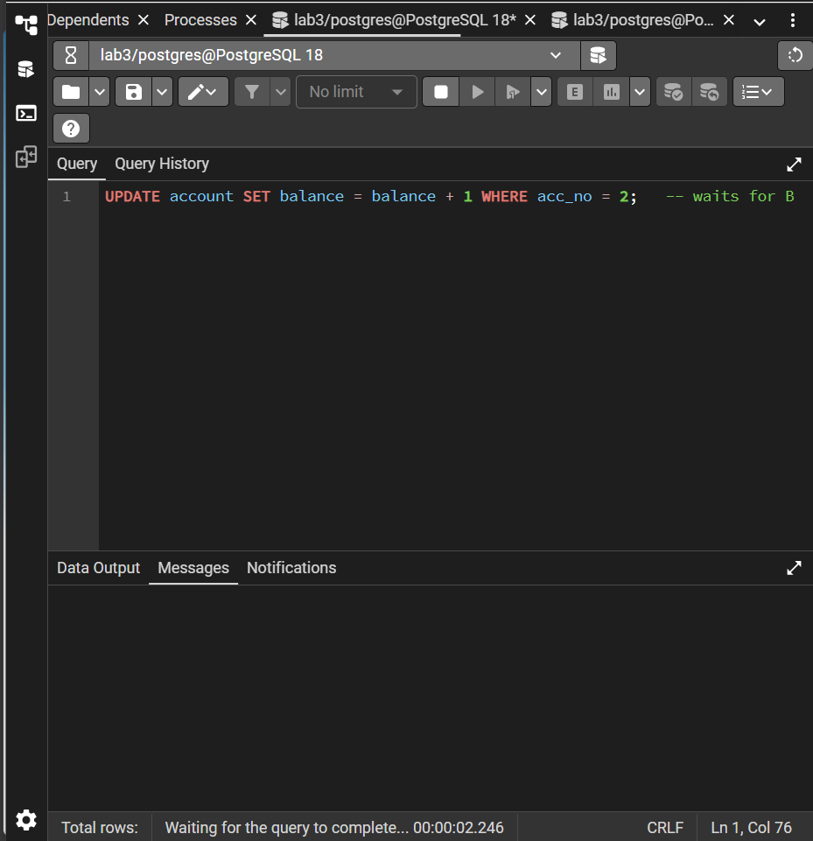
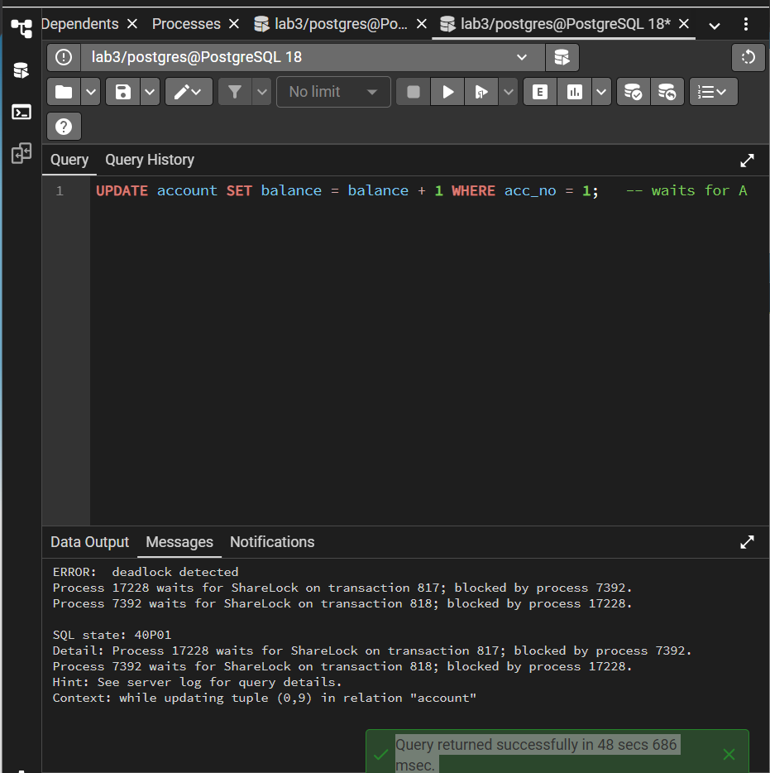
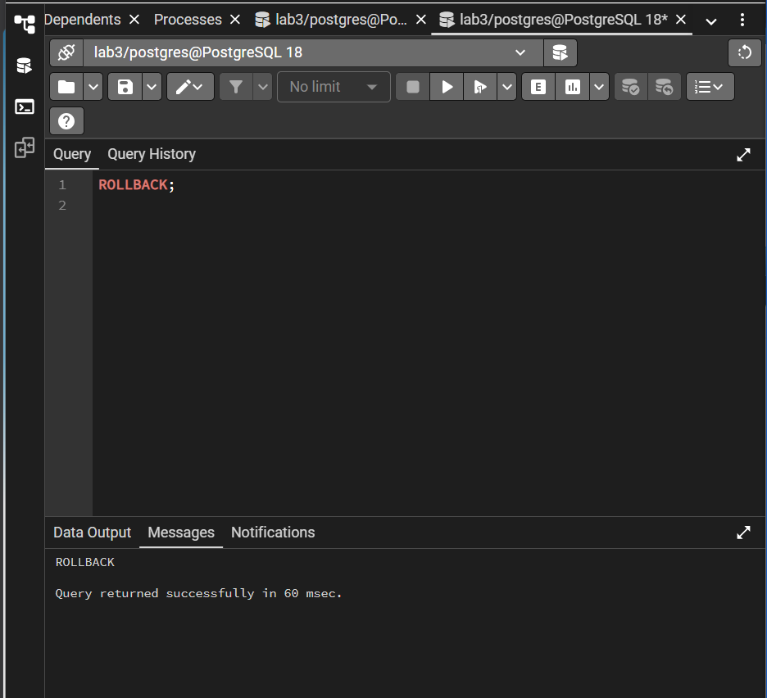
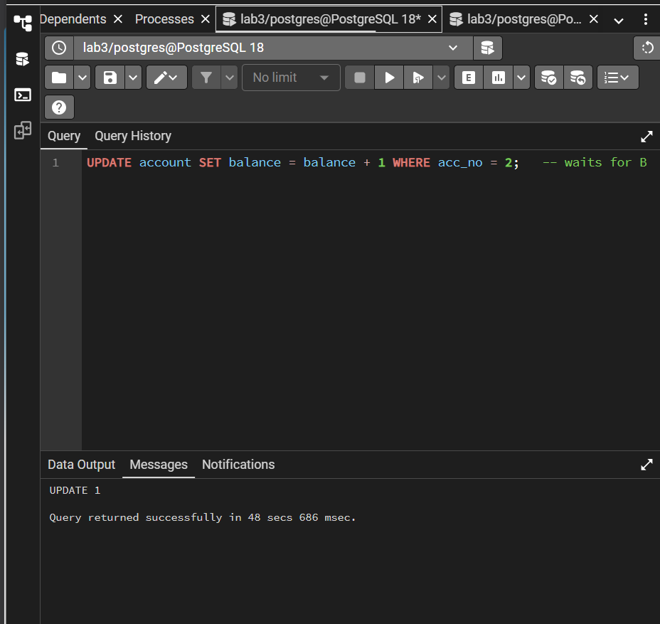
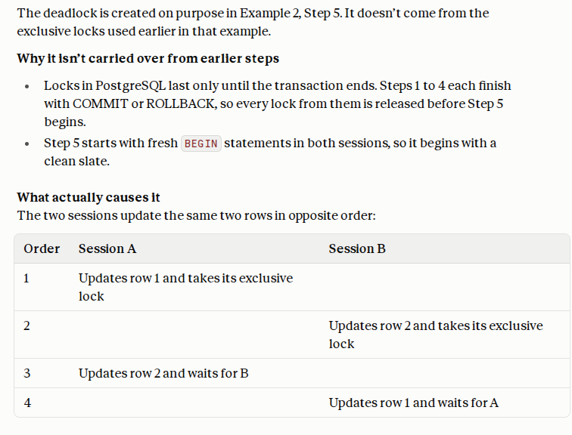
After about one second PostgreSQL reports ERROR: deadlock detected in one of the tabs and aborts that transaction. Run ROLLBACK; in the tab that got the error, and COMMIT; or ROLLBACK; in the other one.
Explanation of Changes:
- An UPDATE takes an exclusive row lock; FOR SHARE takes a shared one. Shared locks are compatible with each other, but not with an exclusive lock, which matches the compatibility table in the introduction.
- Plain SELECT takes no row lock, so it never waits for a writer (see MVCC below). Only explicit table locks such as ACCESS EXCLUSIVE block readers.
- Locks are held until the transaction ends. That is why leaving a transaction open blocks other users.
- A deadlock is resolved by the database killing one of the transactions. The application must catch the error and retry.

Example 3 (Task 3): Explore Multiversion Concurrency Control (MVCC) in PostgreSQL
Example Problem Scenario
In Example 2 writers made other writers wait. Now we show that readers are never blocked, and that every transaction sees a consistent snapshot, because PostgreSQL keeps multiple versions of each row.
Step 1: Look at the hidden version columns (Session A)
SELECT xmin, xmax, ctid, * FROM account ORDER BY acc_no;
xmin is the ID of the transaction that created this row version. xmax is 0 while the version has not been deleted or replaced.
Step 2: An UPDATE creates a new version
UPDATE account SET balance = balance + 1 WHERE acc_no = 3;
SELECT xmin, xmax, ctid, * FROM account WHERE acc_no = 3;
Hamza's row now has a new `xmin` and a new `ctid`. The old version is still on disk as a dead tuple until VACUUM removes it (as in Lab 2).
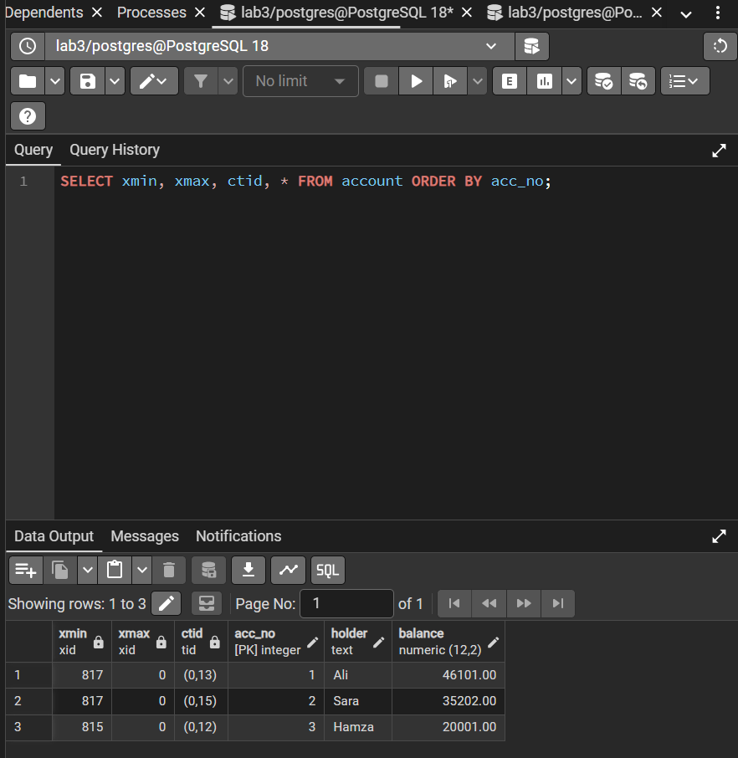
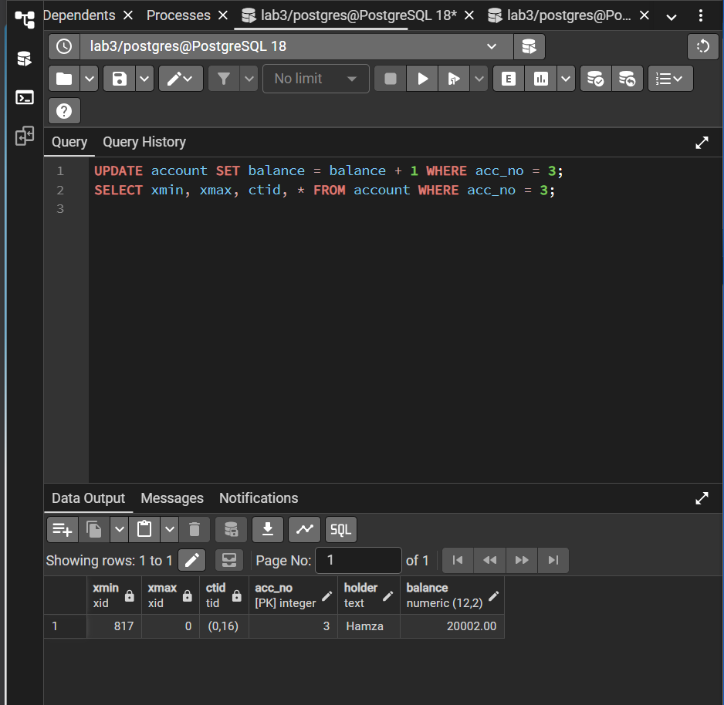

Step 3: Readers do not wait for writers (Read Committed)
Session A
BEGIN;
UPDATE account SET balance = 99999 WHERE acc_no = 3;
-- not committed yet
Session B
SELECT balance FROM account WHERE acc_no = 3;
-- returns the OLD value immediately: no waiting, no dirty read

Session A
COMMIT;
Session B
SELECT balance FROM account WHERE acc_no = 3;
-- now returns 99999

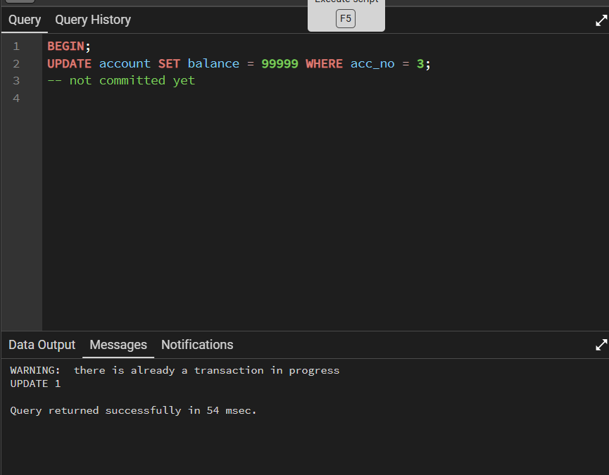
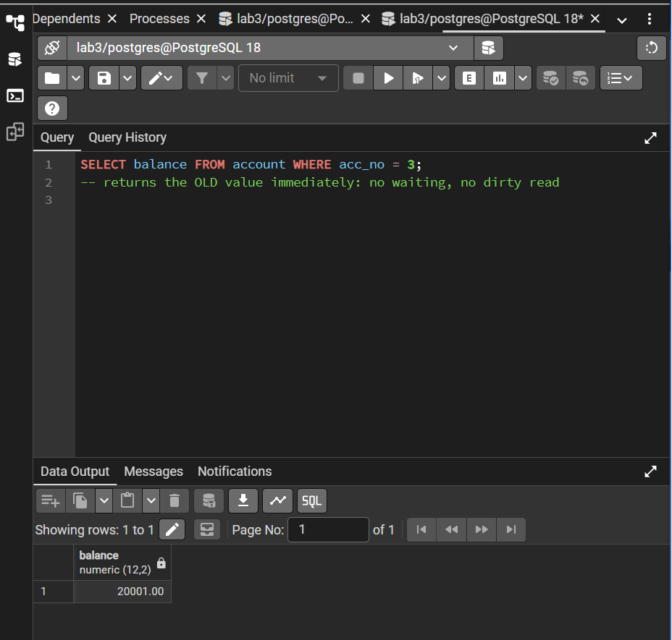
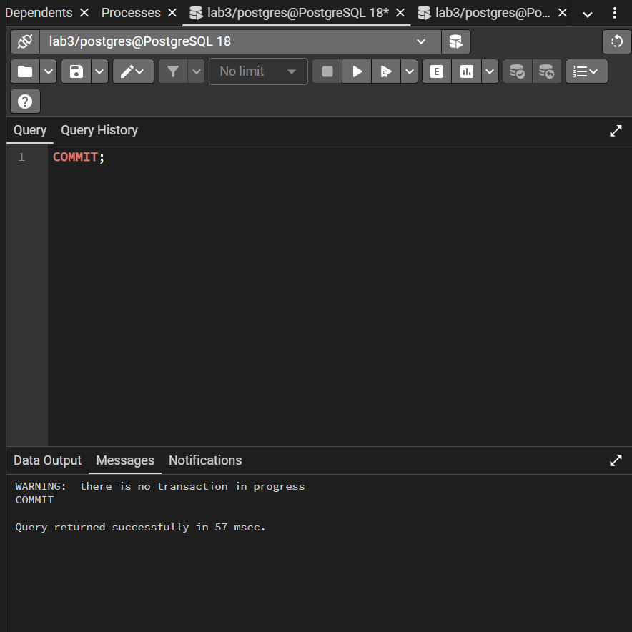
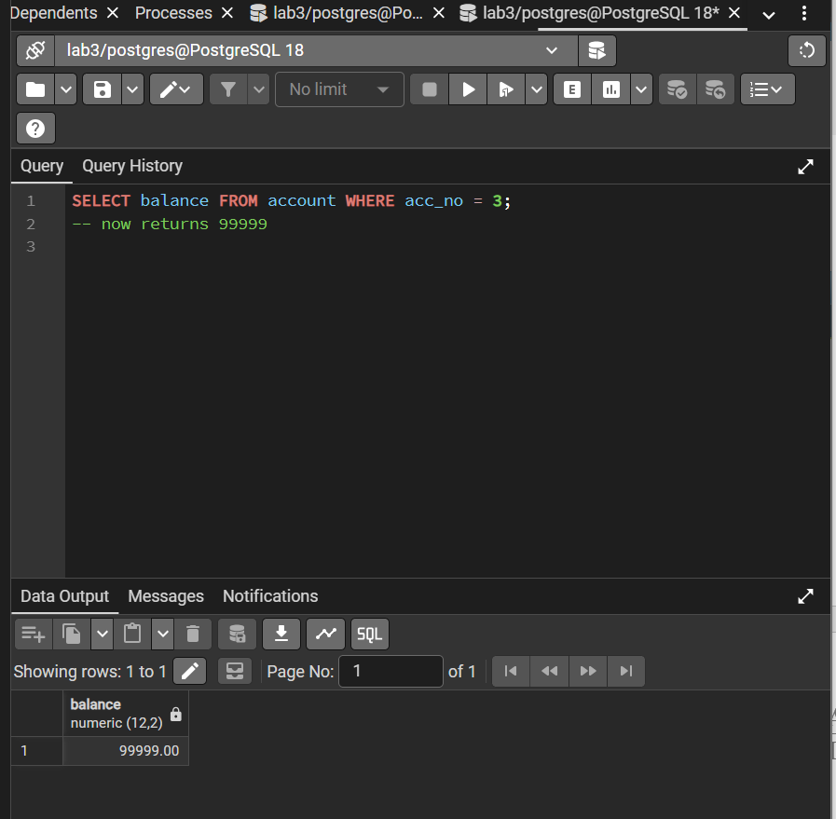

Step 4: A fixed snapshot (Repeatable Read)
Session B
BEGIN ISOLATION LEVEL REPEATABLE READ;
SELECT balance FROM account WHERE acc_no = 3;
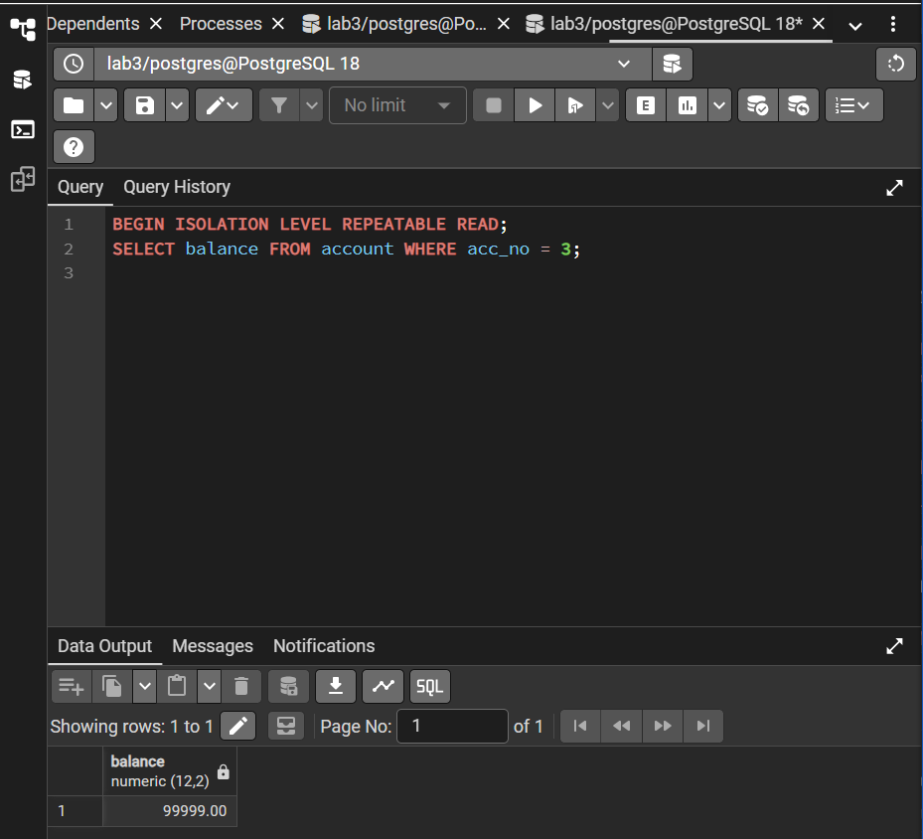
-- note the value
Session A
UPDATE account SET balance = balance + 500 WHERE acc_no = 3; -- autocommits
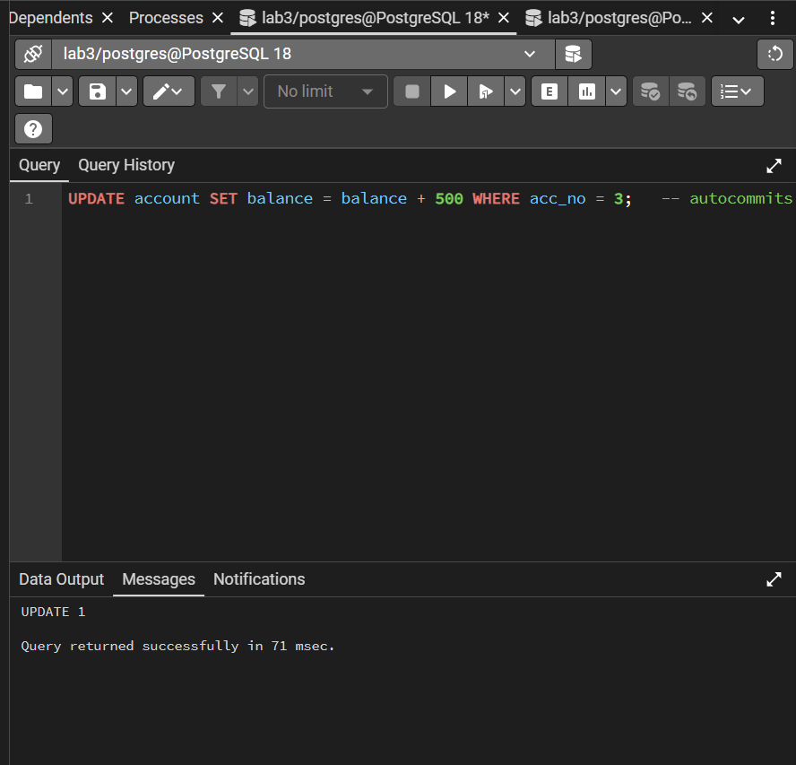

Session B
SELECT balance FROM account WHERE acc_no = 3;
-- STILL the old value: B keeps its snapshot

COMMIT;
SELECT balance FROM account WHERE acc_no = 3;
-- now the new value
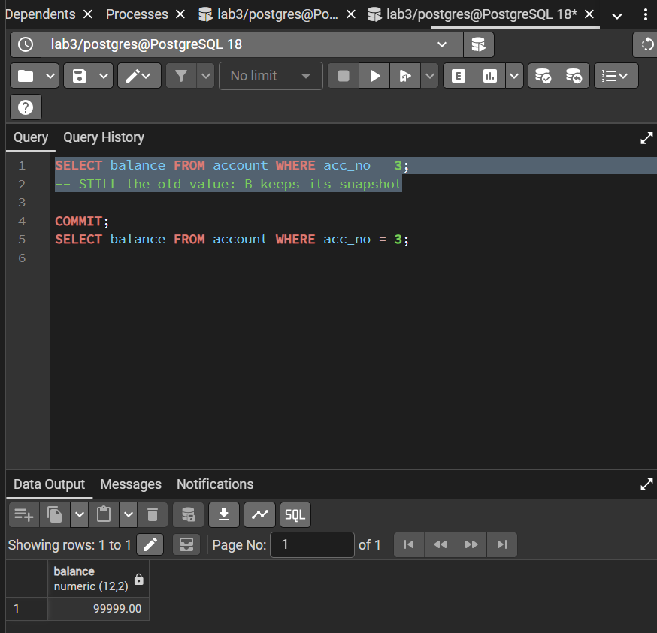
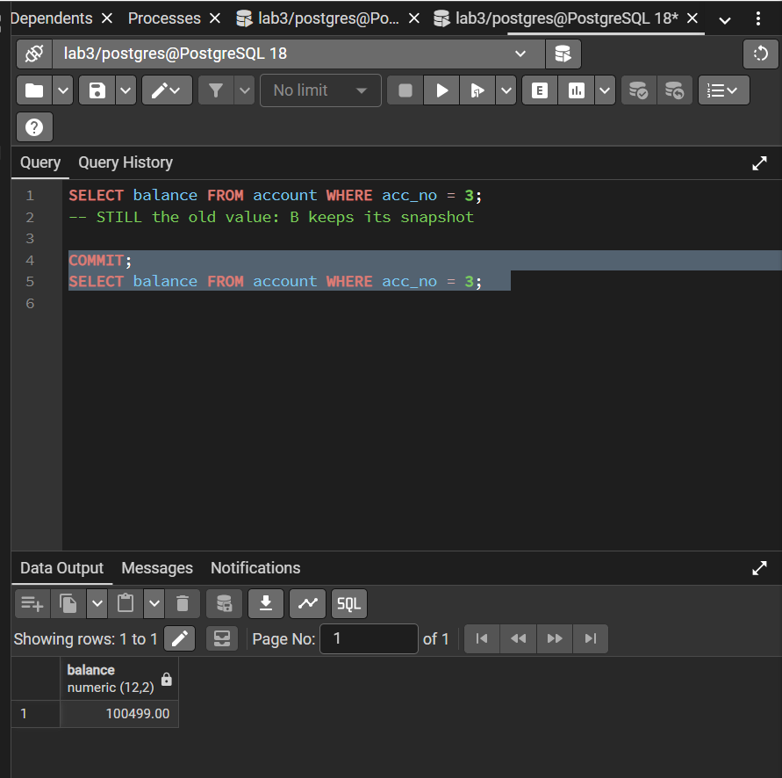

Step 5: Write conflict under Repeatable Read
Session B
BEGIN ISOLATION LEVEL REPEATABLE READ;
SELECT balance FROM account WHERE acc_no = 3;
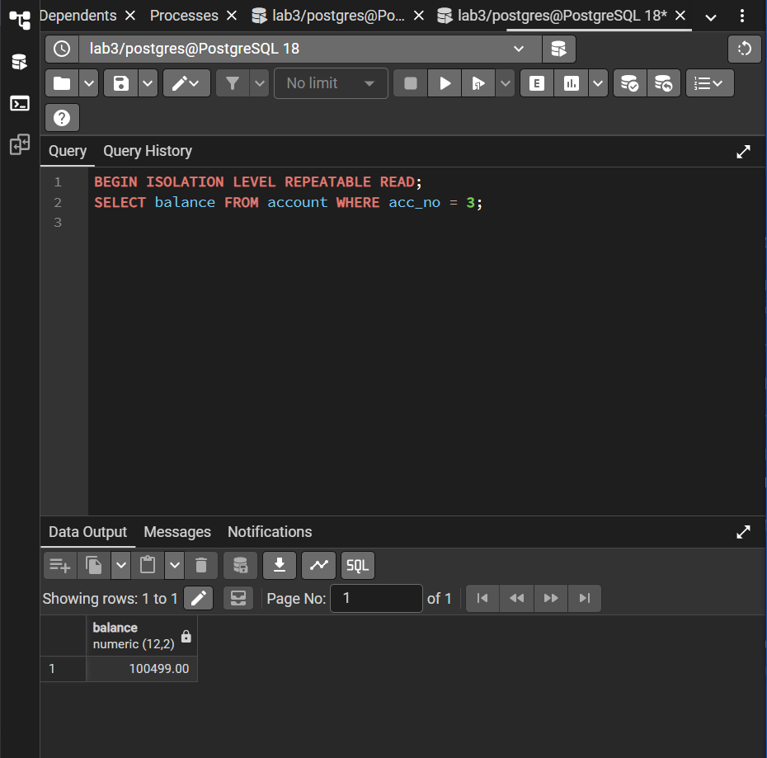
Session A
UPDATE account SET balance = balance + 1 WHERE acc_no = 3;
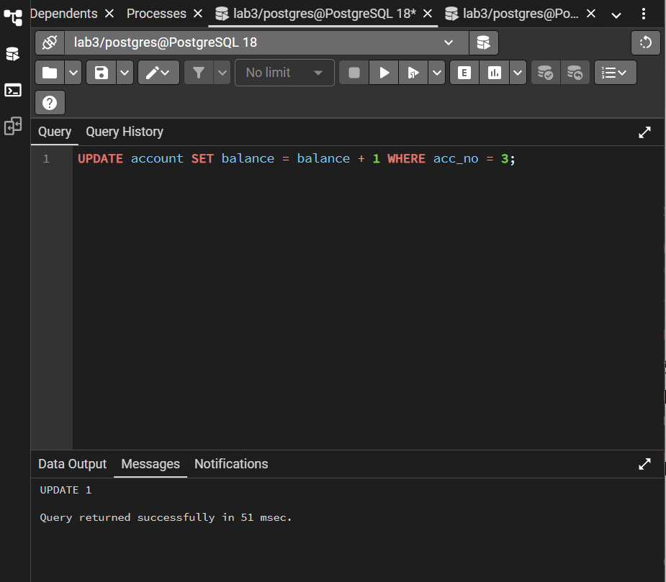
Session B
UPDATE account SET balance = balance + 1 WHERE acc_no = 3;
-- ERROR: could not serialize access due to concurrent update
ROLLBACK;
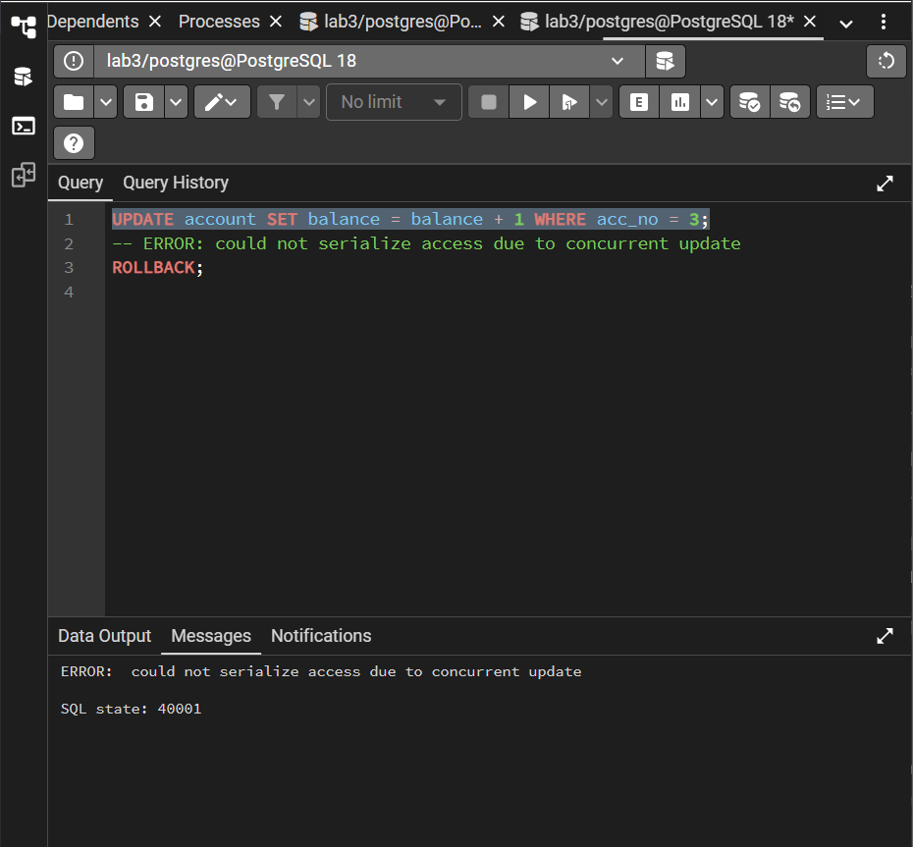
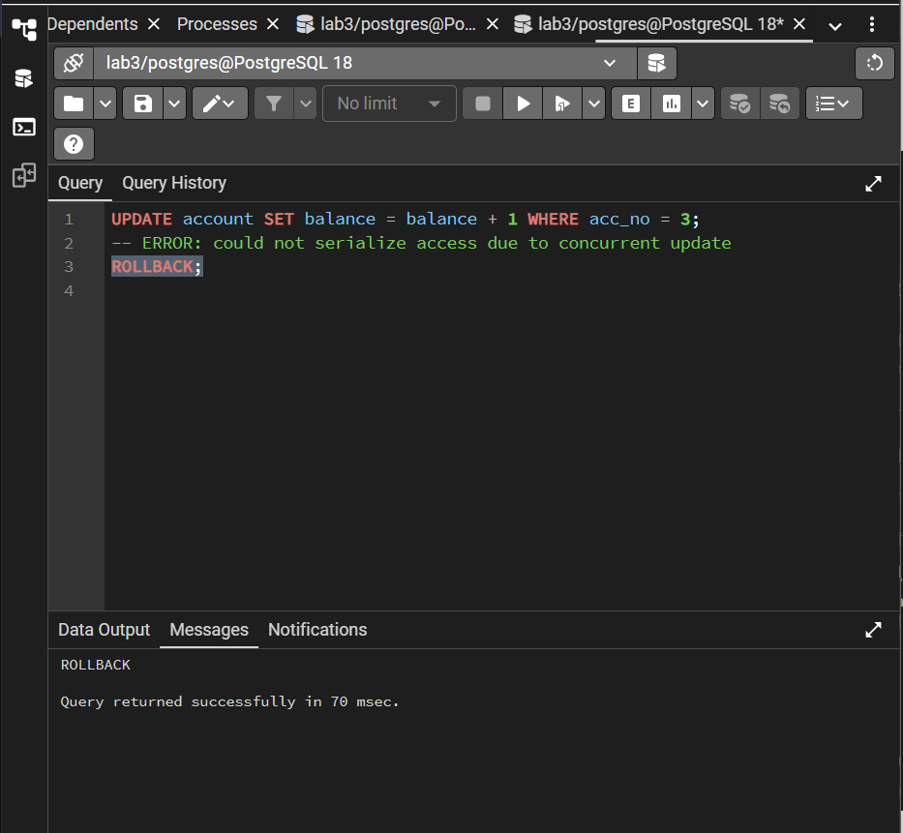
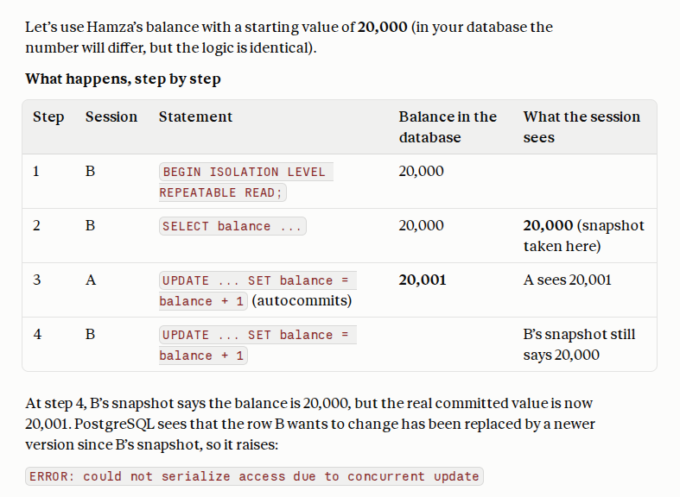
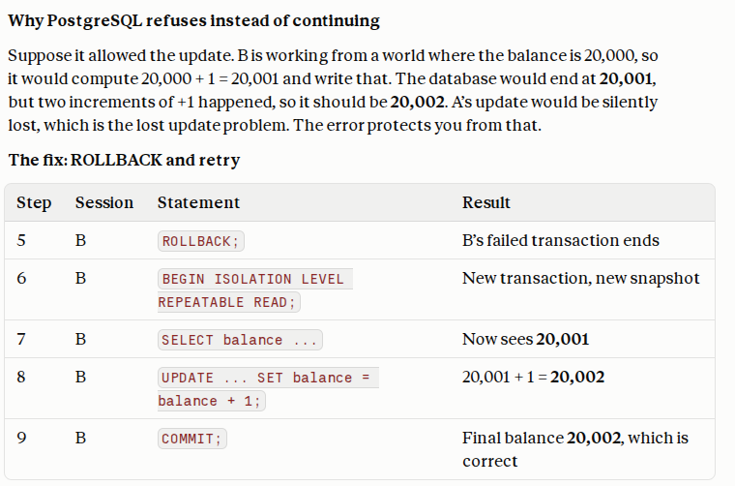

Step 6: Clean up old versions
Run VACUUM alone (highlight only this line):
VACUUM account;
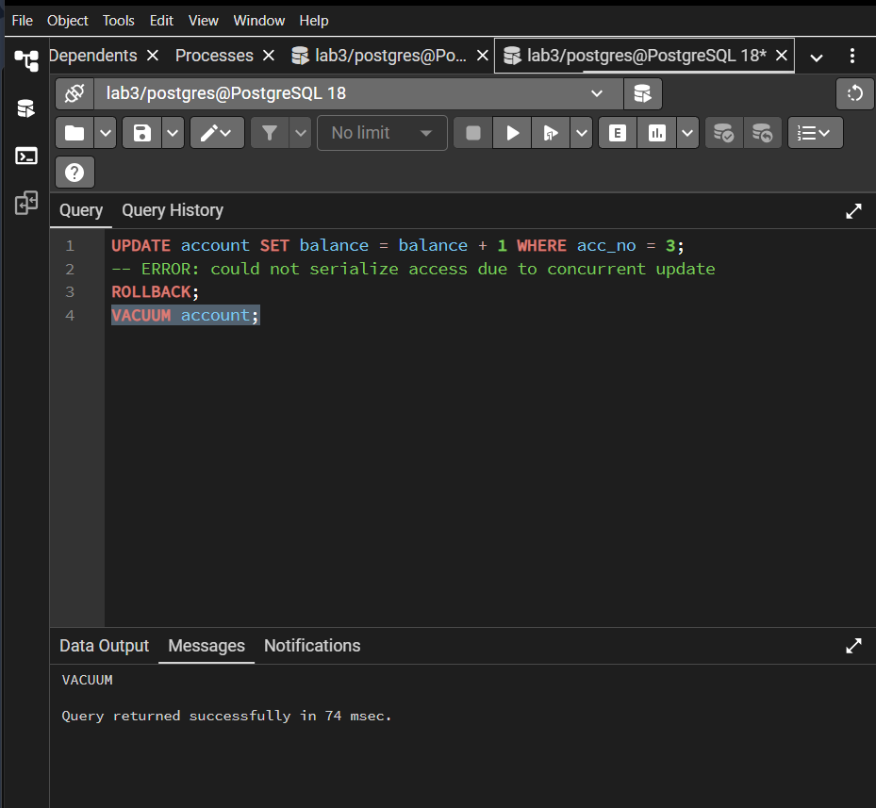
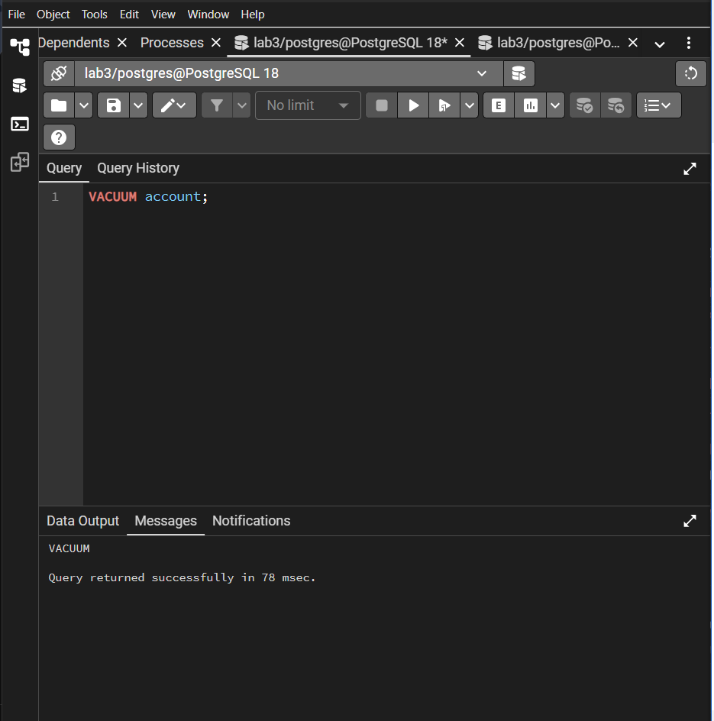
Explanation of Changes:
- Each UPDATE writes a new row version tagged with the new transaction ID. Older transactions keep reading the older version, so reads never need to wait.
- Under Read Committed each statement gets a fresh snapshot (Step 3 shows the new value after commit). Under Repeatable Read one snapshot lasts for the whole transaction (Step 4).
- MVCC only blocks two writers of the same row. Under Repeatable Read the second writer is not made to wait for an outdated snapshot; it fails (Step 5) and the application must retry.
- The price of MVCC is dead row versions, which VACUUM (or autovacuum) must clean up.

CLASS TASKS:
Use the techniques from the examples above. For the two-session tasks, label every code block with the session it was run in, paste the code below each task and attach screenshots of both tabs.
Task 1: Simulate a basic transaction in SQL and explore ACID properties.
(a) Create a table wallet(wallet_id int PRIMARY KEY, owner text, balance numeric(10,2) CHECK (balance >= 0)) and insert three wallets.
(b) Write one transaction that moves 2000 from wallet 1 to wallet 2 and commits. Show the balances before and after.
(c) Start a transfer, display the changed balance inside the transaction, then ROLLBACK and display the balances again. Which ACID property is shown?
(d) Try a transfer larger than the balance. Write the error message and the command needed to continue. Which ACID property is shown?
(e) Use a SAVEPOINT to undo only the second of two updates in one transaction.
CREATE TABLE wallet (
wallet_id INT PRIMARY KEY,
owner TEXT,
balance NUMERIC(10,2) CHECK (balance >= 0)
);

INSERT INTO wallet (wallet_id, owner, balance)
VALUES
(1, 'Ali', 10000),
(2, 'Sara', 8000),
(3, 'Ahmed', 5000);

SELECT * FROM wallet ORDER BY wallet_id;

BEGIN;

UPDATE wallet
SET balance = balance - 2000
WHERE wallet_id = 1;

UPDATE wallet
SET balance = balance + 2000
WHERE wallet_id = 2;

COMMIT;

SELECT * FROM wallet ORDER BY wallet_id;

BEGIN;

UPDATE wallet
SET balance = balance - 1000
WHERE wallet_id = 1;

SELECT * FROM wallet ORDER BY wallet_id;

ROLLBACK;

SELECT * FROM wallet ORDER BY wallet_id;

BEGIN;

UPDATE wallet
SET balance = balance - 10000
WHERE wallet_id = 3;

ROLLBACK;

SELECT * FROM wallet ORDER BY wallet_id;

BEGIN;

UPDATE wallet
SET balance = balance + 1000
WHERE wallet_id = 1;

SAVEPOINT sp1;

UPDATE wallet
SET balance = balance + 3000
WHERE wallet_id = 2;

SELECT * FROM wallet ORDER BY wallet_id;

ROLLBACK TO sp1;

SELECT * FROM wallet ORDER BY wallet_id;

COMMIT;

SELECT * FROM wallet ORDER BY wallet_id;

a)

b)

C)

D)

E)

Task 2: Implement locking (shared, exclusive) using a DBMS.
(a) Open two Query Tool tabs (Session A and Session B) on the same database.
(b) Exclusive lock: in A update one wallet without committing; in B update the same wallet (it waits) and a different wallet (it succeeds). Commit A and note what B does.
(c) Shared lock: in A run SELECT ... FOR SHARE on a wallet; in B run FOR SHARE on it (works) and then an UPDATE (blocks).
(d) While B is waiting, query pg_locks and pg_stat_activity and paste the rows that show the waiting session.
(e) Create a deadlock between the two sessions and record the error message.
a)

b)

Both shared reads can proceed, but the update waits until the conflicting shared lock is released.

C)

D)
E)
Each transaction held one row lock while requesting another lock held by the opposite transaction. PostgreSQL detected the circular wait and aborted one transaction to break the deadlock.

Task 3: Explore multiversion concurrency control (MVCC) in PostgreSQL.
(a) Display xmin, xmax and ctid for the wallet rows. Update one row and display them again. Explain what changed.
(b) Show that a reader in Session B sees the old value while Session A has an uncommitted update, and the new value after A commits.
(c) Repeat with BEGIN ISOLATION LEVEL REPEATABLE READ in Session B and show that B keeps seeing its old snapshot until it commits.
(d) Run VACUUM wallet (alone) and explain what it cleans up.
A

Explanation:
- xmin: Transaction ID associated with the creation of the row version.
- xmax: Transaction ID associated with deletion or replacement of the version, subject to PostgreSQL's internal tuple-state conventions.
- ctid: Physical tuple location within the table.
An update creates a new row version. Consequently, xmin and ctid commonly change. Do not assume xmax is always zero or that every displayed value will follow a particular pattern.
B)

Under PostgreSQL's default Read Committed isolation level, each statement sees a snapshot of data committed before that statement began. The reader does not see Session A's uncommitted change.

C)

Record the returned value.

D)

HOME TASKS:
Task 1: Seat Booking Transaction
- Create seat(seat_no int PRIMARY KEY, passenger text, booked boolean DEFAULT false) and ticket_sales(sale_id serial PRIMARY KEY, seat_no int, amount numeric).
- Write a transaction that books a seat (updates seat) and records the sale (inserts into ticket_sales), then commits.
- Repeat but make the second step fail (e.g. a wrong data type or a NULL violation). Show that the seat is not booked after ROLLBACK. Explain which ACID property this is.
SOL:
--Session A
CREATE TABLE seat (
seat_no INT PRIMARY KEY,
passenger TEXT,
booked BOOLEAN DEFAULT FALSE
);

CREATE TABLE ticket_sales (
sale_id SERIAL PRIMARY KEY,
seat_no INT,
amount NUMERIC
);

INSERT INTO seat (seat_no, passenger, booked)
VALUES
(1, NULL, FALSE),
(2, NULL, FALSE),
(3, NULL, FALSE);

SELECT * FROM seat ORDER BY seat_no;

SELECT * FROM ticket_sales ORDER BY sale_id;

BEGIN;

UPDATE seat
SET passenger = 'Ali',
booked = TRUE
WHERE seat_no = 1;

INSERT INTO ticket_sales (seat_no, amount)
VALUES (1, 2500);

COMMIT;

SELECT * FROM seat ORDER BY seat_no;

SELECT * FROM ticket_sales ORDER BY sale_id;

CREATE TABLE ticket_sales_test (
sale_id SERIAL PRIMARY KEY,
seat_no INT NOT NULL,
amount NUMERIC NOT NULL
);

BEGIN;

UPDATE seat
SET passenger = 'Sara',
booked = TRUE
WHERE seat_no = 2;

INSERT INTO ticket_sales_test (seat_no, amount)
VALUES (2, NULL);

ROLLBACK;

SELECT * FROM seat WHERE seat_no = 2;

SELECT * FROM ticket_sales_test;
1)

2)
Seat 1 is booked for Ali, and the sales table contains a record for Rs. 2,500.

3)

Seat 2 remains unbooked, and the test sales table remains empty.
Task 2: Savepoints
Write a single transaction with three savepoints (sp1, sp2, sp3), each followed by a different change. Roll back to sp2, commit, and show which changes remain. Explain why.
SOL:
BEGIN;

-- Change 1: Increase Ali's balance.
UPDATE wallet
SET balance = balance + 100
WHERE wallet_id = 1;

SAVEPOINT sp1;

-- Change 2: Increase Sara's balance.
UPDATE wallet
SET balance = balance + 200
WHERE wallet_id = 2;

SAVEPOINT sp2;

-- Change 3: Increase Ahmed's balance.
UPDATE wallet
SET balance = balance + 300
WHERE wallet_id = 3;

SAVEPOINT sp3;

-- Undo changes made after sp2.
ROLLBACK TO sp2;

COMMIT;

SELECT * FROM wallet ORDER BY wallet_id;
The rollback returns the transaction to the state at sp2. Therefore, the updates to Ali and Sara remain, while Ahmed's update is undone. sp3 was created after Ahmed's update, so rolling back to sp2 also removes that later savepoint.

Task 3: Isolation Levels
- In Read Committed, show a non-repeatable read: read a row twice in Session B while Session A commits a change in between.
- Repeat in Repeatable Read and show that the problem disappears.
- Present both runs in a table: step, session, statement, value seen.

1)

Step | Session | Statement/action | Value seen
1 | B | First SELECT under Read Committed | Original balance
2 | A | Increase balance by 500 and commit | Updated balance is committed
3 | B | Second SELECT under Read Committed | Original balance + 500
4 | B | First SELECT under Repeatable Read | Balance at snapshot creation
5 | A | Increase balance by 500 and commit | Another updated balance is committed
6 | B | Second SELECT under Repeatable Read | Same value as Step 4
7 | B | Commit and run a new SELECT | Latest committed balance

Under Read Committed, each statement gets a fresh snapshot, so a second read can return a different value. Under Repeatable Read, the transaction retains its snapshot, preventing this non-repeatable read.
Task 4: Lost Update and How to Prevent It
- Simulate a lost update: both sessions read a balance with a plain SELECT, then each writes balance = (value read) + 100 with fixed numbers. Show that one increase is lost.
- Fix it with SELECT ... FOR UPDATE so the second session waits, and show the correct final balance.
1)
Session A:
UPDATE wallet
SET balance = 1000
WHERE wallet_id = 1;

BEGIN;

SELECT balance
FROM wallet
WHERE wallet_id = 1;

--Session A
UPDATE wallet
SET balance = 1100
WHERE wallet_id = 1;

COMMIT;

SESSION B:

--Session B
BEGIN;

SELECT balance
FROM wallet
WHERE wallet_id = 1;

UPDATE wallet
SET balance = 1100
WHERE wallet_id = 1;

COMMIT;

SELECT balance
FROM wallet
WHERE wallet_id = 1;

Both transactions intended to increase the balance by Rs. 100, but the final balance reflects only one increase. Session B overwrote Session A's change with the stale value it had calculated earlier.

2)

SESSION A:
--session A
UPDATE wallet SET balance = 1000 WHERE wallet_id = 1;
BEGIN;
SELECT balance FROM wallet WHERE wallet_id = 1 FOR UPDATE;
--session A UPDATE wallet SET balance = balance + 100 WHERE wallet_id = 1;
COMMIT;

SESSION B:
--session B UPDATE wallet SET balance = 1000 WHERE wallet_id = 1;
BEGIN;
SELECT balance FROM wallet WHERE wallet_id = 1 FOR UPDATE;
--session B UPDATE wallet SET balance = balance + 100 WHERE wallet_id = 1;
COMMIT;
SELECT balance FROM wallet WHERE wallet_id = 1;

SELECT ... FOR UPDATE serializes access to the row. Session B waits for Session A and then reads the latest committed value. Each increment is applied, preserving both updates.

Task 5: Deadlock Avoidance
Reproduce a deadlock between two transfers (A to B and B to A at the same time). Then rewrite both transactions to lock the rows in the same order (for example, always the lower account number first) and show that the deadlock no longer occurs.
1)
Session A:
BEGIN;

UPDATE wallet
SET balance = balance - 100
WHERE wallet_id = 1;

--session A

UPDATE wallet
SET balance = balance + 100
WHERE wallet_id = 2;

ROLLBACK;

SESSION B
BEGIN;

UPDATE wallet
SET balance = balance - 100
WHERE wallet_id = 2;

--session B
UPDATE wallet
SET balance = balance + 100
WHERE wallet_id = 1;

ROLLBACK;

This waits for Session B.

2)

--wallet 1
BEGIN;

SELECT wallet_id, balance
FROM wallet
WHERE wallet_id IN (1, 2)
ORDER BY wallet_id
FOR UPDATE;

UPDATE wallet
SET balance = balance - 100
WHERE wallet_id = 1;

UPDATE wallet
SET balance = balance + 100
WHERE wallet_id = 2;

--wallet 1
COMMIT;

--wallet 2
BEGIN;

SELECT wallet_id, balance
FROM wallet
WHERE wallet_id IN (1, 2)
ORDER BY wallet_id
FOR UPDATE;

UPDATE wallet
SET balance = balance - 100
WHERE wallet_id = 2;

UPDATE wallet
SET balance = balance + 100
WHERE wallet_id = 1;

--wallet 2
COMMIT;

The two transactions do not create a circular wait because both acquire the row locks in the same order.

Task 6: Locking versus MVCC
Research and write a short note (half a page) comparing lock-based concurrency control (two-phase locking) with MVCC. Give one advantage and one disadvantage of each. (Reference: Elmasri & Navathe, chapters on transactions and concurrency control.)

Lock-Based Concurrency Control versus MVCC
Lock-based concurrency control uses locks to regulate concurrent access to database records. Shared locks permit compatible read operations, while exclusive locks prevent conflicting access during modifications. Two-phase locking (2PL) acquires locks during the growing phase and releases them during the shrinking phase. Strict variants retain exclusive locks until the transaction completes, helping prevent certain cascading rollback problems.
Advantage: Locking helps maintain consistency by preventing conflicting transactions from modifying the same data simultaneously. It is particularly useful when strict coordination between concurrent updates is required.
Disadvantage: Transactions can block each other while waiting for locks. Poorly ordered locking can also cause deadlocks, reducing concurrency and requiring transaction retries.
Multiversion Concurrency Control (MVCC) maintains multiple versions of database rows. Instead of forcing every reader to wait for a writer, the database allows a transaction to read a version consistent with its snapshot. PostgreSQL uses MVCC to support concurrent reads and writes while maintaining transaction isolation.
Advantage: Readers generally do not block writers, and writers generally do not block ordinary readers. This can improve concurrency in applications with many read operations.
Disadvantage: Multiple row versions consume storage and require cleanup by mechanisms such as VACUUM. Concurrent writes can still block each other, and transactions at stronger isolation levels may need to be retried after conflicts.
Conclusion: Lock-based control coordinates access by restricting conflicting operations, whereas MVCC allows readers to use appropriate row versions. PostgreSQL combines MVCC with locking to provide transaction consistency and efficient concurrent access.

Discussion and analysis of results:
During this lab, transaction processing and concurrency control were implemented using PostgreSQL. The experiments demonstrated how transactions maintain database consistency and how concurrent users can safely access and modify shared data.
In Task 1, the wallet table was used to demonstrate the ACID properties. COMMIT made the transfer permanent, while ROLLBACK cancelled uncommitted changes. The CHECK constraint prevented a wallet balance from becoming negative, demonstrating consistency. SAVEPOINT allowed selected changes to be undone without cancelling the entire transaction.
In Task 2, exclusive locks prevented conflicting updates to the same wallet, whereas shared locks allowed multiple transactions to read a row while blocking conflicting modifications. The pg_locks and pg_stat_activity system views helped identify locking activity and waiting queries. The deadlock experiment demonstrated how PostgreSQL detects circular waits and aborts one transaction to allow the other to proceed.
In Task 3, MVCC was explored through the xmin, xmax and ctid system columns. Updates created new row versions, allowing concurrent readers to access previously committed data without waiting for an uncommitted update. Read Committed provided a fresh snapshot for each statement, while Repeatable Read maintained a consistent snapshot throughout the transaction. VACUUM was used to clean up obsolete row versions when they were no longer needed.
The home tasks further demonstrated transaction atomicity through seat booking, partial rollback through savepoints, isolation-level differences through non-repeatable reads, and the lost-update problem. Using SELECT FOR UPDATE helped prevent lost updates by coordinating access to a shared row. Consistent lock ordering reduced the possibility of deadlocks.
Finally, the comparison between lock-based concurrency control and MVCC showed that both techniques help maintain database correctness, but they manage concurrent access differently. PostgreSQL combines row and table locking with MVCC to provide reliable transaction processing and efficient concurrent access.

Conclusion:
This lab provided practical experience with transaction processing and concurrency control in PostgreSQL. The experiments demonstrated the use of BEGIN, COMMIT, ROLLBACK and SAVEPOINT, along with the four ACID properties. Shared and exclusive locks were used to examine concurrent access, blocking and deadlocks. MVCC was explored to understand row versioning and snapshot-based reads under different isolation levels. The home tasks further demonstrated lost updates, non-repeatable reads and deadlock prevention through consistent lock ordering. Overall, the lab improved understanding of how PostgreSQL maintains data consistency, protects concurrent transactions and manages multiple versions of database records.

Common Problems and Fixes:
Problem | Fix
A tab stays on "Running..." and does not finish | It is waiting for a lock held by the other tab. Go to the other tab and run COMMIT or ROLLBACK, or press the Stop button.
"current transaction is aborted, commands ignored until end of transaction block" | An earlier command in the transaction failed. Run ROLLBACK; and start again with BEGIN;.
The other tab does not see my changes | You have not run COMMIT yet. Uncommitted changes are invisible to other sessions.
Locks are left behind by a forgotten open transaction | Run COMMIT or ROLLBACK in that tab. If it is closed or stuck, find it with SELECT pid, state FROM pg_stat_activity WHERE state = 'idle in transaction'; and end it with SELECT pg_terminate_backend(pid);.
"deadlock detected" | Expected in the deadlock demo. Run ROLLBACK; in the tab that reported it.
"could not serialize access due to concurrent update" | Expected under Repeatable Read when two sessions change the same row. Run ROLLBACK; and retry the transaction.
"there is no transaction in progress" (warning on COMMIT) | You ran COMMIT without BEGIN. It is harmless.
VACUUM fails inside a transaction block | Highlight and run VACUUM alone, as in Lab 2.

Starting over (reset the database):
First end every open transaction in both tabs, then run:
DROP SCHEMA public CASCADE;
CREATE SCHEMA public;
This deletes everything in lab3, so use it only for lab work.

Viva Preparation Questions:
- What is a transaction? Explain with an example.
- Explain the four ACID properties and give one example of each.
- What is the difference between COMMIT, ROLLBACK and SAVEPOINT?
- What are lost update, dirty read, non-repeatable read and phantom read?
- What are the isolation levels of PostgreSQL and which one is the default?
- What is the difference between a shared lock and an exclusive lock? Which combinations are compatible?
- What is a deadlock and how does PostgreSQL handle it?
- What is MVCC? Why do readers not block writers in PostgreSQL? What are xmin and xmax?

