Diploma of Information Technology
Analyse Software Requirements

System Analyst Team Members:
Michael Booker-Adams
Daniel Palazzolo
Adam Smith



SmartCarShare Web Application
System Requirements Analysis Report

Document Control
Document ID | SYSTEM DESIGN-v0.1
Title | SmartCarShare Web Application  System Requirements Analysis Report
Version Number | 0.1
Issue Date | June 06, 2024
Classification | Public
Document Revision History
Version | Date | Author | Summary of Changes
1.0 | 14/06/2024 | System Analyst Team | Document created.

Contents
1. Selection of data gathering techniques 4
2. Stakeholder Analysis 5
2.1 Stakeholder Summary 5
2.2 Stakeholder Analysis 6
3. Client interview – Questions asked & answers supplied by client 8
3.2 Stakeholder Influence/Impact Matrix 10
3.3 Minutes of the Meeting 10
4. SmartCarShare – Vision Document 11
5. SmartCarShare - System-Wide Requirements Specification 13
5.1 Introduction 13
5.2 System-Wide Functional Requirements 13
5.3 System Qualities 13
5.3.1 Usability 13
5.3.2 Reliability 13
5.3.3 Performance 13
5.3.4 Supportability 13
5.4 System Interfaces 14
5.4.1 User Interfaces 14
5.4.2 Interfaces to External Systems or Devices 14
5.5 Business Rules 14
5.6 System Constraints 14
5.7 System Compliance 14
5.7.1 Licensing Requirements 14
5.7.2 Applicable Standards 14
5.8 System Documentation 14
6. Use Case Diagram 15
7. Validation of high-level requirements 15
8. High Level Solution 16
8.1 Summary of high-level solutions 16
8.2 Use Case Diagram 17
8.3 Cloud Based Computing Solution 17
Database Management System 17
Web Interface Language/s 17
8.2 High level solutions 18
8.3 High level solution checklist 19
9. Identify Business Process Efficiencies 19
9.1 Business Process Efficiencies 19
10. Feasibility Reports 20
10.1 Scope analysis 20
10.2 Time Analysis 20
10.3 Cost Analysis 20
11. Risk Analysis 21
12. Future Requirements 24
13. Client review & sign off for High Level Solutions, Feasibility Study, and Future Requirements 25
15. Develop BPMN2 Diagrams 26
15.1 Booking and Payment 26
15.2 Registration 27
15.3 User Support 28
16. Validation of low-level requirements 29
17. Team Contributions 30
18. Appendix 31
18.1 Interview overview 31

1. Selection of data gathering techniques
The SmartCarShare business is a cooperative owned by its members, primarily serving inner-city residents who need occasional access to a car. The service allows members to rent vehicles for short durations, ranging from one hour to three days. The business maintains a fleet of various vehicle types, including small passenger cars, larger passenger vehicles, small moving vans, and medium-sized four-wheel-drive vehicles. These vehicles are stationed at designated parking spaces provided by city councils, either free of charge or for an annual fee.

SmartCarShare aims to streamline its operations by implementing a new system to manage all aspects of the business. This includes handling member registrations, vehicle bookings, rental fee calculations, fuel and insurance management, vehicle maintenance, and damage reporting. The new system will be developed and delivered in stages to allow gradual data entry and transition to full implementation.
Identifying key stakeholders is crucial to establishing and defining the necessary requirements to complete a project. As seen below in section 2, we have outlined key stakeholders that may influence the design and planning process. There are several data gathering techniques that are being considered for this process, each with their own strengths and weaknesses. We have identified three that may be used for this process:
- Interviews with open-ended questions.
- Brainstorming with each group.
- Surveys.

The decision has been made to create an individual interview process with the CEO, the Developer team, and the Management team to assess key areas and gather the necessary feedback to proceed with the ongoing system analysis and design process. This was chosen as it allows us to get insights from each key stakeholder in a non-constrained method. To complete this, we have developed an interview process that will be used as our primary information gathering technique. This may be supplemented at some stage with other feedback techniques such as questionnaires, observation, review of current trends and contemporary research, or any other technique that may be relevant to our use case. We have developed a set of open-ended questions that will be used to interview the key stakeholders and use their insight and feedback to develop the vision statement and system-wide requirements for this application

2. Stakeholder Analysis

2.1 Stakeholder Summary

Name | Description | Responsibilities
CEO (Mr. Ian Wilson) | Chief executive officer of SmartCarShare. | Providing high-level guidance, decision-making, overall project oversight
Cooperative Members | Individuals who are part of the SmartCarShare cooperative | Adhering to terms and conditions, providing feedback for service improvement, utilizing car-sharing services
City Councils | Municipal governing bodies responsible for providing parking spaces | Allocating designated parking spaces, negotiating agreements with SmartCarShare, ensuring compliance with regulations
Development Team | Team responsible for designing and implementing the custom-built system | Gathering requirements, system design, software development, testing, deployment, maintenance

2.2 Stakeholder Analysis
Stakeholder | Influence | Importance | What is important to the stakeholder? | How could the stakeholder contribute to the project? | How could the stakeholder block the project? | Strategy for engaging the stakeholder
Developer Team | High | High | Technical development and implementation. | Developing and implementing software features and functionalities. | Delays in development or technical issues. | Regular communication, feedback sessions, and agile development methodologies.
Management Team | High | High | Strategic planning and decision-making. | Providing guidance, resources, and support for project execution. | Misalignment in goals or conflicting priorities. | Regular meetings, progress updates, and aligning strategies with organizational objectives.
Regulators | High | High | Ensuring project compliance with regulations. | Setting regulatory standards and ensuring project adherence. | Imposing fines or halting project for non-compliance. | Regular communication, compliance audits, and addressing regulatory concerns proactively.
Payment Processor | Low | High | Secure and efficient financial transactions. | Handling payment transactions between users and drivers. | Payment processing issues or delays. | Working closely with payment processors to optimize transaction processes and resolve issues.
Investors | High | High | Return on investment and project success. | Providing financial backing and resources for project development. | Withholding funding or withdrawing support. | Regular updates on project progress, financial forecasts, and demonstrating potential returns.
Local Businesses | Low | Low | Economic impact and community relations. | Supporting project initiatives and collaborating on local partnerships. | Lack of interest or conflicting priorities. | Engaging with local businesses through partnership opportunities and economic incentives.
Vehicle Manufacturer | Low | Low | Vehicle availability and quality. | Providing vehicles suitable for ride-sharing services. | Supply chain disruptions or quality issues. | Establishing partnerships for vehicle procurement and maintenance, ensuring quality standards are met.
Insurance Company | Low | Low | Risk management and coverage. | Providing insurance coverage for drivers and passengers. | Denial of coverage or high premiums. | Negotiating insurance policies and ensuring compliance with coverage requirements.
Cloud Provider | Low | Low | Hosting and infrastructure services. | Providing reliable cloud services for project infrastructure. | Downtime or service disruptions. | Establishing service level agreements (SLAs) and regular performance monitoring with cloud providers.
Media | Low | High | Accurate and timely reporting. | Providing media coverage and public opinion on the project. | Negative coverage or misinformation. | Engaging with media through press releases, interviews, and providing accurate project updates.
Customers | Low | High | Reliable and convenient service. | Providing feedback and usage data to improve the service. | Negative reviews or complaints. | Engaging with customers through surveys, feedback forms, and communication channels.
Marketing | Low | High | Effective promotion of the service. | Creating marketing campaigns and strategies to attract customers. | Ineffective marketing efforts or messaging. | Collaborating with marketing teams to align messaging and strategies with project goals.
Compliance | Low | High | Adherence to legal and regulatory requirements. | Ensuring project activities comply with relevant laws and regulations. | Legal issues or fines due to non-compliance. | Regular audits and legal reviews to ensure compliance, training on regulatory requirements.
General Public | Low | High | Positive impact on the community. | Providing feedback and community sentiment towards the project. | Public backlash or negative perception. | Engaging with the public through community events, outreach programs, and transparency.
Admin | Low | Low | Administrative support for project activities. | Handling administrative tasks and paperwork related to the project. | Delaying administrative processes or approvals. | Streamlining administrative processes and ensuring clear communication channels.
Council | Low | Low | Regulatory oversight and approval. | Reviewing and approving project plans and activities. | Rejecting project proposals or imposing strict regulations. | Building relationships and advocating for the project's benefits to gain council support.
Competitors | Low | Low | Competitive landscape and market positioning. | Monitoring competitor actions and market trends. | Direct competition or attempts to undermine the project. | Differentiating the project and offering unique value propositions to attract users and stakeholders.

3. Client interview – Questions asked & answers supplied by client

Client Discussion
The following is a summary of the meetings held between the client and the development team where we reviewed the following document:
Date | Who | What | Result
12/05/2024 | Client, System Analyst | Discuss about the hardware and OS | AWS cloud solution
14/05/2024 | Client, System Analyst | Discuss about the database | MongoDB
16/05/2024 | Client, System Analyst | Discuss about the database access | Node.js
17/05/2024 | Client, System Analyst | Discuss about the web application and UI | HTML5, CSS3 and React,
25/05/2024 | Client, System Analyst | Discuss about email solution | Asked interaction with MS Outlook
27/05/2024 | Client, System Analyst | Discuss about licensing requirements | Need software license for AWS, Mongosh, Visual Studio Code, MS Outlook
01/06/2024 | Client, System Analyst | Discuss about supportability and maintainability | Asked to provide: Comments in programming codes, documentation for technical side, documentation for system design, online tutorial for users

The issues that were highlighted in the meeting have now been resolved and the documents are now accepted as accurate and complete:

Client Representative: Jefi Varghese

Client Signature: Jefi Varghese

Date: 17 / 05 / 2024

3.2 Stakeholder Influence/Impact Matrix
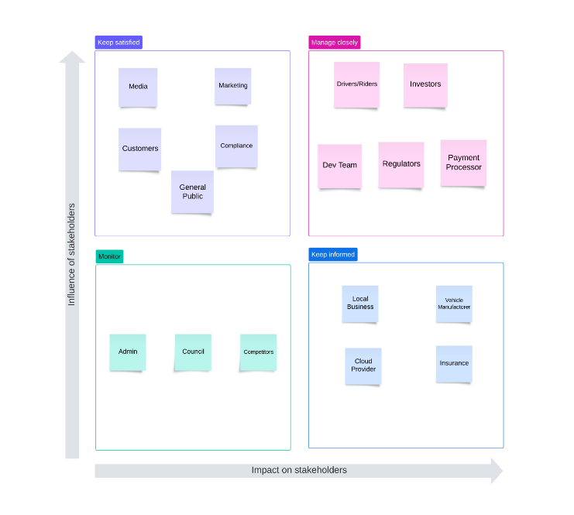

3.3 Minutes of the Meeting
Date: 17/05/2024
Time: 11.00am
Location: Holmesglen Webex
Attendees:
- Jefi Varghese
- Daniel Palazzolo
- Adam Smith
- Michael Booker-Adams
Agenda:
- Overview of current workflow and processes.
- Main pain points experienced.
- Scenarios where a new system could improve efficiency or effectiveness.
- Deployment considerations.
- Design and user experience requirements.
- Considerations for new business establishment.
- Essential features or functionalities for the new system.
- Impact of the new system on cooperative members.
- External factors or constraints.
- Critical features for success.

4. SmartCarShare – Vision Document
Vision Document
Problem Statement
The problem of:
- SmartCarShare is lacking a system to manage the operations of car rentals such as fees, members, and rental dates.
- System needs to be easy to understand/manage by workers of SmartCarShare.
- System needs to be consistent so no information about rentals, cars, and payments are lost during a rental.
- System needs to be able to contact customers to keep them up to date and aware of any excess charges or the ending date of their rental.
Affects:
- Students
- The stakeholders (Customers, Members/Owners, Insurance Providers, Software Developers, City Council)
- Young/Entry level workers.
The impact of which is:
- The manual management system currently used by SmartCarShare presents operational challenges, including inefficient vehicle booking, tracking, and member management. These limitations hinder service quality, member satisfaction, and scalability.
A successful solution would be:
- A system/database that is easily managed and upkept.
- A system that is reliable/has redundancies.
- A system that functions automatically and with little maintenance.
- A system that is highly scalable.
- A system that is efficient.
- Cross-browser compatible website.
- Help students revise for tests and exams.
- Fun and interactive revision for students.
Product Position Statement
For:
- SmartCarShare
Who:
- Need an automatic system to manage and keep track of rentals and rental information without manual work.
The (product name):
- SmartCarShare App
That:
- The idea of the product is that it will be something that can run many rental operations without much manual labor involved.
- Can track a large amount of data about members and rentals.
- Make data easily accessible for employees and members alike.
- The system will provide an efficient and futureproof way to keep track of and keep up to scale with all the data business needs of the company.
Unlike:
- Traditional database systems which often require significant manual input and maintenance, SmartCarShare App offers seamless automation, real-time data tracking, and user-friendly interfaces, enabling more efficient and scalable rental management operations.
Our product:
- A database that will run data processes automatically.
- Will be linked to other SmartCarShare assets to automatically add new stock to the database.
- Will have an automatic communications system for contacting customers about due dates and fees.
- Will be easily accessible to employees to quickly gather records if needed.
- Will be consistent and easily readable for easy future maintenance as to not disrupt the company for long periods of time.

5. SmartCarShare - System-Wide Requirements Specification

5.1 Introduction
This section will outline the purpose of the new system, which is to enhance the car rental process for a diverse user base including the public, admin personnel, and stakeholders. The system aims to address current workflow inefficiencies, improve security, ensure regular car maintenance, and ultimately serve society by providing an enjoyable car riding experience.

5.2 System-Wide Functional Requirements
Registration process with validation for age (over 18), adequate driver's license, and no criminal record.
Availability checking for cars within a reasonable budget.
Payment processing system that supports credit cards without storing sensitive data. Invoice generation with number, price, and tax details.
Detailed transaction reports for tax purposes.
Late return fines calculated on an hourly basis.
Accessibility features, including screen reader support.

5.3 System Qualities

5.3.1 Usability
Simple and intuitive UX, minimizing the number of clicks to complete a booking or payment. Mobile app to increase efficiency and effectiveness.
Consideration for future advertisement spaces within the app.

5.3.2 Reliability
Secure handling of user data and transactions.
Regular maintenance scheduling for cars to ensure reliability.

5.3.3 Performance
Responsive design to ensure quick and efficient user interactions.

5.3.4 Supportability
System should be easily upgradable and maintainable.
Training materials for staff on cloud and database access.

5.4 System Interfaces

5.4.1 User Interfaces
Look & Feel: Simple, intuitive, and guided user journey to booking and payment.
Layout and Navigation Requirements: Efficient grouping of major screen areas for easy navigation.
User Personalization & Customization Requirements: Options for users to customize their experience based on preferences.

5.4.2 Interfaces to External Systems or Devices
Communications Interfaces: Secure communication protocols, preferably HTTPS, for all data exchanges.

5.5 Business Rules
User must have a bank account or payment system.
Users are fined on an hourly basis for late returns.
Users must meet specific criteria (age, driver's license, no criminal record) to register.

5.6 System Constraints
The system must not store credit card data, adhering to privacy laws.
Deployment and technology choices should prioritize data security.

5.7 System Compliance

5.7.1 Licensing Requirements
Any third-party components used must comply with licensing agreements.

5.7.2 Applicable Standards
Compliance with legal standards for data protection and privacy.

5.8 System Documentation
Online user documentation and help systems that are easy to understand.
Training materials for staff on system use, cloud, and database access.
This adaptation of the provided information into the template sections should serve as a foundational step in documenting the requirements for the new system. Each section aligns with the insights gathered from the client, ensuring a comprehensive understanding of the system's needs and expectations.

6. Use Case Diagram

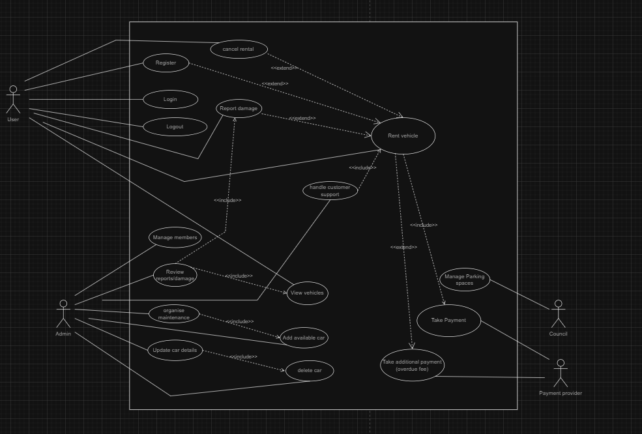

7. Validation of high-level requirements

Client Representative: Jefi Varghese

Client Signature: Jefi Varghese

Date: 17 / 05 / 2024

8. High Level Solution

8.1 Summary of high-level solutions

Area | Option # | Approach | Product | Advantages | Disadvantages
Database | 1 | Relational Database. | MySQL. | reliable, secure | Limited scalability
 | 2 | Relational Database. | Amazon RDS. | Managed service, high scalability and availability. | Cost, limited portability if changing provider.
 | 3 | NoSQL DB | MongoDB | High scalability. | Less data consistency.
User interface | 1 | Responsive design. | HTML5, CSS3. | Enhanced useability & accessibility across all screen sizes. | Can be difficult to ensure consistent design across different screen sizes.
 | 2 | Mobile-first design. | HTML5, CSS3. | Prioritizes mobile users, good experience for smaller screens. | Adapting more complex features for desktop requires time & effort.
 | 3 | MVC. | Laravel Framework. | Organised, many built in features to enhance development | Learning curve.
Business logic & database access | 1 | Database interaction. | Python with MySQLdb. | Broad ecosystem of frameworks and libraries. | Less community support.
 | 2 | Database interaction. | PDO, PHP. | Can use different database systems (MySQL, PostgreSQL, SQLite). | PDO is specific to PHP, if other languages are used, they will need separate connectivity solutions.
Mobile app access | 1 | Native app development | Android Studio, Swift for iOS | High performance, access to device features. | Requires separate development for each platform.
 | 2 | Progressive Web App | React | Easy distribution via web, works on any device with a browser. | Limited access to device features, may not feel as native.

8.2 Use Case Diagram
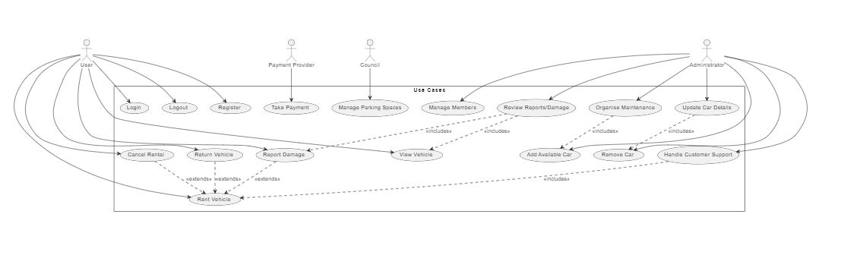

8.3 Cloud Based Computing Solution

Database Management System
for our database management system MongoDB would be best as it’s a well-known database management system that is easy to scale databases with, is simple and effective to implement and use, is reliable and is secure.
The developers are also familiar with MongoDB, making it a more time-effective and cost-effective option.
AWS (Amazon Web Service) is also an option, as it’s also a well-known database management system that uses cloud computing and can deliver fast, scalable and easy to manage databases.

Web Interface Language/s
HTML5 provides the foundation for structuring web content, offering elements for defining layout, text, images, and forms, along with semantic tags for improved accessibility and SEO. CSS3 complements HTML5 by styling web pages and enabling animations and responsive design for seamless adaptation across different devices. JavaScript enhances web pages with interactivity and dynamic behaviour, facilitating manipulation of HTML elements, user interactions and event handling. PHP serves as a server-side scripting language, enabling the development of dynamic web applications that interact with databases, handle form submissions, and implement features like user authentication and session management, providing a comprehensive solution for building modern web interface screens.
Database Connection Framework

Python offers numerous libraries for database connectivity, one of which is MySQLdb, facilitating seamless interaction with databases akin to PHP's PDO. Moreover, Python stands out as a favoured language for web application development, boasting an array of frameworks like Django and Flask, ideal for crafting the web interface of the SmartCarShare system.
Mobile Accessibility
To ensure mobile users can easily carry out tasks, we'll prioritize a responsive, mobile-first design. This approach focuses on optimizing layout, navigation, and interactions for smaller screens, ensuring a consistent and intuitive experience across devices. By starting with mobile design and leveraging responsive techniques, we aim to adapt our application's layout and content dynamically based on the user's device, enhancing usability and accessibility across all platforms.

8.2 High level solutions

Option 1:
Solution | Requirement Met
Use of MongoDB for database management. | Yes
Use of PHP, HTML5 and CSS3 for front end. | Yes
Use of Python for database access. | Yes
Use of progressive web app design for mobile application. | Yes

Option 2:
Solution | Requirement Met
Use of MySQL for database management | Yes
Use of PHP, HTML5 and CSS3 for front end – mobile first design. | Yes
Use of Python with Dynamo DB for database access. | Yes
Use of progressive web app design for mobile application. | Yes

8.3 High level solution checklist
 | Solution 1 | Solution 2
Common coding language | Yes | Yes
Usage of SQL Server for DB | Yes | Yes
Cloud based storage | Yes | No
6 months deadline | Yes | Yes
Budget under $200,000 | Yes | No

9. Identify Business Process Efficiencies
Moving to the new system will provide opportunities for a number of business efficiencies. When you are consulting with the client, you should discuss possible efficiencies and document them in this section of the report.

9.1 Business Process Efficiencies

- New user interface will streamline booking, tracking, and user management for end-users, with an emphasis on ease-of-use and fewer clicks to complete the booking process.
- Improved accessibility options in new UI/UX.
- New automated booking process will trade a small initial learning curve for staff, for automated booking and payment.
- Implementation of MongoDB increases scalability and report-generating processes. This is especially useful for invoice generation.
- Addition of detailed tax breakdown in report generation.
- New implementation increases the security of private data, adhering to local laws and regulations.
- User support will be streamlined with new processes, allowing easier contact between end-users and support platforms.
- New system streamlines the background check process – needed to ensure a clean driving history and valid license details.
- Updated documentation for staff to handle scenarios that involve troubleshooting issues.
- Updated documentation/user guides for users, presented in a simple, easy-to-follow manner.

10. Feasibility Reports

10.1 Scope analysis
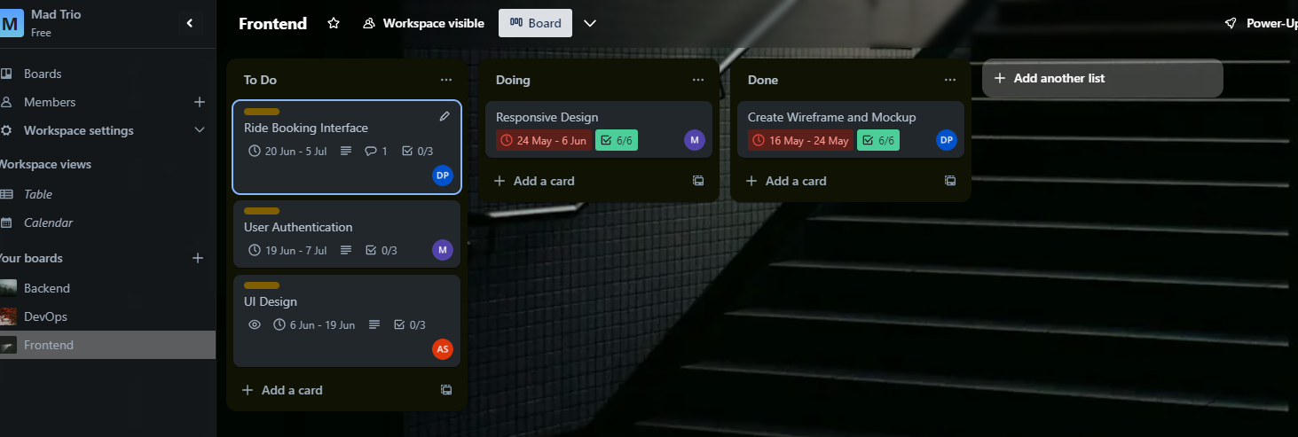

10.2 Time Analysis
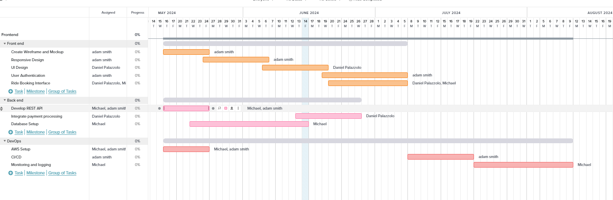

10.3 Cost Analysis

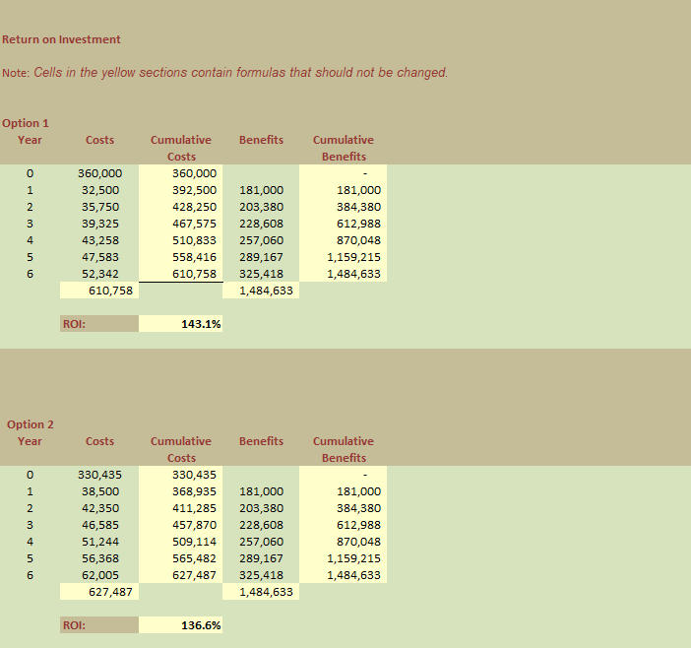

11. Risk Analysis

# | Date Identified | Description | Type | Impact | Probability | Magnitude
1 | Current | Limited scalability with MySQL. | Direct, Technical | 3 | 60 | 1.8
2 | Current | High costs and vendor lock-in with Amazon RDS. | Direct, Financial | 4 | 50 | 2
3 | Current | Less data consistency with MongoDB. | Direct, Technical | 3 | 70 | 2.1
4 | Current | Difficulty ensuring consistent design across devices with responsive design. | Indirect, Technical | 2 | 50 | 1
5 | Current | Challenges adapting complex features for desktop with mobile-first design. | Indirect, Technical | 3 | 60 | 1.8
6 | Current | Learning curve with MVC using Laravel. | Indirect, Technical | 3 | 50 | 1.5
7 | Current | Less community support for Python with MySQLdb. | Indirect, Technical | 2 | 60 | 1.2
8 | Current | PDO being specific to PHP limits flexibility with other languages. | Direct, Technical | 2 | 50 | 1
9 | Current | High development and maintenance costs with native app development. | Direct, Financial | 4 | 70 | 2.8
10 | Current | Limited access to device features and less native feel with Progressive Web Apps. | Direct, Technical | 3 | 60 | 1.8

# | Risk Addressed | Owner | Mitigation Strategy
1 | MySQL scalability | Development Team | Implement database clustering and plan for future scalability or migration.
2 | Amazon RDS costs | Development Team | Prepare for higher initial costs and analyze total cost of ownership with Amazon RDS.
3 | MongoDB consistency | Development Team | Use hybrid database models to ensure data consistency in MongoDB.
4 | Responsive design consistency | Development Team | Employ CSS frameworks like Bootstrap for consistent UI across platforms.
5 | Mobile-first design adaptation | Development Team | Design with mobile constraints in mind and then scale up for desktop features.
6 | MVC Laravel learning curve | Development Team | Offer training and use scaffolding tools to mitigate MVC Laravel learning curve.
7 | Python MySQLdb support | Development Team | Engage more with Python communities or consider more supported libraries.
8 | PDO PHP flexibility | Development Team | Use universal database connectivity libraries or middleware for flexibility.
9 | Native app costs | Development Team | Adopt cross-platform development frameworks to reduce costs and unify codebase.
10 | PWA device features | Development Team | Choose technologies like Flutter or React Native to enhance PWA capabilities.

Swot Analysis
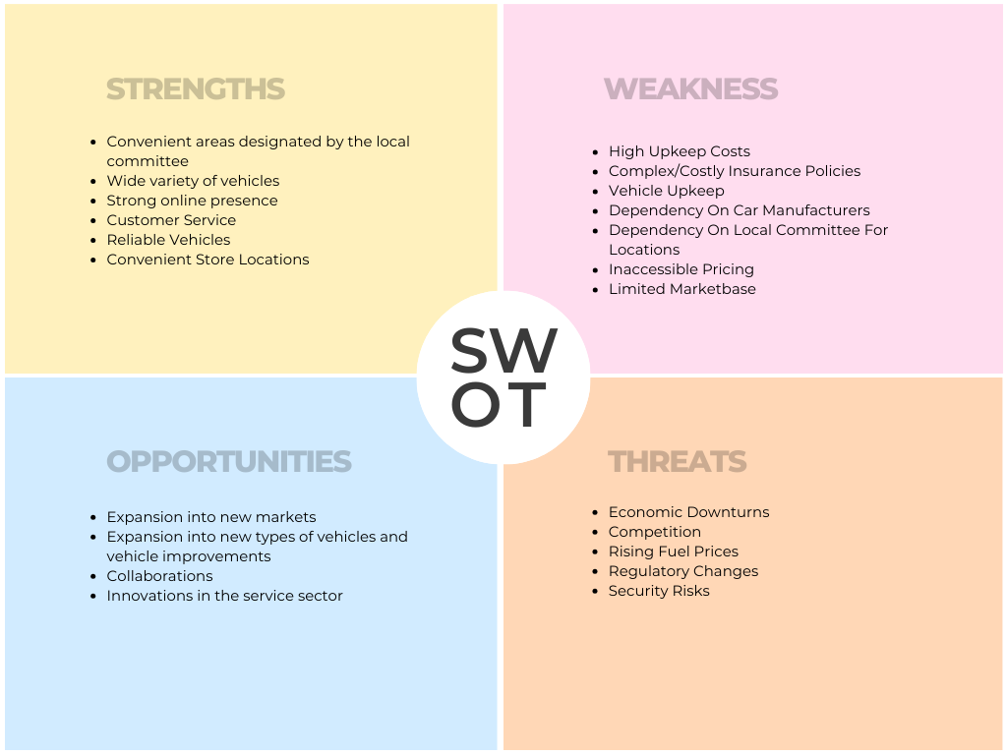

12. Future Requirements

- UI/UX must include customisation and personalisation.
- Expansion into other local government areas (LGA) with cooperation agreements for utilisation of public parking spaces.
- Utilise SMS and email automation for payment reminders, booking reminders, tax invoicing.
- Web and mobile application should be developed.
- Improve payment gateway to include digital wallet and other digital payment forms (such as Apple pay).
- Incorporate positional data for the duration of the car booking to ensure the car rented is being used as described but must adhere to data privacy laws and must not be kept after booking has been completed.

13. Client review & sign off for High Level Solutions, Feasibility Study, and Future Requirements

System Requirements Sign off

Project Title | Customer | Ref | Date
SmartCarShare Web Application | SmartCarShare |  | 07/06/2024

Requirement Traceability matrix
Signed off on behalf of the SmartCarShare

This document acknowledges that the following documents have been completed and signed off by <client>, <roles> on <Date>.

- High Level Solutions
- Feasibility Study Report
- Future Requirements

Signed off on behalf of SmartCarShare

Name:

Title:

Date:

15. Develop BPMN2 Diagrams

15.1 Booking and Payment

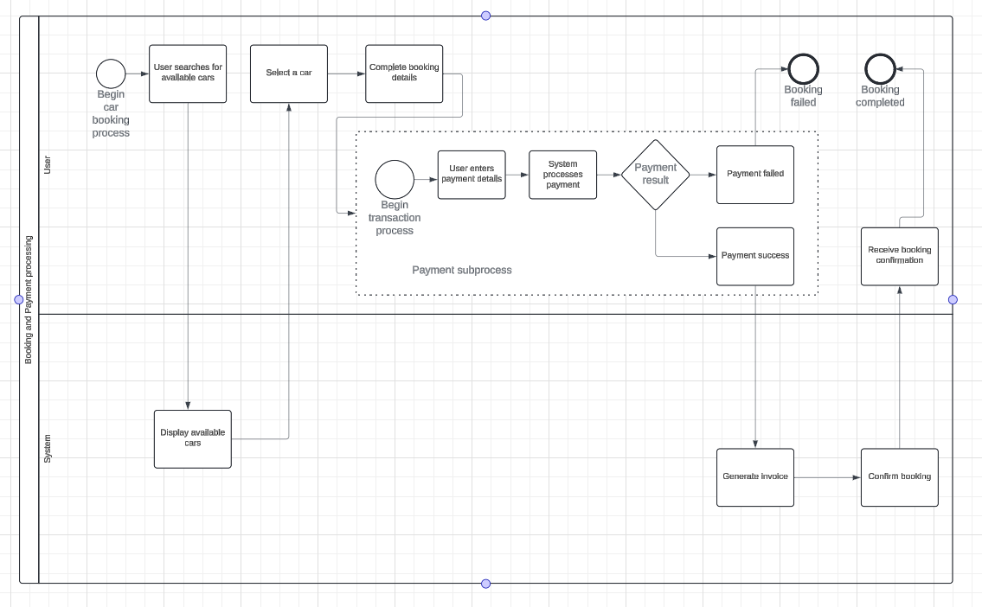

15.2 Registration

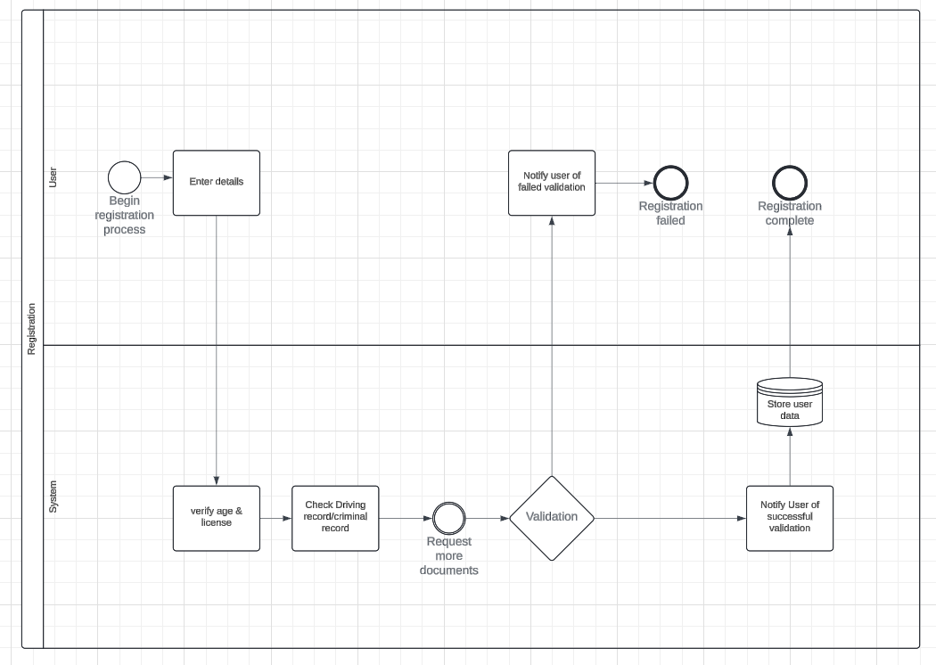

15.3 User Support
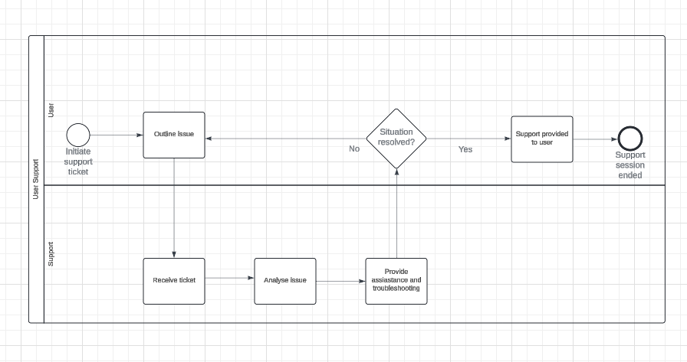

16. Validation of low-level requirements

Client Representative: Bill Smith

Client Sign off

Date: 07/06/2024

17. Team Contributions
Task | Assignee
1.0 Selection of data gathering techniques | Adam Smith
2.0 Stakeholder Analysis & Other Information Sources | Daniel Palazzolo
3.0 Client interview – Question asked & answers supplied by client | Daniel Palazzolo & Adam Smith
4.0 Vision Document | Michael Booker-Adams
5.0 System Wide Requirements | Daniel Palazzolo
6.0 Use Case Diagram | Adam Smith
7.0 Validation of High Level Requirements | Adam, Michael, Daniel
8.0 High Level Solutions | Adam Smith
9.0 Identify and Document any Business Process Efficiencies | Adam Smith
10.0 Provide a Feasibility Study | Adam Smith & Daniel Palazzolo
11.0 Project Risk Analysis | Daniel Palazzolo
12.0 Future Requirements | Adam Smith
13.0 Client Review & Sign Off High Level Solutions | Michael, Adam, Daniel
14.0 Develop BPMN2 Diagrams | Adam Smith
15.0 Validation of Low-Level Requirements | Daniel, Adam, Michael

18. Appendix

18.1 Interview overview

How your current workflow or processes operate
- Admin should be operating this:
  - Staff doesn’t have admin privileges.
  - Owner has full privileges.
  - Staff can update details.
- Processes:
  - First process: Registration.
  - Second process: Checking availability of cars.
  - Third process: Reasonable budget.
- User Requirements:
  - Users must have a bank account and be connected to the respective payment system (Visa, MasterCard, ApplePay).
  - System must be able to process payments without storing details.
  - System should show when a car is booked/available and display available options.
  - Ability to book the car for a specific time and date and show the intended return date.
  - Penalties for returning the car within the time limit.
  - Payment on an hourly basis.
  - User must have an adequate driving license.
  - User must be over 18.
  - No extra cost for o-plate.
Main pain points you currently experience
- Limited admin privileges for staff.
- Manual checking of car availability.
- Handling reasonable budget considerations.
- Ensuring all users meet the requirements (bank account, driving license, age, etc.).
- Managing penalties and payments efficiently.
Examples of scenarios where a new system could improve efficiency or effectiveness
- Payment System and Invoice Generation:
  - Invoice must include tax, invoice number, and price.
  - Detailed reporting.
  - Mainly credit card payments, with some cash payments.
- Regular Car Maintenance:
  - As the establishment grows, ensuring security and regular car maintenance is crucial.
How we deploy it:
- Technologies to Use:
  - Security measures to protect customer interests.
  - Adherence to the privacy policy.
  - Database security.
  - Communication between client and server should be HTTPS.
Design and user experience requirements
- Responsive Design:
  - Mobile app.
  - UI should be simple to use.
  - Minimal clicks for tasks.
  - Focus on accessibility (screen reader support).
  - Cross compatibility between operating systems.
Considerations for new business establishment
- Ease of Operation for Administrators:
  - Automation of tax invoices and registrations.
  - Staff training on using the system, including cloud access, database management, and website internals.
Features or functionalities considered essential for the success of the new system
- Automation:
  - Automated tax invoice generation and registrations.
- User Experience:
  - Simple and intuitive UI.
  - Mobile app support.
  - Accessibility features.
- Security:
  - HTTPS communication.
  - Database security.
  - Adherence to privacy policies.
Anticipated impact of the new system on cooperative members
- Improved user experience with a more intuitive and accessible UI.
- Streamlined processes for booking and returning cars.
- Efficient handling of payments and penalties.
- Enhanced security and compliance with privacy policies.
External factors or constraints to consider
- Integration with existing payment systems (Visa, MasterCard, ApplePay).
- Legal and regulatory compliance for user data and transaction handling.
- Ensuring system scalability to accommodate growth.
Critical features or functionalities for success
- Automated Invoicing and Registration:
  - Reduces manual effort and errors.
- Security and Compliance:
  - Protects user data and meets regulatory requirements.
- User-Friendly Design:
  - Enhances user engagement and satisfaction.
- Scalability:
  - Supports business growth and increased user base.

