High Level Solution
Area | Option # | Approach | Product | Advantages | Disadvantages
Database | 1 | Relational Database. | MySQL. | reliable, secure | Limited scalability
 | 2 | Relational Database. | Amazon RDS. | Managed service, high scalability and availability. | Cost, limited portability if changing provider.
 | 3 | NoSQL DB | MongoDB | High scalability. | Less data consistency.
User interface | 1 | Responsive design. | HTML5, CSS3. | Enhanced useability & accessibility across all screen sizes. | Can be difficult to ensure consistent design across different screen sizes.
 | 2 | Mobile-first design. | HTML5, CSS3. | Prioritizes mobile users, good experience for smaller screens. | Adapting more complex features for desktop requires time & effort.
 | 3 | MVC. | Laravel Framework. | Organised, many built in features to enhance development | Learning curve.
Business logic & database access | 1 | Database interaction. | Python with MySQLdb. | Broad ecosystem of frameworks and libraries. | Less community support.
 | 2 | Database interaction. | PDO, PHP. | Can use different database systems (MySQL, PostgreSQL, SQLite). | PDO is specific to PHP, if other languages are used, they will need separate connectivity solutions.
Mobile app access | 1 | Native app development | Android Studio, Swift for iOS | High performance, access to device features. | Requires separate development for each platform.
 | 2 | Progressive Web App | React | Easy distribution via web, works on any device with a browser. | Limited access to device features, may not feel as native.

Use Case Diagram
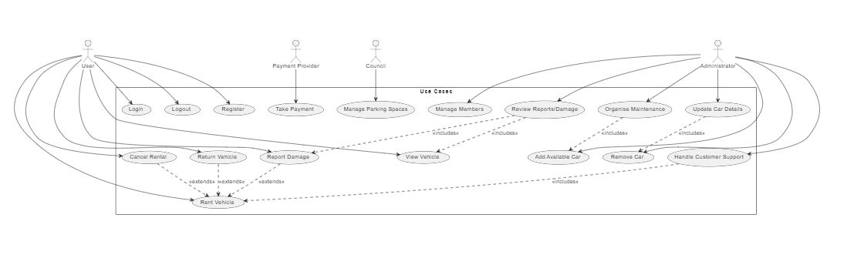

Cloud Based Computing Solution
Database Management System
for our database management system MongoDB would be best as it’s a well-known database management system that is easy to scale databases with, is simple and effective to implement and use, is reliable and is secure.
The developers are also familiar with MongoDB, making it a more time-effective and cost-effective option.
AWS (Amazon Web Service) is also an option, as it’s also a well-known database management system that uses cloud computing and can deliver fast, scalable and easy to manage databases.

Web Interface Language/s
HTML5 provides the foundation for structuring web content, offering elements for defining layout, text, images, and forms, along with semantic tags for improved accessibility and SEO. CSS3 complements HTML5 by styling web pages and enabling animations and responsive design for seamless adaptation across different devices. JavaScript enhances web pages with interactivity and dynamic behaviour, facilitating manipulation of HTML elements, user interactions and event handling. PHP serves as a server-side scripting language, enabling the development of dynamic web applications that interact with databases, handle form submissions, and implement features like user authentication and session management, providing a comprehensive solution for building modern web interface screens.

Database Connection Framework

Python offers numerous libraries for database connectivity, one of which is MySQLdb, facilitating seamless interaction with databases akin to PHP's PDO. Moreover, Python stands out as a favoured language for web application development, boasting an array of frameworks like Django and Flask, ideal for crafting the web interface of the SmartCarShare system.
Mobile Accessibility
To ensure mobile users can easily carry out tasks, we'll prioritize a responsive, mobile-first design. This approach focuses on optimizing layout, navigation, and interactions for smaller screens, ensuring a consistent and intuitive experience across devices. By starting with mobile design and leveraging responsive techniques, we aim to adapt our application's layout and content dynamically based on the user's device, enhancing usability and accessibility across all platforms.

Solution | Requirement Met
Use of MongoDB for database management
Use of PHP, HTML5 and CSS3 for front end
Use of Python for database access
Use of progressive web app design for mobile application

