**SALE AND PURCHASE AGREEMENT**

买卖协议

Between 之间

**SHANGHAI JING TIAN INTERNATIONAL TRADE CO., LTD**

# As **BUYER**

作为买方

And

**BORDER BRAZIL IMPORTAÇÃO E EXPORTAÇÃO**

# As **SELLER**

作为卖方

13TH AUG 2024

THIS SALE AND PURCHASE AGREEMENT OF FROZEN CHICKEN PAWS (the “**Contract**”), is made and entered on AUG **13TH, 2024** by and between

本冷冻鸡爪买卖协议（“合同”）于 2024 年 7 月 13 日由双方订立并签订

**PARTIES AND PURPOSE**

当事方和目的

**THE SELLER**

卖方

|  |  |
| --- | --- |
| Company Name  公司名称 | BORDER BRAZIL IMPORTAÇAO E EXPORTAÇAO |
| Registration Number：  注册号： | CNPJ/MF nº 03.083.869/0001-35 |
| Represented by  代表单位 | Jorge Baklos Alwan |
| Title  标题 | CEO |
| Mailing Address：  邮寄地址 | Avenida 9 de Julho, nº 394, Sala 42, J. Apolo, Sao José dos Campos, Sao Paulo, CEP 12243-001 |
| Email：  电子邮件： | gerencia@borderbrie.com |

**SELLER´S BANKING INFORMATION**

卖方的银行信息

|  |  |
| --- | --- |
| BANK NAME  银行名称 | Banco do Brasil S.A. |
| BANK ADDRESS  银行地址 | Rua Octaviano Gozzano, 325, 6º e 7º andares, Sorocaba/ SP |
| BANK BRANCH NUMBER  银行分行号码 | 6962-0 |
| BANK OFFICER/TITLE  银行职员/职称 | Altanir De Carlos Martini/Manager |
| ACCOUNT HOLDER  账户持有人 | Jorge Baklos Alwan |
| ACCOUNT NUMBER  账户号码 | BR7400000000069620000509671C1 |
| SWIFT CODE  SWIFT代码 | BRASBRRJSBO |
| ACCOUNT NAME  帐户名称 | Border B I E L. |
| ACCOUNTEE ADDRESS  账户地址 | Rua José Bonifácio, 1159 Tatui SP |

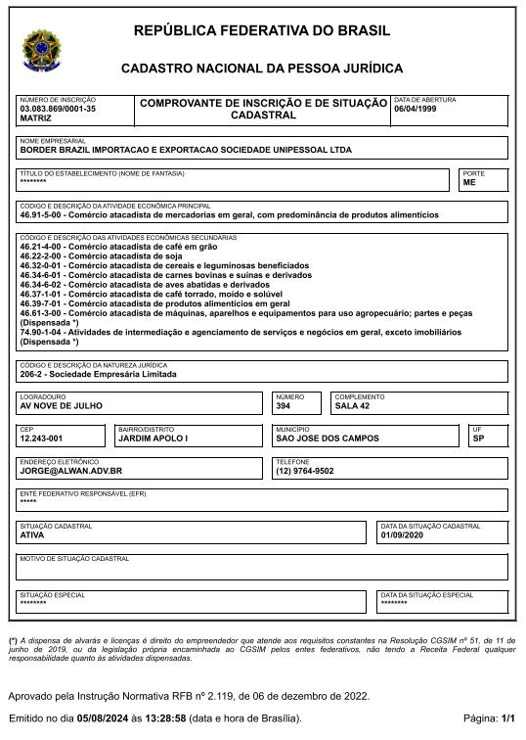

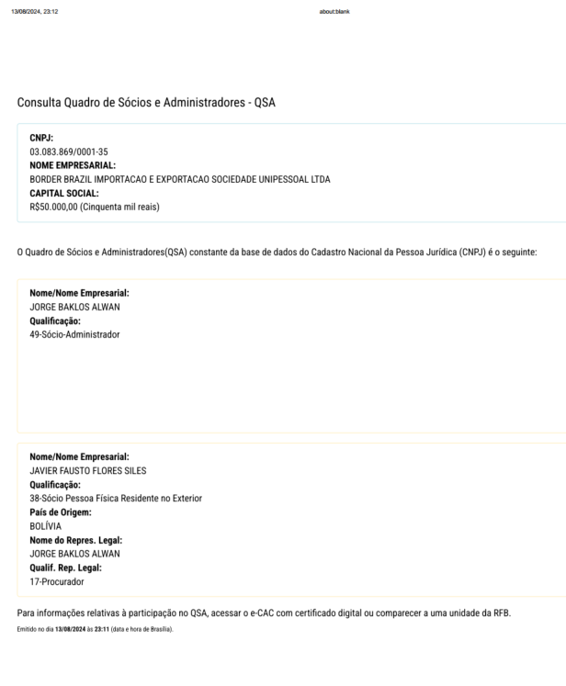

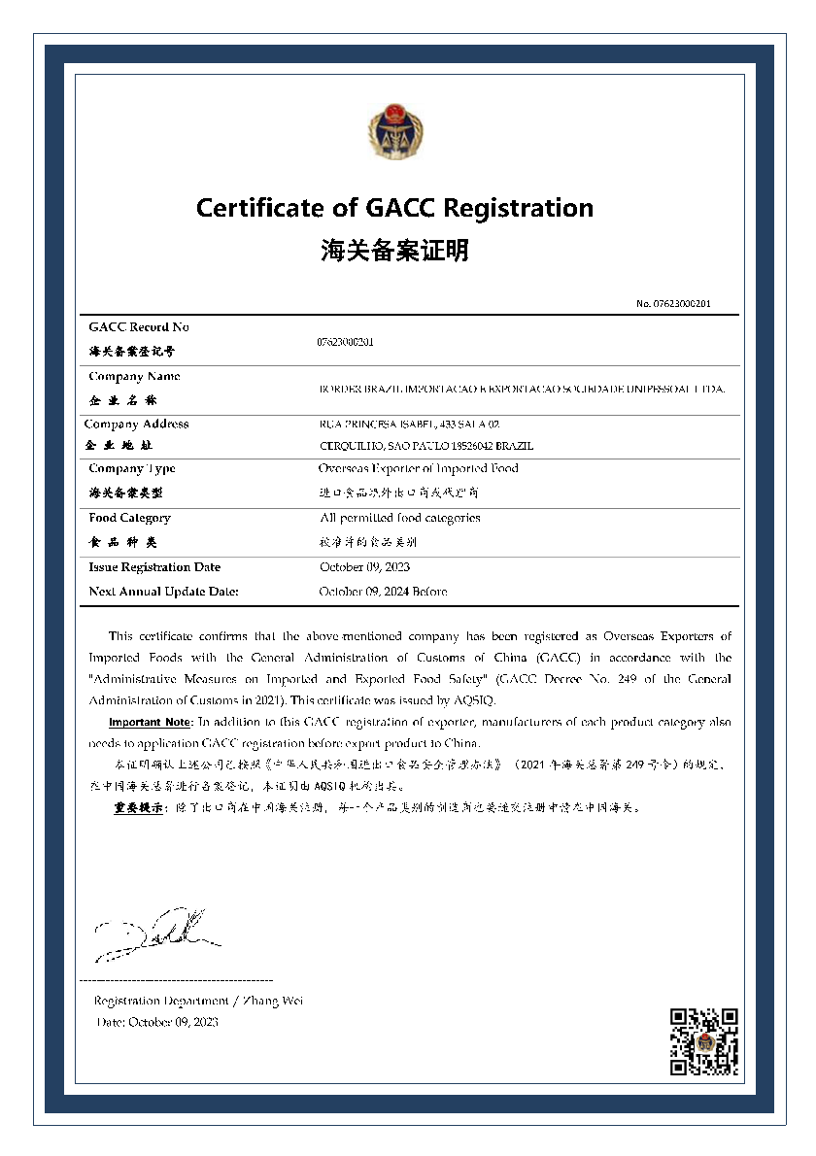

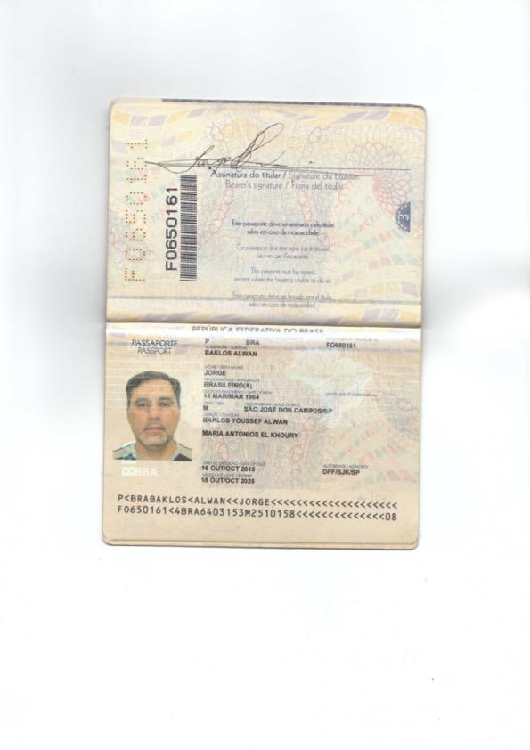

**THE BUYER CIS**

买方 CIS

|  |  |
| --- | --- |
| Company Name  公司名称 | **SHANGHAI JINGTIAN INTERNATIONAL TRADE CO., LTD** |
| Business Registration Number  商业登记号码 | 91310115735406511K |
| Mailing Address  邮寄地址 | 2nd Floor, No.3, Lane 1765, Hong Qiao Rd ,Shanghai China |
| Represented by  代表单位 | Jingning Yang |
| Title  标题 | CEO |
| Passport/ NO  护照/号码 | EK7075928 |
| Phone  护照/号码 | +8613601787889 |
| Email  电子邮件 | shhqly@163.com |
| Bank Name  银行名称 | CHINA MERCHANTS BANK SHANGHAI GUBEI SUB-BRANCH |
| Bank Code / SWIFT  银行代码 / SWIFT | CMBCCNBS051 |
| Bank Address  银行地址 | NO.75 SOUTH SHUICHENG ROAD, SHANGHAI CHINA,200336 |
| Account Name  帐户名称 | SHANGHAI JINGTIAN INTERNATIONAL CO., LTD |
| Account Number  账户号码 | 215180569610001 |
| Bank Officer/ Name & Email  银行职员/姓名及电子邮件 | gubei1108@cmbchina.com |

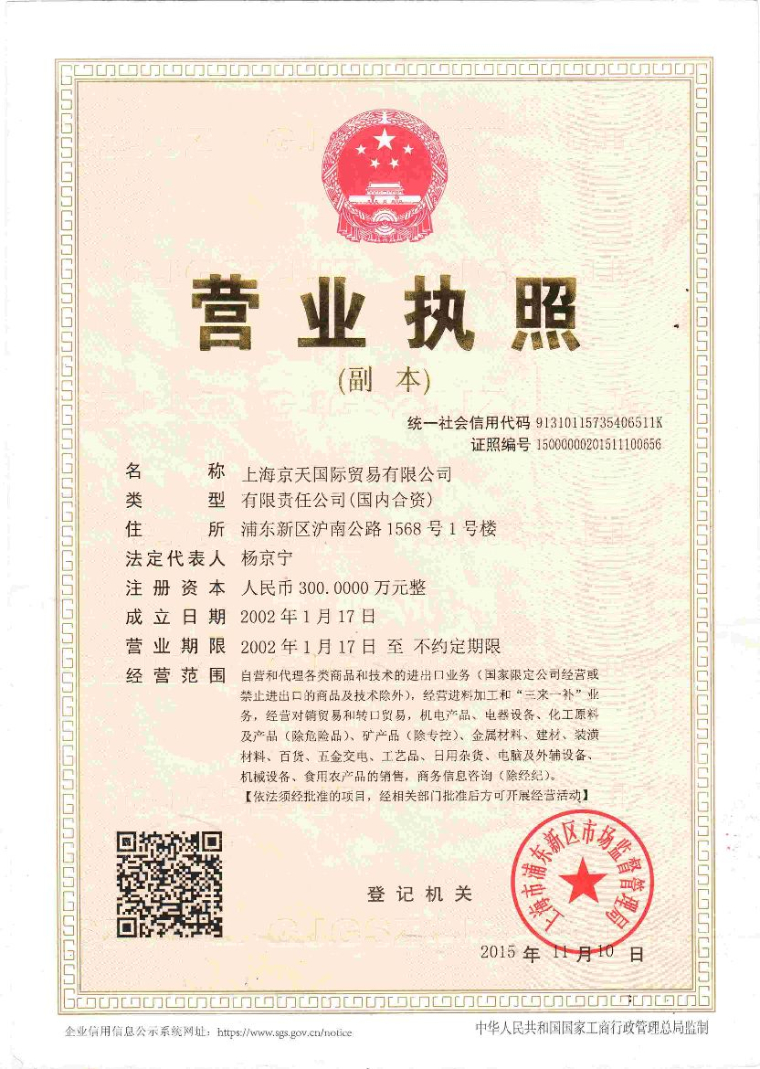

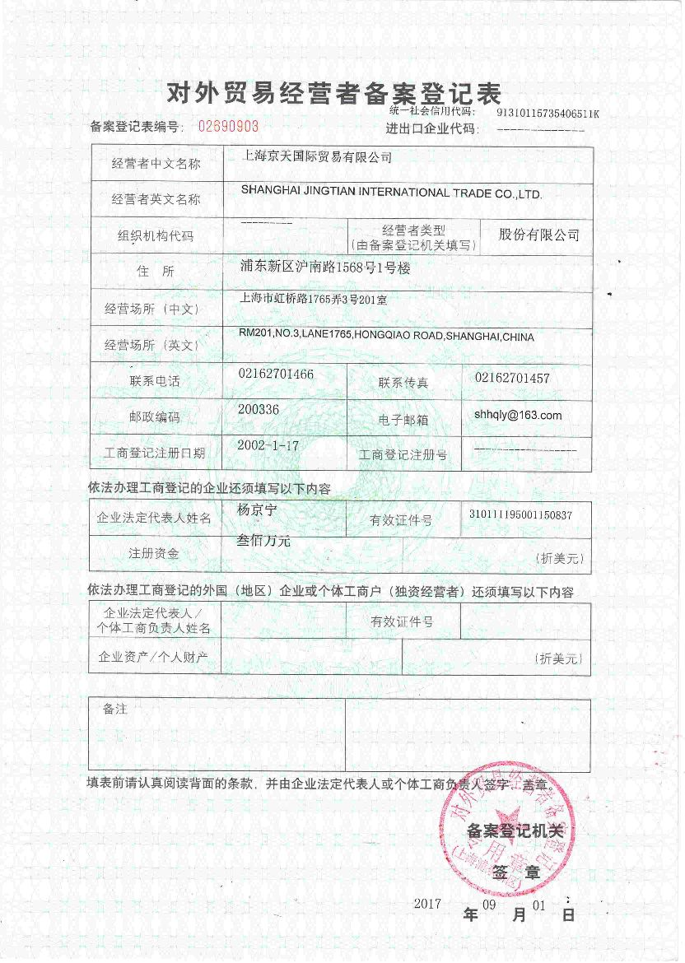

**DEFINITIONS:** 定义：

**Metric Ton:** A measure of weight equivalent to one thousand kilogram mass (1,000 kg)

公吨: 相当于一千公斤质量（1,000 千克）的重量量度

**Commodity**: **FROZEN CHICKEN PAWS GRADE A**

商品: 冷冻鸡爪A级

**Day:** Refers to a calendar Day, unless otherwise specified.

日： 指日历日，除非另有说明

**Month:** Refers to Calendar Month.

月：指日历月

**Out-turn:** The quantity and quality of the product ascertained, according to the ASTM procedures, on completion of the discharge operations of loading. The determined out-turn quantity and quality which is based on the quantity which will be calculated for the payment of the product effectively delivered to the Buyer.

出料量：根据ASTM程序，在完成装货卸料操作时确定的产品的数量和质量。确定的出货数 和质量，基于为有效交付给买方的产品付款而计算的数量

**Bill of Lading:** The official document, issued at loading port after the completion of the loading operations, stating, among other things, the ship´s loaded quantity, expressed in cubic meters (m3) and Metric Tons (MT). The original of this document has to be signed by the ship´s master.

提单: 在装货作业完成后在装货港签发的官方文件，除其他事项外，说明船舶的装载数量，以立方米 （m3） 和公吨 （MT） 表示。该文件的原件必须由船长签字

**Discharge** **Terminal:** The safe port/berth designated by the Buyer as final receiving destination.

卸货码头：买方指定为最终接收目的地的安全港口/泊位

**CIF:**  Cost, insurance and freight according to INCOTERMS 2010 definitions with the latest amendments.

CIF：根据 INCOTERMS 2010 及其最新修订的定义，成本、保险和运费

**The Banking days:** Any day in which the bank opens for business in jurisdiction where the SELLER AND BUYERS are located.

银行营业日：银行在卖方和买方所在的司法管辖区开展业务的任何一天

**Delivery Date:** The date mutually accepted by both parties, as the date ascertained of the reception of the goods at the port of destination.

交货日期：双方共同接受的日期，即目的港确定接收货物的日期

**Execution Date:** Date in which the Seller and Buyer receive their respective copies by fax or email or in any other form agreed by with both parties.

执行日期：卖方和买方通过传真或电子邮件或与双方商定的任何其他形式收到各自副本的日期

**Laboratory# SGS:** Societe Generale of Surveillance, or recognized business.

实验室# SGS：法国兴业银行（Societe Generale of Surveillance）或公认的企业

**FCL:** Full Container Load

FCL： 整箱装载

PB: Performance Bond

PB： 履约保证金

CI: Commercial Invoice

CI： 商业发票

Both being in accord, this Contract is made jointly by the Seller and the Buyer (Seller as LC Receiver) (herein after respectively called singly the “Party” and jointly as the “Parties”), as of the effective date above, in five originals.

在双方一致的情况下，本合同由卖方和买方（卖方作为 LC 接管人）（以下分别称为“一方”，共同称为“双方”）共同订立，截至上述生效日期，一式五份

**Whereas :**

The Parties confirm that each is fully empowered, legally qualified, and duly authorized to execute and deliver this document, and to be bound by its terms and conditions.

双方确认，各方均具有充分的权力、法律资格和正式授权来签署和交付本文件，并受其条款和条件的约束

The Parties hereby warrant and declare that all funds applied in the conduct of this transaction are good, clear, clean authentic, legally earned and of noncriminal origin.

双方特此保证并声明，用于进行本次交易的所有资金都是良好、清晰、干净、真实、合法赚取的和非犯罪来源的

The Parties hereby warrant and declare that the transaction and contract are not entered into in order to facilitate and advance terrorist activities, drug trafficking and/or illegal arms dealings.

缔约双方特此保证并声明，该交易和合同不是为了便利和推进恐怖活动、贩毒和/或非法武器交易而订立的

The Parties have by mutual request to each other reached agreement for the purchase and sale of specified commodity

双方通过相互请求达成了购买和销售特定商品的协议

In consideration of the representations, warranties, covenants, and agreements made by and between the Parties, it is hereby agreed that the parties shall proceed to execution of this Contract under the following terms and conditions:

考虑到双方之间作出的陈述、保证、承诺和协议，特此同意，双方应根据以下条款和条件继续执行本合同：

1. **THE COMMODITY** 大宗商品

**Commodity type:** FROZEN CHICKEN PAWS

商品类型：冷冻鸡爪

**Grade:** A

等级：A

**Shelf Life:** 24 months

保质期：24个月

**Weight:** 30 grams to 45 grams per piece

重量：每片 30 克至 45 克

**Length:** 9-12 cm

长度： 9-12 cm

**Specifications:** 规格:

Year of Production: Current Year

制作年份：当年

100% Fresh and Frozen

100%新鲜和冷冻

Broken Bones Less than 2%

骨折率低于 2%

Moisture content Less than 3%

含水率 小于3%

Frozen at -40°C / Stored at -20°C / Transported at -10°C to -15°C

在 -40°C 下冷冻 / 在 -20°C 下储存 / 在 -10°C 至 -15°C 下运输

Safe for human consumption

人类食用安全

Washed and cleaned

洗涤和清洁

No outer yellow skin

无外层黄皮

No Feathers

没有羽毛

No Bad Smell

没有难闻的气味

No Blood, No Blood stains, No Bruise

没有血液，没有血迹，没有瘀

No Chemical Burns, no ammonia

无化学灼伤，无氨

No black nail, no black pad, no black spot

没有黑色指甲，没有黑色垫子，没有黑点

Freezing Process: IQF (Individually Quick Frozen)

冷冻过程：IQF（单独快速冷冻）

COMMODITY REGISTER (SIF):

商品登记册 （SIF）：

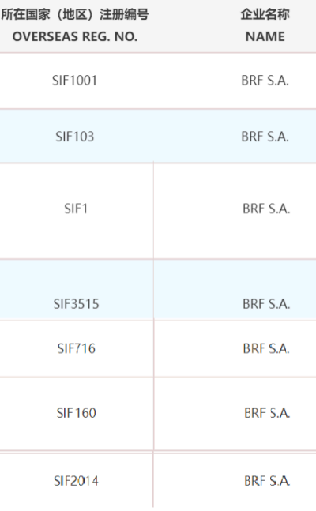

1. **QUANTITY OF GOODS** 货物数量
   1. 40 FCL – 1,080 MT (27MT PER FCL) PER MONTH

40 FCL – 每月 1,080 吨（每整箱 27 吨）

SHIPMENT OF THE FIRST MONTH:

第一个月的发货

1. Trial of 10 FCL on first shipment - 270 MT

首次装运 10 整箱 - 270 吨

1. 30 FCL or 810 MT 15 days after the first shipment of 10 FCL

30 FCL 或 810 MT 首次装运 10 FCL 后 15 天

* 1. CONTRACT DURATION OF 12 MONTHS

合同期限为12个月

* 1. TOTAL QUANTITY ORDER: 480 FCL (12,960 MT)

订单总数： 480 FCL （12,960 MT）

1. **DELIVERY BASIS** 交货基础
   1. Loading Port: Santos or any safe port in Brazil

装货港：桑托斯或巴西的任何安全港口

* 1. Delivery terms: CIF, Incoterms 2020, with payment after documents

交货条件：CIF，Incoterms 2020，在文件后付款

* 1. Commencement: Within 45-50 days upon receipt of the LC

开始时间：收到 LC 后 45-50 天内

|  |
| --- |
| 1. **CIF PRICE DEFINITION WITH PAYMENT AT PORT OF DEPARTURE**   CIF 价格定义，在起运港付款 |
| **3.1 4,050 USD / MT**  4,050 美元 / 吨  **3.2 CONTRACT ORDER VALUE: 40FCL x 12MONTHS x 27MT x 4,050= 52,488,000 USD**  合同订单价值：40FCL X 12个月 X 27MT X 4,050= 52,488,000 美元  **3.3 TRIAL ORDER first shipment: 10 FCL X 27 x 4050= 1,093,500 USD**  试单首次装运：10 FCL X 27 x 4050 = 1,093,500 美元  **3.4 Second shipment (30 FCL): 30 FCL x 27 x 4050= 3,280,500 USD**  第二批（30 整箱）：30 整箱 x 27 x 4050 = 3,280,500 美元 |

1. **DELIVERY CONDITIONS** 交货条件

4.1 The Seller has full and unconditional responsibility, which includes insurance and safe keeping from origin of goods to its delivery at discharge port.

卖方负有全部和无条件的责任，包括从货物原产地到卸货港交货的保险和保管

After shipping for the first month (10 FCL + 30 FCL), subsequent shipments will be 20 FCL + 20 FCL per month.

第一个月发货（10整箱+30整箱）后，后续发货为每月20整箱+20整箱

4.2 The Seller shall issue 2% of PB (Performance Bond) to the Buyer as guarantee to the Buyer after receiving the Buyer's LC. This PB expires after the shipment is received. The Seller agrees to increase the PB according with the increasing of the financial Instrument posed as warrant of compliance by the Buyer. Seller´s Bank should send PB to Buyer´s Bank within 5 Working Days. PERFORMANCE BOND FOR 12 MONTHS ORDER ONLY.

卖方在收到买方的 LC 后，应向买方出具 2% 的 PB（履约保证金）作为对买方的担保。此 PB 在收到货件后过期。卖方同意根据买方作为合规保证的金融工具的增加而增加PB。卖方银行应在 5 个工作日内将 PB 发送到买方银行。仅限 12 个月订单的履约保证金

4.3 Delivery shall commence within 45 (forty five) to 50 (fifty) days after the Buyer’s issuance/opening of the LC, Irrevocable, Non-Transferable, Divisible, Confirmed and Operative Cash Back LC at Sight against full documents as mutually agreed in SPA (MT700) to Seller's Designated Financial Company. LC should be 12 months validity.

交货应在买方签发/开立不可撤销、不可转让、可分割、已确认和可操作的即期现金返还 LC 后 45（四十五）至 50（五十）天内开始，并附上双方在 SPA （MT700） 中共同商定的完整文件给卖方的指定金融公司。LC 的有效期应为 12 个月。

4.4 The Buyer and the Seller will agree a delivery schedule.

买方和卖方将商定交货时间表

4.5 The Certificate of Inspection for Quality and Quantity will be issued by SGS or similar International Surveyor and the cost of the Seller account at the loading port.

质量和数量检验证书将由SGS或类似的国际检验师签发，费用由卖方在装货港承担

4.6 Packing shall be in 4 poly bags x 5Kg/Per Bag=20Kg/Per Carton, or 2 poly bags x 10Kg/Per Bag=20Kg/Per Carton. 1 Container = 27 MT

4.7 包装应为 4 个塑料袋 x 5Kg/每袋 = 20Kg/每箱，或 2 个塑料袋 x 10Kg/每袋 = 20Kg/每箱。1 个集装箱 = 27 吨

1. **PAYMENT TERMS** 付款条件

5.1 The Buyer will issue a Letter of Credit (LC) Mt 700, irrevocable, non-transferable, divisible, confirmed, paid at sight from top 50 bank, as guarantee.

买方将出具前 50 家银行出具的不可撤销、不可转让、可分割、已确认、即期付款的信用证 （LC） Mt 700 作为担保

5.2 Once the bank of the Seller has submitted to the bank of the Buyer a full set of RECEIVED ON BOARD Ocean Bill of Landing made out to order and blank endorsed market “freight prepaid” and notifying Suzhou Central Reserve Merchants Union Trade Co., LTD, the Buyer will proceed to pay bank to bank via MT 103 the full amount of the concerned documented shipment.

The LC will be renewed immediately adding the value of 20 FCL to accomplish the guarantee of the second shipment.

一旦卖方的银行向买方的银行提交了全套“已收到的海运提单”和空白背书市场“运费预付”，并通知苏州中央储备招商联贸易有限公司，买方将通过MT 103向银行支付相关单据货物的全部金额。 信用证将立即续签，增加价值 20 整箱，以完成第二次装运的保证

5.3 The operative LC should be opened within FIVE (5) working days to the Seller’s bank after both parties have signed the SPA. If the Buyer’s bank fails to issue the OPERATIVE Mt700, the Buyer will be responsible for a 3% penalty for each shipment.

双方签署买卖协议后，应在五 （5） 个工作日内向卖方银行开立有效的 LC。如果买方的银行未能签发 OPERATIVE Mt700，买方将负责对每批货物收取 3% 的罚款

5.4 Payment must happen immediately after remission BANK to BANK of the inspection report and all necessary documentation, like BL and others described on detail in this SPA.

必须在将检查报告和所有必要的文件（如本 SPA 中详细描述的 BL 和其他文件）退还给 BANK 后立即付款。

5.5 The validity of LC is 3 months.

LC的有效期为3个月

1. **BUSINESS PROCEDURE** 业务流程

**FASE ONE:** 第一阶段

1. **THE BUYER:** 买方
2. **The buyer will submit bank to bank a proof of funds.**

买方将向银行提交资金证明

1. **The Buyer also will submit a not stamped or signed draft of LC.**

买方还将提交一份未盖章或签名的 LC 草稿

1. **The Buyer will submit the signed SPA, in order to get the proof of product.**

买方将提交已签署的 SPA，以获得产品证明。

1. **THE SELLER:** 卖方
2. **The Seller will submit the DRAFT of SPA.**

卖方将提交SPA的草案

1. **The Seller will submit the proof of product via bank.**

卖方将通过银行提交产品证明

1. **The Seller also will submit a written confirmation of the verbiage of the LC.**

卖方还将提交一份书面确认书，确认 LC 的措辞

**7. PROCEDURES:** 程序：

7.1 Seller proposes to the Buyer to perform this contract bank-to-bank in order to secure both parties.

卖方建议买方在银行对银行之间履行本合同，以确保双方的安全

7.2 Seller and Buyer will contact their respective bank officers and send the copies of the agreed SPA to them.

卖方和买方将联系各自的银行职员，并将商定的买卖协议副本发送给他们

7.3 Seller issues a draft SPA, including NCNDA, ICPO, KYC/CIS.

卖方签发 SPA 草案，包括 NCNDA、ICPO、KYC/CIS

7.4 FASE ONE.

第一阶段

7.5 Both Buyer and Seller sign SPA.

买方和卖方都签署了SPA

7.6 Standard Operating Procedure of LC:

LC的标准操作程序

1. The verbiage of the LC DRAFT with 3 months validity proposed by the Buyer must receive approval from Seller’s bank.

买方提出的有效期为 3 个月的 LC 草案的措辞必须得到卖方银行的批准

1. If the verbiage is not approved, the Buyer will make necessary modifications to gain approval from Seller’s bank.

如果措辞未获批准，买方将进行必要的修改以获得卖方银行的批准

1. After the LC draft /verbiage is approved and accepted by Seller’s bank, the Buyer’s Bank issue the OPERATIVE LC MT-700 (Letter of Credit, Irrevocable, non-transferable, divisible, 100%confirmed).

在信用证汇票/措辞被卖方银行批准并接受后，买方银行签发 OPERATIVE LC MT-700（信用证，不可撤销，不可转让，可分割，100% 确认）。

1. Seller’s bank issue 2% PB within 5 working days after receiving the Buyer’s OPERATIVE LC MT700.

卖方银行在收到买方的 OPERATIVE LC MT700 后的 5 个工作日内签发 2% PB。

7.7 Upon presentation of all required COPY of documents including customs, shipping, and a verifiable SGS/CCIC report exchanged bank to bank, the Buyer will make full payment by MT103 within 24 hrs at port of departure after loading inspection report and documentation agreed. The same has to be stated in the Seller commercial invoice CI. The Seller will release the ownership of the goods to the Buyer and send to the Buyer the full set of original and copy of POP documents, plus a copy via email.

在出示所有必需的文件副本（包括海关、运输和银行间交换的可验证的 SGS/CCIC 报告）后，买方将在装货检验报告和约定的文件后 24 小时内在出发港通过 MT103 全额付款。同样的事情必须在卖方商业发票 CI 中说明。卖方将向买方释放货物的所有权，并向买方发送全套 POP 文件的原件和副本，以及通过电子邮件的副本

7.8 The Seller will deliver the Chicken Paws to port of Yangshan Port – mainland – China, with all the required export documents and the description of the goods "Chicken Paws " on the commercial invoices.

卖方将把鸡爪运送到洋山港 - 大陆 - 中国大陆 - ，连同所有必需的出口文件和商业发票上的货物“鸡爪”的描述

7.9 The Seller informs the Buyer of the accurate shipment weight and ETA (estimated time of arrival).

卖方将准确的装运重量和预计到达时间（预计到达时间）通知买方

7.10 Both parties agree that the currency for payments for goods under this SPA will be USD only.

双方同意，根据本SPA支付货物的货币仅为美元

7.11 All Documents must be issued in English language.

所有文件必须以英文签发

7.12 Charter Party bills of lading are acceptable.

租船合同提单是可以接受

7.13 Partial Shipment acceptable (**Each month can only be sent a maximum of two partial shipments in that month.**).

可接受分批发货（每个月最多只能发送两个当月的部分发货

7.14 Trans-Shipment un-acceptable.

不可接受的转运

7.15 Third Party Shipper acceptable.

接受第三方托运人

**8. SPECIFIC CERTIFICATION** 特定认证

8.1 The Seller will send within 24 hrs after contact signing, GACC and SIF.

卖方将在联系签署后 24 小时内发送，GACC 和 SIF

* 1. The Buyer Signs, Stamps and Returns the Reviewed/Amended Sales Purchase Agreement to the Seller.

买方签署、盖章并将经过审查/修订的销售购买协议退还给卖方

8.3 The Seller sends Signed and Stamped Perform Invoice to Buyer.

卖方将签名并盖章的履约发票发送给买方

8.4 All documentation has to be copied to the corresponding bank officers.

所有文件都必须抄送给相应的银行职员

**9. PRODUCT DOCUMENTATION** 产品文档

9.1 A full set of the following documents will be presented to the Buyer, via bank to bank:

以下全套文件将通过银行对银行提交给买方：

9.2 Three (3) Original and Three (3) Copies of Signed Commercial Invoices.

三 （3） 份已签名的商业发票原件和三 （3） 份复印

9.3 Two (2) Original and Four (4) Copies of Certificates of Quality, Quantity and Weight Inspection, Issued by SGS. The Certificates indicate the inspection attendance time at loading port, certificate showing.

两 （2） 份原件和四 （4） 份由 SGS 出具的质量、数量和重量检验证书复印件。证书上标明了装货港的检验出勤时间，证书上显示

9.4 One (1) Original and Four (4) Copies of Phytosanitary certificate issued by Appropriate Government Authority of the Country of Origin stating that the product is fit for Human Consumption, and Fumigation Certificate if Required.

一 （1） 份原件和四 （4） 份由原产国有关政府机构签发的植物检疫证书副本，说明产品适合人类食用，如果需要，还可以提供熏蒸证书

9.5 One (1) Original and Three (3) Copies of packing list.

一 （1） 份原件和三 （3） 份装箱单复印件

9.6 One (1) Original and Four (4) Copies of certificate of Origin issued by or Endorsed by Chamber of Commerce of Relevant Government Authority of the Country of Origin of the Product.

一 （1） 份原产地证书原件和四 （4） 份原产地证书复印件，由产品原产国相关政府机构的商会签发或认可

9.7 Full set of 3 Original and non-negotiable Copies of Bill of Lading (B/L)

全套 3 份原件和不可转让的提单副本 （B/L）

9.8 One original and 3 copies of Customs Clearance Certificate

《海关清关证书》原件1份，复印件3

9.9 Certificate of Insurance Coverage of 110% of the value of the Invoice value.

保险凭证的承保范围为发票价值的 110%

9.10 Health Certificate.

健康证明

9.11 PHYTOSANITARY certificate issued by SGS or issued and endorsed by local authorized government agency.

由SGS颁发或由当地授权政府机构签发和认可的植物检疫证书

9.12 Radiation level certificate issued or certified by SGS stating the radiation level of the product as normal.

SGS出具或认证的辐射等级证书，说明产品的辐射水平为正常

9.13 No Covid 19 Certificate

没有 Covid 19 证书

**10. DELIVERY** 交货

10.1 The Seller guarantees that the delivery of the products transmitted at CIF INCOTERMS 2010, (CIF China, with payment at port of departure), is conformed to the quality and quantity in the contract.

卖方保证，在2010年CIF国际贸易术语解释通则（CIF中国，在起运港付款）上传输的产品的交付符合合同中的质量和数量

10.2 The Seller shall notify the Buyer all the details of the chartered vessels (general dimensions, system layout of maximum download rate, capacity cargo. This information must be provided at least five (5) days after the designation of the vessel, to assure the operatively at the destination point.

卖方应将租赁船舶的所有详细信息（一般尺寸、最大下载率的系统布局、载重量货。这些信息必须在船舶指定后至少五 （5） 天提供，以确保在目的地有效运行

10.3 The chartered vessel of the Seller must be suitable for the goods covered by this contract and be prepared for inspection.

卖方租用的船舶必须适合本合同所涵盖的货物，并做好检验准备

10.4 The vessel master will advise the Buyer and the shipping agent at the discharge port, its arrival with 120 hours in advance, its name, flag, tonnage, height and depth, the estimated time of arrival with notice of 48, 36, 24 and 12 hours before its arrival.

船长将在卸货港通知买方和装运代理，提前 120 小时到达，其名称、旗帜、吨位、高度和深度，预计到达时间，并在到达前 48、36、24 和 12 小时通知

11. **INSPECTION AND QUANTITY AND DETERMINED QUALITY** 检验和数量以及确定的质量

11.1 The Seller will guarantee the transportation of goods via an inspection certificate of weight and quality at loading and such certificate shall be issued by SGS - SOCIÉTÉ GÉNÉRALE DE SURVEILLANCE or similar authority and approved by writing by the buyer.

卖方将通过装货时的重量和质量检验证书来保证货物的运输，该证书应由 SGS - SOCIÉTÉ GÉNÉRALE DE SURVEILLANCE 或类似机构颁发，并由买方书面批准

11.2 The Seller will make sure that the certificate of inspection is in strict accordance with the International Chambers Of Commerce (ICC) Rules.

卖方将确保检验证书严格符合国际商会 （ICC） 规则

11.3 The Buyer if he wishes can be present after loading port inspection at SGS to check the report of inspection by SOCIÉTÉ GÉNÉRALE DE SURVEILLANCE or similar authority, for which they should notify the day and time when it will take place, or if wished and at the Buyer’s cost, there can be an additional inspection at the port of origin to confirm the load.

如果买方愿意，可以在 SGS 的装货港检验后到场检查 SOCIÉTÉ GÉNÉRALE DE SURVEILLANCE 或类似机构的检验报告，他们应通知检验的日期和时间，或者如果愿意，费用由买方承担，可以在始发港进行额外检验以确认装载货物

11.4 A weight deviation of 5% shall be allowed against the weight mentioned at Bill of Lading.

与提单上注明的重量相比，允许有5%的重量偏差

11.5 In the case that there is an existing deviation or difference in the product quantity, superior to the specified, the parties will compensate the difference increasing or decreasing in the same proposition the amount of the transaction. In case the weight certificate issued by SGS is greater or less than the weight written on the Seller ́s invoice, the Buyer or Seller in their case, the difference shall be compensated proportionately of the established price in the present contract, increasing or decreasing it.

如果产品数量存在超过规定的现有偏差或差异，则双方将在同一提议中补偿增加或减少交易金额的差异。如果 SGS 出具的重量证明大于或小于卖方发票上写的重量，则买方或卖方应按本合同规定的价格按比例补偿差额，增加或减少

11.6 If discrepancies occur, both parties agree to submit to ARBITRATION from The International Arbitration of The Chambers of Commerce in Sao Paulo- Brazil, to settle said differences, being bound by the decision of the arbitrators.如果出现差异，双方同意提交巴西圣保罗商会国际仲裁仲裁，以解决上述分歧，并受仲裁员决定的约束

**12. INSURANCE** 保险

The Seller, at their costs, shall ensure the goods by a First Class Internationally Recognized Insurer, to cover the 110% (One Hundred and Ten percent) of the load value, including between the clauses of the insurer force majeure, war, kidnapping, explosion etc. at the time of loading until the point of unloading at the destination port.

卖方应自费确保货物由国际公认的一级保险人承保，以支付装载价值的 110%（百一十%），包括保险人的不可抗力、战争、绑架、爆炸等条款之间的装货时直到目的港卸货

**13. RECLAMATIONS** 填 海 工程

13.1 Any reclamation or incident which may occur shall be communicated to the other party, no later than two months from the date of the incident.

任何可能发生的填海或事故均应在事故发生之日起两个月内通知另一方

13.2 In the case of the quality of any batch delivered not complying with the contract specification, the Buyer shall have the option to accept the said batch at a much lower price than in the contract, prior to unloading.

如果交付的任何批次的质量不符合合同规格，买方应有权选择在卸货前以远低于合同规定的价格接受该批次

13.3 All the reclamations shall be made in writing.

所有填海申请均应以书面形式进行

**14. OBLIGATION TAXES AND IMPORTATION** 义务税和进口

The Seller will pay all costs, taxes, fees, etc, which should be paid from the date of signed contract until the reception by the Buyer of the goods at the destination port. Being borne by the Buyer all costs, taxes, fees, etc., which should be paid from the storage of the goods at the dock at the destination port.

卖方将支付所有成本、税款、费用等，这些费用、税款、费用等应从签订合同之日起支付，直到买方在目的港收到货物为止。所有成本、税款、费用等均由买方承担，这些费用、税款、费用等应从目的港码头的货物仓库中支付

**15 EXEMPTIONS OF RESPONSIBILITY** 免责条款

Neither of the parties will be responsible for noncompliance, if the delivery of the product is delayed, hindrance of delivery or be prevented in circumstances out of control of the parties despite having exercised due diligence.

如果产品交付延迟、阻碍交付或在双方无法控制的情况下被阻止，尽管已尽职尽责，则任何一方均不对不合规行为负责

**16. CONDITION OF DISCOUNT** 折扣条件

The Buyer has the option to accept the goods with a discount in the event of a deviation which could occur in respect to the contract specifications, provided that such deviation is between the allowed limits. The Maximum/Minimum deviation shall be fixed in the specifications and confirmed by competent technicians/Authority.

如果合同规格可能发生偏差，买方可以选择以折扣接受货物，前提是这种偏差在允许的限度之间。最大/最小偏差应在规格中确定，并由合格的技术人员/权威机构确认

**17 FORCE MAJEURE** 不可抗力

Neither of the parties of this contract will be responsible for breach of the contract caused by act of God, insurrection, civil war, war, military operation or local emergency, as stated by the International Chamber Of Commerce, Geneva, Switzerland, and is defined by the customs rules and practice.

对于因天灾、叛乱、内战、战争、军事行动或当地紧急情况而导致的违约，本合同的任何一方均不承担责任，如瑞士日内瓦国际商会所述，并由海关规则和惯例定义

**18. ARBITRATION** 仲裁

18.1 All the disputes which occur in the present contract will be resolved, amicably, if the parties do not reach an agreement, the controversy shall be submitted to The International Arbitration of The Chambers of Commerce in Sao Paulo- Brazil, for a final solution by one or more fixed arbitrators under said Rules.

本合同中发生的所有争议都将友好解决，如果双方未能达成协议，则争议应提交巴西圣保罗商会国际仲裁，由一名或多名固定仲裁员根据上述规则进行最终解决

18.2 The solution given by Tribunal Arbitration shall be final and binding for both parties.

仲裁庭仲裁给出的解决方案为终局解决方案，对双方均具有约束力

**19 SPECIAL CONDITIONS** 特殊条件

The parties agree to undergo the general rules of ICC INCOTERMS edition 2010 with the latest amendments, for all which is not specified in the present contract.

双方同意对国际商会国际贸易术语解释通则2010年版的一般规则进行最新修订，所有未在本合同中规定的内容均未得到规定

**20 LAYCAN-TIME LAY-DEMURRAGE** LAYCAN-TIME 滞期费

20.1 LAYCAN (time period in which the vessel has to arrive to the destination port).

LAYCAN（船舶必须到达目的港的时间段）

20.1.1 The Seller and the Buyer agree a delivery of Frozen Chicken Paws from Brazil Origin at the Destination port in 12 months Contract Order. The day of the month corresponding to each delivery will be agreed by the parties.

卖方和买方同意在 12 个月的合同订单中从巴西原产地在目的港交付冷冻鸡爪。每次交货对应的月份日期将由双方商定

20.2 LAY-TIME 上架时间

20.2.1 The Buyer shall be in charge of the unloading coordination at the destination port as the average discharge pressure.

买方应负责目的港的卸货协调工作，作为平均卸货压力

20.2.2 Notice of Availability (N.O.R.) of the truck at the designated unloading port of the buyer, will be announced by the master of the ship and or Agent, by radio, or cable transmission.

货车在买方指定卸货港的可用通知 （N.O.R.） 将由船长和/或代理人通过无线电或有线传输宣布

20.2.3 “Play time” will be coordinated between the ship-owner and the parties with the port official.

“游戏时间”将在船东和各方与港口官员之间进行协调

20.2.4 Time used at Customs/Health/procedures by the port authorities, age of the anchor pilot port area, berth, or crossing the mouth of the river, would not count as “Play time”

港务局在海关/卫生/程序使用的时间、锚定引航港区的年龄、泊位或穿越河口的时间，不计入“游戏时间”

20.3. DEMURRAGE 滞期费

The Demurrages will be based on a daily rate or pro data.

滞期费将基于每日费率或专业数据

**21 ASSIGNMENTS** 作业

The parties cannot Give/Endorse/Transmit, etc., the compliance of the present contract, without written consent by the other party.

未经对方书面同意，双方不得将本合同的遵守情况给予/认可/传递等

**22 APPLICABLE LAW** 适用法律

This contract shall be interpreted in accordance with the international Law of Commerce, being the international Chamber of Commerce of Sao Paolo, Brazil responsible in resolving the controversies, the decision will be binding for both parties. The solicitors’ fees and cost will be paid by the losing party.

本合同应根据国际商法进行解释，作为巴西圣保罗国际商会负责解决争议，该决定对双方均具有约束力。律师费和费用将由败诉方支付

**23 BREACH** 缺口

lf any party breaks the assigned obligations with the present contract, shall entitle, without prejudice of any other recourses available to it, to consider such failure as non-compliance of this contract, or to suspend unilaterally their obligation until the failure is corrected, and in both cases, may claim the damages and prejudices which said noncompliance would have caused. A penalty of total contract price (performance bond) will apply to both parties under the circumstance where LC is not paid, and order is not delivered.

如果任何一方违反与本合同有关的转让义务，在不影响其可利用的任何其他追索权的情况下，有权将此类违约视为不遵守本合同，或单方面中止其义务，直至未能得到纠正，并且在这两种情况下，均可要求赔偿上述不遵守可能造成的损害和损害。在未支付 LC 且订单未交付的情况下，双方将适用合同总价（履约保证金）的罚款（履约保证金）

**24 GENERAL** 常规

24.1 The parties declare understanding and accept this contract and it can only be modified by a written agreement. Any previous document, written or verbal will be substituted by this contract.

双方声明谅解并接受本合同，只能通过书面协议进行修改。任何先前的文件，无论是书面的还是口头的，都将被本合同取代

24.2 This contract can be executed simultaneously in two (2) or more counterparts, each one of which will be considered the original.

本合同可以在两 （2） 个或多个对等合同中同时执行，每个对应合同都将被视为原始合同

24.3 The entire text of this contract cannot be interpreted to limit or change the subject matter of this contract.

本合同的全文不能被解释为限制或改变本合同的标的

24.4 All eventual appendices, annexes and supplements shall constitute an integral part of the present contract.

所有最终的附件、附件和补充文件均构成本合同的组成部分

24.5 The exception mentioned in the present contract, neither party shall be held liable of resulting indirect losses and not provoked by any of the parties.

本合同中提到的例外情况，任何一方均不对由此产生的间接损失承担责任，且不得由任何一方挑

24.6 The conditions which have not been specified in the present contract will be governed by INCOTERMS and subsequent amendments related to CIF basis to discharge ports.

本合同中未规定的条件将受《国际贸易术语解释通则》和随后与卸货港CIF基础有关的修正案的约束

24.7 EDT (Electronic Document Transmission), shall be considered to be valid and enforceable in respect of the provisions of the contract. Either party shall be in a position to request a hard copy of any previous electronically transmitted document.

EDT（电子文件传输）应被视为就合同条款而言是有效和可执行的。任何一方均有权要求提供任何先前以电子方式传输的文件的硬拷贝

24.8 Both parties are in agreeing that the signed and stamped fax or EDT copies of this contract are fully binding and enforceable.

双方同意，本合同的签字盖章的传真或EDT副本具有完全约束力和可执行

24.9 The grammatical errors, typing errors if any type shall not be considered as contradictions.

语法错误、打字错误（如果有任何类型）不应被视为矛盾

24.10 All the information contained in this contract will be kept confidential and will not be revealed in any way for 15 years to third parties or be reproduced in any other form, except to third parties which are necessary for the implementation of the contract.

本合同中包含的所有信息将被保密，在15年内不会以任何方式向第三方透露或以任何其他形式复制，但为履行合同所必需的第三方除外

**25 TITLE AND RISK** 标题和风险

25.1 Title on the delivered Frozen Chicken remains with the Seller until the payment of the cargo is made in full.

在全额支付货款之前，已交付的冷冻鸡肉的所有权仍归卖方所有

25.2 Any loss or damage to the Frozen Chicken during transport, if caused by the vessel(s), shall be considered within the insurance, as well as any partial already accepted deviation happens, has to be assumed by the account of the Seller.

冷冻鸡肉在运输过程中的任何损失或损坏，如果是由船舶造成的，应在保险范围内考虑，以及任何已经接受的部分偏差，必须由卖方承担

25.3 Conversely if the receiving seaport causes any loss or damage to the Frozen Chicken, during the unloading, related loss, damage thereof shall be for the account of the Buyer.

反之，如果接收海港对冷冻鸡肉造成任何损失或损坏，则在卸货过程中，相关的损失、损坏应由买方承担

**26 FORCE MAJEURE** 不可抗力

26.1 Neither Seller nor Buyer shall be liable for failure to perform, any or all of the provisions set out in this contract, if the performance has been delayed, hindered or prevented by reason of any cause that may be, even though the affected party exercised due diligence where such failure or delay is caused by force major being any event, occurred by circumstance reasonably beyond the control of that party, including without prejudice to the generality of the foregoing failure or delay caused by or resulting from Acts of God, strikes, fire, floods, wars (whether declared /undeclared), riots, destruction of the materials, delays of carriers due to break down or adverse weather, perils of embargoes, accidents, restrictions imposed on by any Governmental authority (including allocations, requisitions, quotas and price controls).

如果由于任何原因导致履行被延迟、阻碍或阻止，则卖方和买方均不对未能履行本合同中规定的任何或所有条款负责，即使受影响的一方进行了尽职调查，如果这种失败或延迟是由任何重大事件造成的， 因该方合理控制范围之外的情况而发生，包括但不限于因不可抗力、罢工、火灾、洪水、战争（无论宣战/未宣战）、骚乱、材料破坏、承运人因故障或恶劣天气而延误、禁运危险、事故、 任何政府机构施加的限制（包括分配、征用、配额和价格控制）。

26.2 The International Chamber of Commerce rules and regulations shall apply (ICC Edition 2000 with the latest amendments).

应适用《国际商会规则和条例》（国际商会2000年版，最新修订版）。

26.3 Either party, in occurrence of a Force Majeure case, shall inform in written the other Party describing the nature and the estimated period of such occurrence. Should such case of Force Majeure persist for more than thirty (30) days from the notification date, then Seller and Buyer shall, upon mutual decision suspend or cancel the present agreement ceasing in such way their responsibilities, rights and obligations without any compensation for damages, if any.

在发生不可抗力案件时，任何一方均应以书面形式通知另一方，说明此类事件的性质和预计期限。如果此类不可抗力情况自通知之日起持续超过三十 （30） 天，则卖方和买方应在共同决定暂停或取消本协议后，以这种方式终止他们的责任、权利和义务，而无需赔偿任何损害赔偿（如果有）。

26.4 The certificate issued in original by the competent recognized Authority shall be deemed as sufficient proof for the claimed Force Majeure and its duration.

由认可的主管当局出具的证明原件，应被视为对所主张的不可抗力及其持续时间的充分证明

**27 VALIDITY PERIOD OF CONTRACT** 合同有效期

The Validity of the Contract is 12 Month and can be extended.

合同有效期为12个月，可以延长

**28 BANKING INFORMATION** 银行信息

All the Charges and Commissions at Buyers Bank are on the Buyers Account. All Confirmation Charges are on the Buyers Account. All Bank charges and commissions at Sellers Bank are on Sellers Account. Any Additional, Bank Fees shall be for the requested Party’s Account.

买方银行的所有费用和佣金都在买方账户上。所有确认费用都在买家账户上。卖方银行的所有银行费用和佣金都在卖方账户上。任何额外的银行费用应针对被请求方的账户支付

**29 CONTRACT SIGNATORIES** 合同签署人

In witness thereof, the parties have singed below and by doing so have accepted and approved all covenants, terms and conditions of this contract. This Contract is written in pages, each page duly signed by each party.

双方在以下签名，并借此接受并批准了本合同的所有契约、条款和条件，以昭信守。本合同分页编写，每一页均由各方正式签署。

**30 REMARKS** 言论

30.1 Electronically transmitted Contract shall be deemed to be valid and Enforceable after Signature. Either Party shall be allowed to request a hard copy of the contract should it be required and legally Recognized.

以电子方式传输的合同在签署后应被视为有效且可执行。如果要求并得到法律承认，任何一方都应被允许要求提供合同的硬拷贝

30.2 Both parties and facilitators agree to bind to the Obligations of Non Circumvention, Non-Disclosure (NCNDA) of the latest edition of ICC 500/600.

双方和协调人同意遵守最新版《国际商会 500/600》的不规避、不披露义务 （NCNDA）

30.3 The Buyer will assign for the first month a representative to participate in a meeting to receive the results of the first month inspection report of SGS or equivalent under the Buyer expenses.

买方将在第一个月指派一名代表参加会议，以接收 SGS 的第一个月检验报告的结果或买方费用项下的同等费用。

**SIGNATURE PAGE** 签名页

Witness whereof, the parties hereto do set their hands and are witnessed with seals upon this commodity contract of the July 16TH, 2024.

其中，双方于2024年7月16日在本商品合同上举手并盖章。

**SELLER** 卖方

Signature/seal

签字/盖章

Signatory’s full name: JORGE BAKLOS ALWAN

签字人的全名：

Company: **BORDER BRAZIL IMPORTAÇÃO E EXPORTAÇÃO**

公司：

**BUYER** 买方

Signature/seal

签字/盖章

Signatory’s full name:

签字人的全名：

Company: **SHANGHAI JINGTIAN INTERNATIONAL TRADE CO., LTD**

公司：

**Seller’s Company Registration and Passport copy**

卖方的公司注册和护照复印件





**Buyer’s Company Registration and Passport copy**

买方公司注册和护照复印





**END OF DOCUMENT**