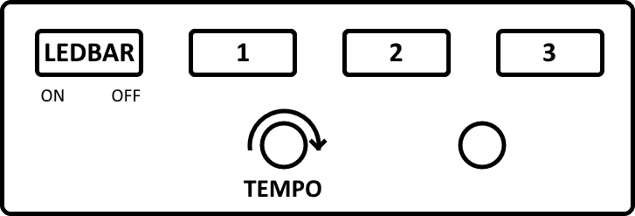

|  |  |  |  |
| --- | --- | --- | --- |
| **1** | **2** | **3** | **OHJELMA** |
| **O** | **O** | **O** | **KAIKKI PÄÄLLÄ** |
| **V** | **O** | **O** | **REUNAT/LEDBAR VILKKUU** |
| **O** | **V** | **O** | **RANDOM REUNAT, LEDBAR ON/OFF** |
| **V** | **V** | **O** | **RITARI ÄSSÄ** |
| **O** | **O** | **V** | **RANDOM REUNAT** |
| **V** | **O** | **V** | **RANDOM REUNAT 2** |
| **O** | **V** | **V** | **VESIPUTOUS** |
| **V** | **V** | **V** | **RANDOM REUNAT 3** |