

WIX 1002: Fundamentals of Programming
Assignment 1
Personal Finance System
Dr. Ang Tan Fong

Name | Matric Number
Tei Wai Kheng | WER150039
Liang Chew Yin | WER150046
Yap Mei Nah | WER150057

Features of the System
Personal finance system is a system that helps the user to manage their personal finance and adjust their budget to eliminate debt and grow wealth by reviewing the report generated.
In order to complete this assignment, a Personal Finance System that are built up from 5 main modules is created by using Java with object-oriented programming concept. The five main modules mentioned above are login module, asset module, income module, expense module and reporting respectively, which are very essential to ensure that the every single function of the system can be carried out smoothly.
In the login module, there will be 2 options which are sign up and sign in .The users are required to sign up by creating a username and password. The details of sign up are being stored in a text file to enables the users to sign in successfully by retrieving the data stored in the text file.
In asset, income and expense module, users are able to add, modify and delete a record on each module respectively. The category reference number, amount of assets and the date recorded are separated by a data separator and being stored in a text file. To quit record your expense, income or asset, simply entering ‘Q’ to stop writing into the text file. If the users record the same category of asset on the same day, the amount of the particular category will be updated instantly. To modify and delete a record in the asset module, users are prompted to enter the category and date of that record. Only if the category is found, the relative record will be deleted. If the user decided to remain the details, users can enter “remain” to keep the record. For the character ‘Q’ and String “remain” , we decide to ignore the alphabetical case to make it convenient to the users .
Last but not least, the part of reporting is to display the records based on daily, weekly or monthly duration. For daily and weekly options, only expenses report will be displayed, while income and asset reports will only be generated for monthly purpose. Total amount will be shown and gentle reminders or comments will be given based on the ratio of expense to income as well as their accumulation of assets as a whole. Colour of the fonts acts as an obvious indicator based on the good, moderate and poor degree of finance conditions by utilizing green, yellow and red colours respectively. The users are encouraged to sign in everyday to ensure the accuracy of the final financial reporting.

Class Description

Personal Finance System

StartUp
Login Module
Reporting
Sign Up

Method

public static void

signUp()

Run whole system

Method

public static void

main(String[] args)
Display reports

Method

public static void

computeDaily()

computeWeekly()

computeMonthly()

Sign In

Method

public static void

signIn()

Personal Finance System

Asset Module
Income Module
Expenses Module
Add asset

Method

public static void

addAssets()

Add Income

Method

public static void

addIncome ()
Add Expense

Method

public static void

addExpenses()

Modify Asset

Method

public static void

setAssets()

Modify income

Method

public static void

setIncome ()
Modify expenses

Method

public static void

setExpenses ()

Delete Asset

Method

public static void

deleteAssets()

Delete income

Method

public static void

deleteIncome()
Delete expenses

Method

public static void

deleteExpenses()

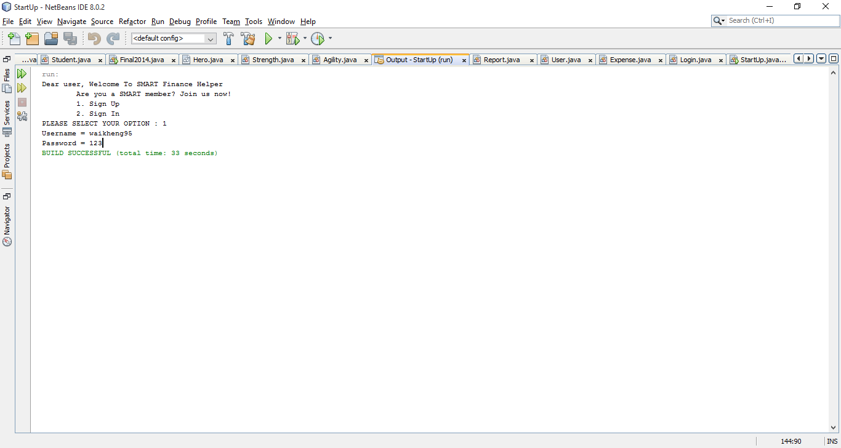
Figure 1: Sign up

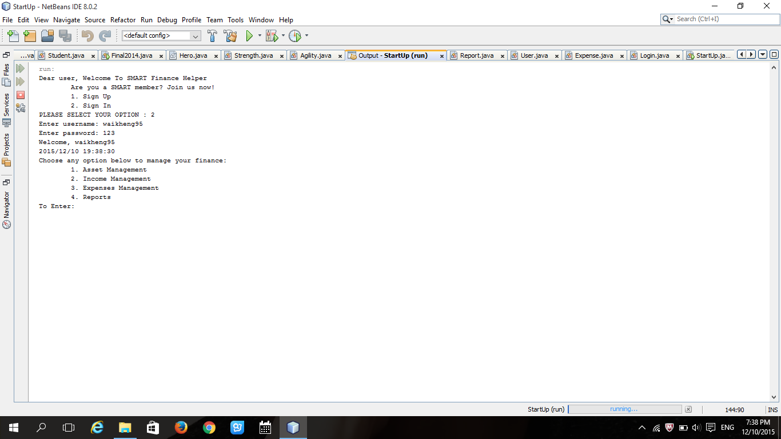
Figure 2: Sign in and asset, income and expense management
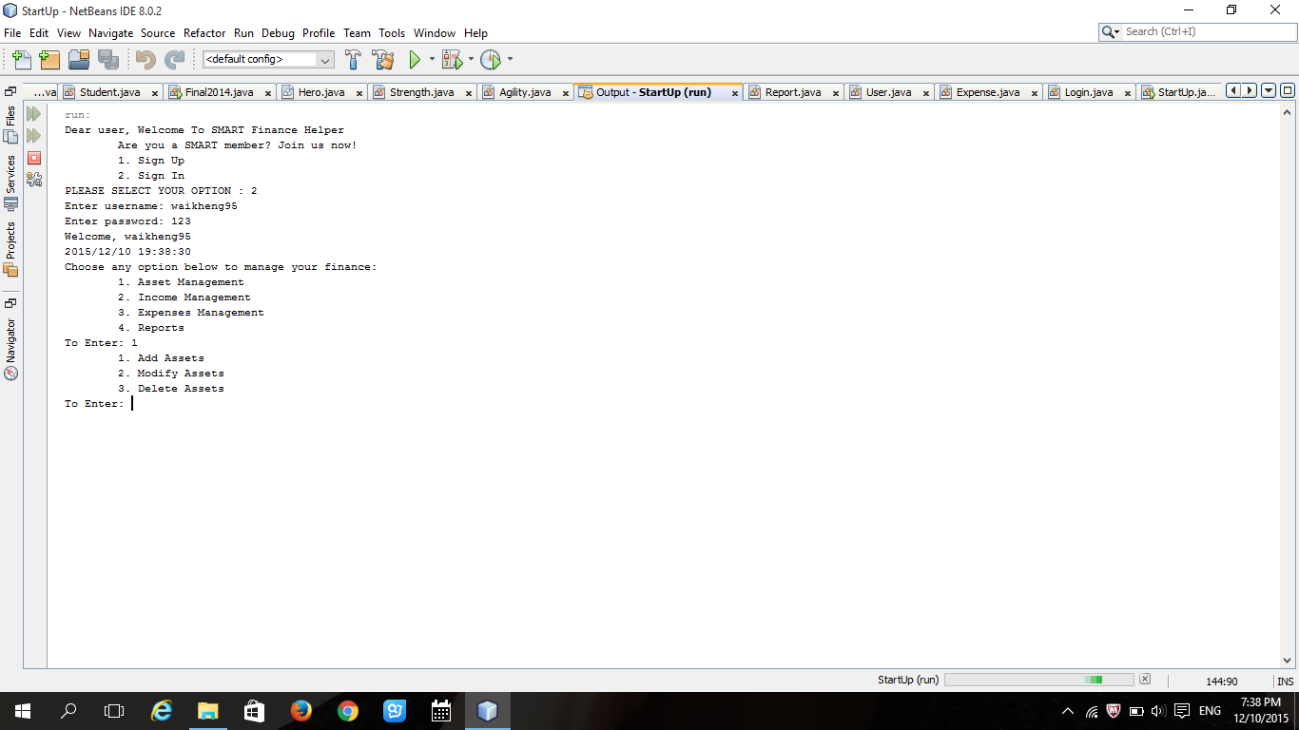
Figure 3: Option to add, modify and delete

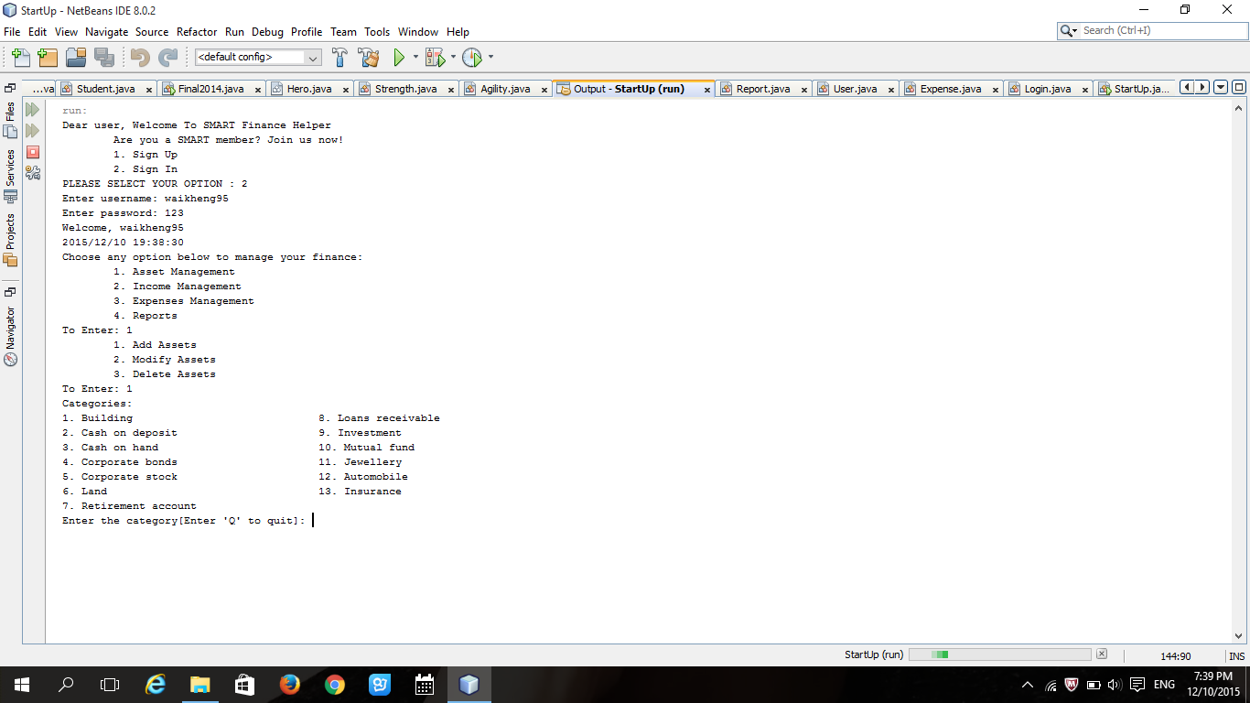
Figure 4: Display categories

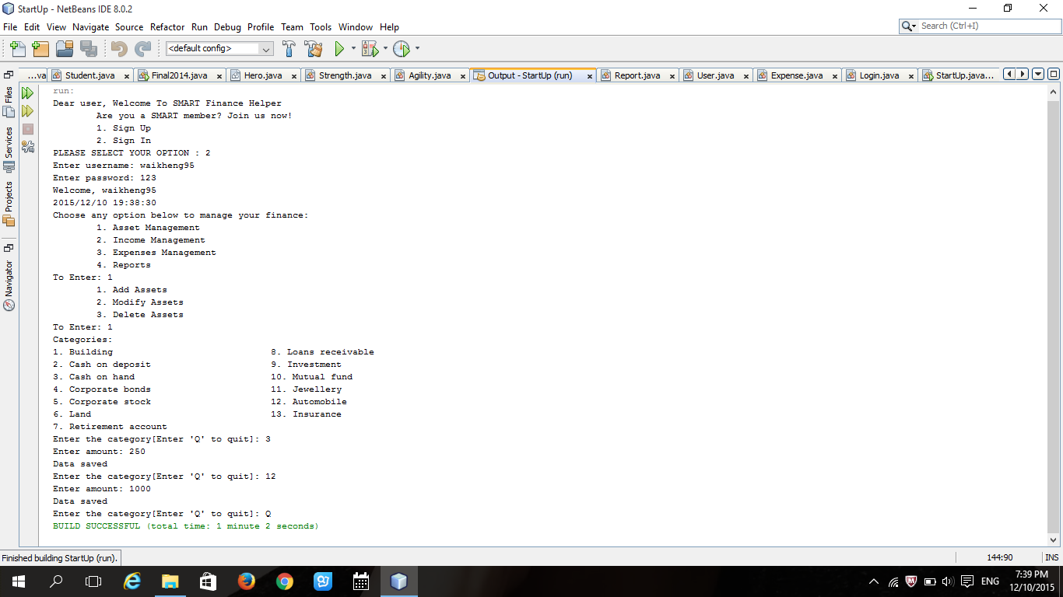
Figure 5: Add asset

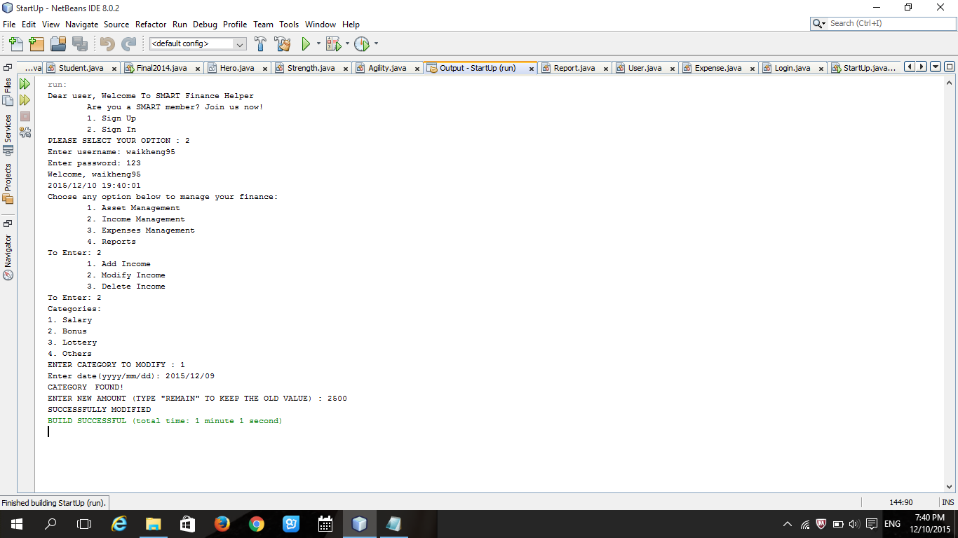
Figure 6: Modify income
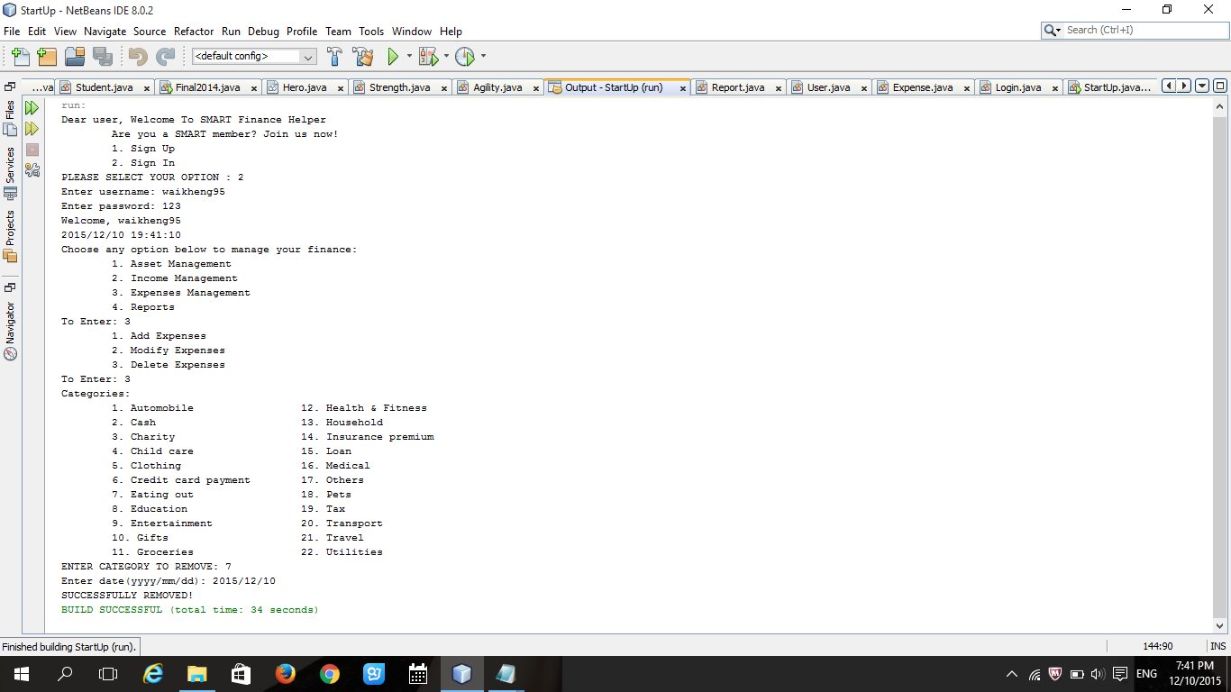
Figure 7: Delete expense

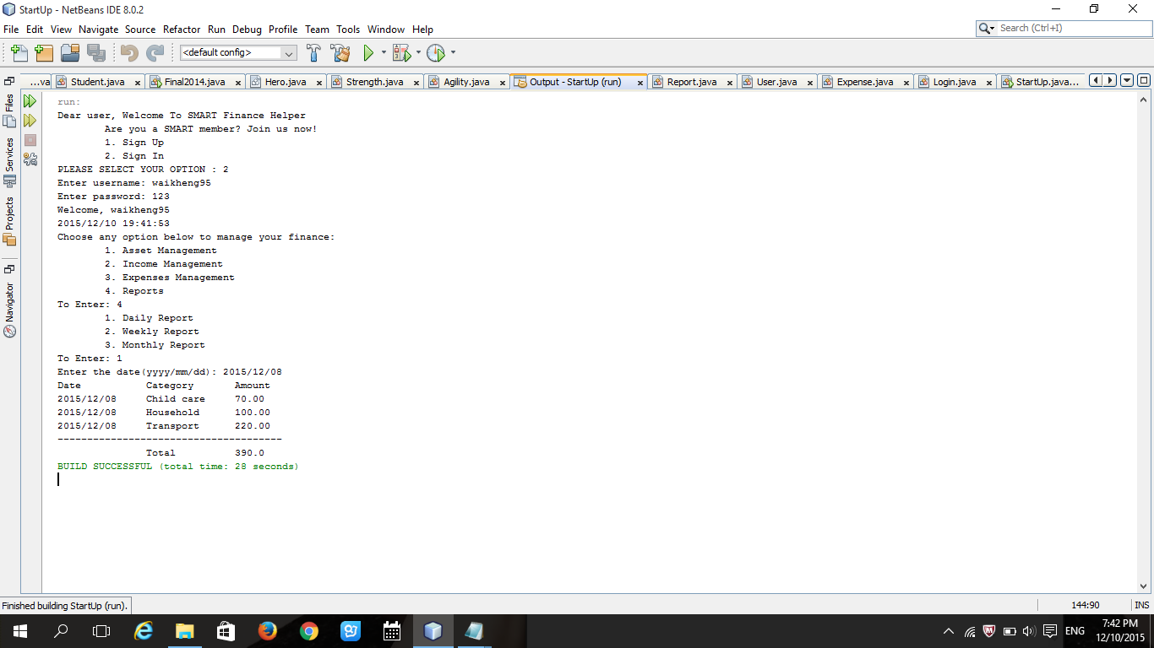
Figure 8: Daily report

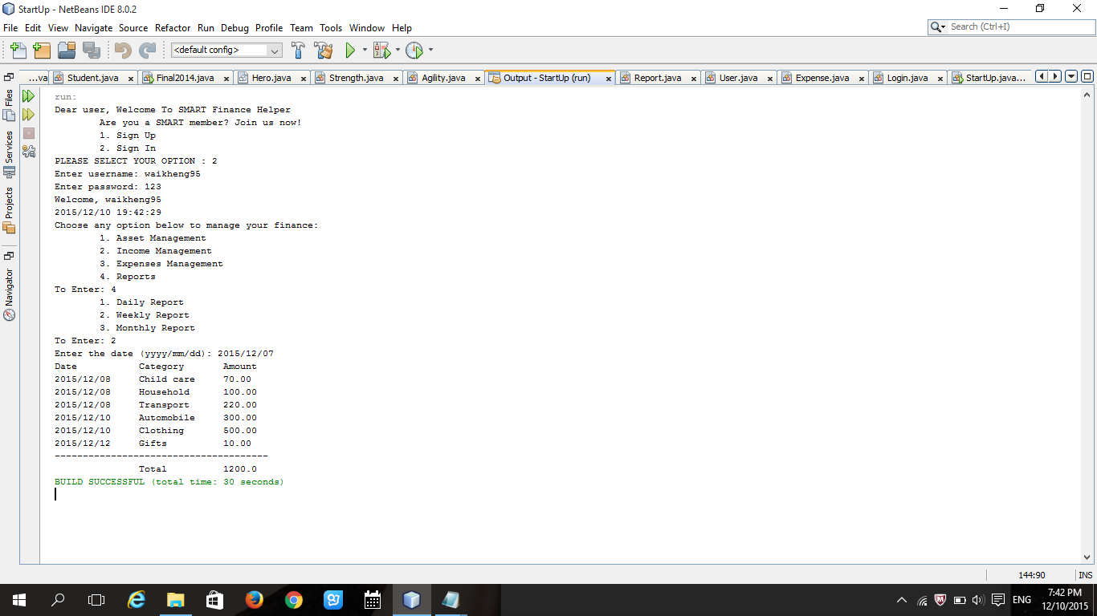
Figure 9: Weekly report

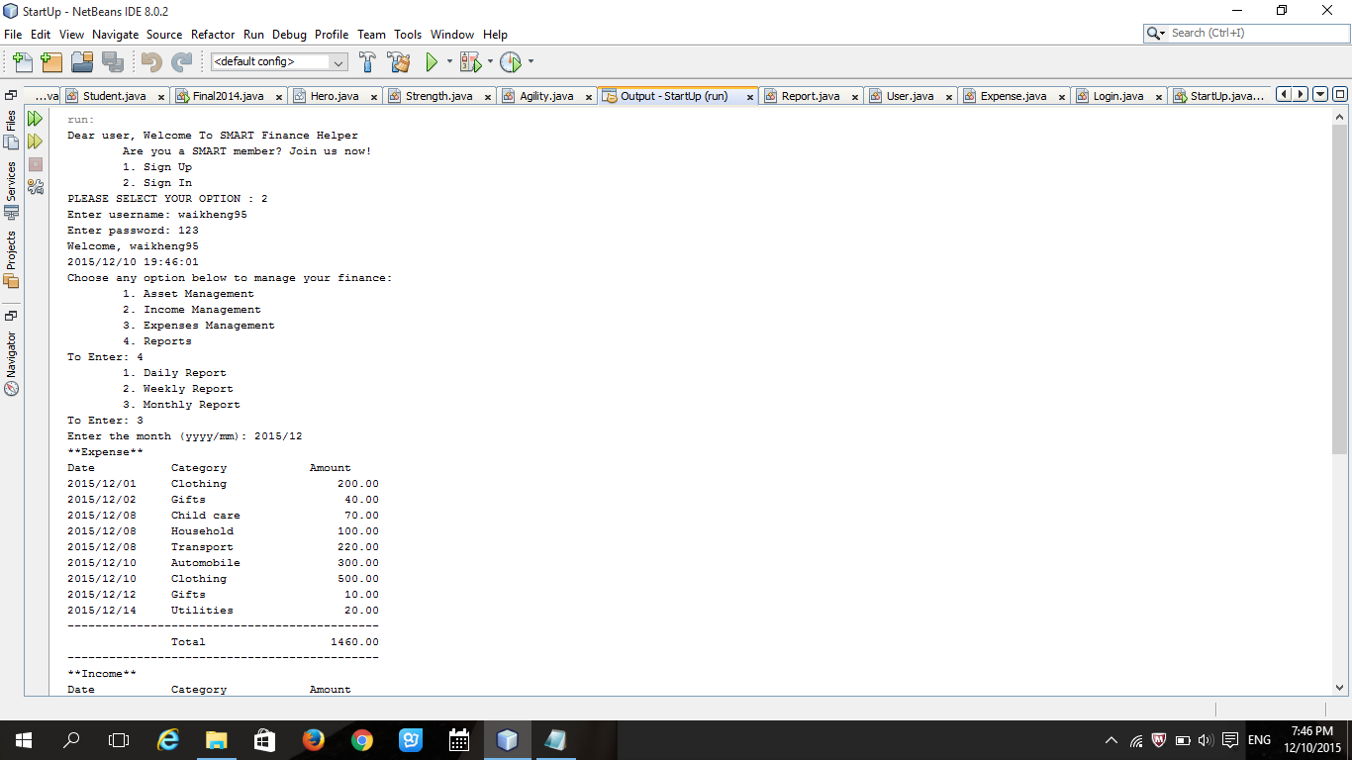
Figure 10: Monthly report (Upper part)
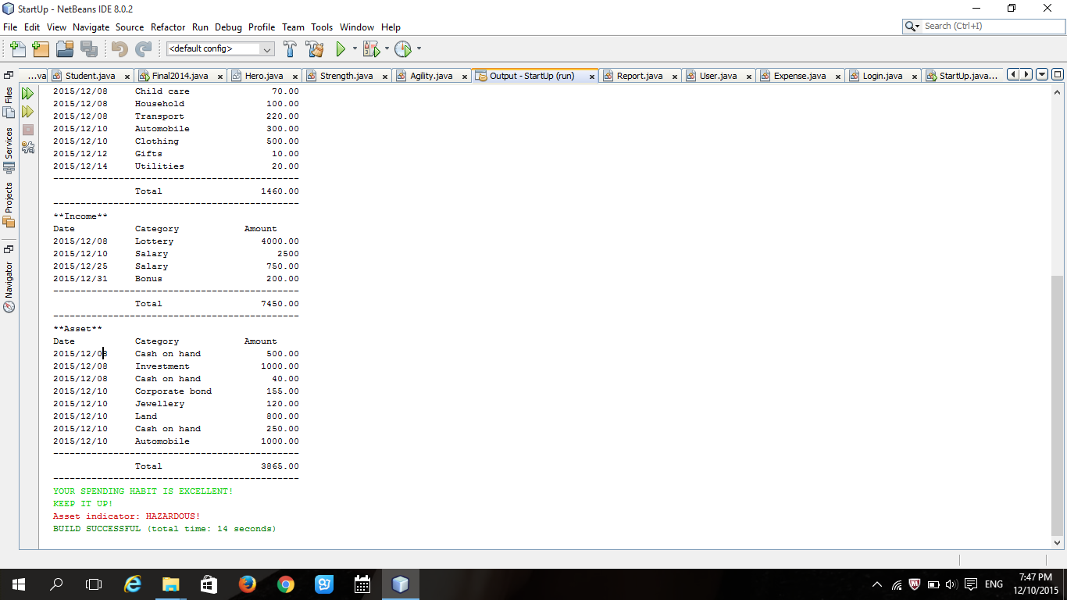
Figure 11: Monthly report (Lower part)

Prepared by:
Tei Wai Kheng _____________________
Liang Chew Yin _____________________
Yap Mei Nah _____________________

