### **Week 34 Epidemiological Bulletin, 19th - 25th, Aug, 2024**

# Summary

**Immediately Notifiable Diseases and Events**

• AFP : 6 suspected cases were reported from Southern Province (3), Eastern Province (2), Western Province (1) provinces.

• Anthrax : 8 suspected cases were reported from Southern Province (7), Western Province (1) provinces.

• Cholera : 4 suspected cases were reported from Copperbelt Province (4) provinces.

• Measles : 28 suspected cases were reported from Western Province (1), North-Western Province (1), Luapula Province (3), Northern Province (14), Eastern Province (7), Lusaka Province (2) provinces.

**Other Diseases and Events**

• Diarrhoea : 35175 suspected cases were reported from Central Province (4568), Southern Province (5142), Western Province (4163), Muchinga Province (1465), Copperbelt Province (3856), North-Western Province (3828), Luapula Province (1950), Northern Province (2289), Lusaka Province (2495), Eastern Province (5419) provinces.

• Malaria : 144640 suspected cases were reported from North-Western Province (23453), Luapula Province (22041), Western Province (10414), Central Province (10517), Lusaka Province (4643), Copperbelt Province (23810), Southern Province (2889), Northern Province (14352), Eastern Province (25239), Muchinga Province (7282) provinces.

• Typhoid : 33 suspected cases were reported from Lusaka Province (18), Northern Province (9), Central Province (2), Copperbelt Province (4) provinces.

# Summary Report Priority Diseases, Conditions and Events

|  | **Week 34** | | | **Week 1 to 34, Cumulative Total** | | |
| --- | --- | --- | --- | --- | --- | --- |
| Disease/Event/Condition | Suspected | Tested | Confirmed | Suspected | Tested | Confirmed |
| **AFP** | 6 | 4 | 1 | 318 | 259 | 1 |
| **Anthrax** | 8 | 2 | 1 | 283 | 36 | 5 |
| **Cholera** | 4 | 0 | 0 | 16,684 | 4,410 | 2,034 |
| **Diarrhoea** | 35,175 | 2,435 | 2,171 | 813,029 | 46,953 | 50,502 |
| **Malaria** | 144,640 | 138,717 | 40,329 | 8,011,914 | 7,570,205 | 3,693,242 |
| **Measles** | 28 | 21 | 3 | 4,360 | 1,343 | 655 |
| **Monkeypox** | 0 | 0 | 0 | 8 | 4 | 0 |
| **Plague** | 0 | 0 | 0 | 13 | 1 | 0 |
| **Typhoid** | 33 | 20 | 4 | 822 | 499 | 45 |

# Summary of VPD Surveillance Indicators

## Measles Laboratory Test Results by Province

• The country has recorded a total of 4360 suspected measles cases in 2024.

• From the 553 measles specimen that have been tested, 192 have been confirmed positive (PR 34.7%)

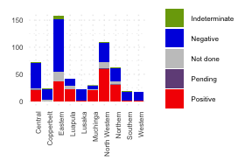

# Maternal Deaths

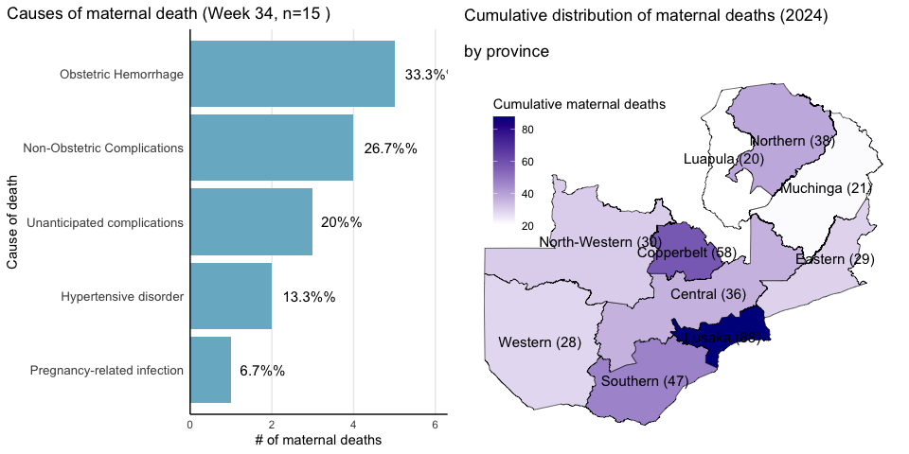

• The bar chart on the summarizes the causes of deaths of 15 maternal deaths recorded in week34 .

• Obstetric Hemorrhage Non-Obstetric Complications Unanticipated complications are the leading causes of maternal deaths this week.

• Cumulatively, in 2024,395 maternal deaths have been recorded across the country, as depicted on the map.

• Provinces with darker shades (Lusaka, Copperbelt and Southern) indicate those with a higher number of reported maternal deaths.