FinVigil AI
Business Requirements Document (BRD) — MVP v1.0
India-only portfolio intelligence SaaS: Consolidate, Replay, Journal, Harvest.
Read-only integrations. Deterministic tax/harvest engine first; AI layers second.
Classification: Internal / Confidential — for engineering, CA validation, and legal review.

1. Document control
Field | Value
Product name | FinVigil AI (Vigil AI)
BRD version | 1.0 (locked)
Primary market | India — retail traders & investors
Assessment Year (MVP default) | AY 2026–27 / FY 2025–26
CBDT alignment | Official ITR-3 / ITR-4 JSON schema (pin utility build in Appendix A)
Stack (reference) | Next.js 15, FastAPI, PostgreSQL (Supabase), Railway, Celery + Redis
Data residency | Supabase ap-south-1 (Mumbai) — mandatory MVP

2. Executive summary
FinVigil AI is an AI-powered portfolio intelligence platform for Indian retail traders. It consolidates multi-broker holdings and AIS data, supports portfolio replay with Monte Carlo simulations, journals trades with voice logging and psychology flags, and surfaces tax-loss harvesting opportunities with exact sell simulations — all read-only with no trade execution.
Target users are active Indian traders (25–45) burdened by Excel workflows, missed tax savings, and lack of structured review. Four modules drive value: Multi-platform Consolidate → Portfolio Replay → Trading Journal / coach → Tax Harvest.

3. Personas (priority)

#1 Tax-anxious salaried trader (~60%)
• 28–40, Tier-1/2; AIS reconciliation + ITR JSON + Harvest.

#2 F&O speculator / active trader
• Journal + Replay; discipline and win-rate focus.

#3 Hybrid portfolio builder
• Replay + Consolidate; scenario planning across equity, MF, crypto.

4. Goals & success metrics (MVP)
Metric | Target
Paying Pro users (4 mo post closed beta) | 100
Free → paid conversion | ≥ 10%
AIS auto-match (test corpus) | ≥ 95%
Harvest / harvest simulation accuracy | ≥ 95% (CA-validated sample)
Time-to-first-value | < 90 seconds
Weekly Journal or Replay usage | ≥ 40% active users
Beta NPS | ≥ 8/10

5. Scope

5.1 In scope (v1)
• India only: NSE/BSE, Indian brokers, AIS, ITR-3/4 JSON export assistance.
• Read-only: Zerodha Kite Connect, Groww Trade API, Upstox; WazirX + CoinDCX + CSV.
• F&O in scope across Consolidate, Journal, Replay, Harvest.
• Demo mode: one-click sample portfolio; no login; reset on refresh.

5.2 Out of scope (v1 guardrails)
• No trade execution, custody, or lending.
• No personalized investment advice; simulations + disclaimers only.
• Not a tax preparer/filer — exports + User/CA input fields.
• No long-term raw voice storage (delete after transcription).
• No US/EU tax; crypto limited to Indian exchanges in MVP.

6. Regulatory, disclaimers & privacy
• Heavy disclaimers: “Not financial advice — consult your CA.”
• DPDP: Mumbai region; MFA for Pro/Premium; JWT + refresh.
• Voice: delete raw audio within <5s of successful transcription; retain transcript + tags.
• Privacy policy string (locked): Raw voice recordings deleted immediately after transcription. Only text transcript retained. User may delete any journal entry at any time.
• WhatsApp (Twilio): opt-in; India DLT compliance.
• Tax persona default: Non-speculative business income (PGBP) — ITR-3; user may override once per AY.

7. User journey (high level)

Figure 1 — Primary journey (happy path)
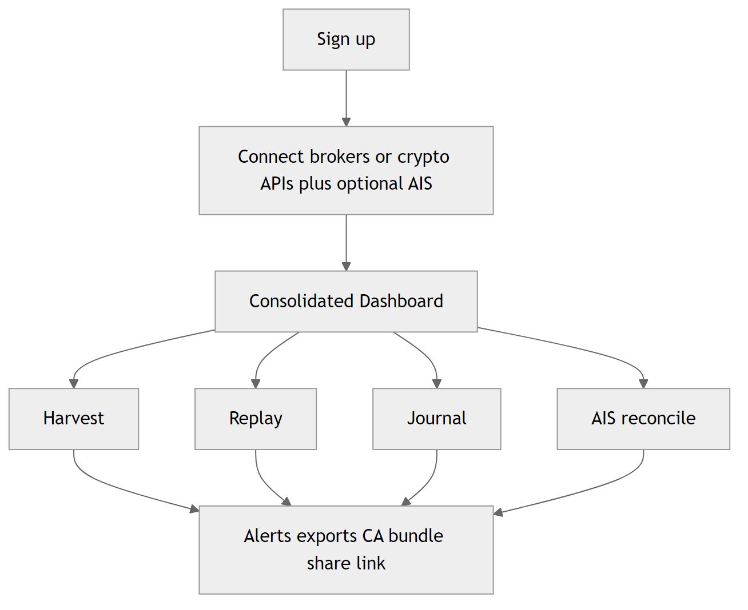

Figure 2 — Onboarding & time-to-first-value (<90s)
Step 1 (~15s): Supabase email/password or Google OAuth. Step 2 (30–45s): broker OAuth or WazirX/CoinDCX API keys plus optional AIS upload. Step 3: consolidated dashboard with holdings, AIS mismatch count, and Harvest banner.

8. Functional requirements by module

8.1 Platform (FR-PLT-*)
• FR-PLT-01: Supabase auth — email/password + Google OAuth.
• FR-PLT-02: Demo mode — seeded data; rate limit 20 req/5 min per IP.
• FR-PLT-03: Tax Persona global setting + one override per AY.
• FR-PLT-04: MFA required Pro/Premium (TOTP); optional Free; nudge before first Harvest/AIS export.
• FR-PLT-05: Short-lived access + refresh tokens.
• FR-PLT-06: Data residency ap-south-1.

8.2 Consolidate (FR-CON-*)
• FR-CON-01: Unified dashboard — equity + F&O + MF + crypto.
• FR-CON-02: Equity/F&O fields: symbol, ISIN, qty, FIFO lots, avg buy, live price, unrealized/realized P&L, charges, STCG/LTCG flag.
• FR-CON-03: MF: folio, units, avg NAV, P&L.
• FR-CON-04: VDA: FIFO cost; 30%+cess display; TDS Credits ledger.
• FR-CON-05: WebSocket or polling per connector.
• FR-CON-06: Corporate actions — manual confirm/apply only (v1).

8.3 AIS (FR-AIS-*)
• FR-AIS-01: Upload JSON → CSV → PDF (OCR last).
• FR-AIS-02: Multiple versions per AY; Latest flag; history + match %; overwrite confirm.
• FR-AIS-03: Auto-match + mismatch types (missing, qty, price, duplicate, TDS).
• FR-AIS-04: Resolution grid + bulk exact-match + mismatch export.
• FR-AIS-05: ITR JSON generation with User/CA input form pre-export.

8.4 Harvest (FR-HAR-*)
• FR-HAR-01: FIFO; equity STCG/LTCG + exemption; VDA 30%+cess; set-off per persona.
• FR-HAR-02: Outputs — tax saved estimate, sell list, post-harvest sim, warnings.
• FR-HAR-03: Free on-demand only; Pro/Premium — 06:00 IST Celery job + portfolio-change + 60s polling on Harvest page.
• FR-HAR-04: Deep link “Simulate in Replay.”

8.5 Replay (FR-REP-*)
• FR-REP-01: User history + Nifty/Bank Nifty + drag-drop what-if.
• FR-REP-02: Price stack — broker → NSE CSV / free API → user CSV.
• FR-REP-03: Monte Carlo 1000 paths + inflation (CPI).
• FR-REP-04: Monte Carlo entitlement — Pro+.

8.6 Journal (FR-JRN-*)
• FR-JRN-01: MediaRecorder → Whisper/Groq → delete audio <5s.
• FR-JRN-02: Fixed psychology taxonomy; no buy/sell advice.
• FR-JRN-03: User-delete cascades transcript + tags.

8.7 Notifications (FR-NOT-*)
• FR-NOT-01: In-app + Resend email + Twilio WhatsApp (opt-in).
• FR-NOT-02: Harvest, AIS mismatch, journal streak, Sunday report, drawdown alert.

8.8 CA export & share (FR-CA-*)
• FR-CA-01: ZIP — ITR JSON + CSV lots/trades + PDF + notes + Harvest/Replay exports.
• FR-CA-02: Tokenized read-only link — TTL 7/30/90 days, optional password.

8.9 Admin (FR-ADM-*)
• FR-ADM-01: Feature flags per user/module.
• FR-ADM-02: Impersonation read-only + broker re-sync only; full audit; user notified.
• FR-ADM-03: DPDP data export on request.

9. ITR export — form selection
Infer recommended form from Tax Persona (default ITR-3). Before final export, confirmation modal with dropdown ITR-3 | ITR-4 and eligibility tooltip. Warn if ITR-4 chosen but capital gains or F&O outside presumptive limits. Exported JSON strictly follows official CBDT schema for chosen form (pin version Appendix A).

10. Subscription, Razorpay & entitlements
Tier | plan_id | Monthly | Annual
Free | plan_free | ₹0 | —
Pro | plan_pro_monthly | ₹299 | —
Pro | plan_pro_annual | — | ₹2,499 (~42% off)
Premium | plan_premium_monthly | ₹799 | —
Premium | plan_premium_annual | — | ₹6,999 (~27% off)
Server enforces entitlements on every protected API (FastAPI + RLS). Webhooks update subscription.status + plan_id.

10.1 Failed payment & grace
• Razorpay pending + Smart Retry (immediate, +3d, +7d).
• Grace: 7 full days from first failed charge — full Pro/Premium access.
• After day 7: downgrade to Free.
• Post-downgrade: read-only dashboard + historical view + one-time CA bundle (JSON+PDF) for current AY (define: once per lapse cycle).
• Blocked: new Harvest, new AIS, Monte Carlo, voice journal, new connections beyond Free, daily alerts.
• Notify Day 0, 3, 6 — in-app + email + WhatsApp with payment update deep link.

10.2 Proration (Razorpay)
• Plan changes immediate; proration auto; min adjustment ₹0.50; UI shows ₹X today and savings.

10.3 Tier limits (brokers / lookback)
Tier | Brokers + crypto | Lookback
Free | 2 + 1 | Current FY only
Pro | 5 + 3 | Lifetime
Premium | Unlimited | Lifetime + multi-AY (3–5 AYs)

11. AY pinning
• MVP/Pro: single current AY (2026–27 / FY 2025–26) for all modules.
• User may upload historical AIS/CSV files solely to reconcile against the current AY dataset (not multi-AY navigation on Pro).
• Premium: multi-AY switcher (last 3–5 AYs), full historical lot exposure, multi-year Harvest, bulk ITR exports.

12. Heavy operations & rate limits
Heavy ops: AIS upload+reconcile, Harvest scan (user-initiated), Monte Carlo 1k.
• Option A (MVP): 5 heavy ops / user / hour (all tiers). Free additionally max 10 heavy ops / rolling 24h.
• Scheduled Pro/Premium daily Harvest + debounced post-sync harvest excluded from user heavy-op quota.
Context | Limit
Demo (per IP) | 20 req / 5 min
Public unauthenticated | 60 req / min per IP
Authenticated Free | 300 req / 15 min per user
Pro / Premium | 1,200 req / 15 min per user

13. Price staleness SLO
• Market hours 09:15–15:30 IST: quotes ≤ 60s stale; WS preferred else poll ≤ 30s.
• Outside hours: ≤ 2 min stale; last close + after-hours if available.
• UI badge + banner + Refresh if threshold exceeded.

14. Data model — ERD (logical)

Figure 3 — Entity relationship diagram (ERD)
Logical model for PostgreSQL (Supabase). Editable Mermaid sources live under scripts/diagrams/sources/fig03-erd.mmd in the repository.
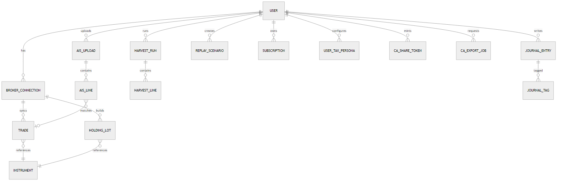
Key entities: User, UserTaxPersona, Subscription, BrokerConnection, Instrument, Trade, HoldingLot, Charge, TdsCreditLedger, CorporateActionAdjustment, AisUpload, AisLine, AisMatchResult, HarvestRun, HarvestRecommendationLine, ReplayScenario, ReplayRun, JournalEntry, JournalTag, CaShareToken, CaExportJob, NotificationPreference, AdminAuditLog.

15. Integration matrix
System | Purpose | Auth
Supabase | Auth, DB, RLS, MFA | OAuth / email
Zerodha Kite | Holdings, orders, F&O | OAuth2
Groww | Portfolio read | Per Groww docs
Upstox | Read-only portfolio | OAuth2
WazirX / CoinDCX | Crypto | API key
CSV | Fallback | Upload
AIS (portal file) | Reconciliation | User upload
Razorpay | Billing | Webhooks
Resend | Email | API key
Twilio WA | Alerts | Templates
Groq / OpenAI | STT + LLM | API keys
Celery + Redis | Jobs | Internal
NSE / Yahoo / Twelve Data | EOD / indices | Varies

16. Backend flows (numbered)
• 1 Signup/login + MFA gate by tier.
• 2 Broker OAuth + initial_full_sync Celery.
• 3 Incremental sync + quote cache + WS/poll.
• 4 AIS upload → parse → version → match engine.
• 5 AIS resolution → ITR export readiness.
• 6 Harvest on-demand / scheduled / on-change (debounced).
• 7 Replay backtest + Monte Carlo + provenance.
• 8 Journal voice pipeline → delete audio → tag.
• 9 ITR JSON + PDF + CSV audit.
• 10 CA ZIP + share token viewer.
• 11 Notifications outbox.
• 12 Razorpay webhook → entitlements.
• 13 Admin impersonation + audit + user notify.

16a. Architecture — client, API, and data plane

Figure 9 — Backend / integration overview
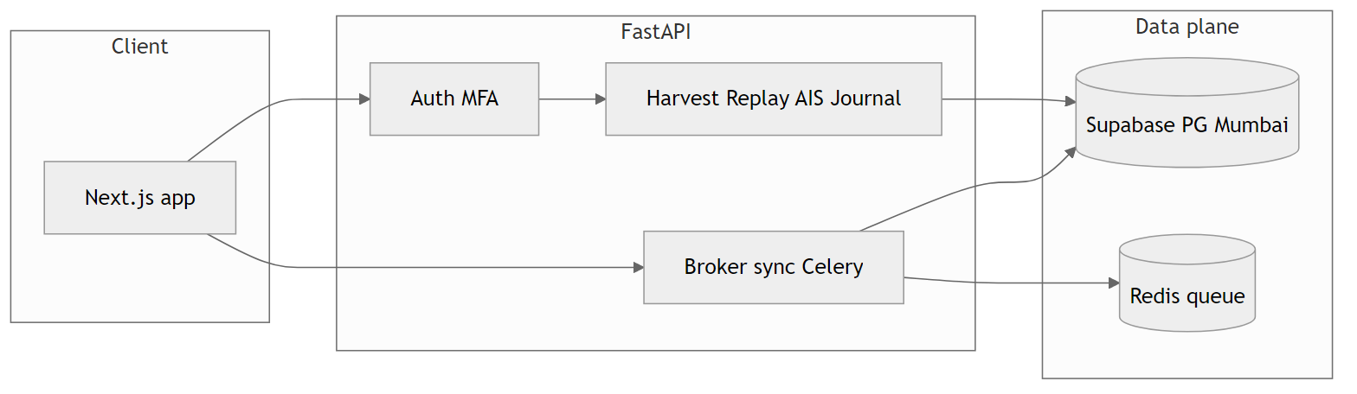

17. UI wireframes (low-fidelity diagram, PNG)
Screen-level layouts as structured block diagrams (Figma-style detail comes later). Sources: scripts/diagrams/sources/fig04–fig08.

17.1 Dashboard (Consolidate) — Figure 4

17.2 Harvest results — Figure 5
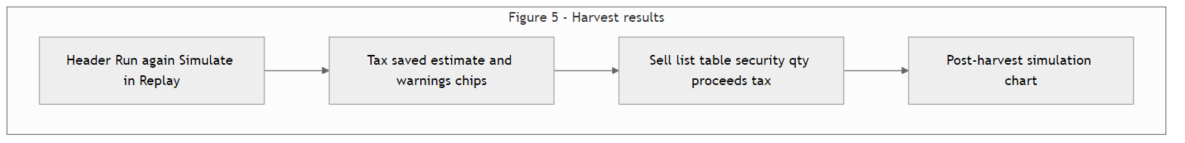

17.3 AIS reconciliation — Figure 6

17.4 Replay builder — Figure 7

17.5 Journal entry — Figure 8
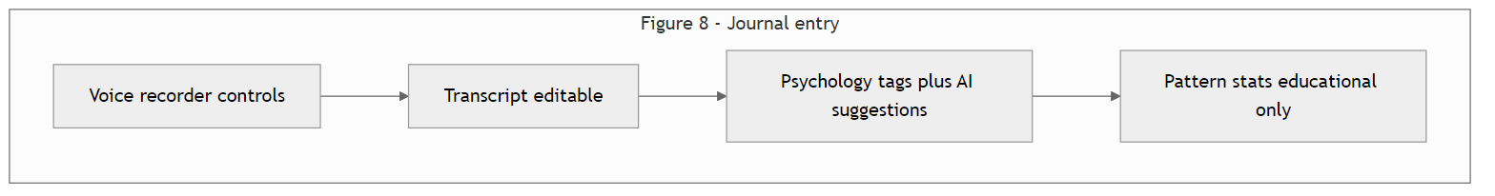

18. Appendix A — Schema & compliance pins (TBD by team)
• Pin CBDT JSON schema version + ITR utility build date for AY 2026–27.
• Pin Razorpay dashboard settings: proration, credit vs refund on downgrade.
• CA validation: first 10 ITR JSON exports.
• Legal: SEBI non-advisory copy pack + DPDP privacy policy + subprocessor list.

19. Revision history
Version | Date | Notes
1.0 | 2026-04-24 | BRD locked from client discovery sessions

