**ANALYSIS OF LOGISTICS MANAGEMENT**

ANANDAPADMANABAN MADHAVAN (529315)

BHARGAVI VASU (529307)

DONDETI SAI TEJA (529447)

GOKULNATH CHANDRAN (529454)

PRIYANKA SATHIYANARAYANAN (529311)

SHYAM BALAKRISHNAN (529308)

***Contents***

Chapter -1 Abstract………...…………...………………………………………………..3

Chapter -2 Introduction…………………………………………………………………..4

Chapter -3 Technologies Used…..……………………………………………………….5

Chapter -4 Design…………………….………………………………………………….8

Chapter -5 Tables/Entities……………………………………………………………….10

Chapter -6 Sql Server Data Tools Output……………….………………………………12

Chapter -7 Final Output-Power BI……………………………………………………….14

Chapter -8 Future Enhancements………………………………………………………..18

Chapter -9 Conclusion…………………………………………………………………...19

Chapter -10 References …………………………………………………………………..20

**CHAPTER-1**

***ABSTRACT:***

OBJECTIVE:

To analyze the shortest distance among the companies situated at different cities.

ABSTRACT:

Logistics analysis has been viewed as an important element in the corporate strategy of many organizations. Logistics refers to a process that is associated with flow of information, goods, and services offered to suppliers and customers from the point of origin to the point of destination. It is commonly the complete process that starts from raw materials to the final disposal or sale of the finished goods. An effective and efficient logistics system is created to meet the requirements of the customers for timely responsiveness, quality and creating value for products and services.

Logistics analysis consists of the integration of inventory, facility location, transportation, packaging activities, and informational flow for the purpose of managing an effective physical movement of outbound and inbound goods and services in a competitive environment. The complete cost and system approach are developed for planning and managing the various logistical functions that are prevalent within the organization. It may be dependent on the techniques of basic sampling and data analysis. This may involve the use of questionnaires and online or electronic ways of gathering information.

**CHAPTER-2**

***INTRODUCTION:***

Logistics has been receiving increased attention in management literature in the past few years. In particular, logistics has been recognised not only as a group of important functions, but as functions that have important strategic impacts as well. Logistics, as demonstrated by many corporations, can either gain or lose leverage in the marketplace, and more firms are recognising its importance. Specifically, for our Logistics system,

the data should be collected and stored in a data warehouse. As you know, data cannot be in same format and clean as always. Therefore data from all sources (flatfiles, DB, CSV, etc.) Should be integrated and proper cleansing should be applied on data and stored in data marts thus, paving a way for creating a report based on the collected data.

**Requirements in Scope:**

1. Data warehouse should be created.

2. Cleanse the data and store it in Data marts.

3. Generate reports using data from Data mart.

4. Attractive reports should be generated using appropriate concepts, styles, patterns, etc.

**Software Requirements:**

1. DBMS : Microsoft Sql Server

2. ETL Tool : Sql Server Data Tools

3. Report Tool/Visualization : Power BI Desktop

**CHAPTER-3**

***Technologies used:***

* 1. Firstly data had to be generated. For this we have used SQL Server and MS-EXCEL
     1. **SQL SERVER:**

SQL Server Management Studio (SSMS) is an integrated environment for managing any SQL infrastructure. Use SSMS to access, configure, manage, administer, and develop all components of SQL Server, Azure SQL Database, and SQL Data Warehouse. SSMS provides a single comprehensive utility that combines a broad group of graphical tools with a number of rich script editors to provide access to SQL Server for developers and database administrators of all skill levels.

A central feature of SSMS is the Object Explorer, which allows the user to browse, select, and act upon any of the objects within the server. It also shipped a separate Express edition that could be freely downloaded, however recent versions of SSMS are fully capable of connecting to and manage any SQL Server Express instance. Microsoft also incorporated backwards compatibility for older versions of SQL Server thus allowing a newer version of SSMS to connect to older versions of SQL Server instances.

* 1. The next step is to fetch theNecessary details of the product ordered by the customer

Including the details like which employee delivered the product, on which date and the total bill amount. This is done based on some functional requirements. For this a separate target table is designed fetching all the required data using Sql Server Data Tools.

* + 1. **SQL SERVER DATA TOOLS**:

Integration Services is a platform for building enterprise-level data integration and data transformations solutions.

* Prior to SSIS, integration capabilities were available as part of SQL Server Database (SQL Server 7.0 & SQL Server 2000) and was called as Data Transformation Service (DTS).
* The first version of SSIS was released with SQL Server 2005 as a separate windows service which provides a complete set of tools, services, and APIs to build complex yet robust and high performing transformations and solutions.

Integration Services is used to solve complex business problems by copying or downloading files, sending e-mail messages in response to events, updating data warehouses, cleaning and mining data, and managing SQL Server objects and data. The packages can work alone or in concert with other packages to address complex business needs. Integration Services can extract and transform data from a wide variety of sources such as XML data files, flat files, and relational data sources, and then load the data into one or more destinations.  
  
Integration Services includes a rich set of built-in tasks and transformations; tools for constructing packages; and the Integration Services service for running and managing packages. You can use the graphical Integration Services tools to create solutions without writing a single line of code; or you can program the extensive Integration Services object model to create packages programmatically and code custom tasks and other package objects.

At a high level, SSIS provides the ability to:

* Retrieve data from just about any source
* Perform various transformations on the data; e.g. convert from one type to another, convert to uppercase or lowercase, perform calculations, etc.
* Load data into just about any source
* Define a workflow
  1. Lastly we had to generate report using Power BI Desktop.
     1. **POWER BI DESKTOP:**

Microsoft Power BI is a free, self-service business intelligence cloud service that provides non-technical business users with tools for aggregating, analyzing, visualizing and sharing data. Power BI's user interface is fairly intuitive for those users familiar with Excel and its deep integration with other Microsoft products makes it a very versatile tool that requires very little upfront training.

A Power BI report is a multi-perspective view into a dataset, with visualizations that represent different findings and insights from that dataset. A report can have a single visualization or pages full of visualizations. Depending on your job role, you may be someone who creates reports and/or you may be someone who consumes or uses reports. The 4 major building blocks of Power BI are: dashboards*,*reports*,*workbooks*, and*datasets. And they're all organized into workspaces*.*

**Datasets**

A dataset is a collection of data that you import or connect to. Power BI lets you connect to and import all sorts of datasets and bring all of it together in one place. Workspaces are containers for dashboards, reports, workbooks, and datasets in Power BI

**Reports**

A Power BI report is one or more pages of visualizations (charts and graphs like line charts, pie charts, treemaps, and many more). Visualizations are also called visuals*.* All of the visualizations in a report come from a single dataset.

**Dashboards**

A *dashboard* is something you create in Power BI service or something a colleague creates in Power BI service and shares with you. It is a single canvas that contains zero or more tiles and widgets. Each tile pinned from a report or from [Q&A](https://docs.microsoft.com/en-us/power-bi/power-bi-q-and-a) displays a single [visualization](https://docs.microsoft.com/en-us/power-bi/power-bi-report-visualizations) that was created from a dataset and pinned to the dashboard. Entire report pages can also be pinned to a dashboard as a single tile

**Workbooks**

Workbooks are a special type of dataset. If you've read the Datasets section above, you know almost all you need to know about workbooks. But you may be wondering why sometimes Power BI classifies an Excel workbook as a Dataset and other times as a Workbook.

**CHAPTER-4**

***DESIGN:***

**4.1 DATA BASE DIAGRAM:**

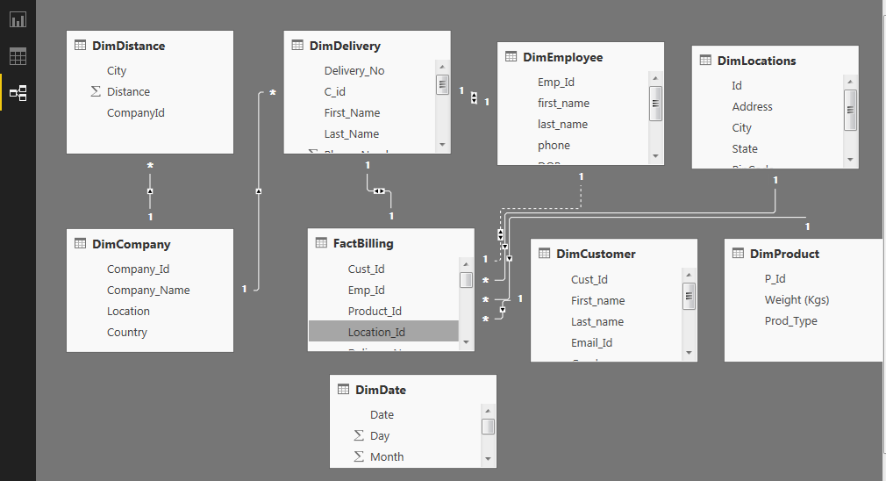

ER-DIAGRAM

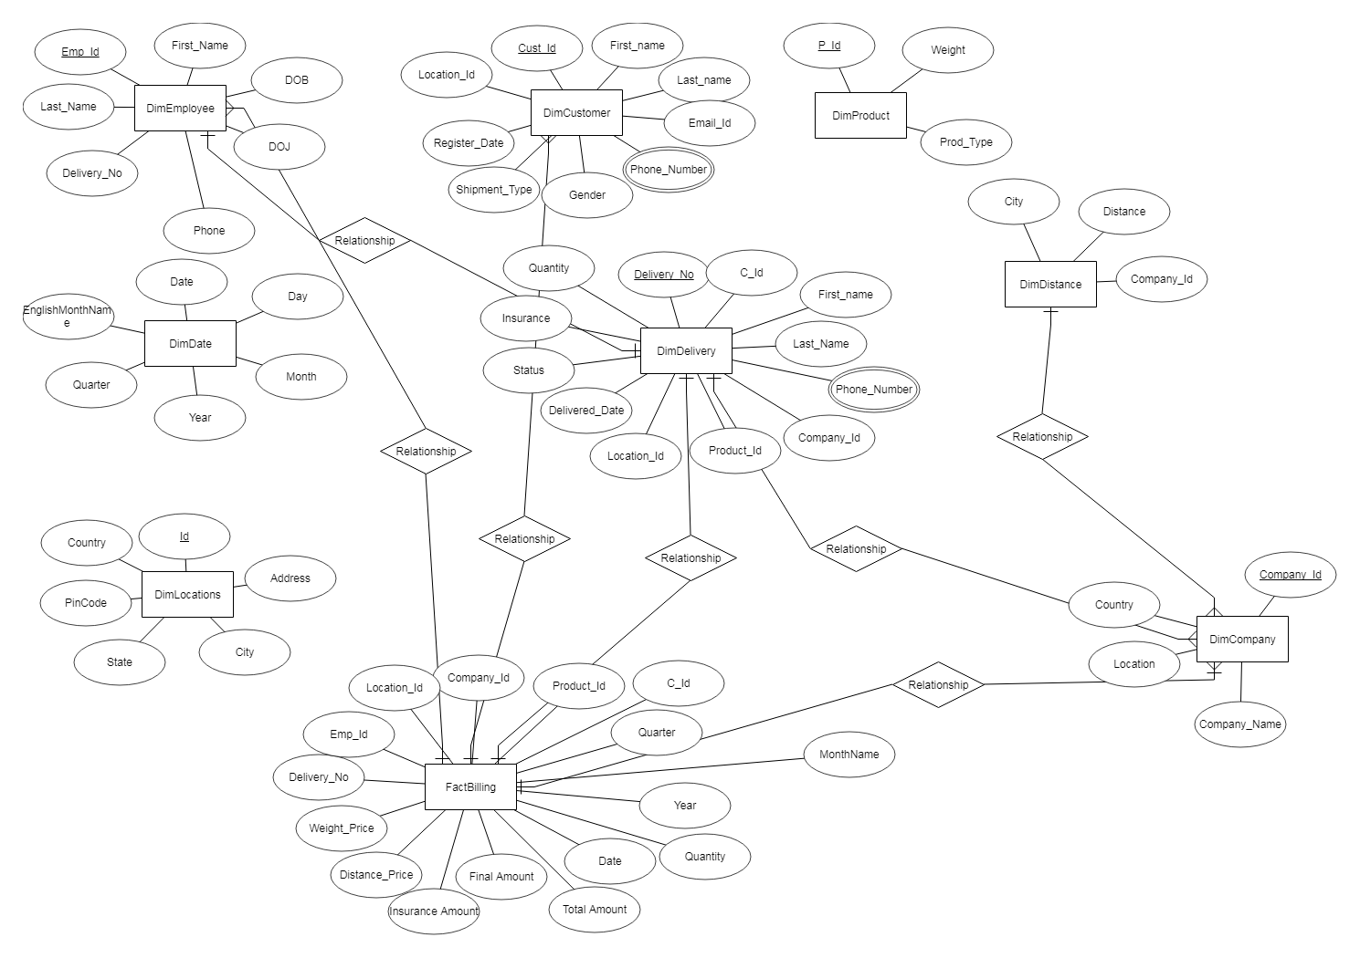

**CHAPTER-5**

***TABLES:***

**5.1 Table 1:** DimCompany



**5.2 Table 2:** DimCustomer

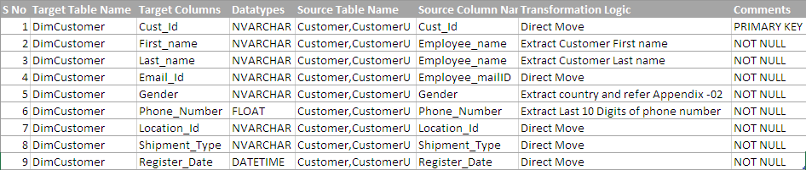

**5.3 Table 3:** DimDate

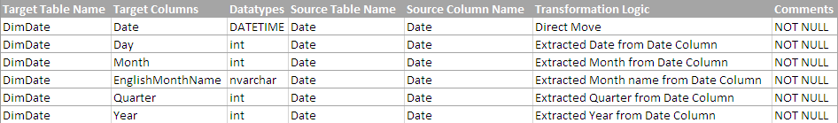

**5.4 Table 4:** DimDelivery

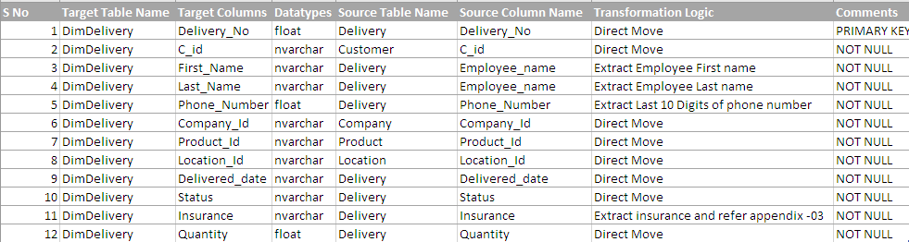

**5.4 Table 5:** DimDistance



**5.4 Table 6:** DimEmployee

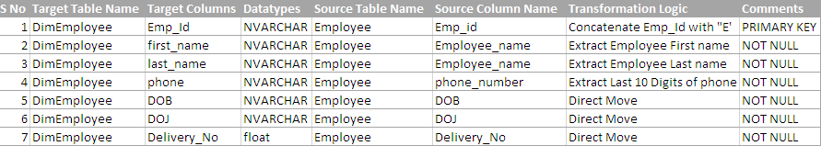

**5.4 Table 7:** DimLocations

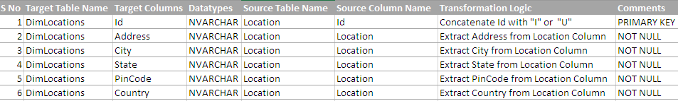

**5.4 Table 8:** DimProduct



**5.4 Table 9:** FactBilling

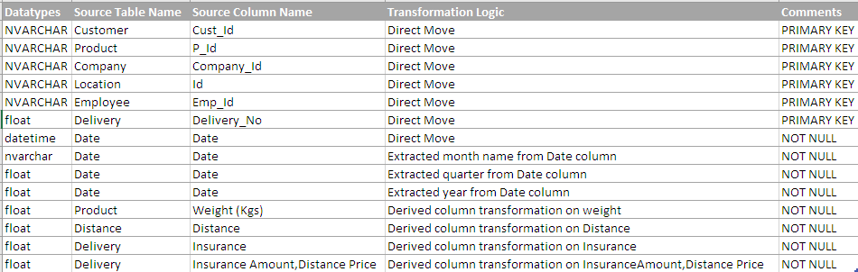

# **CHAPTER-6**

**SQL SERVER DATA TOOLS:**

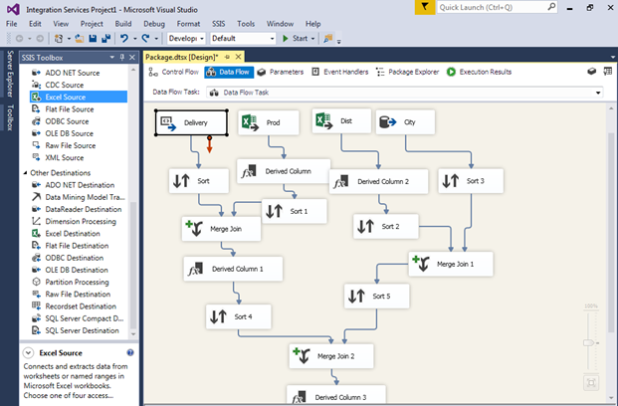

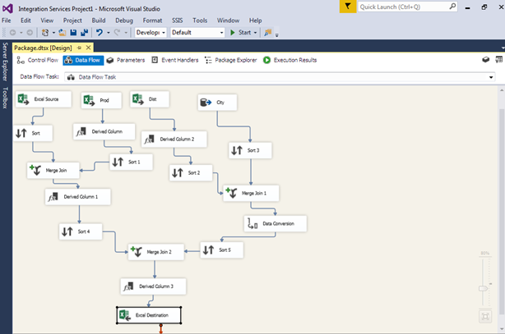

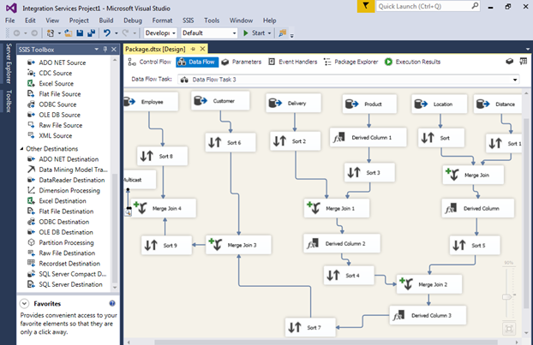

# **chapTER-7**

# **FINAL OUTPUT REPORT- POWER BI DESKTOP**

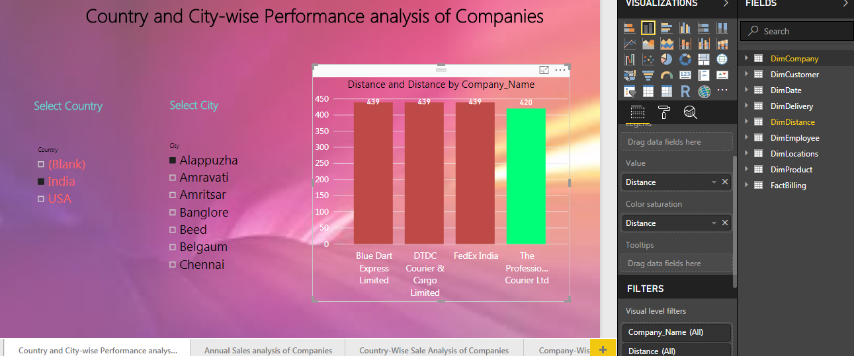

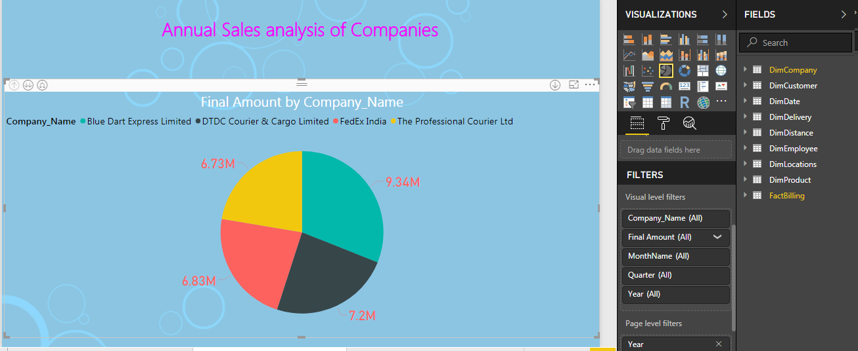

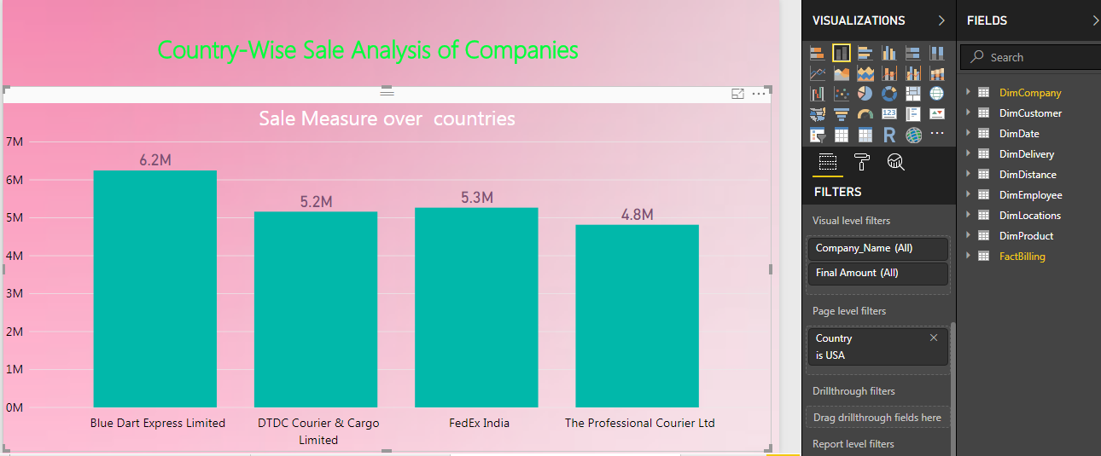

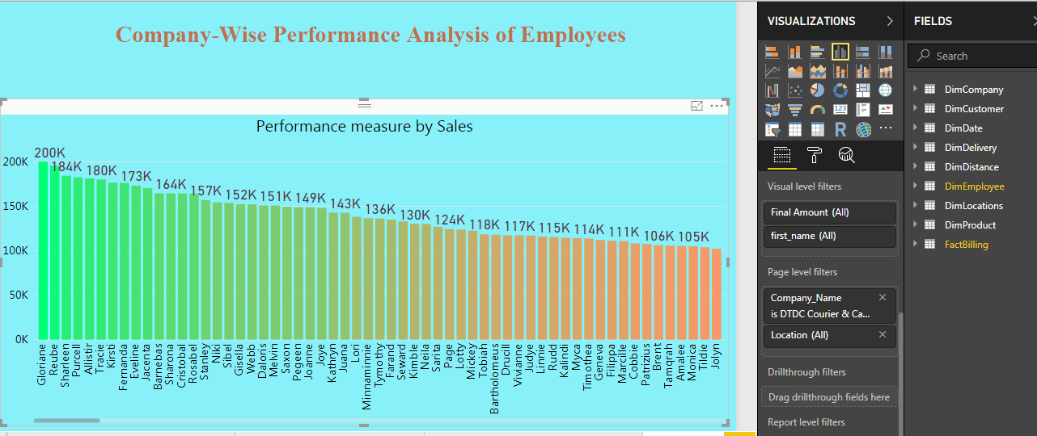

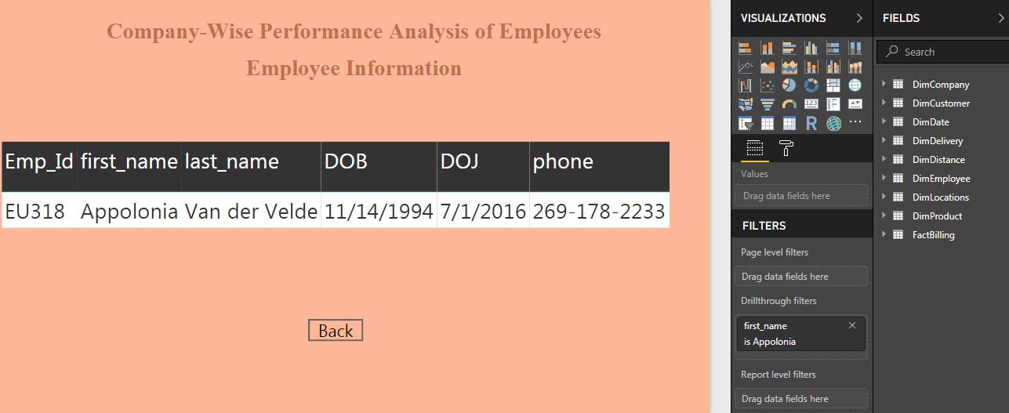

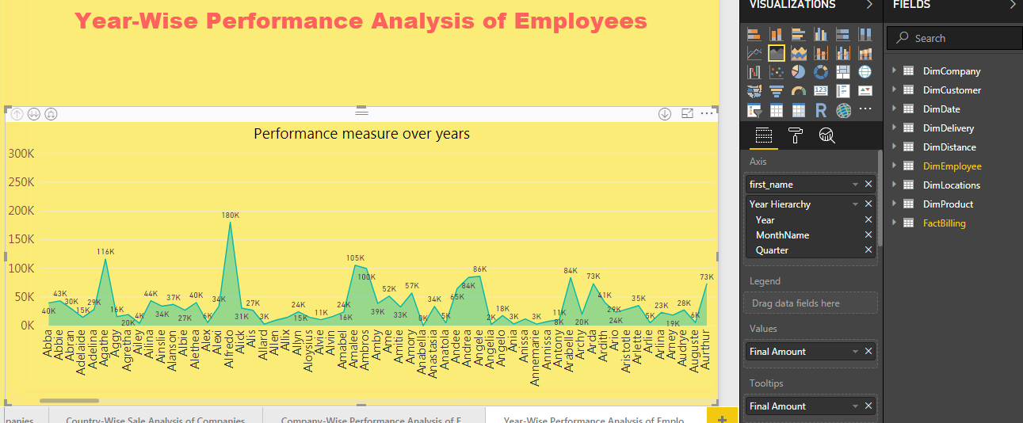

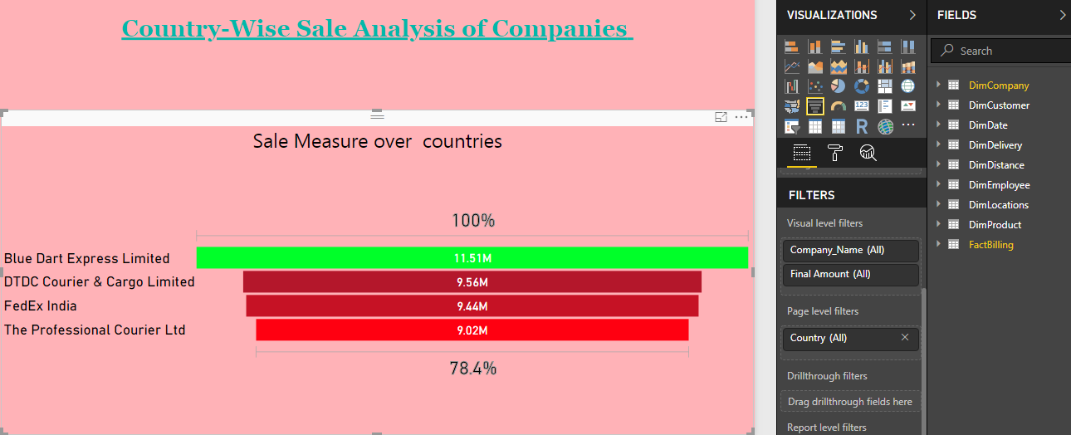

# **CHAPTER*-*8**

***FUTURE ENHANCEMENTS***

* Improve Market Effectiveness through personalization, delivery of context and offers that increase the likelihood of purchase.
* To gain deeper understanding of customer’s behavior, needs, preferences and understanding.
* Optimize the supply chain to ensure the most profitable outcome in terms of demand fulfilment
* To improve user interface

# **CHAPTER-9**

***CONCLUSION***

This project explains about the analysis of the shortest distance covered to deliver the products to the customers in an effective way. In this project, various reports are generated showing the analysis based on the performance of Companies and Employees for Years, Locations and Countries. By using these reports the organizations can analyze the scenario for delivering the products in shortest distance. In this project, attractive and user friendly reports are generated using Power BI for Desktop tool.

**CHAPTER-10**

# ***REFERENCES***

1. <https://searcherp.techtarget.com/definition/logistics-management>
2. <https://docs.microsoft.com/en-us/sql/integration-services/sql-server-integration-services?view=sql-server-2017>
3. <https://searchcontentmanagement.techtarget.com/definition/Microsoft-Power-BI>
4. <https://en.wikipedia.org/wiki/Business_intelligence>
5. <https://en.wikipedia.org/wiki/Microsoft_SQL_Server>