Hospital Management System

Saraf Abhinav Bala (23CSB0A33)

Venneti Teja Sree Charan (23CSB0A34)

18th April 2025

*A database management system for Hospital*The goal of this project is to **design and implement a Hospital Management System (HMS)** that:

* Provides secure and centralized management of patient and doctor records.
* Automates the registration process and assigns unique IDs to each patient.
* Allows users to book appointments based on doctor availability.
* Enables online fee payments and prescription tracking for patients.
* Restricts system access to authorized personnel through secure login.
* Ensures efficient complaint handling by hospital authorities.
* Offers a user-friendly interface that speeds up hospital operations and improves overall patient experience.

The proposed system will significantly reduce manual workload, improve data security, and streamline hospital processes for both administrators and patients.

The database should be scalable to handle large number of users and growing amount of data. The database should be designed to ensure data reliability and database consistency.

The final solution should be presented in the form of an ER model and a database implementation using a RDBMS such as SQL.

Please remember, that this is not a final database system, it has the potential to grow into a vast database system. Thus, more and more features can easily be added to it, and it is not limited to its current capabilities. This database will currently take care of the basic requirement of a general hospital system.We will be able to keep records of wards, doctors, nurses, patients, diagnosis that patient receives, payment made by patients, appointments by patients and many others.

**Part 1. Entities in Hospital Domain Description**

* Ward
* Employee
  + Doctor
  + Nurse
* Research Lab
* Patient
* Admitted patient
* Appointment
* Diagnosis
* Payment

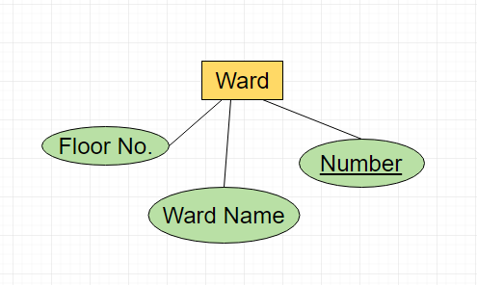

Ward Domain

* Entity: Ward
* Attributes:
  + Number (Primary key)
  + Floor No.
  + Ward name

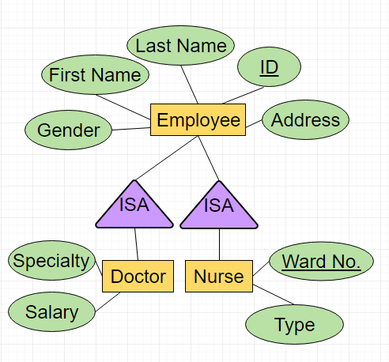

Employee Domain

* Entity Set: Employees
* Entity: Employee
* Attributes:
  + ID (Primary key)
  + First Name
  + Last Name
  + Gender
  + Address

Doctor Domain

* Attributes: A Doctor has all employee attributes plus
  + Specialty
  + Salary

Nurse Domain

* Attributes: A Nurse has all employee attributes plus
  + Type
  + Ward No. (Foreign key)

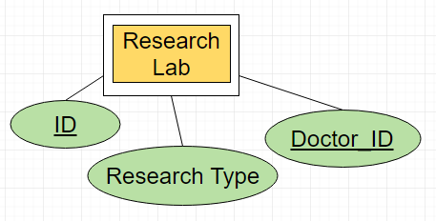Research Lab Domain

* Entity: Research lab
* Attributes:
  + ID (Primary key)
  + Research Type
  + Doctor_ID (Foreign key)

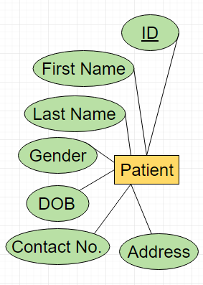Patient Domain

* Entity: Patient
* Attributes:
  + ID (Primary key)
  + First Name
  + Last Name
  + Gender
  + DOB
  + Contact No.
  + Address

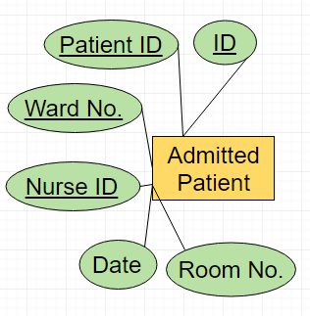Admitted Patient Domain

* Entity: Admitted Patient
* Attributes:
  + ID (Primary key)
  + Patient ID (Foreign Key)
  + Nurse ID (Foreign Key)
  + Ward No.(Foreign Key)
  + Date
  + Room No.

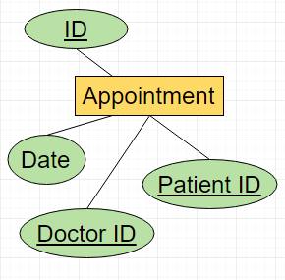Appointment Domain

* Entity: Appointment
* Attributes:
  + ID (Primary key)
  + Patient ID (Foreign Key)
  + Doctor ID (Foreign Key)
  + Date

Diagnosis Domain

* Entity: Diagnosis
* 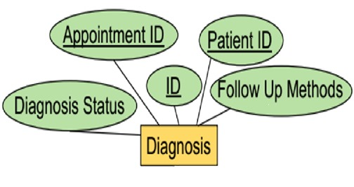Attributes: A Diagnosis has…
  + ID (Primary key)
  + Patient ID (Foreign Key)
  + Doctor ID (Foreign Key)
  + Date

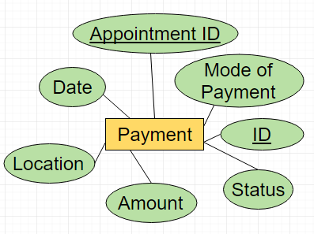Payment Domain

* Entity: Payment
* Attributes:
  + ID (Primary key)
  + Appointment ID (Foreign Key)
  + Mode of Payment
  + Status
  + Amount
  + Location
  + Date

**Part 2. ER DIAGRAM**

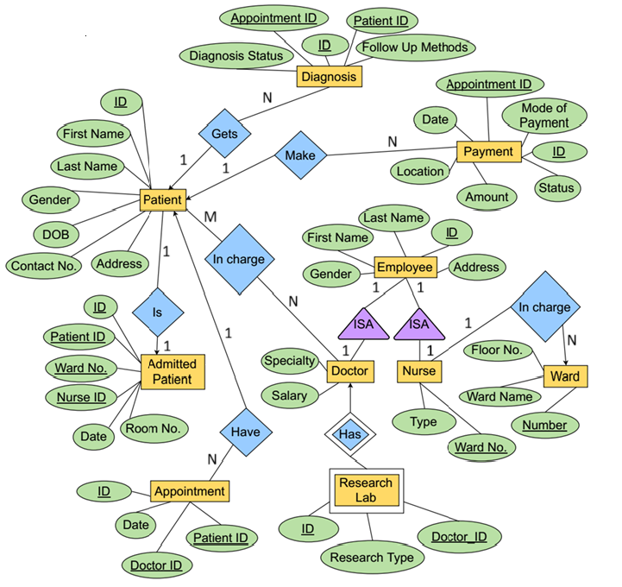

Relationships:

|  |  |  |  |
| --- | --- | --- | --- |
| **Domain 1** | **Domain 2** | **Relationship** | **Note** |
| Nurse | Ward | One-to-many | One ward can have multiple nurse, but one nurse can only belong to a single ward |
| Patient | Diagnosis | One-to-many | One patient can have multiple diagnosis |
| Patient | Payment | One-to-many | One patient can have multiple payments |
| Patient | Admitted Patient | One-to-one | One patient cannot have multiple admission at a time |
| Patient | Appointment | One-to-many | One patient can have multiple appointments |
| Doctor | Patient | Many-to-many | One patient can have multiple doctors, and one doctor can also have multiple patients |
| Doctor | Research Lab | Weak-Entity Set | Doctors may belong to a research lab |
|  |  |  |  |

**Part 3: Database Schema/Normal Forms**

Ward Domain will have the following SQL INSERT statement

CREATE TABLE Ward(

Ward_No VARCHAR(8) NOT NULL PRIMARY KEY,

Ward_Name VARCHAR(20) NOT NULL,

Floor_No VARCHAR(1) NOT NULL

);

Sample looks like this:

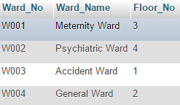

Functional Dependencies = { Ward_No🡪Ward_Name,Floor_No }

The schema is **free** from violations for:

– 3rd Normal form (all column depends on Ward_No column)

– Boyce-Codd Normal Form (All function dependencies have a key on the left-hand side)

– 4th Normal Form (there are no multi value dependencies)

Doctor Domain will have the following SQL INSERT statement

CREATE TABLE Doctor(

Doctor_ID VARCHAR(8) NOT NULL PRIMARY KEY,

Doctor_First_Name VARCHAR(20) NOT NULL,

Doctor_Last_Name VARCHAR(20) NOT NULL,

Doctor_Gender VARCHAR(1) NOT NULL,

Doctor_Specialty VARCHAR(20) NOT NULL,

Doctor_Address VARCHAR(20) NOT NULL,

Doctor_Salary VARCHAR(10) NOT NULL

);

Sample looks like this:

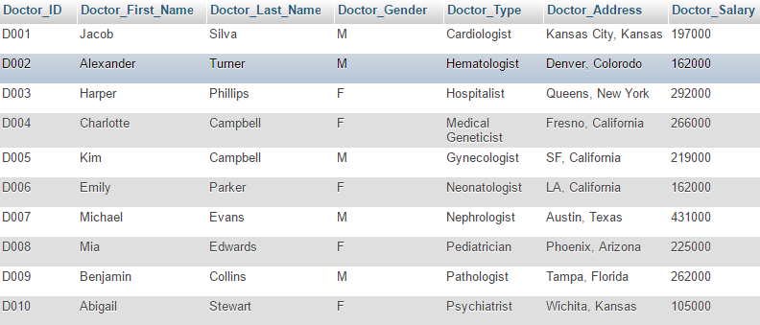

Functional Dependencies = { Doctor_ID 🡪 Doctor_first_name,doctor_last_name,Doctor_Gender,Doctor_Type,Doctor_Address,Doctor_Salary }

The schema is **free** from violations for:

– 3rd Normal form (all column depends on Doctor_ID column)

– Boyce-Codd Normal Form (All function dependencies have a key on the left-hand side)

– 4th Normal Form (there are no multi value dependencies)

Nurse Domain will have the following SQL INSERT statement

CREATE TABLE Nurse(

Nurse_ID VARCHAR(8) NOT NULL PRIMARY KEY,

Nurse_First_Name VARCHAR(20) NOT NULL,

Nurse_Last_Name VARCHAR(20) NOT NULL,

Nurse_Gender VARCHAR(1) NOT NULL,

Ward_No VARCHAR(8) NOT NULL,

Nurse_Type Varchar(20),

FOREIGN KEY (Ward_No) REFERENCES Ward(Ward_No)

)

Sample looks like this:

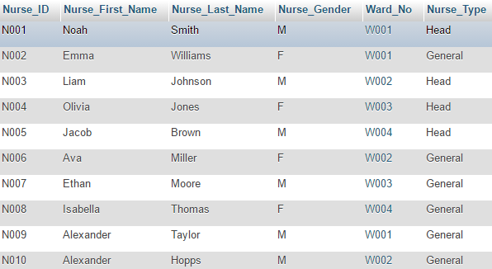

Functional Dependencies = {Nurse_id🡪 Nurse_first_name,Nurse_Last_name,Nurse_Gender,Ward_No,Nurse_Type}

The schema is **free** from violations for:

– 3rd Normal form (all column depends on Doctor_ID column)

– Boyce-Codd Normal Form (All function dependencies have a key on the left-hand side)

The schema is a violation for:

– 4th Normal Form (Column Nurse_Type has multi value dependencies)

Patient Domain will have the following SQL INSERT statement

CREATE TABLE Patient(

Patient_ID VARCHAR(8) NOT NULL PRIMARY KEY,

Patient_First_Name VARCHAR(20) NOT NULL,

Patient_Last_Name VARCHAR(20) NOT NULL,

Patient_Gender VARCHAR(1) NOT NULL,

Patient_Date_Of_Birth DATE NOT NULL,

Patient_Address VARCHAR(20) NOT NULL,

Patient_Contact_No VARCHAR(24) NOT NULL

);

Sample looks like this:

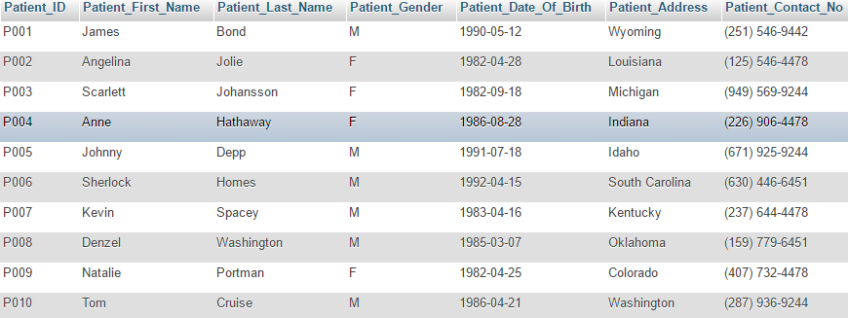

Functional Dependencies = {Patient_ID 🡪 Patient_first_name,Patient_last_name,patient_gender,patient_dob,Patient_Address,Patient_Contact_NO}

The schema is **free** from violations for:

– 3rd Normal form (all column depends on Patient_ID column)

– Boyce-Codd Normal Form (All function dependencies have a key on the left-hand side)

– 4th Normal Form (there are no multi value dependencies)

Admitted Patient Domain will have the following SQL INSERT statement

CREATE TABLE Admitted_Patient(

Admitted_ID VARCHAR(8) NOT NULL PRIMARY KEY,

Patient_ID VARCHAR(8) NOT NULL,

Ward_No VARCHAR(8) NOT NULL,

Nurse_ID VARCHAR(8) NOT NULL,

Admitted_Date_Time DATETIME NOT NULL,

Room_No VARCHAR(20) NOT NULL,

FOREIGN KEY (Patient_ID) REFERENCES Patient(Patient_ID),

FOREIGN KEY (Ward_No) REFERENCES Ward(Ward_No),

FOREIGN KEY (Nurse_ID) REFERENCES Nurse(Nurse_ID)

)

Sample looks like this:

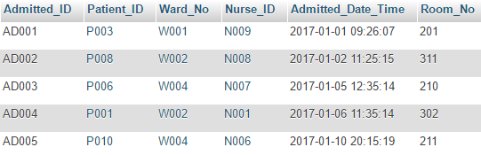

Functional Dependencies = {Admitted_id🡪 Patient_id,Ward_No,Nurse_id,Admitted_date_time,Room_no}

The schema is **free** from violations for:

– 3rd Normal form (all column depends on Admitted_ID column)

– Boyce-Codd Normal Form (All function dependencies have a key on the left-hand side)

– 4th Normal Form (there are no multi value dependencies)

Appointment Domain will have the following SQL INSERT statement

CREATE TABLE Appointment(

Appointment_ID VARCHAR(8) NOT NULL PRIMARY KEY,

Patient_ID VARCHAR(8) NOT NULL,

Doctor_ID VARCHAR(8) NOT NULL,

Appointment_Date_Time DATETIME NOT NULL,

FOREIGN KEY (Doctor_ID) REFERENCES Doctor(Doctor_ID),

FOREIGN KEY (Patient_ID) REFERENCES Patient(Patient_ID)

);

Sample looks like this:

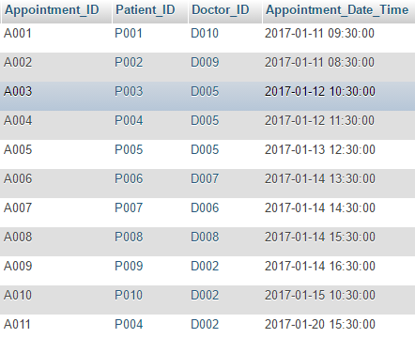

Functional_Dependencies = {Appointment_id --> Patient_id,Doctor_id,Appointment_date_time}

The schema is **free** from violations for:

– 3rd Normal form (all column depends on Appointment_ID column)

– Boyce-Codd Normal Form (All function dependencies have a key on the left-hand side)

– 4th Normal Form (there are no multi value dependencies)

Diagnosis Domain will have the following SQL INSERT statement

CREATE TABLE Diagnosis(

Diagnosis_ID VARCHAR(8) NOT NULL PRIMARY KEY,

Appointment_ID VARCHAR(8) NOT NULL,

Patient_ID VARCHAR(8) NOT NULL,

Diagnosis_Status VARCHAR(50) NOT NULL,

Follow_Up_Methods VARCHAR(50) NOT NULL,

FOREIGN KEY (Appointment_ID) REFERENCES Appointment(Appointment_ID),

FOREIGN KEY (Patient_ID) REFERENCES Patient(Patient_ID)

);

Sample looks like this:

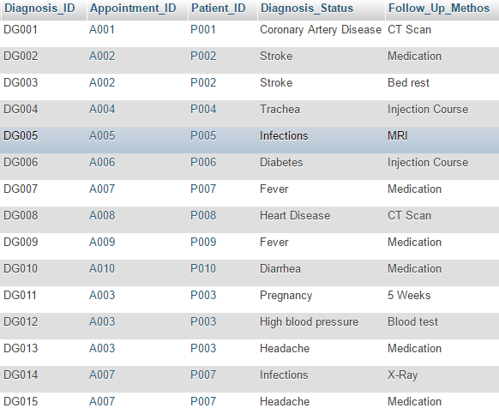

Functional Dependencies= {Diagnosis_id 🡪 Appointment_id,Patient_id,Diagnosis_status,Follow_up_methods}

The schema is **free** from violations for:

– 3rd Normal form (all column depends on Diagnosis_ID column)

– Boyce-Codd Normal Form (All function dependencies have a key on the left-hand side)

– 4th Normal Form (there are no multi value dependencies)

NOTE: Though Diagnosis_Status column and Follow_Up_Methodes column have some data that are common, but these fields are text (comment) fields, they can contain anything, nothing (null value) or duplicates.

Payment Domain will have the following SQL INSERT statement

CREATE TABLE Payment(

Payment_ID VARCHAR(8) NOT NULL PRIMARY KEY,

Appointment_ID VARCHAR(8) NOT NULL,

Mode_Of_Payment VARCHAR(20) NOT NULL,

Payment_Date_Time DATETIME NOT NULL,

Payment_Status VARCHAR(20) NOT NULL,

Payment_Location VARCHAR(20) NOT NULL,

Amount INT NOT NULL,

FOREIGN KEY (Appoinment_ID) REFERENCES Appointment(Appointment_ID)

);

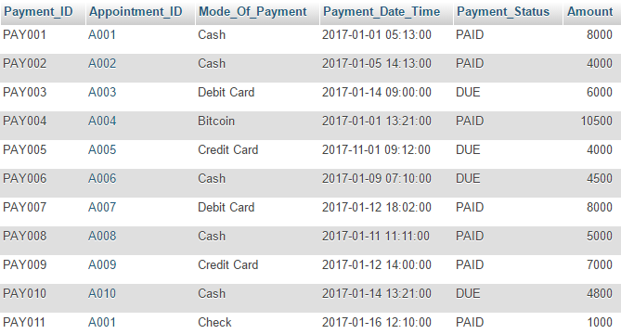

Functional dependencies = {Payment_id🡪 Appointment_id,Mode_of_payment,payment_date_time,Payment_status,Amount}

The schema is **free** from violations for:

– 3rd Normal form (all column depends on Payment_ID column)

– Boyce-Codd Normal Form (All function dependencies have a key on the left-hand side)

The schema is a violation for:

– 4th Normal Form (Column Mode_Of_Payment and Payment_Status has multi value dependencies)

Research Lab Domain will have the following SQL INSERT statement

CREATE TABLE Research_Lab(

Research_ID VARCHAR(8) NOT NULL PRIMARY KEY,

Doctor_ID VARCHAR(8) NOT NULL,

Research_Type VARCHAR(20) NOT NULL,

FOREIGN KEY (Doctor_ID) REFERENCES Doctor(Doctor_ID)

);

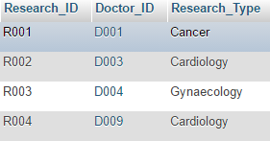

Functional Dependencies = {Research_id 🡪 Doctor_ID , Research_type}

The schema is **free** from violations for:

– 3rd Normal form (all column depends on Research_ID column)

– Boyce-Codd Normal Form (All function dependencies have a key on the left-hand side)

– 4th Normal Form (there are no multi value dependencies)

**Part-4 : Relational Schema**

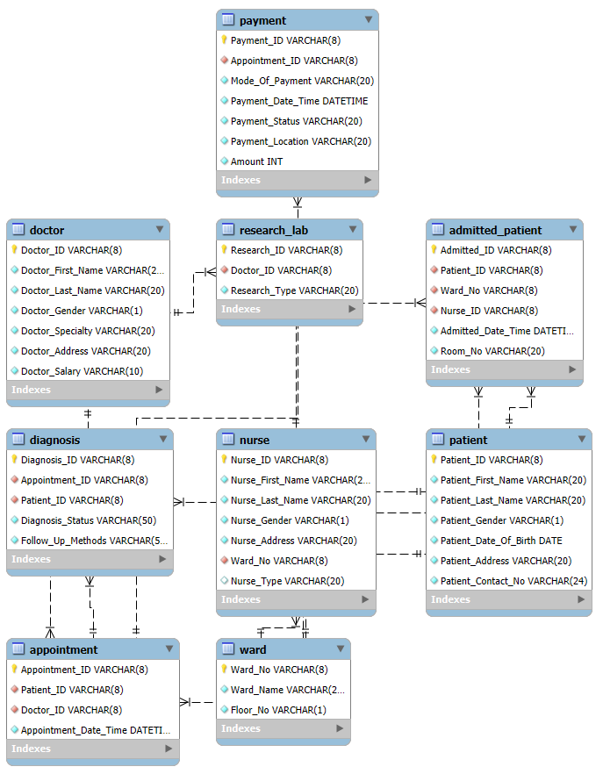

**Part 5: SQL Queries to Insert Data**

**1.Ward**

INSERT INTO Ward VALUES

('W003','Accident Ward','1'),

('W001','Meternity Ward','2'),

('W004','General Ward','2'),

('W002','Psychiatric Ward','3');

2.Doctor

INSERT INTO Doctor Values

('D001','Jacob','Silva','M','Cardiologist','Kansas City, Kansas','197000'),

('D002','Alexander','Turner','M','Hematologist','Denver, Colorodo','162000'),

('D003','Harper','Phillips ','F','Hospitalist','Queens, New York','292000'),

('D004','Charlotte','Campbell','F','Medical Geneticist','Fresno, California','266000'),

('D005','Kim','Campbell','M','Gynecologist','SF, California','219000'),

('D006','Emily','Parker','F','Neonatologist','LA, California','162000'),

('D007','Michael','Evans','M','Nephrologist','Austin, Texas','431000'),

('D008','Mia','Edwards','F','Pediatrician','Phoenix, Arizona','225000'),

('D009','Benjamin','Collins','M','Pathologist','Tampa, Florida','262000'),

('D010','Abigail','Stewart','F','Psychiatrist','Wichita, Kansas','105000');

3.Nurse

INSERT INTO Nurse VALUES

('N001','Noah', 'Smith','M','W001','Head','Kansas'),

('N002','Emma', 'Williams','F','W001','General','Colorodo'),

('N003','Liam', 'Johnson','M','W002','Head','Colorodo'),

('N004','Olivia', 'Jones','F','W003','Head','Colorodo'),

('N005','Jacob', 'Brown','M','W004','Head','Colorodo'),

('N006','Ava', 'Miller','F','W002','General','Kansas'),

('N007','Ethan', 'Moore','M','W003','General','Oaklohama'),

('N008','Isabella', 'Thomas','F','W004','General','Kansas'),

4.Patient

INSERT INTO Patient VALUES

('P001','James','Bond','M','1990-05-12','Alabama','(251) 546-9442'),

('P002','Angelina','Jolie','F','1982-04-28','Louisiana','(125) 546-4478'),

('P003','Scarlett','Johansson','F','1982-09-18','Michigan','(949) 569-4371'),

('P004','Anne','Hathaway','F','1986-08-28','Indiana','(226) 906-2721'),

('P005','Johnny','Depp','M','1991-07-18','Idaho','(671) 925-1352'),

('P006','Sherlock','Homes','M','1992-04-15','South Carolina','(630) 446-8851'),

('P007','Kevin','Spacey','M','1983-04-16','Kentucky','(237) 644-9244'),

('P008','Denzel','Washington','M','1985-03-07','Oklahoma','(159) 779-4578'),

('P009','Natalie','Portman','F','1982-04-25','Colorado','(407) 732-7516'),

('P010','Tom','Cruise','M','1986-04-21','Washington','(287) 936-6451');

5.Admitted_Patient

INSERT INTO Admitted_Patient VALUES

('AD001','P003','W001','N009','2025-01-01 09:26:07','201'),

('AD002','P008','W002','N008','2025-01-02 11:25:15','311'),

('AD003','P006','W004','N007','2025-01-05 12:35:14','210'),

('AD004','P001','W002','N001','2025-01-06 11:35:14','302'),

('AD005','P010','W004','N006','2025-01-10 20:15:19','211');

6.Appointment

INSERT INTO Appointment VALUES

('A001','P001','D010','2025-01-11 09:30:00'),

('A002','P002','D009','2025-01-11 08:30:00'),

('A003','P003','D005','2025-01-12 10:30:00'),

('A004','P004','D005','2025-01-12 11:30:00'),

('A005','P005','D005','2025-01-13 12:30:00'),

('A006','P006','D007','2025-01-14 13:30:00');

7.Diagnosis

INSERT INTO Diagnosis VALUES

('DG001','A001','P001','Coronary Artery Disease','CT Scan'),

('DG002','A002','P002','Stroke','Medication'),

('DG003','A002','P002','Stroke','Bed rest'),

('DG004','A004','P004','Trachea','Injection Course'),

('DG005','A005','P005','Infections','MRI'),

('DG006','A006','P006','Diabetes','Injection Course'),

('DG007','A007','P007','Fever','Medication'),

('DG008','A008','P008','Heart Disease','CT Scan'),

('DG009','A009','P009','Fever','Medication'),

('DG010','A010','P010','Diarrhea','Medication'),

('DG011','A003','P003','Pregnancy','5 Weeks'),

('DG012','A003','P003','High blood pressure','Blood test'),

('DG013','A003','P003','Headache','Medication'),

('DG014','A007','P007','Infections','X-Ray'),

('DG015','A007','P007','Headache','Medication');

8.Payment

INSERT INTO Payment VALUES

('PAY001','A001','Cash','2025-01-01 05:13:00','PAID','8000'),

('PAY002','A002','Cash','2025-01-05 14:13:00','PAID','4000'),

('PAY003','A003','Debit Card','2025-01-14 09:00:00','DUE','6000'),

('PAY004','A004','Bitcoin','2025-01-01 13:21:00','PAID','10500'),

('PAY005','A005','Credit Card','2025-11-01 09:12:00','DUE','4000'),

('PAY006','A006','Cash','2025-01-09 07:10:00','DUE','4500'),

('PAY007','A007','Debit Card','2025-01-12 18:02:00','PAID','8000'),

('PAY008','A008','Cash','2025-01-11 11:11:00','PAID','5000'),

('PAY009','A009','Credit Card','2025-01-12 14:00:00','PAID','7000'),

('PAY010','A010','Cash','2025-01-14 13:21:00','DUE','4800'),

('PAY011','A001','Check','2025-01-16 12:10:00','PAID','1000');

9.Research Lab

INSERT INTO Research_Lab VALUES

('R001','D001','Cancer'),

('R002','D003','Cardiology'),

('R003','D004','Gynaecology'),

('R004','D009','Cardiology');

**Part 6: Database in Action**

1.  **To find a patient by address**

SELECT *

FROM Patient

WHERE Patient_Address='South Carolina';

Result:



2. **To find a specific doctor**

SELECT *

FROM Doctor

WHERE Doctor_Gender='M' AND Doctor_Last_Name='Campbell';



3. **To find appointment on a given date**

SELECT *

FROM Appointment

WHERE DATEDIFF(Appointment_Date_Time, '2025-01-14')=0

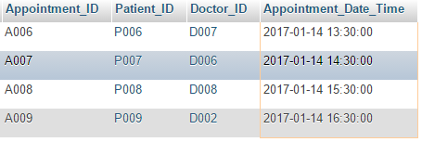

4. **To find the phone number of female patients who are suffering from strokes**

SELECT Patient_Contact_No

FROM Patient

WHERE Patient_ID IN

( SELECT Patient_ID

FROM Diagnosis

WHERE Diagnosis_Status ='Stroke')

)

AND Patient_Gender='F';



5. **To create a new appointment**

INSERT INTO Appointment VALUES

('A011','P004','D002','2025-01-20 15:30:00');

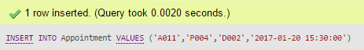

6. **To update the address of a given patient**

UPDATE Patient

SET Patient_Address='Wyoming'

WHERE Patient_First_Name ='James' AND Patient_Last_Name='Bond';

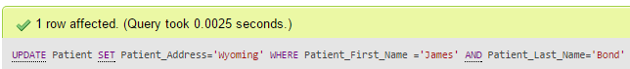

7. **To find assigned doctors for a selected patient, and his salary**

SELECT Doctor_First_Name, Doctor_Last_Name, Doctor_Salary

FROM Appointment a, Doctor d

WHERE

d.Doctor_ID = a.Doctor_ID

AND

a.Patient_ID =

(

SELECT Patient_ID FROM Patient

WHERE Patient_First_Name= 'Scarlett'

AND Patient_Last_Name= 'Johansson'

)

;



8. **To find number of upcoming appointments between dates**

SELECT count(Appointment_ID) AS Appointments_Upcomming

FROM Appointment

WHERE Appointment_Date_Time

BETWEEN '2025-01-14 00:00:00'

AND '2025-01-15 23:59:00';



9. **To find total amount paid by a single patient**

SELECT SUM(Amount) AS Total_Amount_Paid_By_James_Bond

FROM Payment p, Appointment a

WHERE

a.Appointment_ID = p.Appointment_ID

AND

a.Patient_ID = (

SELECT Patient_ID FROM Patient

WHERE Patient_First_Name = 'James'

AND Patient_Last_Name = 'Bond'

);



10. **To find patient with appointment that listed ‘fever’ as their illness**

SELECT Patient_First_Name, Patient_Last_Name

FROM Patient

WHERE Patient_ID IN

(SELECT Patient_ID FROM Appointment WHERE Appointment_ID IN

(SELECT Appointment_ID

FROM Diagnosis

WHERE Diagnosis_Status='Fever')

)

ORDER BY Patient_ID;

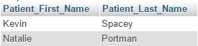

11. **To find number of nurse assigned for each ward**

SELECT Ward_No, COUNT(*) AS Nurse_Count

FROM Nurse

GROUP BY Ward_No

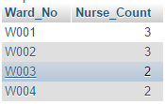

12. **To find nurses in a certain ward with patients in it**

SELECT Nurse_First_Name, Nurse_Last_Name

FROM Nurse

WHERE Nurse_ID IN (

SELECT Nurse_ID FROM Admitted_Patient

WHERE Ward_No='W001'

);



13. **To find maximum payment received by the hospital by a single patient**

SELECT Mode_Of_Payment, Amount AS Max_Payment_Made_By_Patient

FROM Payment

WHERE Amount=(SELECT MAX(Amount) FROM Payment);



14. **To count the number of male patient that are currently admitted in the hospital**

SELECT COUNT(Admitted_ID) AS Male_Patient_COUNT

FROM Admitted_Patient

WHERE Patient_ID IN(

SELECT Patient_ID FROM Patient

WHERE Patient_Gender='M'

);



15. **To Find nurses who are not allotted to any ward**

SELECT Nurse_First_Name, Nurse_Last_Name, Ward_No

FROM Nurse

WHERE Nurse_ID NOT IN (SELECT Nurse_ID FROM Admitted_Patient);

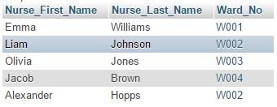

16**. To Find doctors who are treating ‘Diabetes’**

SELECT DISTINCT doc.Doctor_ID, Doctor_First_Name, Doctor_Last_Name

FROM Doctor doc, Appointment a, Diagnosis dig

WHERE doc.Doctor_ID = a.Doctor_ID

AND dig.Diagnosis_Status = 'Diabetes'

AND dig.Appointment_ID = a.Appointment_ID

ORDER BY Doctor_ID;



17. **To cancel an appointment**

DELETE FROM Appointment

WHERE Patient_ID='P004' AND Doctor_ID='D002';

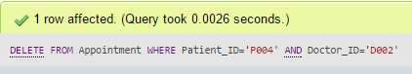

18. **To create multiple appointments at the same time**

INSERT INTO Appointment VALUES

('A011', 'P001', 'D004', '2025-01-26 10:00:00'),

('A012', 'P001', 'D005', '2025-01-23 11:00:00'),

('A013', 'P005', 'D005', '2025-01-25 12:00:00');

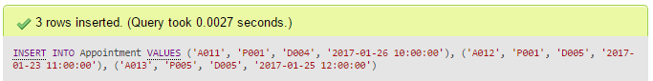

19. To verify **[Appointment count for Patient P001 is now 3]**

SELECT Patient_ID, COUNT(*) AS Appointment_Count

FROM Appointment

GROUP BY Patient_ID;

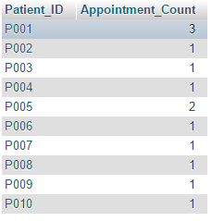

20.To **find Doctors who have multiple appointments**

SELECT Doctor_ID,COUNT(Appointment_ID) AS Appointment_Count

FROM Appointment

GROUP BY Doctor_ID

HAVING COUNT(Appointment_ID) >= 2;

