**TASK - 1**

2) Write a program which will find all such numbers which are divisible by 7 but are not a multiple

of 5, between 2000 and 3200 (both included). The numbers obtained should be printed in a

comma-separated sequence on a single line.

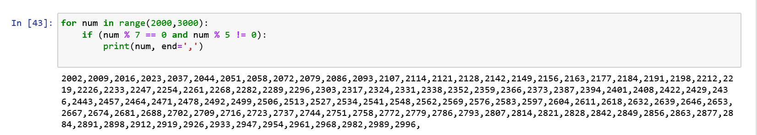

3)Write a Python program to accept the user's first and last name and then getting them printed in

the the reverse order with a space between first name and last name.

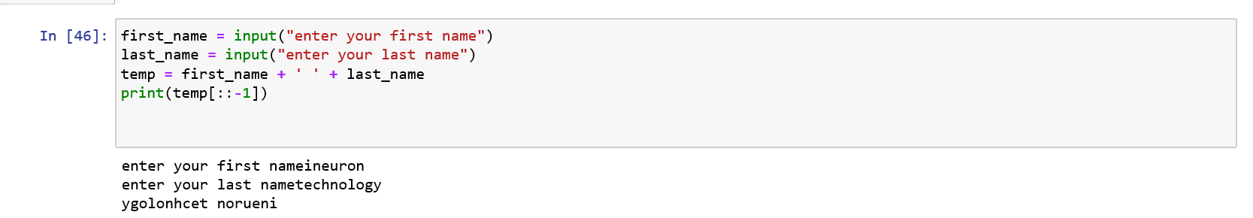

4)Write a Python program to find the volume of a sphere with diameter 12 cm.

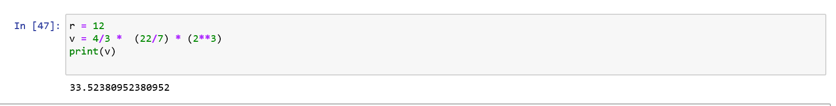

**TASK 2 -**

1)Write a program which accepts a sequence of comma-separated numbers from console and

generate a list.

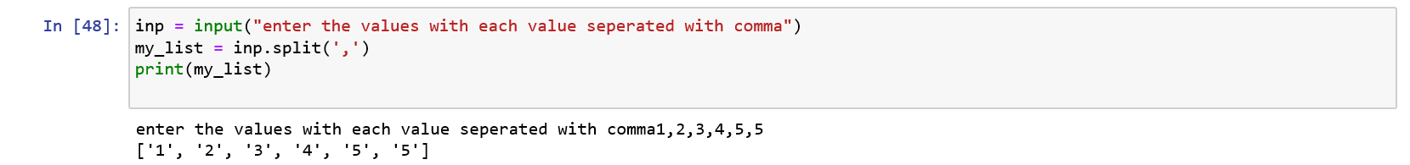

2)Create the below pattern using nested for loop in Python.

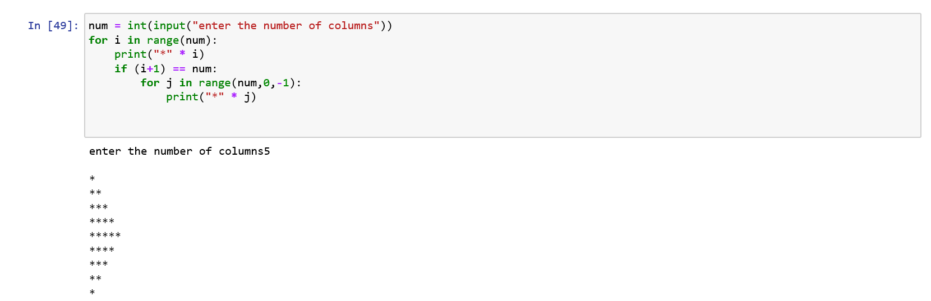

3)Write a Python program to reverse a word after accepting the input from the user.

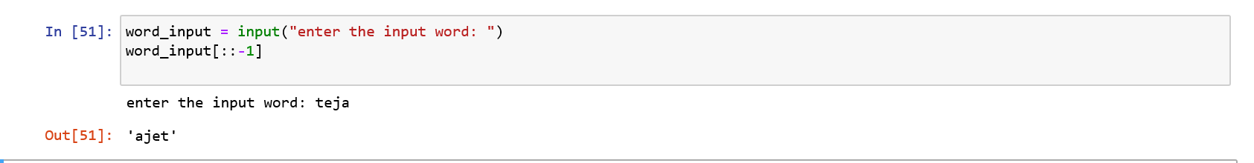

4)

Write a Python Program to print the given string in the format specified in the sample output. WE, THE PEOPLE OF INDIA, having solemnly resolved to constitute India into a SOVEREIGN, SOCIALIST, SECULAR, DEMOCRATIC REPUBLIC and to secure to all its citizens

print("WE, THE PEOPLE OF INDIA,\n %shaving solemnly resolved to constitute India into a SOVEREIGN, {}\n%sSOCIALIST, SECULAR, DEMOCRATIC REPUBLIC\n%sand to secure to all its citizens".format('!')%(' '*5,' '*11,' '*12))

