Networks Assignment 4

Application assigned :- Application 2
Group Number :- Group 20

Group Members:-

Saiteja Talasila 140123040

Nagasai Bodepudi 140123011

A V N K Sai Charan 140123004

TCP Westwood:
TCP Westwood is based on end-to-end bandwidth estimation to set congestion window and slow start threshold after a congestion episode, that is, after three duplicate acknowledgments or a timeout.

TCP New Reno:
TCP New Reno improves retransmission during the fast-recovery phase of TCP Reno. During fast recovery, for every duplicate ACK that is returned to TCP New Reno, a new unsent packet from the end of the congestion window is sent, to keep the transmit window full.

TCP Vegas:
TCP Vegas detects congestion at an incipient stage based on increasing Round-Trip Time (RTT) values of the packets in the connection. The algorithm depends heavily on accurate calculation of the Base RTT value. If it is too small then throughput of the connection will be less than the bandwidth available while if the value is too large then it will overrun the connection.

TCP BIC:
Binary Increase Congestion control is an implementation of TCP with an optimized congestion control algorithm for high speed networks with high. latency BIC is used by default in Linux kernels

TCP Hybla:
TCP Hybla aims to eliminate penalization of TCP connections that incorporate a high-latency terrestrial or satellite radio link, due to their longer round-trip times. It stems from an analytical evaluation of the congestion window dynamics, which suggests the necessary modifications to remove the performance dependence on RTT.

TCP Veno:
TCP Veno is optimised for wireless networks, since it was designed to handle random packet loss better. It tries to keep track of the transfer, and guesses if the quality decreases due to congestion or random packet errors.

TCP Yeah:
YeAH TCP is a delay-aware state-enabled congestion control algorithm. Through delay measures, when the network is sensed unloaded it will quickly exploit the available capacity, trying to keep the network buffer utilization always lower than a threshold. Moreover it is designed to be internal and RTT fair, Reno-friendly and resilient on lossy links

Question 1)
Bic:
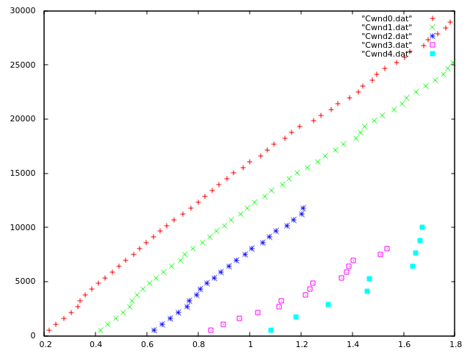
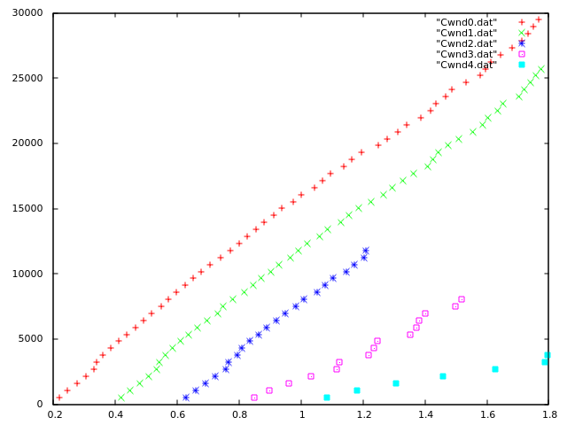
Hybla:
NewReno:
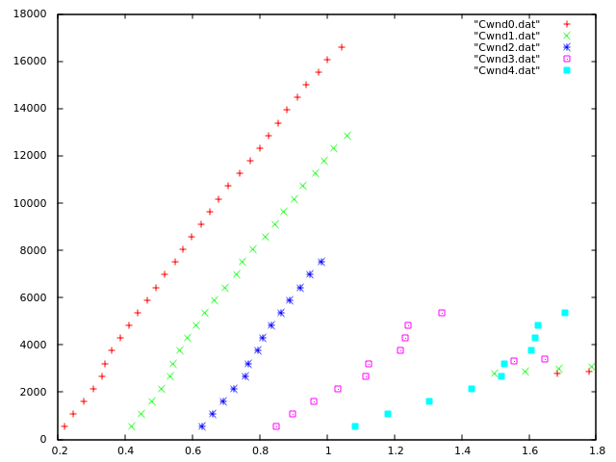
Vegas:
Veno:
Westwood:

Yeah:

we can observe that New Reno is fair for all and Vegas is proportional and also others are quite similar too there is not much difference in different congestion control measures.

Question 2
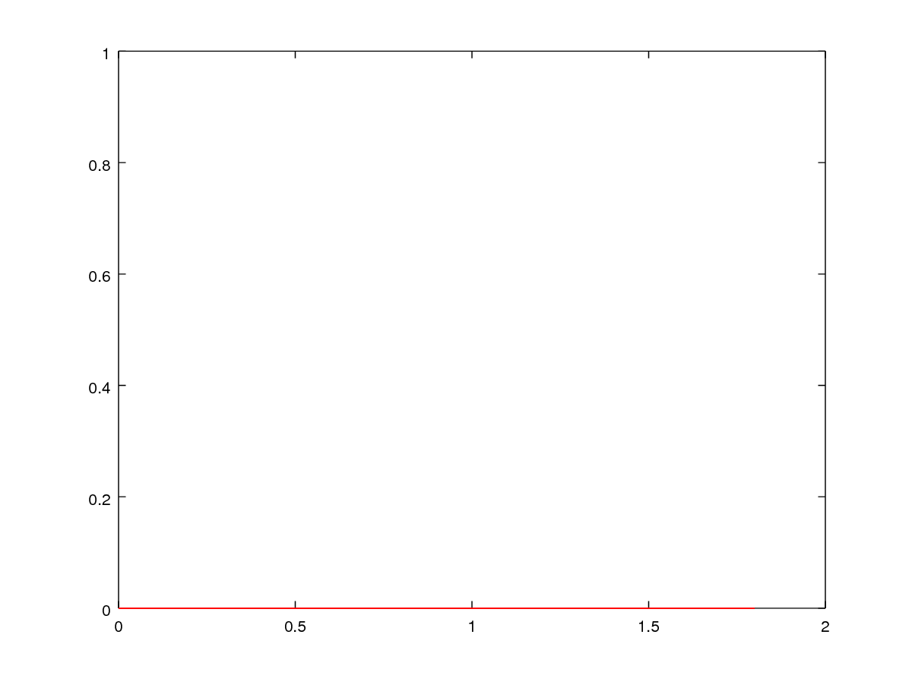
From values obtained from flow-moniter and programs we can observe that no packets were dropped while sending or receiving.

Question 3:
Bic:
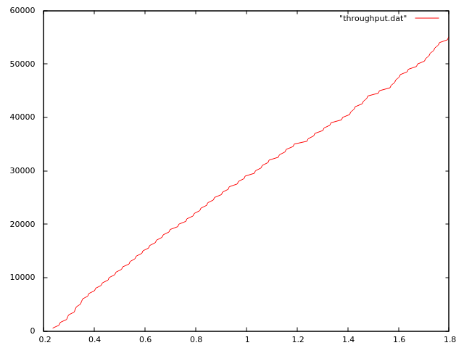
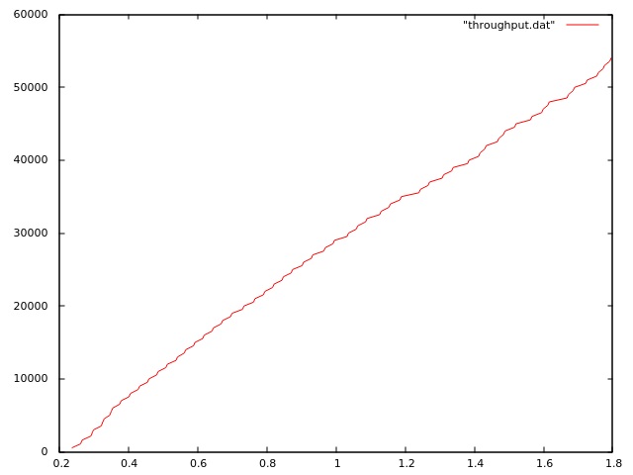
Hybla:

New Reno:

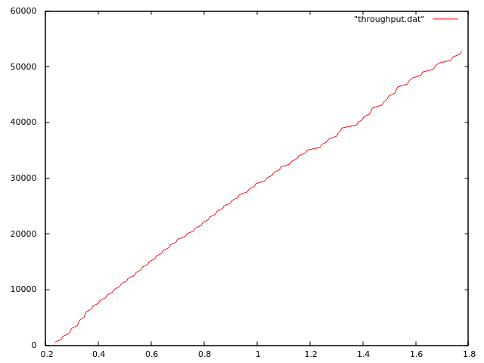
Vegas:
Veno:
Westwood:

Yeah:

Almost all throughputs are similar with some same to same sae and some slight differences.

