A SMART DIGIT SUCKING MONITORING

SYSTEM

* **ABSTRACT:**

-A wearable alarm therapy device

# PROBLEM STATEMENT:

Digit sucking is a common habit among children. However, prolonged digit sucking can lead to significant health issues. It can cause misalignment of teeth, changes in the palate, and even speech issues. The pressure exerted by the fingers can lead to changes in the palate and affect the overall structure of the mouth. Misalignment of teeth may persist into adulthood, requiring orthodontic interventions. Changes in jaw structure can contribute to temporomandibular joint (TMJ) issues, leading to pain and discomfort.

# STATISTICAL DATA:

Thumb sucking is one of the most common habits of children, with about 90% of newborns showing some form of hand sucking within 2 hours after birth. The prevalence of oral habits, including digit sucking, is as high as 85% in some population groups.

However, if these habits persist beyond the age of 5, they can have a negative impact on oral health, general health, and quality of life.

# EXISTING SOLUTIONS AND IT’S DRAWBACKS:

[1]- “The thumb-sucking habit correction device” is granted in Canada. It is based on a mechanical method of detection and activation. It uses an elastic snug-fit elbow sleeve which provides opposing force to the bending of the elbow joint.

DRAWBACK: It causes discomfort during normal activities.

[2]- “Apparatus for deterring thumb sucking” is granted in the US. This device is electrically activated by a simple switch arrangement for detection.

DRAWBACK: There is a possibility of the switch being activated by a process other than digit sucking (i.e., pressing finger against a table).

[3]- “Thumb sucking detection system” is granted in India. It is an embedded electrode- based method for sensing thumb sucking.

DRAWBACK: This method is dependent on the secretion of saliva to trigger the sensor. There is a possibility of microbial growth.

[4]- “Device for preventing sucking of thumb” and [5]- “Thumb and finger sucking prevention device” are granted in the US.

DRAWBACK: It’s like physical punishment to children.

# MY TEAM SOLUTION:

* We present a novel, smart wrist-wearable device designed to monitor and curb the prevalent habit of digit-sucking in children.
* This device operates in conjunction with digit-wearable temperature sensors. The underlying principle of our system is the detection of the temperature difference between the human oral cavity and the external environment.
* The oral cavity typically exhibits a temperature 1-2 degrees Celsius higher than the surrounding environment due to metabolic heat.
* Along with the thermistor, we referred a light sensor for detecting light. When the child puts their finger in the mouth, the light sensor detects darkness.
* Our system capitalizes on this difference to distinguish between two scenarios: the digit inserted in the oral cavity and the digit outside the oral cavity. When a child engages in a digit-sucking episode, the sensor response is proportional to the oral cavity temperature. In the absence of digit- sucking, the sensor response aligns with the ambient temperature.
* By monitoring the sensor response and comparing it with a fixed threshold, our system can accurately detect digit-sucking events. Upon detection, an audio-visual alarm is triggered, serving as a reminder for the child to stop the habit.
* This innovative solution offers several advantages, including non-invasive monitoring, quick sensing, user comfort, safety, reliability, longer sensor functional life, and extended battery duration. It serves as a valuable tool for self-monitoring or for use by caregivers and behavioral therapists to initiate responsive action.

“In conclusion, we believe our smart wrist-wearable device presents a unique and effective solution to address the prevalent issue of digit-sucking in children. We are excited about the potential impact of our invention on improving children’s oral health and overall well-being. We look forward to the opportunity to showcase our work at the AVISHKAAR 2024 Hackathon. We are grateful to the organizers, ADITYA INSTITUTE OF TECHNOLOGY AND MANAGEMENT and GeeksforGeeks, for providing this platform to innovators like us. Thank you for considering our submission.”

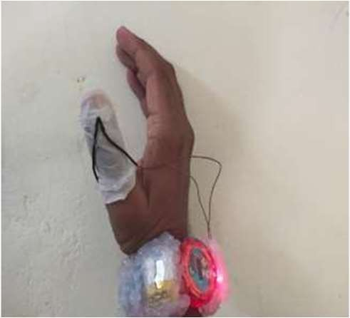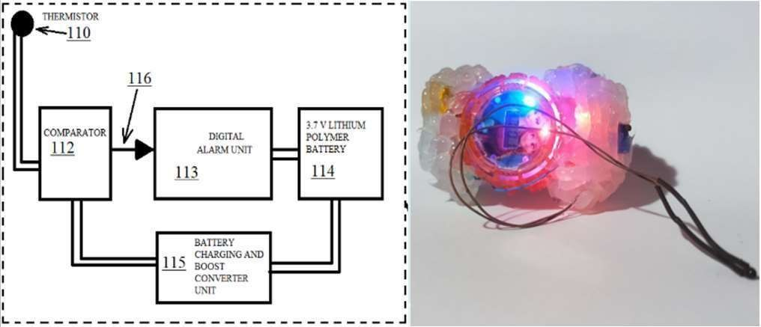

# Reference:

[1]- https://patentscope.wipo.int/search/en/detail.jsf?docId=CA248869628

[2]- https://patents.google.com/patent/US4692748A/en

[3]- https://patents.justia.com/patent/20230414400

[4]- https://patents.google.com/patent/US5010901A/en [5]-https://patents.google.com/patent/US5515870A/en