**NAME: HARISH CHANDRA JYOSHI**

**CLASS ID: 12**

**TEAM ID: 04**

**EMAIL ID:**[**hjddh@mail.umkc.edu**](mailto:hjddh@mail.umkc.edu)

**NAME: ATLURI VENKATA AKHILA KRISHNA**

**CLASS ID: 02**

**TEAM ID: 04**

**EMAIL ID:**[**vagq2@mail.umkc.edu**](mailto:vagq2@mail.umkc.edu)

**Video link:**

**TASK 1:**

**Objective**

**1. search in a string and find the first non-repeated characters in that string** **Input:** **Deep data structure** **Output: p** **(hint: if there is space in the string you need to consider the whole as one string. In the above example ** **Deepdatastructure)**

**Entered an input as a string and converted the string into a list, later used for loop and if-else statements to find the first non-repeated character**

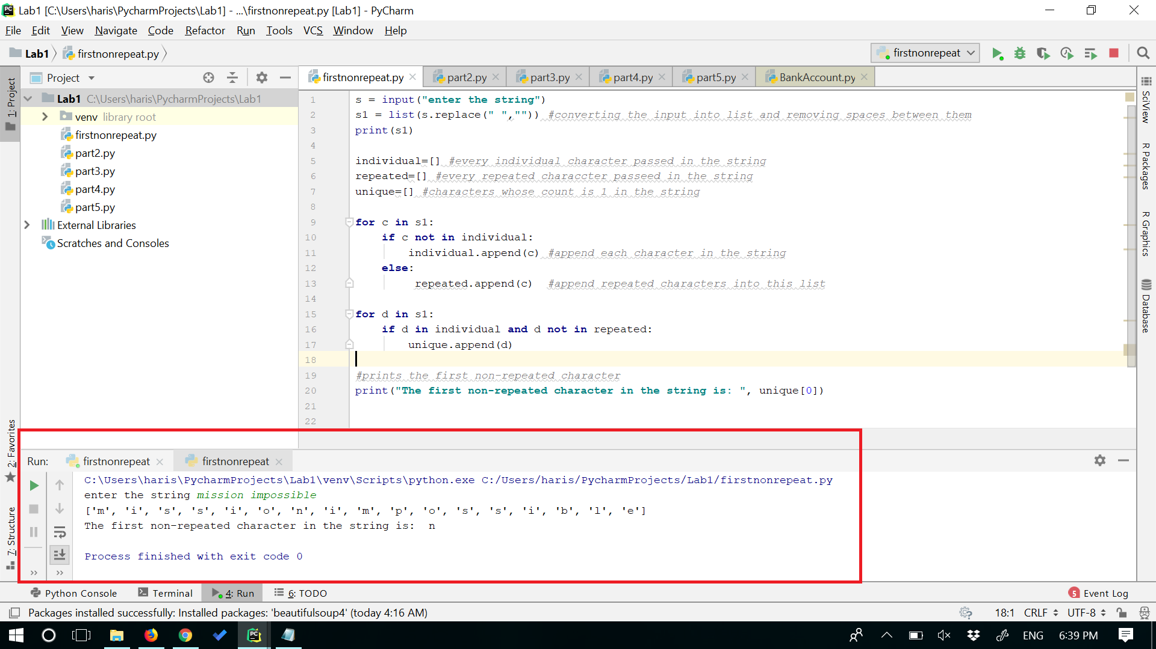

**TASK 2:**

**Objective**

**2. Suppose you have two files. And what is inside the files are as follows:** **File1: “This time, we are going to learn how to write programs that recognize objects in images using deep learning. In other words, we are going to explain the black magic that allows Google Photos to search your photos based on what is in the picture”** **File2: “this we to are in the that your on based what is how other”** **Program a code such that you remove everything in the File1which is inside File2.**

**Opened both the files and converted the string in the file to a list of words and later using for loop removed the words in file1 which is inside file2.**

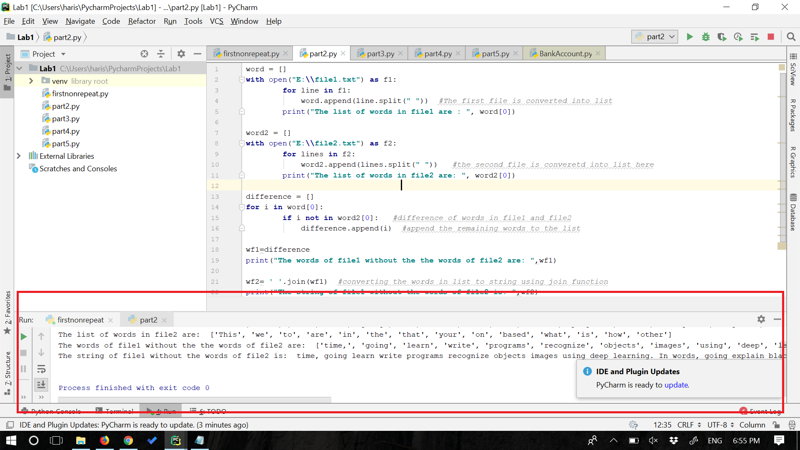

**TASK 3:**

**Objective:**

**3. Consider the following scenario. You have a list of students who are attending class "Python" and another list of** students who are attending class "Web Application".Find the list of students who are attending “python” classes but not “Web Application”**

**Entered the inputs of students attending python and web class separated by a comma, converted the string into a list and later converted the list into sets and calculated the difference between the sets and found out the students attending python class but not the web application.**

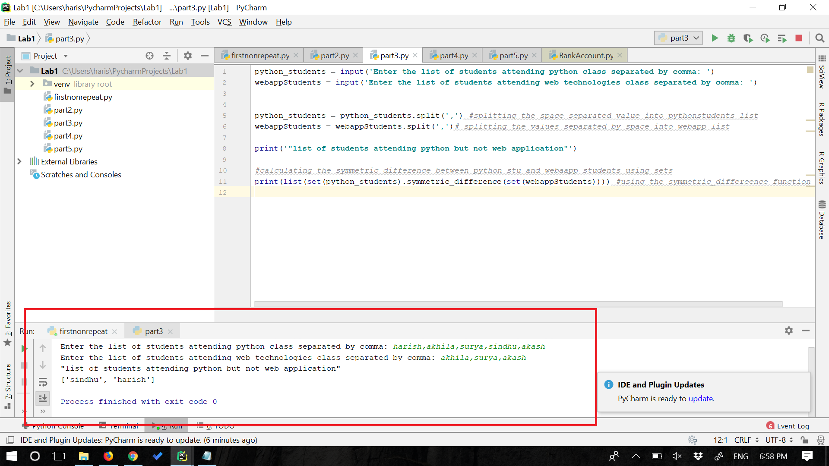

**## TASK 4:**

**Objective:**

**4. Write a python program to create the following management systems.** **a. Hospital admission System (e.g. classes Patient, Doctor, Medical Admission Clerk, Book, Nurse,etc.)** **Prerequisites:** **a. Your code should have at least five classes** **b. Your code should have *init* constructor in all the classes** **c. Your code should show inheritance at least once** **d. Your code should have one super call** **e. Use of self is required** **f. Use at least one private data member in your code** **g. Use multiple Inheritance at least once** **h. Create instances of all classes and show the relationship between them**

**Created 5 classes namely Patient, Doctor, clerk, book, nurse. Used inheritance between the classes and relationship between the classes is shown.**

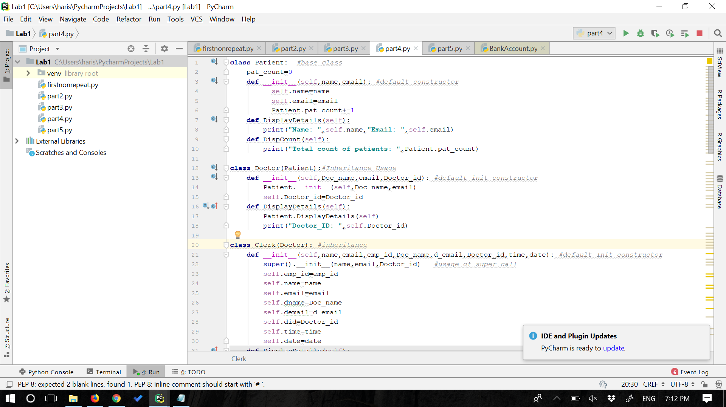

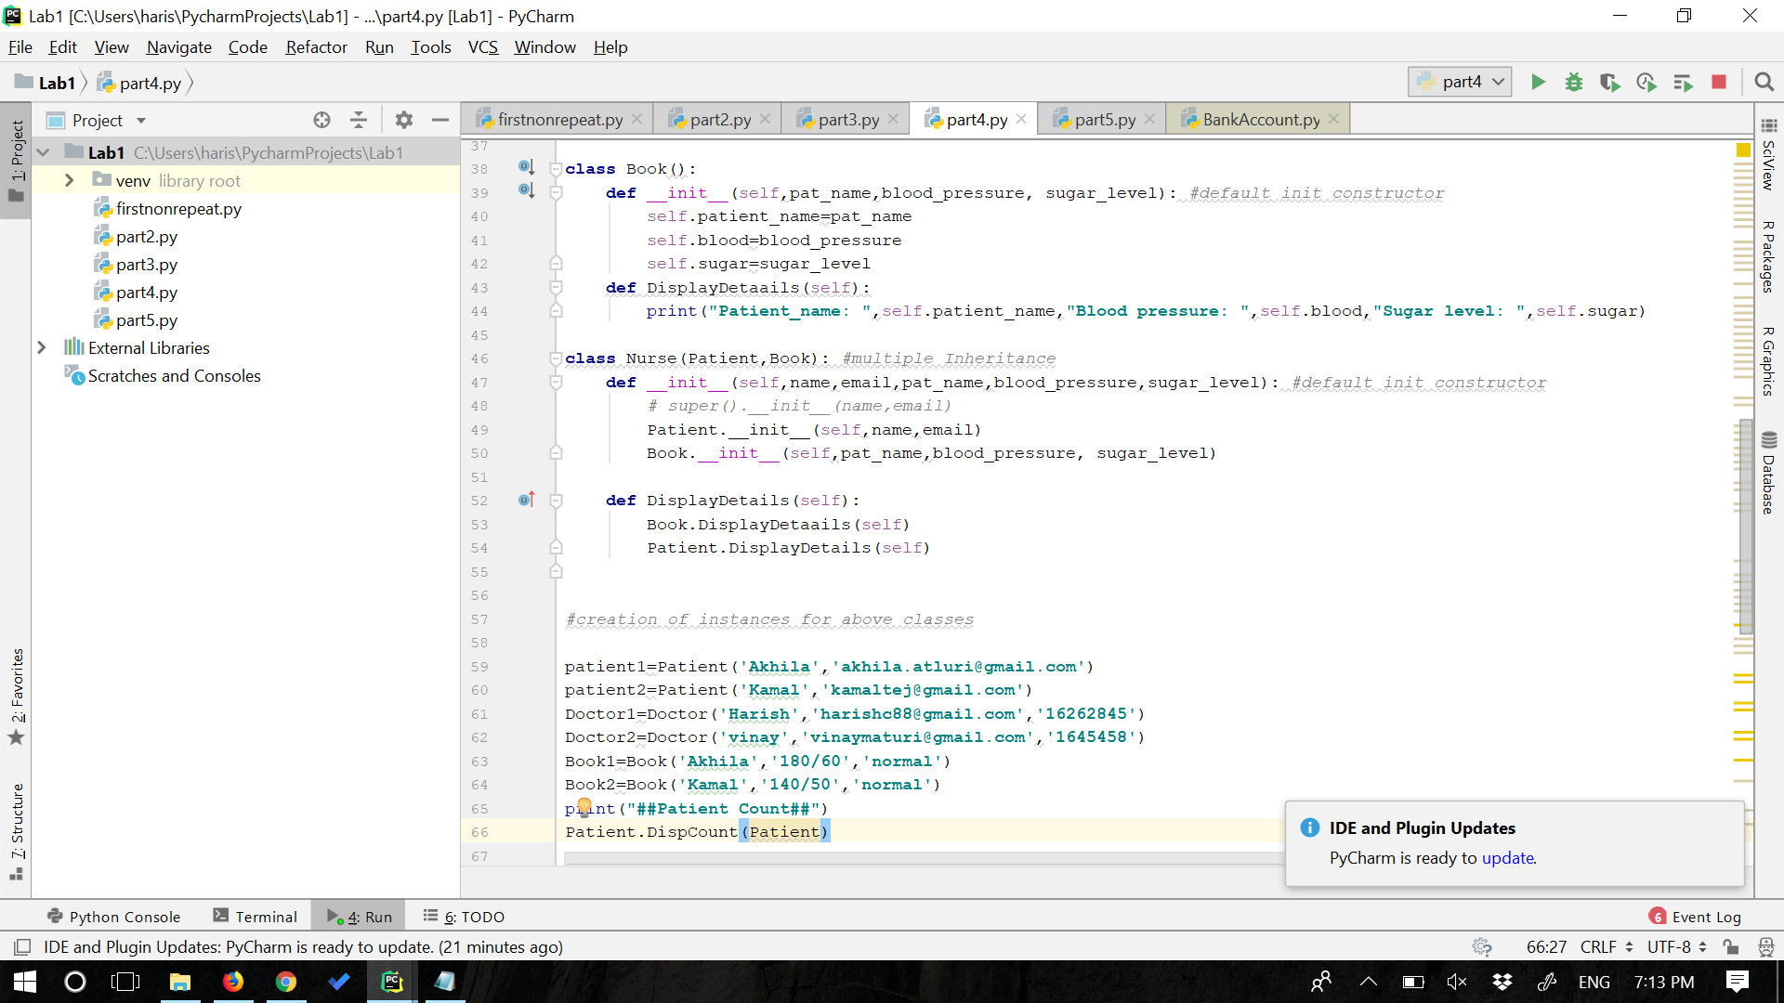

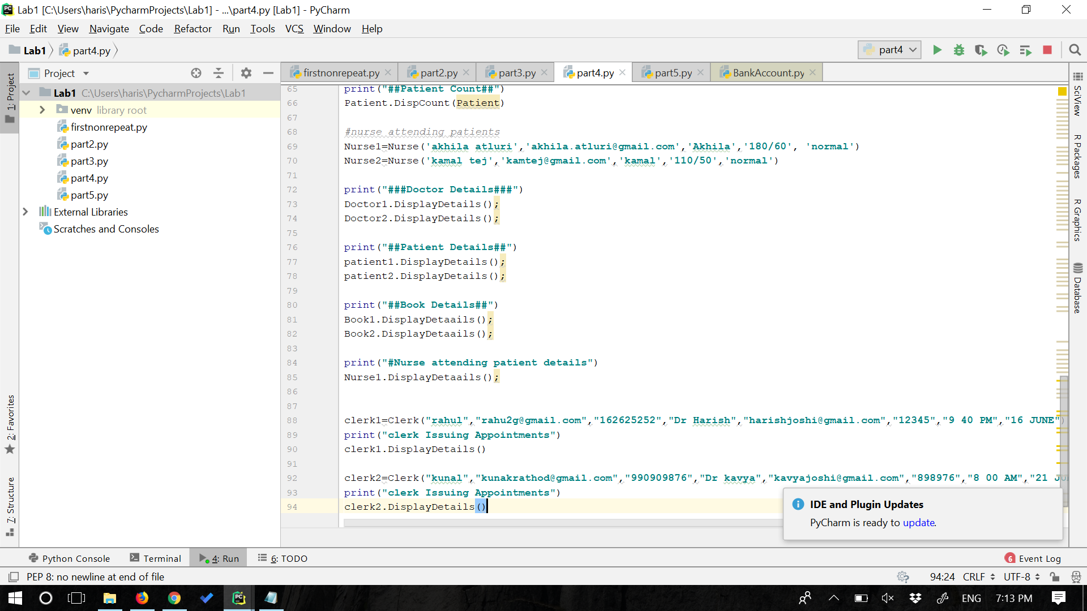

**Output:**

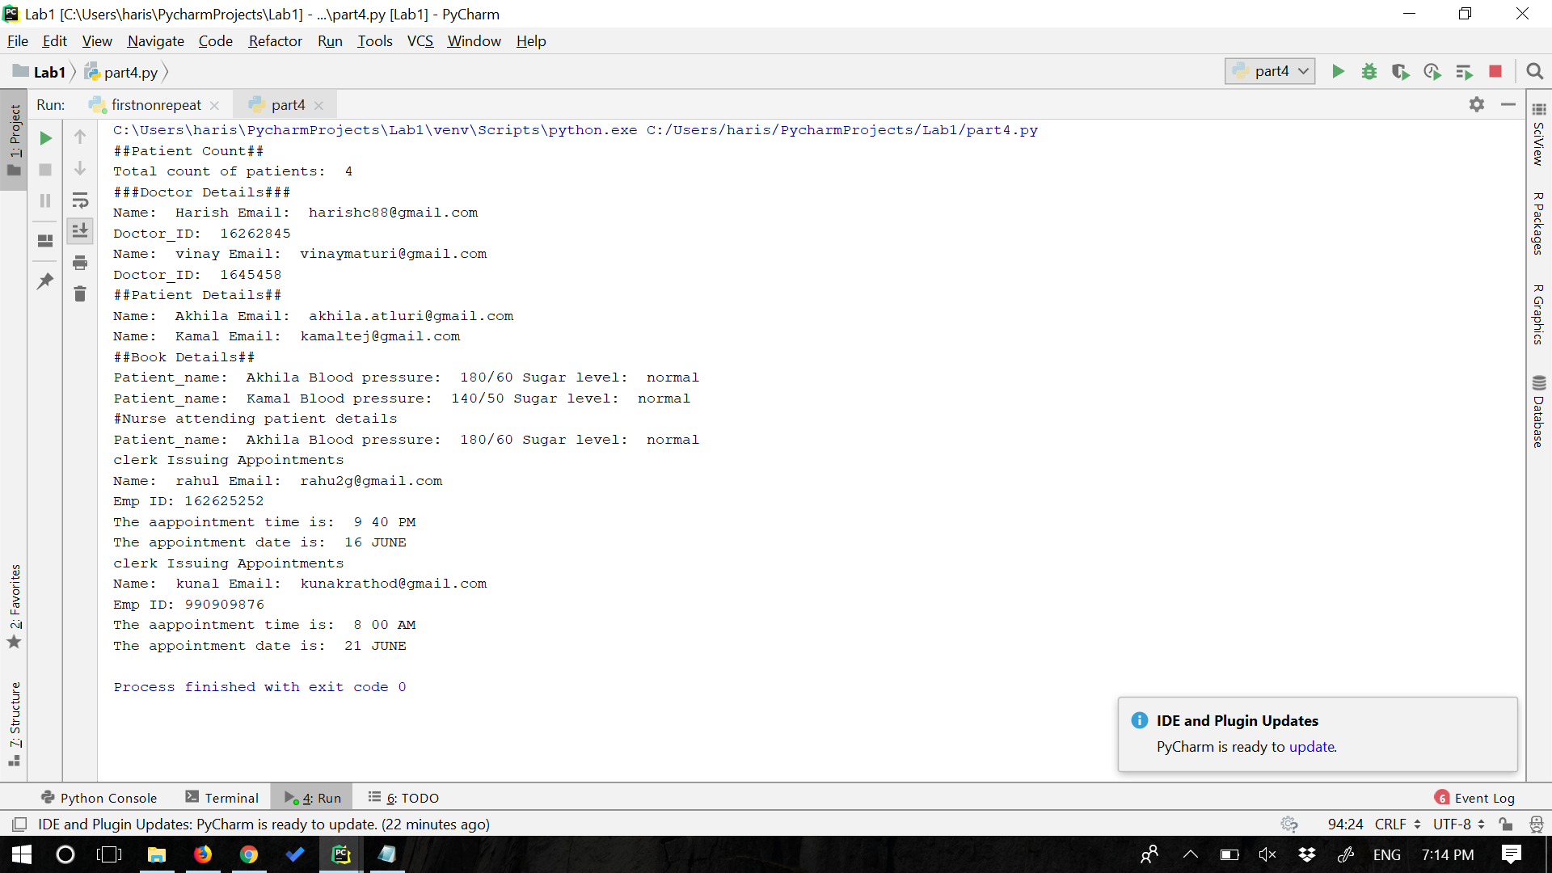

**## TASK 5:**

**### Objective:**

**5. program a code which downloads a webpage contains a table using Request library, then parse the page using Beautiful soup library. You should save all the information in the table in a file. **

**Code is programmed which downloads a table in a webpage using request library and the webpage is parsed using beautiful Soup library extract the contents of a web page and all the contents of the table are stored in a file.**

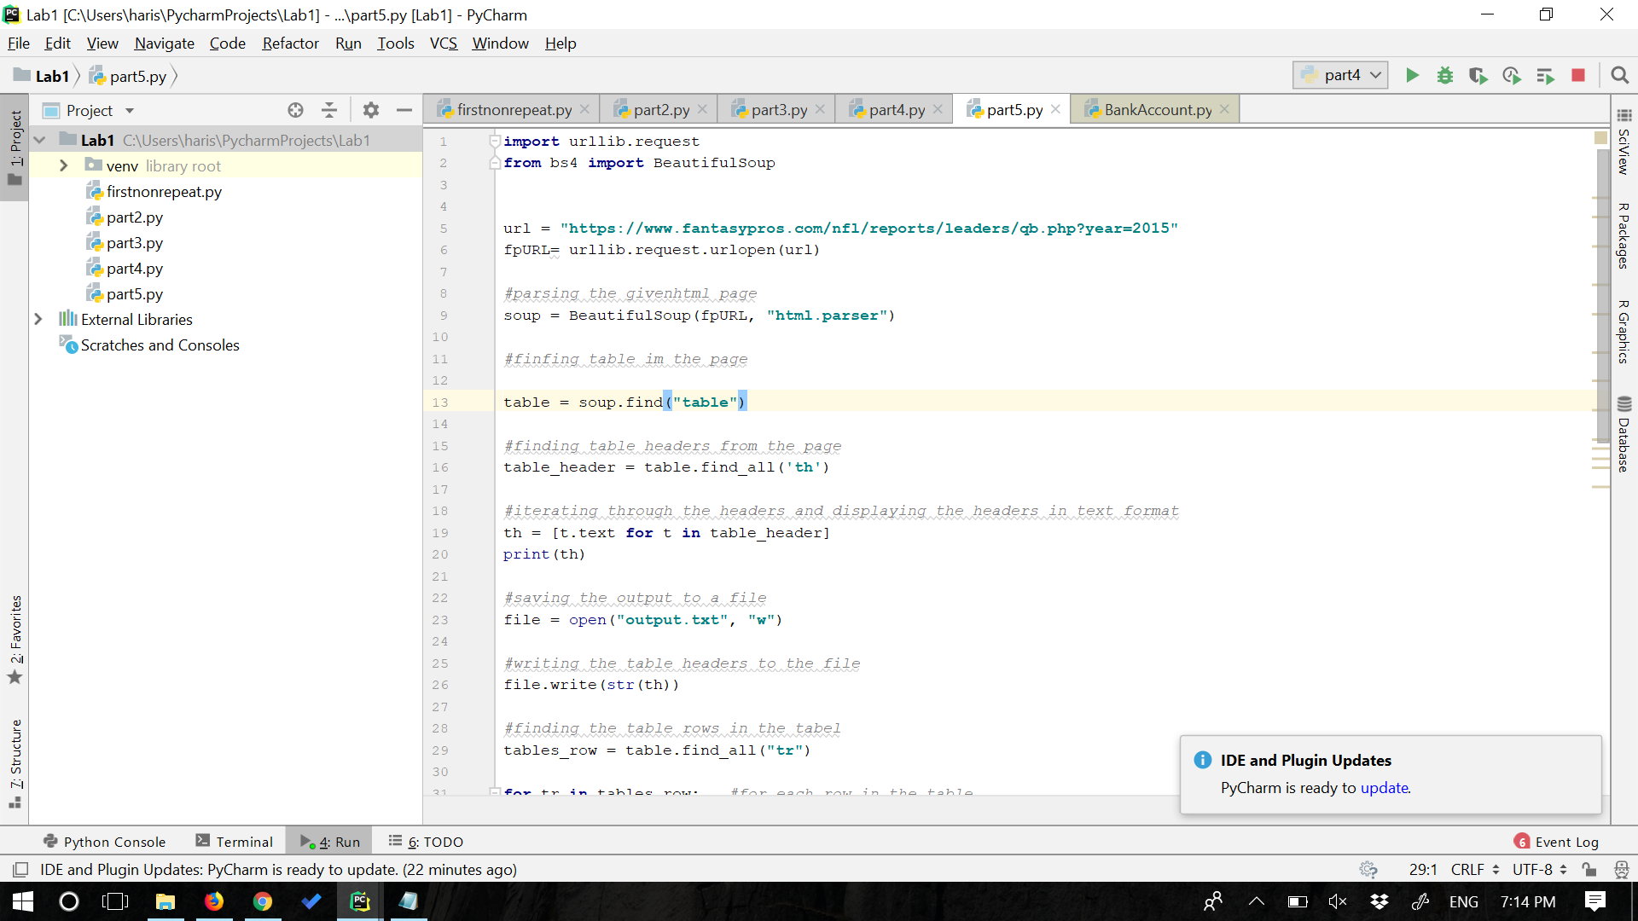

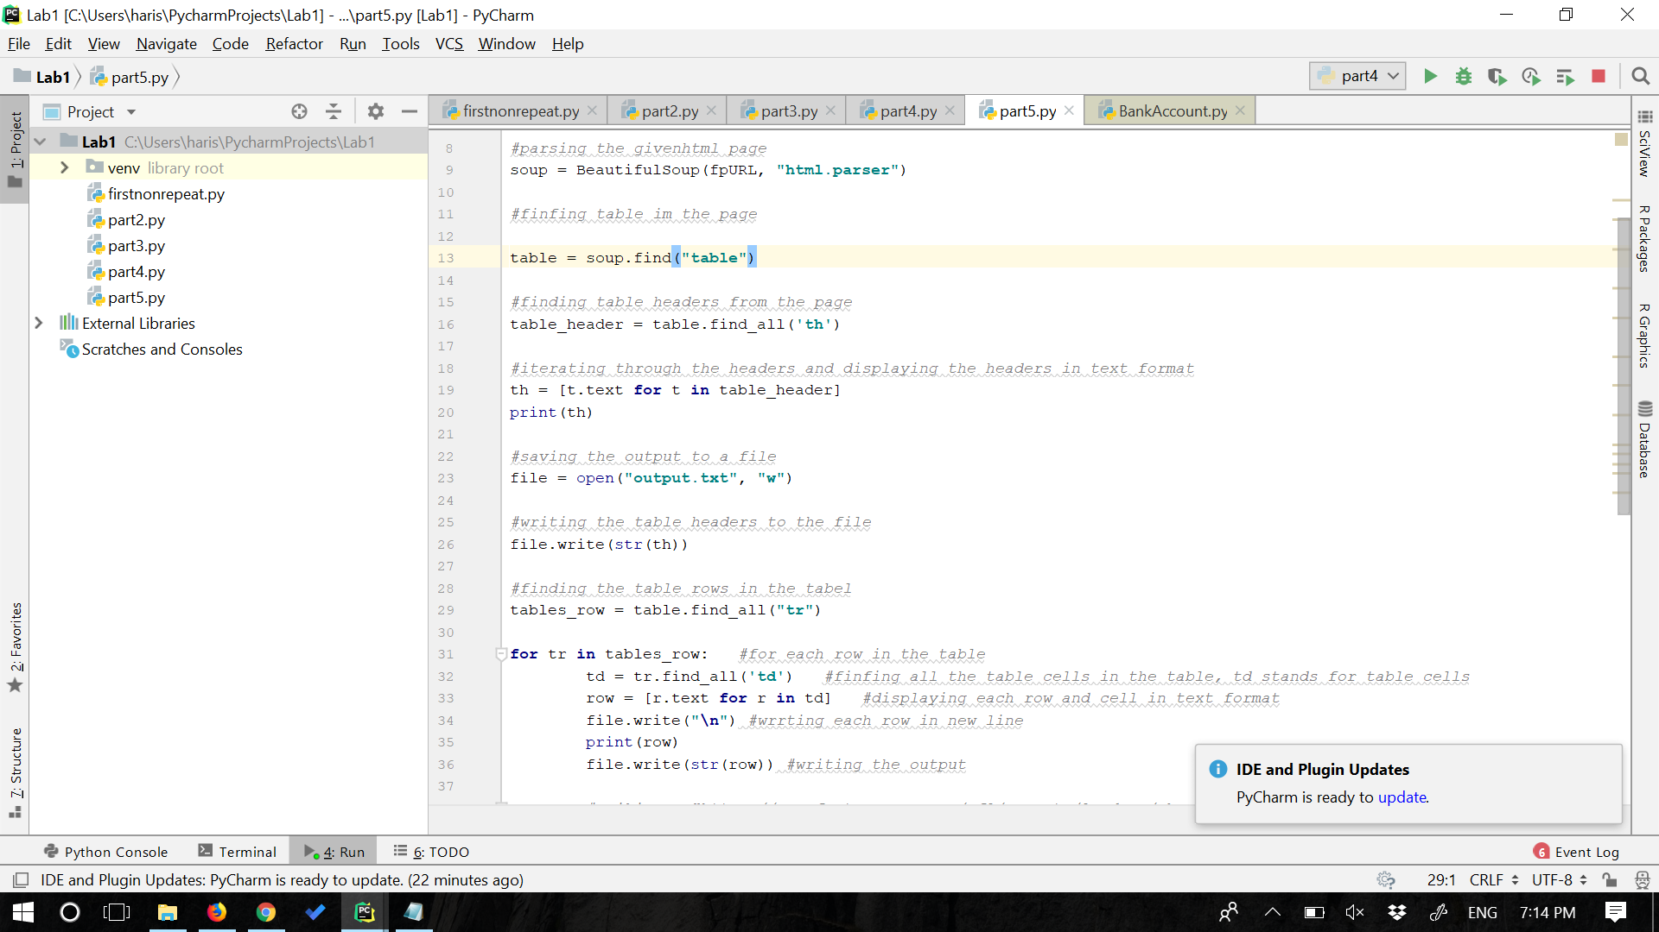

**Output:**

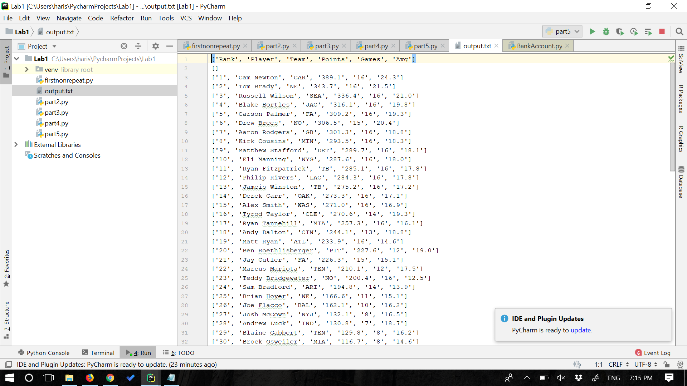

**References:**

1. <https://www.digitalocean.com/community/tutorials/how-to-scrape-web-pages-with-beautiful-soup-and-python-3>
2. <https://stackoverflow.com/questions/576169/understanding-python-super-with-init-methods>