**1) Exercise 1: Mocking and Stubbing**

**Scenario:**

You need to test a service that depends on an external API. Use Mockito to mock the external API and stub its methods.

**Steps:**

1. Create a mock object for the external API.

2. Stub the methods to return predefined values.

3. Write a test case that uses the mock object.

**Solution Code:**

import static org.mockito.Mockito.*;

import org.junit.jupiter.api.Test;

import org.mockito.Mockito;

public class MyServiceTest {

@Test public void testExternalApi() {

ExternalApi mockApi = Mockito.mock(ExternalApi.class); when(mockApi.getData()).thenReturn("Mock Data");

MyService service = new MyService(mockApi);

String result = service.fetchData();

assertEquals("Mock Data", result);

}

}

**Code:**

**External Api Interface**

**package** week2;

**public** **interface** ExternalApi {

String getData();

}

**MyService Class**

**package** week2;

**public** **class** MyService {

**private** **final** ExternalApi externalApi;

**public** MyService(ExternalApi externalApi) {

**this**.externalApi = externalApi;

}

**public** String fetchData() {

**return** externalApi.getData();

}

}

**MyServiceTest Class**

**package** week2;

**import** **static** org.mockito.Mockito.*;

**import** **static** org.junit.Assert.*;

**import** org.junit.Test;

**import** org.mockito.Mockito;

**public** **class** MyServiceTest {

public void testExternalApi() {

ExternalApi mockApi = Mockito.mock(ExternalApi.class);

when(mockApi.getData()).thenReturn("Mock Data");

MyService service = new MyService(mockApi);

String result = service.fetchData();

assertEquals("Mock Data", result);

}

}

**Output:**

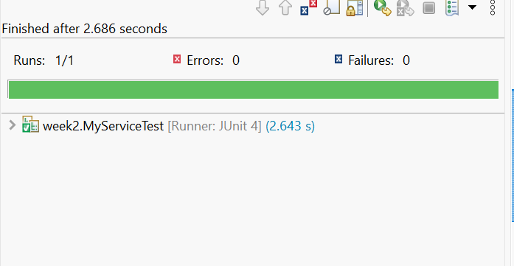

**2) Exercise 2: Verifying Interactions**

**Scenario:**

You need to ensure that a method is called with specific arguments.

**Steps:**

1. Create a mock object.

2. Call the method with specific arguments.

3. Verify the interaction.

**Solution Code:**

import static org.mockito.Mockito.*;

import org.junit.jupiter.api.Test;

import org.mockito.Mockito;

public class MyServiceTest {

@Test public void testVerifyInteraction() {

ExternalApi mockApi = Mockito.mock(ExternalApi.class);

MyService service = new MyService(mockApi);

service.fetchData();

verify(mockApi).getData();

}

}

**Code :**

**package** week2;

**import** **static** org.mockito.Mockito.*;

**import** **static** org.junit.Assert.*;

**import** org.junit.Test;

**import** org.mockito.Mockito;

**public** **class** MyServiceTest {

**public** **void** testVerifyInteraction() {

ExternalApi mockApi = Mockito.*mock*(ExternalApi.**class**);

MyService service = **new** MyService(mockApi);

service.fetchData();

Mockito.*verify*(mockApi).getData();

}

}

**Output:**

