**1) Spring Data JPA - Quick Example**  
  
**Software Pre-requisites**

* MySQL Server 8.0
* MySQL Workbench 8
* Eclipse IDE for Enterprise Java Developers 2019-03 R
* Maven 3.6.2

**Create a Eclipse Project using Spring Initializr**

* Go to <https://start.spring.io/>
* Change Group as “com.cognizant”
* Change Artifact Id as “orm-learn”
* In Options > Description enter "Demo project for Spring Data JPA and Hibernate"
* Click on menu and select "Spring Boot DevTools", "Spring Data JPA" and "MySQL Driver"
* Click Generate and download the project as zip
* Extract the zip in root folder to Eclipse Workspace
* Import the project in Eclipse "File > Import > Maven > Existing Maven Projects > Click Browse and select extracted folder > Finish"
* Create a new schema "ormlearn" in MySQL database. Execute the following commands to open MySQL client and create schema.

> mysql -u root -p

mysql> create schema ormlearn;

* In orm-learn Eclipse project, open src/main/resources/application.properties and include the below database and log configuration.

# Spring Framework and application log

logging.level.org.springframework=info

logging.level.com.cognizant=debug

# Hibernate logs for displaying executed SQL, input and output

logging.level.org.hibernate.SQL=trace

logging.level.org.hibernate.type.descriptor.sql=trace

# Log pattern

logging.pattern.console=%d{dd-MM-yy} %d{HH:mm:ss.SSS} %-20.20thread %5p %-25.25logger{25} %25M %4L %m%n

# Database configuration

spring.datasource.driver-class-name=com.mysql.cj.jdbc.Driver

spring.datasource.url=jdbc:mysql://localhost:3306/ormlearn

spring.datasource.username=root

spring.datasource.password=root

# Hibernate configuration

spring.jpa.hibernate.ddl-auto=validate

spring.jpa.properties.hibernate.dialect=org.hibernate.dialect.MySQL5Dialect

* Build the project using ‘mvn clean package -Dhttp.proxyHost=proxy.cognizant.com -Dhttp.proxyPort=6050 -Dhttps.proxyHost=proxy.cognizant.com -Dhttps.proxyPort=6050 -Dhttp.proxyUser=123456’ command in command line
* Include logs for verifying if main() method is called.

import org.slf4j.Logger;

import org.slf4j.LoggerFactory;

private static final Logger LOGGER = LoggerFactory.getLogger(OrmLearnApplication.class);

public static void main(String[] args) {

SpringApplication.run(OrmLearnApplication.class, args);

  LOGGER.info("Inside main");

}

* Execute the OrmLearnApplication and check in log if main method is called.

SME to walk through the following aspects related to the project created:

1. src/main/java - Folder with application code
2. src/main/resources - Folder for application configuration
3. src/test/java - Folder with code for testing the application
4. OrmLearnApplication.java - Walkthrough the main() method.
5. Purpose of @SpringBootApplication annotation
6. pom.xml
   1. Walkthrough all the configuration defined in XML file
   2. Open 'Dependency Hierarchy' and show the dependency tree.

**Country table creation**

* Create a new table country with columns for code and name. For sample, let us insert one country with values 'IN' and 'India' in this table.

create table country(co_code varchar(2) primary key, co_name varchar(50));

* Insert couple of records into the table

insert into country values ('IN', 'India');

insert into country values ('US', 'United States of America');

**Persistence Class - com.cognizant.orm-learn.model.Country**

* Open Eclipse with orm-learn project
* Create new package com.cognizant.orm-learn.model
* Create Country.java, then generate getters, setters and toString() methods.
* Include @Entity and @Table at class level
* Include @Column annotations in each getter method specifying the column name.

import javax.persistence.Column;

import javax.persistence.Entity;

import javax.persistence.Id;

import javax.persistence.Table;

@Entity

@Table(name="country")

public class Country {

  @Id

    @Column(name="code")

    private String code;

    @Column(name="name")

    private String name;

// getters and setters

  // toString()

}

*Notes:*

* @Entity is an indicator to Spring Data JPA that it is an entity class for the application
* @Table helps in defining the mapping database table
* @Id helps is defining the primary key
* @Column helps in defining the mapping table column

**Repository Class - com.cognizant.orm-learn.CountryRepository**

* Create new package com.cognizant.orm-learn.repository
* Create new interface named CountryRepository that extends JpaRepository<Country, String>
* Define @Repository annotation at class level

import org.springframework.data.jpa.repository.JpaRepository;

import org.springframework.stereotype.Repository;

import com.cognizant.ormlearn.model.Country;

@Repository

public interface CountryRepository extends JpaRepository<Country, String> {

}

**Service Class - com.cognizant.orm-learn.service.CountryService**

* Create new package com.cognizant.orm-learn.service
* Create new class CountryService
* Include @Service annotation at class level
* Autowire CountryRepository in CountryService
* Include new method getAllCountries() method that returns a list of countries.
* Include @Transactional annotation for this method
* In getAllCountries() method invoke countryRepository.findAll() method and return the result

**Testing in OrmLearnApplication.java**

* Include a static reference to CountryService in OrmLearnApplication class

private static CountryService countryService;

* Define a test method to get all countries from service.

    private static void testGetAllCountries() {

        LOGGER.info("Start");

        List<Country> countries = countryService.getAllCountries();

        LOGGER.debug("countries={}", countries);

        LOGGER.info("End");

    }

* Modify SpringApplication.run() invocation to set the application context and the CountryService reference from the application context.

        ApplicationContext context = SpringApplication.run(OrmLearnApplication.class, args);

        countryService = context.getBean(CountryService.class);

        testGetAllCountries();

* Execute main method to check if data from ormlearn database is retrieved.

**Spring Initializr:**

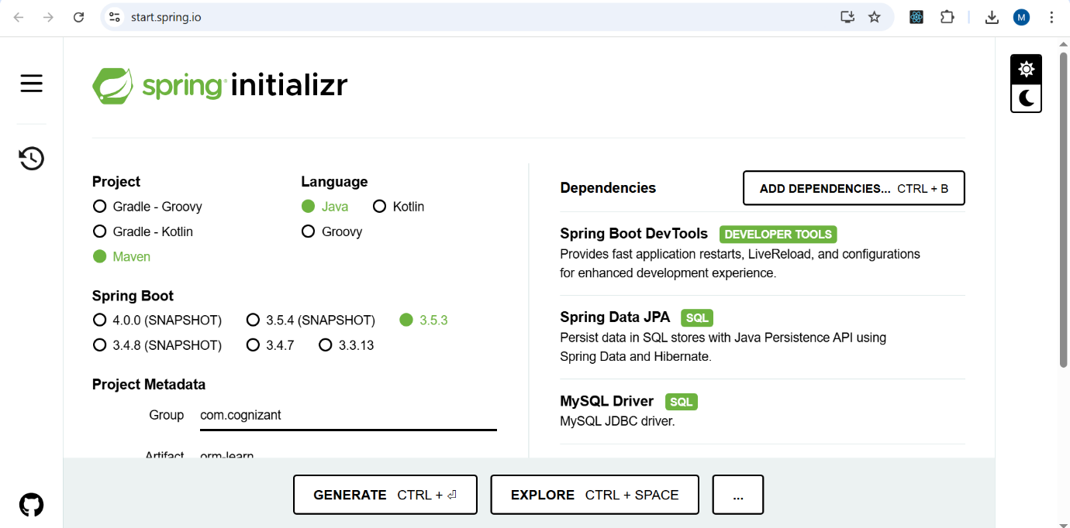

**Project Structure:**

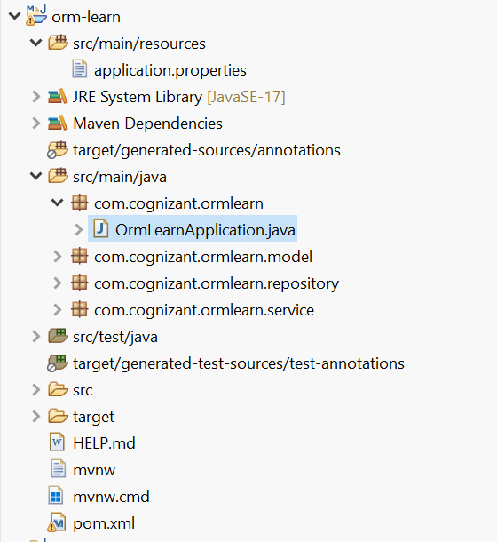

**Code:**

**Country.java:**

package com.cognizant.ormlearn.model;

import jakarta.persistence.Entity;

import jakarta.persistence.Id;

import jakarta.persistence.Column;

import jakarta.persistence.Table;

@Entity

@Table(name = "country")

public class Country {

@Id

@Column(name = "co_code")

**private** String code;

@Column(name = "co_name")

**private** String name;

**public** String getCode() {

**return** code;

}

**public** **void** setCode(String code) {

**this**.code = code;

}

**public** String getName() {

**return** name;

}

**public** **void** setName(String name) {

**this**.name = name;

}

@Override

**public** String toString() {

**return** "Country [code=" + code + ", name=" + name + "]";

}

}

**CountryRepository.java:**

**package** com.cognizant.ormlearn.model;

**import** jakarta.persistence.Entity;

**import** jakarta.persistence.Id;

**import** jakarta.persistence.Column;

**import** jakarta.persistence.Table;

@Entity

@Table(name = "country")

**public** **class** Country {

@Id

@Column(name = "co_code")

**private** String code;

@Column(name = "co_name")

**private** String name;

**public** String getCode() {

**return** code;

}

**public** **void** setCode(String code) {

**this**.code = code;

}

**public** String getName() {

**return** name;

}

**public** **void** setName(String name) {

**this**.name = name;

}

@Override

**public** String toString() {

**return** "Country [code=" + code + ", name=" + name + "]";

}

}

**CountryService.java:**

**package** com.cognizant.ormlearn.service;

**import** java.util.List;

**import** org.springframework.beans.factory.annotation.Autowired;

**import** org.springframework.stereotype.Service;

**import** org.springframework.transaction.annotation.Transactional;

**import** com.cognizant.ormlearn.model.Country;

**import** com.cognizant.ormlearn.repository.CountryRepository;

@Service

**public** **class** CountryService {

@Autowired

**private** CountryRepository countryRepository;

@Transactional(readOnly = **true**)

**public** List<Country> getAllCountries() {

**return** countryRepository.findAll();

}

}

**OrmLearnApplication.java:**

**package** com.cognizant.ormlearn;

**import** java.util.List;

**import** org.slf4j.Logger;

**import** org.slf4j.LoggerFactory;

**import** org.springframework.boot.SpringApplication;

**import** org.springframework.boot.autoconfigure.SpringBootApplication;

**import** org.springframework.context.ApplicationContext;

**import** com.cognizant.ormlearn.model.Country;

**import** com.cognizant.ormlearn.service.CountryService;

@SpringBootApplication

**public** **class** OrmLearnApplication {

**private** **static** **final** Logger ***LOGGER*** = LoggerFactory.*getLogger*(OrmLearnApplication.**class**);

**private** **static** CountryService *countryService*;

**public** **static** **void** main(String[] args) {

ApplicationContext context = SpringApplication.*run*(OrmLearnApplication.**class**, args);

***LOGGER***.info("Inside main");

*countryService* = context.getBean(CountryService.**class**);

*testGetAllCountries*();

}

**private** **static** **void** testGetAllCountries() {

***LOGGER***.info("Start");

List<Country> countries = *countryService*.getAllCountries();

***LOGGER***.debug("countries={}", countries);

***LOGGER***.info("End");

}

}

Output:

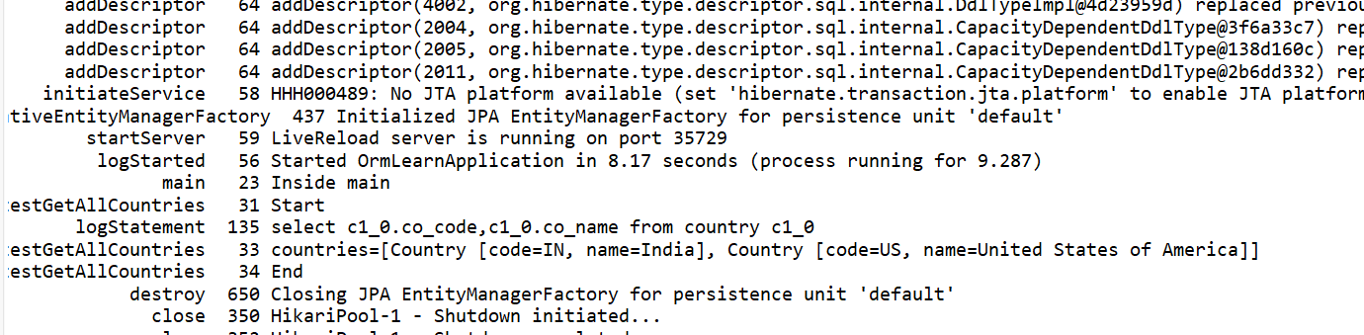

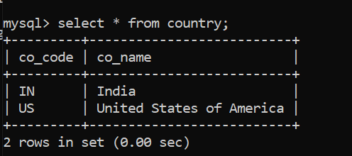

2) **Hands on 4**

**Difference between JPA, Hibernate and Spring Data JPA**   
  
Java Persistence API (JPA)

* JSR 338 Specification for persisting, reading and managing data from Java objects
* Does not contain concrete implementation of the specification
* Hibernate is one of the implementation of JPA

Hibernate

* ORM Tool that implements JPA

Spring Data JPA

* Does not have JPA implementation, but reduces boiler plate code
* This is another level of abstraction over JPA implementation provider like Hibernate
* Manages transactions

**Refer code snippets below on how the code compares between Hibernate and Spring Data JPA  
Hibernate**

   /* Method to CREATE an employee in the database */

   public Integer addEmployee(Employee employee){

      Session session = factory.openSession();

      Transaction tx = null;

      Integer employeeID = null;

      try {

         tx = session.beginTransaction();

         employeeID = (Integer) session.save(employee);

         tx.commit();

      } catch (HibernateException e) {

         if (tx != null) tx.rollback();

         e.printStackTrace();

      } finally {

         session.close();

      }

      return employeeID;

   }

**Spring Data JPA**  
EmployeeRespository.java

public interface EmployeeRepository extends JpaRepository<Employee, Integer> {

}

EmployeeService.java

@Autowire

  private EmployeeRepository employeeRepository;

@Transactional

public void addEmployee(Employee employee) {

  employeeRepository.save(employee);

  }

**Hibernate**

   /* Method to CREATE an employee in the database */

   public Integer addEmployee(Employee employee){

      Session session = factory.openSession();

      Transaction tx = null;

      Integer employeeID = null;

      try {

         tx = session.beginTransaction();

         employeeID = (Integer) session.save(employee);

         tx.commit();

      } catch (HibernateException e) {

         if (tx != null) tx.rollback();

         e.printStackTrace();

      } finally {

         session.close();

      }

      return employeeID;

   }

**Spring Data JPA:**

**EmployeeRespository.java**

public interface EmployeeRepository extends JpaRepository<Employee, Integer> {

}

**EmployeeService.java**

@Autowire

  private EmployeeRepository employeeRepository;

@Transactional

public void addEmployee(Employee employee) {

  employeeRepository.save(employee);

  }

**Difference between them can be explained as follows:**

JPA, Hibernate, and Spring Data JPA are all related, but they each play different roles in how Java applications interact with databases.

**JPA (Java Persistence API)** is basically a standard that defines how Java objects should be saved to a database.

**Hibernate** is one of the most popular tools that implements the JPA specification. It’s an ORM (Object-Relational Mapping) framework that does the heavy lifting of mapping Java classes to database tables and translating Java code into SQL queries. Hibernate can also do a lot more than just JPA, like caching and performance optimizations, but when we use it with JPA, it acts as the actual engine that makes JPA work.

**Spring Data JPA** sits on top of JPA (and Hibernate or another JPA provider) and makes working with databases even easier. It lets you avoid writing boilerplate code like DAOs by simply defining interfaces that extend JpaRepository or CrudRepository. Spring Data JPA can automatically generate common queries just based on our method names, and it also makes it easier to manage transactions.

**Differences:**

| **Aspect** | **JPA** | **Hibernate** | **Spring Data JPA** |
| --- | --- | --- | --- |
| Definition | A specification (JSR 338) defining how Java objects are persisted to relational databases. | An ORM framework that provides a concrete implementation of the JPA specification. | A Spring library that adds an abstraction layer on top of JPA providers like Hibernate. |
| Role | defines annotations, interfaces, and contracts. | executes JPA operations and provides additional features. | Simplifies JPA usage by reducing boilerplate, adds auto-generated queries and repository patterns. |
| Implementation | Not an implementation itself. | Is an implementation (commonly used JPA provider). | Not a JPA provider, works with JPA implementations (like Hibernate). |
| Example Use | We write JPA annotations and API code, but need an implementation (Hibernate, EclipseLink). | Directly use Hibernate Session API or JPA APIs with Hibernate underneath. | Define interfaces extending JpaRepository and Spring Data JPA generates most code for you. |
| Boilerplate | Requires manual code for CRUD, queries, transaction management. | Requires manual transaction and session management (if using Hibernate API). | Drastically reduces boilerplate; repositories handle most standard operations automatically. |
| Query Language | Uses JPQL (Java Persistence Query Language). | Supports JPQL, Hibernate Query Language (HQL), and native SQL. | Can derive queries from method names or use JPQL/SQL with @Query. |
| Transactions | Depends on manual or container-managed transactions. | Requires manual transaction boundaries or external management. | Integrates with Spring’s @Transactional for easy declarative transaction management. |

**Example output:**

