**StudentApp**

**HandsOn 2**

**Create a react app for Student Management Portal named StudentApp and create a component named Home which will display the Message “Welcome to the Home page of Student Management Portal”. Create another component named About and display the Message “Welcome to the About page of the Student Management Portal”. Create a third component named Contact and display the Message “Welcome to the Contact page of the Student Management Portal”. Call all the three components.**

1. Create a React project named “StudentApp” type the following command in terminal of Visual studio:



1. Create a new folder under Src folder with the name “Components”. Add a new file named “Home.js”
2. Type the following code in Home.js

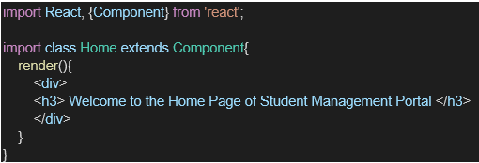

1. Under Src folder add another file named “About.js”
2. Repeat the same steps for Creating “About” and “Contact” component by adding a new file as ”About.js”, “Contact.js” under “Src” folder and edit the code as mentioned for “Home” Component.
3. Edit the App.js to invoke the Home, About and Contact component as follows:

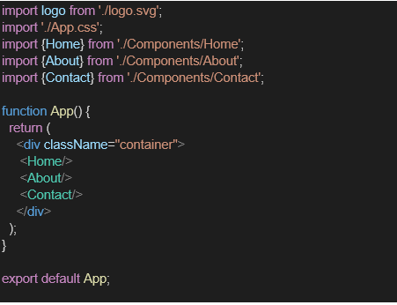

1. In command Prompt, navigate into StudentApp and execute the code by typing the following command:



1. Open browser and type “localhost:3000” in the address bar:

**Project Structure:**

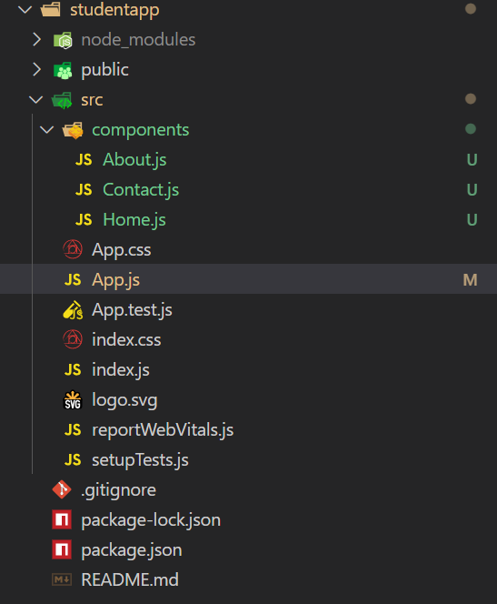

**Code:**

**App.js:**

import './App.css';

function App() {

  return (

    <div>

   <h1>Welcome the first session of React</h1>

   </div>

  );

}

export default App;

**About.js:**

import React, { Component } from 'react';

class About extends Component {

    render() {

        return (

            <div>

                <h3>Welcome to the About Page of Student Management</h3>

            </div>

        );

    }

}

export default About;

**Home.js:**

import React, { Component } from 'react';

class Home extends Component {

    render() {

        return (

            <div>

                <h3>Welcome to the Home Page of Student Management</h3>

            </div>

        );

    }

}

export default Home;

**Contact.js:**

import React, { Component } from 'react';

class Contact extends Component {

    render() {

        return (

            <div>

                <h3>Welcome to the Contact Page of Student Management</h3>

            </div>

        );

    }

}

export default Contact;

**Output:**

