**Create a react app for Student Management Portal named scorecalculatorapp and create a function component named “CalculateScore” which will accept Name, School, Total and goal in order to calculate the average score of a student and display the same.**

1. Create a React project named “scorecalculatorapp” type the following command in terminal of Visual studio:



1. Create a new folder under Src folder with the name “Components”. Add a new file named “CalculateScore.js”
2. Type the following code in CalculateScore.js

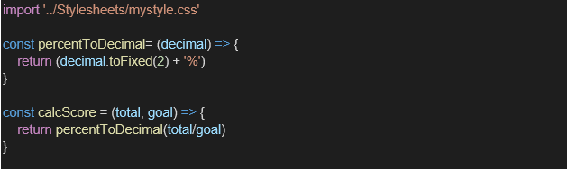

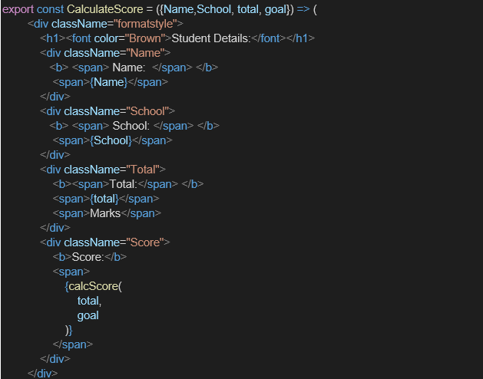

1. Create a Folder named Stylesheets and add a file named “mystyle.css” in order to add some styles to the components:

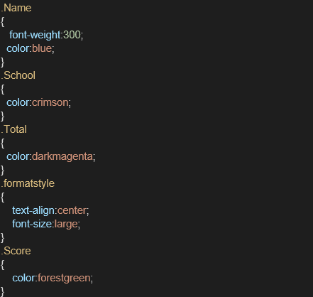

1. Edit the App.js to invoke the CalculateScore functional component as follows:

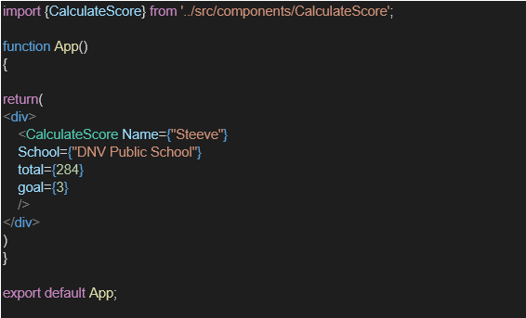

1. In command Prompt, navigate into scorecalculatorapp and execute the code by typing the following command:



1. Open browser and type “localhost:3000” in the address bar:

**Project Structure:**

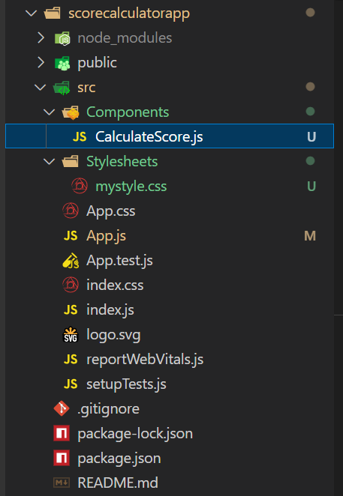

**Code:**

**CalculatorScore.js:**

import '../Stylesheets/mystyle.css';

const percentToDecimal = (decimal)=>{

    return (decimal.toFixed(2)+'%');

}

const calcScore = (total,goal)=>{

    return percentToDecimal(total/goal);

}

export const CalculateScore = ({Name,School,total,goal})=>{

    return(

    <div className = "formatstyle">

        <h1><font color="Brown">Student Details:</font></h1>

        <div className="Name">

            <b><span>Name: </span></b>

            <span>{Name}</span>

        </div>

        <div className="School">

                <b><span>School: </span></b>

                <span>{School}</span>

            </div>

        <div className="Total">

            <b><span>Total: </span></b>

            <span>{total}</span>

            <span>Marks</span>

        </div>

         <div className="Score">

            <b><span>Score: </span></b>

            <span>{

                calcScore(

                    total,

                    goal

                )

            }</span>

        </div>

    </div>

    );

};

**Mystyle.css:**

.Name{

    font-weight:300;

    color:blue;

}

.School{

    color:crimson;

}

.Total{

    color:darkmagneta;

}

.formatstyle{

    text-align:center;

    font-size:large;

}

.Score{

    color:forestgreen;

}

**App.js:**//import logo from './logo.svg';

import './App.css';

import { CalculateScore } from './Components/CalculateScore';

function App() {

  return (

    <div>

      <CalculateScore Name = {"Steeve"}

      School = {"DNV Public School"}

      total = {284}

      goal = {3}

      ></CalculateScore>

    </div>

  );

}

export default App;

**Output:**

