**CricketApp**

**HandsOn – 1**

**Create a React Application named “cricketapp” with the following components**:

1. ListofPlayers

* Declare an array with 11 players and store details of their names and scores using the map feature of ES6

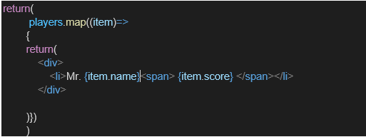

* Filter the players with scores below 70 using arrow functions of ES6.

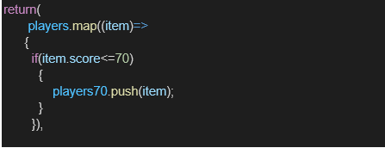

1. IndianPlayers
   1. Display the Odd Team Player and Even Team players using the Destructuring features of ES6

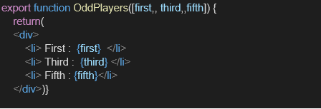

* 1. Declare two arrays T20players and RanjiTrophy players and merge the two arrays and display them using the Merge feature of ES6

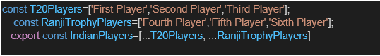

Display these two components in the same home page using a simple if else in the flag variable.

**Output:**

When Flag=true

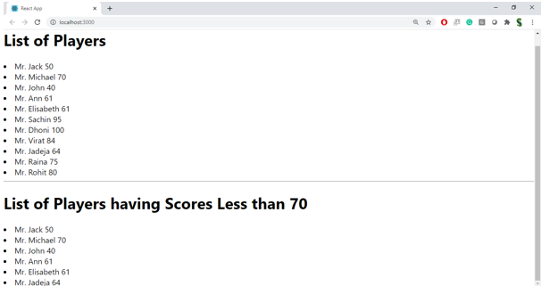

When Flag=false

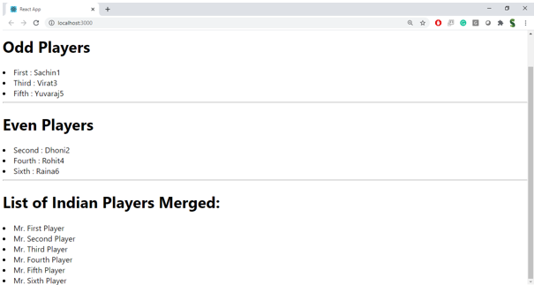

**Hint:**

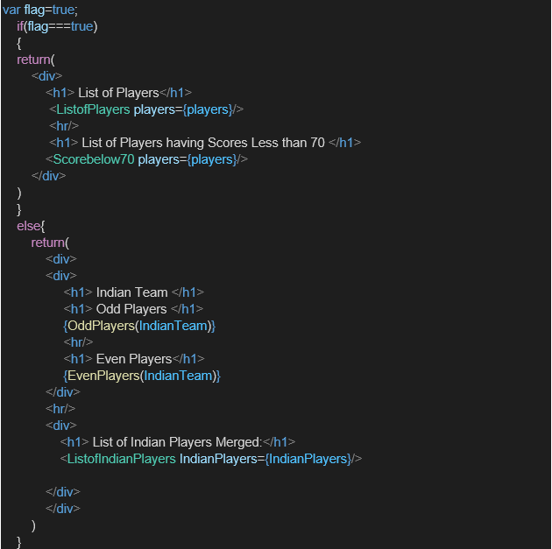

**Creation :**

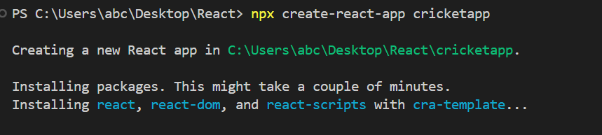

**Project Structure:**

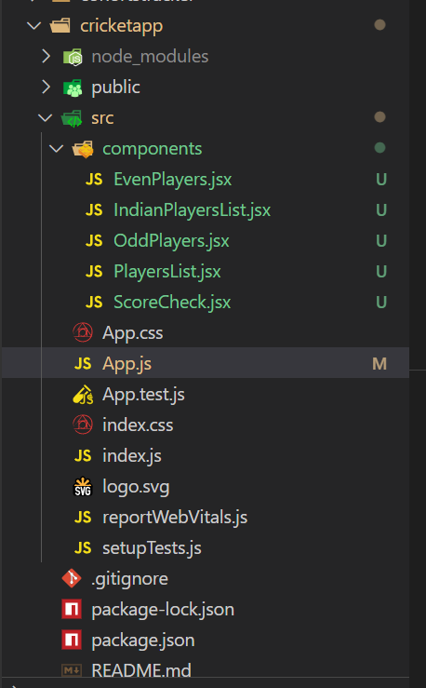

**Code:**

**PlayersList.jsx:**

import React from 'react';

const PlayersList = ({ players }) => {

  return (

    <div>

      {players.map((item, idx) => (

        <div key={idx}>

          <li>

            Mr. {item.name} <span>{item.score}</span>

          </li>

        </div>

      ))}

    </div>

  );

};

export default PlayersList;

**ScoreCheck.jsx:**

import React from 'react';

const ScoreCheck = ({ players }) => {

  const playerslessthan70 = players.filter((item) => item.score <= 70);

  return (

    <div>

      {playerslessthan70.map((item, idx) => (

        <div key={idx}>

          <li>

            Mr. {item.name} <span>{item.score}</span>

          </li>

        </div>

      ))}

    </div>

  );

};

export default ScoreCheck;

**OddPlayers.jsx:**

import React from 'react';

export function OddPlayers([first, , third, , fifth]) {

  return (

    <div>

      <li>First : {first}</li>

      <li>Third : {third}</li>

      <li>Fifth : {fifth}</li>

    </div>

  );

}

**EvenPlayers.jsx:**

import React from 'react';

export function EvenPlayers([, second, , fourth, , sixth]) {

  return (

    <div>

      <li>Second : {second}</li>

      <li>Fourth : {fourth}</li>

      <li>Sixth : {sixth}</li>

    </div>

  );

}

**IndianPlayersList.jsx:**

import React from 'react';

const IndianPlayersList = ({ IndianPlayers }) => {

  return (

    <div>

      {IndianPlayers.map((player, idx) => (

        <li key={idx}>Mr. {player}</li>

      ))}

    </div>

  );

};

export default IndianPlayersList;

**App.js:**

import React from 'react';

import PlayersList from './components/PlayersList';

import ScoreCheck from './components/ScoreCheck';

import { OddPlayers } from './components/OddPlayers';

import { EvenPlayers } from './components/EvenPlayers';

import IndianPlayersList from './components/IndianPlayersList';

function App() {

  const flag = false;

  const players = [

    { name: 'Jack', score: 50 },

    { name: 'Michael', score: 70 },

    { name: 'John', score: 40 },

    { name: 'Ann', score: 61 },

    { name: 'Elisabeth', score: 61 },

    { name: 'Sachin', score: 95 },

    { name: 'Dhoni', score: 100 },

    { name: 'Virat', score: 84 },

    { name: 'Jadeja', score: 64 },

    { name: 'Raina', score: 75 },

    { name: 'Rohit', score: 80 }

  ];

  const T20Players = ['First Player', 'Second Player', 'Third Player'];

  const RanjiTrophyPlayers = ['Fourth Player', 'Fifth Player', 'Sixth Player'];

  const IndianPlayers = [...T20Players, ...RanjiTrophyPlayers];

  const IndianTeam = ['Sachin1', 'Dhoni2', 'Virat3', 'Rohit4', 'Yuvaraj5', 'Raina6'];

  if (flag === true) {

    return (

      <div>

        <h1>List of Players</h1>

        <PlayersList players={players} />

        <hr />

        <h1>List of Players having Scores Less than 70</h1>

        <ScoreCheck players={players} />

      </div>

    );

  } else {

    return (

      <div>

        <div>

          <h1>Odd Players</h1>

          {OddPlayers(IndianTeam)}

          <hr />

          <h1>Even Players</h1>

          {EvenPlayers(IndianTeam)}

        </div>

        <hr />

        <div>

          <h1>List of Indian Players Merged:</h1>

          <IndianPlayersList IndianPlayers={IndianPlayers} />

        </div>

      </div>

    );

  }

}

export default App;

**Output:**

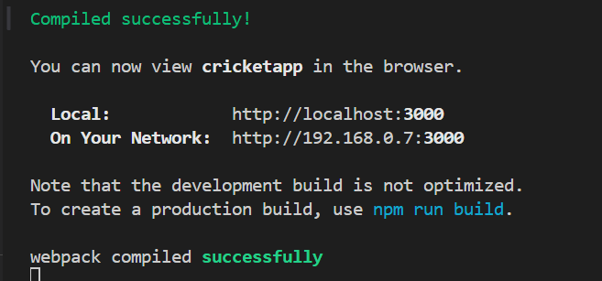

**flag = false;**

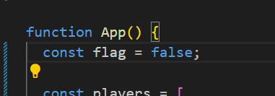

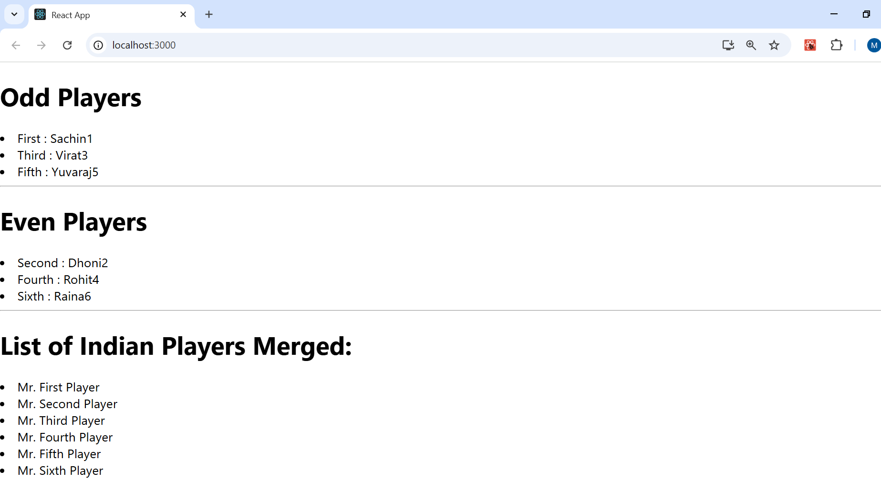

**flag = true;**

