**Event Examples App**

**Hands On 3**

**Create a React Application “eventexamplesapp” to handle various events of the form elements in HTML.**

1. Create “Increment” button to increase the value of the counter and “Decrement” button to decrease the value of the counter. The “Increase” button should invoke multiple methods.
   1. To increment the value
   2. Say Hello followed by a static message.

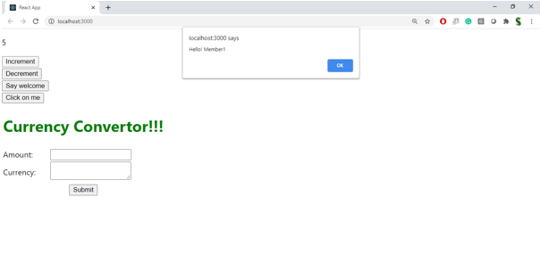

1. Create a button “Say Welcome” which invokes the function which takes “welcome” as an argument.

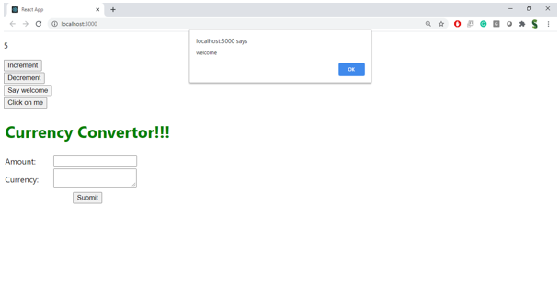

1. Create a button which invokes synthetic event “OnPress” which display “I was clicked”

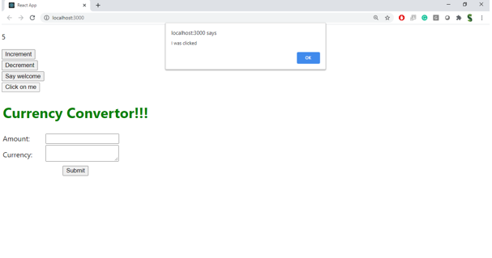

Create a “CurrencyConvertor” component which will convert the Indian Rupees to Euro when the Convert button is clicked.

Handle the Click event of the button to invoke the handleSubmit event and handle the conversion of the euro to rupees.

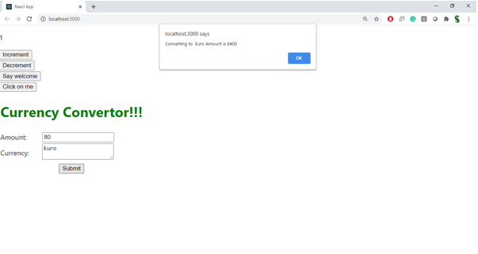

**Creation:**

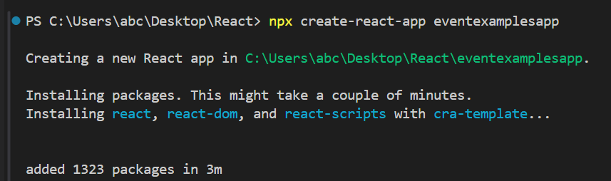

**Project Structure:**  
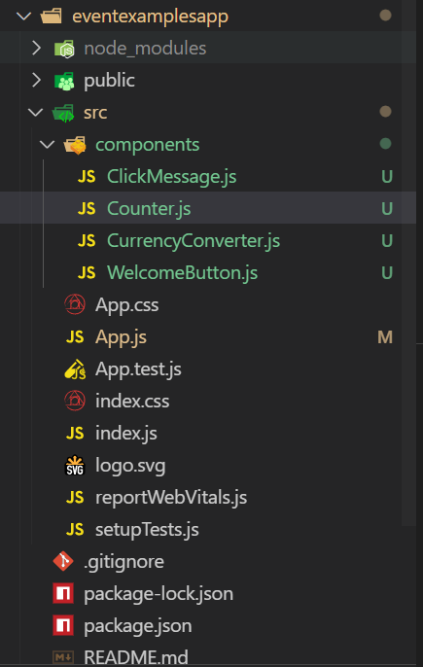

**Code:**

**WelcomButton.js:**

import React from 'react';

function WelcomeButton() {

  const sayWelcome = (msg) => {

    alert(msg);

  };

  return (

    <div>

      <button onClick={() => sayWelcome("Welcome")}>Say welcome</button><br /><br />

    </div>

  );

}

export default WelcomeButton;

**Counter.js:**

import React, { useState } from 'react';

function Counter() {

  const [count, setCount] = useState(1);

  const increment = () => {

    setCount(prev => prev + 1);

    sayHello();

  };

  const sayHello = () => {

    alert("Hello! Member! Counter increased.");

  };

  const decrement = () => {

    setCount(prev => prev - 1);

  };

  return (

    <div>

      <h2>{count}</h2>

      <button onClick={increment}>Increment</button><br /><br />

      <button onClick={decrement}>Decrement</button><br /><br />

    </div>

  );

}

export default Counter;

**ClickMessage.js:**

import React from 'react';

function ClickMessage() {

  const handleClick = () => {

    alert("I was clicked");

  };

  return (

    <div>

      <button onClick={handleClick}>Click on me</button><br /><br />

    </div>

  );

}

export default ClickMessage;

**CurrencyConverter.js:**

import React, { useState } from 'react';

function CurrencyConverter() {

  const [amount, setAmount] = useState('');

  const [currency, setCurrency] = useState('');

  const handleSubmit = (e) => {

    e.preventDefault();

    if (currency.toLowerCase() === 'euro') {

      const result = amount / 100; // Taking one euro equals to 100 INR as per current exchange rate

      alert(`Converting to ${currency} Amount is ${result}`);

    } else {

      alert(`Conversion to ${currency} is not supported.`);

    }

  };

  return (

    <div style={{ marginTop: '30px' }}>

      <h1 style={{ color: 'green' }}>Currency Convertor!!!</h1>

      <form onSubmit={handleSubmit}>

        <div>

          <label>Amount:</label>

          <input

            type="number"

            value={amount}

            onChange={(e) => setAmount(e.target.value)}

          />

        </div><br />

        <div>

          <label>Currency:</label>

          <input

            type="text"

            value={currency}

            onChange={(e) => setCurrency(e.target.value)}

          />

        </div><br />

        <button type="submit">Submit</button>

      </form>

    </div>

  );

}

export default CurrencyConverter;

**Apps.js:**

import React from 'react';

import Counter from './components/Counter';

import WelcomeButton from './components/WelcomeButton';

import ClickMessage from './components/ClickMessage';

import CurrencyConverter from './components/CurrencyConverter';

function App() {

  return (

    <div style={{ padding: '20px' }}>

      <Counter />

      <WelcomeButton />

      <ClickMessage />

      <CurrencyConverter />

    </div>

  );

}

export default App;

**Output:**

