**Ticket Booking App**

**Hands On – 4**

**Create a React Application named “ticketbookingapp” where the guest user can browse the page where the flight details are displayed whereas the logged in user only can book tickets.**

The Login and Logout buttons should accordingly display different pages. Once the user is logged in the User page should be displayed. When the user clicks on Logout, the Guest page should be displayed.

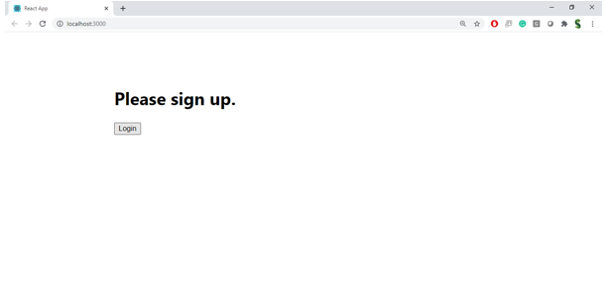

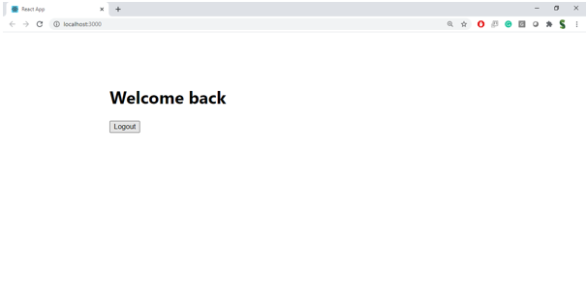

**Hint:**

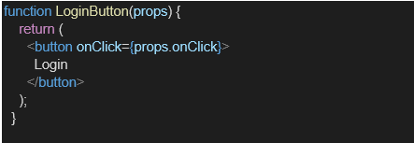

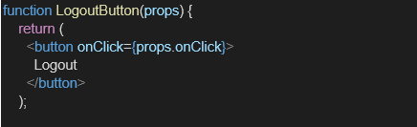

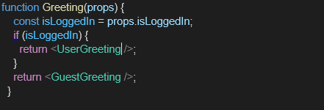

**Creation:**

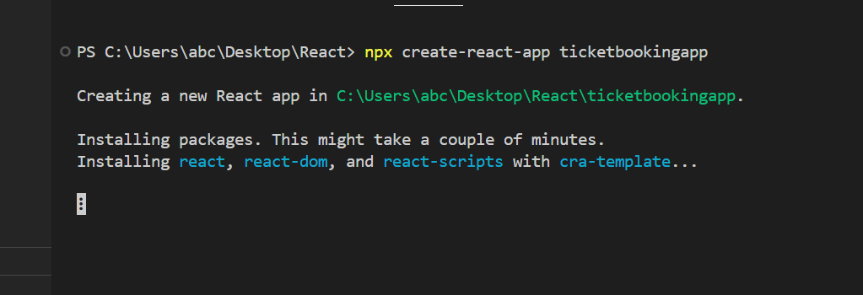

**Project Structure:**

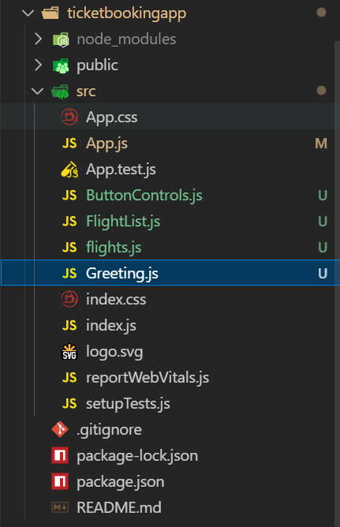

**Code:**

**ButtonControls.js:**

import React from 'react';

export function LoginButton(props) {

  return <button onClick={props.onClick}>Login</button>;

}

export function LogoutButton(props) {

  return <button onClick={props.onClick}>Logout</button>;

}

**Greeting.js:**

import React from 'react';

function UserGreeting() {

  return <h1>Welcome back</h1>;

}

function GuestGreeting() {

  return <h1>Please sign up.</h1>;

}

function Greeting(props) {

  const isLoggedIn = props.isLoggedIn;

  if (isLoggedIn) {

    return <UserGreeting />;

  }

  return <GuestGreeting />;

}

export default Greeting;

**flights.js:**

const flights = [

  { id: 1, name: 'Indigo', from: 'Hyderabad', to: 'Delhi', time: '08:00 AM' },

  { id: 2, name: 'Air India', from: 'Mumbai', to: 'Chennai', time: '09:45 AM' },

  { id: 3, name: 'SpiceJet', from: 'Bangalore', to: 'Hyderabad', time: '12:30 PM' },

  { id: 4, name: 'Vistara', from: 'Pune', to: 'Jaipur', time: '03:15 PM' },

];

export default flights;

**FlightList.js:**

import React from 'react';

import flights from './flights';

function FlightList() {

  return (

    <div>

      <h2>Available Flights</h2>

      <table style={{ margin: '0 auto', borderCollapse: 'collapse' }}>

        <thead>

          <tr>

            <th style={thStyle}>Flight</th>

            <th style={thStyle}>From</th>

            <th style={thStyle}>To</th>

            <th style={thStyle}>Time</th>

            <th style={thStyle}>Action</th>

          </tr>

        </thead>

        <tbody>

          {flights.map((flight) => (

            <tr key={flight.id}>

              <td style={tdStyle}>{flight.name}</td>

              <td style={tdStyle}>{flight.from}</td>

              <td style={tdStyle}>{flight.to}</td>

              <td style={tdStyle}>{flight.time}</td>

              <td style={tdStyle}>

                <button>Book Ticket</button>

              </td>

            </tr>

          ))}

        </tbody>

      </table>

    </div>

  );

}

const thStyle = { padding: '10px', border: '1px solid gray', background: '#eee' };

const tdStyle = { padding: '10px', border: '1px solid lightgray' };

export default FlightList;

**App.js:**

import React, { useState } from 'react';

import Greeting from './Greeting';

import { LoginButton, LogoutButton } from './ButtonControls';

import FlightList from './FlightList';

function App() {

  const [isLoggedIn, setIsLoggedIn] = useState(false);

  const handleLogin = () => setIsLoggedIn(true);

  const handleLogout = () => setIsLoggedIn(false);

  return (

    <div style={{ textAlign: 'center', marginTop: '40px' }}>

      <Greeting isLoggedIn={isLoggedIn} />

      {isLoggedIn ? (

        <LogoutButton onClick={handleLogout} />

      ) : (

        <LoginButton onClick={handleLogin} />

      )}

      <hr style={{ margin: '20px' }} />

      {isLoggedIn ? (

        <FlightList />

      ) : (

        <p style={{ color: 'gray' }}>Please Login</p>

      )}

    </div>

  );

}

export default App;

**Output:**

