**Blogger App**

**HandsOn 5**

**Create a React App named “bloggerapp” in with 3 components.**

1. Book Details
2. Blog Details
3. Course Details

Implement this with as many ways possible of Conditional Rendering.

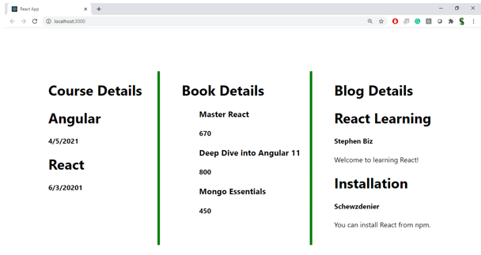

**Hint:**

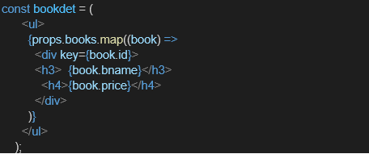

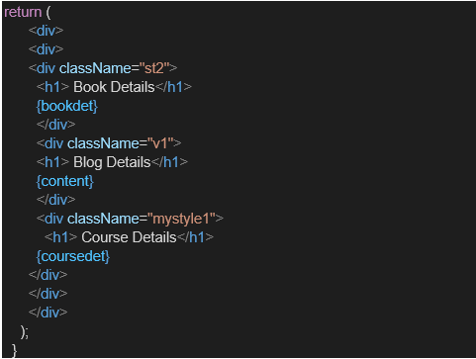

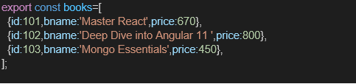

**Creation:**

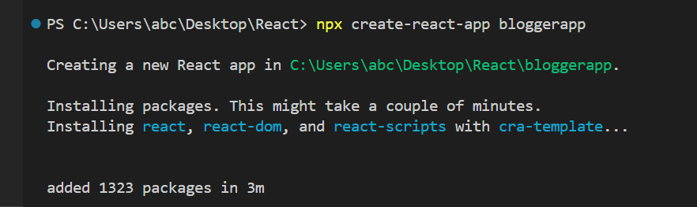

**Project Structure:**

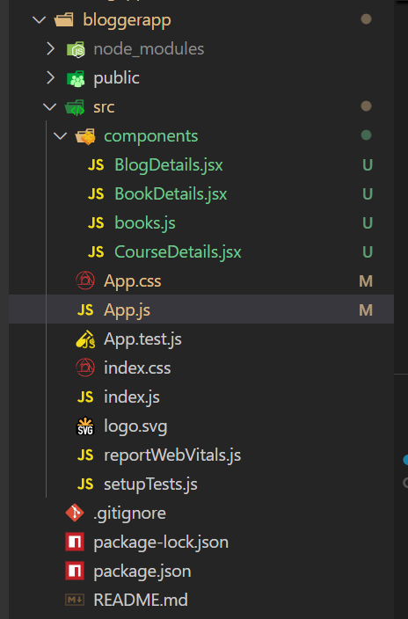

**Code:**

**BlogDetails.jsx:**

import React from 'react';

const BlogDetails = ({ show }) => {

  if (!show) return null;

  return (

    <div className="v1">

      <h1>Blog Details</h1>

      <h2>React Learning</h2>

      <h4>Stephen Biz</h4>

      <p>Welcome to learning React!</p>

      <h2>Installation</h2>

      <h4>Schwezdenier</h4>

      <p>You can install React from npm.</p>

    </div>

  );

};

export default BlogDetails;

**BookDetails.jsx:**

import React from 'react';

const BookDetails = ({ books }) => {

  return (

    <div className="st2">

      <h1>Book Details</h1>

      {books.length > 0 ? (

        <ul>

          {books.map((book) => (

            <div key={book.id}>

              <h3>{book.bname}</h3>

              <h4>{book.price}</h4>

            </div>

          ))}

        </ul>

      ) : (

        <p>No books available.</p>

      )}

    </div>

  );

};

export default BookDetails;

**books.js:**

export const books = [

  { id: 101, bname: 'Master React', price: 670 },

  { id: 102, bname: 'Deep Dive into Angular 11', price: 800 },

  { id: 103, bname: 'Mongo Essentials', price: 450 },

];

**CourseDetails.jsx:**

import React from 'react';

const CourseDetails = ({ showCourses }) => (

  <div className="mystyle1">

    <h1>Course Details</h1>

    {showCourses ? (

      <>

        <h2>Angular</h2>

        <p>4/5/2021</p>

        <h2>React</h2>

        <p>6/3/20201</p>

      </>

    ) : (

      <p>Courses are hidden.</p>

    )}

  </div>

);

export default CourseDetails;

**App.js:**

import React, { useState } from 'react';

import './App.css';

import { books } from './components/books';

import BookDetails from './components/BookDetails';

import BlogDetails from './components/BlogDetails';

import CourseDetails from './components/CourseDetails';

function App() {

  const [activeSection, setActiveSection] = useState('');

  return (

    <div className="container">

      <button onClick={() => setActiveSection('books')}>Books</button>

      <button onClick={() => setActiveSection('blogs')}>Blogs</button>

      <button onClick={() => setActiveSection('courses')}>Courses</button>

      <button onClick={() => setActiveSection('all')}>All Components</button>

      <div className="flex-container">

        {(activeSection === 'books' || activeSection === 'all') && (

          <BookDetails books={books} />

        )}

        {(activeSection === 'blogs' || activeSection === 'all') && (

          <BlogDetails show={true} />

        )}

        {(activeSection === 'courses' || activeSection === 'all') && (

          <CourseDetails showCourses={true} />

        )}

      </div>

    </div>

  );

}

export default App;

**App.css:**

.container {

  text-align: center;

  margin: 20px;

}

.flex-container {

  display: flex;

  justify-content: space-around;

  align-items: flex-start;

  padding: 20px;

}

.st2,

.v1,

.mystyle1 {

  border-left: 4px solid green;

  padding-left: 20px;

  width: 30%;

}

h1 {

  font-size: 24px;

  font-weight: bold;

}

h2 {

  font-size: 20px;

  font-weight: bold;

  margin-top: 10px;

}

h3 {

  font-size: 18px;

  font-weight: bold;

}

h4 {

  font-size: 16px;

  font-weight: normal;

}

p {

  font-size: 14px;

  margin: 4px 0;

}

button {

  margin: 5px;

  padding: 8px 12px;

  font-size: 14px;

  cursor: pointer;

}

**Output:**

