**Hands On - 2**

**Git Ignore**

Create a **“.log”** file and a **log folder** in the working directory of Git. Update the **.gitignore** file in such a way that on committing, these files (.log extensions and log folders) are ignored.

Verify if the git status reflects the same about working directory, local repository and git repository.

**Execution:**

**1) Adding the files and moving them to gitignore**

**Command:**

echo "A log file" > test.log

**Output:**

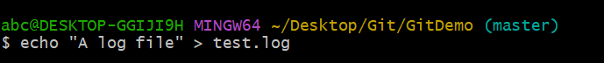

**Command:**

mkdir log

**Output:**



**Command:**

touch log/file.log

**Output:**



**Command:**

touch .gitignore

**Output:**

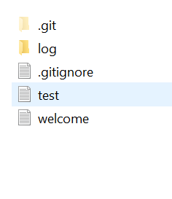

**Command:**

notepad++ .gitignore

**Output:**

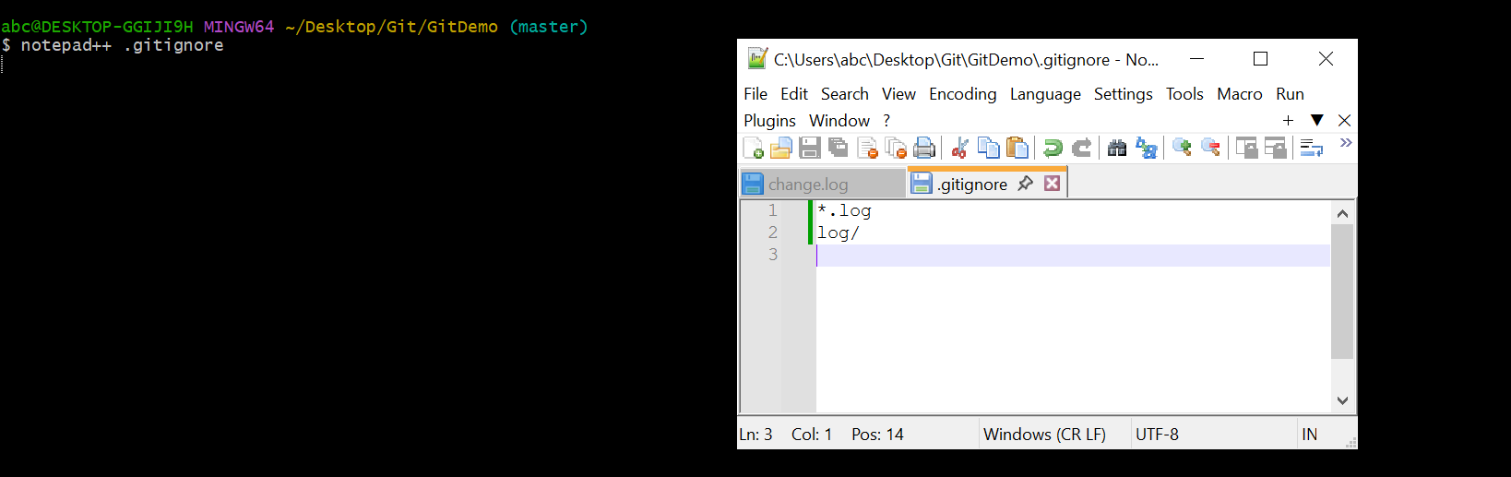

**2) Adding the gitignore file**

**Command:**

git add .gitignore

**Output:**

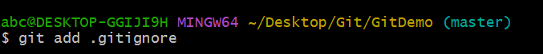

**Command:**

git commit -m "added git ignore file"

**Output:**

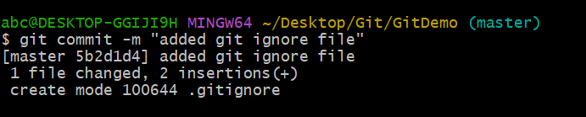

**Command:**

git push -u origin master

**Output:**

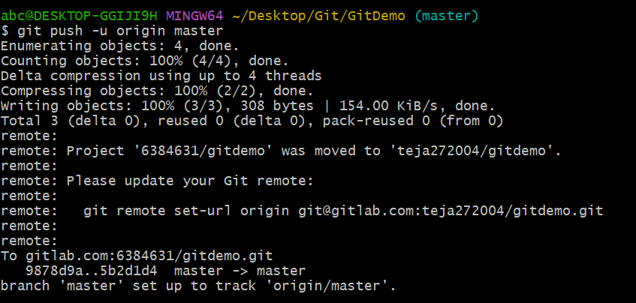

**Repo in GitLab:**

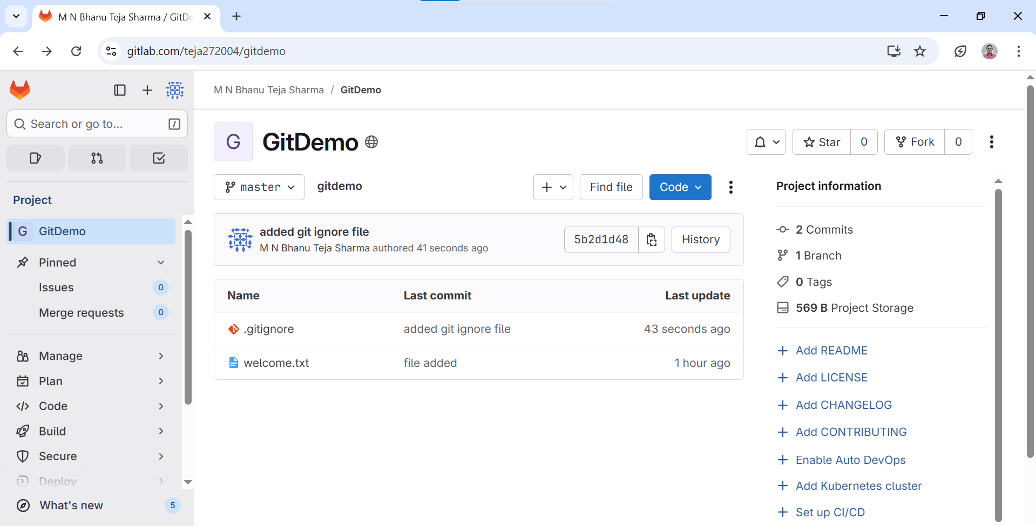

**GitLab Repo URL:**https://gitlab.com/teja272004/gitdemo