**Hands On - 5**

Please follow the instructions to complete the hands-on. Each instruction expects a command for the Git Bash.

1. Verify if master is in clean state.
2. List out all the available branches.
3. Pull the remote git repository to the master
4. Push the changes, which are pending from **“Git-T03-HOL_002”** to the remote repository.
5. Observe if the changes are reflected in the remote repository.

**Execution:**

**1) Verifying if master is in a clean state**

**Command:**

git status

**Output:**

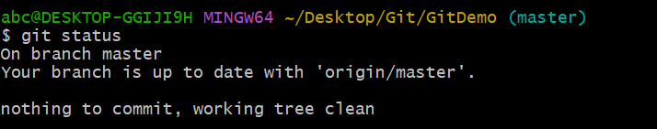

**2) Listing out all the available branches**

**Command:**

git branch

**Output:**

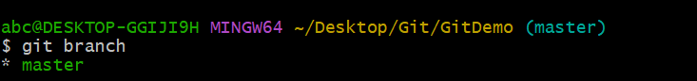

**3) Pulling the remote git repository to the master**

**Command:**

git pull origin master

**Output:**

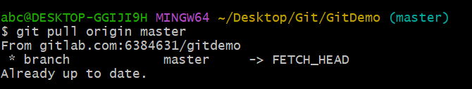

**4) Pushing the changes from Git-T03-HOL_002 to the remote repository**

**Adding all the files which are not added yet**

**Command:**

git add .

git commit -m "added all"

git push origin master

**Output:**

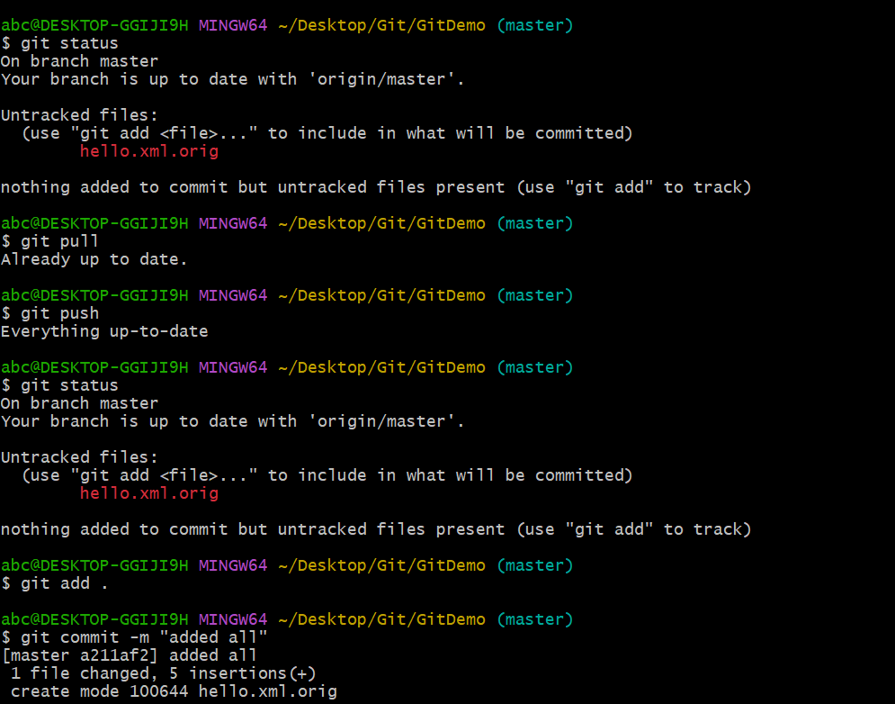

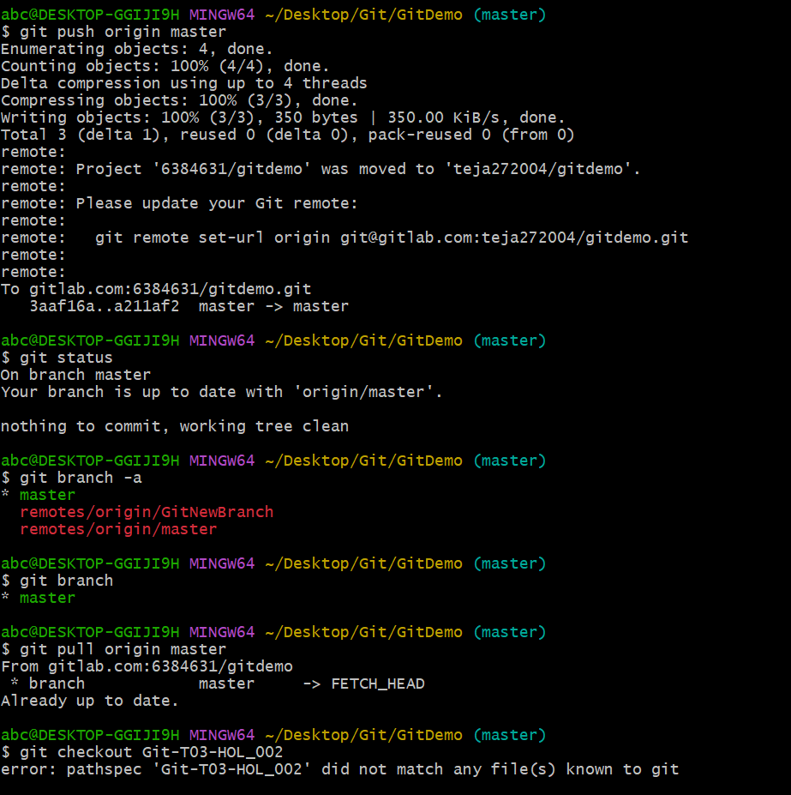

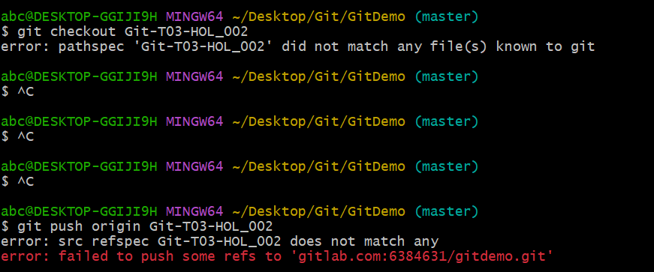

**5) Observing if the changes are reflected in the remote repository**

**Command:**

git fetch --all

git branch -a

**Output:**

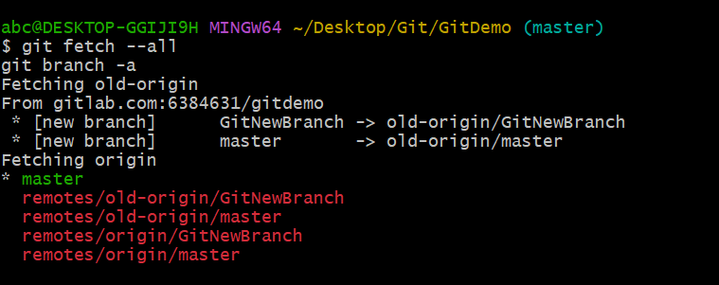

**GitLab Repo Url:**

https://gitlab.com/teja272004/gitdemo