For Voice Based search you can follow below screens



In above screen click on ‘Search By Voice’ link to get below page

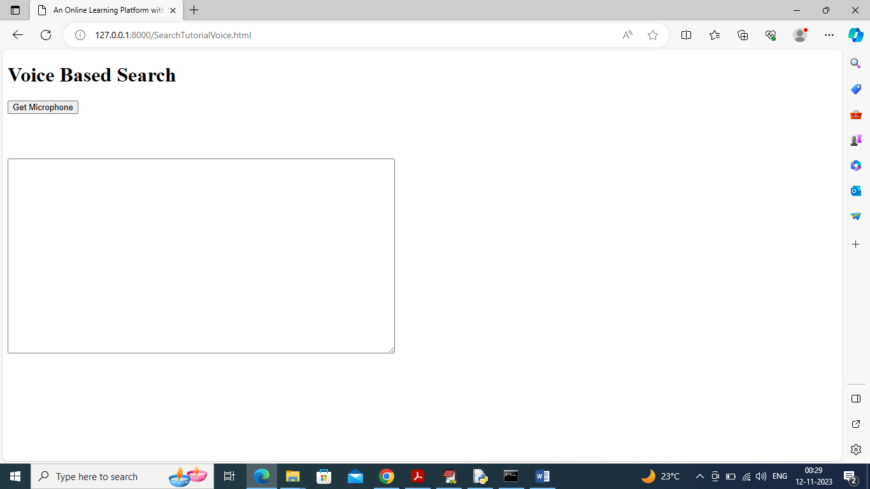

In above screen click on ‘Get Microphone’ button to connect to microphone and get below page

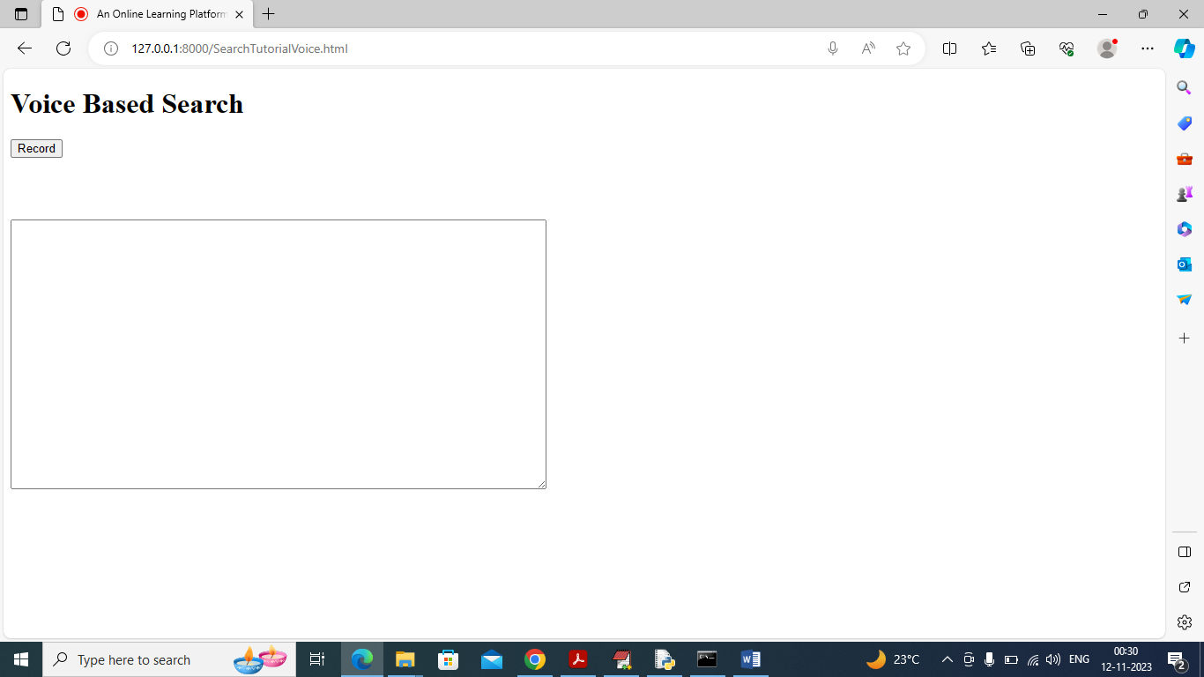

In above screen click on ‘Record’ button and start speaking and once done then click on “Stop” button to get result from application like below screen

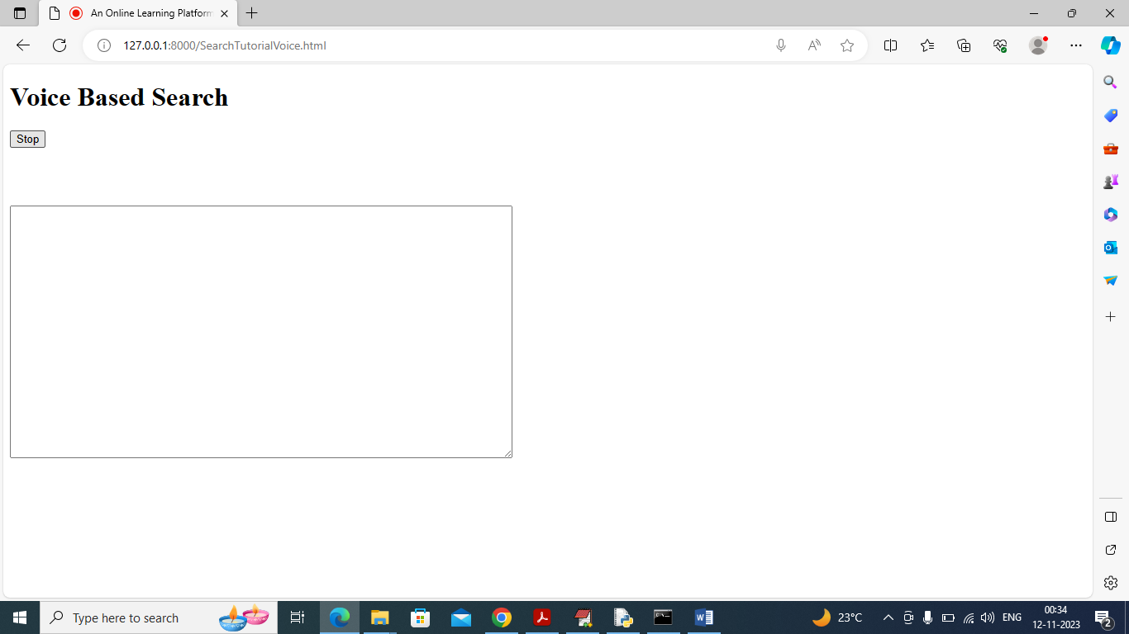

In above screen while recording “Stop” button will come and then once recording done then you can click on “Stop” button to get below page

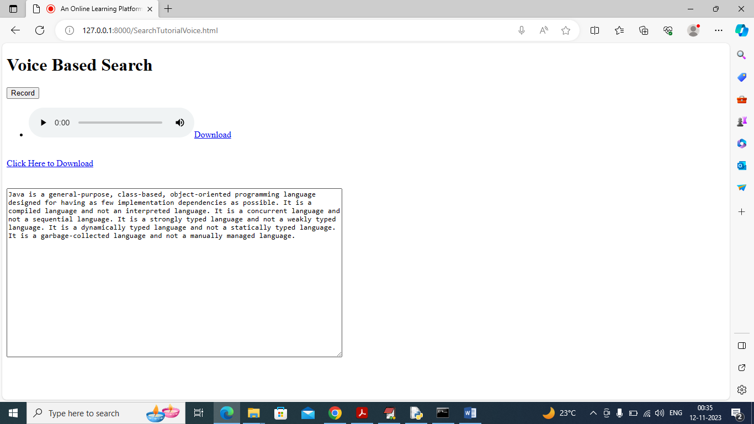

In above screen in text area you can read tutorial description and can click on ‘Click Here to Download” link to download tutoring material and can click on ‘Play’ icon to play your recorded voice.

So by using above voice system you can speak queries like

Sql how to create table and query

Java tutorial

C programming network system

CPP tutorial

Javascript tutorial

By speaking above queries you can get result