WEEK 2 TASK
Data Visualization and Insight Communication using R
Exploring car performance and airline traffic with ggplot2
Student Name: Pulivarthi Sai Teja
Course / Internship: Data Analysis, Yuva Intern
Tools Used: R, ggplot2, dplyr
Datasets: mtcars and AirPassengers (built into R)

1. Introduction and Objective
Numbers in a table are hard to read, but a good chart lets anyone see a pattern in seconds. The objective of this Week 2 task is to use R and the ggplot2 library to turn raw data into clear visualizations, and to explain in plain language what each chart shows and why it matters.
This report presents seven visualizations built from two public datasets. Each one uses a different chart type (bar chart, histogram, scatter plot, box plot, two line charts and a heatmap) and follows the same structure:
- Why this chart: the reason this chart type suits the question.
- R code: the code that produces the chart, so the work can be reproduced.
- Figure: the finished visualization.
- Interpretation: what the chart tells us, written for a non-technical reader.

2. Data Overview
Both datasets ship with R, so anyone can reproduce this analysis by running data(mtcars) and data(AirPassengers) without downloading any files.

2.1 Dataset 1: mtcars (Motor Trend Car Road Tests)
mtcars contains fuel consumption and design details for 32 car models from the 1974 Motor Trend magazine. It is used to study what makes a car fuel efficient. The key variables are:
Variable | Meaning | Type / unit
mpg | Fuel economy | Numeric, miles per US gallon (higher = more efficient)
cyl | Number of cylinders | 4, 6 or 8 (treated as a category)
disp | Engine displacement | Numeric, cubic inches
hp | Gross horsepower | Numeric
drat | Rear axle ratio | Numeric
wt | Weight of the car | Numeric, 1000 lbs
qsec | Quarter-mile time | Numeric, seconds (lower = quicker)
am | Transmission | 0 = automatic, 1 = manual
vs, gear, carb | Engine shape, gears, carburettors | Numeric / categorical (not used in charts)

2.2 Dataset 2: AirPassengers
AirPassengers records the monthly totals of international airline passengers (in thousands) from January 1949 to December 1960, which gives 144 monthly values. It is a classic time series used to study growth over time and seasonal patterns.
Variable | Meaning
date | Month of the observation (January 1949 to December 1960)
passengers | Number of passengers in that month, in thousands
year, month | Helper columns created in R to compare the same month across years

2.3 Setting up R and preparing the data
The code below loads the libraries, reads both datasets and creates readable labels (for example 4 cyl instead of 4, and Automatic instead of 0). A common colour palette is also defined so that cylinders have the same colour in every chart.
R code
# Install once if needed: install.packages(c("ggplot2", "dplyr"))
library(ggplot2)
library(dplyr)

data(mtcars) # Dataset 1: 32 cars, 11 variables
data(AirPassengers) # Dataset 2: monthly airline passengers, 1949-1960

# Prepare mtcars: readable labels and the car names as a column
cars <- mtcars %>%
mutate(
car = rownames(mtcars),
cyl_f = factor(cyl, levels = c(4, 6, 8), labels = c("4 cyl", "6 cyl", "8 cyl")),
trans = factor(am, levels = c(0, 1), labels = c("Automatic", "Manual"))
)

# Prepare AirPassengers: convert the time series to a data frame
ap <- data.frame(
date = seq(as.Date("1949-01-01"), by = "month", length.out = 144),
passengers = as.numeric(AirPassengers)
)
ap$year <- as.integer(format(ap$date, "%Y"))
ap$month <- factor(format(ap$date, "%b"), levels = month.abb)

# Colour palette used across the report
pal_cyl <- c("4 cyl" = "#2A9D8F", "6 cyl" = "#E9C46A", "8 cyl" = "#E76F51")

A first look at the numbers helps decide which charts to build:
R code
summary(cars$mpg)
sd(cars$mpg)
table(cars$cyl_f)
summary(ap$passengers)

Console output
> summary(cars$mpg)
Min. 1st Qu. Median Mean 3rd Qu. Max.
10.40 15.43 19.20 20.09 22.80 33.90
> sd(cars$mpg)
[1] 6.026948
> table(cars$cyl_f)
4 cyl 6 cyl 8 cyl
11 7 14
> summary(ap$passengers)
Min. 1st Qu. Median Mean 3rd Qu. Max.
104.0 180.0 265.5 280.3 360.5 622.0

Fuel economy ranges from 10.4 to 33.9 mpg, so there is a wide spread to explain. Monthly passenger numbers range from 104 thousand to 622 thousand, which suggests strong growth over the period.

3. Visualization Design and Interpretation

3.1 Bar Chart: Average Fuel Economy by Number of Cylinders
Why this chart: A bar chart is the simplest way to compare a single number (average mpg) across a few clear groups. Bar length is easy to judge, so even a first-time reader can rank the groups at a glance.
R code
avg_mpg <- cars %>%
group_by(cyl_f) %>%
summarise(mean_mpg = mean(mpg), n = n())

p1 <- ggplot(avg_mpg, aes(x = cyl_f, y = mean_mpg, fill = cyl_f)) +
geom_col(width = 0.6, show.legend = FALSE) +
geom_text(aes(label = round(mean_mpg, 1)), vjust = -0.5, fontface = "bold") +
scale_fill_manual(values = pal_cyl) +
labs(title = "Fewer cylinders, better fuel economy",
subtitle = "Average mpg by engine size, 32 cars (mtcars)",
x = "Number of cylinders", y = "Average miles per gallon") +
theme_minimal(base_size = 13) +
theme(plot.title = element_text(face = "bold"))

ggsave("p1_bar.png", p1, width = 8, height = 5, dpi = 300)

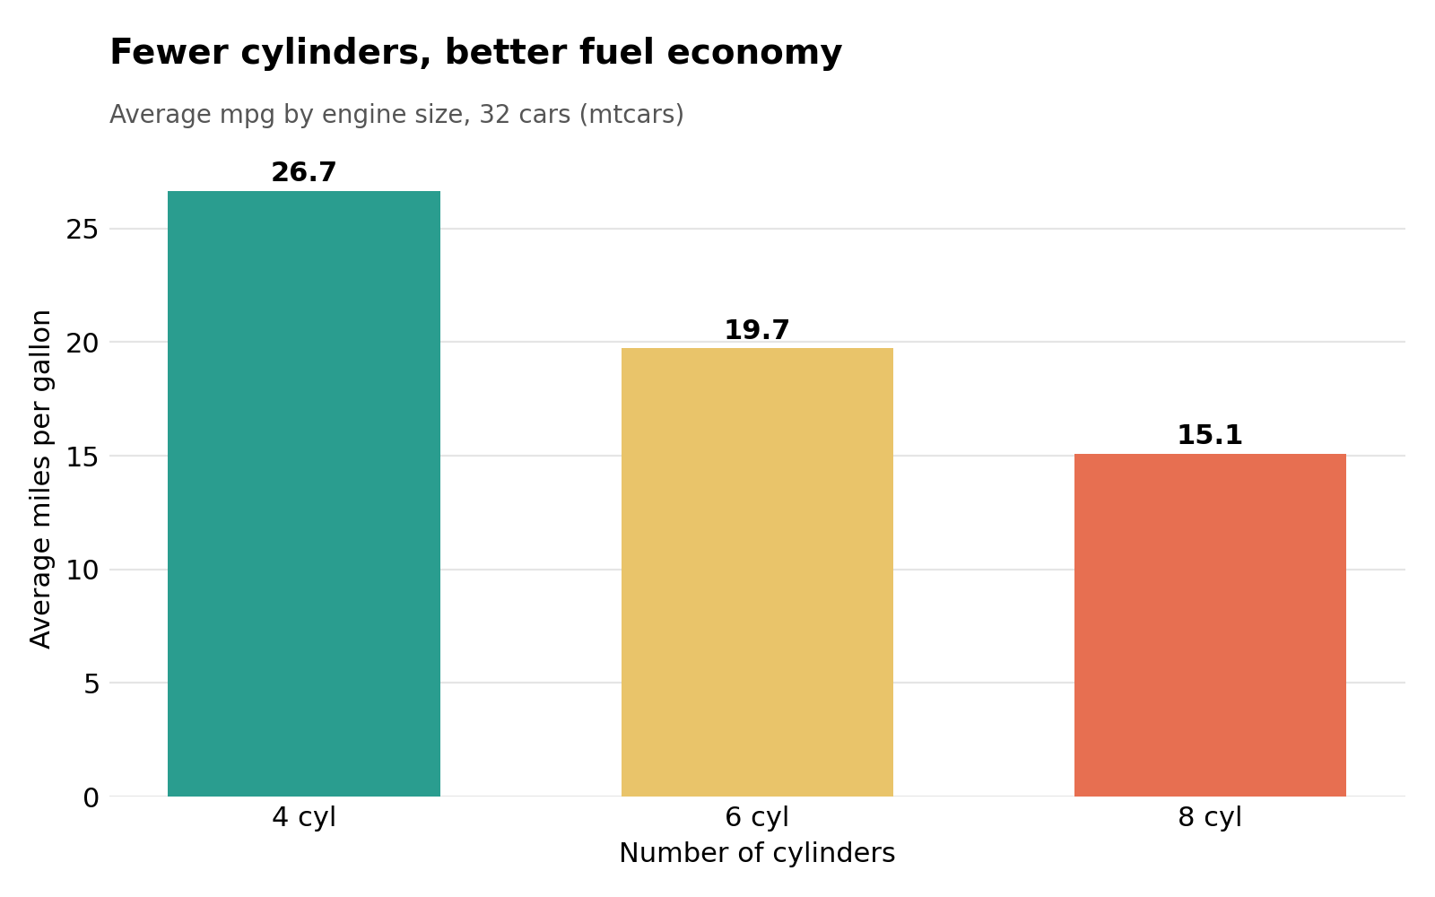
Figure 1: Average mpg by number of cylinders
What the chart tells us
- 4-cylinder cars average 26.7 mpg, 6-cylinder cars 19.7 mpg and 8-cylinder cars only 15.1 mpg.
- A 4-cylinder car is roughly 1.8 times more fuel efficient than an 8-cylinder car on average.
- Each step up in engine size costs fuel economy, and the 8-cylinder group is also the largest (14 of 32 cars), so big engines were very common in this sample.

3.2 Histogram: Distribution of Fuel Economy
Why this chart: A histogram shows how values are spread out: where most cars sit, how wide the range is, and whether there are unusual cars. A bar chart of averages hides this detail, so the histogram complements Figure 1.
R code
p2 <- ggplot(cars, aes(x = mpg)) +
geom_histogram(binwidth = 3, boundary = 10, closed = "left",
fill = "#264653", color = "white") +
geom_vline(xintercept = mean(cars$mpg), linetype = "dashed",
color = "#E76F51", linewidth = 0.9) +
annotate("text", x = mean(cars$mpg) + 0.6, y = 8.4, hjust = 0,
label = paste0("Mean = ", round(mean(cars$mpg), 1), " mpg"),
color = "#E76F51", fontface = "bold") +
labs(title = "Most cars cluster between 15 and 25 mpg",
subtitle = "Distribution of fuel economy (bin width = 3 mpg)",
x = "Miles per gallon", y = "Number of cars") +
theme_minimal(base_size = 13) +
theme(plot.title = element_text(face = "bold"))

ggsave("p2_hist.png", p2, width = 8, height = 5, dpi = 300)

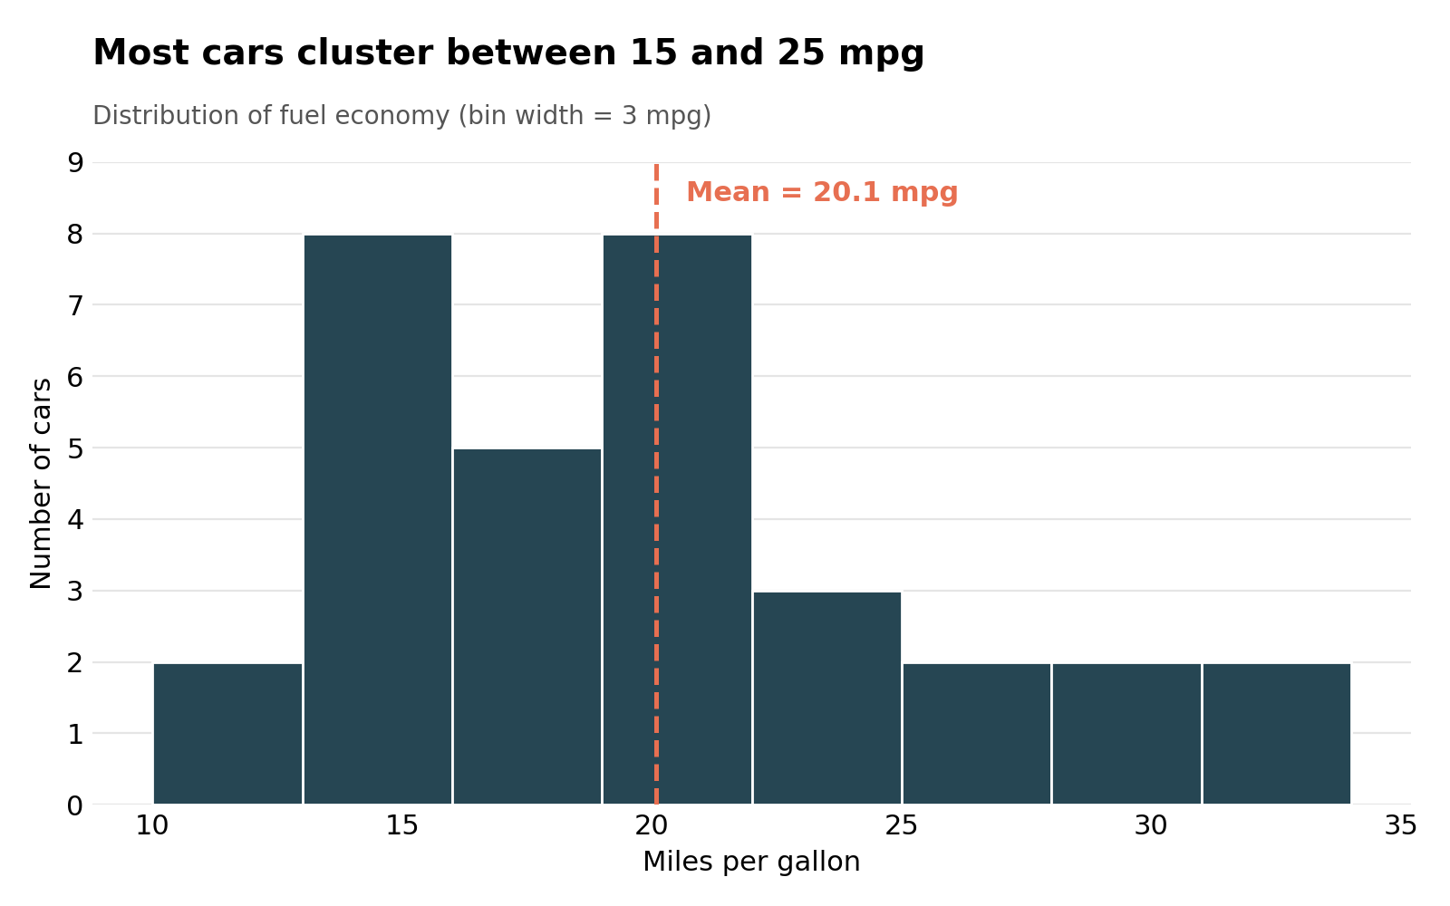
Figure 2: Distribution of miles per gallon
What the chart tells us
- The average is 20.1 mpg and the median is 19.2 mpg. Since the mean is slightly higher than the median, the distribution has a longer tail on the right.
- Most cars fall between about 13 and 25 mpg.
- A small group of four cars reaches 30 mpg or more (Fiat 128, Honda Civic, Lotus Europa and Toyota Corolla). These are the efficient outliers that pull the average up.

3.3 Scatter Plot: Weight versus Fuel Economy
Why this chart: A scatter plot is the standard way to show the relationship between two numeric variables. Each dot is one car, so we can see the overall trend and also spot cars that break the pattern. Colour adds a third variable (cylinders) without cluttering the chart.
R code
fit <- lm(mpg ~ wt, data = cars)
coef(fit) # intercept and slope
summary(fit)$r.squared # R-squared
cor(cars$wt, cars$mpg) # correlation

label_cars <- c("Cadillac Fleetwood", "Lincoln Continental", "Toyota Corolla")

p3 <- ggplot(cars, aes(x = wt, y = mpg)) +
geom_smooth(method = "lm", se = TRUE, color = "grey30",
fill = "grey80", linetype = "dashed") +
geom_point(aes(color = cyl_f), size = 3) +
geom_text(data = subset(cars, car %in% label_cars),
aes(label = car), size = 3, vjust = -1) +
scale_color_manual(values = pal_cyl, name = "Cylinders") +
labs(title = "Heavier cars burn more fuel",
subtitle = "Weight vs. mpg with linear trend",
x = "Weight (1000 lbs)", y = "Miles per gallon") +
theme_minimal(base_size = 13) +
theme(plot.title = element_text(face = "bold"))

ggsave("p3_scatter.png", p3, width = 8, height = 5.4, dpi = 300)

Console output
> coef(fit)
(Intercept) wt
37.285126 -5.344472
> summary(fit)$r.squared
[1] 0.7528328
> cor(cars$wt, cars$mpg)
[1] -0.8676594

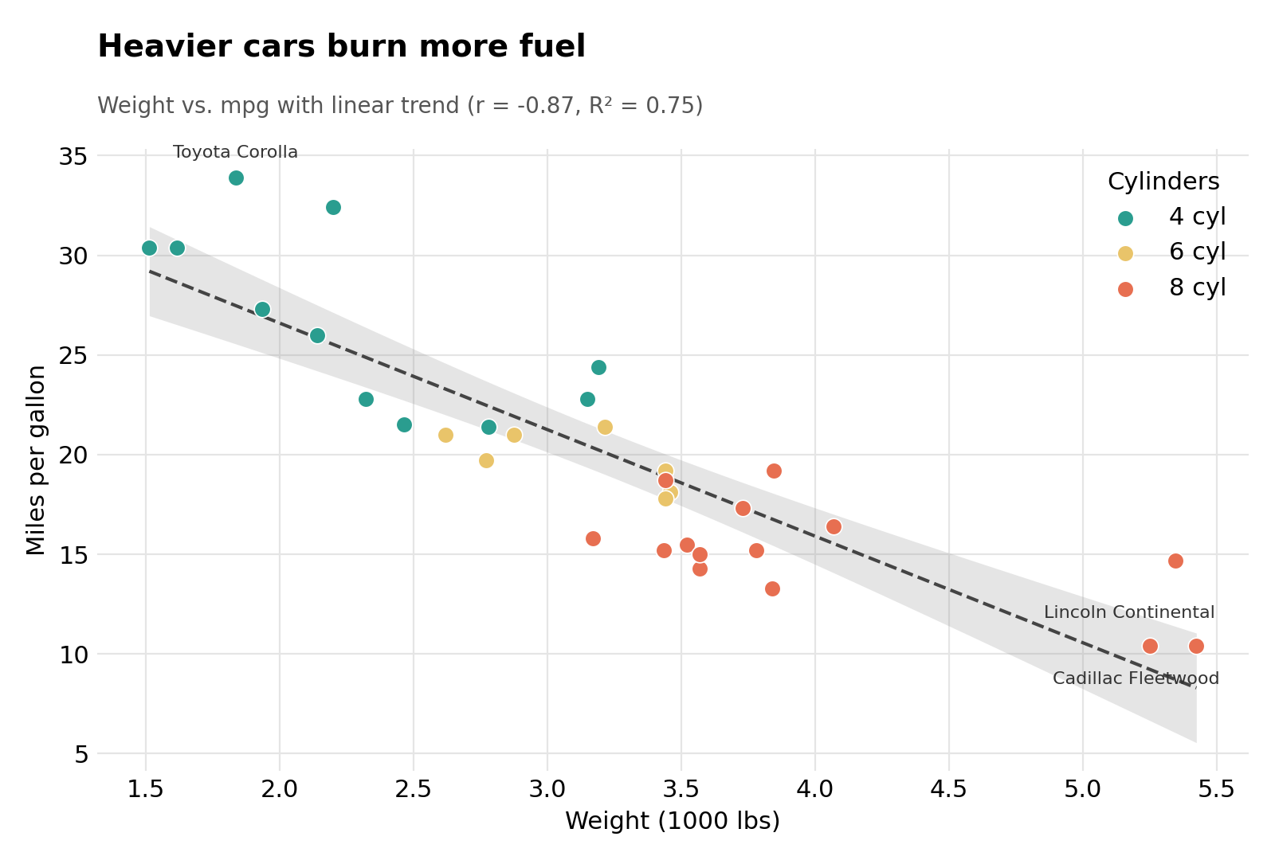
Figure 3: Weight versus mpg, coloured by cylinders, with linear trend line
What the chart tells us
- There is a strong negative relationship (correlation = -0.87): the heavier the car, the lower its mpg.
- On average, every extra 1000 lbs of weight lowers fuel economy by about 5.3 mpg. Weight alone explains about 75% of the variation in mpg (R-squared = 0.75).
- The colours show that light cars are mostly 4-cylinder and the heaviest are 8-cylinder, so weight and engine size go hand in hand.
- Anomalies: the Cadillac Fleetwood and Lincoln Continental are the heaviest cars and the least efficient (10.4 mpg), while the Toyota Corolla is the most efficient car at 33.9 mpg and sits above the trend line.

3.4 Box Plot: Fuel Economy by Transmission Type
Why this chart: A box plot compares the full distribution (median, spread and extremes) of two or more groups side by side. Individual points are added so the reader can see that each group is made of real cars, and that the manual group is small (13 cars).
R code
cars %>%
group_by(trans) %>%
summarise(n = n(), mean_mpg = mean(mpg), median_mpg = median(mpg),
mean_wt = mean(wt))

t.test(mpg ~ trans, data = cars) # Welch two-sample t-test

p4 <- ggplot(cars, aes(x = trans, y = mpg, fill = trans)) +
geom_boxplot(width = 0.5, alpha = 0.85, outlier.shape = NA,
show.legend = FALSE) +
geom_jitter(width = 0.1, alpha = 0.6, size = 2) +
scale_fill_manual(values = c("Automatic" = "#8ECAE6", "Manual" = "#FFB703")) +
labs(title = "Manual cars are more fuel efficient",
subtitle = "mpg by transmission type (points = individual cars)",
x = "Transmission", y = "Miles per gallon") +
theme_minimal(base_size = 13) +
theme(plot.title = element_text(face = "bold"))

ggsave("p4_box.png", p4, width = 7, height = 5, dpi = 300)

Console output
# A tibble: 2 x 5
trans n mean_mpg median_mpg mean_wt
Automatic 19 17.1 17.3 3.77
Manual 13 24.4 22.8 2.41

Welch Two Sample t-test
t = -3.7671, df = 18.332, p-value = 0.001374

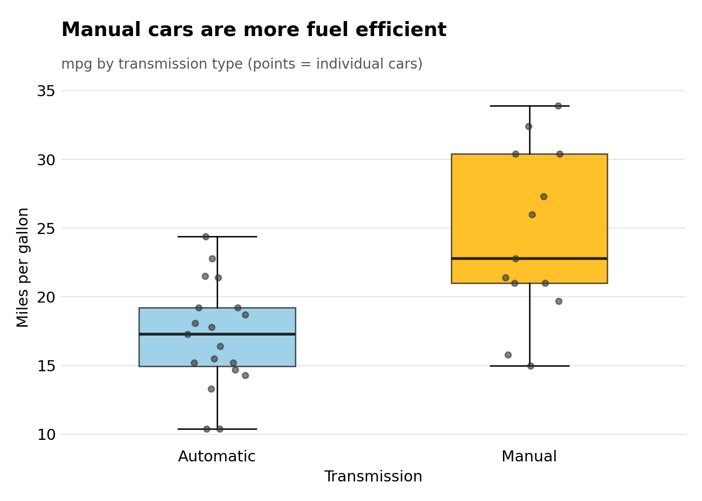
Figure 4: Fuel economy for automatic and manual cars
What the chart tells us
- Manual cars have a median of 22.8 mpg compared with 17.3 mpg for automatics, a gap of about 5.5 mpg.
- The difference is statistically significant (p = 0.0014), so it is unlikely to be due to chance alone.
- The manual group is also more spread out, ranging from 15 to 33.9 mpg.
- A caution for readers: manual cars in this dataset are also much lighter (2.4 vs 3.8 thousand lbs on average). Part of the manual advantage is therefore a weight effect (Figure 3), not purely the gearbox.

3.5 Line Chart: Airline Passenger Growth Over Time
Why this chart: A line chart is the natural choice for data over time because the eye follows the line and sees direction, speed of change and sudden jumps. A dashed trend line separates the long-term growth from the month-to-month ups and downs.
R code
p5 <- ggplot(ap, aes(x = date, y = passengers)) +
geom_line(color = "#1D3557", linewidth = 0.9) +
geom_smooth(method = "lm", se = FALSE, color = "#E63946",
linetype = "dashed") +
scale_x_date(date_breaks = "2 years", date_labels = "%Y") +
labs(title = "Air travel grew steadily through the 1950s",
subtitle = "Monthly international airline passengers, 1949-1960",
x = "Year", y = "Passengers (thousands)") +
theme_minimal(base_size = 13) +
theme(plot.title = element_text(face = "bold"))

ggsave("p5_line.png", p5, width = 9, height = 5, dpi = 300)

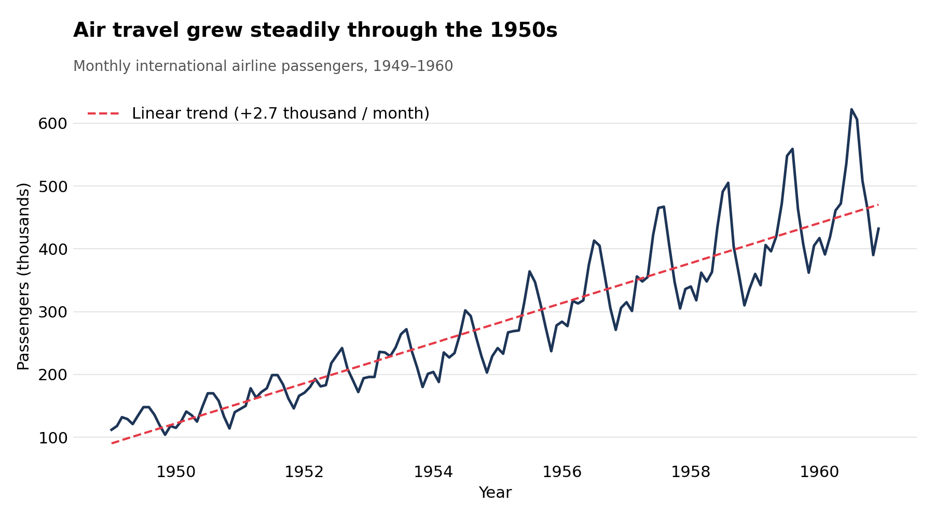
Figure 5: Monthly airline passengers with linear trend, 1949 to 1960
What the chart tells us
- Passenger numbers grew from 112 thousand in January 1949 to 432 thousand in December 1960. Yearly totals rose from 1.52 million to 5.71 million, about 3.8 times higher.
- The trend line adds roughly 2.7 thousand passengers every month, and it explains about 85% of the variation (R-squared = 0.85).
- The wiggles around the trend are not random: they repeat every year and grow larger as traffic grows. The all-time high is 622 thousand in July 1960.
- The data curves upward faster than a straight line, so growth was accelerating. A straight line is used here to keep the message simple.

3.6 Seasonal Line Chart: One Line per Year
Why this chart: To study seasonality, the same 12 months are laid on top of each other for every year. If the lines have the same shape, the pattern is stable. A colour scale (dark to light) shows the progression of years without a long legend.
R code
p6 <- ggplot(ap, aes(x = month, y = passengers, group = year, color = year)) +
geom_line(linewidth = 0.9) +
geom_point(size = 1.2) +
scale_color_viridis_c(name = "Year") +
labs(title = "Travel peaks every summer",
subtitle = "Seasonal pattern: one line per year",
x = "Month", y = "Passengers (thousands)") +
theme_minimal(base_size = 13) +
theme(plot.title = element_text(face = "bold"))

ggsave("p6_season.png", p6, width = 9, height = 5, dpi = 300)

# Average passengers per calendar month
aggregate(passengers ~ month, data = ap, FUN = mean)

Console output
month passengers
1 Jan 241.7500
2 Feb 235.0000
3 Mar 270.1667
4 Apr 267.0833
5 May 271.8333
6 Jun 311.6667
7 Jul 351.3333
8 Aug 351.0833
9 Sep 302.3333
10 Oct 266.6667
11 Nov 232.8333
12 Dec 261.8333

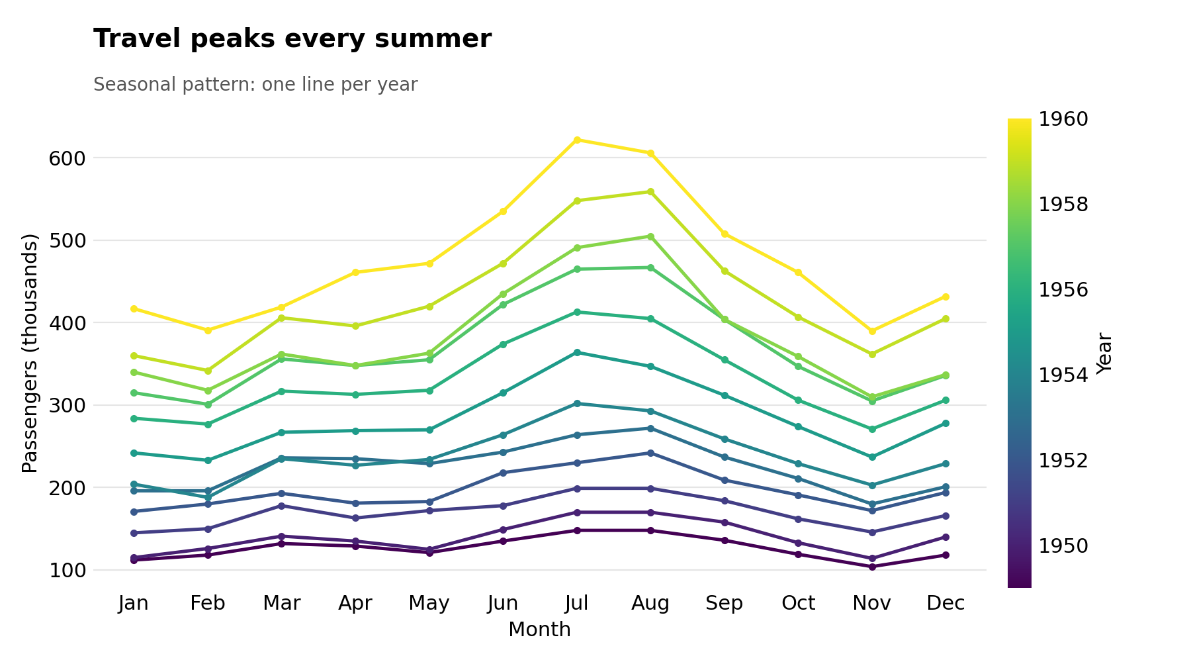
Figure 6: Seasonal pattern of airline passengers, one line per year
What the chart tells us
- Every year follows the same shape: a rise through spring, a sharp peak in July and August, and a drop to the lowest point in November.
- On average July carries about 351 thousand passengers and November about 233 thousand, so the busiest month is around 1.5 times busier than the quietest.
- The business meaning is clear: airlines of that era would need most capacity in summer and could schedule maintenance or promotions for autumn. Each new year also sits higher than the last, which confirms the growth seen in Figure 5.

3.7 Heatmap: Correlations Between Car Measurements
Why this chart: A heatmap summarises many relationships in a single picture. Instead of drawing 21 scatter plots, colour intensity shows how strongly each pair of variables moves together (dark blue = move together, dark red = move in opposite directions).
R code
vars <- c("mpg", "cyl", "disp", "hp", "drat", "wt", "qsec")
cor_mat <- round(cor(mtcars[, vars]), 2)
cor_df <- as.data.frame(as.table(cor_mat))
names(cor_df) <- c("Var1", "Var2", "r")

p7 <- ggplot(cor_df, aes(x = Var1, y = Var2, fill = r)) +
geom_tile(color = "white") +
geom_text(aes(label = sprintf("%.2f", r)), size = 3.5) +
scale_fill_gradient2(low = "#B2182B", mid = "white", high = "#2166AC",
midpoint = 0, limits = c(-1, 1),
name = "Correlation (r)") +
scale_y_discrete(limits = rev) +
coord_fixed() +
labs(title = "Weight, displacement and cylinders move together",
subtitle = "Correlation matrix of mtcars variables",
x = NULL, y = NULL) +
theme_minimal(base_size = 13) +
theme(plot.title = element_text(face = "bold"),
panel.grid = element_blank())

ggsave("p7_heat.png", p7, width = 7.5, height = 6.4, dpi = 300)

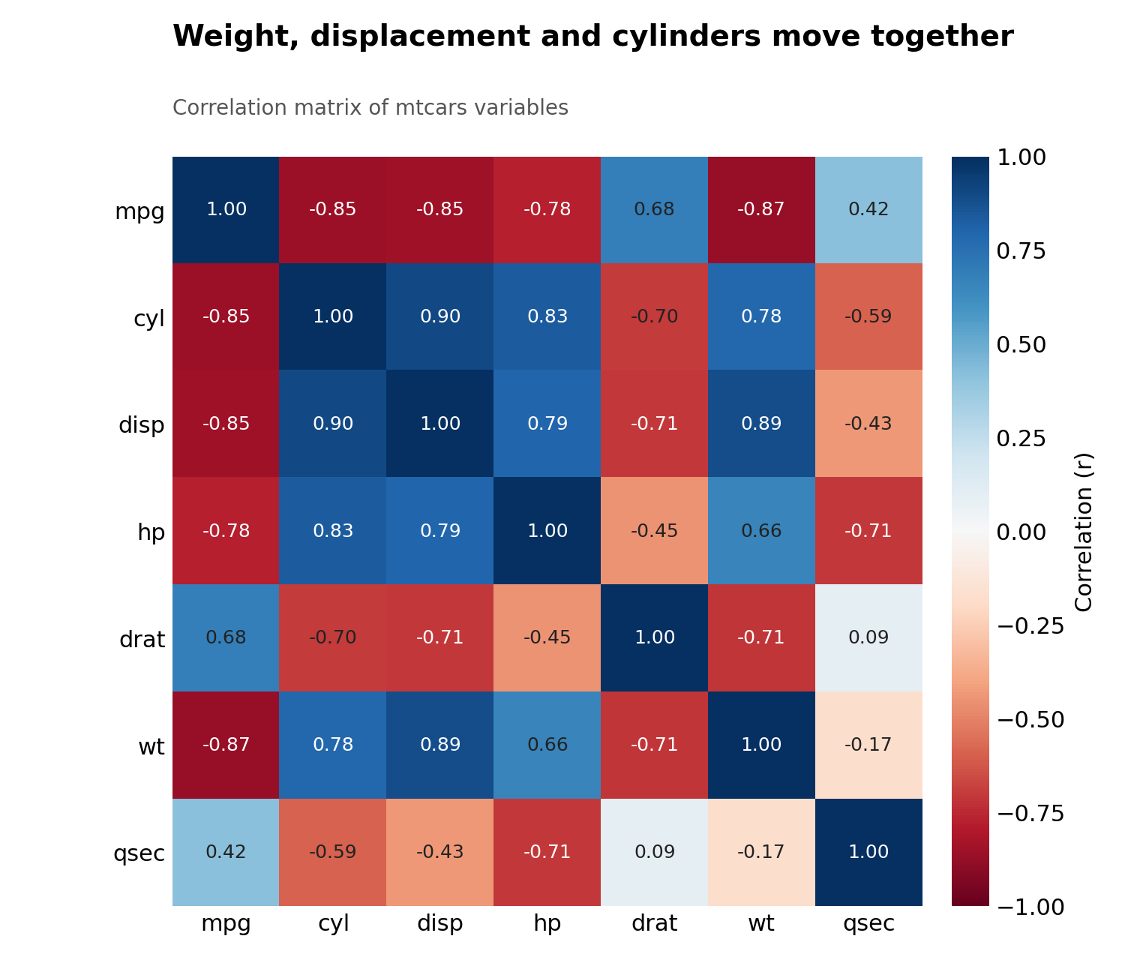
Figure 7: Correlation matrix of seven mtcars variables
What the chart tells us
- Fuel economy (mpg) is strongly and negatively linked to weight (-0.87), cylinders (-0.85), displacement (-0.85) and horsepower (-0.78). Big, heavy, powerful cars use more fuel.
- Cylinders, displacement and weight are strongly linked to each other (0.78 to 0.90), so they carry overlapping information. This matters when building models, because it is hard to separate their individual effects.
- Rear axle ratio (drat) has a moderate positive link with mpg (0.68) and quarter-mile time (qsec) a weak one (0.42).
- Correlation does not prove cause. For example, heavy cars also tend to have big engines, so we cannot say weight alone causes the drop in mpg.

4. Summary of Key Findings
# | Visualization | Main insight
1 | Bar chart | 4-cylinder cars average 26.7 mpg versus 15.1 mpg for 8-cylinder cars.
2 | Histogram | Most cars fall between 13 and 25 mpg; four efficient cars reach 30 mpg or more.
3 | Scatter plot | Every extra 1000 lbs lowers mpg by about 5.3 (r = -0.87).
4 | Box plot | Manual cars show a median of 22.8 mpg versus 17.3 for automatics, partly because they are lighter.
5 | Line chart | Passengers grew about 3.8 times between 1949 and 1960, adding about 2.7 thousand per month.
6 | Seasonal lines | Traffic peaks in July and August and is lowest in November, a stable pattern every year.
7 | Heatmap | Weight, cylinders and displacement are tightly linked and all reduce mpg.

5. Conclusion
This task showed how well-chosen charts can turn two small datasets into clear stories. In the car data, the story is about trade-offs: bigger engines and heavier bodies cost fuel. In the airline data, the story is about growth and rhythm: steady expansion with a predictable summer peak.
Choosing the chart type to match the question was the most important lesson. Bars compare groups, histograms show spread, scatter plots reveal relationships, box plots compare distributions, lines follow time, and heatmaps summarise many relationships at once. Pairing each chart with a short plain-language interpretation makes the findings accessible to readers who do not read code.
Limitations: both datasets are small and old (1949 to 1974), and the correlations shown here describe association, not cause. With more time, the next steps would be to repeat this workflow on a larger, recent dataset and to add interactive charts.

Reproducing this report
All code is in the sections above and in the accompanying script file Week2_R_Visualization_Script.R. Run the script in RStudio from top to bottom; it saves each chart as a high-resolution PNG (300 dpi). It needs R 4.x and the packages ggplot2 (version 3.4 or later) and dplyr.

