WEEK 3 TASK
Statistical Analysis and Predictive Modeling using R
Hypothesis testing and regression to predict car fuel economy (mpg)
Student Name: Pulivarthi Sai Teja
Course / Internship: Data Analysis, Yuva Intern
Tools Used: R, ggplot2, dplyr, car, lmtest
Dataset: mtcars (built into R)

1. Introduction and Objective
This report documents a complete statistical workflow in R, from asking a question to evaluating a predictive model. The business question is simple: what makes a car fuel efficient, and can we predict a car's miles per gallon (mpg) from its design?
The work follows five steps, and each section of this report matches one of them:
- Dataset selection: choose a dataset suited to prediction and explain why (Section 2).
- Exploratory statistical analysis: check distributions and assumptions, and test three hypotheses (Section 3).
- Model building: fit candidate regression models and compare them with cross-validation (Sections 4 and 5).
- Diagnostics and optimization: test the model's assumptions, look for influential cars and try improvements (Sections 6 and 7).
- Interpretation: summarise performance, limitations and next steps (Section 8).

2. Dataset Identification and Rationale
The dataset is mtcars, which ships with R. It holds fuel consumption and ten design measurements for 32 car models from the 1974 Motor Trend magazine. Running data(mtcars) loads it, so no download is needed and anyone can reproduce the results.

2.1 Why this dataset?
- Clear prediction target: mpg is a continuous outcome, which is ideal for regression.
- Meaningful predictors: weight, horsepower, engine size and transmission have a real, explainable link to fuel use, so the model can be interpreted and not just fitted.
- Mix of variable types: numeric and categorical variables allow correlation tests, t-tests and ANOVA in the same dataset.
- Small and clean: there are no missing values, so effort goes into the statistics and not into data cleaning. The small size (32 rows) also makes it a good case for cross-validation, because a single train/test split would waste scarce data.
- Continuity: it is the same dataset used for the Week 2 visualizations, which lets this report build on those findings.

2.2 Key variables
Variable | Meaning | Role in this analysis
mpg | Miles per US gallon | Target (what we predict)
wt | Weight, in 1000 lbs | Predictor
hp | Gross horsepower | Predictor
qsec | Quarter-mile time, seconds | Predictor
am | Transmission (0 = automatic, 1 = manual) | Predictor; hypothesis test H2
cyl | Number of cylinders (4, 6, 8) | Predictor; hypothesis test H3
disp, drat | Engine displacement; rear axle ratio | Candidate predictors

Setup and data preparation:
R code
# Install once if needed:
# install.packages(c("ggplot2", "dplyr", "car", "lmtest"))
library(ggplot2)
library(dplyr)
library(car) # vif()
library(lmtest) # bptest()

data(mtcars) # 32 cars, 11 variables (built into R)

cars <- mtcars %>%
mutate(
car = rownames(mtcars),
cyl_f = factor(cyl),
trans = factor(am, levels = c(0, 1), labels = c("Automatic", "Manual"))
)

str(mtcars)

3. Exploratory Statistical Analysis

3.1 Summary statistics
R code
summary(cars[, c("mpg", "wt", "hp", "qsec")])
sapply(cars[, c("mpg", "wt", "hp", "qsec")], sd)

Variable | Min | Q1 | Median | Mean | Q3 | Max | Std. dev.
mpg | 10.40 | 15.43 | 19.20 | 20.09 | 22.80 | 33.90 | 6.03
wt | 1.513 | 2.581 | 3.325 | 3.217 | 3.610 | 5.424 | 0.978
hp | 52.0 | 96.5 | 123.0 | 146.7 | 180.0 | 335.0 | 68.6
qsec | 14.50 | 16.89 | 17.71 | 17.85 | 18.90 | 22.90 | 1.79

Fuel economy ranges from 10.4 to 33.9 mpg with a mean of 20.1 and a standard deviation of 6.0. The cars range from 1,513 to 5,424 lbs and from 52 to 335 hp, so the sample covers everything from small economy cars to large V8 cruisers.

3.2 Distribution and normality
Many statistical tests and regression assumptions rely on normality. The Shapiro-Wilk test checks it: the null hypothesis is that the data are normally distributed, so a small p-value (below 0.05) is evidence against normality.
R code
shapiro.test(cars$mpg)
shapiro.test(cars$wt)
shapiro.test(cars$hp)

# Histogram with normal curve, and Q-Q plot
p1a <- ggplot(cars, aes(x = mpg)) +
geom_histogram(aes(y = after_stat(density)), binwidth = 3, boundary = 10,
closed = "left", fill = "#264653", color = "white") +
stat_function(fun = dnorm,
args = list(mean = mean(cars$mpg), sd = sd(cars$mpg)),
color = "#E76F51", linewidth = 1) +
labs(x = "Miles per gallon", y = "Density") + theme_minimal(base_size = 13)

p1b <- ggplot(cars, aes(sample = mpg)) +
stat_qq(color = "#264653") + stat_qq_line(color = "#E76F51") +
labs(x = "Theoretical normal quantiles", y = "Sample quantiles (mpg)") +
theme_minimal(base_size = 13)

Console output
Shapiro-Wilk normality test

data: cars$mpg
W = 0.94756, p-value = 0.1229

Shapiro-Wilk normality test

data: cars$wt
W = 0.94326, p-value = 0.09265

Shapiro-Wilk normality test

data: cars$hp
W = 0.93342, p-value = 0.04881

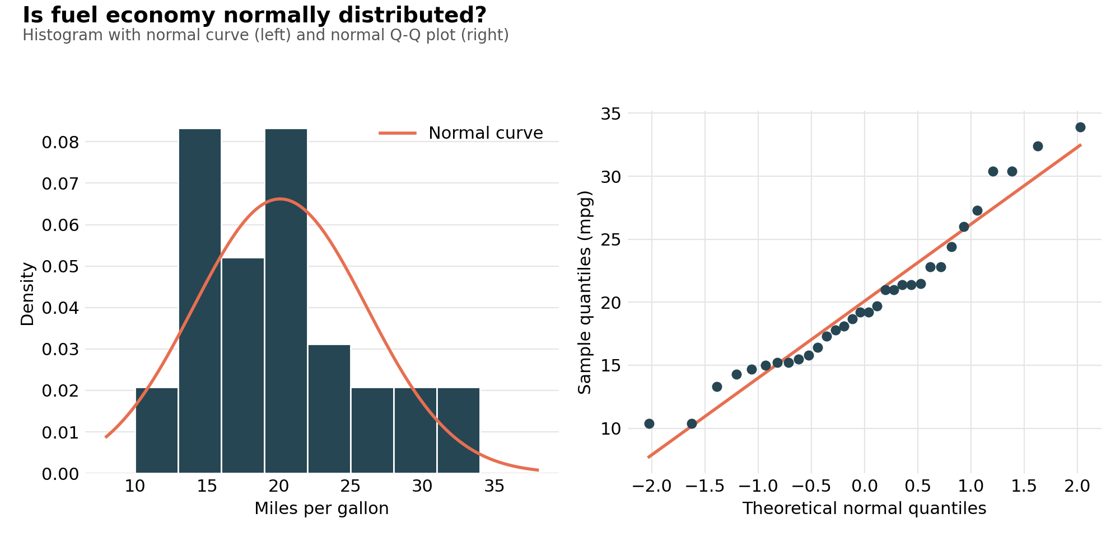
Figure 1: Histogram with normal curve and normal Q-Q plot of mpg
Interpretation
- mpg passes the normality test (W = 0.948, p = 0.123): there is no significant evidence against normality. In the Q-Q plot the points follow the line closely, with small departures in the upper tail (the very efficient cars).
- Weight is borderline (p = 0.093), while horsepower fails the test (p = 0.049) because a few powerful cars (Ford Pantera L at 264 hp and Maserati Bora at 335 hp) create a long right tail.
- With only 32 observations these tests have limited power, so each hypothesis test below is paired with a non-parametric alternative as a safety check.

3.3 Correlation screening
Before modelling, each variable is correlated with mpg to see which ones carry signal.
R code
num_vars <- c("cyl", "disp", "hp", "drat", "wt", "qsec", "vs", "am", "gear", "carb")
cor_mpg <- sapply(mtcars[, num_vars], cor, y = mtcars$mpg)
cor_df <- data.frame(variable = names(cor_mpg), r = cor_mpg) %>%
mutate(variable = reorder(variable, r))

p2 <- ggplot(cor_df, aes(x = r, y = variable, fill = r > 0)) +
geom_col(show.legend = FALSE) +
geom_vline(xintercept = 0) +
scale_fill_manual(values = c("TRUE" = "#2A9D8F", "FALSE" = "#E76F51")) +
labs(x = "Pearson correlation with mpg", y = NULL) +
theme_minimal(base_size = 13)

round(sort(cor_mpg), 2)

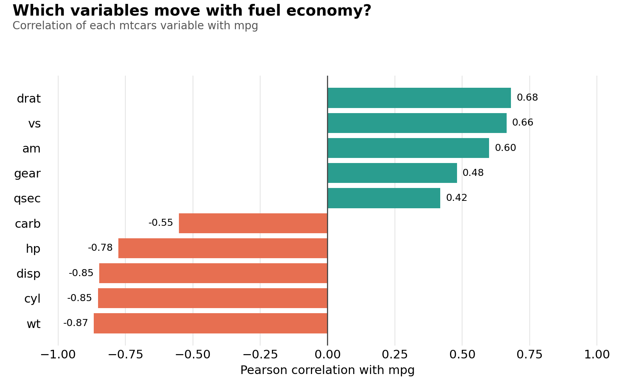
Figure 2: Pearson correlation of each variable with mpg
Interpretation
- Weight (-0.87), cylinders (-0.85), displacement (-0.85) and horsepower (-0.78) have the strongest negative links with mpg: bigger, heavier, more powerful cars use more fuel.
- Rear axle ratio (0.68), engine shape vs (0.66) and manual transmission (0.60) are positively linked with mpg.
- Because cyl, disp and wt are strongly linked to each other, using all of them in one model would add overlapping information. This guides model selection in Section 4.

3.4 Hypothesis tests

Hypothesis 1: Is weight related to fuel economy?
Null hypothesis (H0): The true correlation between weight and mpg is zero.
Alternative hypothesis (H1): The true correlation between weight and mpg is not zero.
Significance level: alpha = 0.05
R code
# H0: true correlation between weight and mpg is 0; H1: it is not 0
cor.test(cars$wt, cars$mpg) # Pearson
cor.test(cars$wt, cars$mpg, method = "spearman", # rank-based check
exact = FALSE)

Console output
Pearson's product-moment correlation

data: cars$wt and cars$mpg
t = -9.559, df = 30, p-value = 1.294e-10
alternative hypothesis: true correlation is not equal to 0
95 percent confidence interval:
-0.9338264 -0.7440872
sample estimates:
cor
-0.8676594

Spearman's rank correlation rho

data: cars$wt and cars$mpg
S = 10292, p-value = 1.488e-11
alternative hypothesis: true rho is not equal to 0
sample estimates:
rho
-0.8864220

Decision: Reject H0. The Pearson correlation is r = -0.868 (t = -9.56, df = 30, p = 1.3e-10), with a 95% confidence interval of -0.934 to -0.744. The rank-based Spearman test agrees (rho = -0.886, p < 0.001), so the result does not depend on the normality assumption.
In plain words: heavier cars have clearly lower fuel economy, and the evidence is overwhelming. This makes weight the natural anchor for the prediction model.

Hypothesis 2: Do automatic and manual cars differ in fuel economy?
Null hypothesis (H0): Mean mpg is the same for automatic and manual cars.
Alternative hypothesis (H1): Mean mpg differs between automatic and manual cars.
Significance level: alpha = 0.05
R code
# H0: mean mpg is equal for automatic and manual cars; H1: it is not
var.test(mpg ~ trans, data = cars) # equal-variance check
t.test(mpg ~ trans, data = cars) # Welch t-test (default)
wilcox.test(mpg ~ trans, data = cars, # non-parametric check
exact = FALSE)

Console output
F test to compare two variances

data: mpg by trans
F = 0.38656, num df = 18, denom df = 12, p-value = 0.06691
alternative hypothesis: true ratio of variances is not equal to 1
95 percent confidence interval:
0.1243721 1.0703429
sample estimates:
ratio of variances
0.3865615

Welch Two Sample t-test

data: mpg by trans
t = -3.7671, df = 18.332, p-value = 0.001374
alternative hypothesis: true difference in means between group Automatic and group Manual is not equal to 0
95 percent confidence interval:
-11.280194 -3.209684
sample estimates:
mean in group Automatic mean in group Manual
17.14737 24.39231

Wilcoxon rank sum test with continuity correction

data: mpg by trans
W = 42, p-value = 0.001871
alternative hypothesis: true location shift is not equal to 0

Decision: Reject H0. Manual cars average 24.4 mpg versus 17.1 mpg for automatics. The Welch t-test gives t = -3.77, df = 18.3, p = 0.0014, and the automatic mean is lower by between 3.2 and 11.3 mpg (95% CI). The Wilcoxon test agrees (W = 42, p = 0.0019).
Assumption check: the variance test is borderline (p = 0.067), so the Welch version of the t-test, which does not assume equal variances, is the safer choice and is the default in R. A caution: manual cars in this dataset are also lighter (2.4 vs 3.8 thousand lbs on average), so this difference is partly a weight effect. This is exactly why a multi-variable model is needed.

Hypothesis 3: Does fuel economy differ by number of cylinders?
Null hypothesis (H0): Mean mpg is the same for 4, 6 and 8 cylinder cars.
Alternative hypothesis (H1): At least one group has a different mean mpg.
Significance level: alpha = 0.05
R code
# H0: mean mpg is equal across 4, 6 and 8 cylinder cars; H1: at least one differs
anova_fit <- aov(mpg ~ cyl_f, data = cars)
summary(anova_fit)
TukeyHSD(anova_fit)

# Assumption checks and robust alternatives
leveneTest(mpg ~ cyl_f, data = cars) # equal variances?
oneway.test(mpg ~ cyl_f, data = cars) # Welch ANOVA (unequal variances)
kruskal.test(mpg ~ cyl_f, data = cars) # non-parametric

p3 <- ggplot(cars, aes(x = cyl_f, y = mpg, fill = cyl_f)) +
geom_boxplot(width = 0.5, alpha = 0.85, outlier.shape = NA, show.legend = FALSE) +
geom_jitter(width = 0.1, alpha = 0.6) +
scale_fill_manual(values = c("#2A9D8F", "#E9C46A", "#E76F51")) +
labs(x = NULL, y = "Miles per gallon") + theme_minimal(base_size = 13)

Console output
Df Sum Sq Mean Sq F value Pr(>F)
cyl_f 2 824.8 412.4 39.7 4.98e-09 ***
Residuals 29 301.3 10.4
---
Signif. codes: 0 '***' 0.001 '**' 0.01 '*' 0.05 '.' 0.1 ' ' 1

Tukey multiple comparisons of means
95% family-wise confidence level

Fit: aov(formula = mpg ~ cyl_f, data = cars)

$cyl_f
diff lwr upr p adj
6-4 -6.920779 -10.769350 -3.0722086 0.0003424
8-4 -11.563636 -14.770779 -8.3564942 0.0000000
8-6 -4.642857 -8.327583 -0.9581313 0.0112287

Levene's Test for Homogeneity of Variance (center = median)
Df F value Pr(>F)
group 2 5.5071 0.009390 **
29

One-way analysis of means (not assuming equal variances)

data: mpg and cyl_f
F = 31.624, num df = 2.000, denom df = 18.032, p-value = 1.271e-06

Kruskal-Wallis rank sum test

data: mpg by cyl_f
Kruskal-Wallis chi-squared = 25.746, df = 2, p-value = 2.566e-06

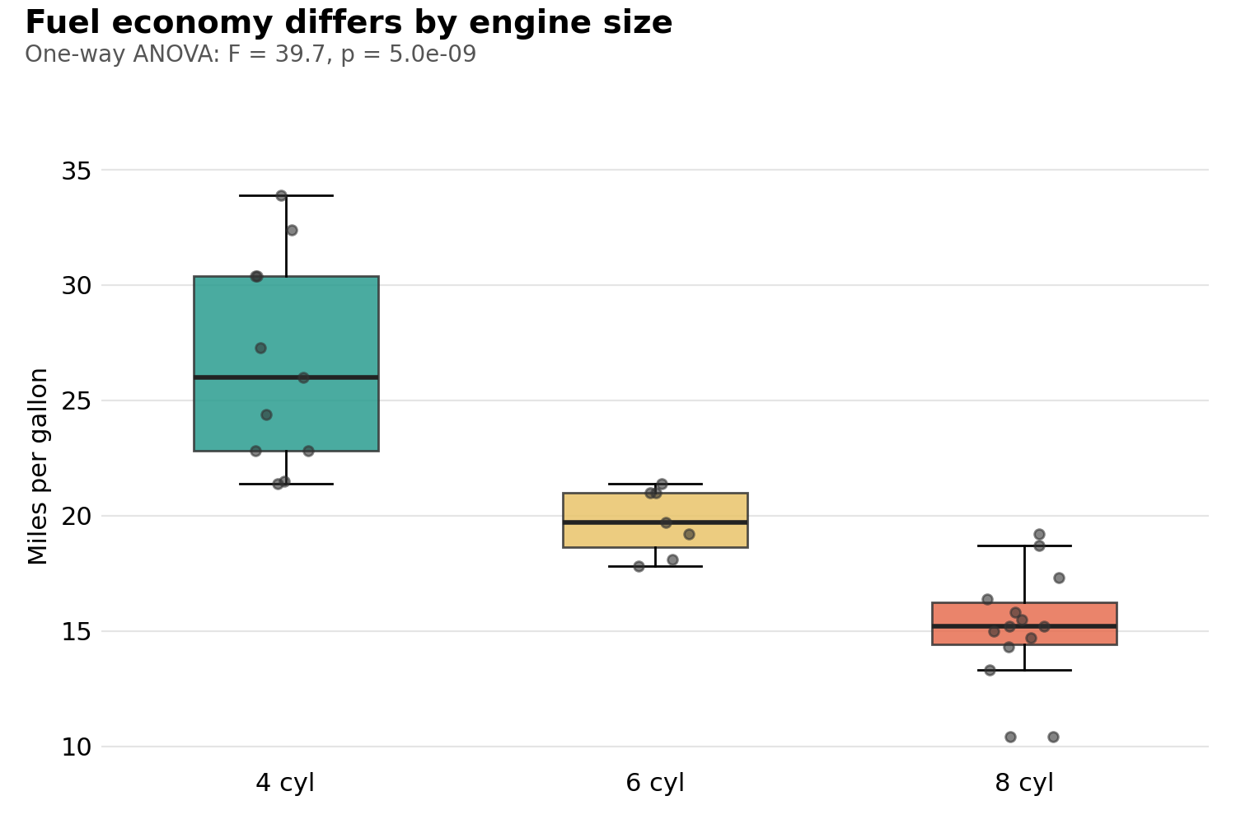
Figure 3: mpg by number of cylinders (one-way ANOVA)
Decision: Reject H0. ANOVA gives F(2, 29) = 39.7, p = 5.0e-09. Tukey's post-hoc test shows that all three pairs differ: 6 vs 4 cylinders is -6.9 mpg (p = 0.0003), 8 vs 4 is -11.6 mpg (p < 0.001) and 8 vs 6 is -4.6 mpg (p = 0.011).
Assumption check: Levene's test is significant (p = 0.009), which means the spread of mpg is not equal across the groups (the 4-cylinder group is the most spread out). The standard ANOVA is therefore backed up by Welch's ANOVA (F = 31.6, p = 1.3e-06) and the Kruskal-Wallis test (p = 2.6e-06). All three methods reach the same conclusion, so the finding is robust.

4. Model Building

4.1 Approach and rationale
The target is continuous, so linear regression is the natural starting point: it is accurate enough for this kind of data, and its coefficients can be explained to a non-technical audience. The hypothesis tests guided the choice of predictors:
- Weight is the strongest single predictor (H1), so it is the baseline model.
- Horsepower, cylinders and transmission each add information (H2, H3 and the correlation screening).
- Weight and horsepower are themselves correlated (r = 0.66), so the effect of one may depend on the other. An interaction term (wt * hp) tests this idea.
Seven candidate models were defined, from the simple baseline (M1) up to a model with seven predictors (M7).

4.2 Cross-validation design
With only 32 cars, setting aside a separate test set would leave too little data for training. Instead, cross-validation is used so that every car is predicted by a model that never saw it:
- 5-fold cross-validation: the cars are split into 5 groups. The model is trained on 4 groups and predicts the 5th, and this repeats until every car has an out-of-fold prediction. Folds are assigned by a fixed pattern (1, 2, 3, 4, 5, 1, 2, ...), not at random, so results are exactly reproducible.
- Leave-one-out cross-validation (LOOCV): the extreme version with 32 folds, where each car is predicted by a model trained on the other 31. It gives a second, nearly unbiased estimate of error.
Three performance metrics are reported. RMSE (root mean squared error) is the typical prediction error in mpg and penalises large mistakes. MAE (mean absolute error) is the average size of the error. Out-of-fold R-squared is the share of the variation in mpg that the model predicts for unseen cars. AIC (Akaike information criterion) is also reported as a measure of fit that penalises complexity; lower is better.
R code
# Candidate models, from simple to complex
model_formulas <- list(
M1 = mpg ~ wt,
M2 = mpg ~ wt + hp,
M3 = mpg ~ wt + qsec + am,
M4 = mpg ~ wt + hp + am,
M5 = mpg ~ wt * hp,
M6 = mpg ~ wt + cyl_f,
M7 = mpg ~ cyl + disp + hp + drat + wt + qsec + am
)

# Fixed (non-random) fold labels 1,2,3,4,5,1,2,... so results are reproducible.
# With folds = 1:n the same function performs leave-one-out cross-validation.
folds <- rep(1:5, length.out = nrow(cars))

cv_predictions <- function(formula, data, folds, inv = identity) {
pred <- numeric(nrow(data))
for (k in sort(unique(folds))) {
fit <- lm(formula, data = data[folds != k, ]) # train on other folds
pred[folds == k] <- inv(predict(fit, newdata = data[folds == k, ]))
}
pred # out-of-fold predictions
}

rmse <- function(obs, pred) sqrt(mean((obs - pred)^2))
mae <- function(obs, pred) mean(abs(obs - pred))
r2 <- function(obs, pred) 1 - sum((obs - pred)^2) / sum((obs - mean(obs))^2)

results <- do.call(rbind, lapply(names(model_formulas), function(m) {
f <- model_formulas[[m]]
fit <- lm(f, data = cars)
pred <- cv_predictions(f, cars, folds)
loo <- cv_predictions(f, cars, seq_len(nrow(cars)))
data.frame(Model = m,
Adj_R2 = summary(fit)$adj.r.squared,
AIC = AIC(fit),
CV5_RMSE = rmse(cars$mpg, pred),
LOOCV_RMSE = rmse(cars$mpg, loo))
}))
print(results, row.names = FALSE, digits = 4)

res_long <- data.frame(
Model = rep(results$Model, 2),
Type = rep(c("5-fold CV RMSE", "Leave-one-out RMSE"), each = nrow(results)),
RMSE = c(results$CV5_RMSE, results$LOOCV_RMSE))

p4 <- ggplot(res_long, aes(x = Model, y = RMSE, fill = Type)) +
geom_col(position = "dodge") +
scale_fill_manual(values = c("#264653", "#E9C46A"), name = NULL) +
labs(y = "Prediction error, RMSE (mpg)") + theme_minimal(base_size = 13)

Console output
Model Adj_R2 AIC CV5_RMSE LOOCV_RMSE
M1 0.7446 166.0 3.174 3.202
M2 0.8148 156.7 2.874 2.775
M3 0.8336 154.1 2.626 2.689
M4 0.8227 156.1 2.778 2.732
M5 0.8724 145.6 2.427 2.342
M6 0.8200 156.6 2.703 2.699
M7 0.8290 158.1 2.941 2.855

ID | Model formula | Adj. R2 | AIC | 5-fold RMSE | LOOCV RMSE | R2 (CV)
M1 | mpg ~ wt | 0.745 | 166.0 | 3.174 | 3.202 | 0.714
M2 | mpg ~ wt + hp | 0.815 | 156.7 | 2.874 | 2.775 | 0.765
M3 | mpg ~ wt + qsec + am | 0.834 | 154.1 | 2.626 | 2.689 | 0.804
M4 | mpg ~ wt + hp + am | 0.823 | 156.1 | 2.778 | 2.732 | 0.781
M5 | mpg ~ wt * hp | 0.872 | 145.6 | 2.427 | 2.342 | 0.833
M6 | mpg ~ wt + cyl_f | 0.820 | 156.6 | 2.703 | 2.699 | 0.792
M7 | mpg ~ cyl + disp + hp + drat + wt + qsec + am | 0.829 | 158.1 | 2.941 | 2.855 | 0.754

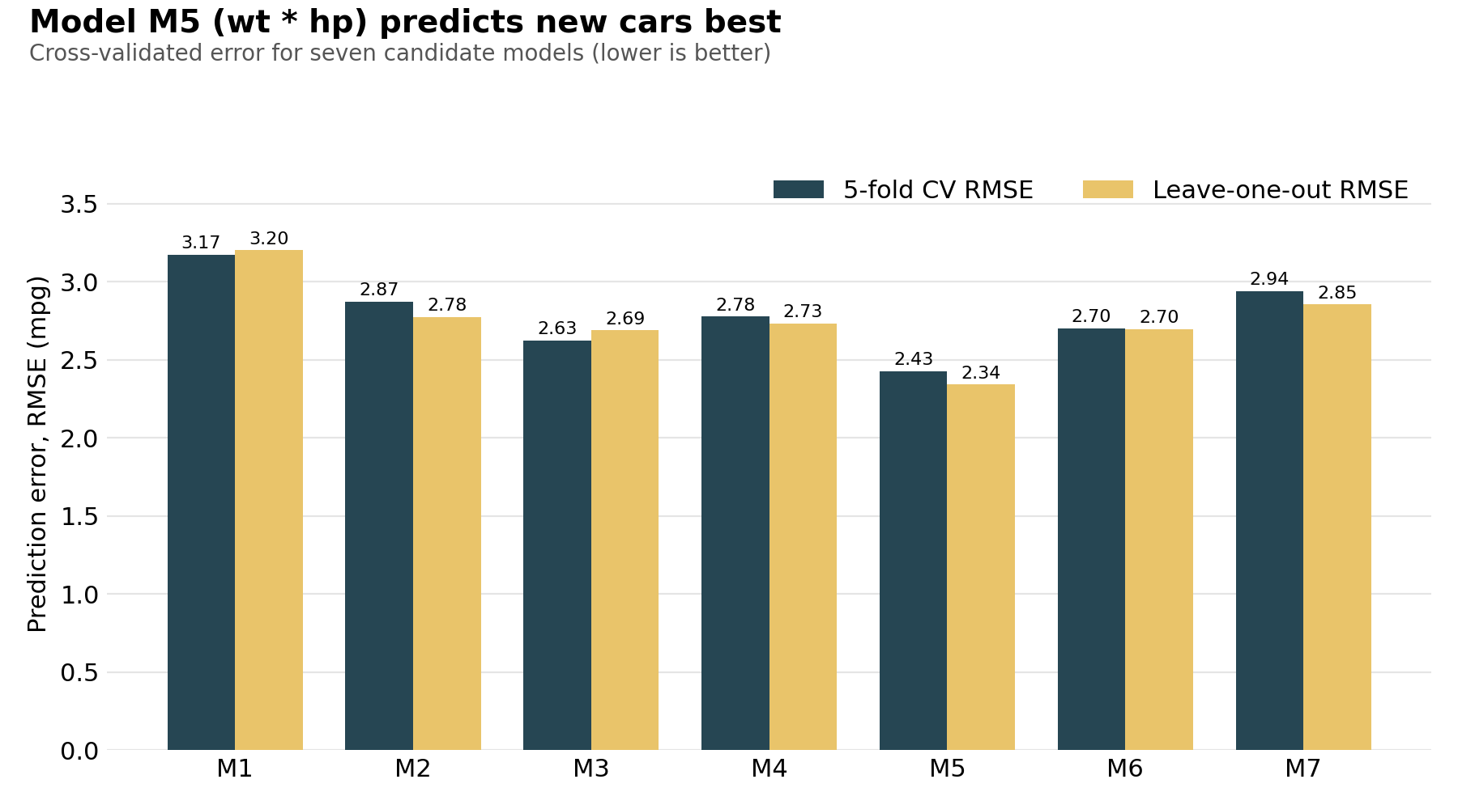
Figure 4: Cross-validated prediction error of the seven candidate models
Interpretation
- The baseline M1 (weight only) has a typical error of about 3.2 mpg. Adding horsepower (M2) reduces it to 2.9, and the transmission and quarter-mile time model (M3) to 2.6.
- M5 (wt * hp) wins on every measure: the lowest cross-validated error (2.43 mpg on 5-fold and 2.34 on LOOCV), the lowest AIC (145.6) and the highest adjusted R-squared (0.872).
- The most complex model, M7 with seven predictors, is among the worst on unseen data (2.94 mpg). It fits the training cars well but predicts new cars badly, which is the classic sign of overfitting and shows why cross-validation matters more than in-sample R-squared.
- M5 is therefore selected as the final model.

4.3 The final model
R code
final <- lm(mpg ~ wt * hp, data = cars)
summary(final)
confint(final)

# Predict a new car: 3000 lbs and 150 hp
predict(final, newdata = data.frame(wt = 3.0, hp = 150), interval = "prediction")
predict(final, newdata = data.frame(wt = 3.0, hp = 150), interval = "confidence")

# Interaction plot: predicted mpg at three horsepower levels
grid <- expand.grid(wt = seq(1.5, 5.4, length.out = 100),
hp = quantile(cars$hp, c(0.10, 0.50, 0.90)))
grid$mpg_hat <- predict(final, newdata = grid)
p7 <- ggplot(grid, aes(x = wt, y = mpg_hat, color = factor(round(hp)))) +
geom_line(linewidth = 1.2) +
geom_point(data = cars, aes(x = wt, y = mpg), inherit.aes = FALSE,
color = "grey60", alpha = 0.7) +
labs(x = "Weight (1000 lbs)", y = "Predicted mpg", color = "Horsepower") +
theme_minimal(base_size = 13)

Console output
Call:
lm(formula = mpg ~ wt * hp, data = cars)

Residuals:
Min 1Q Median 3Q Max
-3.0632 -1.6491 -0.7362 1.4211 4.5513

Coefficients:
Estimate Std. Error t value Pr(>|t|)
(Intercept) 49.80842 3.60516 13.816 5.01e-14 ***
wt -8.21662 1.26971 -6.471 5.20e-07 ***
hp -0.12010 0.02470 -4.863 4.04e-05 ***
wt:hp 0.02785 0.00742 3.753 0.000811 ***
---
Signif. codes: 0 '***' 0.001 '**' 0.01 '*' 0.05 '.' 0.1 ' ' 1

Residual standard error: 2.153 on 28 degrees of freedom
Multiple R-squared: 0.8848, Adjusted R-squared: 0.8724
F-statistic: 71.66 on 3 and 28 DF, p-value: 2.981e-13

2.5 % 97.5 %
(Intercept) 42.4235965 57.1932503
wt -10.8175035 -5.6157451
hp -0.1706944 -0.0695098
wt:hp 0.0126498 0.0430465

fit lwr upr
1 19.674904 15.144779 24.205028
fit lwr upr
1 19.674904 18.637372 20.712435

Term | Estimate | Std. error | p-value | 95% CI
(Intercept) | 49.8084 | 3.6052 | 5.01e-14 | 42.424 to 57.193
wt | -8.2166 | 1.2697 | 5.20e-07 | -10.818 to -5.616
hp | -0.1201 | 0.0247 | 4.04e-05 | -0.171 to -0.070
wt:hp | 0.0278 | 0.0074 | 0.000811 | 0.013 to 0.043

How to read the model
- All four coefficients are statistically significant (p < 0.001). The model explains 88.5% of the variation in mpg (adjusted R-squared 0.872) and the overall F-test is highly significant (F = 71.7, p = 3e-13).
- The residual standard error is 2.15 mpg: a typical prediction is within about 2 mpg of the real value, and roughly 95% of predictions are within about 4.3 mpg.
- The positive interaction (0.0278) means the penalty for weight depends on horsepower. Each extra 1000 lbs lowers mpg by about 6.4 for a low-power car (66 hp), 4.8 for a mid-range car (123 hp) and only 1.4 for a high-power car (244 hp).
- A real-world reading: light, low-power economy cars are the most sensitive to extra weight, while heavy muscle cars are already inefficient, so extra weight changes their mpg less.
- Example prediction: a car of 3000 lbs and 150 hp is predicted at 19.7 mpg. The 95% prediction interval for a single new car is 15.1 to 24.2 mpg, and the narrower interval for the average of all such cars is 18.6 to 20.7 mpg.
- The intercept (49.8) is the predicted mpg of a car with zero weight and zero horsepower. This is outside any real car, so it has no practical meaning.
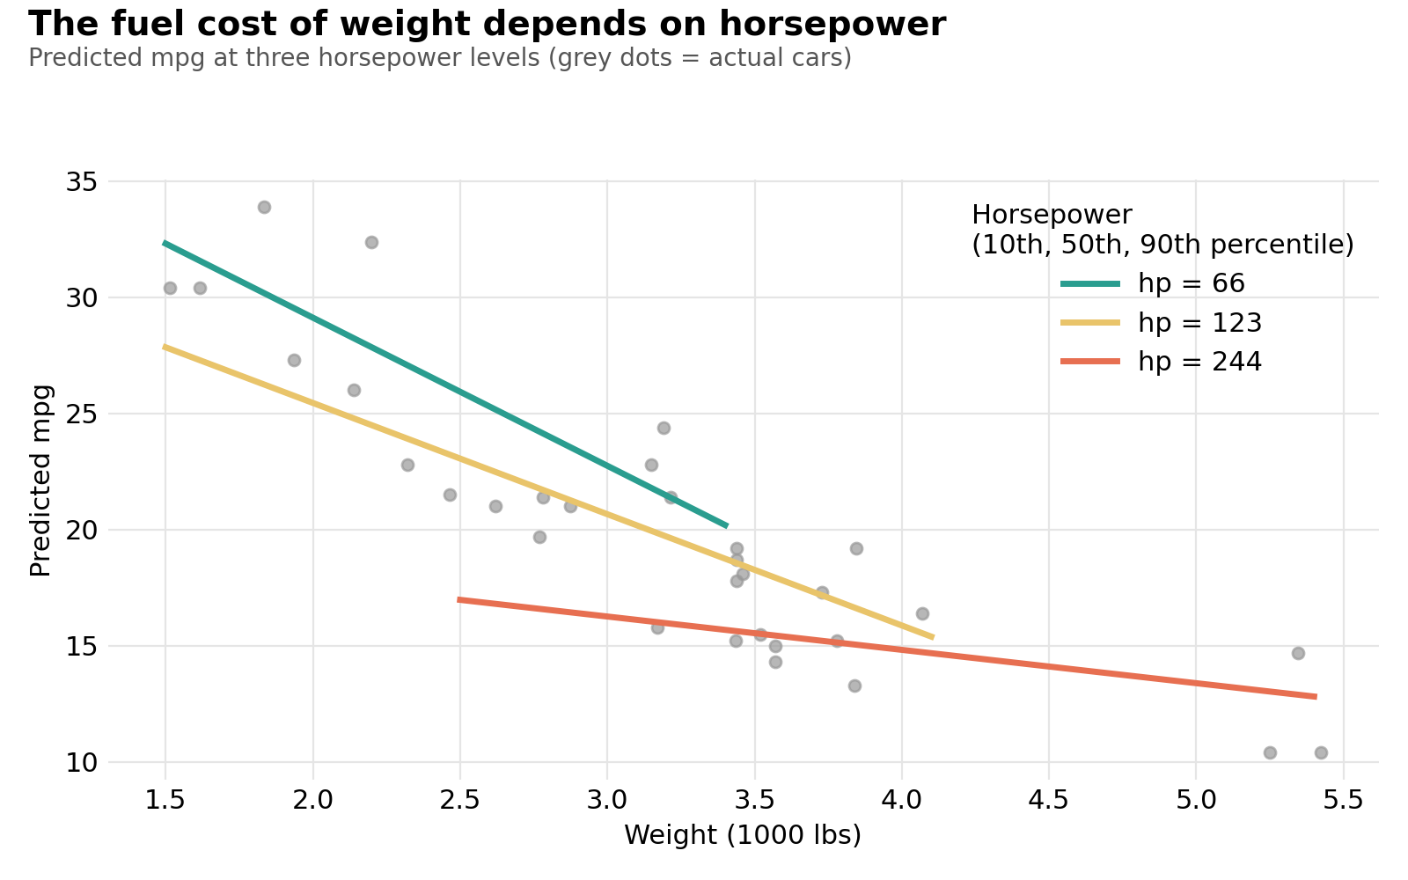
Figure 5: Predicted mpg by weight at three horsepower levels

5. Model Performance Evaluation
R code
cv_final <- cv_predictions(model_formulas$M5, cars, folds)
cv_base <- cv_predictions(model_formulas$M1, cars, folds)
loo_fin <- cv_predictions(model_formulas$M5, cars, seq_len(nrow(cars)))

perf <- data.frame(
Model = c("Baseline mpg ~ wt (5-fold)", "Final mpg ~ wt * hp (5-fold)",
"Final mpg ~ wt * hp (leave-one-out)"),
RMSE = c(rmse(cars$mpg, cv_base), rmse(cars$mpg, cv_final), rmse(cars$mpg, loo_fin)),
MAE = c(mae(cars$mpg, cv_base), mae(cars$mpg, cv_final), mae(cars$mpg, loo_fin)),
R2 = c(r2(cars$mpg, cv_base), r2(cars$mpg, cv_final), r2(cars$mpg, loo_fin)))
print(perf, row.names = FALSE, digits = 4)

# Largest out-of-fold errors
err <- cars$mpg - cv_final
head(data.frame(car = cars$car, actual = cars$mpg, predicted = cv_final,
error = err)[order(-abs(err)), ], 4)

p6 <- ggplot(data.frame(pred = cv_final, actual = cars$mpg),
aes(x = pred, y = actual)) +
geom_abline(slope = 1, intercept = 0, linetype = "dashed", color = "#E76F51") +
geom_point(size = 3, color = "#264653") +
coord_equal(xlim = c(8, 36), ylim = c(8, 36)) +
labs(x = "Predicted mpg (5-fold cross-validation)", y = "Actual mpg") +
theme_minimal(base_size = 13)

Console output
Model RMSE MAE R2
Baseline mpg ~ wt (5-fold) 3.174 2.523 0.7137
Final mpg ~ wt * hp (5-fold) 2.427 2.144 0.8327
Final mpg ~ wt * hp (leave-one-out) 2.342 2.033 0.8441

car actual predicted error
1 Fiat 128 32.4 27.140 5.260
2 Toyota Corolla 33.9 29.644 4.256
3 Toyota Corona 21.5 25.177 -3.677
4 Chrysler Imperial 14.7 11.065 3.635

Model | RMSE (mpg) | MAE (mpg) | Out-of-fold R2
Baseline: mpg ~ wt (5-fold) | 3.174 | 2.523 | 0.714
Final: mpg ~ wt * hp (5-fold) | 2.427 | 2.144 | 0.833
Final: mpg ~ wt * hp (LOOCV) | 2.342 | 2.033 | 0.844

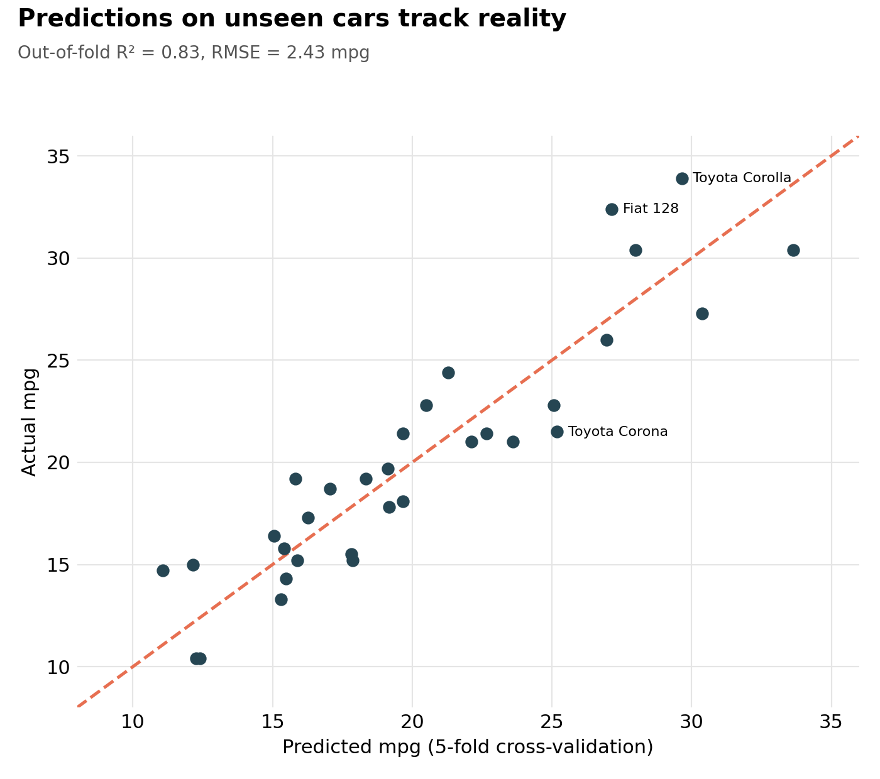
Figure 6: Actual vs predicted mpg using 5-fold cross-validation
Interpretation
- On cars it has never seen, the final model is off by about 2.4 mpg on average (RMSE), which is about 12% of the mean mpg of 20.1. It predicts 83% to 84% of the variation (R-squared), against 71% for the weight-only baseline.
- Compared with the baseline, the error falls by about 24% (3.17 to 2.43 mpg). This shows that the extra horsepower and interaction terms improve real predictive accuracy and not only in-sample fit.
- The LOOCV result (2.34) is close to the 5-fold result (2.43), which indicates the estimate is stable and not an accident of how the folds were drawn.
- The biggest misses are the very efficient small cars: the Fiat 128 (actual 32.4, predicted 27.1) and Toyota Corolla (actual 33.9, predicted 29.6) are under-predicted, while the Toyota Corona is over-predicted by 3.7 mpg. In the plot the dots at the top-right sit above the dashed line, so the model is somewhat too cautious about the most efficient cars.

6. Diagnostic Analysis
A regression is only trustworthy if its assumptions hold: the relationship is roughly linear, the errors are approximately normal with constant variance, the predictors are not excessively collinear, and no single car dominates the result. Each assumption is checked below.
R code
par(mfrow = c(2, 2))
plot(final) # residuals vs fitted, Q-Q, scale-location, leverage
par(mfrow = c(1, 1))

shapiro.test(residuals(final)) # are residuals normal?
bptest(final) # constant variance? (Breusch-Pagan)
vif(final) # multicollinearity

# Centring the predictors removes most of the collinearity
cars$wt_c <- cars$wt - mean(cars$wt)
cars$hp_c <- cars$hp - mean(cars$hp)
final_c <- lm(mpg ~ wt_c * hp_c, data = cars)
vif(final_c)

# Influential observations
cooks <- cooks.distance(final)
sort(cooks, decreasing = TRUE)[1:5]
names(which(cooks > 4 / nrow(cars)))

Console output
Shapiro-Wilk normality test

data: residuals(final)
W = 0.95447, p-value = 0.1928

studentized Breusch-Pagan test

data: final
BP = 8.4646, df = 3, p-value = 0.03732

wt hp wt:hp
10.32442 19.18172 43.05685

wt_c hp_c wt_c:hp_c
1.79591 1.77020 1.01938

Chrysler Imperial Toyota Corolla Honda Civic Fiat 128
0.2213969 0.1831237 0.1562972 0.1444665

Maserati Bora
0.1298600

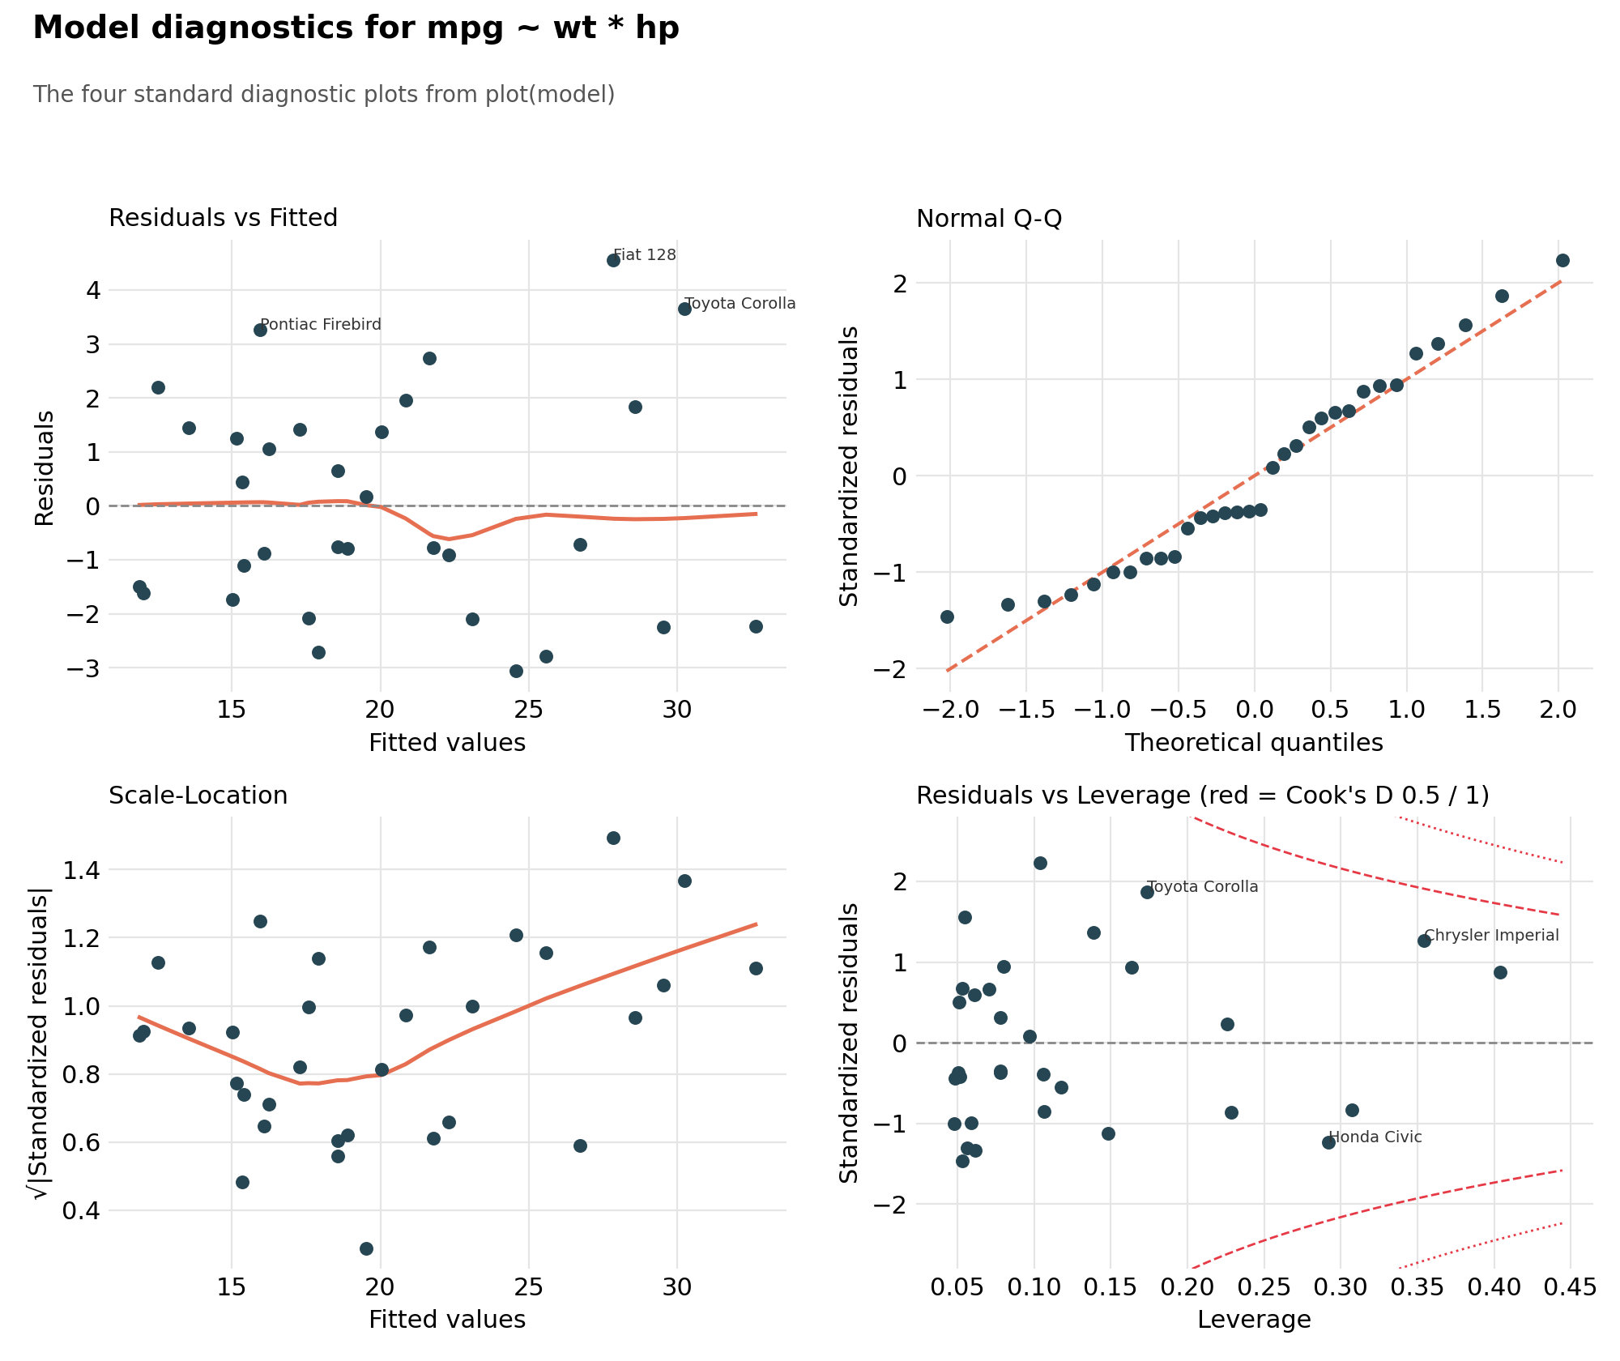
Figure 7: The four standard diagnostic plots for the final model
Assumption | Check | Result
Linearity | Residuals vs Fitted plot | Residuals scatter around zero with only a slight dip near 22 mpg. No strong curve, so a linear model is adequate.
Normal errors | Q-Q plot, Shapiro-Wilk | Points follow the line. Shapiro-Wilk W = 0.954, p = 0.193: no evidence against normality.
Constant variance | Scale-Location plot, Breusch-Pagan | The smoothed line rises slightly. Breusch-Pagan p = 0.037: mild evidence that errors are larger for high-mpg cars.
Multicollinearity | Variance inflation factor (VIF) | Raw VIFs of 10.3, 19.2 and 43.1 are high, as expected when an interaction is present. After centring the predictors they fall to 1.8, 1.8 and 1.0.
Influential cars | Cook's distance, leverage | Largest Cook's distance is 0.221 (Chrysler Imperial), well below 0.5. No standardized residual exceeds 3 (largest is 2.23).

Interpretation
- Overall the model is sound. Linearity and normality hold, and no car is an extreme outlier or has a damaging influence on the fit.
- Heteroscedasticity (unequal spread) is mild but present: the Breusch-Pagan test is significant at the 5% level and the Scale-Location line rises. In practice this means prediction intervals for very efficient cars are somewhat too narrow, and this matches the larger errors on the Fiat 128 and Toyota Corolla.
- Collinearity looks alarming on the raw model (VIF up to 43), but this is mostly an artefact of including a product term. Centring weight and horsepower leaves predictions unchanged and brings all VIFs to 1.8 or below, so the coefficients can be trusted.
- Five cars have a Cook's distance above the common 4/n = 0.125 rule of thumb (Chrysler Imperial, Toyota Corolla, Honda Civic, Fiat 128 and Maserati Bora). Chrysler Imperial and Maserati Bora also have high leverage (hat values of 0.35 and 0.40 against a threshold of 0.25) because of their unusual weight or power. None is an error, and none crosses the 0.5 danger line, so all are kept.

7. Optimization and Possible Improvements

7.1 Improvements tested
Using the same cross-validation setup, five variations of the final model were tested to see whether prediction could be improved: a log transformation of mpg (which targets the unequal variance), and the addition of quarter-mile time, transmission, displacement and a squared weight term.
R code
candidates <- list(
list(name = "mpg ~ wt * hp (final)", f = mpg ~ wt * hp, inv = identity),
list(name = "log(mpg) ~ wt * hp", f = log(mpg) ~ wt * hp, inv = exp),
list(name = "mpg ~ wt * hp + qsec", f = mpg ~ wt * hp + qsec, inv = identity),
list(name = "mpg ~ wt * hp + am", f = mpg ~ wt * hp + am, inv = identity),
list(name = "mpg ~ wt * hp + disp", f = mpg ~ wt * hp + disp, inv = identity),
list(name = "mpg ~ wt * hp + I(wt^2)", f = mpg ~ wt * hp + I(wt^2), inv = identity)
)

improve <- do.call(rbind, lapply(candidates, function(m) {
data.frame(
Model = m$name,
CV5_RMSE = rmse(cars$mpg, cv_predictions(m$f, cars, folds, m$inv)),
LOOCV_RMSE = rmse(cars$mpg, cv_predictions(m$f, cars, seq_len(nrow(cars)), m$inv)))
}))
print(improve, row.names = FALSE, digits = 4)

Console output
Model CV5_RMSE LOOCV_RMSE
mpg ~ wt * hp (final) 2.427 2.342
log(mpg) ~ wt * hp 2.432 2.361
mpg ~ wt * hp + qsec 2.333 2.284
mpg ~ wt * hp + am 2.470 2.409
mpg ~ wt * hp + disp 2.548 2.414
mpg ~ wt * hp + I(wt^2) 2.507 2.589

Model | 5-fold CV RMSE | LOOCV RMSE
mpg ~ wt * hp (final) | 2.427 | 2.342
log(mpg) ~ wt * hp | 2.432 | 2.361
mpg ~ wt * hp + qsec | 2.333 | 2.284
mpg ~ wt * hp + am | 2.470 | 2.409
mpg ~ wt * hp + disp | 2.548 | 2.414
mpg ~ wt * hp + I(wt^2) | 2.507 | 2.589

What the results show
- Log transformation does not help (2.43 and 2.36, no better than 2.43 and 2.34). The heteroscedasticity is therefore mild enough that a transformation is not worth the loss of easy interpretation.
- Adding transmission, displacement or a squared weight term makes predictions worse on unseen cars (for example 2.59 on LOOCV for the squared term). These extras fit the training data better but do not generalise.
- Only quarter-mile time (qsec) helps: error falls to 2.33 (5-fold) and 2.28 (LOOCV), about 4% and 2.5% better. With 32 cars a gain this small is within the noise of the estimate, so the simpler model with two predictors and one interaction is retained.
- The main conclusion is that the final model is already near the limit of what this small dataset can support. Larger gains need more data and not more terms.

7.2 Strengths of the model
- Interpretable: every coefficient has a plain meaning, and the interaction reveals a real pattern (the cost of weight depends on power).
- Honest evaluation: performance is measured on unseen cars through two forms of cross-validation, not on the training data.
- Parsimonious: only two predictors and one interaction, which avoids the overfitting seen in the seven-predictor model.
- Assumptions largely hold: errors are approximately normal and no car is unduly influential.

7.3 Weaknesses and areas for improvement
- Small sample: with 32 cars, every estimate has wide uncertainty. Collecting a larger and more recent dataset is the single most valuable improvement.
- Mild unequal variance: errors are larger for very efficient cars. Weighted least squares or robust regression (for example MASS::rlm) could address this.
- Repeated cross-validation: repeating the 5-fold process with several random shuffles (for example with the caret or tidymodels packages) would give a more stable error estimate with a confidence band.
- Regularisation: ridge or lasso regression (glmnet package) could use more predictors safely by shrinking their coefficients.
- Non-linear methods: generalised additive models or random forests could capture curves and interactions automatically, though they need more data and are harder to explain.
- Hold-out test set: with a larger dataset, a final untouched test set would give a clean last check of performance.

8. Summary and Conclusion
Step | Outcome
Dataset | mtcars: 32 cars, target mpg, clean and interpretable.
Normality | mpg is normal (p = 0.12); horsepower is right-skewed (p = 0.049), so non-parametric checks were added.
H1: weight vs mpg | Rejected H0: strong negative correlation, r = -0.87, p < 0.001.
H2: transmission | Rejected H0: manual cars average 24.4 mpg vs 17.1, Welch p = 0.0014, partly a weight effect.
H3: cylinders | Rejected H0: all pairs differ (ANOVA, Welch ANOVA and Kruskal-Wallis agree).
Final model | mpg ~ wt * hp, adjusted R-squared 0.872, lowest AIC and lowest cross-validated error of seven candidates.
Performance | 5-fold RMSE 2.43 mpg and out-of-fold R-squared 0.83, versus 3.17 and 0.71 for the weight-only baseline.
Diagnostics | Linearity and normality hold; mild unequal variance (Breusch-Pagan p = 0.037); no highly influential cars.
Optimization | Log transform and extra terms add nothing meaningful; qsec gives a small gain within the noise, so the simpler model is kept.

In short, a car's weight and power explain most of its fuel economy, and the two work together: weight costs the most mpg in light, low-power cars. A simple two-predictor model with an interaction can predict the mpg of an unseen car to within roughly 2.4 mpg, and a more complicated model does not do better.
Limitations: the data are only 32 cars from 1974, the study is observational (association, not proof of cause), and predictions outside the observed range of weight and horsepower should not be trusted. The method (test the assumptions, compare models with cross-validation, check diagnostics, then try improvements) can be applied directly to a larger, modern dataset.

Reproducing this report
All code is shown in the sections above and in the accompanying script Week3_R_Modeling_Script.R. Run it from top to bottom in RStudio. It needs R 4.x and the packages ggplot2 (3.4 or later), dplyr, car and lmtest. Fold assignment is fixed (not random), so the cross-validation numbers are reproducible exactly.

