FINAL REPORT | WEEK 4
Comprehensive Data Analysis Report
From data preparation and visualization to statistical testing and predictive modeling in R
Student Name: Pulivarthi Sai Teja
Course / Internship: Data Analysis, Yuva Intern
Tools Used: R, ggplot2, dplyr, car, lmtest
Datasets: mtcars and AirPassengers (built into R)

1. Executive Summary
This report brings together four weeks of work into one story. It asks two practical questions: what makes a car fuel efficient, and how did airline passenger traffic behave over time? Using R, the data were cleaned and checked, explored with charts, tested with formal statistics, and used to build a model that predicts a car's fuel economy.

What we found
- Weight and power drive fuel economy. Heavier cars use more fuel (correlation -0.87). Each extra 1000 lbs lowers fuel economy by about 5.3 miles per gallon (mpg) on average, and 4-cylinder cars average 26.7 mpg versus 15.1 mpg for 8-cylinder cars.
- The differences are real, not chance. Formal tests give p-values far below 0.05 for weight, transmission type and cylinder count. Backup tests that make fewer assumptions reach the same conclusions.
- A simple model predicts well. A regression using weight and horsepower (and how they interact) predicts the mpg of cars it has never seen to within about 2.4 mpg, and explains about 83% of the variation. A weight-only model is off by about 3.2 mpg.
- Weight matters most in light, low-power cars. An extra 1000 lbs costs about 6.4 mpg in a 66 hp car but only 1.4 mpg in a 244 hp car.
- Air travel grew steadily and seasonally. Monthly passengers rose about 3.8-fold between 1949 and 1960, and every year peaked in July and August at roughly 1.5 times the November level.

What we recommend
- Treat weight reduction as the most reliable lever for better fuel economy in smaller, lower-power vehicles, and look to engine efficiency for high-power vehicles.
- Use the simple weight-and-horsepower model as a quick estimating tool, with its stated margin of error, and do not add extra variables without cross-validated evidence.
- Plan capacity and staffing around the strong summer peak in the airline data, and schedule maintenance in the autumn trough.
- Repeat the workflow on a larger, more recent dataset before drawing conclusions about today's vehicles or airlines.

Key numbers at a glance
Measure | Result
Data quality | No missing values, no duplicate rows; 5 plausible outlier cars kept
Weight vs. mpg | r = -0.87, p < 0.001; slope -5.3 mpg per 1000 lbs
Manual vs. automatic | 24.4 vs. 17.1 mpg (p = 0.0014), partly because manual cars are lighter
Final model | mpg ~ weight * horsepower; adjusted R-squared 0.872
Prediction error (5-fold CV) | RMSE 2.43 mpg (baseline 3.17); out-of-fold R-squared 0.83
Airline passengers | 1.52 million (1949) to 5.71 million (1960) per year; July is the peak

2. Introduction

2.1 Background and objectives
Organisations rarely struggle to collect data. The hard part is turning it into a decision that someone can trust. This project follows the full path from raw data to decision-ready insight, using R as the single tool so that every step can be repeated and checked.
The objectives are to:
- prepare and validate two public datasets so that later results can be trusted;
- use visualization to find patterns, trends and unusual observations;
- test the main patterns with formal statistical hypothesis tests;
- build and evaluate a predictive model using cross-validation; and
- explain what it all means in plain language for a mixed audience.

2.2 Intended audience
The report is written for two readers at once. Managers and other non-technical readers can follow the headings, figures, interpretation boxes and the glossary in Appendix A. Technical readers will find the annotated R code, the statistical output and the diagnostic checks that support each claim.

2.3 The datasets
Dataset | Content | Used for
mtcars | 32 car models from 1974 with 11 measurements, including mpg, weight, horsepower, cylinders and transmission | Cleaning, visualization, hypothesis tests and the prediction model
AirPassengers | 144 monthly totals of international airline passengers (thousands), 1949 to 1960 | Cleaning and time-series visualization (trend and seasonality)

Both datasets are built into R, so every result in this report can be reproduced with data(mtcars) and data(AirPassengers) and no downloads.

2.4 How the report is organised
The report follows the order in which the work was done, and each section sets up the next one. Section 4 makes the data trustworthy. Section 5 uses charts to see what the data say. Section 6 tests whether those patterns are statistically real. Section 7 turns the confirmed patterns into a prediction model. Section 8 discusses what the findings mean, and Sections 9 and 10 give recommendations and conclusions.
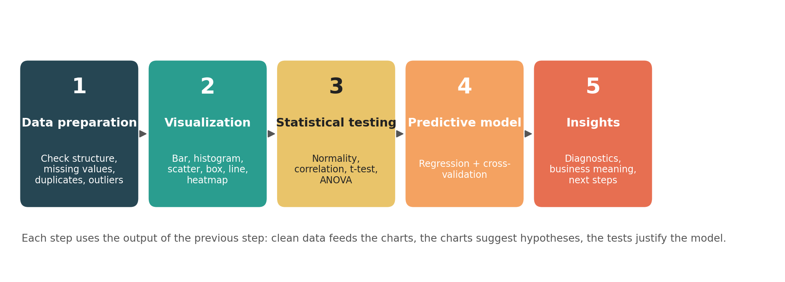
Figure 1: The analysis workflow used throughout this report

3. Methodology
The method follows one principle: each stage must answer a question that the next stage depends on. The table below summarises the questions, methods and R tools used.
Phase | Question asked | Methods | R tools
Data preparation | Is the data complete, valid and ready to use? | Structure, missing-value, duplicate, range and outlier checks | str, is.na, quantile, dplyr
Visualization | What patterns, trends and anomalies exist? | Bar, histogram, scatter, box, line, seasonal line, heatmap | ggplot2
Statistical testing | Are the patterns real or due to chance? | Shapiro-Wilk, Pearson/Spearman, Welch t-test, ANOVA, Tukey, non-parametric checks | shapiro.test, cor.test, t.test, aov
Predictive modeling | Can mpg be predicted for unseen cars? | Linear regression, interaction term, 5-fold and leave-one-out cross-validation | lm, predict, AIC
Diagnostics | Can the model be trusted? | Residual plots, Breusch-Pagan, VIF, Cook's distance | plot, bptest, vif

3.1 Setup and reproducibility
All work lives in one script, which loads the libraries and both datasets. Cross-validation uses fixed fold labels rather than random ones, so anyone who runs the script gets exactly the same numbers.
R code
# Install once if needed:
# install.packages(c("ggplot2", "dplyr", "car", "lmtest"))
library(ggplot2)
library(dplyr)
library(car) # vif()
library(lmtest) # bptest()

data(mtcars) # Dataset 1: 32 cars, 11 variables
data(AirPassengers) # Dataset 2: monthly airline passengers, 1949-1960

4. Data Preparation and Cleaning
Every later result is only as good as the data behind it, so the first stage is to inspect the data before analysing it. Six checks were run, and for each one the finding and the resulting decision are recorded.
R code
# 1. Structure and data types
str(mtcars)
class(AirPassengers)

# 2. Missing values and duplicate rows
colSums(is.na(mtcars))
sum(is.na(AirPassengers))
sum(duplicated(mtcars))

# 3. Plausibility checks: ranges and allowed values
sapply(mtcars[, c("mpg", "wt", "hp", "qsec")], range)
table(mtcars$cyl)
all(mtcars$am %in% c(0, 1))

# 4. Outlier screen with the 1.5 x IQR rule (flag, then decide)
flag_outliers <- function(x, names) {
q <- quantile(x, c(0.25, 0.75))
iqr <- diff(q)
names[x < q[1] - 1.5 * iqr | x > q[2] + 1.5 * iqr]
}
lapply(mtcars[, c("mpg", "hp", "wt", "qsec")], flag_outliers,
names = rownames(mtcars))

# 5. Is the time series complete (144 months, no gaps)?
length(AirPassengers)
frequency(AirPassengers)
start(AirPassengers)
end(AirPassengers)
any(diff(as.numeric(time(AirPassengers))) > 1/12 + 1e-8)

# 6. Recoding: readable labels, car names as a column, time series -> data frame
cars <- mtcars %>%
mutate(
car = rownames(mtcars),
cyl_f = factor(cyl), # for tests and models
cyl_lab = factor(cyl, levels = c(4, 6, 8),
labels = c("4 cyl", "6 cyl", "8 cyl")), # for chart labels
trans = factor(am, levels = c(0, 1), labels = c("Automatic", "Manual"))
)

ap <- data.frame(
date = seq(as.Date("1949-01-01"), by = "month", length.out = 144),
passengers = as.numeric(AirPassengers)
)
ap$year <- as.integer(format(ap$date, "%Y"))
ap$month <- factor(format(ap$date, "%b"), levels = month.abb)

pal_cyl <- c("4 cyl" = "#2A9D8F", "6 cyl" = "#E9C46A", "8 cyl" = "#E76F51")

4.1 Findings
Console output
> colSums(is.na(mtcars))
mpg cyl disp hp drat wt qsec vs am gear carb
0 0 0 0 0 0 0 0 0 0 0
> sum(is.na(AirPassengers))
[1] 0
> sum(duplicated(mtcars))
[1] 0

> sapply(mtcars[, c("mpg", "wt", "hp", "qsec")], range)
mpg wt hp qsec
[1,] 10.4 1.513 52 14.5
[2,] 33.9 5.424 335 22.9

> table(mtcars$cyl)

4 6 8
11 7 14
> all(mtcars$am %in% c(0, 1))
[1] TRUE

> lapply(mtcars[, c("mpg", "hp", "wt", "qsec")], flag_outliers, names = rownames(mtcars))
$mpg
[1] "Toyota Corolla"

$hp
[1] "Maserati Bora"

$wt
[1] "Cadillac Fleetwood" "Lincoln Continental" "Chrysler Imperial"

$qsec
[1] "Merc 230"

> length(AirPassengers); frequency(AirPassengers)
[1] 144
[1] 12
> start(AirPassengers); end(AirPassengers)
[1] 1949 1
[1] 1960 12
> any(diff(as.numeric(time(AirPassengers))) > 1/12 + 1e-8)
[1] FALSE

Check | Method | Finding | Action
Structure | str(), class() | mtcars: 32 rows, 11 numeric columns. AirPassengers: a monthly time-series object | Convert to data frames and add labels
Missing values | colSums(is.na()) | 0 missing values in both datasets | None needed
Duplicates | duplicated() | 0 duplicate rows | None needed
Plausibility | range(), table() | All values realistic (mpg 10.4 to 33.9, weight 1.5 to 5.4 thousand lbs); cyl is 4, 6 or 8; am is 0 or 1 | None needed
Outliers | 1.5 x IQR rule | 5 cars flagged: Toyota Corolla (high mpg), Maserati Bora (high hp), three heavy cars, Merc 230 (slow quarter-mile) | Keep all (see below)
Time-series completeness | length(), diff(time()) | 144 months, one per month from Jan 1949 to Dec 1960, no gaps | None needed

4.2 The outlier decision
A flagged value is not automatically an error. Each of the five cars is a real vehicle with a plausible measurement: the Toyota Corolla really was very efficient, the Maserati Bora really was powerful, and the Cadillac Fleetwood, Lincoln Continental and Chrysler Imperial really were very heavy. Deleting them would remove genuine variation and make later results look more certain than they are, and with only 32 cars every observation counts. All five were therefore kept, and their influence on the model was checked formally later (Section 7.5).

4.3 Recoding and preparation
The last step makes the data easier to use. Car names move from row names to a column so they can be used as chart labels. Cylinders and transmission are turned into labelled categories (for example 4 cyl, Manual) so charts and tests read clearly. The AirPassengers time series is converted to a table with a date, a year and a month column, which allows the same month to be compared across years. The result is a clean, validated dataset ready for analysis.

5. Exploratory Visualization
With trustworthy data in hand, the next question is what patterns it contains. Charts are the fastest way to find out, and each chart type was chosen to match a specific question: bars compare groups, scatter plots show relationships, box plots compare distributions, lines follow time, and a heatmap summarises many relationships at once. Short excerpts of the code are shown below; the full, styled code is in the accompanying script.

5.1 Comparing groups: fuel economy by engine size
R code
avg_mpg <- cars %>% group_by(cyl_lab) %>% summarise(mean_mpg = mean(mpg)) # average per group

ggplot(avg_mpg, aes(x = cyl_lab, y = mean_mpg, fill = cyl_lab)) +
geom_col(width = 0.6, show.legend = FALSE) + # bar length = average mpg
geom_text(aes(label = round(mean_mpg, 1)), vjust = -0.5) # print the value on each bar

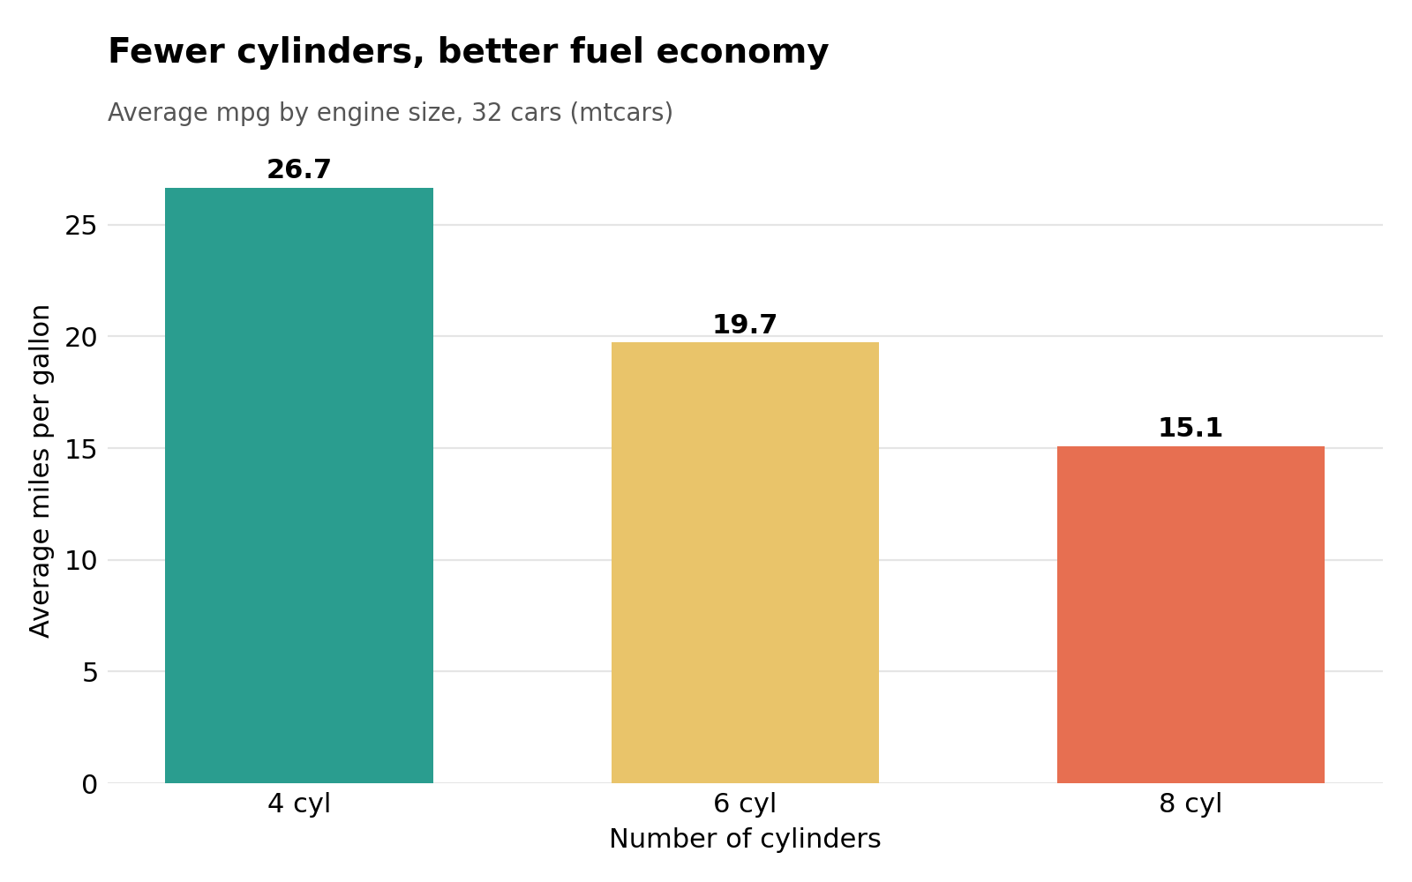
Figure 2: Average mpg by number of cylinders
4-cylinder cars average 26.7 mpg, 6-cylinder cars 19.7 mpg and 8-cylinder cars 15.1 mpg. In practical terms, an 8-cylinder car needs about 77% more fuel than a 4-cylinder car to travel the same distance. The pattern is clear and consistent, so it becomes Hypothesis 3 in Section 6.

5.2 Relationships: weight versus fuel economy
R code
ggplot(cars, aes(x = wt, y = mpg)) +
geom_smooth(method = "lm", se = TRUE, linetype = "dashed") + # linear trend with confidence band
geom_point(aes(color = cyl_lab), size = 3) # one dot per car, coloured by cylinders

coef(lm(mpg ~ wt, data = cars)) # slope = change in mpg per extra 1000 lbs

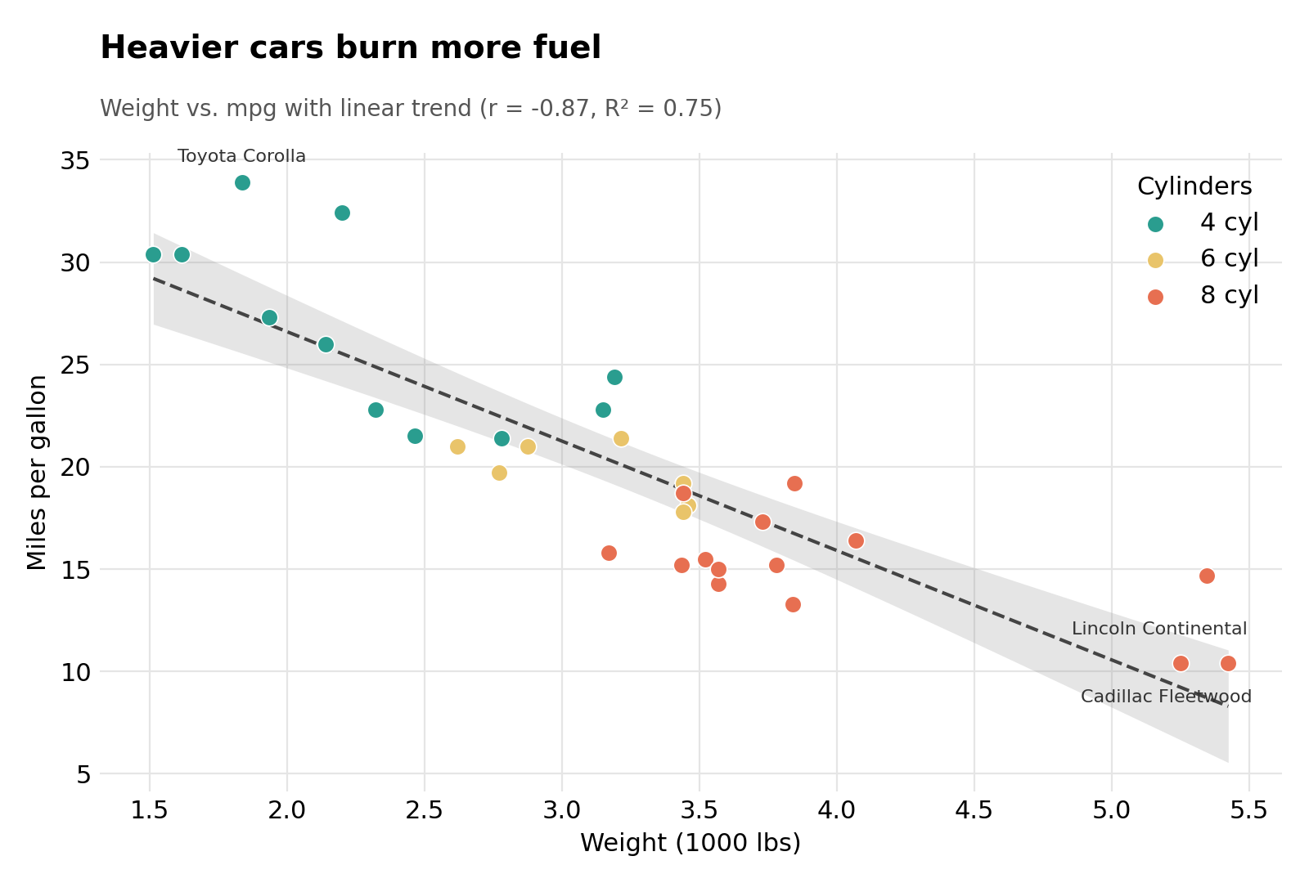
Figure 3: Weight versus mpg, coloured by cylinders
The dots fall along a clear downward line (correlation -0.87): every extra 1000 lbs lowers mpg by about 5.3, and weight alone accounts for about 75% of the variation. The colours also show that light cars are mostly 4-cylinder and the heaviest are 8-cylinder, so weight and engine size travel together. The Cadillac Fleetwood and Lincoln Continental (10.4 mpg) and the Toyota Corolla (33.9 mpg) sit at the extremes. This relationship becomes Hypothesis 1 and the anchor of the prediction model.

5.3 Comparing distributions: manual versus automatic
R code
ggplot(cars, aes(x = trans, y = mpg, fill = trans)) +
geom_boxplot(outlier.shape = NA) + # median, quartiles and range
geom_jitter(width = 0.1) # show the individual cars

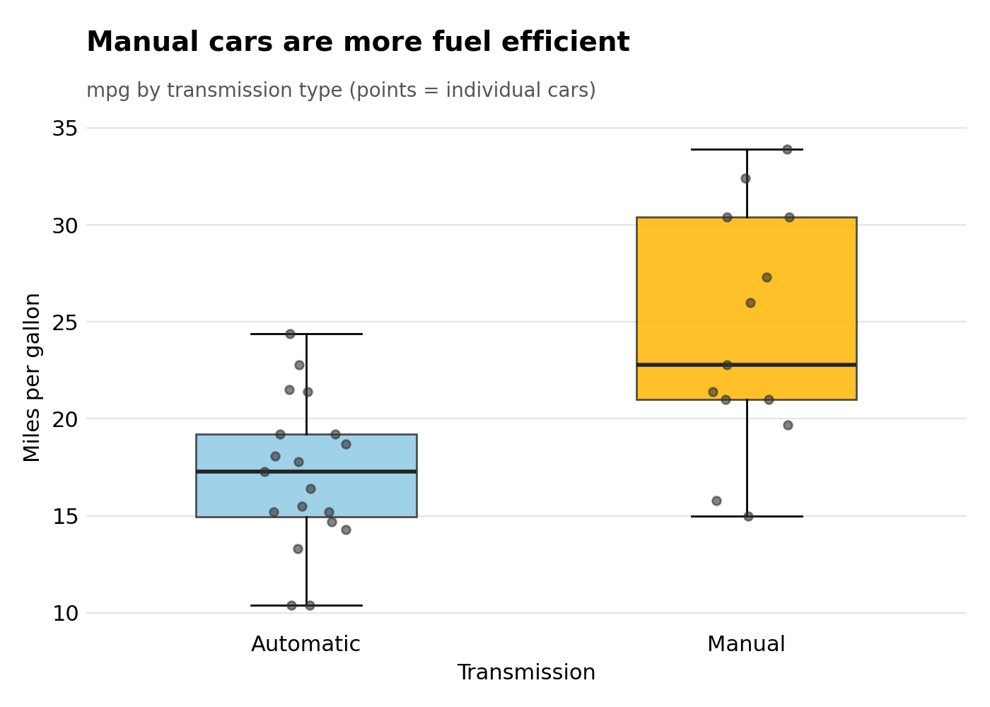
Figure 4: Fuel economy for automatic and manual cars
Manual cars have a median of 22.8 mpg against 17.3 mpg for automatics, but the manual group is small (13 cars) and more spread out. A warning sign appears here: manual cars in this dataset are also much lighter (2.4 versus 3.8 thousand lbs on average), so part of the gap may be a weight effect and not purely the gearbox. This is tested as Hypothesis 2 and resolved by the multi-variable model.

5.4 Trends over time: airline passengers
R code
ggplot(ap, aes(x = date, y = passengers)) +
geom_line() + # monthly values
geom_smooth(method = "lm", se = FALSE) # long-term linear trend

ggplot(ap, aes(x = month, y = passengers, group = year, color = year)) +
geom_line() + scale_color_viridis_c() # one line per year, colour = year

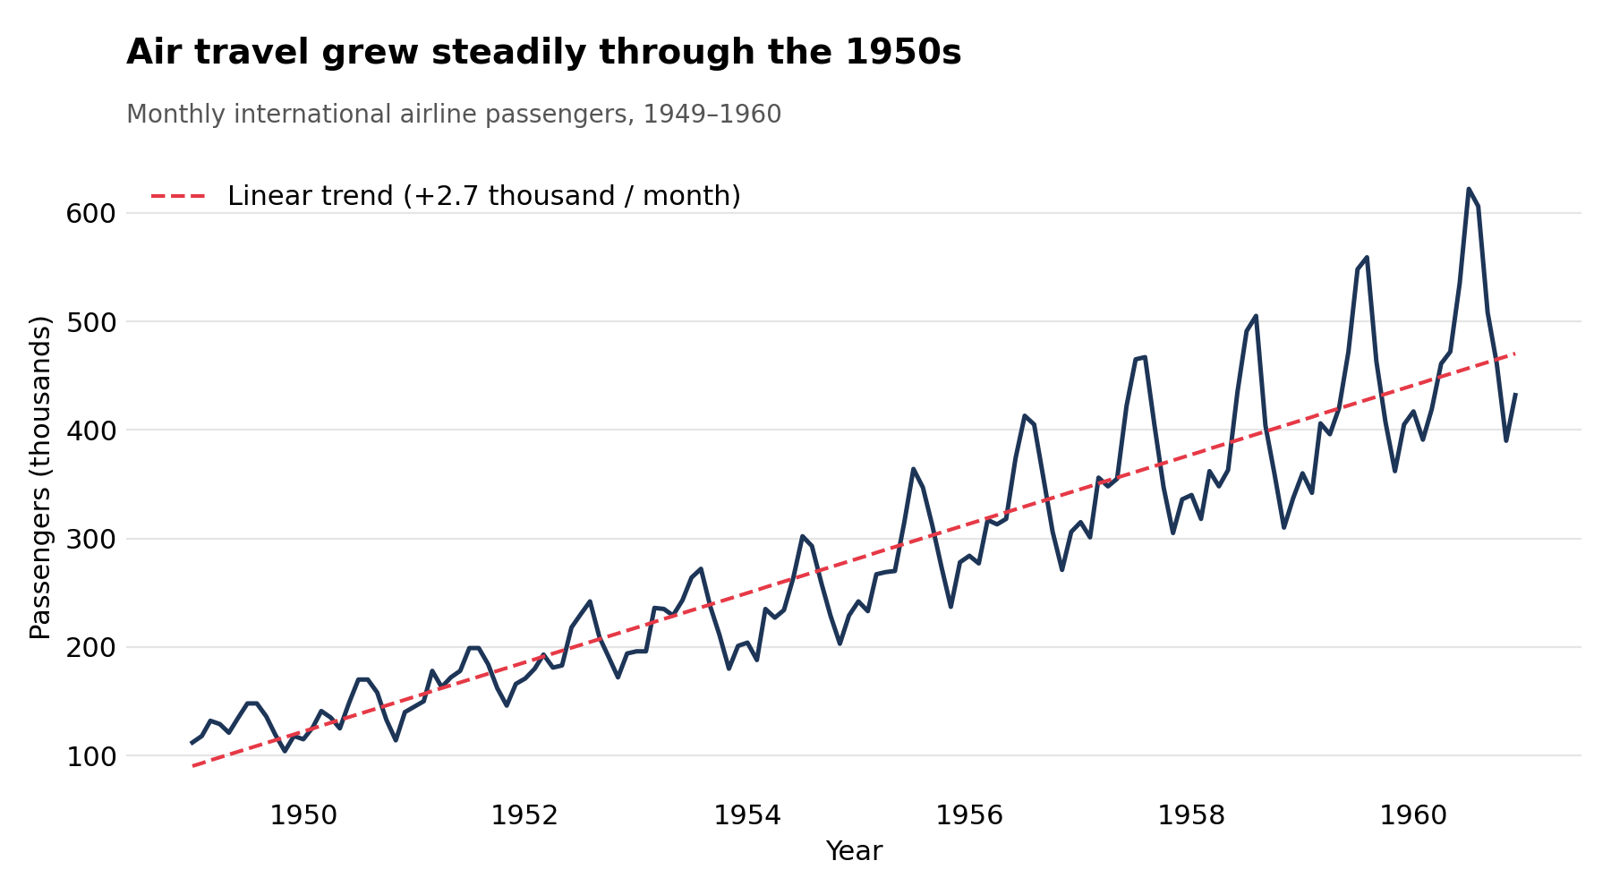
Figure 5: Monthly airline passengers with linear trend, 1949 to 1960
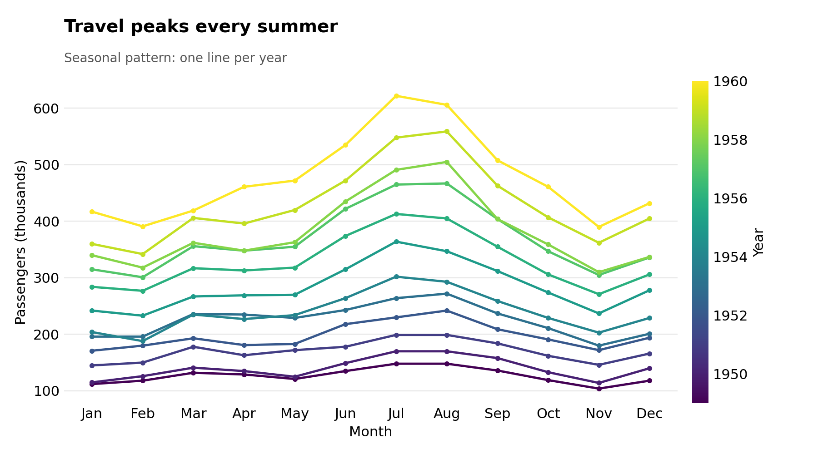
Figure 6: Seasonal pattern: one line per year
Passengers grew from 112 thousand in January 1949 to 432 thousand in December 1960, and yearly totals rose from 1.52 million to 5.71 million, about 3.8 times higher. The trend adds roughly 2.7 thousand passengers per month and explains about 85% of the variation. The second chart reveals a stable seasonal rhythm: every year rises through spring, peaks in July and August (about 351 thousand on average) and bottoms out in November (about 233 thousand), a peak-to-trough ratio of about 1.5. The swings also get larger as traffic grows.

5.5 Many relationships at once: correlation heatmap
R code
cor_mat <- cor(mtcars[, c("mpg", "cyl", "disp", "hp", "drat", "wt", "qsec")])
cor_df <- as.data.frame(as.table(cor_mat)) # long format for ggplot
ggplot(cor_df, aes(Var1, Var2, fill = Freq)) +
geom_tile() + scale_fill_gradient2(limits = c(-1, 1)) # blue = together, red = opposite

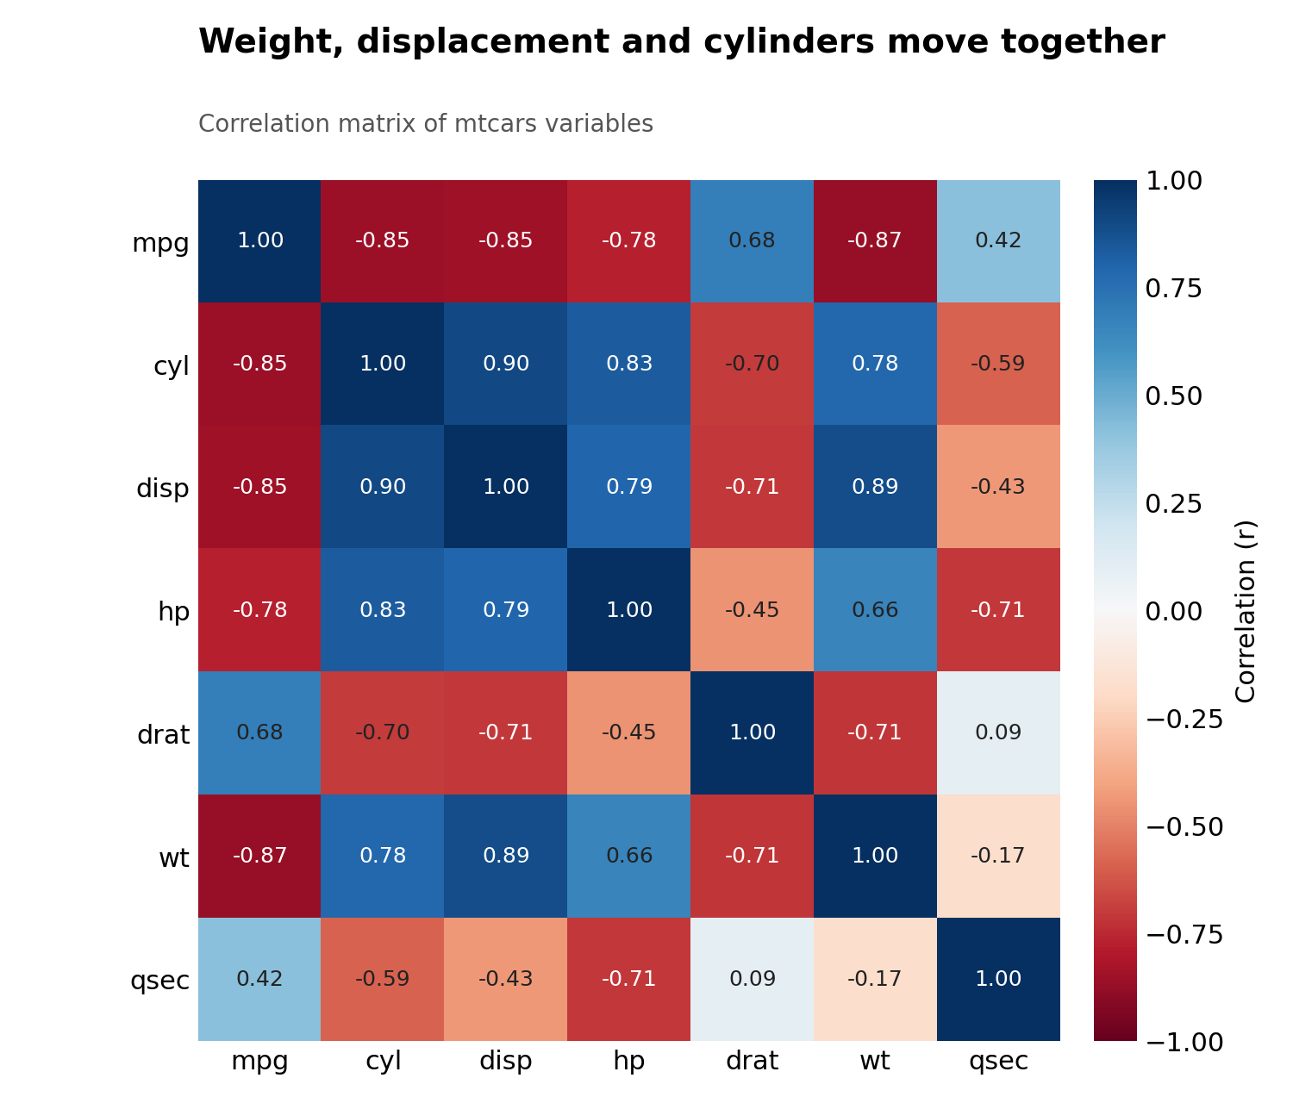
Figure 7: Correlation matrix of seven mtcars variables
Fuel economy is strongly and negatively linked to weight (-0.87), cylinders (-0.85), displacement (-0.85) and horsepower (-0.78). Cylinders, displacement and weight are also strongly linked to each other (0.78 to 0.90), which means they carry overlapping information. This matters for modelling: adding all of them to one model would add complexity without adding much new information.

5.6 Summary of visual findings
# | Chart | Main insight and what it led to
1 | Bar chart | Fewer cylinders means better mpg (26.7 vs 15.1). Led to Hypothesis 3.
2 | Scatter plot | Heavier cars burn more fuel (r = -0.87). Led to Hypothesis 1 and the baseline model.
3 | Box plot | Manual cars look more efficient, but they are lighter. Led to Hypothesis 2 and the need for a multi-variable model.
4 | Line chart | Passengers grew about 3.8 times from 1949 to 1960.
5 | Seasonal chart | A stable summer peak, with July about 1.5 times November.
6 | Heatmap | Weight, cylinders and displacement overlap, so model choice must be careful.

The charts show strong patterns, but a pattern in a small sample can be a coincidence. The next section checks whether the car patterns are statistically real.

6. Statistical Analysis
Statistical tests answer one question: could this pattern plausibly be due to chance? Each test below starts with a null hypothesis (H0, which assumes no effect) and an alternative (H1). A p-value below 0.05 is treated as evidence against H0. Because the sample is small, each result is checked with a second, more cautious test.

6.1 Checking the assumptions: normality
R code
shapiro.test(cars$mpg) # H0: the data are normally distributed
shapiro.test(cars$hp)

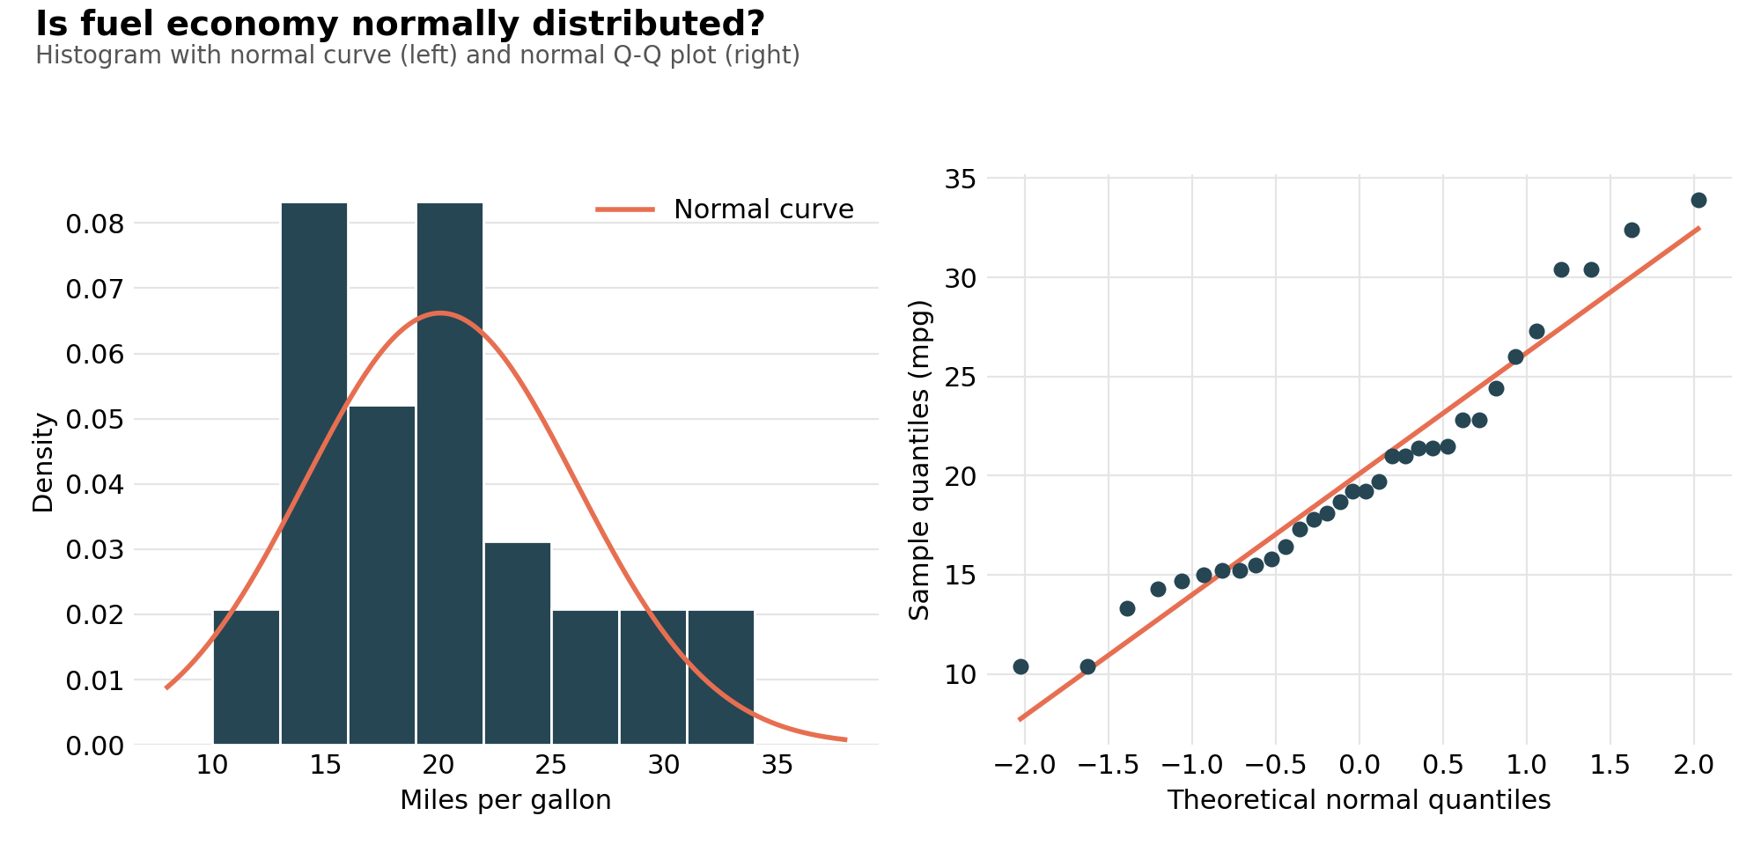
Figure 8: Histogram with normal curve and Q-Q plot of mpg
mpg passes the normality test (W = 0.948, p = 0.123), and the Q-Q points follow the line closely. Horsepower fails it (W = 0.933, p = 0.049) because a few powerful cars create a long right tail. Since normality is not guaranteed everywhere, every parametric test below is paired with a non-parametric alternative.

6.2 The three hypotheses
R code
cor.test(cars$wt, cars$mpg) # H1: weight and mpg are correlated
t.test(mpg ~ trans, data = cars) # H2: manual and automatic differ (Welch)
anova_fit <- aov(mpg ~ cyl_f, data = cars) # H3: mpg differs by cylinders
summary(anova_fit)
TukeyHSD(anova_fit) # which pairs differ?
leveneTest(mpg ~ cyl_f, data = cars) # are variances equal?
kruskal.test(mpg ~ cyl_f, data = cars) # non-parametric backup

Hypothesis | Test and result | Backup check | Decision
H1: weight and mpg are related | Pearson r = -0.868, p = 1.3e-10, 95% CI -0.934 to -0.744 | Spearman rho = -0.886, p < 0.001 | Reject H0
H2: transmission changes mpg | Welch t = -3.77, df = 18.3, p = 0.0014; automatic is lower by 3.2 to 11.3 mpg | Wilcoxon W = 42, p = 0.0019 | Reject H0
H3: cylinders change mpg | ANOVA F(2, 29) = 39.7, p = 5.0e-09 | Welch ANOVA p = 1.3e-06; Kruskal-Wallis p = 2.6e-06 | Reject H0

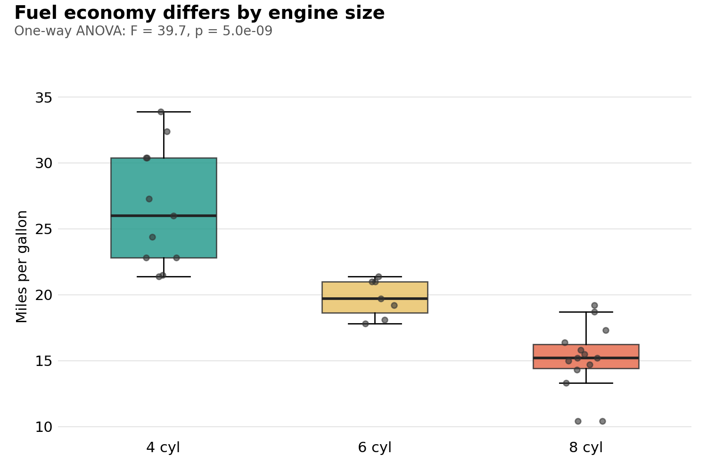
Figure 9: mpg by number of cylinders (one-way ANOVA)
Interpretation
- All three null hypotheses are rejected, and the backup tests agree every time, so the conclusions do not depend on any single assumption.
- Tukey's follow-up shows that every pair of cylinder groups differs: 6 vs 4 cylinders is -6.9 mpg, 8 vs 4 is -11.6 mpg and 8 vs 6 is -4.6 mpg (all p < 0.05).
- Levene's test is significant (p = 0.009), meaning the spread of mpg differs between groups. This is why Welch's ANOVA and Kruskal-Wallis, which do not assume equal spread, were added. They support the same answer.
- Statistical significance is not the same as practical importance. Here the effects are also large: a gap of up to 11.6 mpg between engine sizes and 5.3 mpg per 1000 lbs are differences a driver would notice at the pump.
- Hypothesis 2 comes with a caution: manual cars are lighter, so the transmission effect is mixed up with a weight effect. Separating them needs a model that includes both.
The tests confirm that weight, engine size and transmission are all linked to fuel economy, but they look at one factor at a time. The next section combines them in a single model.

7. Predictive Modeling

7.1 Approach
Because mpg is a continuous number, linear regression is the natural choice: it is accurate enough for this kind of data and its coefficients can be explained in plain language. The earlier stages decided the starting point. Weight is the strongest single predictor (Hypothesis 1), so it forms the baseline. Horsepower, cylinders and transmission each add information, but weight and horsepower are themselves correlated (r = 0.66), which suggests that the effect of one may depend on the other. An interaction term (wt * hp) tests that idea.

7.2 Fair evaluation with cross-validation
With only 32 cars, setting aside a separate test set would leave too little data for training. Cross-validation solves this: in 5-fold cross-validation the cars are split into five groups, and each group is predicted by a model trained on the other four. Leave-one-out cross-validation does the same with 32 groups of one car. Folds are assigned in a fixed pattern, so results are exactly reproducible.
R code
# Fixed (non-random) fold labels 1,2,3,4,5,1,2,... so results are reproducible.
# With folds = 1:n the same function performs leave-one-out cross-validation.
folds <- rep(1:5, length.out = nrow(cars))

cv_predictions <- function(formula, data, folds, inv = identity) {
pred <- numeric(nrow(data))
for (k in sort(unique(folds))) {
fit <- lm(formula, data = data[folds != k, ]) # train on other folds
pred[folds == k] <- inv(predict(fit, newdata = data[folds == k, ]))
}
pred # out-of-fold predictions
}

7.3 Choosing the model
Seven candidate models were compared, from the weight-only baseline (M1) to a seven-predictor model (M7). The comparison uses adjusted R-squared, AIC (a fit measure that penalises complexity) and cross-validated error (RMSE, the typical prediction error in mpg).
ID | Model formula | Adj. R2 | AIC | 5-fold RMSE | LOOCV RMSE | R2 (CV)
M1 | mpg ~ wt | 0.745 | 166.0 | 3.174 | 3.202 | 0.714
M2 | mpg ~ wt + hp | 0.815 | 156.7 | 2.874 | 2.775 | 0.765
M3 | mpg ~ wt + qsec + am | 0.834 | 154.1 | 2.626 | 2.689 | 0.804
M4 | mpg ~ wt + hp + am | 0.823 | 156.1 | 2.778 | 2.732 | 0.781
M5 | mpg ~ wt * hp | 0.872 | 145.6 | 2.427 | 2.342 | 0.833
M6 | mpg ~ wt + cyl_f | 0.820 | 156.6 | 2.703 | 2.699 | 0.792
M7 | mpg ~ cyl + disp + hp + drat + wt + qsec + am | 0.829 | 158.1 | 2.941 | 2.855 | 0.754

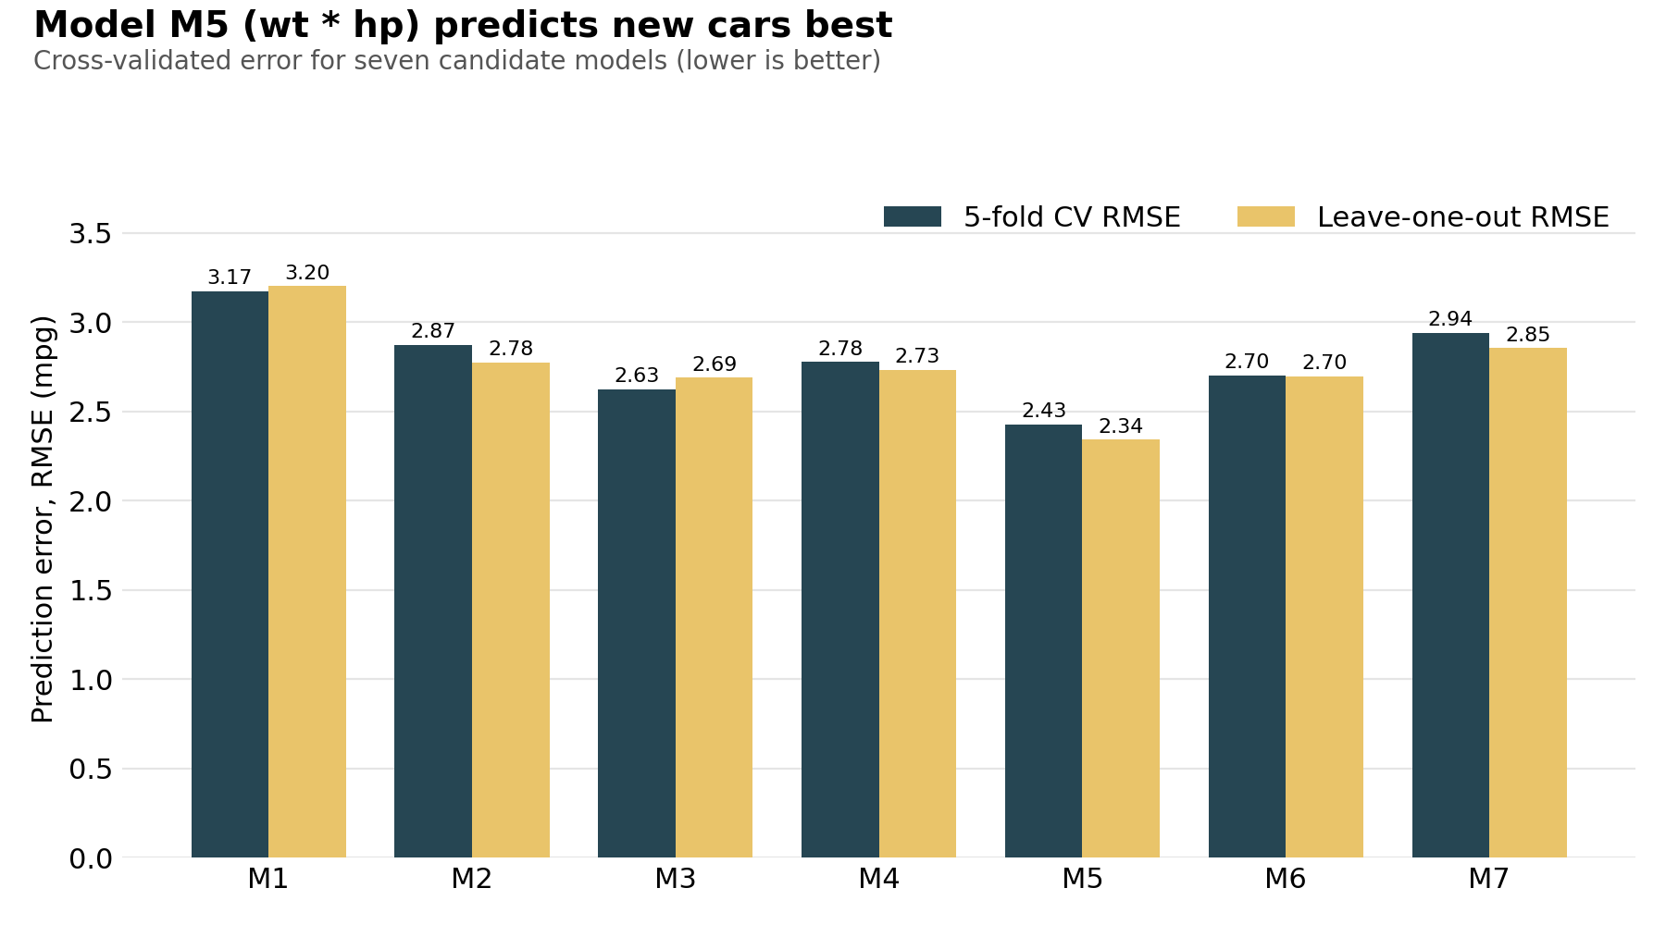
Figure 10: Cross-validated prediction error of the seven candidate models
Model M5, which uses weight, horsepower and their interaction, wins on every measure: the lowest cross-validated error (2.43 mpg on 5-fold, 2.34 on leave-one-out), the lowest AIC (145.6) and the highest adjusted R-squared (0.872). The most complex model, M7, is among the worst on unseen cars (2.94 mpg). It fits the training cars well but predicts new cars badly, a classic case of overfitting, and it shows why cross-validated error, not in-sample fit, should drive model choice.

7.4 The final model
R code
final <- lm(mpg ~ wt * hp, data = cars) # weight, horsepower and their interaction
summary(final) # coefficients, R-squared, F-test
confint(final) # 95% confidence intervals

# Predict a new car: 3000 lbs and 150 hp
predict(final, newdata = data.frame(wt = 3.0, hp = 150), interval = "prediction")

Console output
Call:
lm(formula = mpg ~ wt * hp, data = cars)

Residuals:
Min 1Q Median 3Q Max
-3.0632 -1.6491 -0.7362 1.4211 4.5513

Coefficients:
Estimate Std. Error t value Pr(>|t|)
(Intercept) 49.80842 3.60516 13.816 5.01e-14 ***
wt -8.21662 1.26971 -6.471 5.20e-07 ***
hp -0.12010 0.02470 -4.863 4.04e-05 ***
wt:hp 0.02785 0.00742 3.753 0.000811 ***
---
Signif. codes: 0 '***' 0.001 '**' 0.01 '*' 0.05 '.' 0.1 ' ' 1

Residual standard error: 2.153 on 28 degrees of freedom
Multiple R-squared: 0.8848, Adjusted R-squared: 0.8724
F-statistic: 71.66 on 3 and 28 DF, p-value: 2.981e-13

How to read the model
- All four coefficients are significant (p < 0.001). The model explains 88.5% of the variation in mpg (adjusted R-squared 0.872) and the overall F-test is highly significant (p = 3e-13).
- The residual standard error is 2.15 mpg: a typical prediction is within about 2 mpg of the truth.
- The positive interaction (0.0278) means the penalty for weight depends on horsepower. An extra 1000 lbs lowers mpg by about 6.4 for a 66 hp car, 4.8 for a 123 hp car and only 1.4 for a 244 hp car.
- In plain words: light, low-power economy cars are the most sensitive to added weight, while heavy high-power cars are already inefficient, so extra weight changes their mpg less.
- Example: a car of 3000 lbs and 150 hp is predicted at 19.7 mpg, with a 95% prediction interval of 15.1 to 24.2 mpg for a single new car.
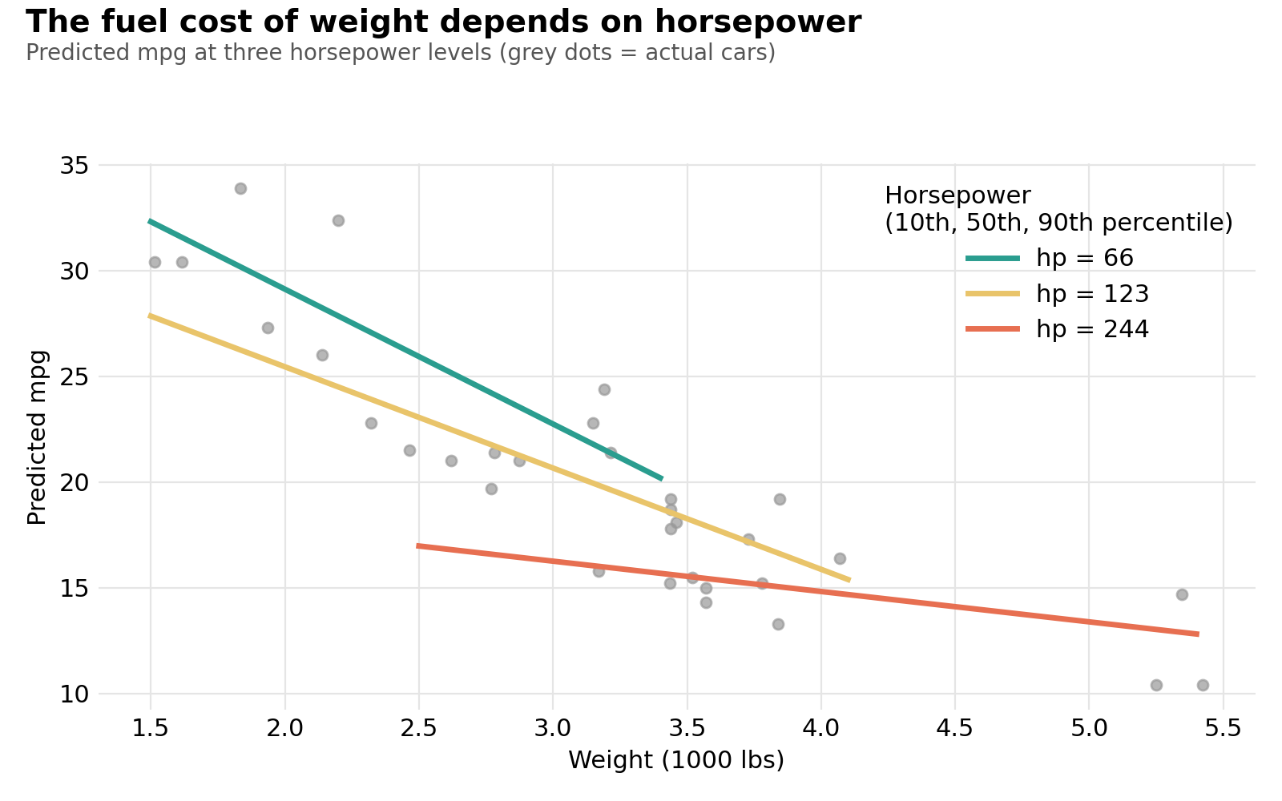
Figure 11: Predicted mpg by weight at three horsepower levels

Predictive performance on unseen cars
Model | RMSE (mpg) | MAE (mpg) | Out-of-fold R2
Baseline: mpg ~ wt (5-fold) | 3.174 | 2.523 | 0.714
Final: mpg ~ wt * hp (5-fold) | 2.427 | 2.144 | 0.833
Final: mpg ~ wt * hp (leave-one-out) | 2.342 | 2.033 | 0.844

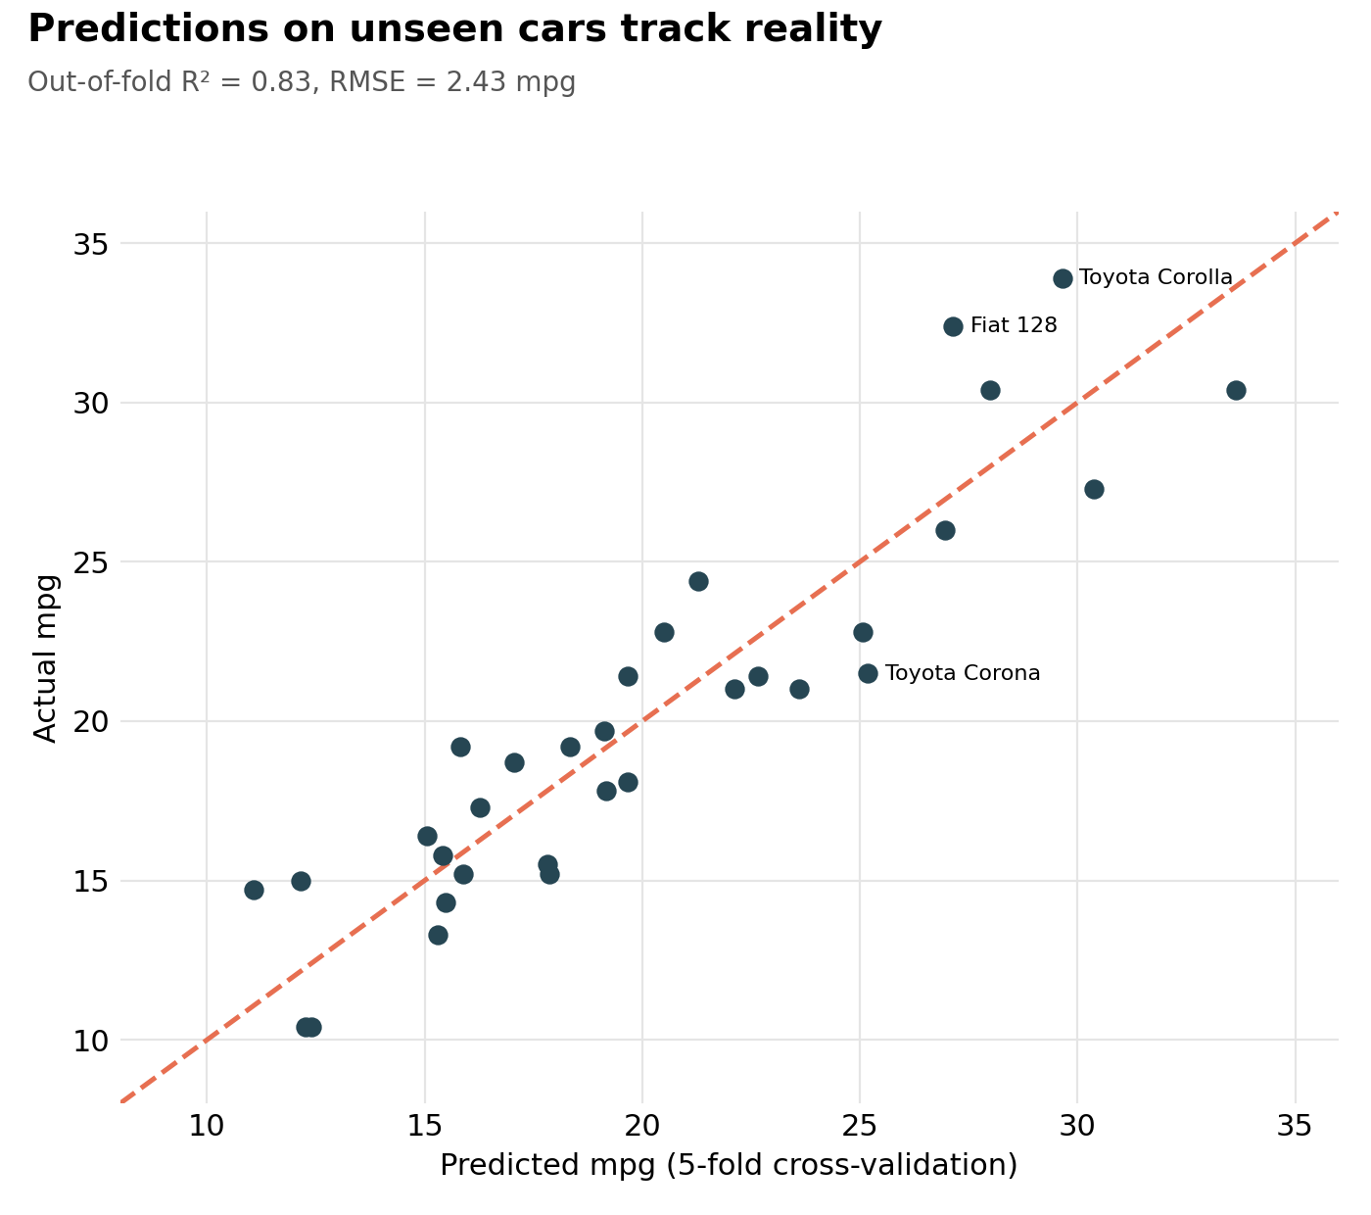
Figure 12: Actual versus predicted mpg using 5-fold cross-validation
On cars it has never seen, the final model is off by about 2.4 mpg (about 12% of the average mpg of 20.1) and predicts 83% to 84% of the variation, compared with 71% for the baseline. The error fell by about 24% (3.17 to 2.43 mpg). The biggest misses are very efficient small cars: the Fiat 128 (actual 32.4, predicted 27.1) and the Toyota Corolla (actual 33.9, predicted 29.6) are under-predicted, so the model is somewhat too cautious about the most efficient cars.

7.5 Can the model be trusted? Diagnostics
A model is only trustworthy if its assumptions hold. The standard checks were run on the final model.
R code
png("f5_diag.png", width = 3000, height = 2500, res = 300)
par(mfrow = c(2, 2))
plot(final) # residuals vs fitted, Q-Q, scale-location, leverage
par(mfrow = c(1, 1))
dev.off()

shapiro.test(residuals(final)) # are residuals normal?
bptest(final) # constant variance? (Breusch-Pagan)
vif(final) # multicollinearity

# Centring the predictors removes most of the collinearity
cars$wt_c <- cars$wt - mean(cars$wt)
cars$hp_c <- cars$hp - mean(cars$hp)
final_c <- lm(mpg ~ wt_c * hp_c, data = cars)
vif(final_c)

# Influential observations
cooks <- cooks.distance(final)
sort(cooks, decreasing = TRUE)[1:5]
names(which(cooks > 4 / nrow(cars)))

Console output
Shapiro-Wilk normality test

data: residuals(final)
W = 0.95447, p-value = 0.1928

studentized Breusch-Pagan test

data: final
BP = 8.4646, df = 3, p-value = 0.03732

wt hp wt:hp
10.32442 19.18172 43.05685

wt_c hp_c wt_c:hp_c
1.79591 1.77020 1.01938

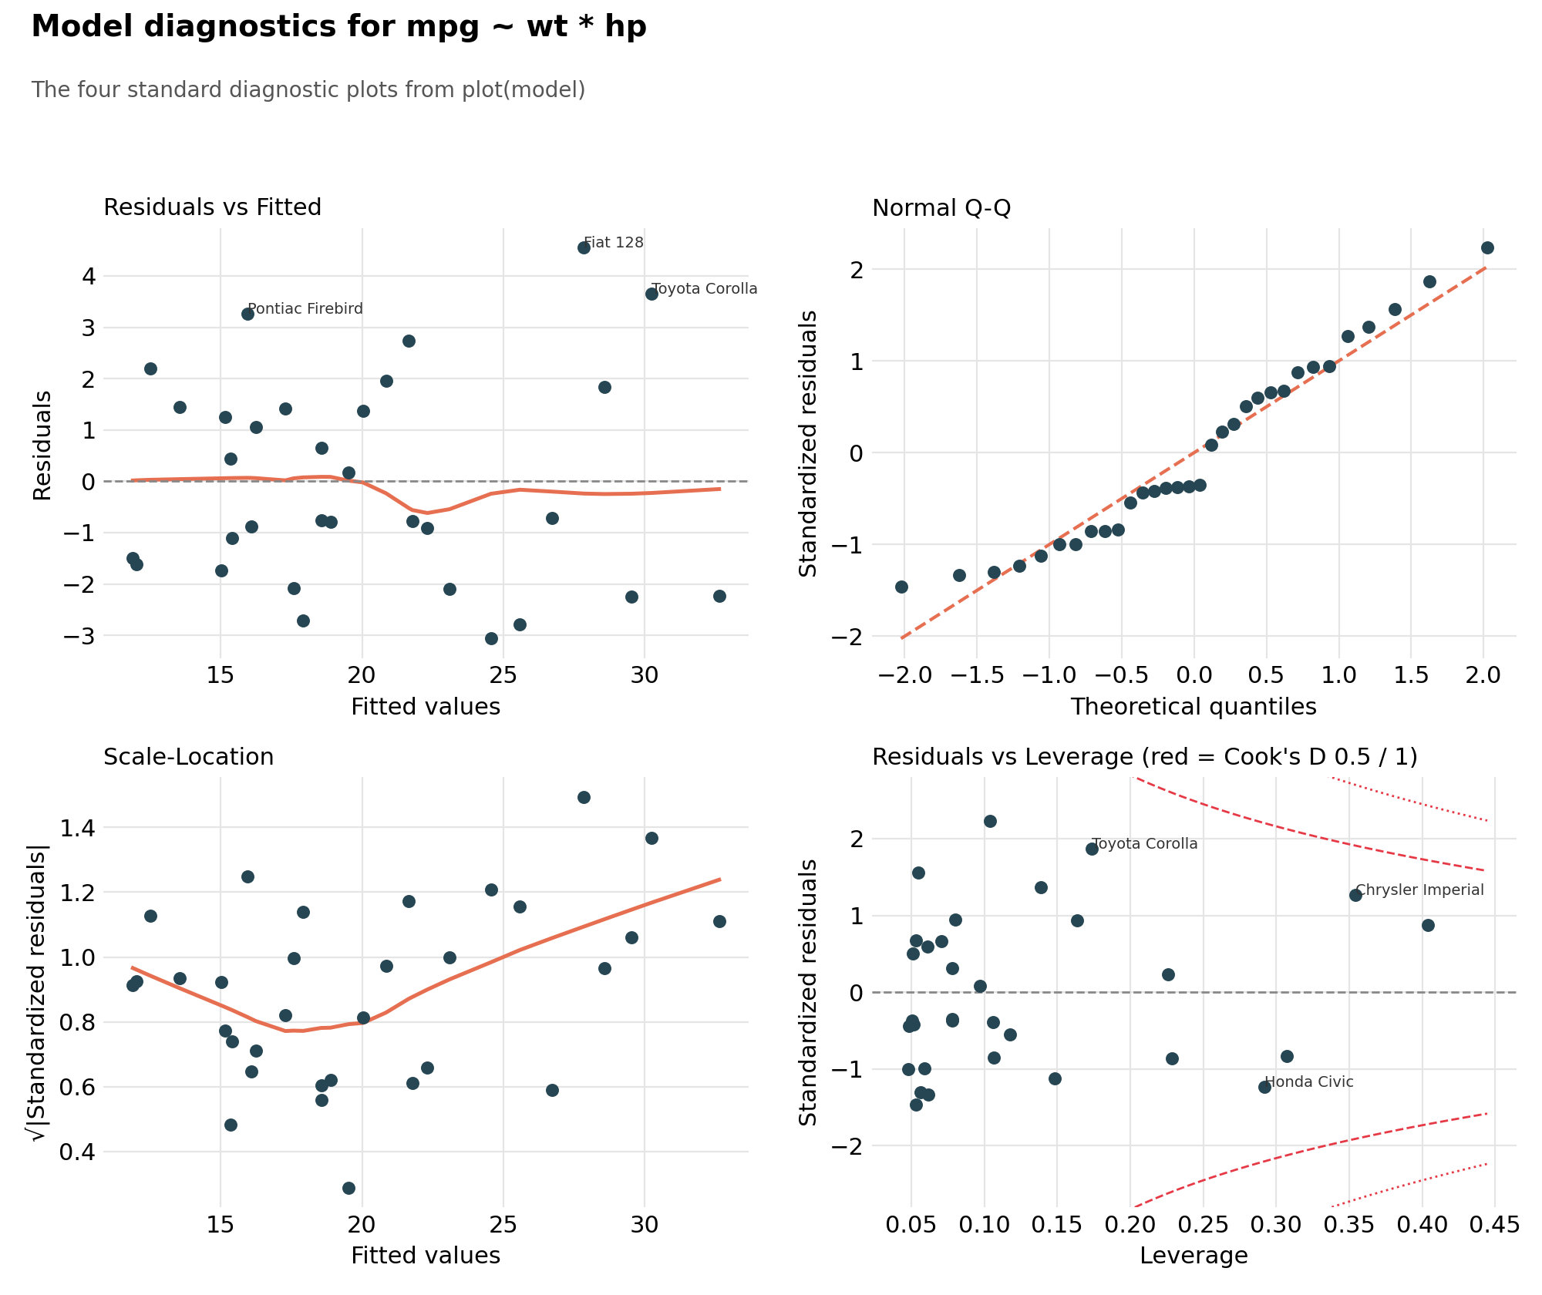
Figure 13: The four standard diagnostic plots for the final model
Assumption | Check | Result
Linearity | Residuals vs Fitted | Residuals scatter around zero with only a slight dip near 22 mpg. A linear model is adequate.
Normal errors | Q-Q plot, Shapiro-Wilk | Points follow the line; W = 0.954, p = 0.193. No evidence against normality.
Constant variance | Scale-Location, Breusch-Pagan | Mild issue: p = 0.037, errors are somewhat larger for high-mpg cars.
Collinearity | VIF | Raw VIFs of 10 to 43 are expected with an interaction; after centring they fall to 1.8 or below.
Influential cars | Cook's distance, leverage | Largest Cook's distance is 0.221 (Chrysler Imperial), well below 0.5; no standardized residual exceeds 3.

Overall the model is sound. Five cars exceed the common 4/n rule of thumb for Cook's distance (Chrysler Imperial, Toyota Corolla, Honda Civic, Fiat 128 and Maserati Bora), and two of them, Chrysler Imperial and Maserati Bora, also have high leverage because of unusual weight or power. None crosses the 0.5 danger line, which supports the earlier decision to keep all outliers. The mild unequal variance explains why prediction intervals for very efficient cars are a little too narrow.

7.6 Attempts to improve the model
Five variations of the final model were tested with the same cross-validation, targeting the unequal variance (a log transformation) and possible missing information (extra predictors and a squared weight term).
Console output
Model CV5_RMSE LOOCV_RMSE
mpg ~ wt * hp (final) 2.427 2.342
log(mpg) ~ wt * hp 2.432 2.361
mpg ~ wt * hp + qsec 2.333 2.284
mpg ~ wt * hp + am 2.470 2.409
mpg ~ wt * hp + disp 2.548 2.414
mpg ~ wt * hp + I(wt^2) 2.507 2.589

Model | 5-fold CV RMSE | LOOCV RMSE
mpg ~ wt * hp (final) | 2.427 | 2.342
log(mpg) ~ wt * hp | 2.432 | 2.361
mpg ~ wt * hp + qsec | 2.333 | 2.284
mpg ~ wt * hp + am | 2.470 | 2.409
mpg ~ wt * hp + disp | 2.548 | 2.414
mpg ~ wt * hp + I(wt^2) | 2.507 | 2.589

The log transformation does not help, and adding transmission, displacement or a squared weight term makes predictions worse on unseen cars. Only quarter-mile time gives a small gain (2.33 and 2.28 versus 2.43 and 2.34), which is within the noise of an estimate based on 32 cars, so the simpler model is kept. The lesson is that this dataset is close to the limit of what it can support: larger gains need more data, not more terms.

8. Discussion

8.1 Putting the pieces together
The four stages reinforce each other. Data preparation showed that the data were clean and that the unusual cars were genuine. Visualization suggested three patterns and one warning: weight, engine size and transmission seem linked to mpg, but weight and transmission overlap. Hypothesis tests confirmed that the patterns are statistically real and robust to the choice of test. The model then combined the factors, separated their effects and quantified them, finding that weight and power work together. At each step, the previous step either supplied the question or justified the method.

8.2 Statistical significance versus practical importance
Every hypothesis test returned a significant result, which can make a report sound more certain than it is. Two points keep the conclusions honest. First, the effects are large enough to matter in practice, not only statistically: 5.3 mpg per 1000 lbs and 11.6 mpg between engine sizes are noticeable differences. Second, significance does not equal causation. The data are observational, so the report describes associations. For example, heavy cars also tend to have big engines, so weight alone cannot be said to cause the drop in mpg.

8.3 Business implications
Audience | Implication
Vehicle designers and manufacturers | Weight is the most dependable lever on fuel economy, and the payoff is largest in light, low-power vehicles (about 6.4 mpg per 1000 lbs at 66 hp, compared with 1.4 at 244 hp). For high-power vehicles, powertrain efficiency matters more than shaving weight alone.
Buyers and fleet managers | In this data, a 4-cylinder car uses about 43% less fuel per mile than an 8-cylinder car (26.7 vs 15.1 mpg). Weight and engine size are quick screening criteria when comparing running costs, and a manual transmission is not a guarantee of efficiency because it largely reflects lighter cars.
Policy makers and analysts | Weight and power are measurable, regulable drivers of consumption, and a simple two-variable model estimates mpg within about 2.4 mpg, which is useful for first-pass estimates.
Airlines and airport planners | Demand grew about 3.8 times in 12 years and follows a stable summer peak about 1.5 times the November level. This supports seasonal capacity planning, summer staffing and scheduling maintenance in the autumn trough.

8.4 Limitations
- Small, old data: 32 cars from 1974 and airline data from 1949 to 1960 cannot describe today's vehicles or airlines, so the results illustrate the method more than they set current benchmarks.
- Observational data: relationships are associations, not proven causes.
- Limited range: predictions outside the observed weight and horsepower range should not be trusted.
- Mild unequal variance: errors are larger for very efficient cars, so intervals there are somewhat optimistic.
- Linear trend on growing data: the airline series curves upward and has growing seasonal swings, so a straight line is only a first approximation.

8.5 Challenges encountered and how they were handled
Challenge | How it was addressed
Very small sample (32 cars) | Used cross-validation and leave-one-out instead of a single train/test split, so every car contributed to both training and testing.
Assumptions not fully met (non-normal horsepower, unequal variances) | Paired each parametric test with a non-parametric or Welch alternative, and all pointed to the same conclusion.
Transmission effect mixed up with weight | Moved from one-factor tests to a multi-variable model that separates the effects.
Risk of overfitting with many predictors | Chose the model by cross-validated error, which exposed the seven-predictor model as the worst performer on unseen cars.
High VIF caused by the interaction term | Centred the predictors, which cut VIF from up to 43 to below 2 without changing predictions.
Deciding what to do with outliers | Checked each flagged car, confirmed it was genuine, kept it, and verified its influence with Cook's distance.
Explaining technical results to a mixed audience | Added plain-language interpretation to every result, an executive summary and a glossary.

9. Recommendations and Future Directions

9.1 Recommendations from the findings
- Prioritise weight reduction for smaller, lower-power vehicles, where each 1000 lbs removed is worth about 6 mpg in the model.
- Use the weight-and-horsepower model for quick estimates and always quote its margin of error (about plus or minus 4 mpg for a single car).
- Do not add predictors on the strength of in-sample fit; require evidence from cross-validation.
- For airline-type demand, plan around the seasonal pattern as well as the growth trend.

9.2 Further analysis
- Larger, more recent data: repeat the workflow on a modern vehicle dataset (for example, public fuel-economy data) to test whether the weight-by-power pattern still holds.
- Better time-series modelling: use forecasting methods such as ETS or ARIMA, with a log transformation to capture the growing seasonal swings, and measure forecast error on a held-out final year.
- More robust and flexible models: try regularised regression (ridge, lasso), robust regression for the unequal variance, and non-linear models such as GAMs or random forests.
- Repeated cross-validation: repeat 5-fold cross-validation with several random shuffles (caret or tidymodels) to give the error estimate a confidence band.
- Communication and automation: turn the script into a reproducible R Markdown or Quarto report, and build an interactive Shiny dashboard so non-technical users can explore the findings.

10. Conclusion

10.1 Why a data-driven approach matters
Opinions about what makes a car efficient or when airlines are busiest are easy to hold and hard to defend. A data-driven approach replaces them with evidence that can be measured, tested and repeated. Here it confirmed what common sense suggests (heavy, powerful cars use more fuel), but it also added what common sense cannot: how much, with what uncertainty, and how the factors interact. It also flagged where common sense could mislead, as with the apparent advantage of manual cars, which turned out to be largely about weight.

10.2 Lessons learned
- Clean and check the data first; every later result depends on it.
- Choose each chart to match the question it must answer.
- State hypotheses before testing, check assumptions, and back up each test with a second one.
- Judge a model by how it predicts new data, not by how well it fits the data it was built on.
- Simple models that can be explained are often as good as complex ones, especially with small data.
- Report uncertainty honestly, using confidence and prediction intervals, and separate association from causation.
- Make the work reproducible: one script, fixed folds, and every decision documented.

10.3 Final remarks
Across four weeks, the project moved from raw data to a validated, explained and tested prediction model. The two main results are that weight and power together explain most of a car's fuel economy and can predict it to within about 2.4 mpg, and that airline travel combined strong growth with a predictable summer peak. Just as important is the method: prepare, visualize, test, model, diagnose and communicate. That sequence can be applied to any dataset, and the next step is to apply it to larger, current data.

Appendix A: Glossary for Non-Technical Readers
Term | Plain-language meaning
mpg | Miles per gallon: how far a car travels on one gallon of fuel. Higher is more efficient.
Correlation (r) | A number from -1 to +1 showing how strongly two things move together. Near -1 means one rises as the other falls.
Hypothesis test | A formal check of whether a pattern in the data could just be luck.
p-value | The probability of seeing a pattern this strong if there were really no effect. Below 0.05 is treated as convincing evidence.
ANOVA | A test that compares the averages of three or more groups at once.
Regression | A method that fits a line or equation to predict one number (mpg) from others (weight, horsepower).
Interaction | When the effect of one factor depends on the level of another, such as weight mattering more in low-power cars.
R-squared | The share of the variation in the outcome that the model explains (1 = all of it, 0 = none).
Cross-validation | Testing a model on cars it was not trained on, to see how well it will predict new cases.
RMSE | The typical size of the model's prediction error, in the same unit as the outcome (mpg).
Outlier | A value far from the rest, which may be a mistake or simply an unusual but real case.
Residual | The gap between the real value and the model's prediction for one car.
VIF | A check for whether predictors overlap too much. High values make coefficients unstable.

Appendix B: Files and Reproduction
File | Content
Week4_Final_Analysis_Script.R | Complete R script: data preparation, all visualizations, hypothesis tests, models, cross-validation and diagnostics
images/ | Exported charts used in this report
report/ | This Word report

To reproduce the analysis, install R and RStudio, install the packages ggplot2, dplyr, car and lmtest, and run the script from top to bottom. It needs R 4.x and ggplot2 version 3.4 or later. Cross-validation folds are fixed, so the modelling results are identical on every run.

