ICP_1

700756561

Tejendra Konduru

**Program1.1**

str=input("Enter the input string:")

if len(str)>=2:

    str=str[:-2]

else:

    str=str[:-1]

print(str[::-1])

**Output:**

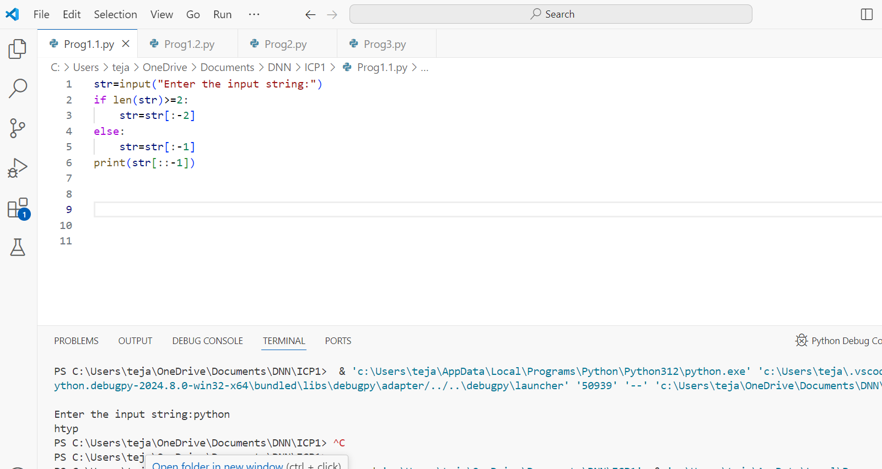

**Program1.2**

a=int(input("Enter the Number 1:"))

b=int(input("Enter the Number 2:"))

print(a+b)

print(a-b)

print(a*b)

print(a/b)

**Program2**

str=input("enter a string:")

rep=str.replace('python','pythons')

print(rep)

**Output:**

**Program3**

x=int(input("Enter your marks between 0 and 100:"))

def marks(x):

    if x>=90 and x<=100:

        return "A"

    elif x>=80 and x<90:

        return "B"

    elif x>=70 and x<80:

        return "C"

    elif x>=60 and x<70:

        return "D"

    else:

        return "F"

print("Grade:",marks(x))

**Output**

Video recording link:

<https://github.com/teja375/DNN/tree/main/ICP1>